Screening inflammatory protein biomarkers on premature infants with necrotizing enterocolitis
Running title: Inflammatory biomarkers on preterm NEC infants
Huifang Dong MD^{1, 2*}, Lingling Zhang MSc^{1*}, Bingbing Li MD¹, Jing Li MD², Yanshan Chen MD², Seidu R. Richard MD, PhD¹，Yiran Xu MD, PhD¹, Changlian Zhu, MD, PhD^{1,3,4}

Journal：Inflammation Research

Corresponding authors: Yiran Xu, Henan Key Laboratory of Child Brain Injury, Third Affiliated Hospital, Zhengzhou 450052, China. Tel: +86 371 6690 3550, Email: yiran.xu@zzuneuro.cn or Changlian Zhu, Center for Brain Repair and Rehabilitation, Institute of Neuroscience and Physiology, University of Gothenburg, Gothenburg 40530, Sweden. Tel: +46 31 786 3339, Email: changlian.zhu@neuro.gu.se or Third Affiliated Hospital of Zhengzhou University, Zhengzhou 450052, China. Tel: +86 371 6690 3974 Email: zhuc@zzu.edu.cn

Supplementary Materials

Supplementary Table1. Proinflammatory biomarkers between NEC and HC group
Biomarkers（NPX） | NEC vs. HC group(n) | Univariate analysis |  | Multivariate Analysis#
Biomarkers（NPX） | NEC vs. HC group(n) | OR (95%CI) | p value | OR (95%CI) | p value
IL-8 | 30/29 | 5.897(2.264-15.361) | <0.001*** | 7.50(2.235-25.171) | 0.001**
OPG | 30/29 | 18.978(3.651-98.660) | <0.001*** | 32.410(4.270-246.003) | 0.001**
TRAIL | 30/29 | 0.115(0.033-0.406) | 0.001** | 0.117 (0.033-0.413) | 0.001**
CXCL1 | 30/29 | 2.977(1.598-5.547) | 0.001** | 3.295(1.610-6.745) | 0.001**
TSLP | 30/29 | 6.443(2.132-19.469) | 0.001** | 15.728(3.369-73.413) | <0.001***
MCP-4 | 30/29 | 0.340(0.166-0.698) | 0.003** | 0.262(0.111-0.617) | <0.001***
TNFSF14 | 30/29 | 1.893(1.110-3.231) | 0.019* | 1.193(1.078-3.395) | 0.027*
IL-24 | 30/29 | 2.60(1.568-4.309) | <0.001*** | 3.320(1.734-6.358) | <0.001***
MMP-10 | 30/29 | 11.773(2.805-49.408) | 0.001** | 17.433(2.999-101.330) | 0.001**
LIF | 30/29 | 9.353(2.50-34.992) | 0.001** | 8.499(2.091-34.553) | 0.003**
CCL20 | 30/29 | 3.524(1.858-6685) | <0.001*** | 5.020(2.180-11.560) | <0.001***
#: Adjusted by gestational age, birth weight, sex, and fetal distress. *p<0.05, **p<0.01, ***p<0.001.

Supplementary Table2. Proinflammatory biomarkers between NEC and sepsis group
Biomarkers（NPX） | NEC vs Sepsis group(n) | Univariate analysis |  | Multivariate analysis#
Biomarkers（NPX） | NEC vs Sepsis group(n) | OR (95%CI) | p value | OR (95%CI) | p value
IL-8 | 30/29 | 1.736(1.195-2.521) | 0.004** | 1.802(1.221-2.659) | 0.003**
OPG | 30/29 | 2.660(1.306-5.416) | 0.007** | 2.838(1.333-6.042) | 0.007**
TRAIL | 30/29 | 0.318(0.150-0.673) | 0.003** | 0.298(0.137-0.649) | 0.002**
CXCL1 | 30/29 | 2.841(1.504-5.368) | 0.001** | 2.754(1.437-5.278) | 0.002**
TSLP | 30/29 | 3.730(1.484-9.373) | 0.005** | 3.90(1.495-10.178) | 0.005**
MCP-4 | 30/29 | 0.041(0.202-0.798) | 0.009** | 0.388(0.188-0.799) | 0.010*
TNFSF14 | 30/29 | 2.381(1.214-4.670) | 0.012* | 2.277(1.128-4.597) | 0.022*
IL-24 | 30/29 | 2.148(1.353-3.412) | 0.001** | 2.333(1.413-3.853) | 0.001**
MMP-10 | 30/29 | 3.694(1.461-9.341) | 0.006** | 4.743(1.585-14.195) | 0.005**
LIF | 30/29 | 2.499(1.286-4.857) | 0.007** | 2.670(1.224-5.823) | 0.014*
CCL20 | 30/29 | 1.631(1.113-2.389) | 0.012* | 1.813(1.182-2.782) | 0.006**
# Adjusted by gestational age, birth weight, sex, and fetal distress. *p<0.05, **p<0.01.

Supplementary Fig.1. Diagnostic value of the biomarkers between NEC and HC group
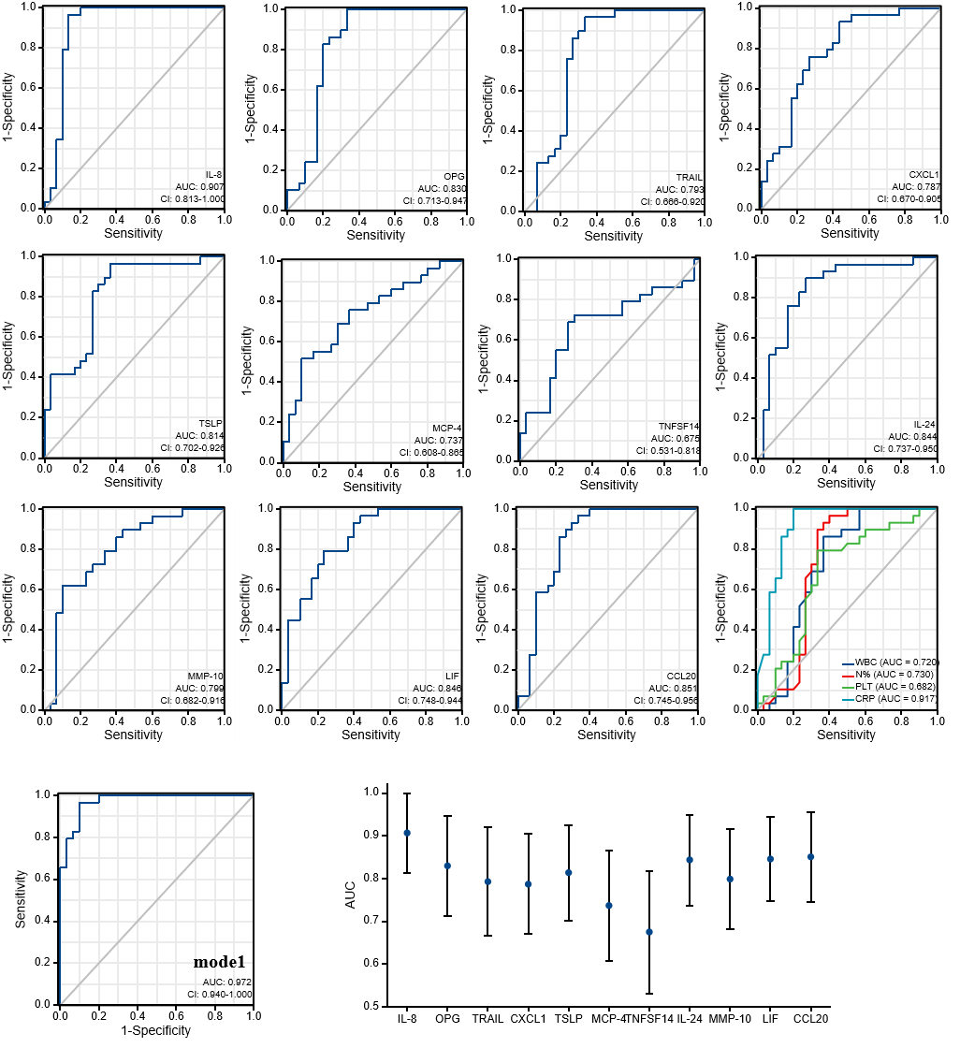
Diagnostic value of the biomarkers between NEC and HC group: AUC for different biomarkers. AUC 0.5-0.7: acceptable; AUC 0.7-0.85: good; AUC 0.85-0.95: excellent. Model 1: the11 markers are combined.

Supplementary Fig.2. Diagnostic value of the biomarkers between NEC and sepsis group
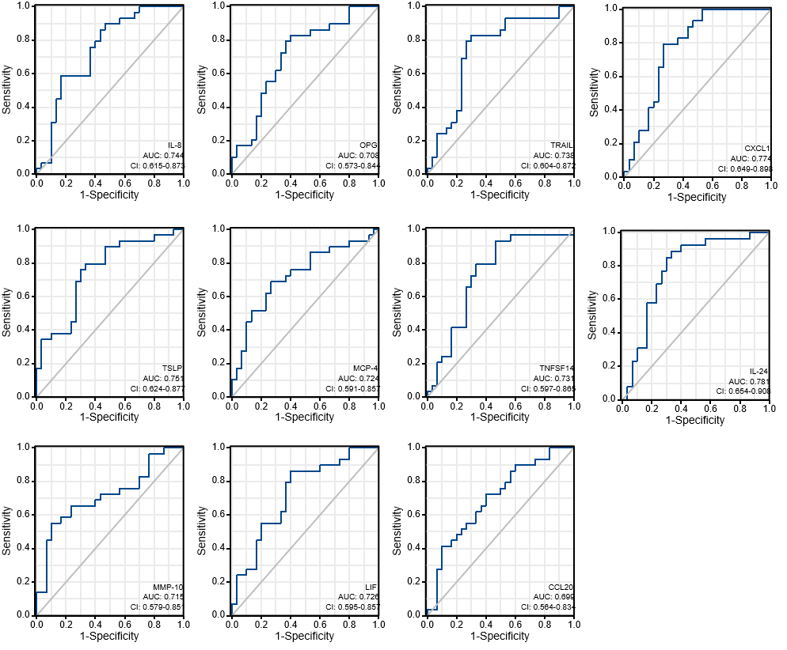
Diagnostic value of the biomarkers between NEC and Sepsis group: AUC for different biomarkers. AUC 0.5-0.7: acceptable; AUC 0.7-0.85: good; AUC 0.85-0.95: excellent.

Supplementary Fig.3. Diagnostic value of the biomarkers between NEC stage II and III
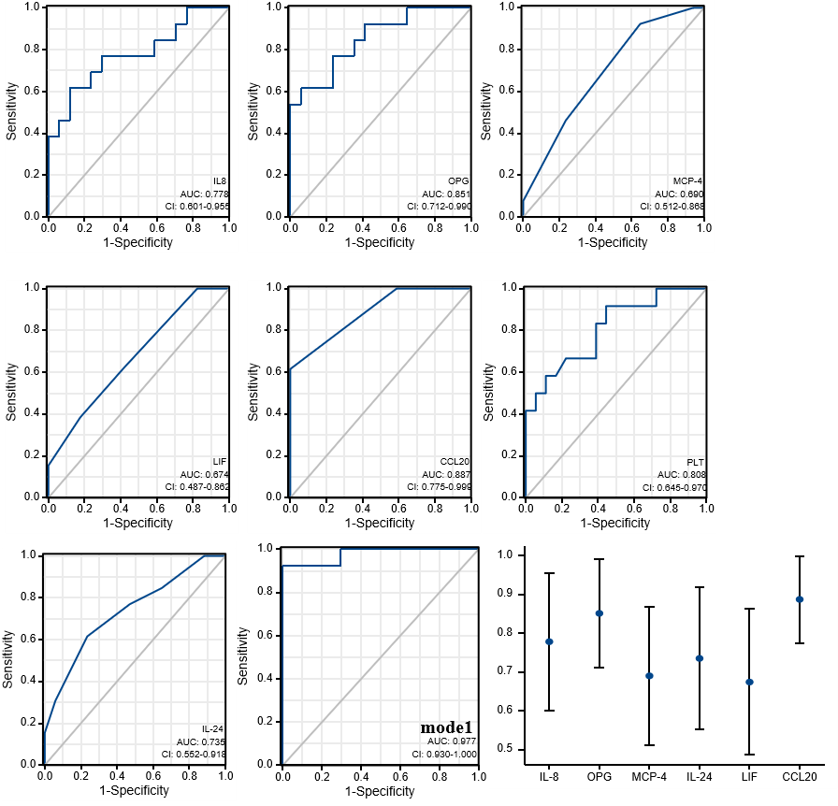
Diagnostic value of the biomarkers between NE C stage II and III groups: AUC for different biomarkers. AUC 0.5-0.7: acceptable; AUC 0.7-0.85: good; AUC 0.85-0.95: excellent. Model 1：the 6 markers are combined.

