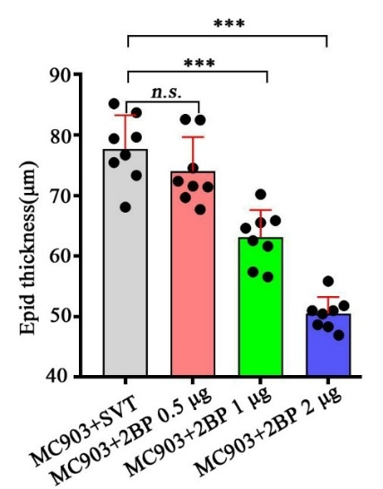
Supplementary figure 1. The effect of intradermal injection of 2BP on epidermal thickness in AD-like lesions from nape-AD model. MC903 was topically applied to the exposed nape of 8–10-week-old wt mice for 12 consecutive days. On days 3, 6, 9, the mice received intradermal injection of different dose of 2BP (0.5,1, or 2 μg/cm², dissolved in 30 μL). Statistics: One-way ANOVA+ Bonferroni’s tests, *** P <0.001, n.s. P >0.05.

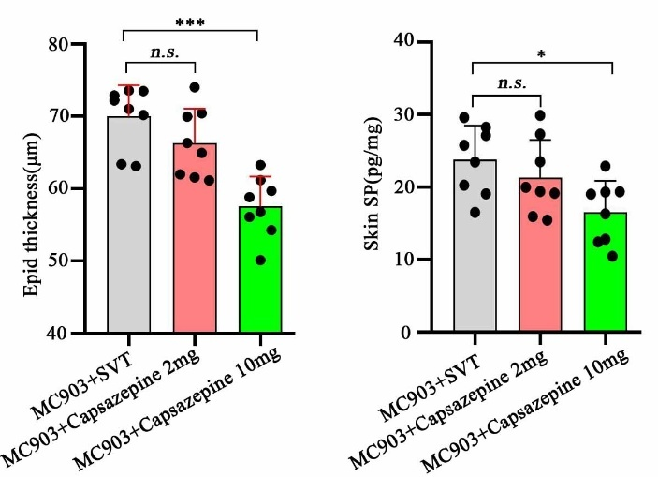
Supplementary figure 2. The effect of subcutaneous injection of capsazepine on epidermal thickness and SP content in AD-like lesions. MC903 was topically applied to the exposed nape of 8–10-week-old wt mice for 12 consecutive days. On days 3, 6, 9, the mice received subcutaneous injection of different dose of capsazepine (2, or 10 mg/kg, dissolved in 100 μL) or an equal volume of SVT. Statistics: One-way ANOVA+ Bonferroni’s tests, * P <0.05, *** P <0.001, n.s. P >0.05.

