Supplementary Files

Diagnostic significance of salivary and glandular siglec-5 in Sjögren disease and non-Sjögren sicca

Table of contents
Supplementary File 1 – Antibodies, assay kits, sources, reagents, manufacturers, software and Research Resource Identifiers (RRIDs).......................................................1
Supplementary File 2 - Number of patients included in the study per assay...................6
Supplementary File 3 - Comparative analysis of comorbidity prevalence in patients with SjD and nSS.......................................................................................................................7
Supplementary File 4 - Comparative analysis of medication use in patients with SjD and nSS.....................................................................................................................................9
Supplementary File 5 - Clinicodemographic data of SjD and overlapping SjD..............11
Supplementary File 6 - Expression of inflammatory cells in SjD and nSS.....................12
Supplementary File 7 - Spearman correlation matrix of clinical parameters, salivary siglec-5 and inflammatory markers..................................................................................13
Supplementary File 8 - Association of xerostomia with immune marker positivity (siglec-5, CD20 and CD3) and cytokine expression in salivary gland..............................14
Supplementary File 9 - Evaluation of area under the curve (AUC), sensitivity, specificity, Youden index, and cut-off point of EULAR (SjD and nSS) in relation to measures..........................................................................................................................15
Supplementary File 10 – Pairwise AUC comparisons (DeLong’s test)..........................17
Supplementary File 11 - Combined ROC curves...........................................................19

Supplementary File 1. Antibodies, assay kits, sources, reagents, manufacturers, software and Research Resource Identifiers (RRIDs)
Antibodies
Target | Application | Host | Reactivity | Clone/Cat No. | Dilution | Source | Lot No. | RRIDs
Siglec-5 Polyclonal Antibody | IHC | Rabbit/ IgG | Human | Polyclonal PA5-11675 | 1:200 | ThermoFisher Scientific Inc. Waltham, MA, USA | YL4143926A | AB_2189281
Polyclonal Rabbit Anti-Human CD3 | IHC | Rabbit | Human | Polyclonal GA503 | Ready-to-use | Agilent Dako Santa Clara, CA, USA | 41546367 | AB_3665673
Monoclonal Mouse Anti-Human CD20cy | IHC | Mouse | Human | Monoclonal Clone L26 GA604 | Ready-to-use | Agilent Dako Santa Clara, CA, USA | 41614232 | AB_3678473
Human Siglec-5/ Siglec-14 DuoSet | ELISA | - | Human | DY1072 | - | R&D Systems Minneapolis, MN, USA | P325298 | AB_3720330
Human IgA (Immunoglobulin A) | ELISA | - | Human | EH0415 | - | Wuhan Fine Biotech Co. Wuhan, Hubei, China | H0415I045 | AB_3720331
Human IgG (Immunoglobulin G) | ELISA | - | Human | EH0417 | - | Wuhan Fine Biotech Co. Wuhan, Hubei, China | H0417I045 | AB_3720332
Human IFN-gamma DuoSet | ELISA | - | Human | DY285B-05 | - | R&D Systems Minneapolis, MN, USA | P364279 | AB_2928044
Human IL-6 Quantikine | ELISA | - | Human | HS600C | - | R&D Systems Minneapolis, MN, USA | P341391 | AB_2893335
Human IL-8/CXCL8 DuoSet | ELISA | - | Human | DY208-05 | - | R&D Systems Minneapolis, MN, USA | P362550 | AB_2892143
Myeloperoxidase Polyclonal Antibody | ELISA | Rabbit/ IgG | Human, Mouse, Rat | PA5-16672 | 1:500 | ThermoFisher Scientific Inc. Waltham, MA, USA | - | AB_11006367
Colorimetric Assay Kits
Name | Application |  |  | Cat No. |  | Source | Lot No. | RRIDs
Nitrate/Nitrite | Biochemical colorimetric assay (Griess reaction-based) |  |  | 780014 |  | Cayman Chemical Co. Ann Arbor, MI, USA | - | -
Quant-iTTM PicoGreen® dsDNA Assay Kit | Fluorescent quantification of dsDNA |  |  | P7589 |  | ThermoFisher Scientific Inc. Waltham, MA, USA | 2247972 | -
Other supplies
Material | Application |  |  | Cat No. |  | Source |  | RRIDs
EnVision FLEX, Mini Kit, High pH (Link) | IHC |  |  | K8023 |  | Agilent Dako, Santa Clara, CA, USA |  | AB_2890017
Polarized slides Perfecta | IHC |  |  | 301.615.810 |  | Perfecta, São Paulo, SP, Brazil |  | -
Antibody diluent (FLEX) | IHC |  |  | K8006 |  | Agilent Dako, Santa Clara, CA, USA |  | -
Citric Acid, Anhydrous | IHC |  |  | 01A1026.01.AG |  | Synth, Diadema, SP, Brazil |  | -
Mayer’s hematoxylin solution | IHC |  |  | MHS16 |  | Sigma Aldrich, St. Louis, MO, USA |  | -
Axioskop 40 Microscope | IHC |  |  | D-37030 |  | Zeiss, Goettingen, Germany |  | -
FlexStation 3 Multi-Mode Microplate Reader | ELISA |  |  | - |  | Molecular Devices, San Jose, CA, USA |  | SCR_025281
BioTek Microplate Washer | ELISA |  |  | - |  | BioTek Instruments (Agilent), Santa Clara, CA, USA |  | SCR_019725
Software
Resource | Version |  |  | Manufacturer |  | Location |  | RRIDs
IBM SPSS Statistics | 25.0 |  |  | IBM Corporation |  | Armonk, NY, USA |  | SCR_002865
GraphPad Prism | 7.0 |  |  | GraphPad Software Inc. |  | La Jolla, CA, USA |  | SCR_002798
Jamovi | 2.5 |  |  | The jamovi project |  | Sydney, Australia |  | SCR_016142
R | 4.5.0 |  |  | R Core Team |  | Vienna, Austria |  | SCR_001905
MedCalc | 23.3.2 |  |  | MedCalc Software Ltd. (BVBA) |  | Ostend, Flanders, Belgium |  | SCR_015044
Python | 3.11 |  |  | Python Software Foundation |  | Wilmington, DE, USA |  | SCR_008394
Note: ELISA, Enzyme-linked immunosorbent assay; IgA, immunoglobulin A; IgG, immunoglobulin G; IHC, immunohistochemistry; IL, interleukin; IFN, interferon; NETs, neutrophil extracellular traps; NO, nitric oxide; Siglec, sialic acid-binding immunoglobulin-like lectin.

Supplementary File 2. Number of patients included in the study per assay

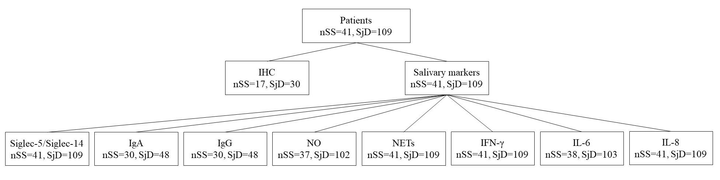
Note: IgA, immunoglobulin A; IgG, immunoglobulin G; IHC, immunohistochemistry; IL, interleukin; IFN, interferon; NETs, neutrophil extracellular traps; NO, nitric oxide; nSS, non-Sjögren sicca; Siglec, sialic acid-binding immunoglobulin-like lectin; SjD, Sjögren disease.
Supplementary File 3. Comparative analysis of comorbidity prevalence in patients with SjD and nSS
Variables, n (%) | SjD (n=106) | nSS (n=41) | p value
RA |  |  | 0.446 ^{ꝉ}
Yes | 13 (12.3) | 7 (17.1)
No | 93 (87.7) | 34 (82.9)
SLE |  |  | 0.351^{ǂ}
Yes | 12 (11.3) | 2 (4.9)
No | 94 (88.7) | 39 (95.1)
Other rheumatological diseases |  |  | 0.390 ^{ꝉ}
Yes | 39 (36.8) | 12 (29.3)
No | 67 (63.2) | 29 (70.7)
Heart disease |  |  | 0.263 ^{ꝉ}
Yes | 60 (56.6) | 19 (46.3)
No | 46 (43.4) | 22 (53.7)
Metabolic diseases |  |  | 0.948 ^{ꝉ}
Yes | 29 (27.4) | 11 (26.8)
No | 77 (72.6) | 30 (73.2)
Respiratory diseases |  |  | 0.220^{ǂ}
Yes | 20 (18.9) | 4 (9.8)
No | 86 (81.1) | 37 (90.2)
Nervous system diseases |  |  | 0.337 ^{ꝉ}
Yes | 35 (33) | 17 (41.5)
No | 71 (67) | 24 (58.5)
Renal diseases |  |  | 0.656 ^{ꝉ}
Yes | 15 (14.2) | 7 (17.1)
No | 91 (85.8) | 34 (82.9)
Gastrointestinal diseases |  |  | 0.069 ^{ꝉ}
Yes | 19 (17.9) | 13 (31.7)
No | 87 (82.1) | 28 (68.3)
Thyroid diseases |  |  | 0.034^{ǂ}
Yes | 24 (22.6) | 3 (7.3)
No | 82 (77.4) | 38 (92.7)
Bone disease |  |  | 0.193 ^{ꝉ}
Yes | 29 (27.4) | 7 (17.1)
No | 77 (72.6) | 34 (82.9)
Malignant neoplasm |  |  | 1.000^{ǂ}
Yes | 3 (2.8) | 1 (2.4)
No | 103 (97.3) | 40 (97.6)
Lymphoma | 0 | 0
Monoclonal gammopathy |  |  | 0.481^{ǂ}
Yes | 1 (0.9) | 1 (2.4)
No | 105 (99.1) | 40 (97.6)
Note: nSS, non-Sjögren sicca; RA, rheumatoid arthritis; SjD, Sjögren disease; SLE, systemic lupus erythematosus.
^{ǂ}Fisher exact test.
^{ꝉ}Pearson Chi-Square test.
Supplementary File 4. Comparative analysis of medication use in patients with SjD and nSS
Variables, n (%) | SjD (n=106) | nSS (n=41) | p value
Corticosteroid |  |  | 0.576^{ꝉ}
Yes | 28 (26.4) | 9 (22)
No | 78 (73.6) | 32 (78)
Hydroxychloroquine |  |  | 0.189^{ǂ}
Yes | 18 (17) | 3 (7.3)
No | 88 (83) | 38 (92.7)
Methotrexate |  |  | 0.656^{ꝉ}
Yes | 27 (25.5) | 9 (22)
No | 79 (74.5) | 32 (78)
Folic acid |  |  | 0.153^{ꝉ}
Yes | 24 (22.6) | 5 (12.2)
No | 82 (77.4) | 36 (87.8)
Mycophenolate mofetil |  |  | 0.322^{ǂ}
Yes | 5 (4.7) | 0
No | 101 (95.3) | 41 (100)
Other immunosuppressants |  |  | 0.780^{ǂ}
Yes | 13 (12.3) | 4 (9.8)
No | 93 (87.7) | 37 (90.2)
Immunomodulators |  |  | 0.726^{ǂ}
Yes | 8 (7.5) | 2 (4.9)
No | 98 (92.5) | 39 (95.1)
Antihypertensives |  |  | 0.781^{ꝉ}
Yes | 57 (53.8) | 21 (51.2)
No | 49 (46.2) | 20 (48.8)
Thyroxine |  |  | 0.033^{ǂ}
Yes | 25 (23.6) | 3 (7.3)
No | 81 (76.4) | 38 (92.7)
Antidepressants |  |  | 0.587^{ꝉ}
Yes | 49 (46.2) | 21 (51.2)
No | 57 (53.8) | 20 (48.8)
Anticonvulsants |  |  | 0.870^{ꝉ}
Yes | 14 (13.2) | 92 (86.8)
No | 5 (12.2) | 36 (87.8)
Antipsychotics |  |  | 1.000^{ǂ}
Yes | 8 (7.5) | 3 (7.3)
No | 98 (92.5) | 38 (92.7)
Antidiabetics |  |  | 0.718^{ꝉ}
Yes | 18 (17) | 8 (19.5)
No | 88 (83) | 33 (80.5)
Statins |  |  | 0.640^{ꝉ}
Yes | 27 (25.5) | 12 (29.3)
No | 79 (74.5) | 29 (70.7)
Opioids |  |  | 0.671^{ǂ}
Yes | 4 (3.8) | 2 (4.9)
No | 102 (96.2) | 39 (95.1)
Anticoagulants |  |  | 1.000^{ǂ}
Yes | 5 (4.7) | 1 (2.4)
No | 101 (95.3) | 40 (97.6)
Bisphosphonates |  |  | 0.558^{ǂ}
Yes | 13 (12.3) | 3 (7.3)
No | 93 (87.7) | 38 (92.7)
Vitamin D |  |  | 0.004^{ǂ}
Yes | 31 (29.2) | 3 (7.3)
No | 75 (70.8) | 38 (92.7)
Calcium |  |  | 0.106^{ꝉ}
Yes | 32 (30.2) | 7 (17.1)
No | 74 (69.8) | 34 (82.9)
Eye drops |  |  | 0.026^{ꝉ}
Yes | 47 (44.3) | 10 (24.4)
No | 59 (55.7) | 31 (75.6)
Note: nSS, non-Sjögren sicca; SjD, Sjögren disease.
^{ǂ}Fisher exact test;
^{ꝉ}Pearson Chi-Square test.
Supplementary File 5. Clinicodemographic data of SjD versus SjD overlapping with other rheumatic diseases
Variables | SjD (n=54) | Overlapping SjD (n=57) | p value
Age, median (range) | 57 (10-76) | 58 (19-76) | 0.552§
Sex, n (%) |  |  | 1.000^{ǂ}
Female | 49 (94.2) | 54 (94.7)
Male | 3 (5.8) | 3 (5.3)
Xerostomia, n (%) |  |  | 0.640^{ꝉ}
Yes | 38 (73.2) | 49 (86)
No | 8 (15.3) | 8 (14)
NR | 6 (11.5) | 0
Xerophthalmia, n (%) |  |  | 0.151^{ꝉ}
Yes | 32 (61.5) | 48 (84.2)
No | 9 (17.3) | 6 (10.5)
NR | 11 (21.1) | 3 (5.2)
AntiRo/SSA, n (%) |  |  | 0.021 ^{ꝉ}
Positive | 31 (59.6) | 45 (78.9)
Negative | 18 (34.6) | 9 (15.8)
NR | 3 (5.7) | 3 (5.3)
Hyposalivation, n (%) |  |  | 0.594^{ꝉ}
Yes | 38 (73.1) | 39 (68.4)
No | 14 (26.9) | 18 (31.6)
Focus Score, median (range) | 2.3 (0-7.7) | 1.7 (0-7) | 0.095§
Unstimulated whole salivary flow rate (ml/min), median (range) | 0.1 (0-0.9) | 0.1 (0-0.8) | 0.457§
Parotitis, n (%) |  |  | 0.732^{ꝉ}
Yes | 22 (42.3) | 23 (40.3)
No | 25 (48.1) | 30 (52.6)
NR | 5 (9.6) | 4 (7.1)
Note: NR, not reported; SjD, Sjögren disease.
§Mann-Whitney test.
^{ǂ}Fisher exact test.
^{ꝉ}Pearson chi-square test.

Supplementary File 6. Expression of inflammatory cells in SjD and nSS
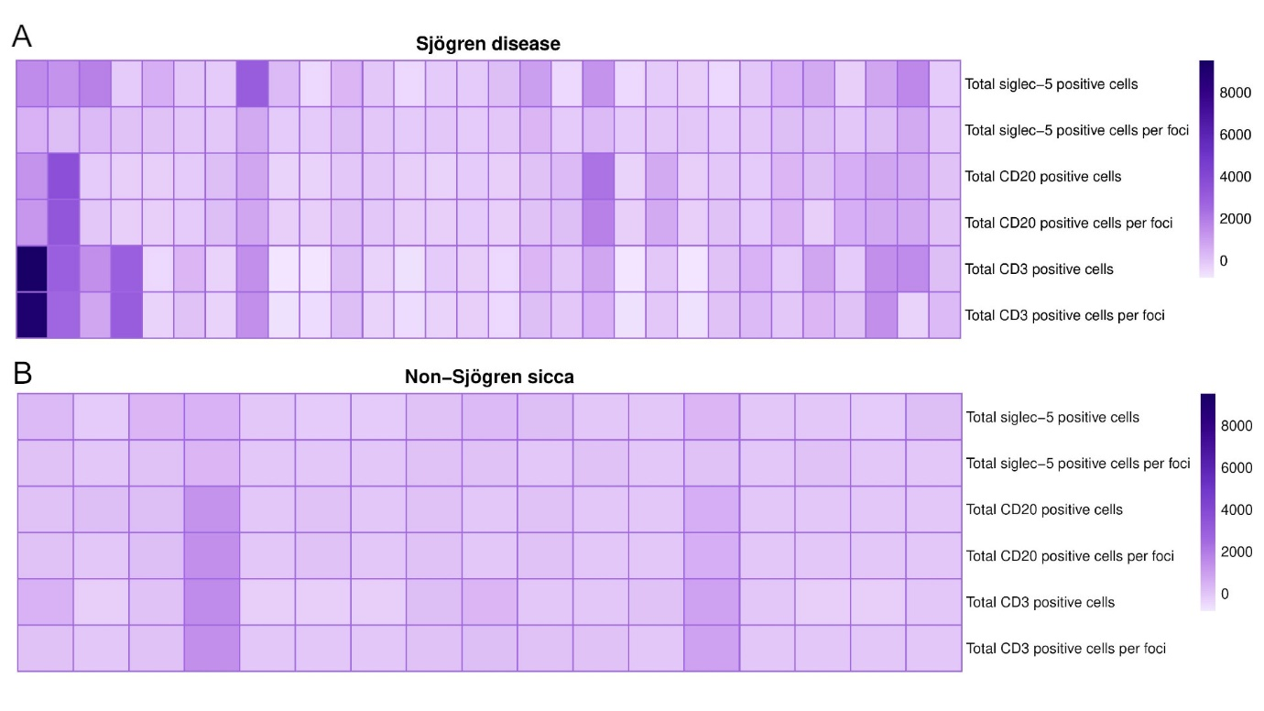
Note: Diagram illustrating differences in immunoquantification of siglec-5, CD3, and CD20 cells (total count and count per foci) between SjD and nSS groups. Each column represents an individual sample.

Supplementary File 7. Spearman correlation matrix of clinical parameters, salivary siglec-5/siglec-14 and inflammatory markers
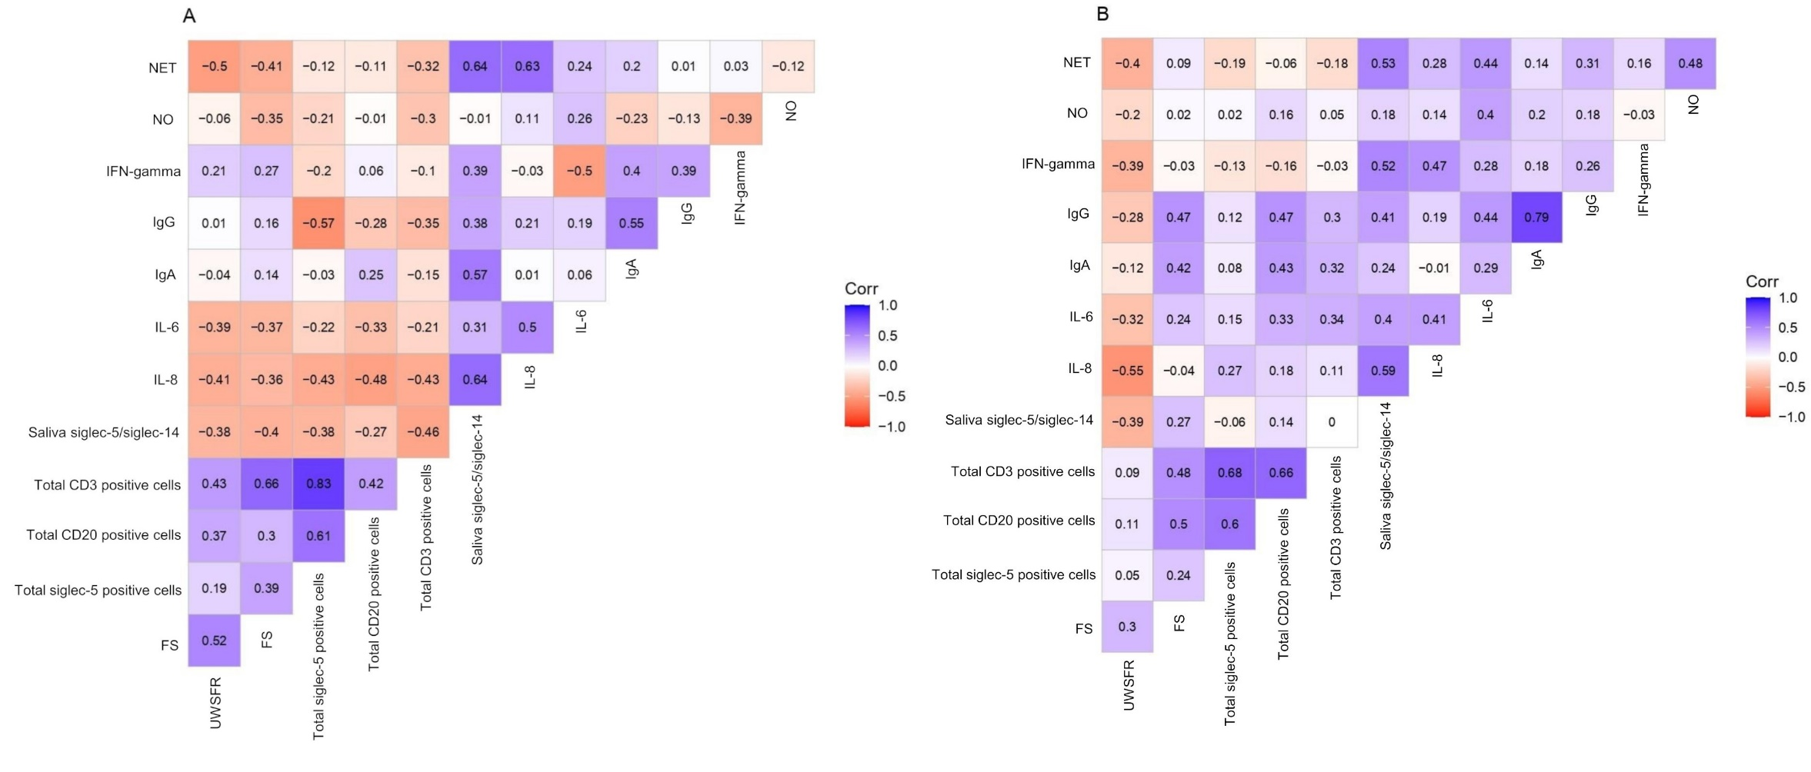
Note: Spearman correlation matrix showing pairwise associations. Values shown represent Spearman’s correlation coefficients (R). Positive correlations are indicated by positive R values, and negative correlations by negative R values. (A) nSS (B) SjD. SjD: Sjögren disease; nSS: non-Sjögren sicca; CODS: Clinical Oral Dryness Score; UWSFR: unstimulated salivary flow rate; FS: focus score; Siglec: Sialic acid-binding immunoglobulin-like lectins; IL: Interleukin.
Variables‡ |  | Xerostomia
Tissue |  | Positive (n=27) | Negative (n=9) | p value
Total siglec-5 positive cells |  | 343 (0-3,511) | 343.5 (3-2,100) | 0.117§
Total siglec-5 positive cells per foci |  | 66 (0-776) | 0 (0-815) | 0.009§
Total CD20 positive cells |  | 150 (0-3,984) | 42 (0-1,064) | 0.029§
Total CD20 positive cells per foci |  | 53 (0-3,669) | 8 (0-952) | 0.348§
Total CD3 positive cells |  | 645 (0-10,334) | 103 (65-2,286) | 0.244§
Total CD3 positive cells per foci |  | 246 (0-9,739) | 35 (0-294) | 0.068§
Saliva |  | Positive | Negative
Siglec-5/Siglec-14, pg/mL (n=122 positive; n=21 negative) |  | 1,626.9 (0-6,654.7) | 784.4 (17.7-1,192.3) | 0.736§
IL-8, pg/mL (n=122 positive; n=21 negative) |  | 995.5 (56.3-2,769.9) | 385.1 (146.6-752.1) | 0.714§
IL-6, pg/mL (n=116 positive; n=19 negative) |  | 9.4 (0.3-66.6) | 2.3 (0.2-16.5) | 0.037§
IgA, ng/mL (n=65 positive; n=12 negative) |  | 286.0 (85.5-1,492.1) | 327.2 (306.1-329.2) | 0.416§
IgG, ng/mL (n=65 positive; n=12 negative) |  | 17.8 (7.3-64.8) | 25.3 (19.9-28.5) | 0.573§
IFN-γ, pg/mL (n=122 positive; n=21 negative) |  | 19.7 (0-110.5) | 22.6 (9.9-33.9) | 0.414§
NO, µM (n=117 positive; n=16 negative) |  | 44.2 (8.7-325.1) | 24.7 (11.4-34) | 0.016§
NETs, ng/mL (n=122 positive; n=21 negative) |  | 36.3 (0-251.3) | 0 (0-17.9) | 0.005§
Supplementary File 8. Association of xerostomia with immune marker positivity (siglec-5, CD20 and CD3) and cytokine expression in salivary gland tissue and saliva
Note: FS, focus score; IgA, immunoglobulin A; IgG, immunoglobulin G; IL, interleukin; IFN, interferon; NETs, neutrophil extracellular traps; NO, nitric oxide; nSS, non-Sjögren sicca; Siglec, sialic acid-binding immunoglobulin-like lectin; SjD, Sjögren disease; UWSFR, unstimulated salivary flow rate.
‡Median and range.
§Mann-Whitney test.

Supplementary File 9. Evaluation of AUC, sensitivity, specificity, PPV, NPV, accuracy, Youden index, and cut-off point for 2016 EULAR classification in SjD
 | AUC (%)  95% CI | SE for AUC | Sensitivity (%)  95% CI | Specificity (%)  95% CI | PPV (%)  95% CI | NPV (%)  95% CI | Accuracy (%) 95% CI | Youden index | Cut-off
Salivary siglec-5/siglec-14 (nSS=41, SjD=109) | 67 (58.9 – 74.4) | 0.0503 | 68.8 (59.2 – 77.3) | 58.5 (42.1 – 73.7) | 81.5 (75 – 86.6) | 41.3 (32.5 – 50.7) | 66 (57.8 – 73.5) | 0.2734 | >1984.54
Tissue siglec-5 (nSS=17, SjD=30) | 73.1 (58.2 – 85) | 0.0734 | 46.6 (28.3 – 65.7) | 100 (80.5 – 100) | 100 (NaN – 100) | 51.5 (43.1 – 59.7) | 65.9 (50.6 – 79.1) | 0.4667 | >616
Focus Score (nSS=40, SjD=94) | 89 (82.5 – 93.8) | 0.0333 | 86.1 (77.5 – 92.4) | 87.5 (73.2 – 95.8) | 94.1 (87.6 – 97.3) | 72.9 (61.5 – 81.8) | 86.5 (79.6 – 91.8) | 0.7367 | >0.94
Anti-Ro/SSA (nSS=41, SjD=103) | 80.8 (73.4 – 86.9) | 0.0338 | 73.7 (64.2 – 82) | 87.8 (73.8 – 95.9) | 98.8 (86.9 – 97.2) | 57.1 (48.6 – 65.2) | 77.7 (70.1 – 84.2) | 0.6159 | -
Schirmer test (nSS=16, SjD=56) | 66.1 (54 – 76.8) | 0.0543 | 44.6 (31.3 – 58.5) | 87.5 (61.7 – 98.4) | 92.5 (76.8 – 97.9) | 31.1 (25.1 – 37.8) | 54.1 (42 – 65.9) | 0.3214 | -
Ocular Staining Score (nSS=16, SjD=57) | 72.7 (61 – 82.5) | 0.0540 | 57.8 (44.1 – 70.9) | 87.5 (61.7 – 98.4) | 94.3 (81.5 – 98.4) | 36.8 (29 – 45.4) | 64.3 (52.3 – 75.2) | 0.4539 | -
Note: AUC: area under the curve; CI: confidence interval; NaN: not a number; NPV: negative predictive value; nSS: non-Sjögren sicca; PPV: positive predictive value; SE: standard error; Siglec, sialic acid-binding immunoglobulin-like lectin; SjD: Sjögren disease.
Supplementary File 10. Pairwise AUC comparisons (DeLong’s test)
 | 95% Confidence Interval
 | AUC difference | Lower | Upper | z | p
Salivary siglec-5 vs. tissue siglec-5 | -0.06142 | -0.336 | 0.15577 | -0.7187 | 0.472
Salivary siglec-5 vs. Anti-Ro/SSA | -0.13801 | -0.255 | -0.02061 | -2.3040 | 0.021
Salivary siglec-5 vs. Schirmer test | 0.00923 | -0.139 | 0.23755 | 0.5108 | 0.610
Salivary siglec-5 vs. OSS | -0.05703 | -0.201 | 0.17686 | -0.1251 | 0.900
Salivary siglec-5 vs. FS | -0.22048 | -0.358 | -0.10716 | -3.6329 | <0.001
Tissue siglec-5 vs. Anti-Ro/SSA | -0.07658 | -0.190 | 0.15271 | -0.2131 | 0.831
Tissue siglec-5 vs. Schirmer test | 0.07066 | -0.625 | 0.79186 | 0.2305 | 0.818
Tissue siglec-5 vs. OSS | 0.00440 | -0.462 | 0.29493 | -0.4318 | 0.666
Tissue siglec-5 vs. FS | -0.15905 | -0.305 | 6.85e-4 | -1.9512 | 0.051
Anti-Ro/SSA vs. Schirmer test | 0.14724 | -0.141 | 0.21759 | 0.4190 | 0.675
Anti-Ro/SSA vs. OSS | 0.08098 | -0.181 | 0.17503 | -0.0313 | 0.975
Anti-Ro/SSA vs. FS | -0.08247 | -0.206 | 0.00169 | -1.9281 | 0.054
Schirmer test vs. OSS | -0.06626 | -0.185 | 0.06776 | -0.9108 | 0.362
Schirmer test vs. FS | -0.22971 | -0.355 | 0.05667 | -1.4207 | 0.155
OSS vs. FS | -0.16345 | -0.261 | 0.15080 | -0.5261 | 0.599
Note: AUC: area under the curve; FS: focus score; OSS: ocular staining score; Siglec, sialic acid-binding immunoglobulin-like lectin.
Supplementary File 11. Combined ROC curves
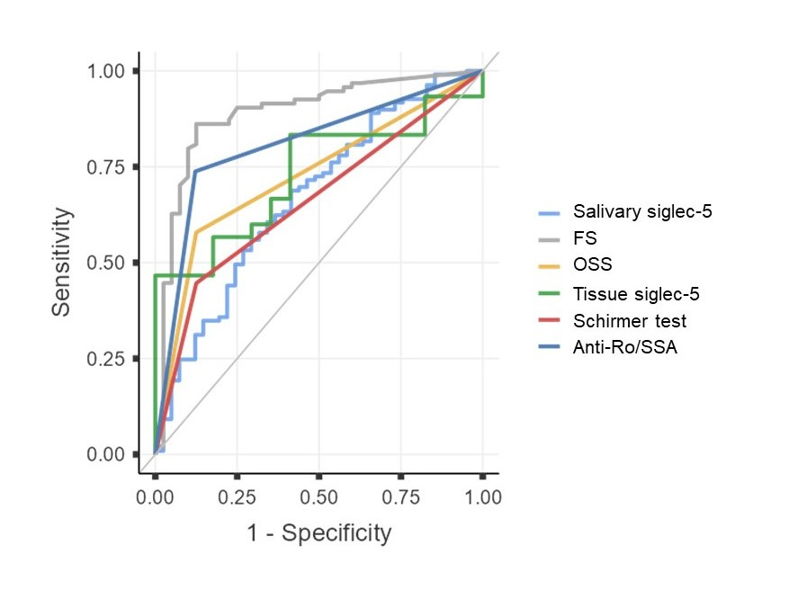
Note: FS: focus score; OSS: ocular staining score; ROC: Receiver Operating Characteristic; Siglec, sialic acid-binding immunoglobulin-like lectin.

