Immature Leukocyte and Plasma-Induced Cell Death Reveal Subclinical Immune Activation in EGPA Patients in Remission
Chiara Baggioª*, Luca Iorioª, Carlotta Boscaro^{b,c}, Federica Davanzoª, Veronica Davanzo^{d}, Michela Pelloso^{d}, Marta Tonelloª, Paolo Sfrisoª, Mattia Albiero^{e}, Roberta Ramondaª, Andrea Doriaª, Roberto Padoan^{a†}, Francesca Oliviero^{a†}*
ª Rheumatology Unit, Department of Medicine - DIMED, University of Padova, Padova, Italy
^{b} Department of Medicine - DIMED, University of Padova, Padova, Italy
^{c} Veneto Institute of Molecular Medicine, Laboratory of Experimental Diabetology, Padova, Italy
^{d} Department of Laboratory Medicine, University-Hospital of Padova, Padova, Italy
^{e} Department of Surgery, Oncology, and Gastroenterology, University of Padova, Padova, Italy

Corresponding authors: Chiara Baggio, Francesca Oliviero
Rheumatology Unit, Department of Medicine - DIMED, University of Padova, Padova, Italy.
e-mail: chiara.baggio@unipd.it, francesca.oliviero@unipd.it
Phone: +39 049 8218682

Online Resource 1. Leukocyte morphological features, definitions, and functional interpretations.
Feature | Morphology | Biological Significance
Vacuoles (Figure 1e, g)  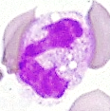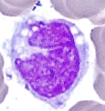 | Cytoplasmic clear spaces within leukocytes, often appearing as rounded, unstained areas in the cytoplasm | Cellular stress or degeneration
Micronuclei (Figure 1l)  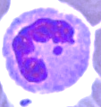 | A round cytoplasmic inclusion having a diameter one-tenth to one-third that of the primary nucleus, containing intact or fragments of chromosomes | DNA damage and chromosomal instability
Buds (Figure 1l)  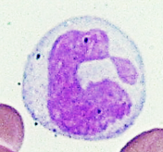 | Small nuclear protrusions | DNA damage and chromosomal instability
Binucleated cells (Figure 1m)  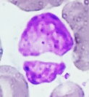 | Cells with two nuclei | Cytokinesis defects or abnormal cell division
Karyorrhectic cells (Figure 1n)  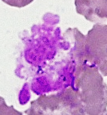 | Disintegration of nuclear chromatin into separate structures | Advanced apoptosis or necrosis
Karyolytic cells (Figure 1n)  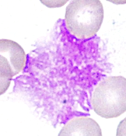 | Loss of chromatin staining ability and its dissolution. Uniformly eosin-stained, ghost-like nucleus | Very late-stage cell death / necrosis
Pyknosis (Figure 1n)  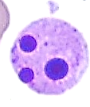 | Irreversible condensation of chromatin. Nuclear shrinkage, condensed chromatin | Apoptosis or early necrosis
Left shift (Figure 1a)  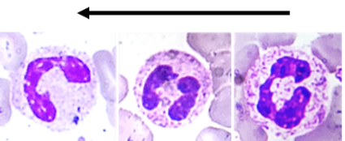 | The presence of immature neutrophils | Reflecting bone marrow response to stress or inflammation
Right shift (Figure 1d)  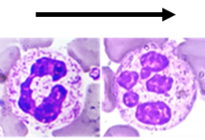 | The presence of hypersegmented neutrophils | Normal response to recovery from an infection or inflammation

Online Resource 2. Cytological analysis of EGPA patients stratified by ANCA status at diagnosis.
 | ANCA positive | ANCA negative | p
N, median (IQR) | 63.2 (54-64) | 69.8 (54-73) | 0.984
Hyposegmented N, median (IQR) | 8.5 (5.6-13) | 9.5 (5.5-13.5) | 0.960
Band N, median (IQR) | 4.0 (2.5-6.6) | 4.8 (3.0-8.6) | 0.301
Hypersegmented N, median (IQR) | 2.2 (0.8-3.2) | 1.5 (0.6-3.4) | 0.638
N with vacuoles, median (IQR) | 0 (0.0-1.3) | 0.0 (0.0-0.6) | 0.511
M, median (IQR) | 7.4 (5.4-9.7) | 6.1 (4.6-9.4) | 0.429
M with vacuoles, median (IQR) | 1.3 (0.7-3.4)* | 0.6 (0.0-1.2) | 0.029
L, median (IQR) | 22.3 (17-29) | 20.3 (18-32) | 0.913
Eosinophils + Basophils, median (IQR) | 5.8 (0.0-9.5) | 1.7 (0.0-10) | 0.927
N with NA, median (IQR) | 0.0 | 0.0 | 0.887
Binucleated M, median (IQR) | 0.5 (0.0-1.4) | 0.0 (0.0-0.8) | 0.522
Cell Death, median (IQR) | 1.6 (0.6-2.7)** | 0.0 (0.0-0.8) | 0.007
Data are expressed as the median and interquartile range (IQR). p was calculated according to Mann-Whitney test. Abbreviations are as follows: EGPA, eosinophilic granulomatosis with polyangiitis; ANCA, Anti-neutrophil cytoplasmic antibodies; N, neutrophils; M, monocytes; L, lymphocytes; NA, nuclear abnormalities; IQR, interquartile range.
Online Resource 3. Correlation between cytokine, chemokines, growth factors and cytological analysis.
 |  | N, % | M, % | L, %
EGPA ANCA+ | IL-1β, pg/mL | *p = 0.019, r = 0.818 | *p = 0.013, r = -0.706 | **p = 0.004, r = -0.774
 | IL-18, pg/mL | p = 0.619, r = 0.161 | p = 0.266 , r = -0.350 | p = 0.09, r = -0.515
 | CCL-23, pg/mL | *p = 0.036, r = 0.664 | *p = 0.017, r = -0.699 | p = 0.082, r = -0.525
EGPA ANCA− | IL-1β, pg/mL | p = 0.091, r = 0.390 | p = 0.867, r = 0.041 | p = 0.405, r = -0.203
 | IL-18, pg/mL | p = 0.505, r = 0.163 | p = 0.811, r = 0.059 | p = 0.875 , r = 0.039
 | CCL-23, pg/mL | p = 0.060, r = 0.437 | p = 0.569, r = -0.140 | p = 0.175, r = -0.325
Spearman’s rank correlation test. *p<0.05, **p<0.01. Abbreviations are as follows: GPA, granulomatosis with polyangiitis; EGPA, eosinophilic granulomatosis with polyangiitis; N, neutrophils; M, monocytes; L, lymphocytes.
Online Resource 4. Correlation between cell death parameters.
 | Cell death  MGG, % | Cell death  Trypan blue, % | MTT reduction, OD | LDH release, OD | IL-1α,  pg/mL
PI, % | ****p<0.0001  r = 0.853 | ****p<0.0001  r = 0.901 | ****p<0.0001  r = -0.798 | **p = 0.0055  r = 0.5383 | ****p<0.0001  r = 0.726
PI/Annexin, % | ****p<0.0001  r = 0.786 | ****p<0.0001  r = 0.868 | ****p<0.0001  r = -0.786 | **p = 0.0044  r = 0.5503 | ***p=0.0006  r = 0.640
Cell death (MGG), % | / | ****p<0.0001  r = 0.938 | ****p<0.0001  r = -0.841 | p = 0.0625  r = 0.3779 | ****p<0.0001  r = 0.835
Cell death (Trypan blue), % | ****p<0.0001  r = 0.938 | / | ****p<0.0001  r = -0.847 | *p = 0.0179  r = 0.4694 | ****p<0.0001  r = 0.7669
MTT reduction (OD) | ****p<0.0001  r = -0.841 | ****p<0.0001  r = -0.847 | / | p = 0.1388  r = -0.3046 | ****p<0.0001  r = -0.796
Pearson correlation test. Abbreviations are as follows: MGG, May-Grünwald Giemsa; PI, propidium iodide; OD, optical density.
Online Resource 5. Cytokines, CCL-23 and VEGEF levels correlates with cell migration.
 | Cell migration (OD)
IL-1β, pg/mL | *p = 0.013, r = 0.546
IL-1α, pg/mL | ****p<0.0001, r = 0.846
IL-18, pg/mL | **p = 0.001, r = 0.674
CCL-23, pg/mL | ***p = 0.001, r = 0.753
VEGF, pg/mL | ****p<0.0001, r = 0.766
Pearson correlation test. Abbreviations are as follows: OD, optical density.

Online Resource 6. Correlation between in vitro and ex vivo cell death outcomes
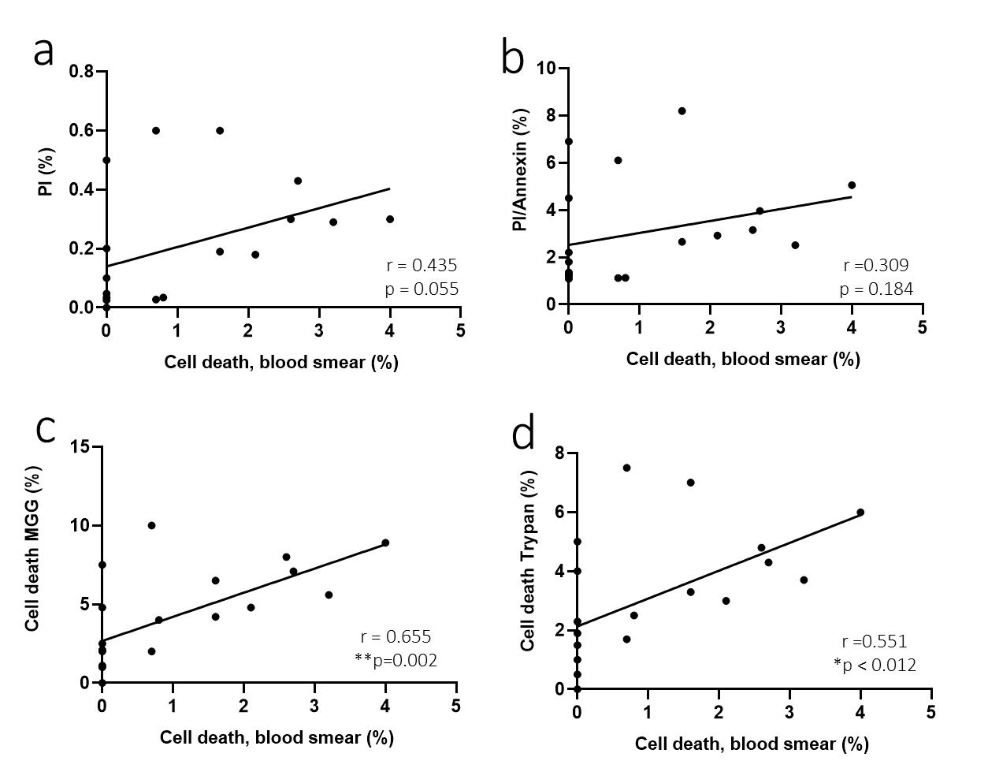
Pearson correlation test. Abbreviations are as follows: MGG, May-Grünwald Giemsa; PI, Propidium.

