Supplementary Materials for

Eosinophil cationic protein driven type 2 inflammation impairs olfactory dysfunction in a murine model
Zhong Zheng^{1,#}, Liufeiyan Fan^{1,#}, Haofei Bai¹, Silyu Jing¹, Chunyang Zhang^{1,2}, Yubin Lai¹, Min Xu¹, Jian Wang¹, Tao Xue¹, Dingjun Zha^{1,*}, Fuquan Chen^{1,*}
¹Department of Otolaryngology, Xijing Hospital, The Air Force Military Medical University, Xi'an, Shaanxi, China.
²Department of Pharmacy, The Fourth Affiliated Hospital of Soochow University, Suzhou, Jiangsu, China
*Correspondence to: Dingjun Zha, zhadjun@fmmu.edu.cn; Fuquan Chen, chenfq@fmmu.edu.cn.
#These authors contributed equally to this work.

Supplementary Table 1. List of antibodies and ELISA kits used in this study.
Antibodies and reagents | Cat No. | Vendor | Application
ECP antibody | ab207429 | Abcam | WB 1:1000; IF 1:100
EDN antibody | PAD169Hu01 | Cloud-clone | WB 1:1000
EPX antibody | DF15679 | Affinity | WB 1:1000
MBP antibody | PAA539Mu01 | Cloud-clone | WB 1:1000
GAPDH antibody | 60004-1-Ig | Proteintech | WB 1:50000
Goat Anti-Rabbit IgG H&L | SA00001-2 | Proteintech | WB 1: 2000
Goat Anti-Mouse IgG H&L | SA00001-1 | Proteintech | WB 1: 2000
OMP antibody | ab183947 | Abcam | IF 1:500
GAP43 antibody | ab75810 | Abcam | IF 1:100
CK18 antibody | ab133263 | Abcam | IF 1:100
ASCL1 antibody | ab211327 | Abcam | IF 1:100
P63 antibody | ab124762 | Abcam | IF 1:200
Ki67 antibody | ab15580 | Abcam | IF 1:100
Goat Anti-Rabbit IgG H&L (Alexa Fluor® 594) | ab150080 | Abcam | IF 1:500
ECP ELISA kit | YX-E11396 | SINOBESTBIO
EDN ELISA kit | E-EL-H2341 | Elabscience
EPX ELISA kit | SEJ138Hu | Cloud-clone
MBP ELISA kit | SEB650Hu | Cloud-clone
IL-4 ELISA kit | KE10010 | Proteintech
IL-5 ELISA kit | KE10018 | Proteintech
IL-13 ELISA kit | KE10021 | Proteintech
IL-33 ELISA kit | KE10054 | Proteintech
TNF-α ELISA kit | KE10002 | Proteintech
IgE ELISA kit | EMC117.96 | Neobioscience
WB, western blot; IF, immunofluorescence; ECP, eosinophil cationic protein; EDN, eosinophil derived neurotoxin; EPX, eosinophil protein X; MBP, major alkaline protein;
OMP, olfactory marker protein; GAP43, growth-associated protein 43; CK18, cytokeratin 18; ASCL1, achaete-scute homolog 1; P63, tumor protein 63; IL, interleukin; TNF, tumor necrosis factor; IgE, immunoglobulin E.

Supplementary Table 2. List of qRT-PCR primer used in this study.
Gene symbol | Forward sequence (5' to 3') | Reverse sequence (5' to 3')
GAPDH | TGAGGCCGGTGCTGAGTATGT | CAGTCTTCTGGGTGGCAGTGAT
Ddx58 | AATATGTGCCCCTACTGGTTGT | CGAAGAAGACCACTTTCCCTTT
Ifi44 | GACAAGAGGCATTGCTGTGTT | CGTGTTTGCTGAACCAGGTCT
Ifit1 | ATCGCGTAGACAAAGCTCTTC | GTTTCGGGATGTCCTCAGTTG
Ifit3 | TCAGGCTTACGTTGACAAGGT | CACACTTTAGGCGTGTCCATC
Irf7 | CCCCAGCCGGTGATCTTTC | CACAGTGACGGTCCTCGAAG
Isg15 | AGTGATGCTAGTGGTACAGAACT | CAGTCTGCGTCAGAAAGACCT
Oasl2 | TTGTGCGGAGGATCAGGTACT | TGATGGTGTCGCAGTCTTTGA
Rsad2 | AGCATTAGGGTGGCTAGATCC | CTGAGTGCTGTTCCCATCTTC
Rtp4 | GCCTCAGACCCGGAATACG | TGGCTCTATTTCACGTTGGGG
Usp18 | CAGGAGTCCCTGATTTGCGTG | CAGAGGCTTTGCGTCCTTATC
GAPDH, Glyceraldehyde-3-phosphate dehydrogenase; Ddx58, Antiviral innate immune response receptor RIG-I; Ifi44, Interferon-induced protein 44; Ifit1, Interferon-induced protein with tetratricopeptide repeats 1; Ifit3, Interferon-induced protein with tetratricopeptide repeats 3; Irf7, Interferon regulatory factor 7; Isg15, Ubiquitin-like protein ISG15; Oasl2, 2'-5'-oligoadenylate synthase-like protein 2; Rsad2, Radical S-adenosyl methionine domain-containing protein 2; Rtp4, Receptor-transporting protein 4; Usp18, Ubl carboxyl-terminal hydrolase 18.

Supplementary Table 3. Demographic and clinical characteristics of the control and ECRSwNP group.
 | Control (n = 10) | ECRSwNP (n = 20) | p value
Age (years) | 35.60±9.31 | 39.25±10.23 | 0.351
Sex (male, %) | 5 (50.00%) | 10 (50.00%) | 1.000
Smoking | 2 (20.00%) | 5 (25.00%) | 0.760
Drinking | 2 (20.00%) | 5 (25.00%) | 0.760
Allergic rhinitis | 0 (0.00%) | 7 (35.00%) | 0.144
Asthma | 0 (0.00%) | 4 (20.00%) | 0.129
T score | 8.30±2.00 | 1.20±1.32 | 0.001***
D score | 13.00±0.67 | 5.05±2.26 | ＜0.001***
I score | 14.20±1.14 | 4.60±3.03 | ＜0.001***
TDI score | 35.50±2.95 | 10.85±5.56 | ＜0.001***
All results are presented as means ± the standard error of the mean or the number of cases and the percentage in parentheses. Statistical significance was assessed using Student's t-test. *** p < 0.001.
ECRSwNP, eosinophilic chronic rhinosinusitis with nasal polyps; T, odor threshold; D, odor discrimination; I, odor identification; TDI, threshold discrimination identification.

Supplementary Figure 1. Expression of eosinophil-derived granule proteins in olfactory mucosal secretions and their correlations with olfactory function scores in control subjects and ECRSwNP patients
(A) Comparative analysis of EPX levels in olfactory mucosal secretions between the control group (n = 10) and individuals with ECRSwNP (n = 20). (B) Correlation analysis examining the relationships between EPX levels in olfactory mucosal secretions and T, D, I, and TDI scores. (C) Comparative analysis of MBP levels in olfactory mucosal secretions between the control group (n = 10) and individuals with ECRSwNP (n = 20). (D) Correlation analysis examining the relationships between MBP levels in olfactory mucosal secretions and T, D, I, and TDI scores. (E) Comparative analysis of ECP levels in olfactory mucosal secretions between the control group (n = 10) and individuals with ECRSwNP (n = 20). (F) Correlation analysis examining the relationships between ECP levels in olfactory mucosal secretions and T, D, I, and TDI scores. (G) Comparative analysis of EDN levels in olfactory mucosal secretions between the control group (n = 10) and individuals with ECRSwNP (n = 20). (H) Correlation analysis examining the relationships between EDN levels in olfactory mucosal secretions and T, D, I, and TDI scores.
All the data are expressed as the means ± standard errors of the means, with individual values represented by dots (A, C, E, G). Statistical significance was assessed via Student's t test (A, C, E, G). Spearman's correlation coefficients and the corresponding P values were determined via Spearman correlation analysis (B, D, F, H). * p < 0.05.
ECRSwNP, eosinophilic chronic rhinosinusitis with nasal polyps; EPX, eosinophil protein X; MBP, major alkaline protein; ECP, eosinophil cationic protein; EDN, eosinophil-derived neurotoxin; T, odor threshold; D, odor discrimination; I, odor identification; TDI, threshold discrimination identification.

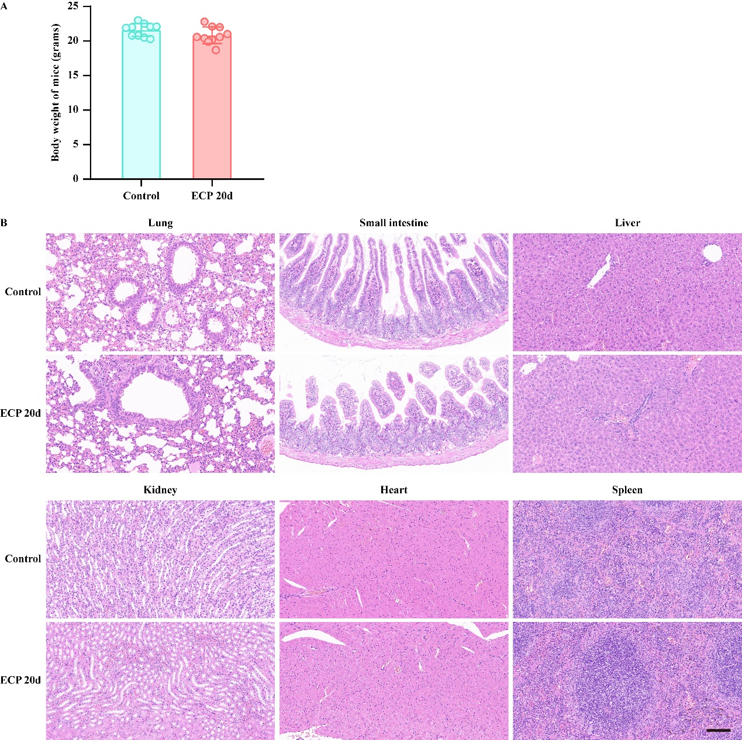
Supplementary Figure 2. Changes in body weight and HE staining of systemic organs in mice after intranasal administration of physiological saline and ECP.
(A) Changes in body weight of mice after intranasal administration of physiological saline and ECP. (B). HE staining of lungs, small intestine, liver, kidneys, heart, and spleen in mice after intranasal administration of physiological saline and ECP. Scale bar = 100 µm.
All data are expressed as means ± standard error of the mean, with individual values represented by dots (A). Statistical significance was assessed using Student's t-test (F-I).
ECP, eosinophil cationic protein.

Supplementary Figure 3. Changes in RE mucosa and OB after intranasal administration of ECP.
(A) The slices selected for RE mucosal assessment were located between the anterior nasal orifice and the eye. The RE measurement areas are (I) nasal septum and (II) turbinate. (B) Photomicrographs of representative RE coronal sections in the control group, ECP 10d group, and ECP 20d group. Scale bar=50 µm. (C) The slices selected for OB assessment were located directly behind the posterior edge of the eye. (D) Photomicrographs of representative left side OB coronal sections in the control group, ECP 10d group, and ECP 20d group. Scale bar=50 µm. Black scale bar=100 µm, white scale bar=20 µm.
R, right side (non administered side); L, left side (administered side); I, nasal septum; II, turbinate; ECP, eosinophil cationic protein; OB olfactory bulb.

Supplementary Figure 4. Heatmap of GO enriched pathway genes in control and ECP 10d group.
(A-E) Heatmaps showing the GO enriched pathway genes associated with lymphocyte mediated immunity (A), cytokine-mediated signaling pathway (B), regulation of T cell activation (C), interleukin-6 production (D), and regulation of leukocyte differentiation (E).

Supplementary Figure 5. Heatmap of KEGG enriched pathway genes and GSEA enriched pathway in control and ECP 10d group.
(A-F) Heatmaps showing the KEGG enriched pathway genes associated with cytokine-cytokine receptor interaction (A), Th1 and Th2 cell differentiation (B), Th17 cell differentiation (C), NF-kappa B signaling pathway (D), chemokine signaling pathway (E), and NOD-like receptor signaling pathway (F). (G) GSEA enriched pathway in control and ECP 10d group.

Supplementary Figure 6. Analysis of eosinophil infiltration and its association with hub genes and OD.
(A) ssGSEA analysis showing eosinophil infiltration levels between the control and ECP 10d groups. (B) Correlation analysis between eosinophil infiltration levels and food finding time in mice. (C) Correlation analysis between eosinophil infiltration levels and the expression of the top 10 hub genes. (D) Correlation analysis between the expression levels of the top 10 hub genes and food-finding time in mice.
All the data are expressed as the means ± standard errors of the means, with individual values represented by dots (A). Statistical significance was assessed via Student's t test (A). Correlation analysis was performed using Pearson correlation analysis (B–D). * p < 0.05, ** p < 0.01.

