SUPPLEMENTAL MATERIAL

Ablation of kallikrein 7 (KLK7) in adipose tissue ameliorates metabolic consequences of high-fat diet induced obesity by counteracting adipose tissue inflammation in vivo
Konstanze Zieger, Juliane Weiner, Anne Kunath, Martin Gericke, Kerstin Krause, Matthias Kern, Michael Stumvoll, Nora Klöting, Matthias Blüher, and John T. Heiker

Supplementary Table 1. Primer sequences used for RNA expression analysis
Gene | Forward | Reverse

36b4 AAGCGCGTCCTGGCATTGTCT CCGCAGGGGCAGCAGTGGT

Pparγ CGTGAAGCCCATCGAGGACATC TGGAGCAGGGGGTGAAG

Ki-67 TGTGAGGCTGAGACATGGAG CCTTGATGGTTCCTTTCCAA

Klf4 GACTAACCGTTGGCGTGAGG GTCTAGGTCCAGGAGGTCGT

Fatp4 ATTGTGGTGCACAGCAGGTAT AGTCATGCCGTGGAGTAAGC

Il-1β TGCCACCTTTTGACAGTGATG AAGGTCCACGGGAAAGACAC

Il-6 ACCTGGAGTACATGAAGAACA TTGGAAATTGGGGTAGGAAG

Il-4 CCATATCCACGGATGCGACA CTGTGGTGTTCTTCGTTGCTG

Il-10 GGCGCTGTCATCGATTTCTC CGGAGAGAGGTACAAACGAGG

Mcp-1 GCCCCACTCACCTGCTGCTACT CCTGCTGCTGGTGATCCTCTTGT

Midkine TGGAGCCGACTGCAAATACAA GGCTTAGTCACGCGGATGG

Inf-γ AGGAACTGGCAAAAGGATGGT TCATTGAATGCTTGGCGCTG

Tnf-α GTCCCCAAAGGGATGAGAAGT GCTCCTCCACTTGGTGGTTT

Tnc-c CAGCTACCGACGGGATCTTC TTCCGGTTCAGCTTCTGTGG
Chemerin TACAGGTGGCTCTGGAGGAGTTC CTTCTCCCGTTTGGTTTGATTG
Pgc1α CTTTTGTGGACGGAAGCAAT GAGTCTTGGGAAAGGACACG
Vaspin CCGCATCTCGTCTACTTAC CTCCCACCTTCAGGCTTC
Ucp1 CCGAAACTGTACAGCGGTCT CCGAGAGAGGCAGGTGTTTC
Pref1 TGT GCA GGA GCA TTC GTA CT CGG GAA ATT CTG CGA AAT AG

Supplementary Figure 1
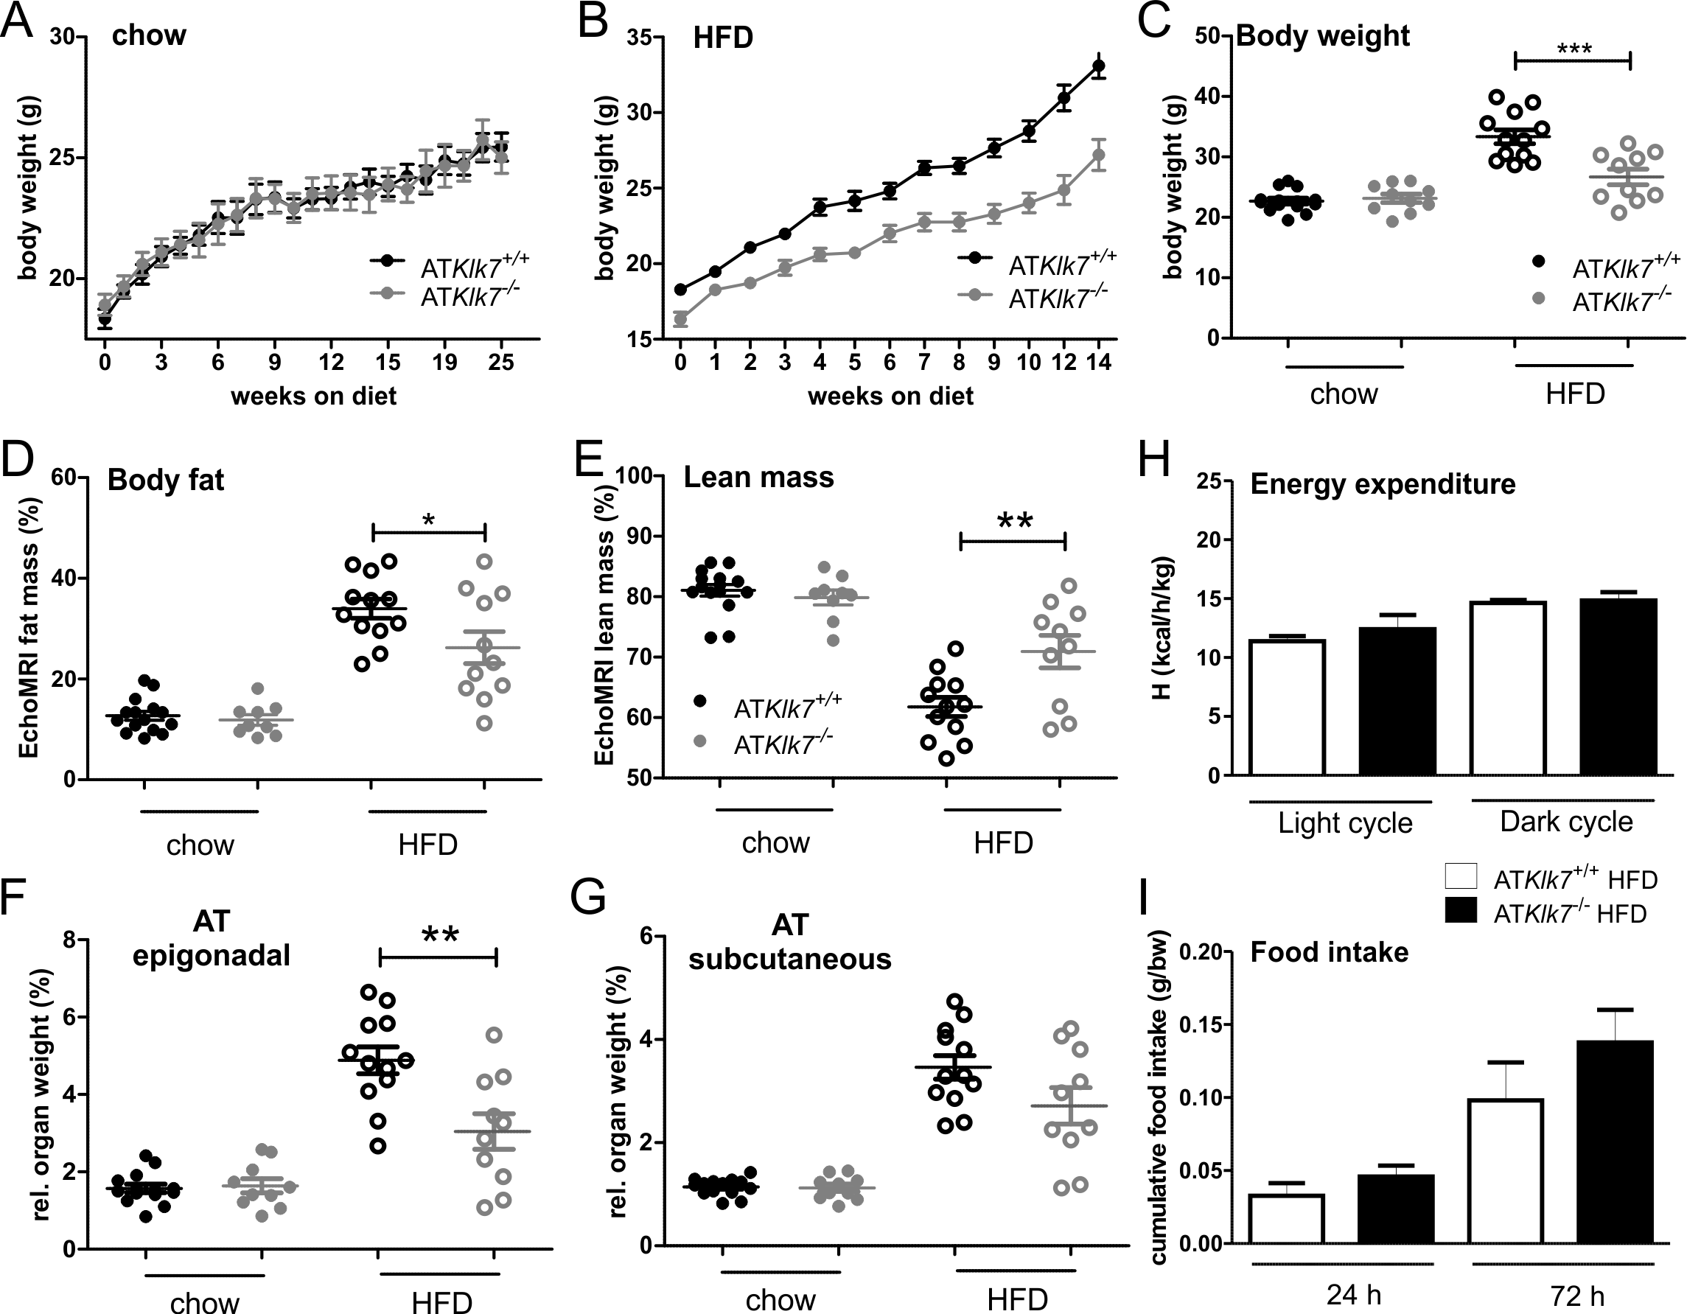
Supplementary Figure 1. Klk7-deficiency in adipose tissue in female mice under chow and high fat diet. (A, B) Body weight gain and (C) final body weight of ATKlk7^{-/-} and control littermates fed chow diet or HFD (B), starting at the age of 6 weeks (n=9-16). (D, E) The percentage of fat mass and lean body mass as determined by EchoMRI at the end of the studies under chow (at age 26 weeks) and HFD conditions (20 weeks of age; n=10-12). (F-H) Relative organ weights of epigonadal and subcutaneous WAT depots (n=8-14) at the end of chow and HFD studies. ATKlk7^{-/-} exhibit altered fat distribution with decreased epigonadal AT mass. (H-I) Net energy expenditure (H) and cumulative food intake (I) is slightly higher in ATKlk7^{-/-} compared to controls. Data are represented as mean ± SEM and for each diet condition, differences between genotypes were tested for statistical significance by a two-tailed Student´s t-test; *P ˂ 0.05, ** P ˂ 0.01, *** P ˂ 0.001.

Supplementary Figure 2
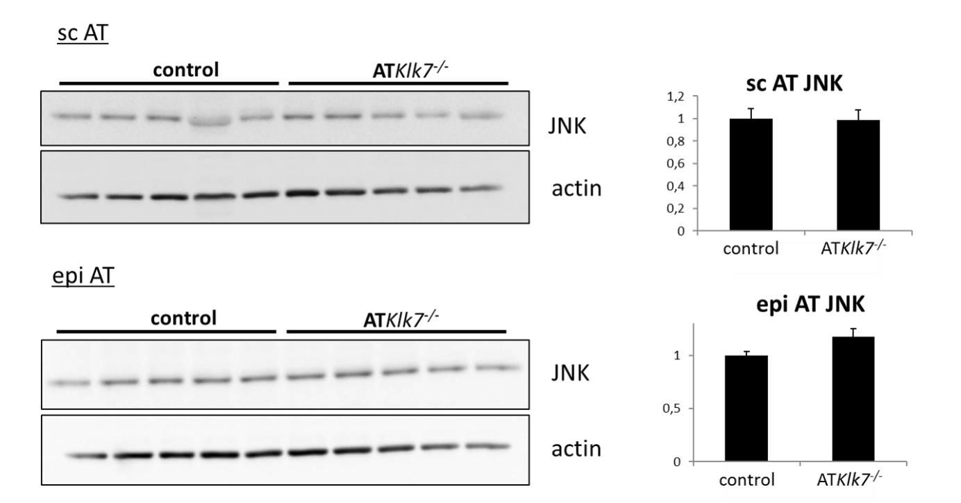
Supplementary Figure 2. JNK expression in sc (top) and epi (bottom) AT of control and ATKLK7^{-/-} mice after HFD. Western Blot analyses (left) and quantification of band intensities (right) in AT of n=5 animals. JNK band intensities were normalized against actin band.

Supplementary Figure 3
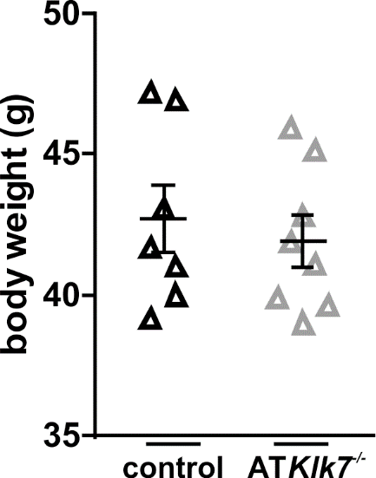
Supplementary Figure 3. Body weights of HFD-fed control and ATKLK7^{-/-} mice used for adipose tissue macrophage characterization. n=6 animals with matched weights were used in these experiments to preclude body weight effects.

