Modulation of SRSF2 expression reverses the exhaustion of TILs via the epigenetic regulation of immune checkpoint molecules

Ziqiang Wang^{1,2†}, Kun Li^{3†}, Wei Chen^{1,2†}, Xiaoxia Wang^{1,2}, Yikun Huang^{1,2}, Weiming Wang^{1,2}, Wanjun Wu^{1,2}, Zhiming Cai^{1,2*}, Weiren Huang^{1,2*}

¹Department of Urology, Shenzhen Second People’s Hospital, The First Affiliated Hospital of Shenzhen University, International Cancer Center, Shenzhen University School of Medicine, Shenzhen 518039, China;
²Guangdong Key Laboratory of Systems Biology and Synthetic Biology for Urogenital Tumors, Shenzhen 518035, China;
³Department of Nuclear Medicine, Shandong Provincial Qianfoshan Hospital, the First Hospital Affiliated with Shandong First Medical University, Jinan 250014, China.

†These authors contributed equally to this work.
*To whom correspondence should be addressed to Weiren Huang. Email: pony8980@163.com, Correspondence may also be addressed to Zhiming Cai. Email: caizhiming2000@163.com.
*Corresponding author, Department of Urology, Shenzhen Second People’s Hospital, The First Affiliated Hospital of Shenzhen University, International Cancer Center, Shenzhen University School of Medicine, Shenzhen, China, phone: (86) 755-26036884, fax: (86) 755-26036884.

The authors have declared that no conflict of interest exists.
Supplementary Materials

Supplementary figures
Figure S1. Expression of SRSF2 is downregulated by SRSF2-targeting siRNAs. TILs were transfected with SRSF2-targeting siRNAs (siSRSF2) or negative control siRNAs (siCTRL) for 36 hours. The levels of SRSF2 were determined with real-time PCR. The data were normalized to the control level.

Figure S2. Expression of SRSF2 is upregulated in RCC tumor tissue. SRSF2 analysis in the RCC tumor tissue and adjacent tumor tissue in a RCC Dataset (GSE40435). P-values were calculated using nonparametric Kolmogorov-Smirnov tests. **p < 0.0001.

Figure S3. Expression of immune checkpoint molecules regulated by SRSF2. Jurkate E6 cells were transfected with SRSF2-targeting siRNAs (siSRSF2) or negative control siRNAs (siCTRL) for 36 hours. The levels of the immune checkpoint molecules were determined with real-time PCR in three independent experiments. The data are represented as the mean ± SD. The data were normalized to the control level. *p < 0.01.

Figure S4. Schematic diagram showing the gene structure of PD-L1, BTLA, CTLA4, LAG3 and CD160 in which the black boxes represent the primer-amplified regions.

Figure S5. STAT3 regulates the expression of immune checkpoint molecules. (A) STAT3 analysis in the RCC tumor tissue and adjacent tumor tissue in a RCC Dataset (GSE40435). P-values were calculated using nonparametric Kolmogorov-Smirnov tests. **p < 0.0001. (B-F). Schematic representation of the STAT3-binding site in the human PD-L1 (B), BTLA (C), CTLA4 (D), LAG3 (E) and CD160 (F) genes. The black box shows the potential binding site, and the red characters indicate matching sequences. (G). Jurkate E6 cells were transfected with STAT3-targeting siRNAs (siSTAT3) or negative control siRNAs (siCTRL) for 36 hours. The levels of the immune checkpoint molecules were determined with real-time PCR in three independent experiments. The data are represented as the mean ± SD. The data were normalized to the control level. *p < 0.01. **p < 0.0001.
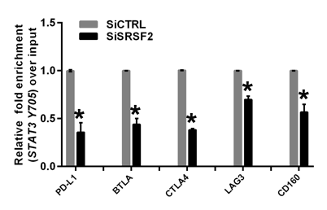
Figure S6. SRSF2 recruits STAT3 to immune checkpoint genes. Jurkate E6 cells transfected with SRSF2 siRNAs or negative control siRNAs were collected for ChIP assays to analyze the relative fold enrichment of the PD-L1 promoter, BTLA promoter, CTLA-4 promoter, LAG3 promoter or CD160 promoter by an anti-STAT3 Y705 antibody. The data points represent mean values determined from three independent experiments. The data are presented as the mean ± SD. *p < 0.01.

Table S1. Sequences of primers and siRNAs used in this study
Name sense sequence antisense sequence
SiRNAs
SRSF2 siRNA | GUGAGAAGUUGCUUAGAAA | UUUCUAAGCAACUUCUCAC
STAT3 siRNA | GAAGGAGGCGUCACUUUCA | UGAAAGUGACGCCUCCUUC
Negative control siRNA | UUCUCCGAACGUGUCACGU | ACGUGACACGUUCGGAGAA
Primers pairs for Real Time PCR
SRSF2 | GAGAACCAAAGGGAGGGGTG | TGCTGCGTATGCAAGTCTGA
STAT3 | TGTGTGACACCATTCATTGATGC | TCCTCACATGGGGGAGGTAG
PD-L1 | TACTGGCATTTGCTGAACGC | ACAATTAGTGCAGCCAGGTCT
BTLA | GAAGCAAGCACCAGGCAAAA | CTTGCCAGTCTTGAGTTCGG
CTLA-4 | AGGTGACTGAAGTCTGTGCG | CATGAGCTCCACCTTGCAGA
LAG3 | TGGGACCTACACCTGCCATA | GAGCTCCACACAAAGCGTTC
CD160 | GGGAACTACACAGTGACGGG | AGTTTCTTTTGGCACAAGGCT
Actin-beta | TGACGTGGACATCCGCAAAG | CTGGAAGGTGGACAGCGAGG
Primers pairs for ChIP
PD-L1-TSS1 | CGAGGAACTTTGAGGAAGTCACA | AGCCTCTTCAAGGTGACTGAAC
PD-L1-TSS2 | CAAGGTGCGTTCAGATGTTGG | TTTCACCGGGAAGAGTTTCG
PD-L1-TSS3 | AACTGAAAGCTTCCGCCGAT | CAGCTGCTCAGCGTTGC
PD-L1-TSS4 | AGGTAGGGAGCGTTGTTCCT | TACTGCCCCCTAGACCATCG
BTLA-TSS1 | TGCAGTTGTTGTCTCGATGAAG | GTGGATGTGGAGAAAACAGTCC
BTLA-TSS2 | GGTTGAGGTTTTTCCTGCACTC | TCACAAGCTATCACAAAGGGG
BTLA-TSS3 | TTTGCTTCTTGTCAGGTTGGC | TGGGGCAAAAACGTGGTAGA
BTLA-TSS4 | CAGGTGCCTTACCATGGATGT | CTGCAGCACTCAGAAGACGA
CTLA-4-TSS1 | TGGGTTGGCTTTTCTTTGGAC | GCCTCTGGTTTTGCAGAAGG
CTLA-4-TSS2 | AGAGGCAGCTTCTTTTCCGC | CCTTGGGCTAATGGCAGGATT
CTLA-4-TSS3 | CCACGGCTTCCTTTCTCGT | GGAGCGGTGTTCAGGTCTTC
CTLA-4-TSS4 | TCAGCAGTCAAAGGCAGTGA | AGGGTCTGAAATTGCCTGTGT
LAG3-TSS1 | GCATGGGGACCTGAGTTGG | AGTGTACCTGTGTGCGTGAC
LAG3-TSS2 | CAGCTTTTATCTTCACGCTCCC | AAGCCTTACTGCACCCCAAA
LAG3-TSS3 | GTTCCAGGCAGAAATGGTTCG | TCGCAGTGGAAAGTCTGAGG
LAG3-TSS4 | GAGACCAGCAGAACGGCAT | GGCCGGAATCCAGAGGAAAG
CD160-TSS1 | GGGTGGGAAGATAAGGTCAGTC | GAAAGGTACCAAGTCTTCTCCTGA
CD160-TSS2 | CAAAATCTTTGTTCCCCAGGGT | TAGACTAGGGTGCTGAGGGG
CD160-TSS3 | GGGTGGCGGAAGATCTATGAC | CTGGGGGCTCACGTTGAAAT
CD160-TSS4 | CAGGTGAAGGGATGGGATGG | TCCAGAGGGCAGAGGACATT

Figures for response to comments
A B
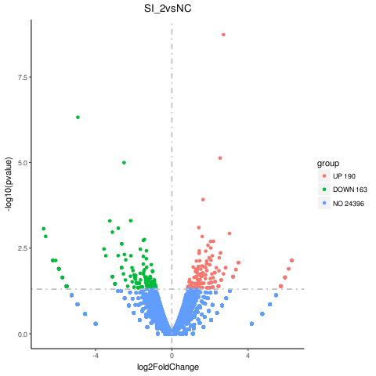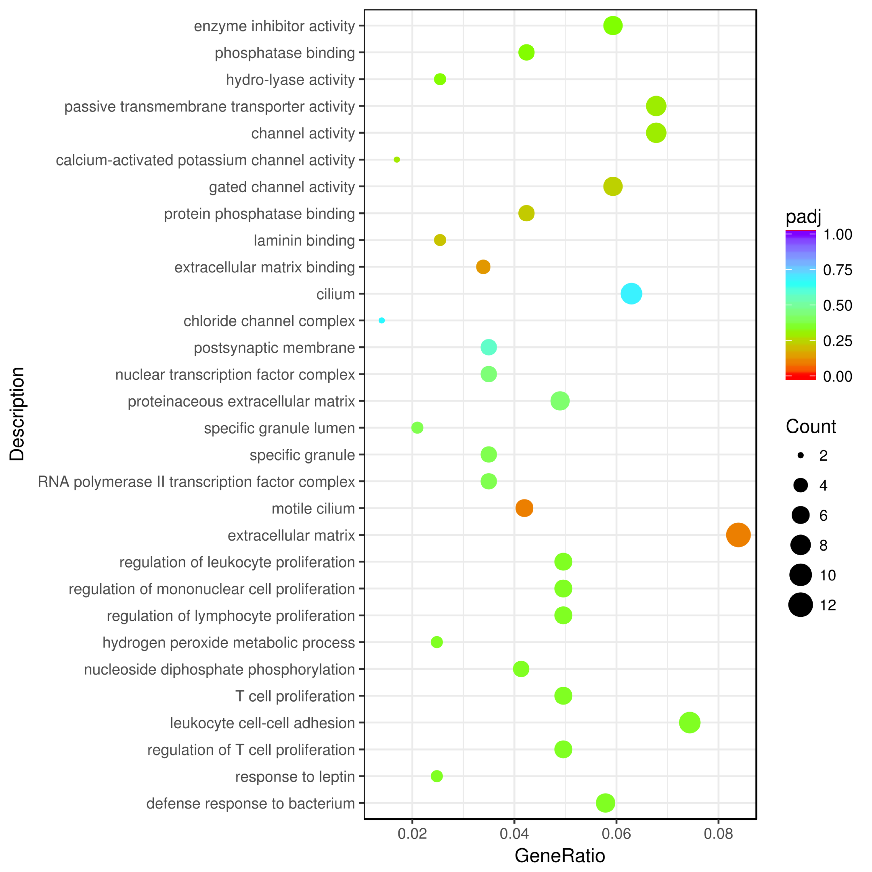

C
Figure R1. The RNA-seq data of TILs with the knockdown of SRSF2. The number of genes regulated by SRSF2 (A), pathways that these altered genes participated in (B), mRNA levels of PD-L1, BTLA, CTLA4, LAG3 and CD160 (C) were analyzed with the RNA-seq data. ND: not detected. *p < 0.001.

A B
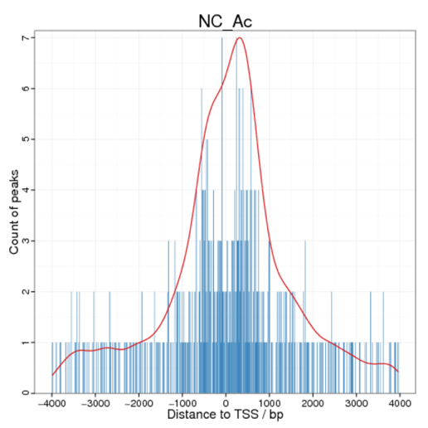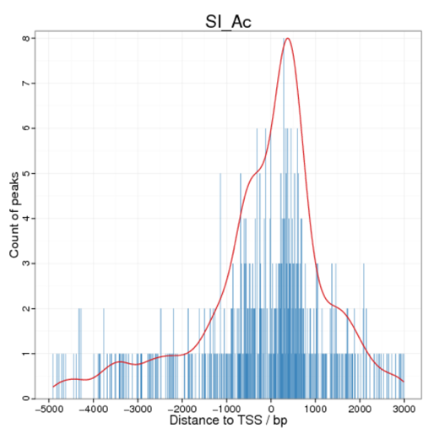

C
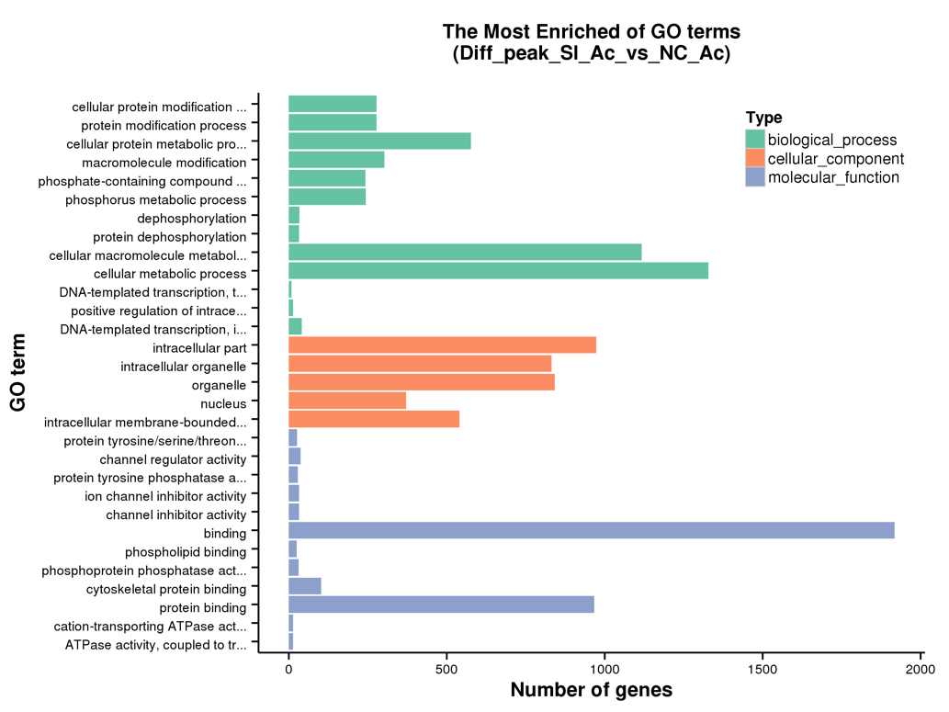
Figure R2. The ChIP-seq data of TILs with the knockdown of SRSF2. The location (A and B) of H3K27Ac and the functions (C) of genes that differentially enriched by H3K27Ac were analyzed with the ChIP-seq data.

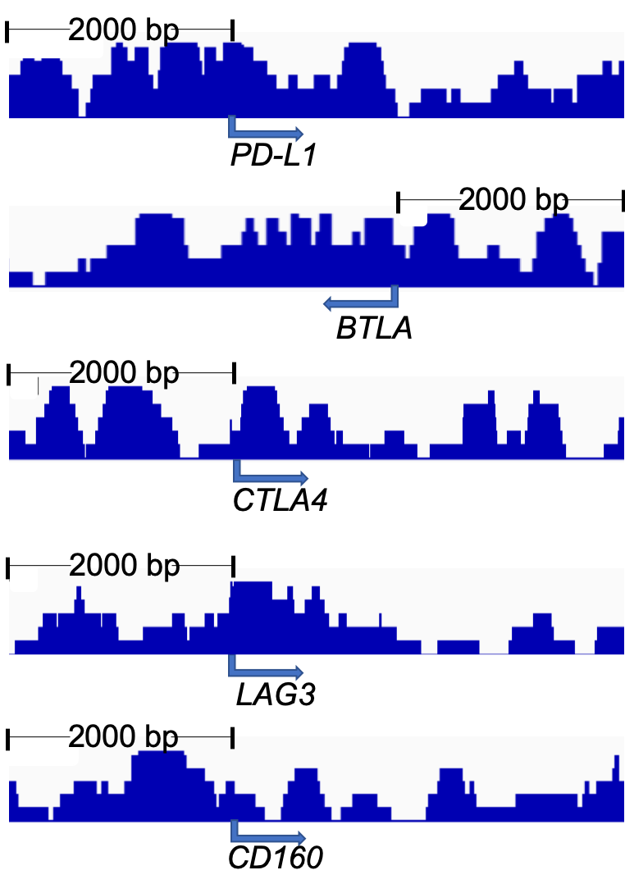
Figure R3. Schematic diagram showing H3K27Ac profiles at checkpoints gene promoters (2000 bp upstream from genes TSS).

Table R1. The list of genes modulated by SRSF2 from RNA-seq and ChIP-seq data
ID Gene name Log2 (Fold Change) P-value

ENSG00000240303 | ACAD11 | 5.843243093 | 0.02267682
ENSG00000070985 | TRPM5 | 5.625032847 | 0.04096458
ENSG00000118997 | DNAH7 | 3.189627466 | 0.02156655
ENSG00000184984 | CHRM5 | 2.408533329 | 0.04103203
ENSG00000228237 | EFCAB14-AS1 | 2.370499004 | 0.00288962
ENSG00000153093 | ACOXL | 2.295498542 | 0.02095211
ENSG00000272980 | Z94721.2 | 2.13073634 | 0.00973269
ENSG00000257488 | LINC02354 | 2.090867599 | 0.04399131
ENSG00000272752 | STAG3L5P-PVRIG2P-PILRB | 2.074241373 | 0.02307085
ENSG00000261460 | AC009690.2 | 1.843026789 | 0.03337634
ENSG00000203799 | CCDC162P | 1.594955698 | 0.01753907
ENSG00000131379 | C3orf20 | 1.550730465 | 0.02169529
ENSG00000145864 | GABRB2 | 1.521740665 | 0.00878145
ENSG00000168610 | STAT3 | 1.368521741 | 0.00115131
ENSG00000272733 | AP000345.2 | 1.355796751 | 0.00783513
ENSG00000177311 | ZBTB38 | 1.193438345 | 0.03728125
ENSG00000183091 | NEB | 1.123376382 | 0.03526717
ENSG00000266969 | AP002449.1 | 1.057906738 | 0.04095754
ENSG00000260386 | LINC01225 | 1.050620613 | 0.03571136
ENSG00000182326 | C1S | 1.002637354 | 0.02892392
ENSG00000067955 | CBFB | 0.91210834 | 0.02818953
ENSG00000185900 | POMK | 0.883451987 | 0.03992985
ENSG00000181038 | METTL23 | -0.845987062 | 0.04983818
ENSG00000271856 | LINC01215 | -0.899555025 | 0.04673993
ENSG00000158485 | CD1B | -0.900513319 | 0.03881005
ENSG00000152475 | ZNF837 | -0.904111373 | 0.0374028
ENSG00000174165 | ZDHHC24 | -0.927486178 | 0.0279634
ENSG00000250400 | LINC00977 | -1.008073285 | 0.04134606
ENSG00000172456 | FGGY | -1.106808915 | 0.03029574
ENSG00000229124 | VIM-AS1 | -1.107766272 | 0.03991628
ENSG00000245954 | LINC02273 | -1.186171726 | 0.01161589
ENSG00000254682 | AP002387.1 | -1.210785936 | 0.00531109
ENSG00000138134 | STAMBPL1 | -1.22046974 | 0.00413692
ENSG00000235423 | AC068768.1 | -1.223733801 | 0.01895017
ENSG00000255857 | PXN-AS1 | -1.226015412 | 0.01900998
ENSG00000276791 | AC092117.1 | -1.269703069 | 0.02185337
ENSG00000280194 | AD000864.1 | -1.295049268 | 0.02586449
ENSG00000225721 | AL592166.1 | -1.399319999 | 0.02668238
ENSG00000143167 | GPA33 | -1.554908706 | 0.01230283
ENSG00000161547 | SRSF2 | -1.592545626 | 0.0001586
ENSG00000270332 | SMC2-AS1 | -2.049911172 | 0.04399131
ENSG00000273154 | AL121845.3 | -2.049911172 | 0.04399131
ENSG00000263884 | AP000845.1 | -2.192382366 | 0.01180303
ENSG00000279494 | AL117328.2 | -2.466364115 | 0.00314942
ENSG00000236269 | ENO1-IT1 | -2.903465354 | 0.00524731
ENSG00000007062 | PROM1 | -3.000212227 | 0.0348666
ENSG00000001626 | CFTR | -3.150223468 | 0.02156655
ENSG00000230648 | AL138831.1 | -3.286095246 | 0.01341209
ENSG00000242154 | AC004884.2 | -5.822613317 | 0.02267682
ENSG00000260360 | AL353708.1 | -5.822613317 | 0.02267682

Supplemental Materials and Methods
RNA-Seq
Total RNA was extracted using RNAiso Plus (Takara, D9108B) according to the manufacturer’s instructions and RNA degradation and contamination were monitored on 1% agarose gels.
RNA purity was checked using the NanoPhotometer®spectrophotometer (IMPLEN, CA, USA).
The size and quality of RNA was assessed using the Agilent Bioanalyzer 2100 system (Agilent Technologies, CA, USA). Sequencing libraries were generated using NEBNext® UltraTM RNA Library Prep Kit for Illumina® (NEB, USA) following manufacturer’s protocol. Libraries were sequenced on the Illumina HiSeq 2500 platform. Differentially expressed genes were identified using the DESeq2 R package (1.16.1). Genes with P-adjust < 0.05 were considered as differentially expressed. The differentially expressed mRNAs were used for KEGG enrichment analysis by the clusterProfiler R package.
ChIP-Seq
ChIP assay was conducted according to Dahl’s protocol [56]. The chromatin DNA purity was checked using the NanoPhotometer® spectrophotometer (IMPLEN, CA, USA). DNA concentration was measured using Qubit® DNA Assay Kit in Qubit® 2.0 Flurometer (Life Technologies, CA, USA). Libraries were generated using Illumina’s TruSeq Library Prep Kit following instructions. Library quality was assessed on the Agilent Bioanalyzer 2100 system. Libraries were sequencd on the Illumina HiSeq platform at 150 bp pair-ended reads were generated. ChIP-Seq reads were quality controlled by FastQC performs basic statistics and Trimmomatic software. At last, Gene Ontology (GO) enrichment analysis was implemented by the GOseq R package, in which gene length bias was corrected. GO terms with corrected P-value less than 0.05 were considered significantly enriched by peak related genes.

