Supplementary Tables
Table 1: Guide RNA targeting Id2 and Id4
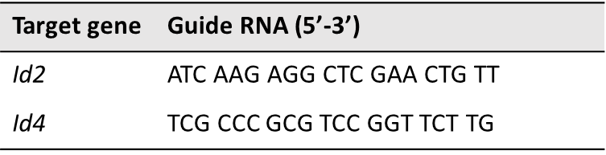

Table 2: Antibody list
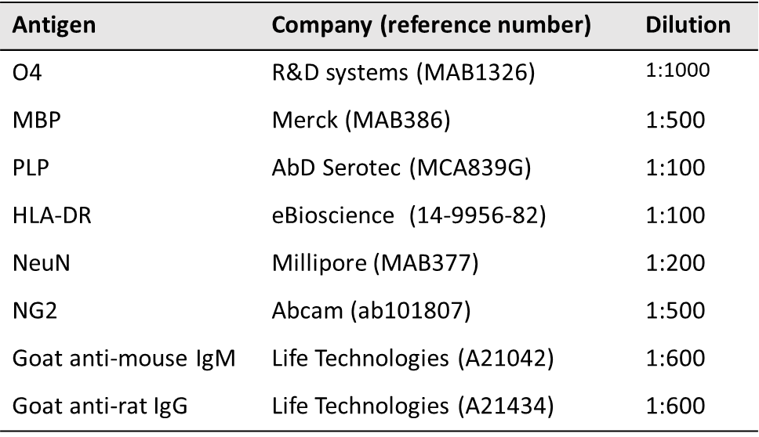

Table 3: qPCR primer list
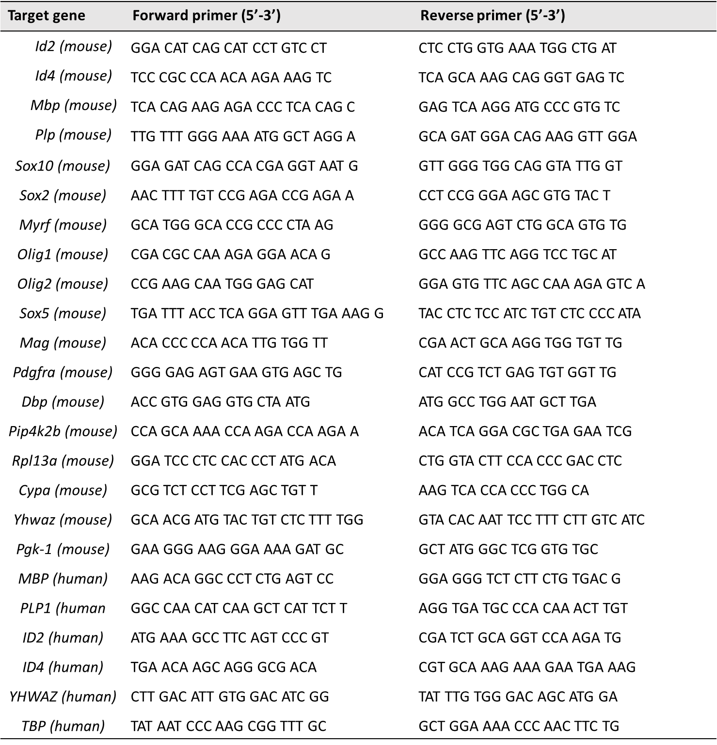

Table 4: Pyrosequencing primer list
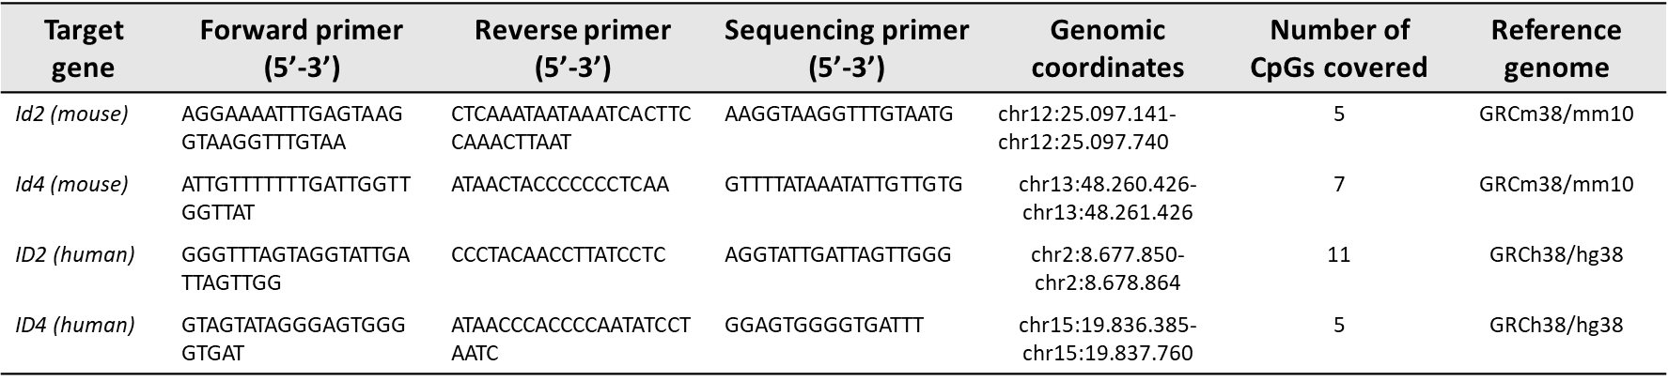

Supplementary Figures
Figure S1 – Treatment with 5-AZA does not affect Oli-neu cell viability at a concentration of 1 µM. Oli-neu cells were treated with different concentrations of 5-AZA for 48 hours. DMSO was used as a vehicle control condition. Cell viability was assessed via an MTT-assay. Data are represented as mean + SEM and are relative to the control condition (n = 6; **p<0.01, ***p<0.001, ****p<0.0001).

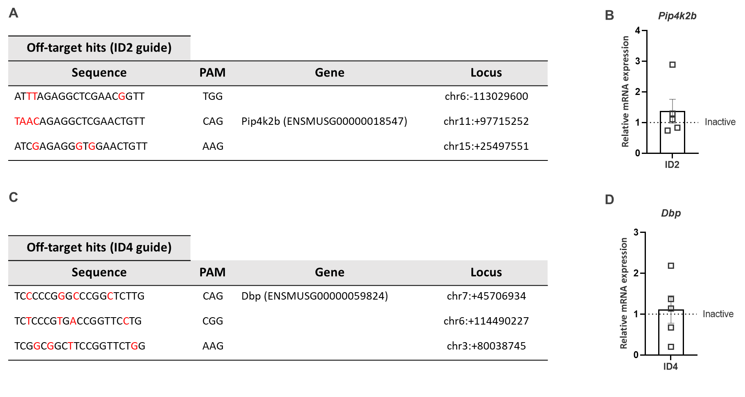
Figure S2 – Top 3 off-target hits of the Id2/Id4 sgRNA. (A,C) The most likely off-targets of the designed sgRNAs are determined by the Benchling software®. The mismatches are depicted in red. (B,D) Off-target effects are analyzed by qPCR of the relevant genes. No difference between the active and inactive constructs is observed. Data are represented as mean ± SEM, n=5 (one sample t-test).

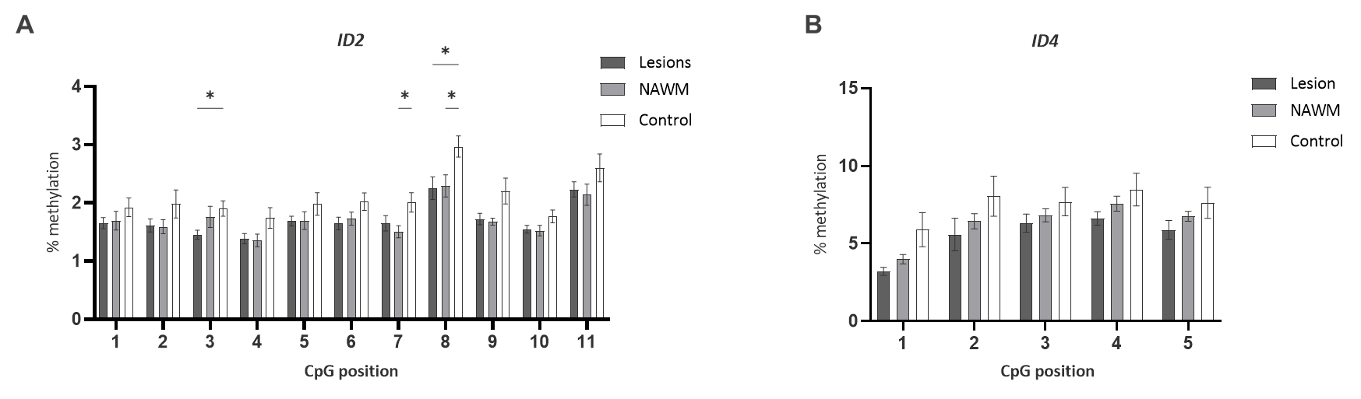
Figure S3 – ID2 and ID4 methylation levels per measured CpG site. Methylation analysis within the CpG island of the ID2 and ID4 genes in chronically demyelinated MS lesions, the surrounding NAWM and matched control samples (n=10, two-way repeated measures ANOVA with Šídák's multiple comparisons test). Data are represented as mean ± SEM, *p<0.05.

Supplementary Methods

Cell viability assay
The effect of 5-AZA on cell viability and cell survival was measured via the 3-(4, 5-dimethylthiazolyl-2)-2,5-diphenyltetrazolium bromide (MTT) assay. Oli-neu cells were seeded in a 96-well plate at a density of 20 x 10³ cells per well in standard culture medium (DMEM, 10% FCS, 1% P/S). Cells were treated with increasing concentrations of 5-AZA or dimethylsufloxide (DMSO; Sigma-Aldrich) as a control. After 48 hours, medium was removed and cells were incubated with 500 µg/ml MTT (Sigma-Aldrich) in DMEM for four hours at 37°C. After removal of the MTT-solution, a glycine-DMSO mixture was added to induce reduction of MTT to formazan. The absorbance was measured at 540 nm with the iMark Microplate Reader (Bio-rad Laboratories, Temse, Belgium).

