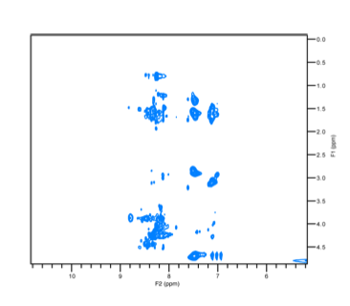
Supplementary Figure S1. Physical characterization of CD4-PP. Analytical HPLC chromatogram and LC-MS spectrum of CD4-PP TOCSY spectrum of CD4-PP displayed broadening of signals and overlapping resonances which prevented accurate sequence-specific chemical shift assignments.
Supplementary Figure S2. Proteolytic stability of CD4-PP in Aureolysin: (a) Identified cleavage site, dotted arrow between L31 and V32 in LL-37 represent cleavage sites reported in this study (b) Stability of peptides in presence of aureolysin.
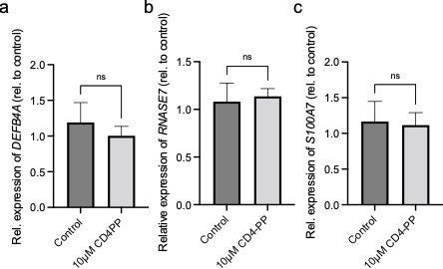
Supplementary Figure S3. CD4-PP does not induce the expression of other antimicrobial peptides. Expression of DEFB4A (a), RNASE7 (b), and S100A7 (c) in uninfected uroepithelial cells, 5637, after stimulation with 10µM of CD4-PP.

Supplementary Table S1. Sequences, net charge, hydropathicity and molecular weight of peptides
Peptide | Sequence | Net Charge  (at neutral pH)ª | Grand average of hydropathicity | Molecular Weight (Expected)^{b} | Molecular Weight (Observed)^{b}
CD4-PP | CPGGKRIVKRIKAFLRGPGGKRIVKRIKAFLR | +12 | - 0.309 | 3602.54 | 3603.04
LL-37 | LLGDFFRKSKEKIGKEFKRIVQRIKDFLRNLVPRTES | +6 | - 0.724 | 4493.32 | 4493.98

ªExPASy ProtParam tool was used to calculate the molecular weight, net charge and hydropathy index (http://web.expasy.org/protparam/)
^{b}Observed peptides masses presented as (M+1)⁺ have been deconvoluted from (M+2)²⁺, (M+3)³⁺ and (M+4)⁴⁺ masses.
Supplementary Table S2. Impact of salts on the minimum inhibitory concentration (MIC) of CD4-PP and L-37. MICs are in µM.

Species | Peptides | Tris-buffer  10mM | NaCl  150mM | NH₄Cl  6 μM | CaCl₂  2.5 mM | MgCl₂  1 mM | FeCl₃  4 μM
E. coli | LL-37 | 0.625 | 5 | 1.25 | >10 | 5 | 2.5
E. coli | CD4-PP | 0.312 | 1,25 | 0.625 | 1,25 | 0.625 | 0.625
P. aeruginosa | LL-37 | 1.25 | 5 | 1.25 | >10 | 5 | 2.5
P. aeruginosa | CD4-PP | 0.625 | 1.25 | 0.625 | 1.25 | 1.25 | 0.625

Supplementary Table S3. List of genes and their primer sequences. ACTB was used on the housekeeping gene, and the fold change in gene expression was calculated using the 2^{-ΔΔCT} method.
Gene | Forward Sequence (5’-3’) | Reverse Sequence (5’-3’)
ACTB | AAG AGA GGC ATC CTC ACC CT | TAC ATC GCT GGG GTG TTG
CAMP | ACC CAG CAG GGC AAA TCT | GAA GGA CGG GCT GGT GAA
CLDN14 | TGT ACC TGG GCT TCA TCT CC | CCT CGC ATT CAC ATT ATT TCC
OCLN | TTT GTG GGA CAA GGA ACA CA | TCA TTC ACT TTG CCA TTG GAT
CXCL8 | AAG AGA GCT CTG TCT GGA CC | GAT ATT CTC TTG GCC CTT GG
RNASE7 | CAT GGC TGA GTT GCA TCG TTG A | GGA GTC ACA GCA CGA AGA CCA
DEFB4A | CCC TTT CTG AAT CCG | GAG GGT CTT GTA TCT CCT
S100A7 | CAC CAG ACG TGA TGA CAA | GGC TAT GTC TCC CAG CAA

