Altered thymocyte development observed in EphA4-deficient mice courses with changes in both thymic epithelial and extracellular matrix organization

Javier García-Ceca^{1,2}*, Sara Montero-Herradón^{1,2}*, Ana González¹, Rosa Plaza¹ and Agustín G Zapata^{1,2}†
¹ Department of Cell Biology, Faculty of Biology, Complutense University of Madrid, 28040 Madrid, Spain.
² Health Research Institute, Hospital 12 de Octubre (imas12), 28041 Madrid, Spain.
* These authors contribute equally to the study
† Corresponding author: Agustín G Zapata; Department of Cell Biology, Faculty of Biology, Complutense University of Madrid, 28040 Madrid, Spain. zapata@ucm.es
ORCID: García-Ceca, J: 0000-0002-0940-455X; Montero-Herradón S: 0000-0003-2004-8987; Zapata AG: 0000-0003-0576-2672

Antibody | Fluorochrome | Clone | Company
anti-CD4 | APC, FITC | GK1.5 | Biolegend
anti-CD8α | APC, PE, Pacific Blue | 53-6.7 | Biolegend
anti-TCRβ | FITC | H57-597 | Biolegend
anti-CD44 | FITC | IM7 | Biolegend
anti-cKit (CD117) | PE | 2B8 | Biolegend
anti-CD5 | FITC | 53-7.3 | Biolegend
anti-CD69 | APC | H1.2F3 | Biolegend
Anti-lineage (Lin) cocktail | APC | --- | BD Biosciences
anti-CD25 | PerCP | PC61 | Biolegend
anti-CD45 | PerCP, APCCy7, Pacific Blue | 30-F11 | Biolegend
anti-EpCAM (CD326) | AlexaFluor488, PE | G8.8 | Biolegend
anti-Ly51 (CD249) | PE, AlexaFluor647 | 6C3 | Biolegend
anti-MHCII (IA/IE) | PerCP | M5/114.15.2 | Biolegend
anti-CD80 | APC | 16-10A1 | Biolegend
UEA1-Biotin | --- | --- | Vector Labs
anti-TCRγδ | PE | GL3 | Biolegend
anti-CD11c | PE | N418 | Biolegend
anti-CD49b | PE | DX5 | Biolegend
anti-F4/80 | PE | BM8 | Biolegend
anti-CD62L | PerCP | MEL-14 | Biolegend
anti-cleaved Caspase-3 | PE | polyclonal | Cell Signalling
anti-FoxP3 | PE | FJK-16s | eBioscience
anti-VLA4 (CD49d) | PE | R1-2 | Biolegend
anti-VLA6 (CD49f) | PE | GoH3 | Biolegend
anti-CXCR4 | PE | 2B11 | eBioscience
anti-CCR9 | PE | eBioCW-1.2 | eBioscience
anti-CCR7 | PE | 4B12 | eBioscience
anti-RatIgG2b,k | PE | RTK4530 | Biolegend
anti-MouseIgG2a,k | PE | MOPC-173 | Biolegend
anti-RatIgG2a,k | PE | RTK2758 | Biolegend
anti-Armenian HamsterIgG | PE | HTK888 | Biolegend
AnnexinV | BrilliantViolet605, APC | --- | Biolegend
Streptavidin | PECy7/PerCP | --- | Biolegend
Online Resource 1. Flow cytometry antibodies

Antibody | Fluorochrome | Clone | Company
anti-keratin 8 (K8) | --- | Troma-1 | Developmental Studies Hybridoma Bank
anti-keratin 5 (K5) | --- | AF138 | Covance
anti-mouse thymic stroma 10 (MTS10) | --- | --- | kindly gifted by Ann Chidgey, Monash University
anti-Pan Cytokeratin | FITC | C11 | Sigma
anti-laminin | --- | polyclonal | Sigma
anti-fibronectin | --- | polyclonal | Novotec
anti-collagen type IV | --- | polyclonal | Novotec
anti-CCL21 | --- | polyclonal | R&D Systems
anti-CCL25 | --- | polyclonal | R&D Systems
anti-CXCL12 | --- | polyclonal | Fitzgerald
anti-AIRE | AlexaFluor488 | 5H12 | eBioscience
Goat anti-Rat IgMDyLight | AlexaFluor594 | --- | ThermoFisher Scientific
Donkey anti-Rat IgG | AlexaFluor594, 488 | --- | ThermoFisher Scientific
Donkey anti-Goat IgG | AlexaFluor488 | --- | ThermoFisher Scientific
Donkey anti-Rabbit IgG | AMCA | --- | Jackson InmunoResearch
Donkey anti-Rabbit IgG | AlexaFluor488 | --- | ThermoFisher Scientific
Online Resource 2. Immunofluorescence antibodies

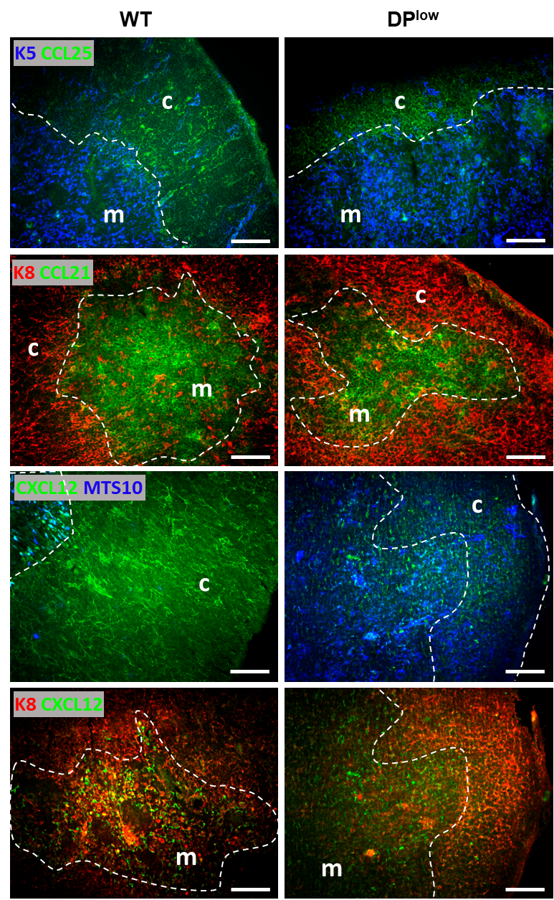

Online Resource 3. Expression of CCL25, CCL21 and CXCL12 (green) in the thymic cortex (c) stained with keratin 8 (K8, red) or in medulla (m) stained with MTS10⁺ or keratin 5⁺ (K5) (blue) in both WT and DP^{low} EphA4 mutant thymuses. Scale bar: 100µm

