Intrauterine Botulinum Toxin A administration promotes endometrial regeneration mediated by IGFBP3-dependent OPN proteolytic cleavage in thin endometrium

¹Danbi Lee, ²Jungho Ahn, ^{3, #}Hwa Seon Koo, ^{2, #}Youn-Jung Kang

Affiliations
¹Department of Biomedical Science, School of Life Science, CHA University, 335 Pangyo-ro, Bundang-gu, Seongnam-si, Gyeonggi-do, South Korea
²Department of Biochemistry, Research Institute for Basic Medical Science, School of Medicine, CHA University, 335 Pangyo-ro, Bundang-gu, Seongnam-si, Gyeonggi-do, South Korea
³CHA Fertility Center Bundang, 59, Yatap-ro, Bundang-gu, Seongnam-si, Gyeonggi-do, South Korea

#Corresponding Authors: Youn-Jung Kang (yjkang@cha.ac.kr), Hwa Seon Koo (hwas0605@cha.ac.kr),

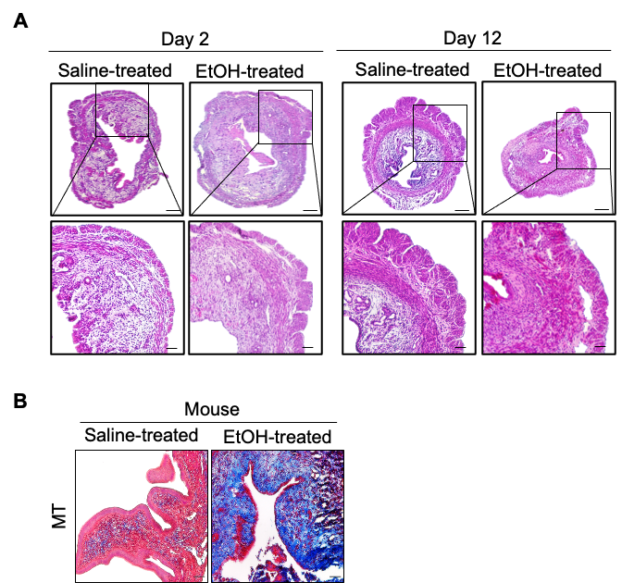

Supplemental Figure S1.
(A) Representative 2 H&E images of 95% EtOH-treated vs. saline-treated uteri harvested on Day 2 and 12. Upper panel shows the entire region of each uterus and magnified images are shown in lower panel. (B) Comparison of deposition of Collagen in endometrial tissues in mouse samples (Saline-treated vs. EtOH-treated) by MT staining

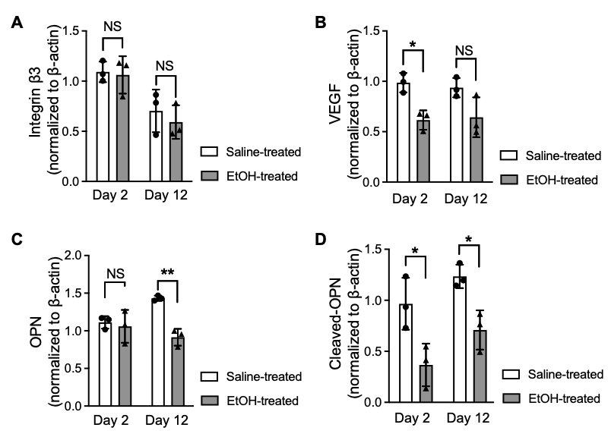

Supplemental Figure S2.
Densitometry of immunoblot bands of integrin β3 (A), VEGF (B), OPN (C), and cleaved-OPN (D) shown in Figure 2 using Image J. Loading control; β-actin. 3 independent experiments were performed. Data shown in (A-D) are analyzed by two-way ANOVA with Tukey’s multiple comparisons test including P-values (*<0.05, **<0.01, ***<0.001, ****<0.0001).

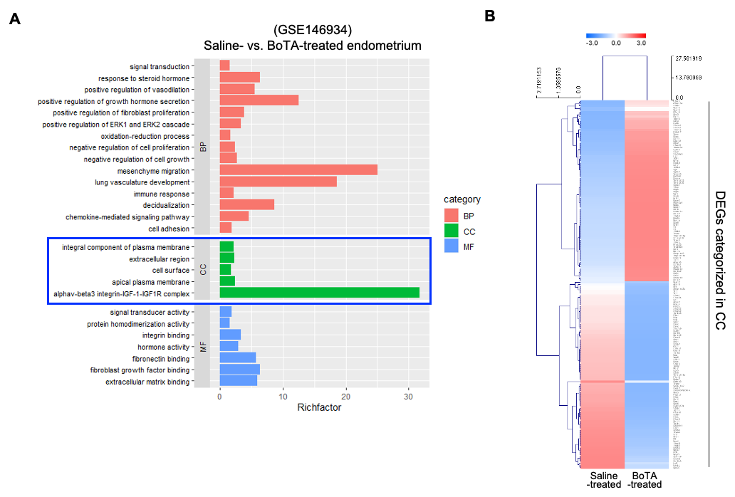

Supplemental Figure S3.
(A) Bar chart displaying biological process (BP), cellular component (CC), molecular function (MF) of gene ontology (GO) and pathway analysis of differentially expressed from GSE146934 using DAVID tool and their fold enrichment on X-axis. Chart was plotted by R studio. (B) Heatmap of DEGs from cellular component (CC) terms shown in (A).

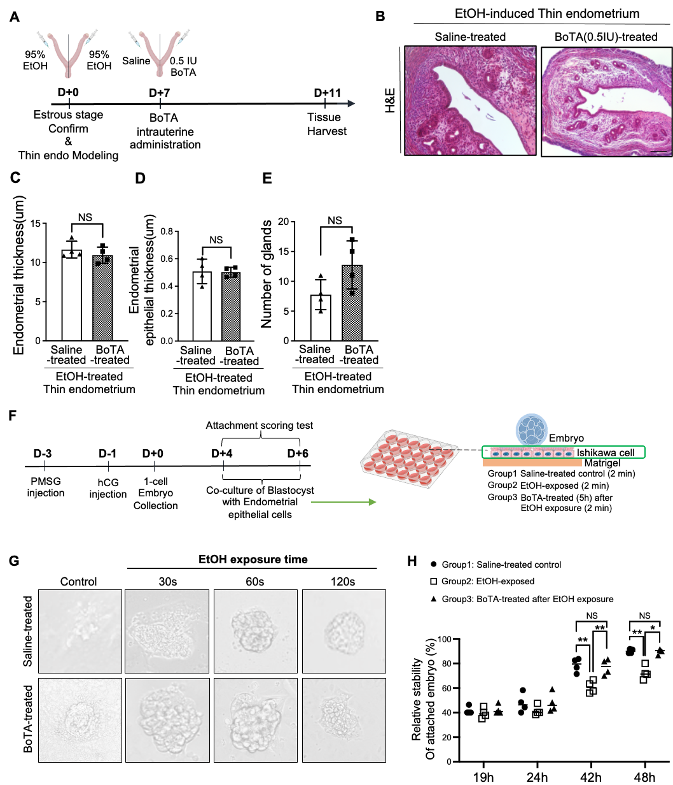
Supplemental Figure S4.
(A) An experimental schedule for intrauterine administration of 0.5 IU BoTA. (B) H&E staining of 0.5 IU BoTA-treated thin endometrium compared to saline-treated thin endometrium. Scale bar; 100 µm. (C-E) Comparisons of endometrial epithelial thickness, endometrial thickness and total number of glands between saline-treated thin endometrium and 0.5 IU BoTA-treated thin endometrium. Data are expressed as mean ± SD and analyzed by unpaired t test including P-values (*<0.05, **<0.01, ***<0.001, ****<0.0001, NS; not significant). (F) An experimental schedule and design for the embryo attachment scoring test. (G) Representative images of attached embryos onto EtOH-primed (indicated exposure time) saline-treated or BoTA-treated Ishikawa cells at 48h after co-culture. (H) Relative stability of attached embryos in each condition. Data shown for (H) are from 3 independent experiments (9 of mice, 95 of embryos) and analyzed by two-way ANOVA with Tukey’s multiple comparisons test including P-values (*<0.05, **<0.01, ***<0.001, ****<0.0001).

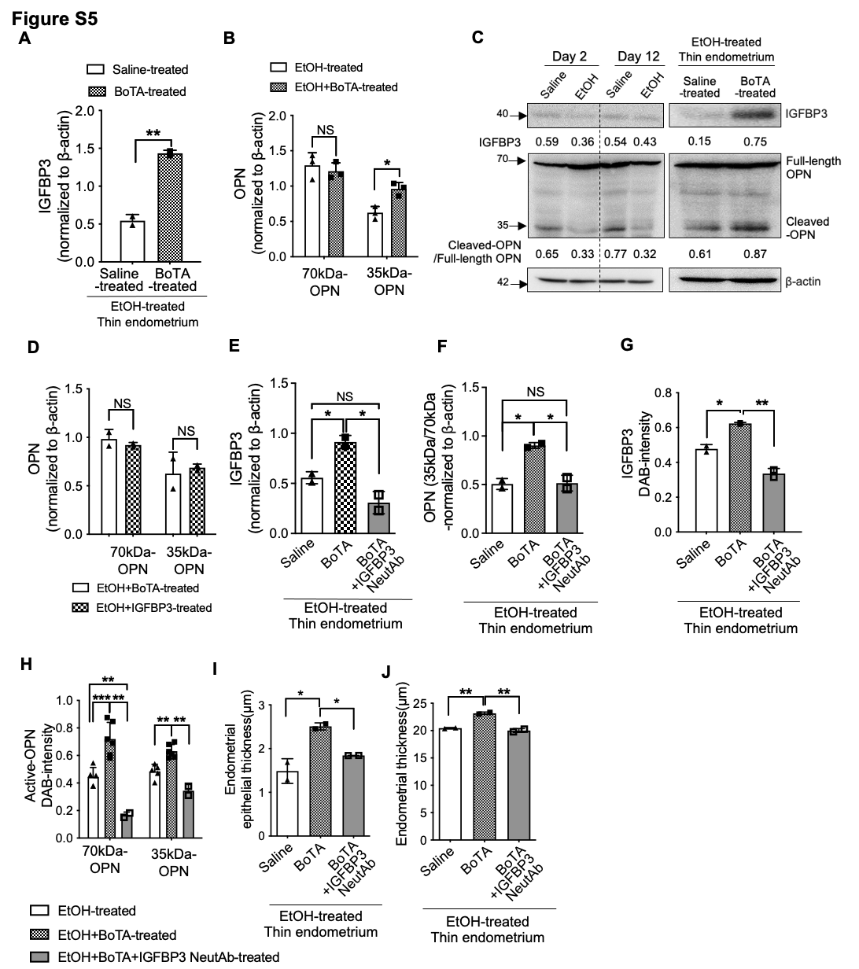

Supplemental Figure S5.
Densitometry of immunoblot bands of IGFBP3 (A), OPN (B) shown in Figure 5C using Image J. Loading control; β-actin. 3 independent experiments were performed. Data shown in (A) are expressed as mean ± SD and analyzed using the two-way ANOVA with Tukey’s multiple comparisons test, and including P-values (*<0.05, **<0.01, ***<0.001, ****<0.0001, NS; not significant). Data shown in (B) are analyzed using the Unpaired t test. (C) Immunoblotting analysis of IGFBP3 and OPN in saline-treated vs. EtOH-treated (Day 2 & 12) and saline-treated vs. BoTA-treated thin endometrium. Numbers below each blot for IGFBP3 are corresponding to the densitometry of each band, which was normalized to the β-actin, and numbers below each blot for OPN are corresponding to the densitometry of each band of cleaved-OPN, which was normalized to the β-actin and then standardized to Full-length OPN. (D) Densitometry of immunoblot band of OPN shown in Figure 5D using Image J. Loading control; β-actin. (E-F) Densitometry of immunoblot band of IGFBP3 and OPN (35kDa/70kDa) shown in Figure 5F using Image J. Loading control; β-actin. IHC images shown in Figure 5G-H are quantified in graphs in (G-H). Data shown in (G) are analyzed using the ordinary one-way ANOVA with Dunnett’s multiple comparisons test, and data shown in (H) are expressed as mean ± SD and analyzed using the two-way ANOVA with Tukey’s multiple comparisons test, and including P-values (*<0.05, **<0.01, ***<0.001, ****<0.0001, NS; not significant). Quantification of histological evaluations of endometrial epithelial thickness (I), endometrial thickness (J) shown in Figure 5I and data shown in (I-J) are analyzed using the ordinary one-way ANOVA with Dunnett’s multiple comparisons test including P-values (*<0.05, **<0.01, ***<0.001, ****<0.0001, NS; not significant).

Supplemental Figure S6.
Whole blot of Figure 2E

Supplemental Figure S7.
Whole blot of Figure 5C (A), 5D (B), 5F (C)

Species | Gene | Direction | Sequence
Mouse | Rpl7 | Forward | TCAATGGAGTAAGCCCAAAG
Mouse | Rpl7 | Reverse | CAAGAGACCGAGCAATCAAG
Mouse | Spp1 | Forward | AGAGCGGTGAGTCTAAGGAG
Mouse | Spp1 | Reverse | TGCCCTTTCGGTTGTTGTCC
Mouse | Vegfb | Forward | TGACATCATCCATCCCACTC
Mouse | Vegfb | Reverse | CCTTGGCAATGGAGGAAG
Mouse | Vegfa | Forward | GCACATAGAGAGAGAATCAGCTTC
Mouse | Vegfa | Reverse | CTCCGCTCTGAACAAGGCT
Mouse | Tie1 | Forward | GGTCACACACACGGTGAACAA
Mouse | Tie1 | Reverse | TGCCAGTCTAGGGTATTGAAG
Mouse | Ang1 | Forward | AAAATGGGTTTTGGGAATCCC
Mouse | Ang1 | Reverse | TCGGCACCGTGTAAGATCAAG
Mouse | Vegfr2 | Forward | CCACACGAGGCGTGAACTC
Mouse | Vegfr2 | Reverse | CTTCAGGTTACATCGCGGTGA
Mouse | Il-1b | Forward | GAAATGCCACCTTTTGACAGTG
Mouse | Il-1b | Reverse | TGGATGCTCTCATCAGGACAG
Mouse | Tgfb1 | Forward | GTGAAACGGAAGCGCATCGAAG
Mouse | Tgfb1 | Reverse | CATAGTAGTCCGCTTCGGGCTCC
Mouse | Timp1 | Forward | GACCTATAGTGCTGGCTGTGG
Mouse | Timp1 | Reverse | GTAGTCCTCAGAGCCCACGA
Human | ACTB | Forward | CATGTACGTTGCTATCCAGGC
Human | ACTB | Reverse | GCCTTAATGTCACGCACGAT
Human | TGFB1 | Forward | AGAGTGTCTGCGGATACTTCC
Human | TGFB1 | Reverse | CCAACAGTGTAGGTCTTGGTG
Human | TIMP1 | Forward | CTAATGGTGGAAACCCACAACG
Human | TIMP1 | Reverse | TATCGCCAGGAATTGTTGCTG
Human | SPP1 | Forward | GAAGTTTCGCAGACCTGACAT
Human | SPP1 | Reverse | GTATGCACCATTCAACTCCTCG

Supplemental Table S1. Primer sequence pairs used for RT-PCR analyses

Gene symbol  (Up-regulated) | P-values | Fold changes
Tceal8 | 0.019 | 2.032
G530011O06Rik | 0.043 | 2.754
Pi15 | 0.016 | 2.826
Igf1 | 0.016 | 4.103
2210015D19Rik | 0.008 | 2.076
Tmem17 | 0.010 | 2.106
Nipal4 | 0.000 | 2.205
Acsl6 | 0.005 | 3.760
Pmp22 | 0.026 | 2.002
Rangrf | 0.031 | 2.220
Kcnab3 | 0.004 | 2.742
Ccl7 | 0.035 | 2.607
Tmem132e | 0.008 | 2.170
Tubd1 | 0.023 | 2.856
Rad51b | 0.039 | 2.507
Akr1c12 | 0.013 | 2.627
Fam65b | 0.022 | 3.235
Ear3 | 0.004 | 2.358
Ear12 | 0.004 | 2.358
Dok2 | 0.005 | 2.279
Il7r | 0.005 | 2.141
Tbc1d31 | 0.049 | 2.598
Sqle | 0.046 | 2.733
Khdrbs3 | 0.035 | 2.057
C1qtnf6 | 0.016 | 2.220
Lgals1 | 0.031 | 2.419
Ccdc134 | 0.026 | 2.366
Mettl22 | 0.004 | 2.265
Vgll3 | 0.019 | 2.580
Adamts1 | 0.006 | 2.574
Runx1 | 0.024 | 2.395
Zfp948 | 0.023 | 2.095
Rab26os | 0.040 | 2.217
Zfp119b | 0.007 | 2.516
Tubb6 | 0.039 | 2.522
1810055G02Rik | 0.023 | 2.828
Fxn | 0.004 | 2.172
Slc16a12 | 0.018 | 2.523
Ffar4 | 0.020 | 2.674
Hacd1 | 0.016 | 3.352
Lhx6 | 0.013 | 2.664
Lrp4 | 0.030 | 2.264
Rcn1 | 0.019 | 2.019
Bfsp1 | 0.032 | 2.062
Slc2a10 | 0.003 | 3.310
Abhd16b | 0.014 | 2.646
Dclk1 | 0.014 | 2.540
Slitrk3 | 0.016 | 2.411
Ctps | 0.031 | 2.516
Ajap1 | 0.011 | 2.928
Ccdc146 | 0.033 | 2.428
Smarcd3 | 0.012 | 2.995
Ndufa4 | 0.001 | 2.027
Clec5a | 0.033 | 5.834
Zfp248 | 0.024 | 2.911
Mfap5 | 0.014 | 2.227
Plaur | 0.008 | 2.638
Fbxo17 | 0.011 | 2.239
Ano5 | 0.038 | 2.565
Mrps11 | 0.002 | 2.269
Chrdl2 | 0.048 | 2.569
Hbb-bt | 0.034 | 3.700
Hbb-b2 | 0.034 | 3.728
Hbb-bs | 0.005 | 3.938
Hbb-b1 | 0.005 | 3.939
Ifitm6 | 0.003 | 2.654
Tnni2 | 0.011 | 2.843
Ascl2 | 0.011 | 2.141
Scarna9 | 0.026 | 2.283
Thyn1 | 0.029 | 2.054
Slc37a4 | 0.012 | 2.049
Loxl1 | 0.016 | 2.412
Bcl2a1a | 0.044 | 2.120
Plod2 | 0.018 | 2.870
Rnf113a1 | 0.004 | 2.360
Gene symbol  (Down-regulated) | P-values | Fold changes
Paqr8 | 0.013 | 0.499
Il1rl2 | 0.007 | 0.454
Il18r1 | 0.045 | 0.442
Mogat1 | 0.001 | 0.269
Sp100 | 0.040 | 0.385
4933407L21Rik | 0.000 | 0.473
Rab17 | 0.038 | 0.272
Ikbke | 0.002 | 0.339
Ptgs2os2 | 0.037 | 0.447
Nos1ap | 0.041 | 0.499
Ipcef1 | 0.002 | 0.473
Pdxk | 0.011 | 0.236
Misp | 0.036 | 0.322
Cpm | 0.008 | 0.235
Gck | 0.000 | 0.309
Igfbp3 | 0.032 | 0.158
4930415F15Rik | 0.049 | 0.466
Cobl | 0.044 | 0.386
Tgtp2 | 0.050 | 0.458
Slc22a4 | 0.034 | 0.359
Alox12e | 0.006 | 0.238
Alox15 | 0.008 | 0.249
Shpk | 0.032 | 0.471
Tmem98 | 0.023 | 0.354
Hoxb2 | 0.028 | 0.490
Plxdc1 | 0.044 | 0.429
Fbxl20 | 0.013 | 0.383
Abca8b | 0.038 | 0.463
Abca8a | 0.039 | 0.281
Cog1 | 0.018 | 0.433
Gprc5c | 0.019 | 0.434
BC100451 | 0.048 | 0.476
Hgs | 0.039 | 0.435
Hs1bp3 | 0.013 | 0.363
Lrrn3 | 0.023 | 0.302
Gm17821 | 0.025 | 0.492
Dhrs7 | 0.018 | 0.475
Syne2 | 0.035 | 0.489
Vash1 | 0.000 | 0.438
Clmn | 0.012 | 0.407
D430020J02Rik | 0.016 | 0.460
Tmem196 | 0.025 | 0.450
Tubb2b | 0.001 | 0.272
Mylip | 0.049 | 0.426
S1pr3 | 0.025 | 0.303
Chdh | 0.030 | 0.493
Txndc16 | 0.017 | 0.397
Haus4 | 0.026 | 0.447
Gjb2 | 0.041 | 0.368
Klf5 | 0.011 | 0.474
Tspyl5 | 0.020 | 0.435
Peg13 | 0.013 | 0.458
Ly6e | 0.014 | 0.348
Kifc2 | 0.009 | 0.450
1810021B22Rik | 0.029 | 0.456
Tmem117 | 0.032 | 0.331
Pou6f1 | 0.016 | 0.305
Serpind1 | 0.045 | 0.366
E130310I04Rik | 0.035 | 0.358
Dnajc28 | 0.044 | 0.380
Fndc1 | 0.026 | 0.415
Unc93a | 0.020 | 0.315
Syngap1 | 0.049 | 0.431
Tapbp | 0.033 | 0.466
H2-K2 | 0.042 | 0.490
AA388235 | 0.003 | 0.269
Ppt2 | 0.011 | 0.410
Tnxb | 0.012 | 0.450
H2-Q4 | 0.001 | 0.400
A930015D03Rik | 0.000 | 0.232
Rcan2 | 0.050 | 0.406
Rasgrp3 | 0.041 | 0.473
Npc1 | 0.036 | 0.499
Lims2 | 0.019 | 0.342
Pcdhgc4 | 0.030 | 0.455
1700120E14Rik | 0.009 | 0.344
Sptbn2 | 0.004 | 0.425
Tmem151a | 0.037 | 0.240
Ifit2 | 0.028 | 0.308
Pdlim1 | 0.020 | 0.464
Frat2 | 0.010 | 0.443
Pax2 | 0.022 | 0.490
Pcgf6 | 0.026 | 0.470
Tprn | 0.042 | 0.462
Naif1 | 0.050 | 0.492
Gyltl1b | 0.046 | 0.463
Shc4 | 0.010 | 0.490
Zfp661 | 0.021 | 0.205
Gm14057 | 0.016 | 0.451
Slc52a3 | 0.041 | 0.387
Lbp | 0.029 | 0.248
Zfp831 | 0.025 | 0.458
Pcmtd2 | 0.014 | 0.494
Lrrc31 | 0.020 | 0.416
Fmo5 | 0.021 | 0.376
Ptpn22 | 0.019 | 0.449
Gstm1 | 0.038 | 0.420
Tox | 0.048 | 0.434
Ddx58 | 0.048 | 0.457
Enho | 0.033 | 0.474
Dnajc6 | 0.032 | 0.408
Acot11 | 0.001 | 0.426
Spata6 | 0.011 | 0.459
Sesn2 | 0.043 | 0.423
B930041F14Rik | 0.046 | 0.494
Perm1 | 0.050 | 0.353
Sema3e | 0.022 | 0.267
Napepld | 0.007 | 0.421
Wdr86 | 0.048 | 0.480
Txk | 0.003 | 0.333
Spink2 | 0.039 | 0.434
Cldn4 | 0.005 | 0.498
Dlx5 | 0.043 | 0.473
Strip2 | 0.019 | 0.400
Gimap3 | 0.014 | 0.467
Fam188b | 0.006 | 0.381
2310040G24Rik | 0.023 | 0.467
1810044D09Rik | 0.037 | 0.432
Klra15 | 0.017 | 0.273
Klra18 | 0.003 | 0.371
Klra4 | 0.014 | 0.352
Klra12 | 0.010 | 0.338
Klra21 | 0.008 | 0.396
Klra8 | 0.030 | 0.413
8430419L09Rik | 0.008 | 0.392
Itpr2 | 0.003 | 0.434
Ttyh1 | 0.001 | 0.368
Sipa1l3 | 0.030 | 0.416
Fam71e1 | 0.004 | 0.357
Ccdc114 | 0.033 | 0.390
Tenm4 | 0.014 | 0.436
Arntl | 0.012 | 0.369
Tubgcp2 | 0.026 | 0.485
Sirt3 | 0.014 | 0.400
Evi5l | 0.004 | 0.435
Lrrc8e | 0.038 | 0.399
Irs2 | 0.015 | 0.332
Gm16159 | 0.033 | 0.376
Lonrf1 | 0.001 | 0.392
Mylk3 | 0.021 | 0.313
Gpt2 | 0.016 | 0.299
Cx3cl1 | 0.003 | 0.442
Lrrc36 | 0.010 | 0.436
Casp4 | 0.022 | 0.498
Barx2 | 0.016 | 0.233
Tmem136 | 0.033 | 0.498
Gm5617 | 0.035 | 0.434
Slc24a1 | 0.041 | 0.473
Acpp | 0.017 | 0.328
Hyal1 | 0.001 | 0.353
Cmtm8 | 0.020 | 0.435
Ccdc120 | 0.030 | 0.458
AW822252 | 0.011 | 0.483
Arhgef6 | 0.002 | 0.419

Supplementary Table S2. A list of differentially expressed genes of EtOH-treated endometrial samples compared to saline-treated control, shown in a heatmap of Fig. 3B. The cutoff for significance was set by P-value < 0.05 and Fold change > 2.0 (up-regulated genes) and < 0.5 (down-regulated genes).

Gene symbol  (Up-regulated) | P-values | Fold changes
Adamts1 | 0.008 | 2.359
Adamts4 | 0.030 | 2.465
Adcyap1 | 0.009 | 11.496
Adgrb3 | 0.008 | 5.277
Agr2 | 0.033 | 2.769
Aqp5 | 0.012 | 3.315
Asic2 | 0.001 | 2.545
Bmp8a | 0.047 | 20.515
Bpifc | 0.042 | 4.539
Btbd17 | 0.011 | 2.660
Cav3 | 0.005 | 5.186
Ccl11 | 0.032 | 13.107
Ccl7 | 0.029 | 7.979
Cd34 | 0.038 | 2.047
Col6a1 | 0.007 | 2.371
Col6a2 | 0.035 | 2.312
Cpa6 | 0.043 | 2.201
Crispld2 | 0.006 | 2.957
Dscam | 0.015 | 5.365
F2rl3 | 0.006 | 4.255
Ffar4 | 0.018 | 3.136
Fgl1 | 0.003 | 2.375
Gdf6 | 0.029 | 3.718
Grm1 | 0.007 | 3.117
Gypa | 0.019 | 7.356
Hrh1 | 0.049 | 2.954
Hspa1a | 0.002 | 2.548
Igf1 | 0.037 | 2.554
Igsf5 | 0.033 | 2.165
Il11 | 0.045 | 3.237
Il27ra | 0.049 | 2.047
Il4ra | 0.019 | 2.169
Inhbb | 0.009 | 4.080
Itgb3 | 0.002 | 2.894
Jchain | 0.017 | 3.054
Kcne4 | 0.041 | 2.083
Kl | 0.001 | 5.498
Lgals1 | 0.033 | 2.207
Lif | 0.008 | 4.021
Ly96 | 0.002 | 2.510
Muc13 | 0.040 | 3.536
Myrip | 0.004 | 3.175
Nppc | 0.036 | 13.837
Nrtn | 0.046 | 2.692
Ogn | 0.004 | 2.826
Oxtr | 0.016 | 5.309
Pcdh11x | 0.007 | 3.552
Pcsk9 | 0.001 | 3.386
Pm20d1 | 0.025 | 5.100
Prss23 | 0.035 | 2.304
Serpina9 | 0.004 | 7.816
Sgca | 0.040 | 4.560
Sgms2 | 0.001 | 2.492
Slc39a8 | 0.043 | 2.387
Slc3a1 | 0.020 | 2.774
Spock3 | 0.014 | 16.438
Spon1 | 0.036 | 2.722
Stc2 | 0.033 | 2.522
Tcam1 | 0.016 | 4.782
Tfrc | 0.038 | 2.911
Tmem45a | 0.036 | 2.317
Tmprss11a | 0.010 | 12.702
Tmprss11g | 0.009 | 9.881
Trabd2b | 0.004 | 2.976
Trpc3 | 0.011 | 2.363
Wfdc15a | 0.041 | 2.177
Gene symbol  (Down-regulated) | P-values | Fold changes
2300002M23Rik | 0.004 | 0.224
Ano1 | 0.018 | 0.486
Apoc2 | 0.003 | 0.197
Apol6 | 0.025 | 0.415
Bcan | 0.016 | 0.291
Car4 | 0.001 | 0.028
Car6 | 0.033 | 0.195
Ccbe1 | 0.018 | 0.448
Ccl4 | 0.035 | 0.494
Cd163 | 0.005 | 0.231
Clca3b | 0.003 | 0.227
Clcn5 | 0.044 | 0.255
Col6a5 | 0.023 | 0.338
Cthrc1 | 0.006 | 0.481
Ctss | 0.040 | 0.429
Cyp4a12a | 0.021 | 0.260
Daw1 | 0.011 | 0.248
Epha7 | 0.013 | 0.291
Eppin | 0.015 | 0.247
F9 | 0.041 | 0.350
Flrt3 | 0.009 | 0.387
Gabrb3 | 0.016 | 0.325
Ghr | 0.018 | 0.498
Ghrl | 0.043 | 0.375
Gkn3 | 0.026 | 0.329
Gldn | 0.048 | 0.222
Gpc6 | 0.018 | 0.237
Htr2a | 0.040 | 0.471
Igf1r | 0.045 | 0.466
Itih2 | 0.030 | 0.242
Kcnh5 | 0.021 | 0.205
Kiss1 | 0.025 | 0.312
Klk11 | 0.042 | 0.384
Klkb1 | 0.020 | 0.398
Lgr5 | 0.001 | 0.146
Lhb | 0.001 | 0.234
Lpl | 0.015 | 0.246
Mbl2 | 0.019 | 0.265
Mip | 0.047 | 0.364
Ms4a1 | 0.027 | 0.298
Mup12 | 0.018 | 0.438
Ndp | 0.034 | 0.114
Nox4 | 0.012 | 0.236
Npy2r | 0.023 | 0.264
Ntrk1 | 0.031 | 0.391
Olr1 | 0.012 | 0.427
Oosp2 | 0.029 | 0.243
Opn1sw | 0.041 | 0.313
Plxnb1 | 0.048 | 0.479
Ptprz1 | 0.045 | 0.099
S1pr3 | 0.043 | 0.469
Serpina3c | 0.033 | 0.279
Serpine2 | 0.009 | 0.360
Sfrp1 | 0.047 | 0.401
Slc2a2 | 0.039 | 0.344
Slc7a9 | 0.035 | 0.362
Spink2 | 0.027 | 0.339
Stc1 | 0.018 | 0.447
Stra6 | 0.024 | 0.275
Tgfbi | 0.015 | 0.326
Them6 | 0.034 | 0.419
Tnfrsf11b | 0.001 | 0.323
Trf | 0.016 | 0.337
Trpm1 | 0.008 | 0.267
Vwa2 | 0.012 | 0.461
Vwa7 | 0.020 | 0.437
Wif1 | 0.003 | 0.006

Supplementary Table S3. A list of differentially expressed genes of BoTA-treated endometrial samples compared to saline-treated control, shown in a heatmap of Fig. S3B. The cutoff for significance was set by P-value < 0.05 and Fold change > 2.0 (up-regulated genes) and < 0.5 (down-regulated genes).

EtOH-treated vs. Saline-treated  (GSE207379) |  | BoTA-treated vs. Saline-treated  (GSE146934) |  | Shared
Up-regulation | Down-regulation | Up-regulation | Down-regulation | Up-regulation | Down-regulation | Reciprocal
C1qtnf6 | Acpp | Adamts1 | 2300002M23Rik | Adamts1 | S1pr3 | Igfbp3
Adamts1 | Ajap1 | Adcyap1 | Adamts4 | Ccl7 | Spink2
Ccdc134 | Casp4 | Adgrb3 | Col6a5 | Ffar4
Ccl7 | Cldn4 | Agr2 | Apol6 | Igf1
Chrdl2 | Cx3cl1 | Aqp5 | Apoc2 | Lglas1
Fam65b | Enho | Asic2 | Cpa6
Ffar4 | Gstm1 | Bace2 | Ano1
Igf1 | Hyal1 | Btbd17 | Bcan
Lgals1 | Igfbp3 | Bpifc | Cd8b1
Loxl1 | Itpr2 | Clec2f | Bmp8a
Mfap5 | Lbp | Cav3 | Clca3b
Plaur | Nos1ap | Ccl11 | Clcn5
Sema3e | Npc1 | Crispld2 | Car4
 | Pi15 | Ccl7 | Car6
 | S1pr3 | Cd34 | Ccbe1
 | Sipa1l3 | Dpp6 | Col6a2
 | Slc22a4 | Dscam | Cthrc1
 | Slc52a3 | F2rl3 | Ctss
 | Spata6 | Fbln2 | Ccl4
 | Spink2 | Ffar4 | Cxcr2
 | Sptbn2 | Fgl1 | Col6a1
 | Syne2 | Gdf6 | Cd163
 | Tnxb | Gpx3 | Cd200r1
 | Txndc16 | Grm1 | Cyp4a12a
 | Vash1 | Gypa | Epha7
 |  | Igf1 | Eppin
 |  | Igfbp3 | F9
 |  | Il11 | Flrt3
 |  | ITGB3 | Fzd10
 |  | Itgb6 | Gabrb3
 |  | Jchain | Ghr
 |  | Kcne4 | Ghrl
 |  | Kl | Gkn3
 |  | Lgals1 | Gldn
 |  | Lif | Gpc6
 |  | Ly96 | Gpr37
 |  | Muc13 | Hrh1
 |  | Myrip | Hspa1a
 |  | Ngfr | Htr2a
 |  | Nppc | Igf1r
 |  | Nrtn | Il27ra
 |  | Ogn | Il4ra
 |  | Oxtr | Inhbb
 |  | Pcdh11x | Itga8
 |  | Pcsk9 | Itih2
 |  | Pm20d1 | Kcnh5
 |  | Sgca | Kiss1
 |  | Sgms2 | Klk11
 |  | Slc3a1 | Klkb1
 |  | Spock3
 |  | Spon1
 |  | Stc2
 |  | Tcam1
 |  | Tfrc
 |  | Trabd2b
 |  | Trpc3
b |  | Lgr5
 |  | Lhb
 |  | Lpl
 |  | Ly6c2
 |  | Ly9
 |  | Mbl2
 |  | Mip
 |  | Ms4a1
 |  | Mup12
 |  | Ndp
 |  | Nox4
 |  | Npy2r
 |  | Ntrk1
 |  | Olr1
 |  | Oosp2
 |  | Opn1sw
 |  | Plxnb1
 |  | Prss23
 |  | Ptprz1
 |  | S1pr3
 |  | Serpina3c
 |  | Serpina9
 |  | Serpine2
 |  | Sfrp1
 |  | Slc2a2

Supplemental Table S4. DEGs categorized in CC terms of GSE207379 and GSE146934.

