Supplementary Figure 1(Fig S1).
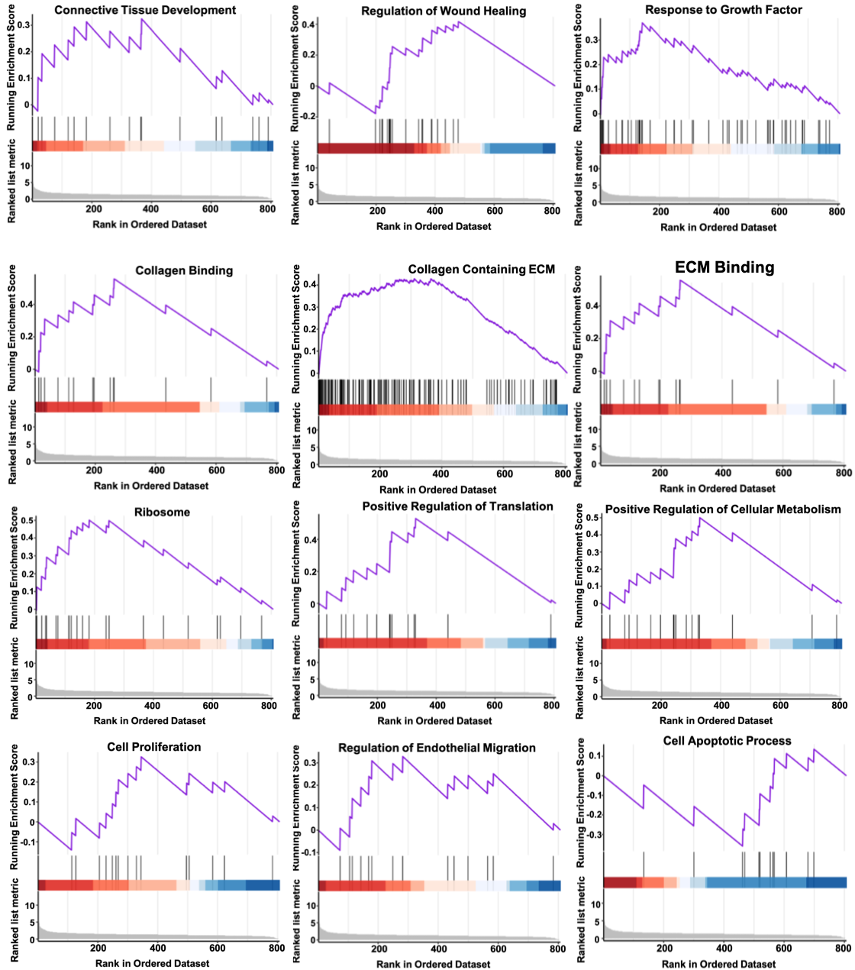
Fig S1. All the potential pathways which are involved with 51 (10 down- and 41 up-regulated) differentially expressed proteins based on GSEA.

Supplementary Figure 2 (Fig S2).
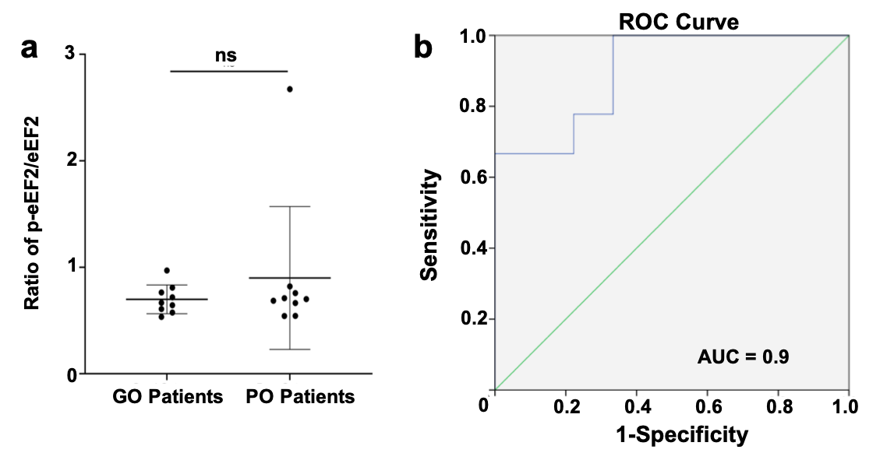
Fig S2. a) Semi-quantitative analysis based on western blotting result among 18 patients, the ratio of phosphorylated-eEF2 (p-eEF2)/total eEF2 shows no statistical significance between good- and poor outcome patients, n = 18; b) AUC for eEF2 to report its predictive significance based on Western Blot result, n = 18.

Supplementary Figure 3 (Fig S3).
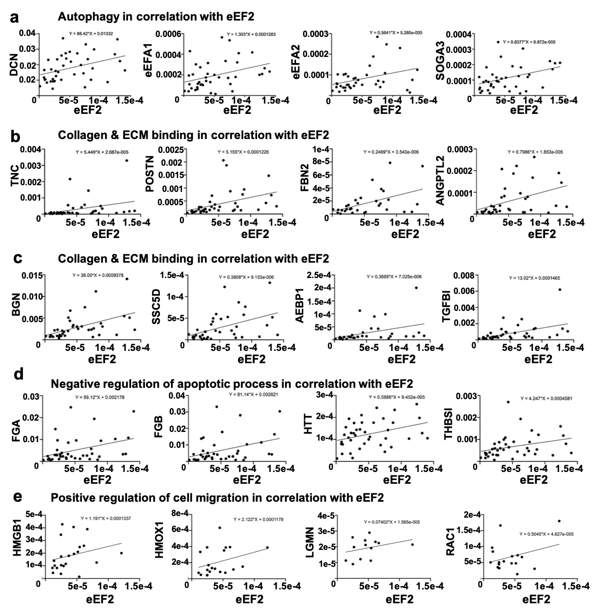
Fig S3. Bioinformatics of eEF2 in relation to inflammatory stage of healing.
a) A positive correlation between eEF2 and autophagy; b-c) There was a positive association between collagen & ECM binding and eEF2; d) eEF2 was positively associated with regulation of apoptosis; e) eEF2 was positively associated with cell migration. All the proteins which were enriched in autophagy, collagen & ECM binding, negative regulation of apoptotic process and positive regulation of cell migration were collected and used a regression analysis with eEF2.

Supplementary Figure 4 (Fig S4).
Fig S4. eEF2 knock down among the inflammatory fibroblast model.
a) Representative images of western blotting from proteins lysates generated from fibroblasts treated with normal medium, TNF stimulation and si-eEF2 incubation after TNF stimulation. Cells treated with TNF showed a 22% decrease in eEF2 expression while si-eEF2 incubated cells demonstrated a 67% decrease in eEF2 expression.
b) Representative images of western blotting from proteins lysates generated from fibroblasts treated with normal medium, TNF stimulation and si-eEF2 incubation after TNF. Cells incubated with TNF showed a 37% decrease of Col1a1 production when compared with normal control. Cells showed a 50% (48 hours) decrease and 87% (72 hours) decrease in Col1a1 production when treated with si-eEF2 after incubating with TNF.

Supplementary Figure 5 (Fig S5).
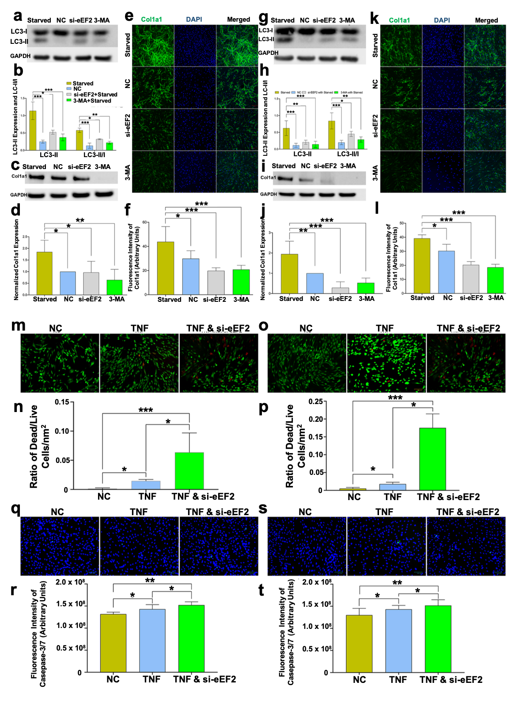
Fig S5. eEF2 enhances healing processes in TNF-induced inflammatory fibroblast models.
a-f) eEF2 affects Col1a1 expression through autophagy in primary fibroblasts. a, b) Representative Western blot images and semi-quantitative analysis of LC3-II and LC3-II/LC3-I ratio, c-f) Representative Western blot (c) and confocal images (e) along with semi-quantitative analysis of Col1a1(d, f) in cells treated with normal medium, starved medium for autophagy, si-eEF2 and 3-MA incubation based on autophagy; g-l) eEF2 affects Col1a1 synthesis by autophagy in fibroblast cell line. g, h) Representative Western blot images and semi-quantitative analysis of LC3-II and LC3-II/LC3-I ratio. Representative Western blot (i) and confocal images (k) along with semi-quantitative analysis of Col1a1 (l, j) synthesis in cells treated with normal medium, starved stimulation for autophagy, si-eEF2 and 3-MA incubation based on autophagy; Semi-quantitative analysis demonstrated eEF2 enhanced autophagy and then increased Col1a1 synthesis during inflammation. Signal intensity (a-d, g-j) and fluorescent green intensity (e-f, k-l) were used for semi-quantitative analysis; m-t) Representative images captured by fluorescent microscope demonstrated the cell death and apoptosis when treated with normal condition, TNF and si-eEF2: si-eEF2 increases the ratio of dead/live cells among primary fibroblast (m, n) and fibroblast cell line (o, p); si-eEF2 positively associate with cell apoptosis among primary fibroblasts (q, r) and fibroblast cell line (s, t); The ratio of dead/live cells was reported by percentage and the apoptotic level of cells was presented by fluorescent green intensity. Data reported as mean $±$ SD, * p < 0.05, ** p < 0.01, *** p < 0.001, scale bars = 100 µm, 3 replicates were used for quantitative analysis.

Supplementary Figure 6 (Fig S6).
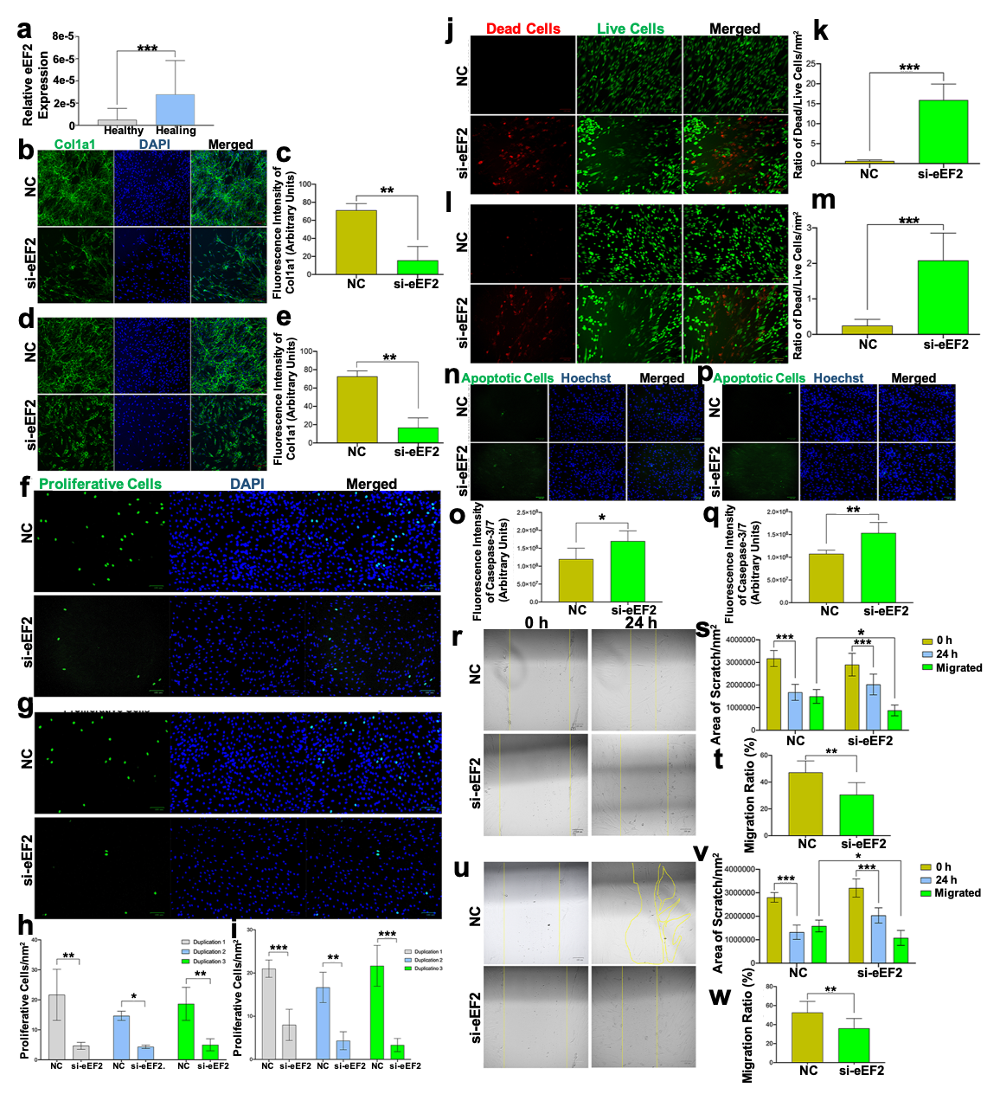
Fig S6. eEF2 enhances fibroblast proliferative processes.
a) eEF2 expression from micro-dialysate MS data, micro-dialysate collected from the intact and healing Achilles tendons, 2 weeks post-surgery, *** p < 0.001, n = 28 in each group; b-e) Representative confocal images and semi-quantitative analysis of Col1a1 in b,c) primary fibroblasts and, d,e) fibroblast cell line, with and without si-eEF2, data reported as mean $±$ SD, ** p < 0.01, scale bars = 100 µm, n = 3 replicates; f-i) Representative immunofluorescence images and number of proliferating f,h) primary fibroblasts and g,i) fibroblast cell line, with and without si-eEF2. Data reported as mean $±$ SD, * p < 0.05, ** p < 0.01, *** p < 0.001, scale bars = 100 µm, n =3 replicates; j-m) Representative immunofluorescence images and ratio of dead/live cells from, j,k) primary fibroblasts, and l,m) fibroblast cell line, with and without si-eEF2. Data reported as mean $±$ SD, *** p < 0.001, scale bars = 100 µm, n = 3 replicates; n-q) Representative immunofluorescence images and number of apoptotic cells from n,o) primary fibroblasts, and p,q) fibroblast cell line, with and without si-eEF2. Data reported as mean $±$ SD, * p < 0.05, ** p < 0.01, scale bars = 100 µm, n =3 replicates; r-w) Representative images and quantitative analysis of cell migration rate assessed at 0 and 24 hours in r-t) primary fibroblast, and u-w) fibroblast cell line, with and without si-eEF2. Data reported as mean $±$ SD, * p < 0.05, ** p < 0.01, *** p < 0.001, scale bars = 100 µm, n =3 replicates.

