Cellular and Molecular Life Sciences

Supplementary Material

Ablation of specific long PDE4D isoforms increases neurite elongation and conveys protection against amyloid-β pathology

Dean Paes^{1,2}, Melissa Schepers^{1,2}, Emily Willems^{1,2}, Ben Rombaut^{1,2}, Assia Tiane^{1,2}, Yevgeniya Solomina¹, Amy Tibbo³, Connor Blair³, Elka Kyurkchieva³, George S. Baillie³, Roberta Ricciarelli^{4,5}, Chiara Brullo⁶, Ernesto Fedele^{5,7}, Olga Bruno⁶, Daniel van den Hove^{1,8*}, Tim Vanmierlo^{1,2*}, Jos Prickaerts^{1*}

¹Department of Psychiatry & Neuropsychology, School for Mental Health and Neuroscience, Maastricht University, Maastricht, the Netherlands.
²Department of Neuroscience, Biomedical Research Institute, Hasselt University, Diepenbeek, Belgium.
³Institute of Cardiovascular and Medical Sciences, College of Medical, Veterinary and Life Sciences, University of Glasgow, Glasgow, United Kingdom.
⁴Department of Experimental Medicine, Section of General Pathology, School of Medical and Pharmaceutical Sciences, University of Genoa, Genoa, Italy.
⁵IRCCS Opsedale Policlinico San Martino, Genoa, Italy.
⁶Department of Pharmacy, Section of Medicinal Chemistry, School of Medical and Pharmaceutical Sciences, University of Genoa, Genoa, Italy.
⁷Department of Pharmacy, Section of Pharmacology and Toxicology, School of Medical and Pharmaceutical Sciences, University of Genoa, Genoa, Italy.
⁸Department of Psychiatry, Psychosomatics and Psychotherapy, University of Würzburg, Würzburg, Germany
*Contributed equally

Corresponding author Jos Prickaerts: jos.prickaerts@maastrichtuniversity.nl

Supplementary Table 1. Primer sequences and annealing temperatures used for qPCR.
Transcript | Forward primer (5’-3’) | Reverse primer (5’-3’) | T_{a} (°C)
Pde4d1 | GTCAAGCTGGAGCATCTCAGCC | TTCGTAAGCGCTTCACGGG | 63
Pde4d3 | GCTCAAACCAGAGTGTTGGG | TTCGCAGCTCTTCCGTCATT | 58
Pde4d4 | GAGCGCTACCTGTACTGCCG | ATGGGATCCAAGGGACTCCG | 58
Pde4d5 | AATGGCTCAGCAGACGACAA | GGGGAGAGCTTGGGAGAAAC | 58
Pde4d6 | AGCTGCTGAATTCCGTTCCA | GCCATTCAGGGTGTGGGAAT | 58
Pde4d7 | CTCACCACCTGCCCTCAAAT | AGGCTCTCCTCACTCTCTCC | 58
Pde4d8 | CCAGGACCATCTCCAAGAACTA | GCTGTCAGATCGGTACAGGAA | 58
Pde4d9 | GTTCCCTGAGGACAACGGAG | TGCTTGGAGAATCAGCCCAG | 58
18s | ACGGACCAGAGCGAAAGCAT | TGTCAATCCTGTCCGTGTCC | 55
Ppia | GCGTCTCCTTCGAGCTGTT | AAGTCACCACCCTGGCA | 55
Ywhaz | GCAACGATGTACTGTCTCTTTTGG | GTACACAATTCCTTTCTTGTCATC | 49

Supplementary Table 2. Oligonucleotide sequences annealed and ligated in the PX458 vector as gRNA against PDE4D isoforms.
Isoform | Forward gRNA (5’-3’) | Reverse gRNA (5’-3’) | Frameshift frequency  (based on inDelphi algorithm)
Pde4d1 | CACCGCATCCGAGCATGGCGGGGTA | AAACTACCCCGCCATGCTCGGATG | 67,7%
Pde4d3 | CACCGTACATGCAACATAGGAGACG | AAACCGTCTCCTATGTTGCATGTAC | 89,4%
Pde4d4 | CACCGCCCGGGCGGTCAGCGAAGA | AAACTCTTCGCTGACCGCCCGGGC | 61,6%
Pde4d5 | CACCGAAGTGGATAATCCGCATGT | AAACACATGCGGATTATCCACTTC | 61,5%
Pde4d6 | CACCGTATTTATTGTCAGTGTCTTG | AAACCAAGACACTGACAATAAATA | 80,5%
Pde4d7 | CACCGATCTCGTACGGCGACTTTCT | AAACAGAAAGTCGCCGTACGAGAT | 85.9%
Pde4d8 | CACCGAGAACTAGAACAAGATTGCG | AAACCGCAATCTTGTTCTAGTTCTC | 73,7%
Pde4d9 | CACCGGTCTACAAGTTCCCTGAGG | AAACCCTCAGGGAACTTGTAGACC | 57,5%

Supplementary Table 3. Primers for HT22 genomic amplicon generation for the in vitro cell-free cleavage assay.
Isoform | Forward primer (5’-3’) | Reverse primer (5’-3’) | Amplicon size (bp) | Fragment sizes (bp)
Pde4d1 | AGCTGATTCATTCGCTTCGC | AGGTCACAGGGATCGGTGAT | 681 | 283 + 398
Pde4d3 | TCACCAGGACAATACTCGCC | CTTCTATGGAAATGCAGGCCA | 739 | 286 + 453
Pde4d6 | TGCTGAATTCCGTTCCATTTTGG | AGCTTTAAAGACGAAGGTGGGAA | 720 | 261 + 459
Pde4d9 | GAACTCCCTTCGGAAGAGCC | ATGCTCGTGTTTAGCCTCGT | 753 | 239 + 514

Supplementary Table 4. sgRNA 58bp forward templates including T7 promoter sequence for the in vitro cell-free cleavage assay. sgRNA sequence in bold.
Isoform | Forward sequence (5’-3’)
Pde4d1 | CCTCTAATACGACTCACTATAGGCATCCGAGCATGGCGGGGTAGTTTAAGAGCTATGC
Pde4d3 | CCTCTAATACGACTCACTATAGGTACATGCAACATAGGAGACGGTTTAAGAGCTATGC
Pde4d6 | CCTCTAATACGACTCACTATAGGTATTTATTGTCAGTGTCTTGGTTTAAGAGCTATGC
Pde4d9 | CCTCTAATACGACTCACTATAGGCCTCAGGGAACTTGTAGACCGTTTAAGAGCTATGC

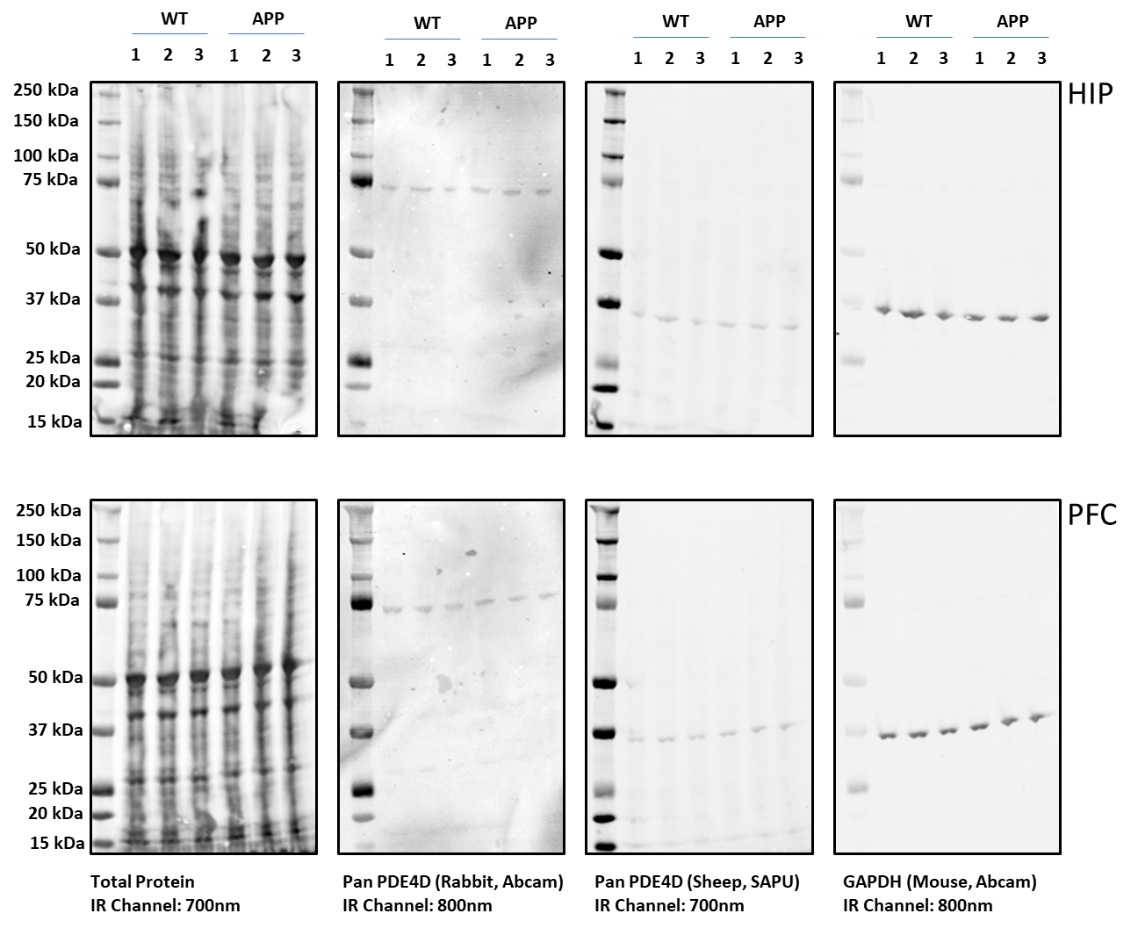
Supplementary Figure 1. Western blot scans used for quantification as depicted in Figure 2A.

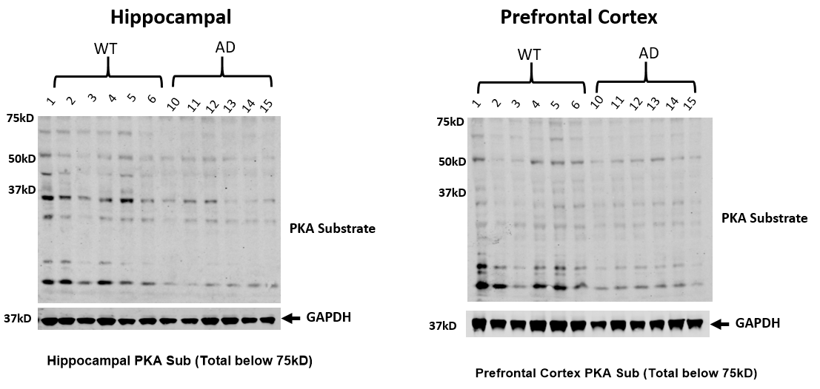
Supplementary Figure 2. Western blot scans used for quantification as depicted in Figure 2C.

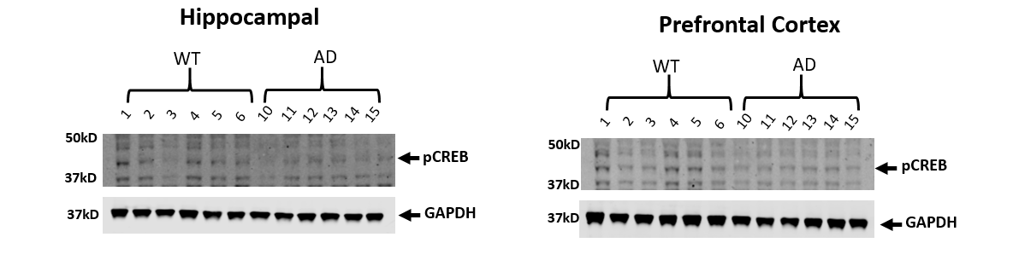
Supplementary Figure 3. Western blot scans used for quantification as depicted in Figure 2D.

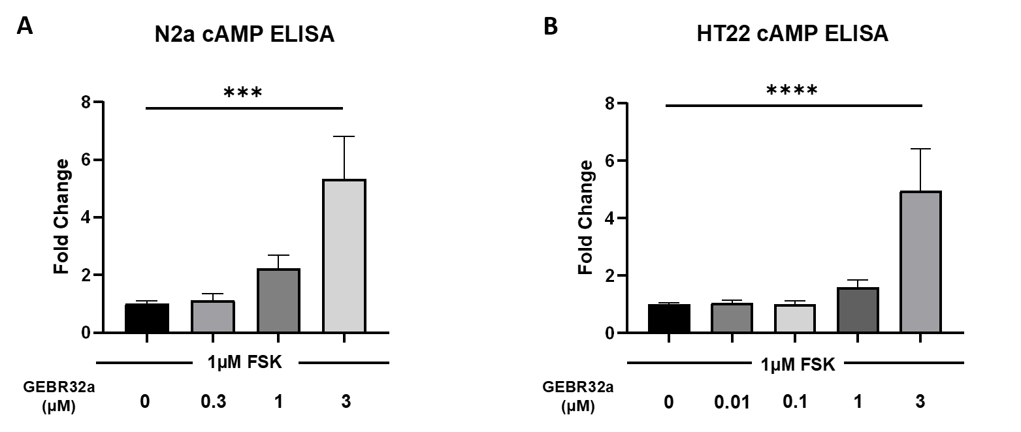

Supplementary Figure 4. Determination of intracellular cAMP concentration upon forskolin (FSK) stimulation to increase baseline cAMP levels, and concomitant GEBR32a treatment in N2a (A) and HT22 (B) cells (Dunnett’s post-hoc: ***P<0.001, ****P<0.0001; n≥4/condition). Data is presented as mean + SEM.

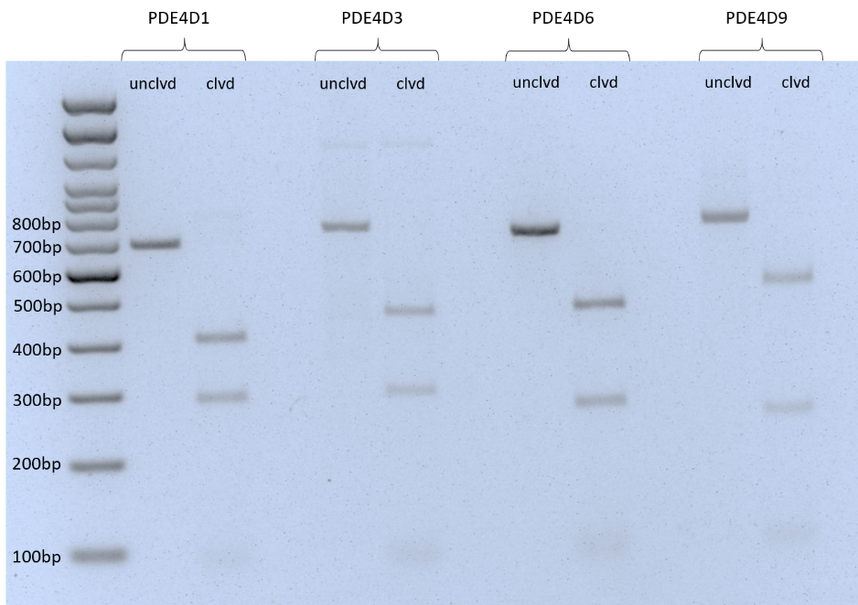

Supplementary Figure 5. A cell-free in vitro cleavage assay indicates that the sgRNA designed for PDE4D1, PDE4D3, PDE4D6, and PDE4D9 induces a double stranded break at the predicted site. sgRNAs for PDE4D1 and PDE4D6 were evaluated in this assay as these target (super)short PDE4D isoforms that did not show a biological effect in the neurite outgrowth assay. sgRNAs for PDE4D3 and PDE4D9 were evaluated as knocking down these long isoforms showed the largest effect in the neurite outgrowth assay. For each sgRNA, the figure shows an uncleaved (unclvd) fragment in lane 1, and two cleaved (clvd) fragments in lane 2. Fragment size is based on primer design as shown in supplementary table 3. The sgRNA itself appears slightly near the 130bp position.

