WD Repeat Domain 82 (Wdr 82) Facilitates Mouse iPSCs Generation by Interfering Mitochondrial Oxidative Phosphorylation and Glycolysis
Guina Cui^{1,2,3}, Jingxuan Zhou^{1,3}, Jiatong Sun^{1,2}, Xiaochen Kou², Zhongqu Su^{1,2}, Yiliang Xu^{1,2}, Tingjun Liu¹, Lili Sun¹, Wenhui Li¹, Xuanning Wu¹, Qingqing Wei¹, Shaorong Gao^{2,4*}，Kerong Shi^{1*}

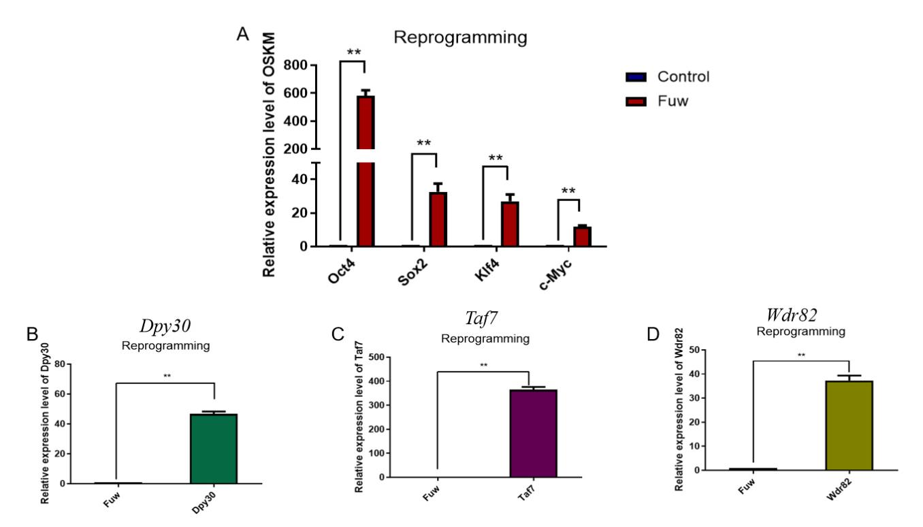

Figure S1. Yamanaka factors (Oct4, Sox2, Klf4, c-Myc, shown in panel A) and/or the three target factors (Dpy30 in panel B, Taf7 in panel C or Wdr82 in panel D) were detected to be overexpressing in cells at reprogramming Day 2 via RT-PCR method. * P <0.05 and ** P <0.01.

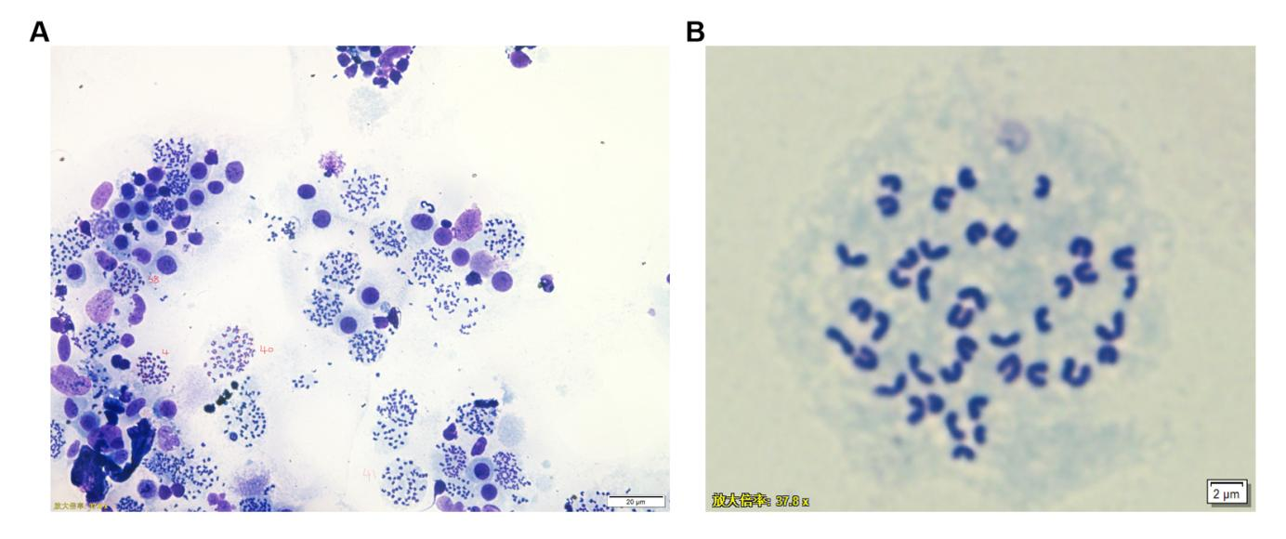
Figure S2. Reprsentative karyotype images of OSKM+Wdr82-iPS cell line, showing multiple cell metaphases with different number of chromosomes at both lower (A) and higher (B) magnifications, which indicates that the induced iPS clones have correct karyotype.

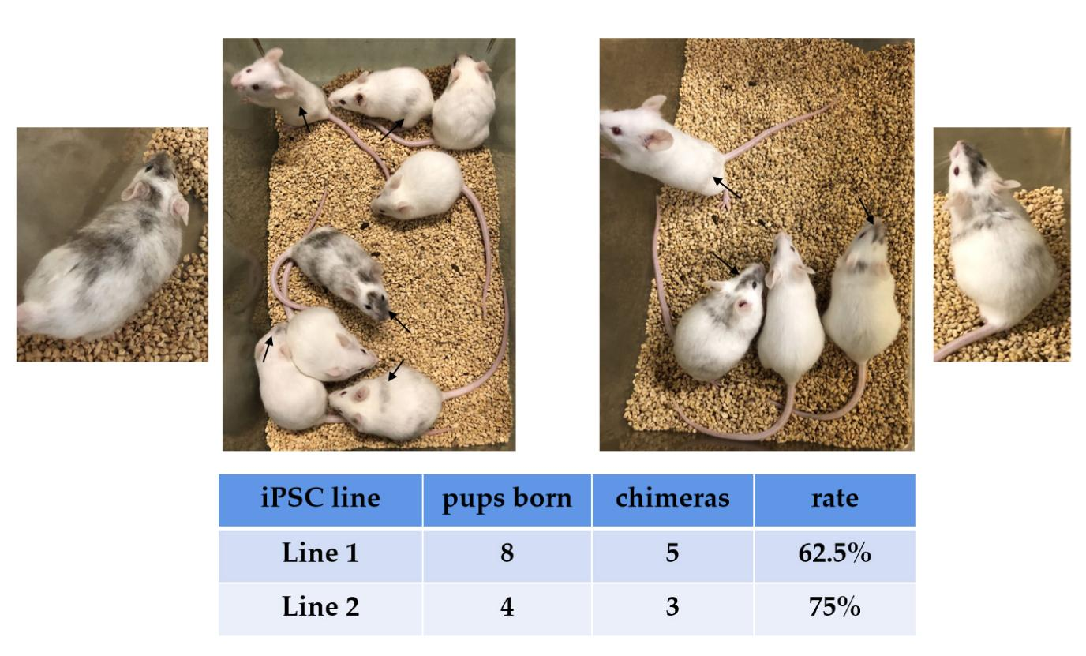
Figure S3. Representative images of adult chimeric mice (black arrows) from two OSKM+Wdr82-iPS cell lines (upper panel) and the corresponding rate of chimera formation (lower panel). The degree of chimerism can be evaluated by the white and black coat color.

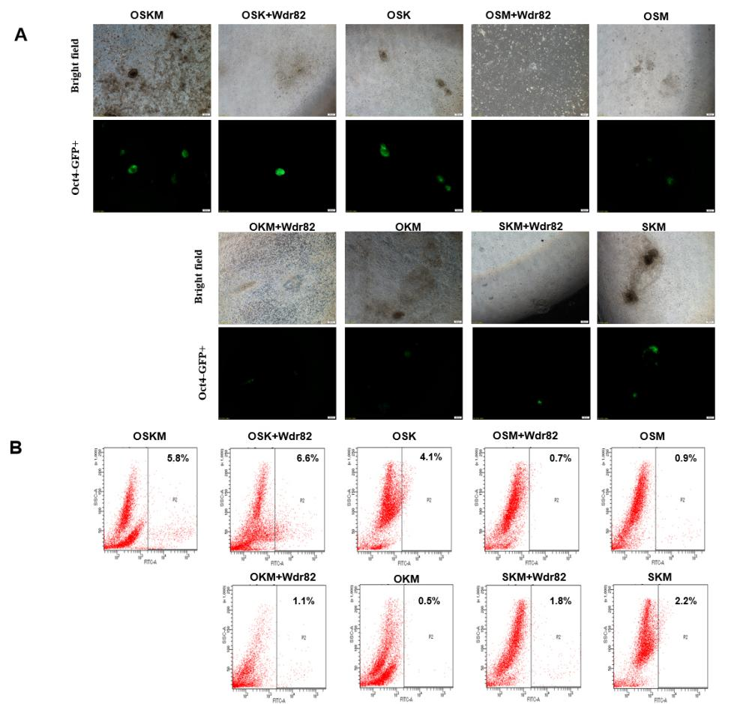
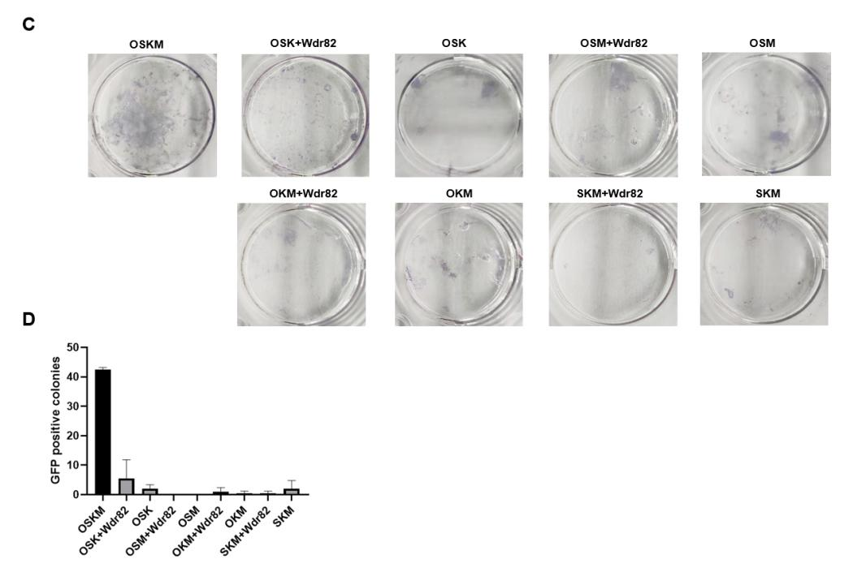
Figure S4. Wdr82 single-factor replacement reprogramming experiment
A. Clonal morphology under bright and fluorescence field upon Wdr82 replacement of each one of the four-factors, as well as OSKM control. The combination of kept factors with Wdr82 are indicated. B. Flow cytometric analysis of obtained Oct4+ cell percentage in each combination during reprogramming induction. C. AP+ staining results of each combination during reprogramming induction. D. Statistics of the number of Oct4-GFP+ clones during reprogramming induction.

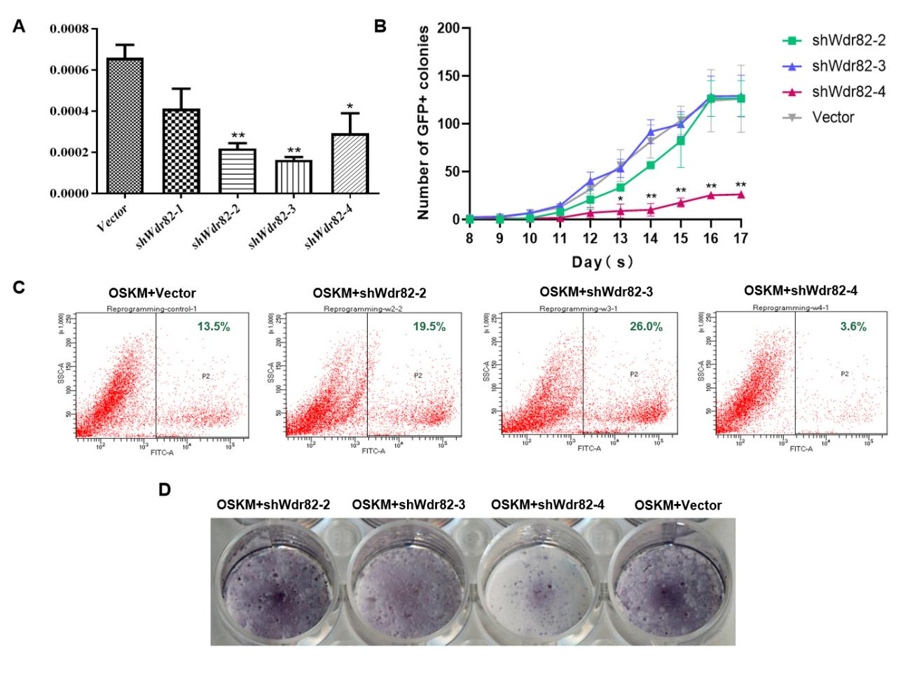
Figure S5. Knockdown of Wdr82 inhibits OSKM mediated reprogramming efficiency. A. The assessment of Wdr82 knockdown efficiency via RT-PCR method, showing that constructs of shWdr82-2, shWdr82-3 and shWdr82-4 had significant knockdown efficiency, good to use for their follwing assessments on reprogramming efficiency. B. Compared with the OSKM control (Vector), knockdown of Wdr82 (OSKM+shWdr82-4) significantly reduced the number of Oct4+ clones; C. The proportion of Oct4+ cells upon Wdr82 knockdown (OSKM+Wdr82-4) was significantly reduced, compared with the OSKM control. D. Compared with the OSKM control, AP+ clones number upon knockdown of Wdr82 (OSKM+Wdr82-4) is significantly reduced. * P <0.05 and ** P <0.01.

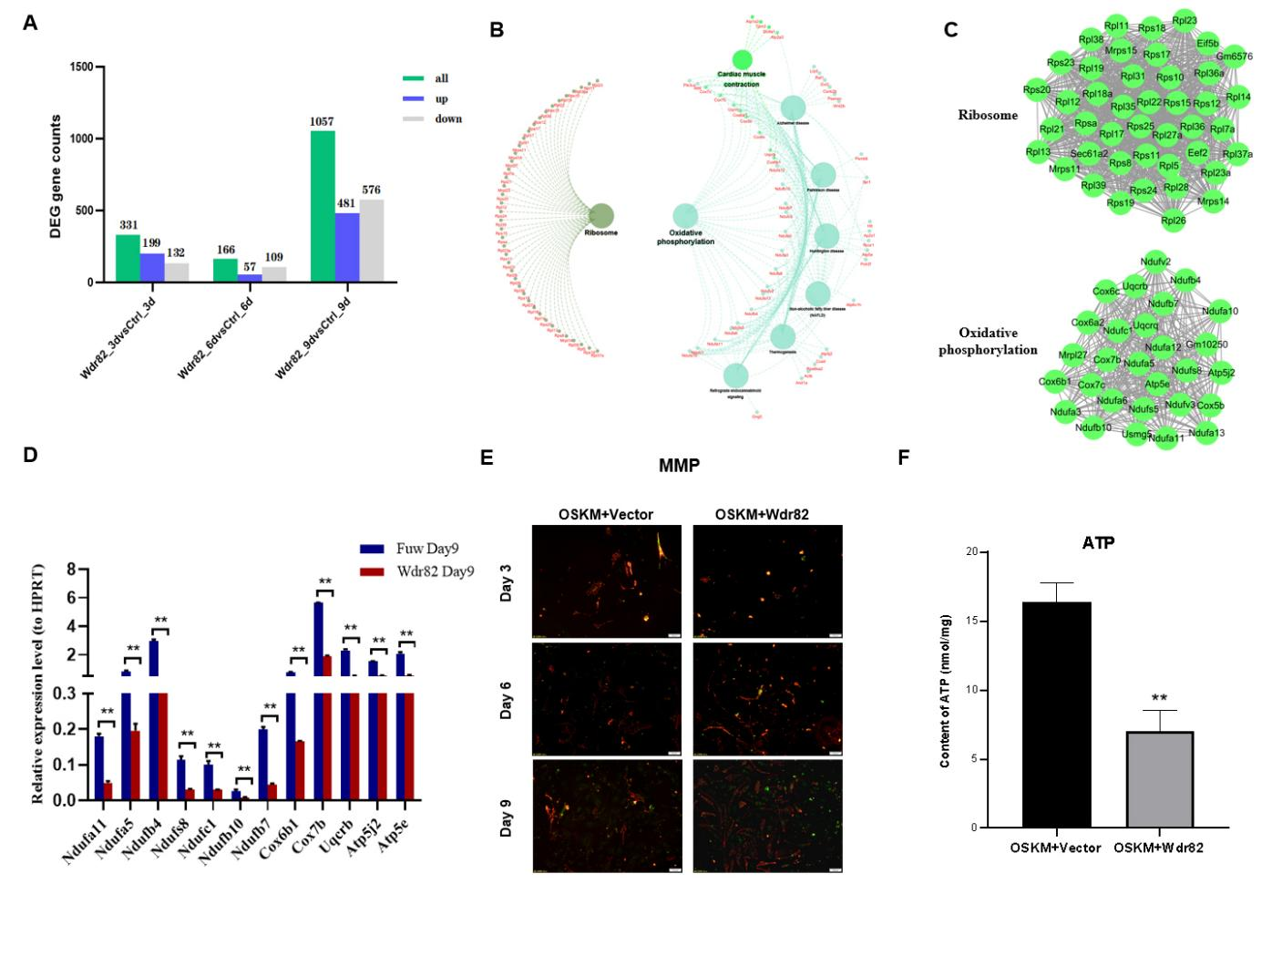
Figure S6. Transcriptome analysis of OSKM+Wdr82 cells during reprogramming induction. A. Number of differentially expressed genes were identified by comparing the OSKM+Wdr82 (Wdr82) with its corresponding OSKM control (Ctrl). Samples from reprogramming Day 9 got the most dramatic gene expression difference compared with that of OSKM control. B. The combined analysis of GO and KEGG pathways shows that they are mainly enriched in the biological pathways associated with ribosomes and oxidative phosphorylation. C. The protein-protein interaction network analysis indicates three highly interactive protein clusters at reprogramming Day9, including ribosomes and oxidative phosphorylation. D. RT-PCR results confirmed that the expression of oxidative phosphorylation-related genes upon Wdr82 overexpression (Wdr82) was significantly inhibited during reprogramming induction, compared to its vector control (Fuw). E. JC-1 mitochondrial membrane potential (MMP) assay indicates that cells enter into a lower level metabolic state upon Wdr82+OSKM treatment than OSKM only, during reprogramming, especially at Day 9. F. ATP production were significantly decreased at reprogramming Day 9. * P <0.05 and ** P <0.01.

A Reprogramming Day 6 B Reprogramming Day 9

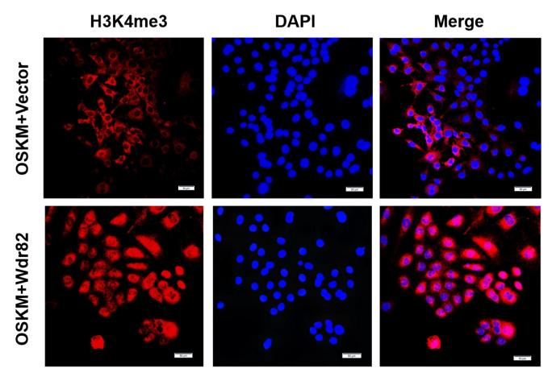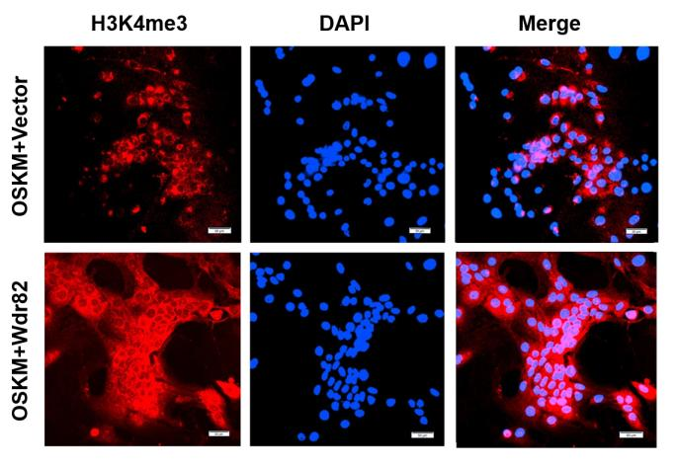
Figure S7. The addition of Wdr82 (OSKM+Wdr82) did enhanced the H3K4me3 level in reprogrammed cells at day 6 (A) and day 9 (B), confirming its recruitment role in the Setd1A/B complex, a H3K4me3 methyltransferase complex, during the reprogramming process.
Table S1. Sequences of primer pairs used to amplify and contrut the full-length cDNA plasmid specific to indicated genes
Construct Name (Gene) | Primer sequence (restriction enzyme cutting site)
Fuw-TetOn-Wdr82 | Forward (XbaI): GCTCTAGAATGAAGCTGACCGACAGCG  Reverse (EcoRI): CGGAATTCTCAGTCATCAATGGTGGGC
Fuw-TetOn-Dpy30 | Forward (EcoRI): CCGGAATTCATGGAGTCGGAGCAGATGCT  Reverse (BamHI): CGCGGATCCTCAATTTCGATCTTCAAACTGCG
Fuw-TetOn-Taf7 | Forward (EcoRI): CCGGAATTCATGAGTAAGAACAAAGACGATG  Reverse (BamHI): CGGGATCCTCACTTCTCCAGAAGTGATTC

Table S2. Sequences of DNA oligo used to contrut the plasmid specific Wdr82 knowdown
Construct name | Primer sequences
sh Wdr82-1 | Forward :TTGATCCAGAAGGGTTAATTTTCAAGAGAAATTAACCCTTCTGGATCATTTTTTC  Reverse :TCGAGAAAAAATGATCCAGAAGGGTTAATTTCTCTTGAAAATTAACCCTTCTGGATCAA
sh Wdr82-2 | Forward :TCAGCCAACACAGTCGTTTATTCAAGAGATAAACGACTGTGTTGGCTGTTTTTTC  Reverse :TCGAGAAAAAACAGCCAACACAGTCGTTTATCTCTTGAATAAACGACTGTGTTGGCTGA
sh Wdr82-3 | Forward :TACACTCGAAGCTTCATTTATTCAAGAGATAAATGAAGCTTCGAGTGTTTTTTTC  Reverse :TCGAGAAAAAAACACTCGAAGCTTCATTTATCTCTTGAATAAATGAAGCTTCGAGTGTA
sh Wdr82-4 | Forward:TACGGAGAGAGTGGTATAAATTCAAGAGATTTATACCACTCTCTCCGTTTTTTTC  Reverse:TCGAGAAAAAAACGGAGAGAGTGGTATAAATCTCTTGAATTTATACCACTCTCTCCGTA

Table S3. Primer sequences of OSKM gene expression assessment at reprogramming Day 2
Genes | Primer sequences
Total-Oct4 | Forward: TCTTTCCACCAGGCCCCCGGCTC  Reverse: TGCGGGCGGACATGGGGAGATCC
Total-Sox2 | Forward: TAGAGCTAGACTCCGGGCGATGA  Reverse: TTGCCTTAAACAAGACCACGAAA
Total-Klf4 | Forward:GCGGGAAGGGAGAAGACAC  Reverse:GGGGAAGACGAGGATGAAGC
Total-c-Myc | Forward:CAGCGACTCTGAAGAAGAGCA  Reverse:TTGTGCTGGTGAGTGGAGAC
qPCR-Dpy30 | Forward:ACCCTCACTCTGAGTACGGG  Reverse:CCACCTTCTGTTTCGATGACTT
qPCR-Taf7 | Forward:AACAAAGACGATGCGCCTCAT  Reverse:CAGGTTGACATGCCCAGACT
qPCR-Wdr82 | Forward:GACCTCATCAGATACACCCATGC  Reverse:GTCATGCAAGGACAAGTAACGAA
Hprt | Forward: CACAGGACTAGAACACCTGC  Reverse: GCTGGTGAAAAGGACCTCT
Gapdh | Forward: TGGCAAAGTGGAGATTGTTGCC  Reverse: AAGATGGTGATGGGCTTCCCG

Table S4. RT-qPCR primer sequences used for expression assessment of pluripotency genes
Genes | Primer sequences
Endogenous-Oct4 | Forward: TCTTTCCACCAGGCCCCCGGCTC  Reverse: TGCGGGCGGACATGGGGAGATCC
Endogenous-Sox2 | Forward: TAGAGCTAGACTCCGGGCGATGA  Reverse: TTGCCTTAAACAAGACCACGAAA
Endogenous-Klf4 | Forward: GCGAACTCACACAGGCGAGAAACC  Reverse: TCGCTTCCTCTTCCTCCGACACA
Endogenous-c-Myc | Forward: TGACCTAACTCGAGGAGGAGCTGGAATC  Reverse: AAGTTTGAGGCAGTTAAAATTATGGCTGAAGC
Nanog | Forward: AGGGTCTGCTACTGAGATGCTCTG  Reverse: CAACCACTGGTTTTTCTGCCACCG
Rex1 | Forward: ACGAGTGGCAGTTTCTTCTTGGGA  Reverse: TATGACTCACTTCCAGGGGGCACT
Utf1 | Forward: GGATGTCCCGGTGACTACGTCTG  Reverse: GGCGGATCTGGTTATCGAAGGGT

Table S5. Primer sequences of marker genes specifically expressed
in differentiated embryonic germ layers
Embryonic Germ Layer | Marker Genes | Primer sequences
Ectoderm | Fgf5 | Forward: AACTCCATGCAAGTGCCAAAT  Reverse: CGGACGCATAGGTATTATAGCTG
Ectoderm | Kdr | Forward: TTTGGCAAATACAACCCTTCAGA  Reverse: GCAGAAGATACTGTCACCACC
Mesoderm | Nkx2.5 | Forward: GACAAAGCCGAGACGGATGG  Reverse: CTGTCGCTTGCACTTGTAGC
Mesoderm | Myf5 | Forward: AAGGCTCCTGTATCCCCTCAC  Reverse: TGACCTTCTTCAGGCGTCTAC
Mesoderm | MyoD | Forward: CCACTCCGGGACATAGACTTG  Reverse: AAAAGCGCAGGTCTGGTGAG
Endoderm | Sox17 | Forward: GATGCGGGATACGCCAGTG  Reverse: CCACCTCGCCTTTCACCTTTA
Endoderm | Gata4 | Forward: CCCTACCCAGCCTACATGG  Reverse: ACATATCGAGATTGGGGTGTCT
Endoderm | Sox7 | Forward: CAAGATGCTGGGTAAGTGCG  Reverse: CCTTTCCGAACAGCGTTGTC
Trophoblast | Eomes | Forward: GAGCTTCAACATAAACGGACTCAA  Reverse: CGGCCAGAACCACTTCCA
Trophoblast | Cdx2 | Forward: CAAGGACGTGAGCATGTATCC  Reverse: GTAACCACCGTAGTCCGGGTA

Table S6. Sequences of primer pairs used to confirmation the expression difference of OXPHOS genes during reprogramming process
Gene Name | Primer sequences
Ndufa11 | Forward: GGTGAAGCGGTTCTTTGAATCT  Reverse: GAGCCGATTATGCCGCAAATG
Ndufa5 | Forward: ATGGCGGGCTTGCTGAAAA  Reverse: GCTGCATGTTTAGGAAAGTGCTT
Ndufb4 | Forward: CTTGATTCGCTGGACCTATGC  Reverse: GGAGTGGGCCTGAAATTAGGA
Ndufs8 | Forward: AGTGGCGGCAACGTACAAG  Reverse: TCGAAAGAGGTAACTTAGGGTCA
Ndufc1 | Forward: GTAGTGCTGCGCTCGTTTTC  Reverse: CCAACCAGTTAGGTTTGGCAT
Ndufb10 | Forward: GATTCTTGGGACAAGGATGTGT  Reverse: CCTTCGTCAAGTAGGTGATGGG
Ndufb7 | Forward: CGGCGCTATCTGTGGGATG  Reverse: CTGTCTCGCTTGCACTTCAG
Cox6b1 | Forward: ACTACCTGGACTTCCACCG  Reverse: ACCCATGACACGGGACAGA
Cox7b | Forward: TTGCCCTTAGCCAAAAACGC  Reverse: TCATGGAAACTAGGTGCCCTC
Uqcrb | Forward: GGCCGATCTGCTGTTTCAG  Reverse: CATCTCGCATTAACCCCAGTT
Atp5j2 | Forward: TGCCGAGCTGGATAATGATGC  Reverse: ACCATGCTAATCCCCGAGATG
Atp5e | Forward: CAGGCTGGACTCAGCTACATC  Reverse: GTTCGCTTTGAACTCGGTCTT
Hk2 | Forward: TGATCGCCTGCTTATTCACGG  Reverse: AACCGCCTAGAAATCTCCAGA
Pk2 | Forward: GCCGCCTGGACATTGACTC  Reverse: CCATGAGAGAAATTCAGCCGAG
Pfk | Forward: TGTGGTCCGAGTTGGTATCTT  Reverse: GCACTTCCAATCACTGTGCC
Cpt1α | Forward: CTCCGCCTGAGCCATGAAG  Reverse: CACCAGTGATGATGCCATTCT
Cpt2 | Forward: CAGCACAGCATCGTACCCA  Reverse: TCCCAATGCCGTTCTCAAAAT
Ldhα | Forward: TGTCTCCAGCAAAGACTACTGT  Reverse: GACTGTACTTGACAATGTTGGGA

