SUPPLEMENTARY TABLES

Supplementary Table 1
Table of the echocardiographic measurements and post-mortem gravimetric heart analyses after 6 weeks of treatment with doxorubicin 18 mg/kg in c57BL6J and Tg-DN-MST1 mice. Data represent mean ± SEM (n = 7-11 independent samples).
Supplementary Table 2
Table of the echocardiographic measurements after 6 weeks of treatment with doxorubicin 18 mg/kg and/or XMU-MP-1 3 mg/kg/week. Data represent mean ± SEM (n = 8–10 independent samples).

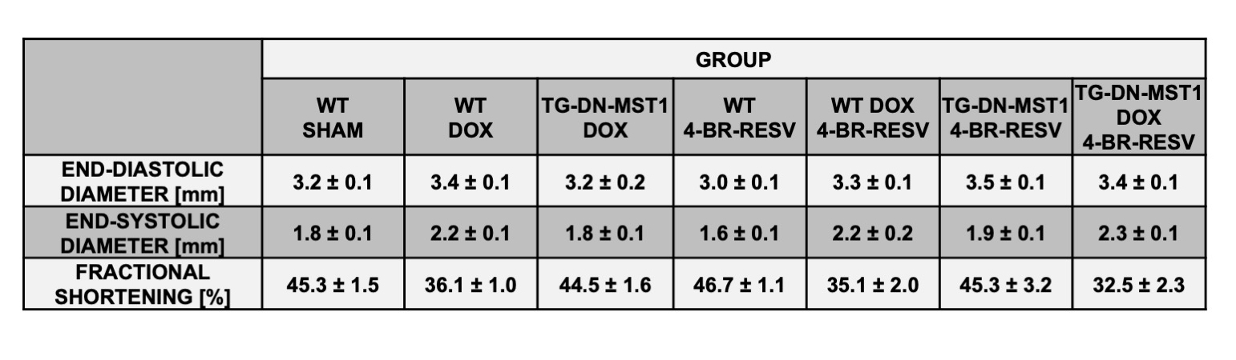
Supplementary Table 3
Table of the echocardiographic measurements and post-mortem gravimetric heart analyses after 6 weeks of treatment with doxorubicin 18 mg/kg and/or 4’-Br-Resveratrol 30 mg/kg/week. Data represent mean ± SEM (n = 4–7 independent samples).

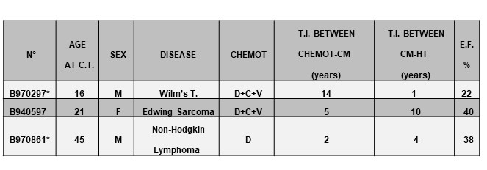

Supplementary Table 4
Clinical data table of the donor patients treated with doxorubicin whose specimens were harvested after heart transplantation for the immunofluoremetric study performed. (H.Tx.= Heart Transplantation; CHEMOT.=Chemotherapy; E.F.=Ejection Fraction; T.I.=Time Interval; *= Radiation therapy D=Doxorubicin; C=Cyclophosphamide=Vincristine.
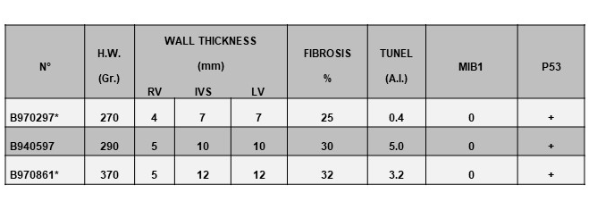
Supplementary Table 5
Late-onset cardiomyopathy pathological data table of the donor patients treated with doxorubicin whose specimens were harvested after heart transplantation for the immunofluoremetric study performed. (* Radiation Therapy; RV= right ventricle; LV= left ventricle; IVS= interventricular septum)

