Supplementary Table S1: List of sequence variants for each TRPC6 mutant and primer sequence
Plasmid Sequence variant 5’ → 3’
TRPC6-WT-YFP | Sequence from (Addgene#21084)
TRPC6-P112Q-YFP | ctttttggatgcagctgaatatggtaaTatTcAagtggtgcggaagatgttagaaga
TRPC6-G757D-YFP | tctggttttcctactttgaggaggAcagaacacttcctgtacccttcaatct
TRPC6-V691Kfs* | ttctgggctatatttggactttctgaagtgaaatcaAAGgtga
Sequencing
Primer name Sequence 5’ → 3’
TRPC6_P112Q_seq_fwd | TGATCGCTCCACAAGCCTATC
TRPC6_G757D_seq_fwd | CTACTCCTACTACATTGGTGC
M13-rev | CCCAGTCACGACGTTGTAAAACG
TRPC6_seq_rv | CTGCCAACTGTAGGGCATTCT

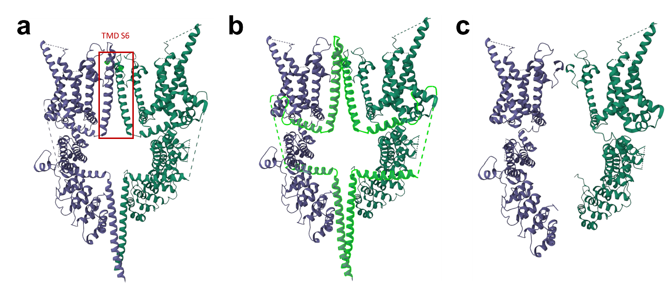
Supplementary Figure 1: Tridimensional Cryo-EM structure of tetrameric TRPC6 (PDB: 6UZ8). a) Two subunits of wild-type TRPC6 indicating the transmembrane domain (TMD) S6 with highlighted position of V691Kfs* in bright green. b) The truncation results in the removal of the highlighted helices. c) Truncated TRPC6 channel with loss of TMD S6.

