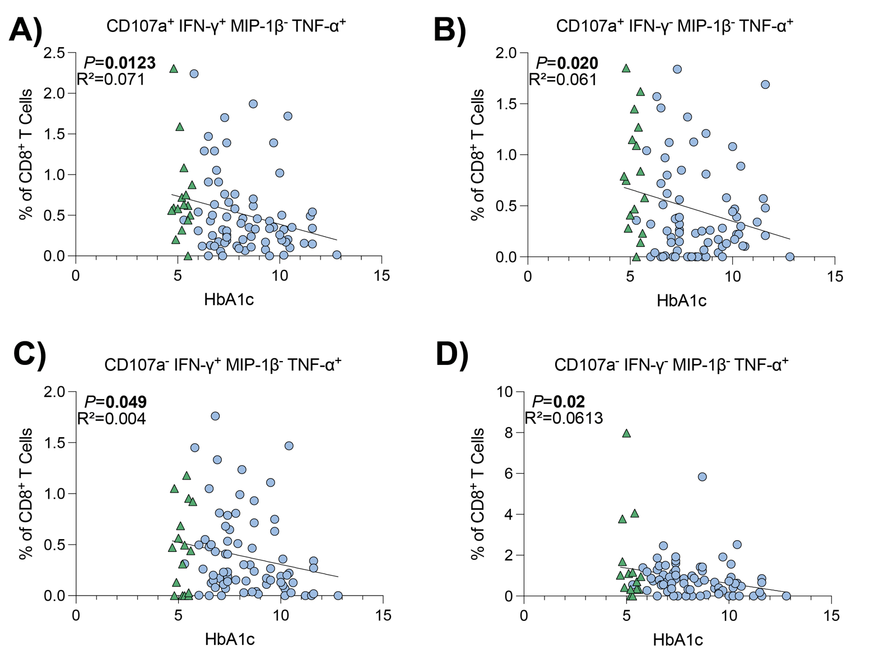
Supplementary Figure 1: TNF-α expression was affected in multiple polyfunctional CD8⁺ T cell populations.
CD8⁺ T cells were stimulated for 18 hours using anti-CD3/anti-CD28 coated beads. Results are presented as the frequency of CD8⁺ T cells expressing the select markers, with background staining subtracted. Data points represent individual donors (n=88). Statistical significance was determined using simple linear regression, with significant P values displayed. A-D) Donors without diabetes are represented by green triangles. Donors with diabetes are represented by blue circles.

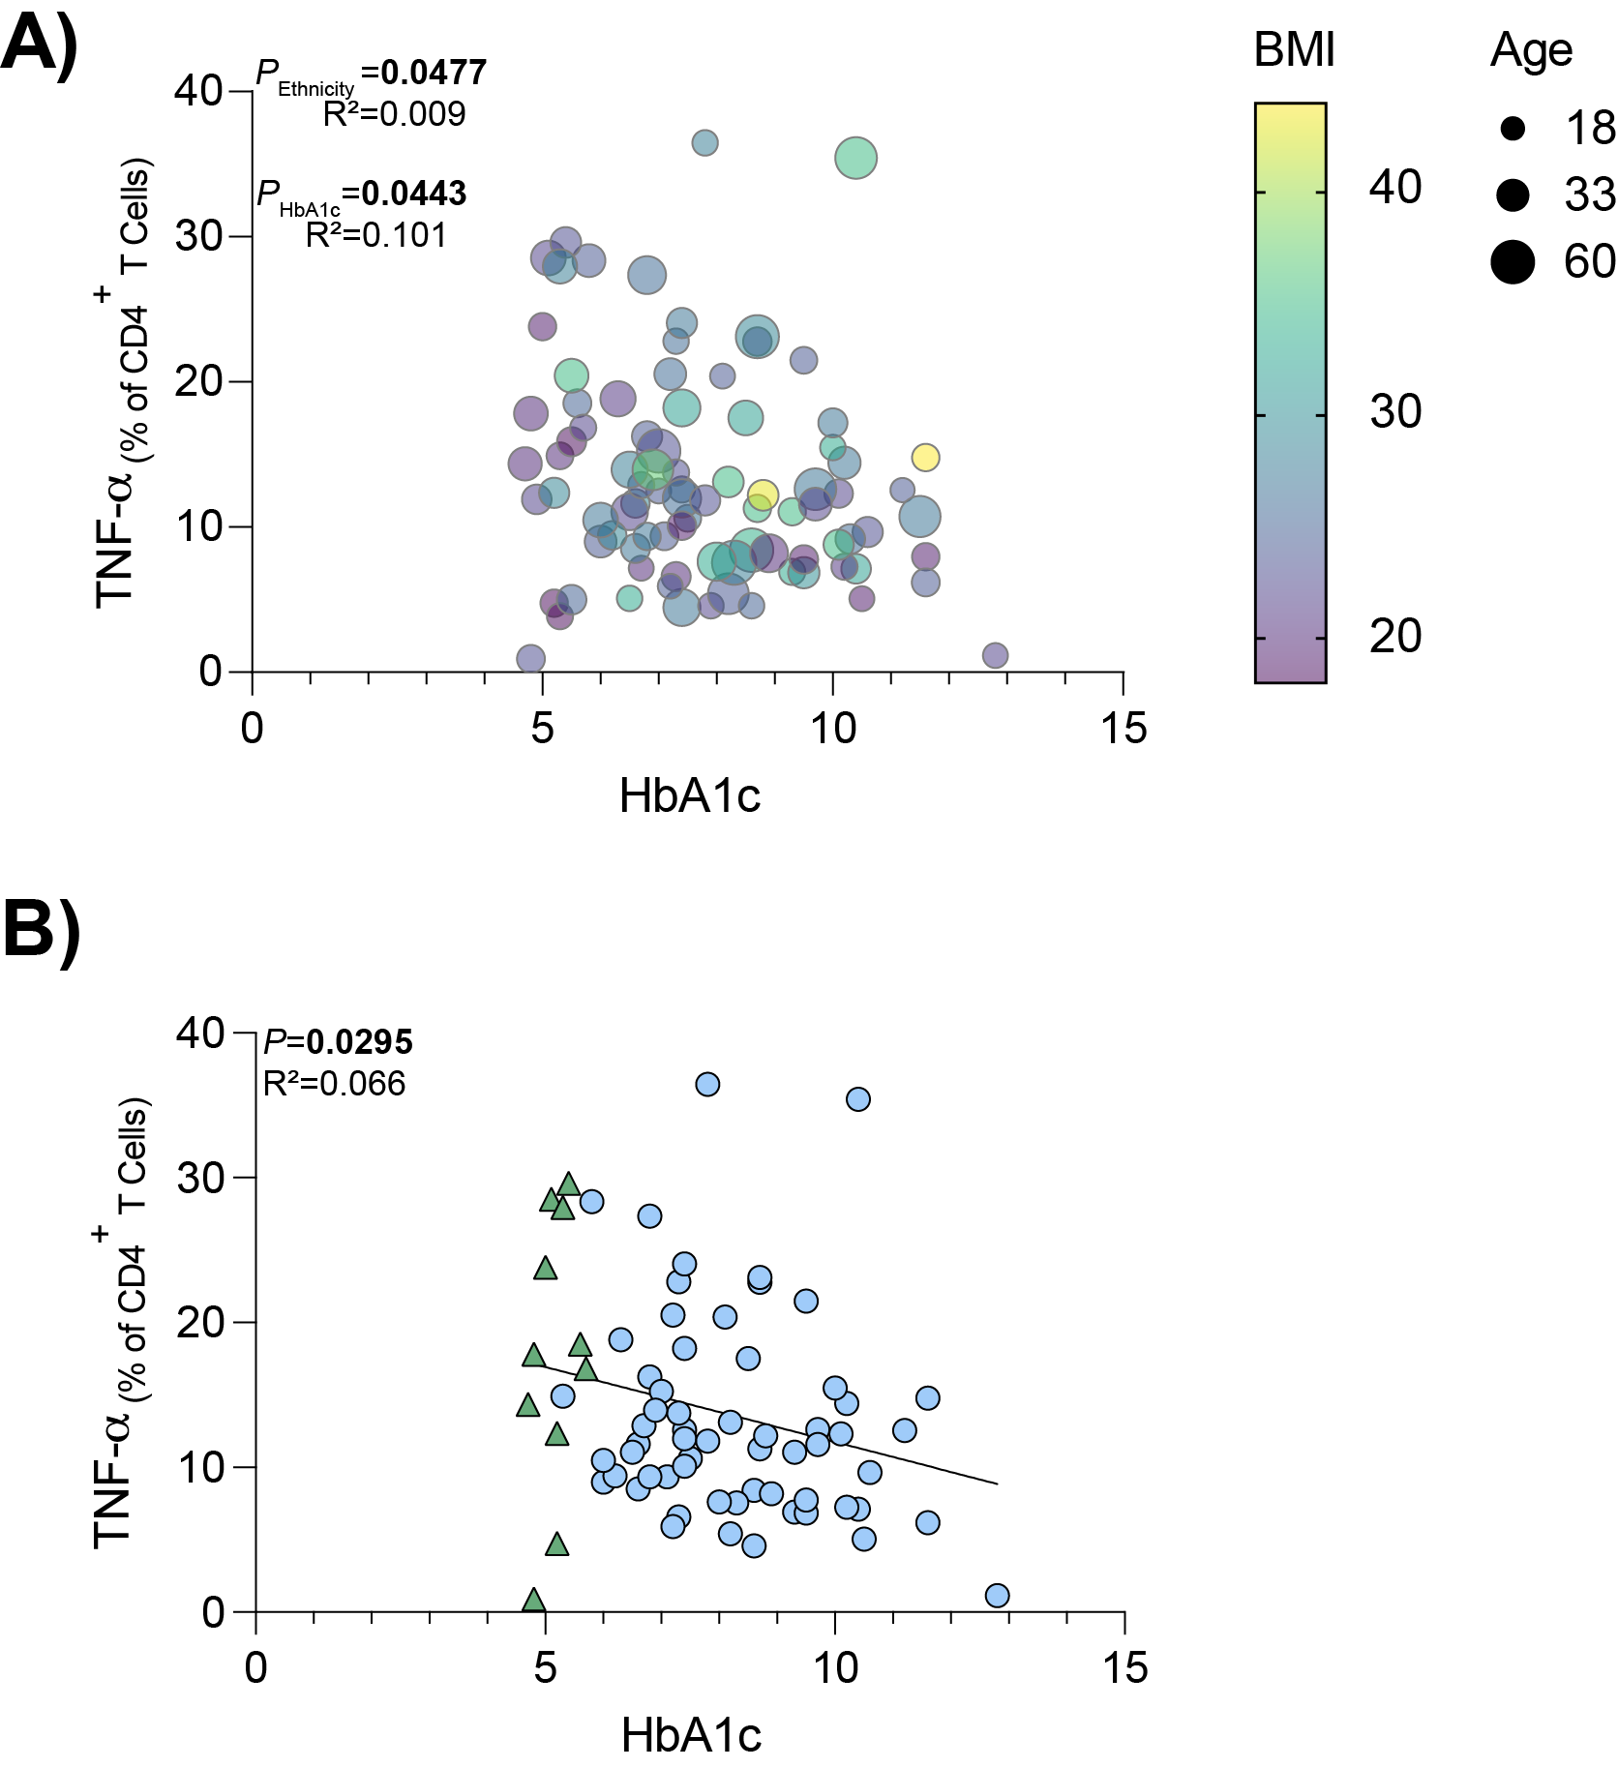
Supplementary Figure 2: Reduced TNF-α expression associated with increasing HbA1c was also observed in CD4⁺ T cells.
CD4⁺ T cells were stimulated for 18 hours using anti-CD3/anti-CD28 coated beads. Results are presented as the frequency of CD8⁺ T cells expressing TNF-α, with background staining subtracted. A) Data points represent individual donors (n=88). Statistical significance was determined using multiple variable regression analysis, where input variables were age, sex, BMI, HbA1c and ethnicity, with significant P values displayed. B) Relationship between HbA1c and TNF-α produced by CD4⁺ T cells in Caucasian donors. Each data point represents an individual donor (n=73). Statistical significance was determined using simple linear regression. Donors without diabetes are represented by green triangles. Donors with diabetes are represented by blue circles.

