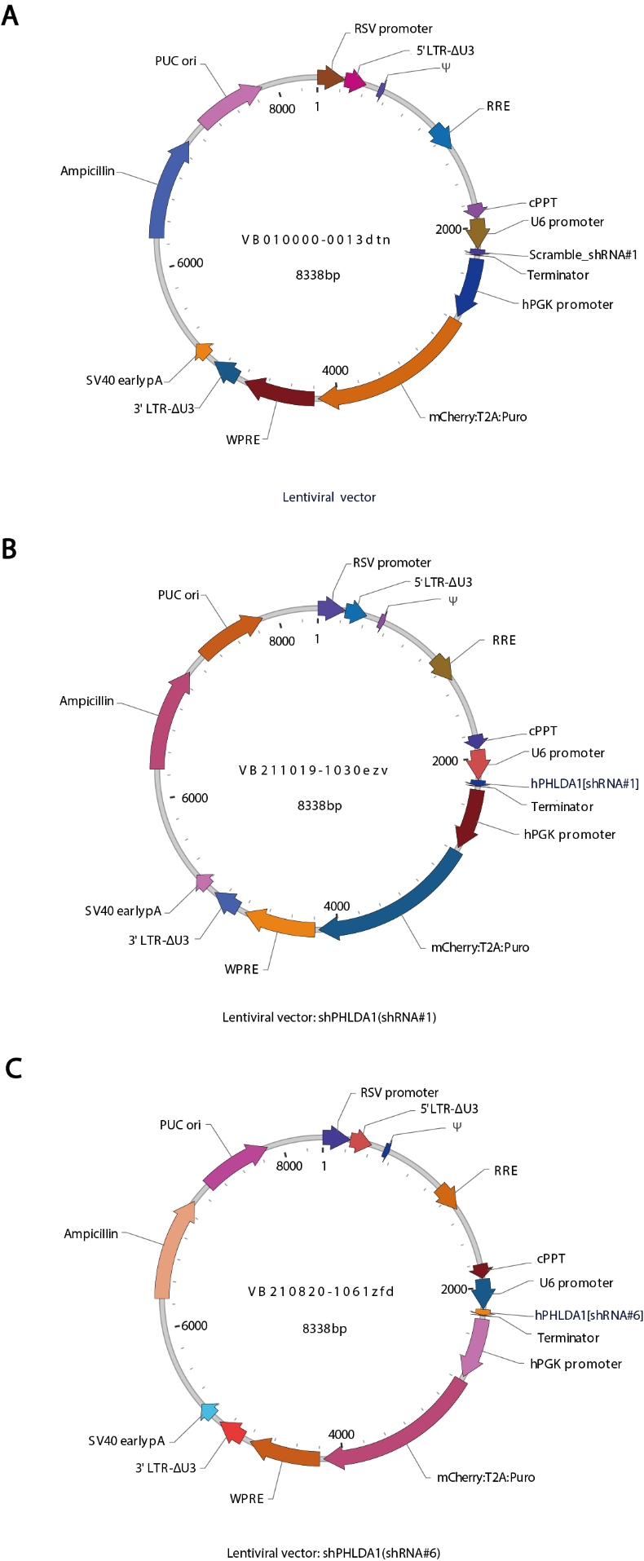
Supplementary Fig. 1 Plasmid map of lentiviral vector-transduced retinal organoids. A An empty lentiviral vector packed with non-targeting human shRNA. B-C Lentiviral vectors for targeted knockdown of PHLDA1.
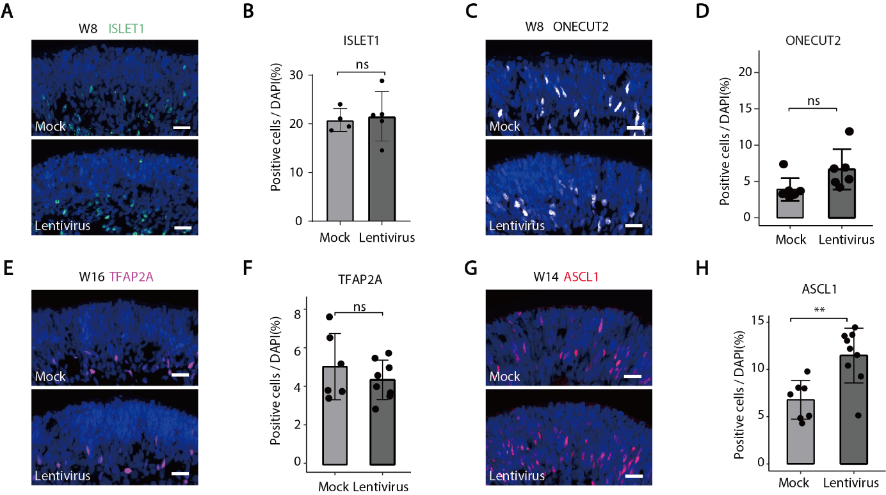
Supplementary Fig. 2 The effect of lentiviral vectors infection on other retinal cell types. A-B Lentivirus infection did not cause significant changes in the number of (ISLET1⁺) retinal ganglion cells in retinal organoids. Scale bars, 20 μm. C-D Lentivirus infection did not cause significant changes in (ONECUT2⁺) horizontal cells. Scale bars, 20 μm. E-F Lentivirus infection did not cause significant changes in (TFAP2A⁺) amacrine cells. Scale bars, 20 μm. G-H The numbers of (ASCL1⁺) neurogenic retinal progenitor cells were significantly increased after infection of lentiviral vectors. Scale bars, 20 μm.

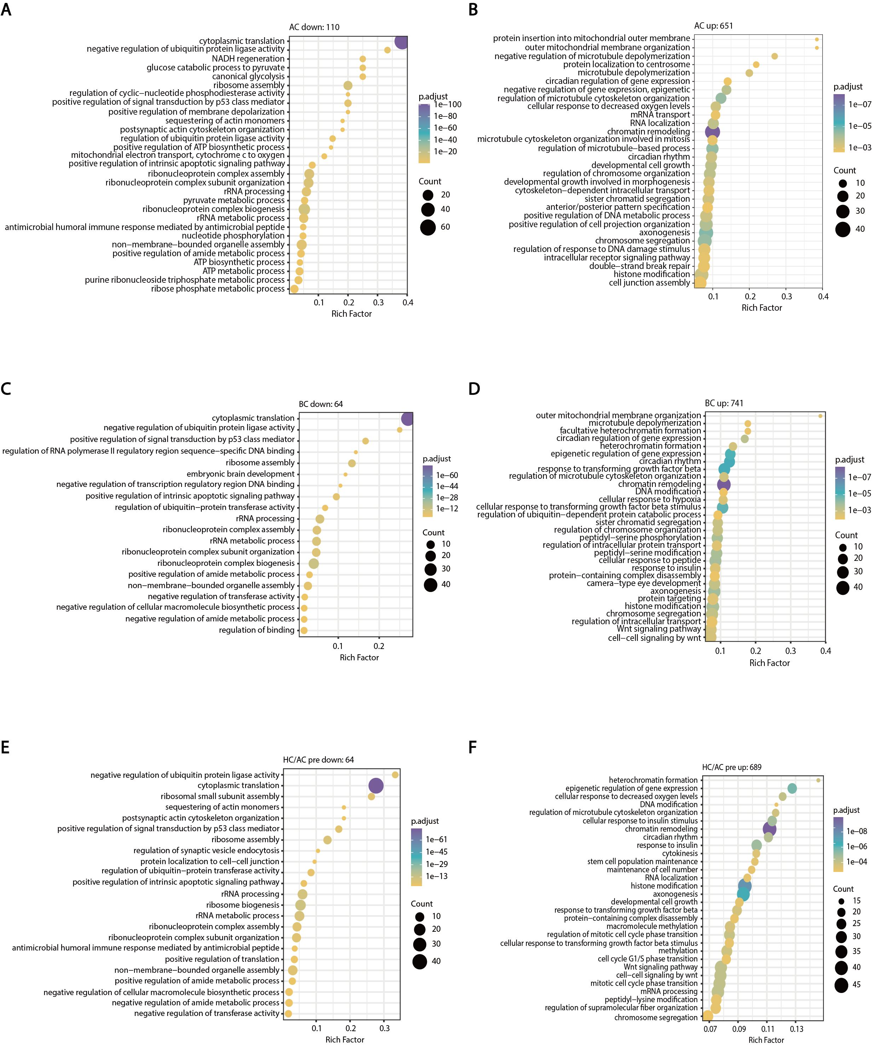
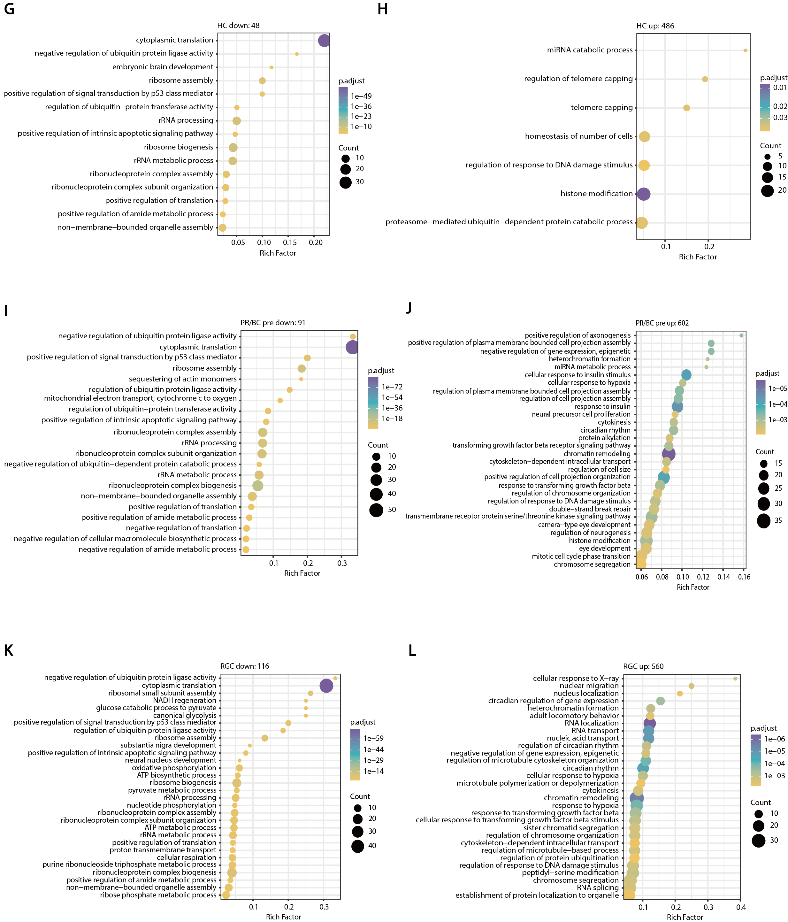

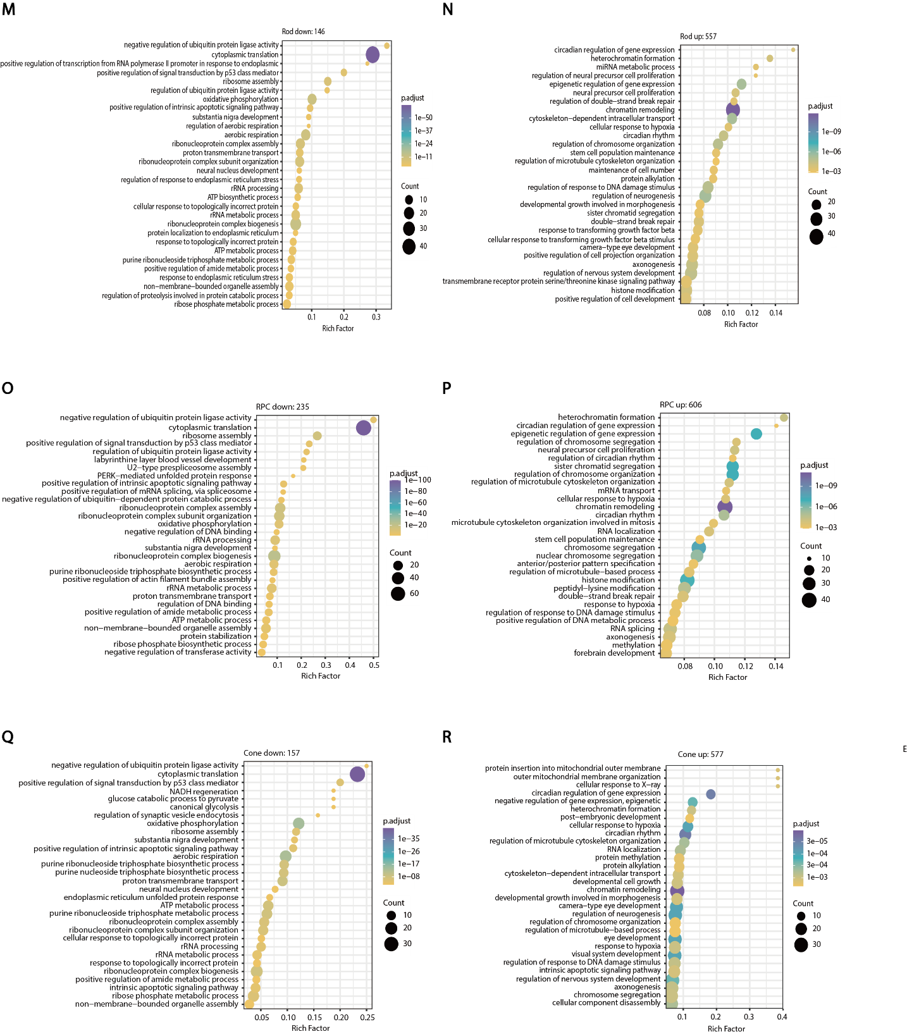
Supplementary Fig. 3 GO analysis of differential gene expression in different cells of W14 retinal organoids after transfection with lentiviral vectors. A-B GO analysis of 110 genes downregulated and 651 genes upregulated in amacrine cells after infection with lentiviral vectors. C-D GO analysis of 64 genes downregulated and 741 genes upregulated in bipolar cells after infection with lentiviral vectors. E-F GO analysis of 64 genes down-regulated and 689 genes up-regulated in horizontal/amacrine precursor cells after infection with lentiviral vectors. G-H GO analysis of 48 genes down-regulated and 486 genes up-regulated in horizontal progenitor cells after infection with lentiviral vectors. I-J GO analysis of 91 genes down-regulated and 602 genes up-regulated in photoreceptor/bipolar cell precursor cells after infection with lentiviral vectors. K-L GO analysis of 116 genes down-regulated and 560 genes up-regulated in retinal ganglion cells after infection with lentiviral vectors. M-N GO analysis of 146 genes down-regulated and 557 genes up-regulated in retinal rod cells after infection with lentiviral vectors. O-P GO analysis of 235 genes down-regulated and 606 genes up-regulated in retinal progenitor cells after infection with lentiviral vectors. Q-R GO analysis of 157 genes down-regulated and 557 genes up-regulated in cone cells after infection with lentiviral vectors.

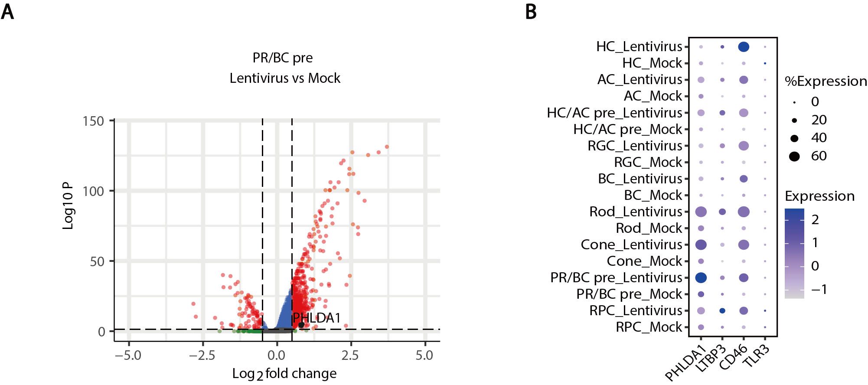
Supplementary Fig. 4 Infection of W14 retinal organoids with lentiviral vector leads to upregulation of PHLDA1. A Volcano plot of differential gene distribution of photoreceptor /bipolar precursor cells after infection with lentivirus. B PHLDA1 expression after lentivirus infection in different cells of retinal organoids.

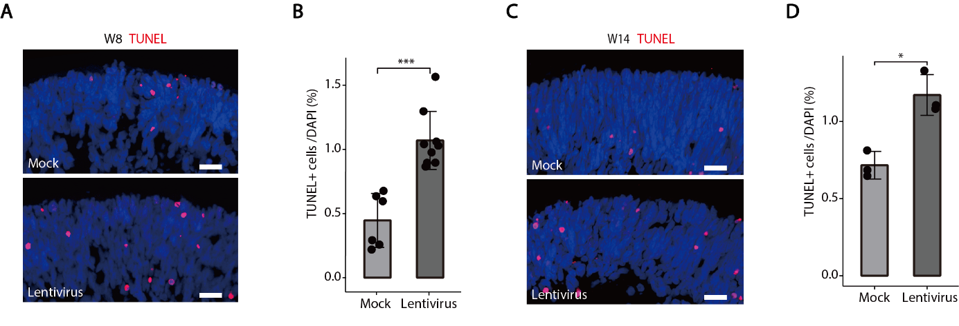
Supplementary Fig. 5. Lentivirus infection of retinal organoids results in slight upregulation of apoptotic cells. A-B Apoptosis cells were increased in W8 retinal organoids after infection with lentivirus. Scale bars, 20 μm. C-D Lentivirus vectors increased the number of apoptotic cells in W14 retinal organoids. Scale bars, 20 μm.

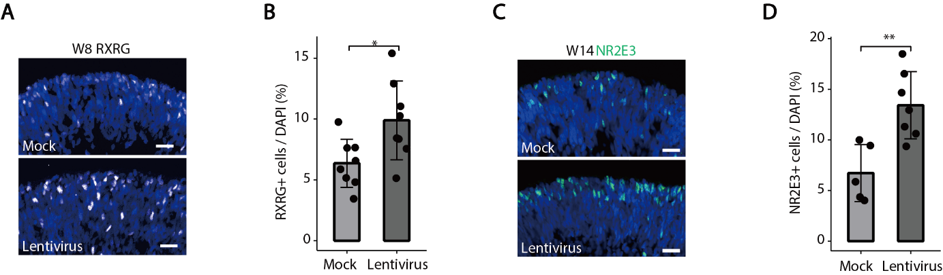
Supplementary Fig. 6 Infection of retinal organoids with lentiviral vectors leads to the increase of RXRG⁺ cells. A-B The numbers of RXRG⁺ cone cells were significantly increased after infection of lentivirus. Scale bars, 20 μm. C-D The numbers of NR2E3⁺ rod cells were significantly increased after infection of lentivirus. Scale bars, 20 μm.

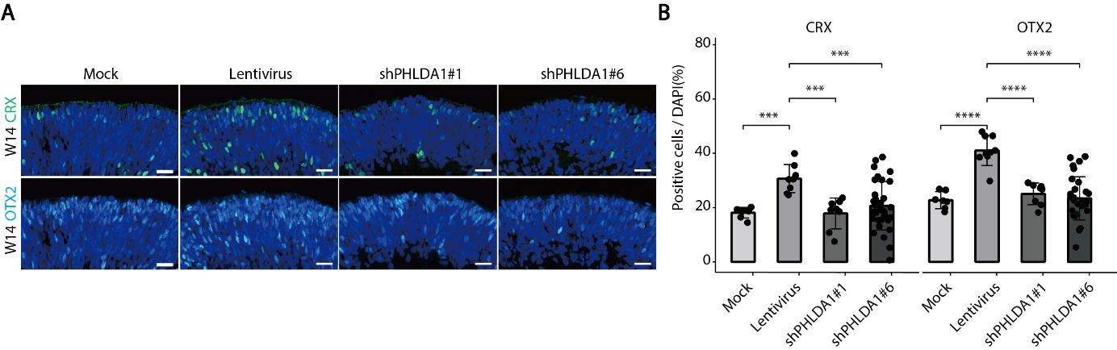
Supplementary Fig. 7 Effects of PHLDA1 on photoreceptor differentiation. A-B Immunofluorescence showed that knockdown of PHLDA1 in retinal organoids reduced the proportion of lentiviral-induced CRX⁺ and OTX2⁺ photoreceptor cells. Scale bars, 20 μm.
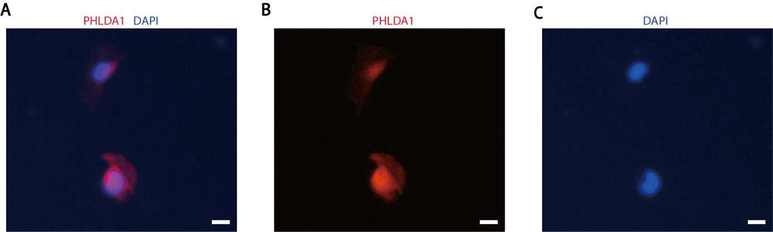
Supplementary Fig. 8 PHLDA1 is distributed in the nucleus of Mesenchymal progenitor cells (MPCs). A-C Subcellular localization of PHLDA1 in hESC differentiated MPCs (P6). Scale bars, 20 μm.

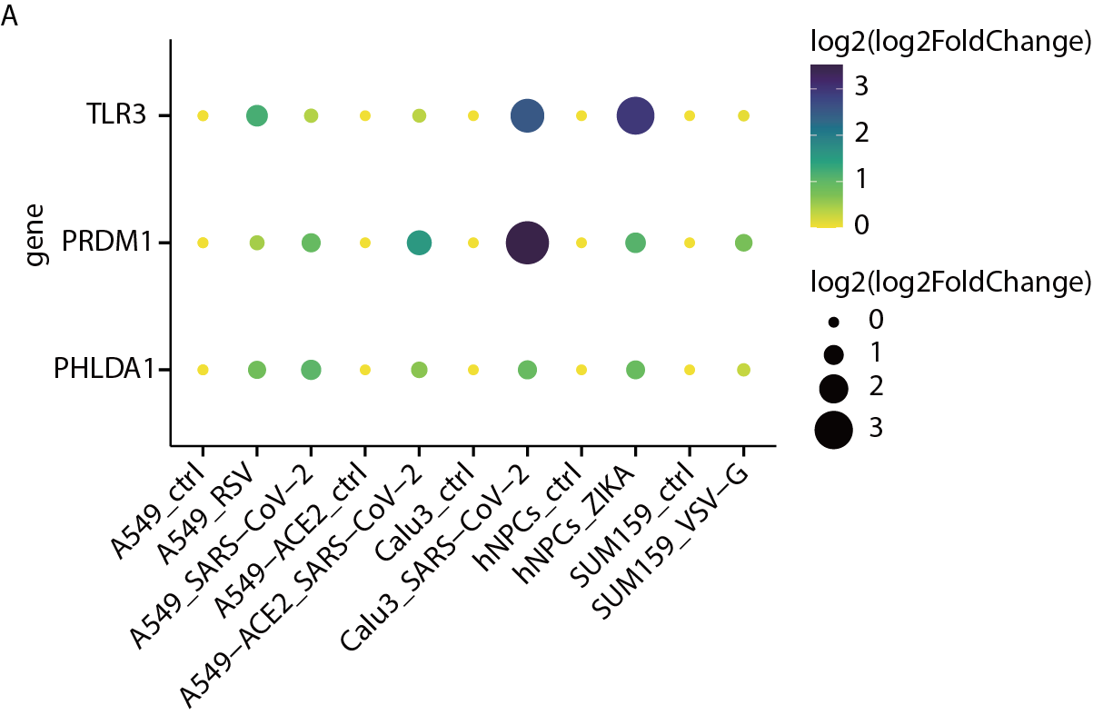
Supplementary Fig. 9 Differential changes of PRDM1 in transcription levels after infection with different viruses. A Transcriptome sequencing showed that compared with the mock group, transfection with SARS-Cov-2, RSV, ZIKA, and VSV-G viruses resulted in significantly up-regulated expression of PHLDA1 and PRDM1 mRNA.
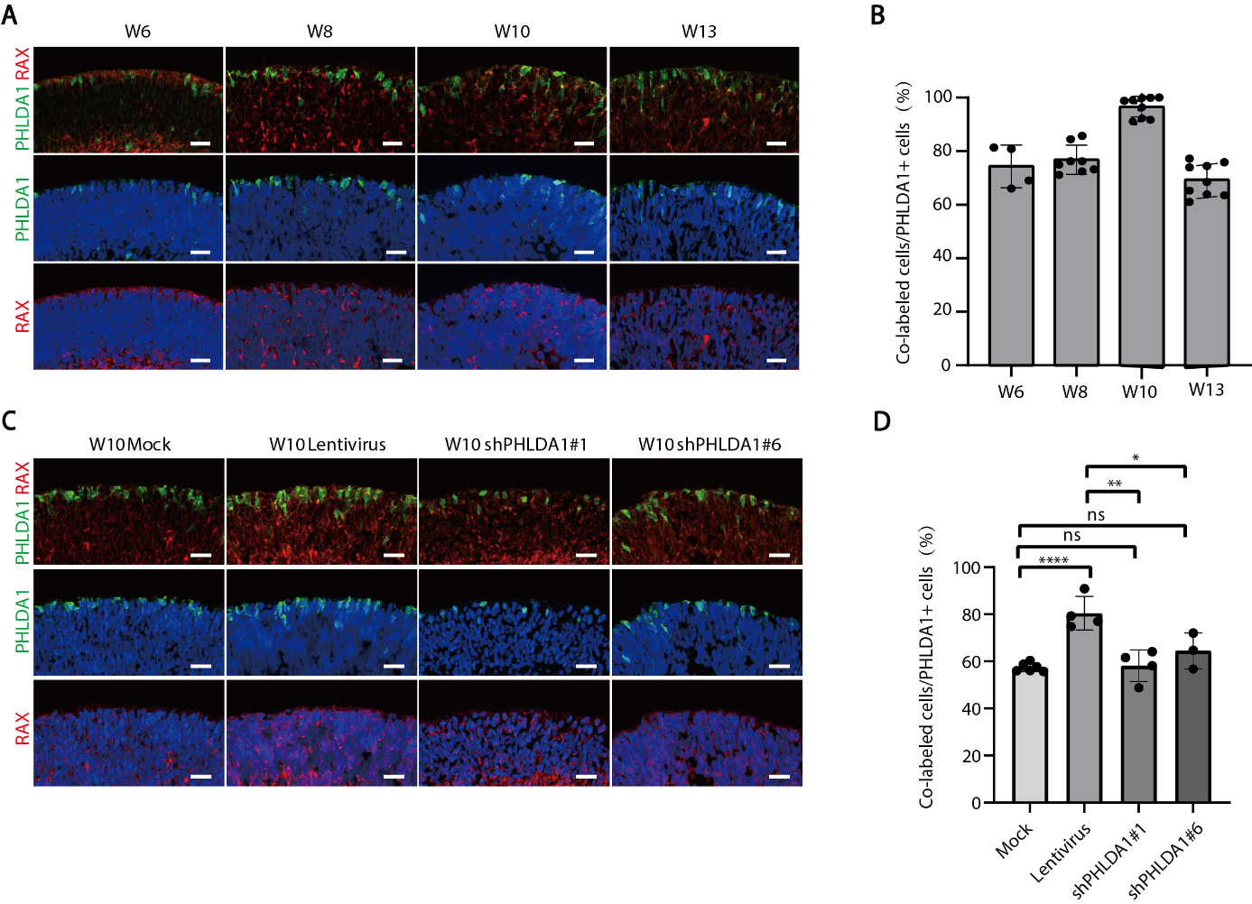
Supplementary Fig. 10 PHLDA1 regulate the expression of RAX. A-B Immunofluorescence co-localization staining results show that PHLDA1 is predominantly co-localized with RAX in retinal organoids at different developmental stages. Scale bars, 20 μm. C-D Lentivirus-induced RAX⁺ cell number in organoids was reversed by shRNA-mediated PHLDA1 knockdown (KD) compared to the mock control. Scale bars, 20 μm.

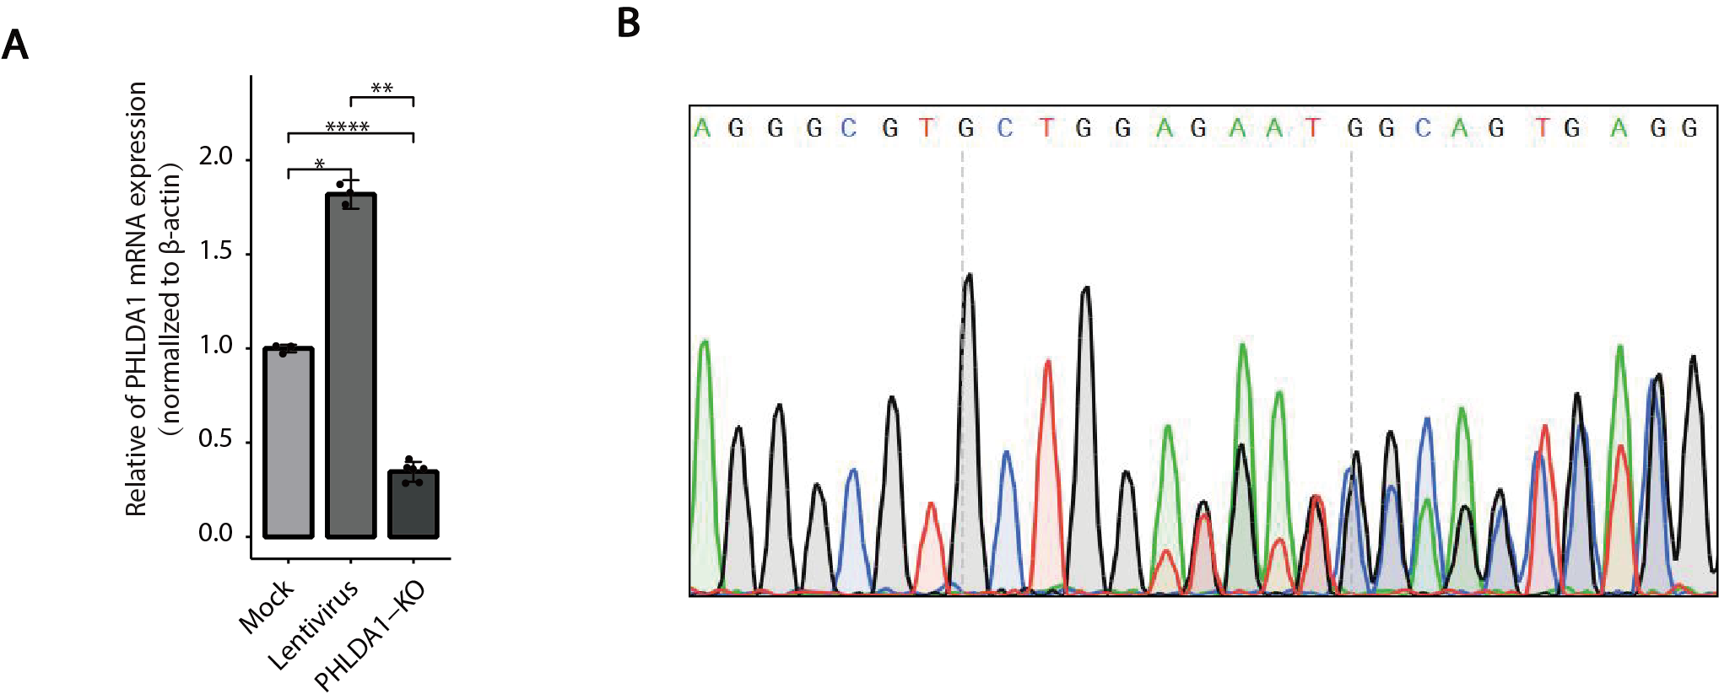
Supplementary Fig. 11 Transcript levels and Sanger sequencing of PHLDA1 in PHLDA1 knockout Y79 cell line. A PHLDA1 mRNA expression in PHLDA1-KO Y79 cell line. B Sanger sequencing of Y79 cells confirms knockout of PHLDA1.
Appendix Table-1 shRNA target sequence
shRNA Name | Target Sequence
Scramble (lentivirus) | CCTAAGGTTAAGTCGCCCTCG
ShPHLDA1#1 | CGAGCACATTTCTATTGTCTT
ShPHLDA1#6 | CAGATCAAGTAGTTTGGACAT

Appendix Table-2 Immunofluorescence staining antibody information
Antibody | Dilution concentration | Company | Catalog number
PRDM1 | 1:100 | Santa cruz | Cat# sc-47732
PHLDA1 | 1:100 | Santa cruz | Cat# sc-23866
β-actin | 1:1000 | CST | Cat# 13E5
CRX | 1:200 | R&D | Cat# AF7085-SP
OTX2 | 1:50 | Santa cruz | Cat# sc-514195
MKI67 | 1:200 | Abcam | Cat# ab15580-100ug
Donkey anti-mouse 488 | 1:500 | Abcam | Cat# ab50109
Donkey anti-rat 594 | 1:500 | Abcam | Cat# ab150156
Donkey anti-mouse 594 | 1:500 | Abcam | Cat# ab150112
Donkey anti-rabbit 647 | 1:500 | Abcam | Cat# ab150063

Appendix Table-3 RT-qPCR primer sequence
Primer Name | Sequence (5'-3')
PHLDA1-qRT-F | CTTCACTGTGGTGATGGCAGAG
PHLDA1-qRT-R | CCTGACGATTCTTGTACTGCACC
PRDM1-qRT-F | CAGTTCCTAAGAACGCCAACAGG
PRDM1-qRT-R | GTGCTGGATTCACATAGCGCATC
ACTB-qRT-F | CACCATTGGCAATGAGCGGTTC
ACTB-qRT-R | AGGTCTTTGCGGATGTCCACGT

