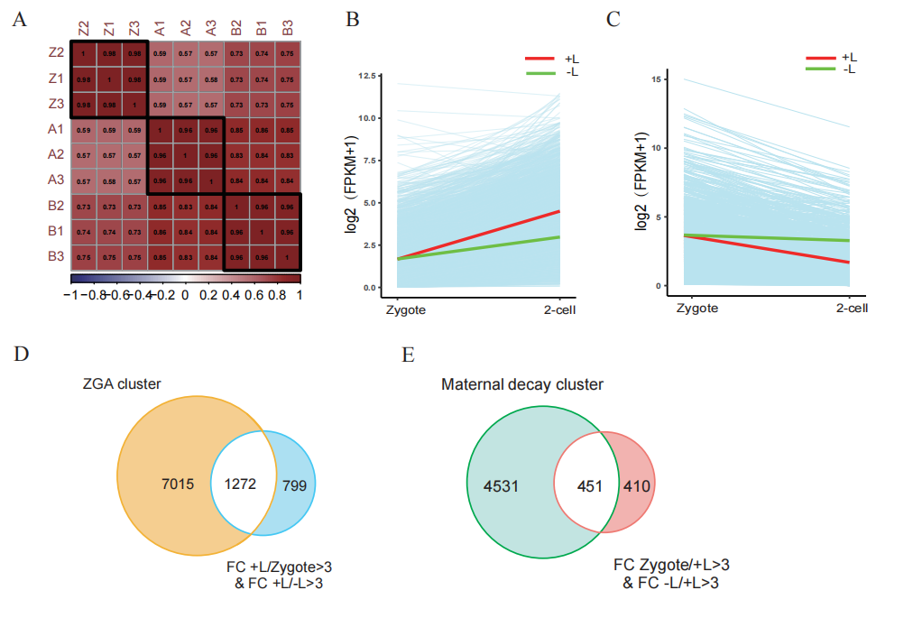
Figure S1. The depletion of lactate leads to the failure of ZGA
- The correlation coefficient among the duplicates for zygotes, the +L group, and the -L group.
- Expression patterns of mouse zygotic genomes during the zygote-2cell transition derived from the +L and -L groups. Each light blue line represents the expression levels of an individual gene, while the red and green lines depict the median expression levels of the +L and -L groups, respectively.
- Degradation patterns of mouse maternal transcripts during the zygote-2cell transition derived from +L group and -L group. Each light blue line represents the expression levels of an individual gene, and the red, green lines represent the median expression levels of +L group and -L group, respectively.
- Venn diagrams showing the overlap between ZGA genes published by Ken-ichiro Abe et al. ³⁰ and transcripts meeting the criteria (fold change [+L/zygote] > 3 & fold change [+L/-L] in late 2-cell > 3).
- Venn diagrams showing the overlap between maternal decay genes published by Ken-ichiro Abe et al. ³⁰ and transcripts meeting the criteria (fold change [zygote/+L] > 3 & fold change [-L/+L] in late 2-cell > 3).
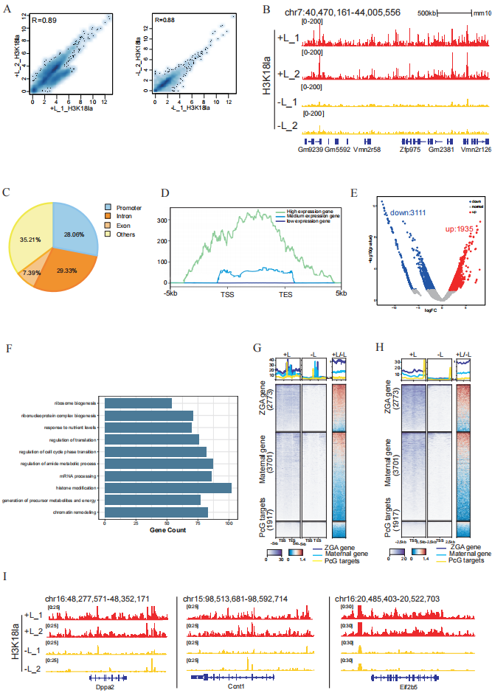
Figure S2. The histone lactylation is responsible for the ZGA failure.
- Scatterplot correlation depicting CUT & Tag replicates (rep1 and rep2) in two groups, with and without sodium lactate.
- A snapshot from the genome browser displaying the enrichment of H3K18la in the replicates of the two groups, with and without sodium lactate.
- A pie chart illustrating the distribution of H3K18la signals in the genome.
- Metaplot of H3K18la signals (Z-score normalized), presenting the average H3K18la enrichment along gene bodies and 5 kilobases (kb) upstream/ downstream of gene bodies categorized by high, mid, and low expression level in 2-cell embryos sorted by RPKM.
- A volcano diagram displaying differential genes corresponding to the signals detected by the H3K18la CUT & Tag in the +L and -L groups.
- Gene Ontology (GO) enrichment analysis for the down regulated genes in (E).
- Heatmap illustrating the enrichment of H3K18la signals in the gene bodies of maternal decay genes, Polycomb Group (PcG) genes, and Zygotic Genome Activation (ZGA) genes between the +L and -L groups. Refer to Zhang Yi et al. for the gene list²⁹. Average plots demonstrate the enrichment of H3K18la signals in the +L compared with -L group.
- Heatmap showing the enrichment of H3K18la signals in the promoters of maternal decay genes, PcG genes, and ZGA genes between the +L and -L groups. Refer to Zhang Yi et al. for the gene list²⁹. Average plots exhibit the enrichment of H3K18la signals in the +L compared with -L group.
- Representative IGV snapshots illustrating the enrichment of H3K18la signal in both +L and -L groups.

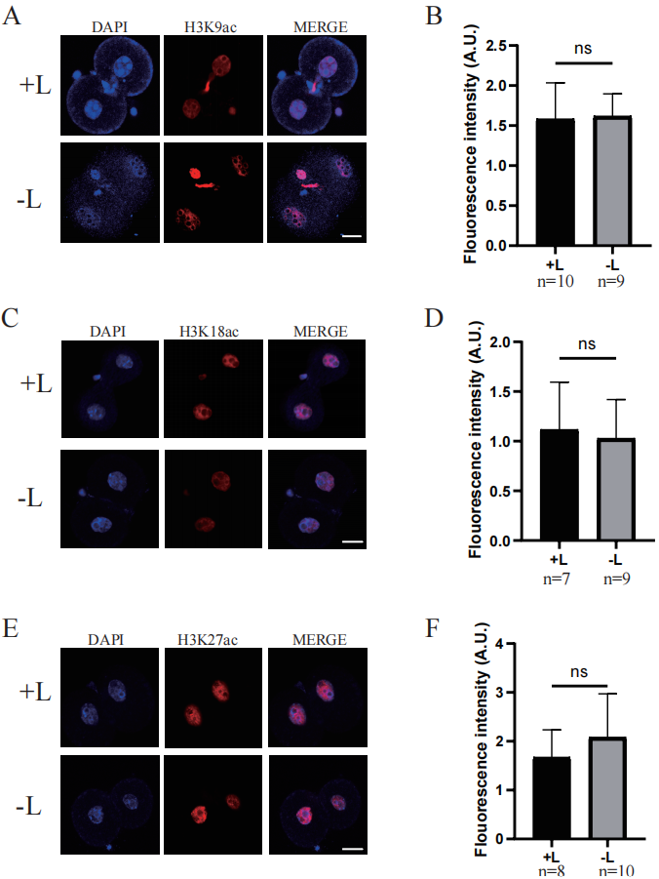
Figure S3. There were no significant differences in histone acetylation modifications at the three sites in 2-cell embryos between the sodium lactate-treated and untreated groups.
- Images of embryos immunostained with antibodies against H3K9ac in the +L and -L groups. Scale bar: 20μm.
- Bar plot showing the H3K9ac fluorescent intensity of 2-cell embryos derived from the +L and -L groups. ns: no significant.
- Images of embryos immunostained with antibodies against H3K18ac in the +L and -L groups. Scale bar: 20μm.
- Bar plot showing the H3K18ac fluorescent intensity of 2-cell embryos derived from the +L and -L group. ns: no significant.
- Images of embryos immunostained with antibodies against H3K27ac in the +L and -L groups. Scale bar: 20μm.
- Bar plot showing the H3K27ac fluorescent intensity of 2-cell embryos derived from the +L and -L group. ns: no significant.

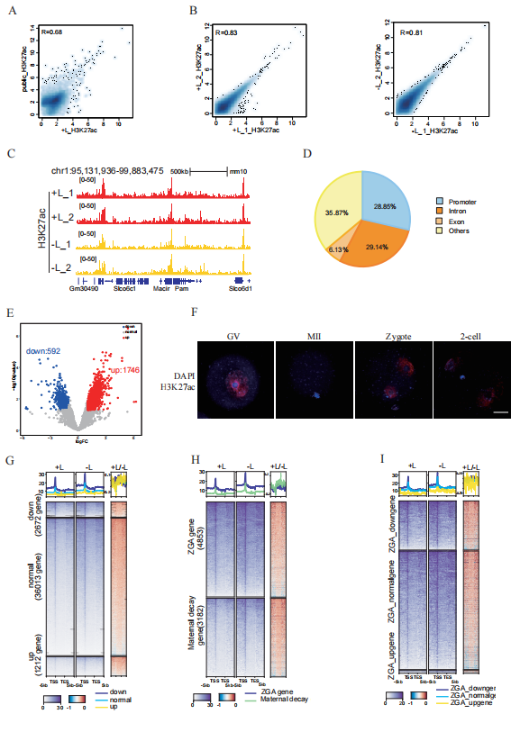
Figure S4. H3K27ac does not responsible to ZGA failure due to lactate deficiency
- Scatterplot correlation of CUT & Tag in the +L group with publicly available data on 2-cell embryos ²⁹.
- Scatterplot correlation of CUT & Tag replicates (rep1 and rep2) in the two groups, with and without sodium lactate.
- A snapshot from the genome browser displaying the enrichment of H3K27ac in the replicates of the two groups, with and without sodium lactate.
- A pie chart illustrating the distribution of H3K227ac signals in the genome.
- A volcano diagram displaying the differential genes corresponding to the signals detected by the H3K27ac CUT & Tag in the +L and -L groups.
- Immunostaining of H3K27ac in mouse germinal vesicle (GV) oocytes, metaphase II (MII) oocytes, zygotes and late 2-cell embryos. Scale bar: 20 μm.
- Heatmap showing the enrichment of H3K27ac signals in DEG gene bodies between the +L group and -L group. "Down," "normal," and "up" denote genes that are down-regulated, exhibit no significant difference, and are up-regulated, respectively, in the -L compared to +L. Average plots depict the enrichment of H3K27ac signals in the +L compared with -L group.
- Heatmap showing the enrichment of H3K27ac signals in maternal decay genes (fold change [zygote/+L] > 3) and ZGA genes (fold change [+L/zygote] > 3) gene bodies between the +L group and -L group. Average plots demonstrate the enrichment of H3K27ac signals in the +L compared with -L group.
- Heatmap showing the enrichment of H3K27ac signals in DEGs belonging to ZGA genes (fold change [+L/zygote] > 3) gene bodies between the +L group and -L group. Average plots show the enrichment of H3K27ac signals in the +L compared with -L group.
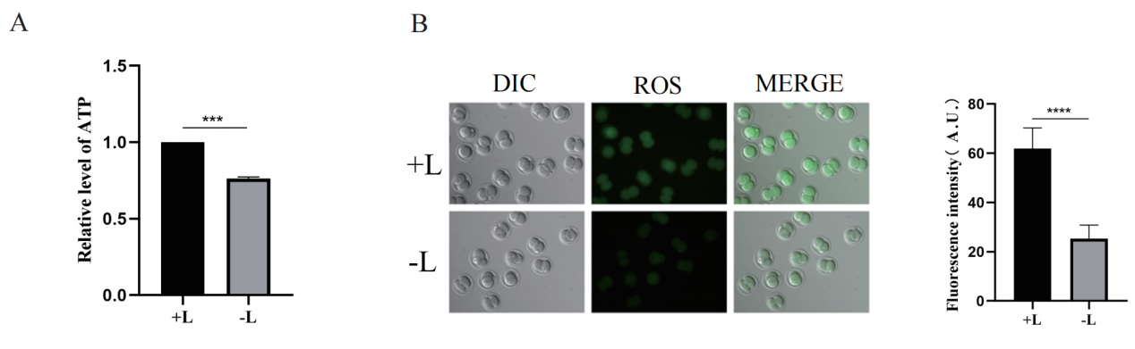
Figure S5. Lactate deficiency may affect energy supply in early embryos
- Relative ATP levels in late 2-cell stage embryos for both +L and -L conditions.
- Reactive Oxygen Species (ROS) levels in late 2-cell stage embryos for both +L and -L conditions. The right panel provides quantification of immunostaining relative signal intensities.

Supplementary Information
Table S1. The development rate of embryos cultured in medium by switching between +L and -L.
 | Experiments | Embryos | 4-cell | Blastocyst
 | （n） | (n) | （%） | （%）
-L/+L/-L | 3 | 87 | 45.9±3.5 | 35.6±2.1
+L/-L/+L | 3 | 89 | 8.7±4.5*** | 3.3±3.3***

Zygotes cultured in –L (until 24hrs) and then shifted to +L (from 24 to 54hrs) and then shifted back to –L (after 54hrs) is called -L/+L/-L medium for simplicity; Zygotes cultured in +L (until 24hrs) and then shifted to -L (from 24 to 54hrs) and then shifted back to +L (after 54hrs) is called +L/-L/+L medium for short. Two-tailed Student’s t-test was used for the statistical analysis. ***P<0.001.

Table S2. Primers used for qPCR
Gene | GeneBank No. (Ensemble ID) | Primer Pairs
Ccnb1 | NM 172301.3 | F: GCCTCACAAAGCACATGACTG  R: GTACAGTTCAGCTGTGCCA
Cdk1 | NM 007659.4 | F: ACTCGGCCTCTAAGCTCCT  R: AGGTTACGACGGACCCTCTC
Cdc25c | NM 009860.3 | F: TGCCTGACGTCTATAGCCCC  R: TGCAGGTGGGATAGGTCCTG
Wee1b | NM 001356375.1 | F: CCGCACACTCCCAAGAGTT  R: TGGGGAGTTTGCCGTGTATC
Dppa2 | NM 028615.1 | F: CACTCTTCGGGAGTGGTGTC  R: TTCTGGCCTCCCGAGATGTA
Dppa4 | NM 028610.2 | F: AAGGCTAAAGCAACGGGGAA  R: GGTTCACTGGGGGCAGATAC
Dux | NM 001081954.1 | F: GGCCCTGCTATCAACTTTCAAGA  R: TTCTGAAACCACACGCGGA
Sirt1 | NM 001159589.2 | F: CGGCTACCGAGGTCCATATAC  R: ACAATCTGCCACAGCGTCAT
Ddx21 | NM 019553.2 | F: AACTTGCCCTCATTGGGTGT  R: CTTAATCGCCAGGTGCTCCA
Hprt | NM 013556.2 | F: GGCTTCCTCCTCAGACCGCTTT  R: CACTTTTTCCAAATCCTCGGCATAA

