Supplementary Information
Extended replicative lifespan of primary resting T cells by CRISPR/dCas9-based epigenetic modifiers and transcriptional activators

Siping Huang^{1#}, Cia-Hin Lau^{1#}, Chung Tin¹*, and Raymond H. W. Lam¹*
¹Department of Biomedical Engineering, City University of Hong Kong, Hong Kong, SAR, China.

# Contribute equally

Total Figures: 7
Total Tables: 0
Supplemental Figures: 2
Supplemental Tables: 1

*Corresponding authors:

Raymond H. W. Lam, PhD
Department of Biomedical Engineering,
City University of Hong Kong,
Room P6414, Yeung Kin Man Academic Building,
83 Tat Chee Avenue,
Kowloon Tong, Hong Kong, SAR, China.
Phone: +852 3442 8577
Email: rhwlam@cityu.edu.hk

Chung Tin, PhD
Department of Biomedical Engineering,
City University of Hong Kong,
Room P6416, Yeung Kin Man Academic Building,
83 Tat Chee Avenue,
Kowloon Tong, Hong Kong, SAR, China.
Phone: +852-3442 5145
Email: chungtin@cityu.edu.hk

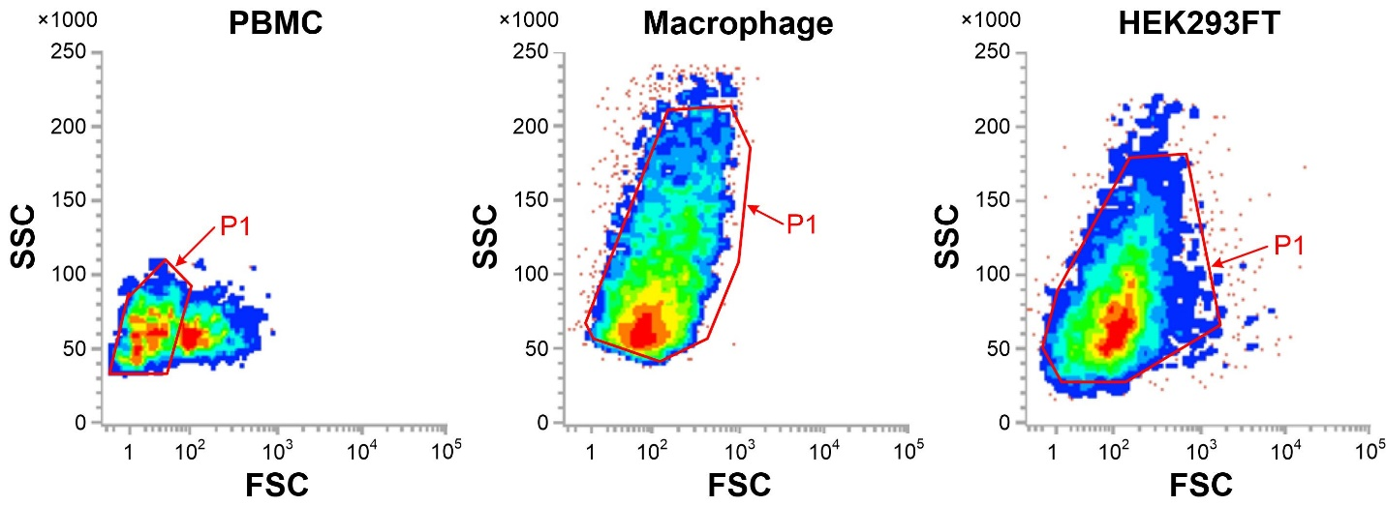
Supplementary Figure S1. FSC-SSC images (all events) of PBMCs, M0 macrophages, and HEK293FT cells. FSC intensity is proportional to the diameter of the cells, and side scatter (SSC) is helpful for identification of cells with varying complexity. ‘P1’ indicates a grating region.

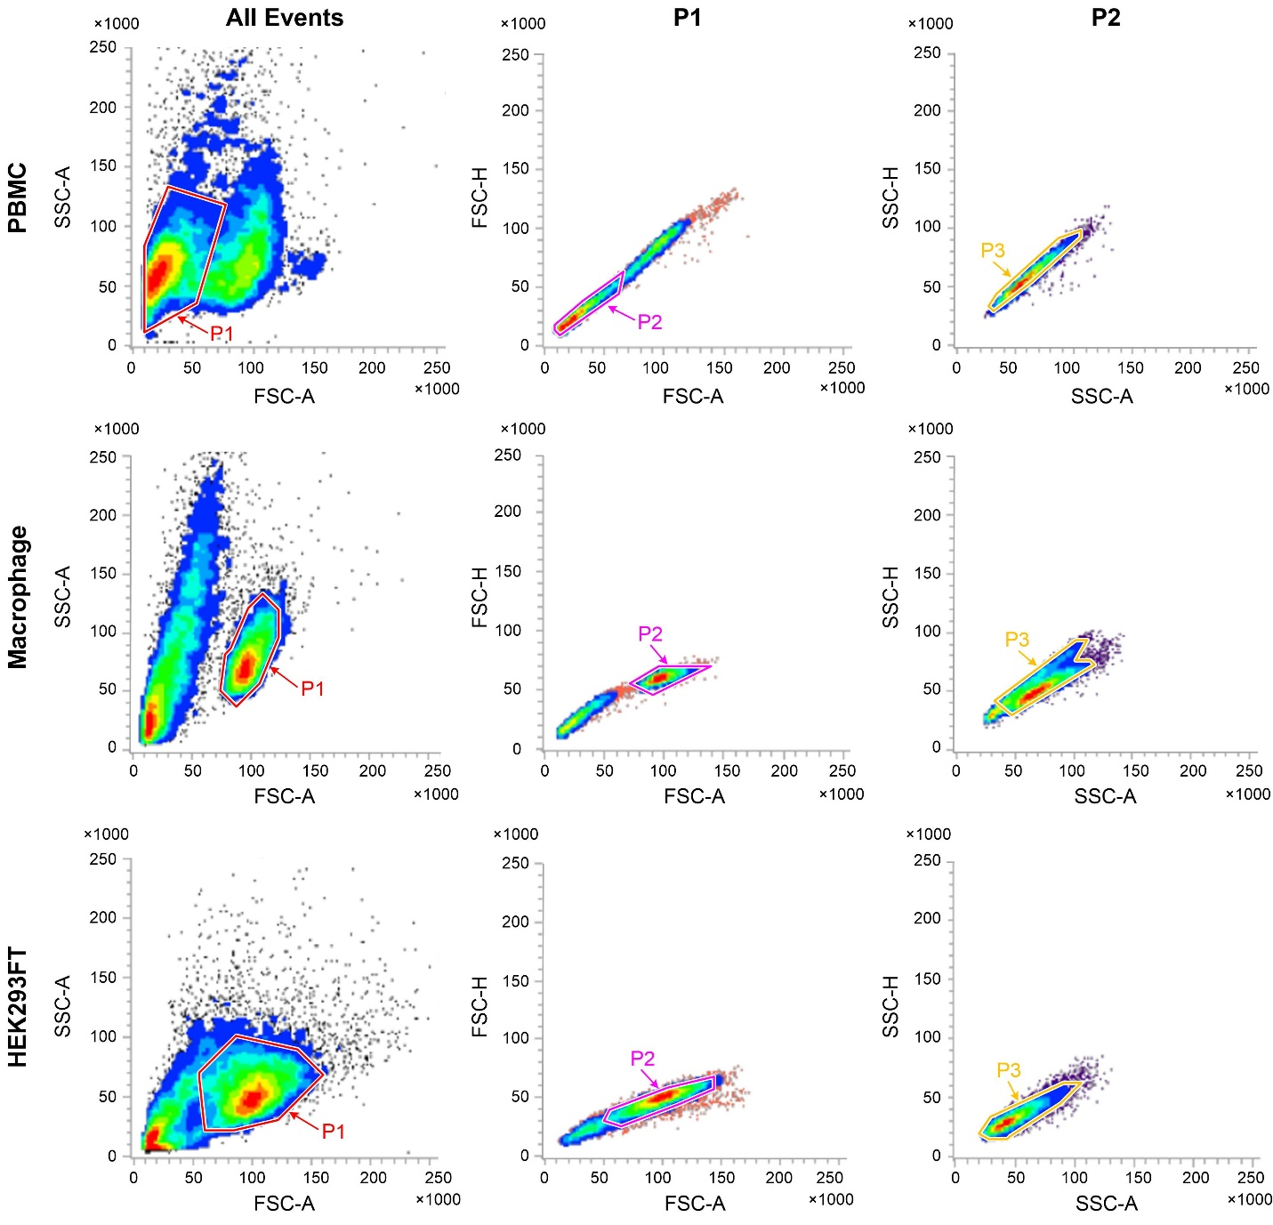
Supplementary Figure S2. Gating for single cell. Based on FSC-SSC, we exclude the clumps of data points outside the major cell region. We utilized the FSC-A&FSC-H and SSC-A&SSC-H to achieve single cell isolation. The single cells will be distributed near the diagonal of FSC-A & FSC-H and SSC-A &SSC-H.

Table S1. All primers used in this study.
Primer sequence (5’ to 3’)  (forward, FP; reverse, RP) | Amplicon size (bp) | Description
FP: CACC GGACCGCGCTTCCCACGTGG  RP: AAAC CCACGTGGGAAGCGCGGTCC | - | for designing sgRNA site-1 of CRISPRa to target human TERT promoter
FP: CACC GGTCGAATCGGCCTAGGCTG  RP: AAAC CAGCCTAGGCCGATTCGACC | - | for designing sgRNA site-2 of CRISPRa to target human TERT promoter
FP: CACC GGACGTGAAGGGGAGGACGG  RP: AAAC CCGTCCTCCCCTTCACGTCC | - | for designing sgRNA site-3 of CRISPRa to target human TERT promoter
FP: GCATATACGATACAAGGCTGTTAGAGAG | - | for sequencing pU6-sgRNA
FP: ACCATCTTCCAGGAGCGAGA  RP: TGGCATGGACTGTGGTCATG | 319 | qPCR mRNA expression level of human GAPDH
FP: CGAACGCCGCTTCCTCAGG  RP: CTTGCTCCAGACACTCTTCCGGT | 301 | qPCR mRNA expression level of human TERT
FP: GCGCTGCCTGAAACTCGC  RP: CGTCCTGCCCCTTCACCT |  | CHIP-QPCR of TERT

