Supplementary Table S1. Primers sequences used in this study.
Gene | Primers sequences
β-actin | F: 5’-GCTCAGTAACAGTCCGCCTAG-3’
β-actin | R: 5’-AGTGTGACGTTGACATCCG-3’
E130310I04Rik | F: 5’-TTCCACGACTGACCTGCTTT-3’
E130310I04Rik | R: 5’-CCGACTCACATTCTGCTTGT-3’
Gm14964 | F: 5’-TGGCTTTGGCGGAGACTAC-3’
Gm14964 | R: 5’-TTTCCTTTCCTTTCTGTTCCGT-3’
E130307A14Rik | F: 5’-CCGATAGCATGGATAGGCTC-3’
E130307A14Rik | R: 5’-AGCATCCAGGTGATTCTTGTG-3’
Gm17276 | F: 5’-AGTGGACAGTGCTGGTATGG-3’
Gm17276 | R: 5’-GCTTATGCAGCCAACGACTG-3’
Mcp-1 | F: 5’-TTCCACAACCACCTCAAGCACTTC-3’
Mcp-1 | R: 5’-ATTAAGGCATCACAGTCCGAGTCAC-3’
Tnf-α | F: 5’-GGACTAGCCAGGAGGGAGAACAG-3’
Tnf-α | R: 5’-GCCAGTGAGTGAAAGGGACAGAAC-3’
Hmgb1 | F: 5’-AGGCTGACAAGGCTCGTTATGAAAG-3’
Hmgb1 | R: 5’-GGGCGGTACTCAGAACAGAACAAG-3’

Supplementary Table S2. Predicting potential binding proteins for Hmgb1
Protein Names | Literatures index  (literatures numbers by searching for "diabetic kidney disease”+inflammation” with the protein on Pubmed in the last five years ) | Interaction Score | Confidence
NF-κB | 247 | 0.536 | High
p53 | 18 | 0.536 | High
Ttp | 1 | 0.536 | High
Hdac4 | 1 | 0.536 | High
Rb | 0 | 0.536 | High
Tle5 | 0 | 0.536 | High
Havr2 | 0 | 0.537 | High
Tle1 | 0 | 0.536 | High
Mecp2 | 0 | 0.536 | High

Legends
Supplementary figure 1. Validation of transfection efficiency of Hmgb1 overexpression plasmids and siRNAs.
Hmgb1 over-expression plasmid and three siRNAs were constructed. qRT-PCR and western blot results clearly showed that the over-expression plasmid or siRNAs of Hmgb1 increased or decreased the levels of Hmgb1 mRNA and protein, with si-H-1 and si-H-3 demonstrating the most effective knockdown efficiency among the three siRNA. Data are presented as mean ± SD. *P<0.05, **P<0.01, ***P<0.001 and NS, no significance.

Supplementary figure 2 Validation of the inhibition efficiency of Hmgb1 by Glycyrrhizin and si-Hmgb1.
Western blot results clearly showed that the si-Hmgb1 and Glycyrrhizin decreased the levels of Hmgb1 protein. Data are presented as mean ± SD. *P<0.05, **P<0.01, ***P<0.001 and NS, no significance.

Supplementary figure 3. Validation of transfection efficiency of E130307A14Rik overexpression plasmids and siRNAs. The relative expression of E130307A14Rik was detected by qRT-PCR after up-regulation of E130307A14Rik in L-MC or after down-regulation of E130307A14Rik (si-E-1 , si-E-2 and si-E-3) in H-MC. Data are presented as mean ± SD. *P<0.05, **P<0.01, ***P<0.001 and NS, no significance.

Supplementary figure 4. Detection of biochemical parameters in db/m and db/db mice. Blood glucose, body weight, kidney weight to body weight ratio, urinary albumin, urinary creatinine, and UACR were examined in db/m mice (n=15 for 8 weeks) and db/db mince (n=25 for 8 weeks). The db/db mice were found to have entered the DKD state at eight weeks of age by testing for the above biochemical parameters. Data are presented as mean ± SD. *P<0.05, **P<0.01, ***P<0.001 and NS, no significance.

Supplementary figure 1.

Supplementary figure 2
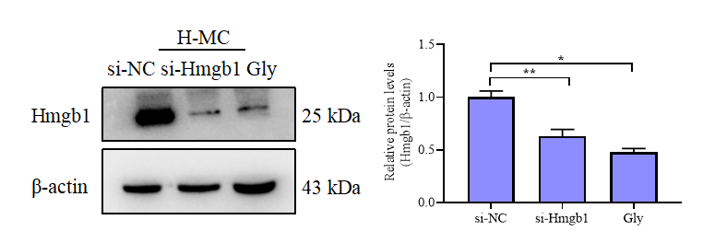

Supplementary figure 3.
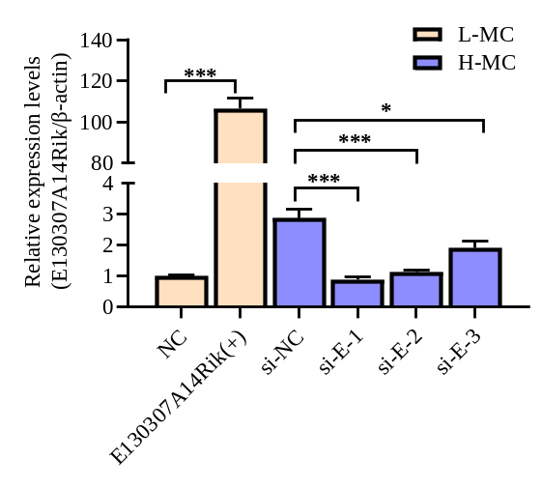

Supplementary figure 4.
