Supplementary Information

Endothelial CD38-induced endothelial-to-mesenchymal transition is a pivotal driver in pulmonary fibrosis

Min Hu^{1,2#}, Xiao-Hui Guan^{1#}, Ling-Fang Wang^{1#}, Hao-Min Xu^{1,2}, Shu-Fen Ke^{1,2}, Qing-Yun Yuan¹, Hui-Lan Tan¹, Jie Wu¹, Guan-Hui Yu^{1,2}, Qi-Ming Huang^{1,3}, Yu Liu⁴, Long Hu⁵, Ke-Yu Deng^{1,2,3*} and Hong-Bo Xin^{1,2,3*}

This file includes:
Supplementary Figure S1, S2, S3, S4 and S5
Supplementary Table S1 and Table S2

Supplementary Figure Legends
Figure S1 Flow cytometry analysis of CD38 expression on endothelial cell in mice. (A) Representative diagram of CD31⁺CD38⁺ cells in lung tissue single-cell suspensions of control and BLM-induced pulmonary fibrosis mice detected by flow cytometry. (B) Quantitative analysis of proportion of CD31⁺CD38⁺ cells. (C) Representative diagram of CD31⁺αSMA⁺ cells in lung tissue single-cell suspensions of control and BLM-induced pulmonary fibrosis mice detected by flow cytometry. (D) Quantitative analysis of proportion of CD31⁺αSMA⁺ cells. Data were represented as mean ± SEM, *p<0.05, n = 3 per group.

Figure S2 Analysis of CD38 expression and EndMT in bleomycin-induced HUVECs. (A-B) The expressions of CD38, CD31 and α-SMA were determined by western blot analysis in HUVECs treated with 0, 1, 10, 50 μg/mL BLM. (C-E) Quantitative analysis of CD38, CD31 and α-SMA, respectively. (F-H) The expressions of CD38, CD31 and α-SMA were determined by RT-qPCR in HUVECs treated with 0, 1, 10, 50 μg/mL BLM. (I-J) The expressions of CD38, CD31 and α-SMA were determined by western blot analysis in HUVECs treated with 0, 12, 24, 48 h BLM at 10 μg/mL concentration. (K-M) Quantitative analysis of CD38, CD31 and α-SMA, respectively. (N-P) The expressions of CD38, CD31 and α-SMA were determined by RT-qPCR in HUVECs treated with 0, 12, 24, 48 h BLM at 10 μg/mL concentration. Data were represented as mean ± SEM, *p<0.05, **p<0.01, ***p<0.001, ****p<0.0001, n = 3 per group.

Figure S3 Validation of endothelial cell-specific CD38 deficiency mice knockout efficiency. (A) Co-immunostaining of CD31 and α-SMA of primary mouse aortic endothelial cell (PMAECs) and human aortic smooth muscle cell line (HASMCs) to identify PMAEC. (B) The expression of CD38 was determined by western blot analysis of PMAECs from CD38^{flox/flox} and CD38^{EndKO} mice. (C) Quantitative analysis of CD38. Data were represented as mean ± SEM, ****p<0.0001, n = 3 per group.

Figure S4 Analysis of role of TLR4 axis mediated endothelial inflammation in BLM-induced EndMT. (A) Co-immunostaining of CD31 and α-SMA in BLM-induced (10 μg/mL) scramble and CD38KD HUVECs treated with TAK242 (5μM) for 48 h. (B-C) Quantitative analysis of CD31 and α-SMA. Data were represented as mean ± SEM, *p<0.05, **p<0.01, ***p<0.001, n = 3 per group.

Figure S5 The mRNA expressions of NOX1, NOX2 and NOX4 in HUVECs were detected by RT-qPCR. Data were represented as mean ± SEM, **p<0.01, ****p<0.0001, n = 3 per group.
Supplementary Figure S1
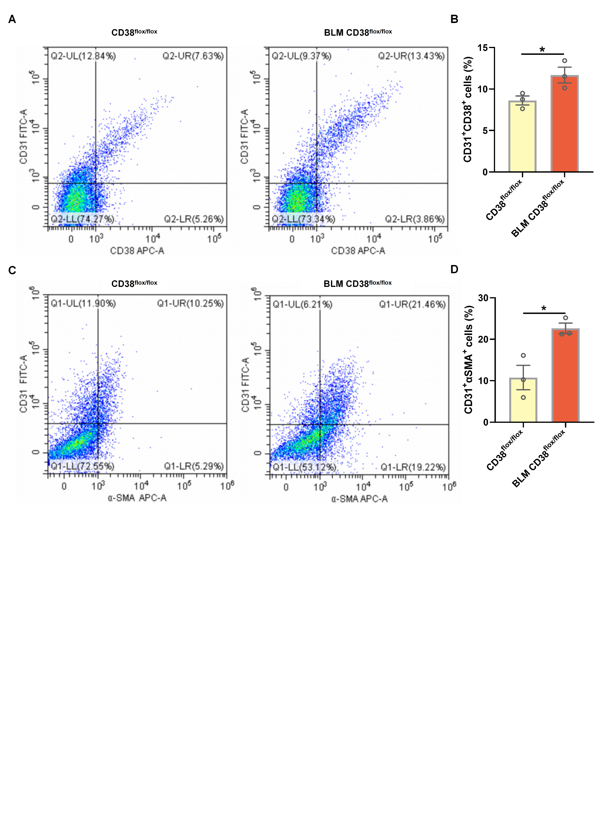
Supplementary Figure S2
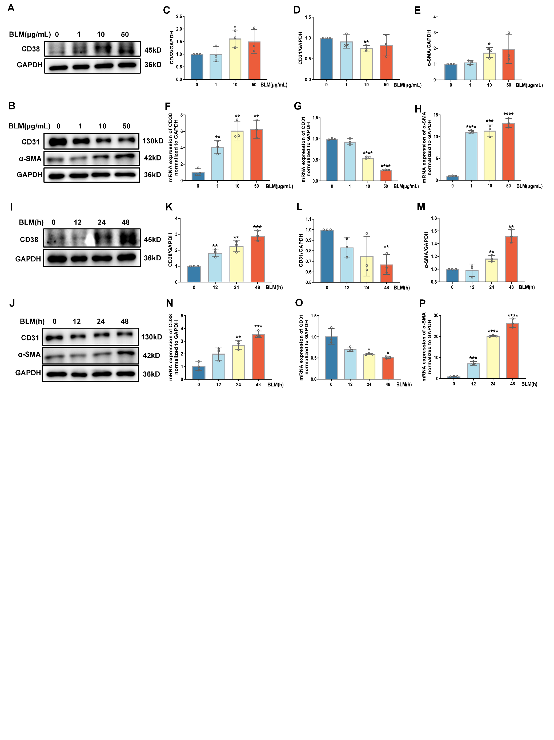

Supplementary Figure S3
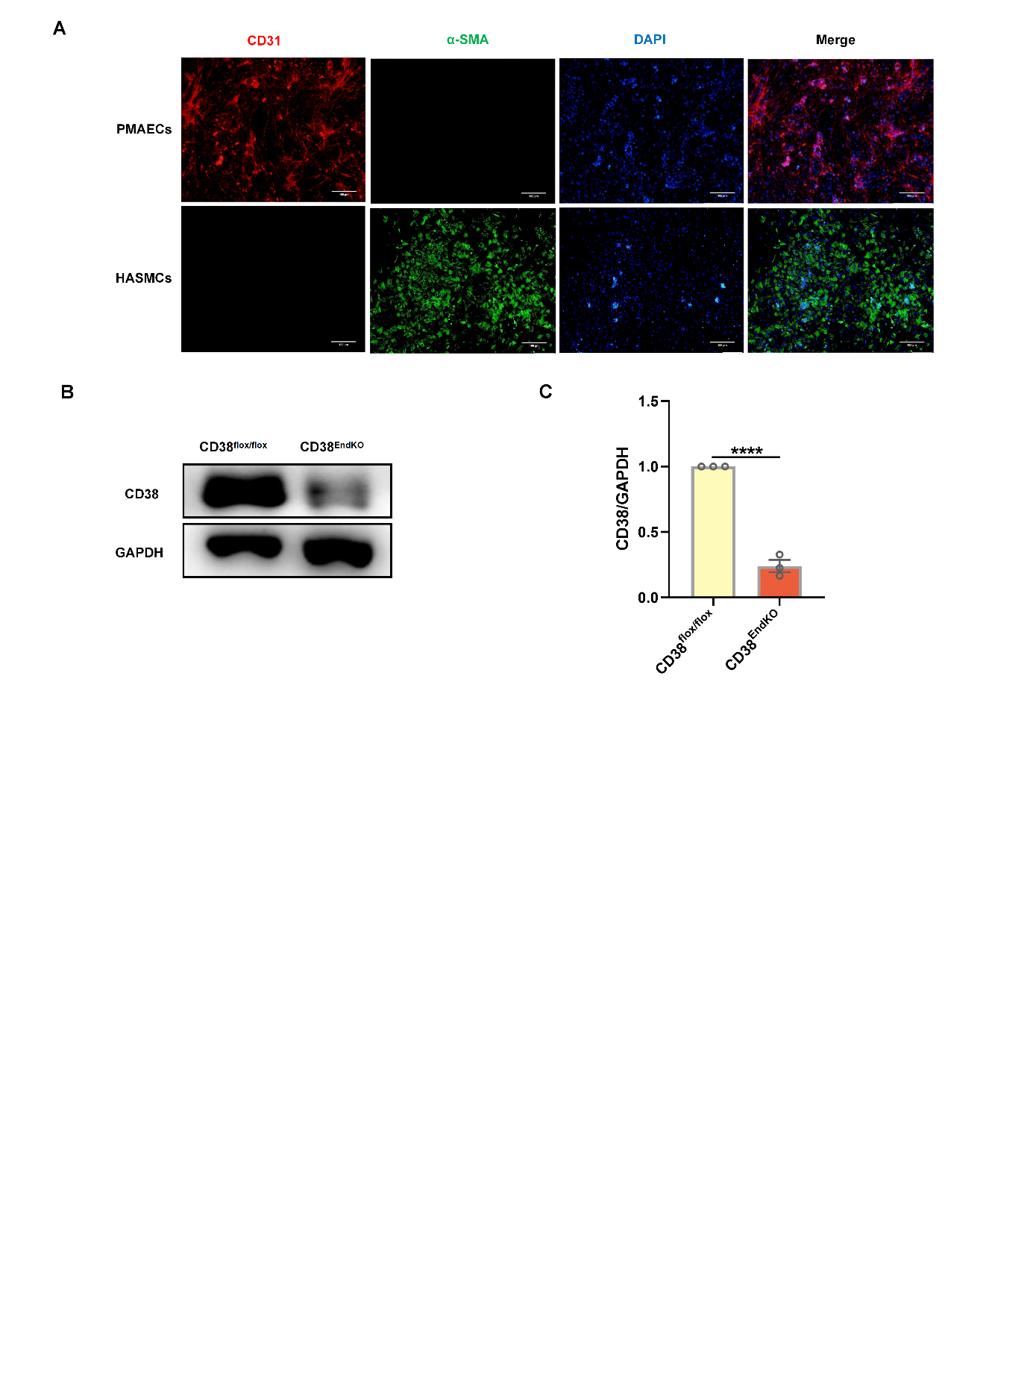

Supplementary Figure S4
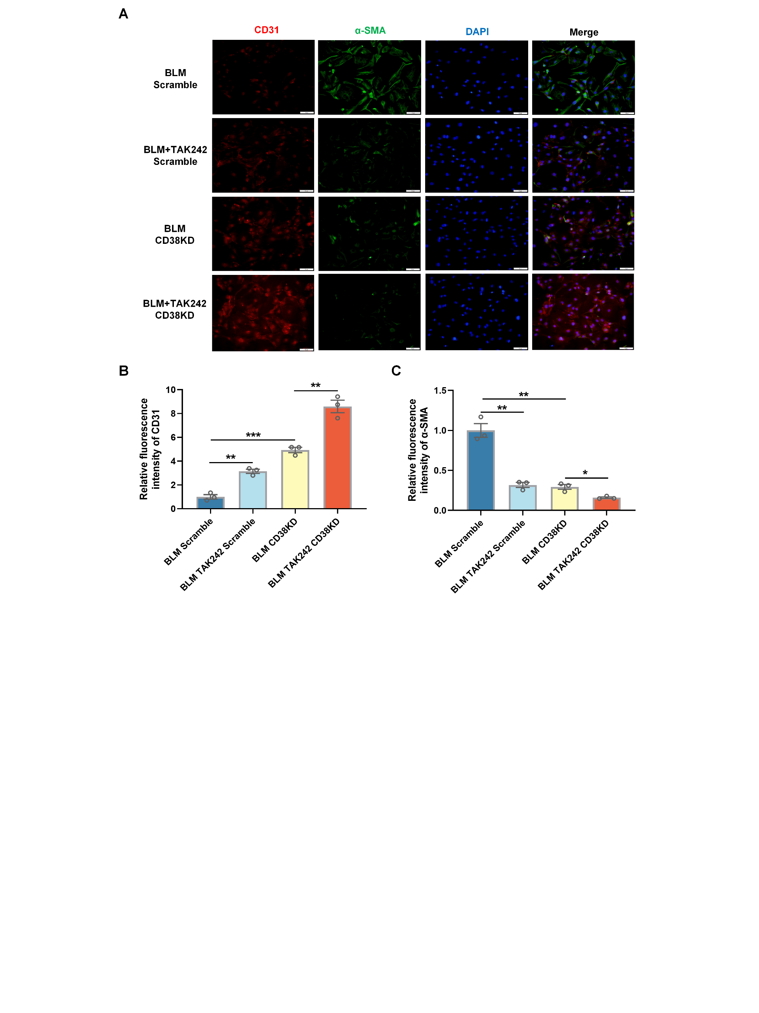

Supplementary Figure S5
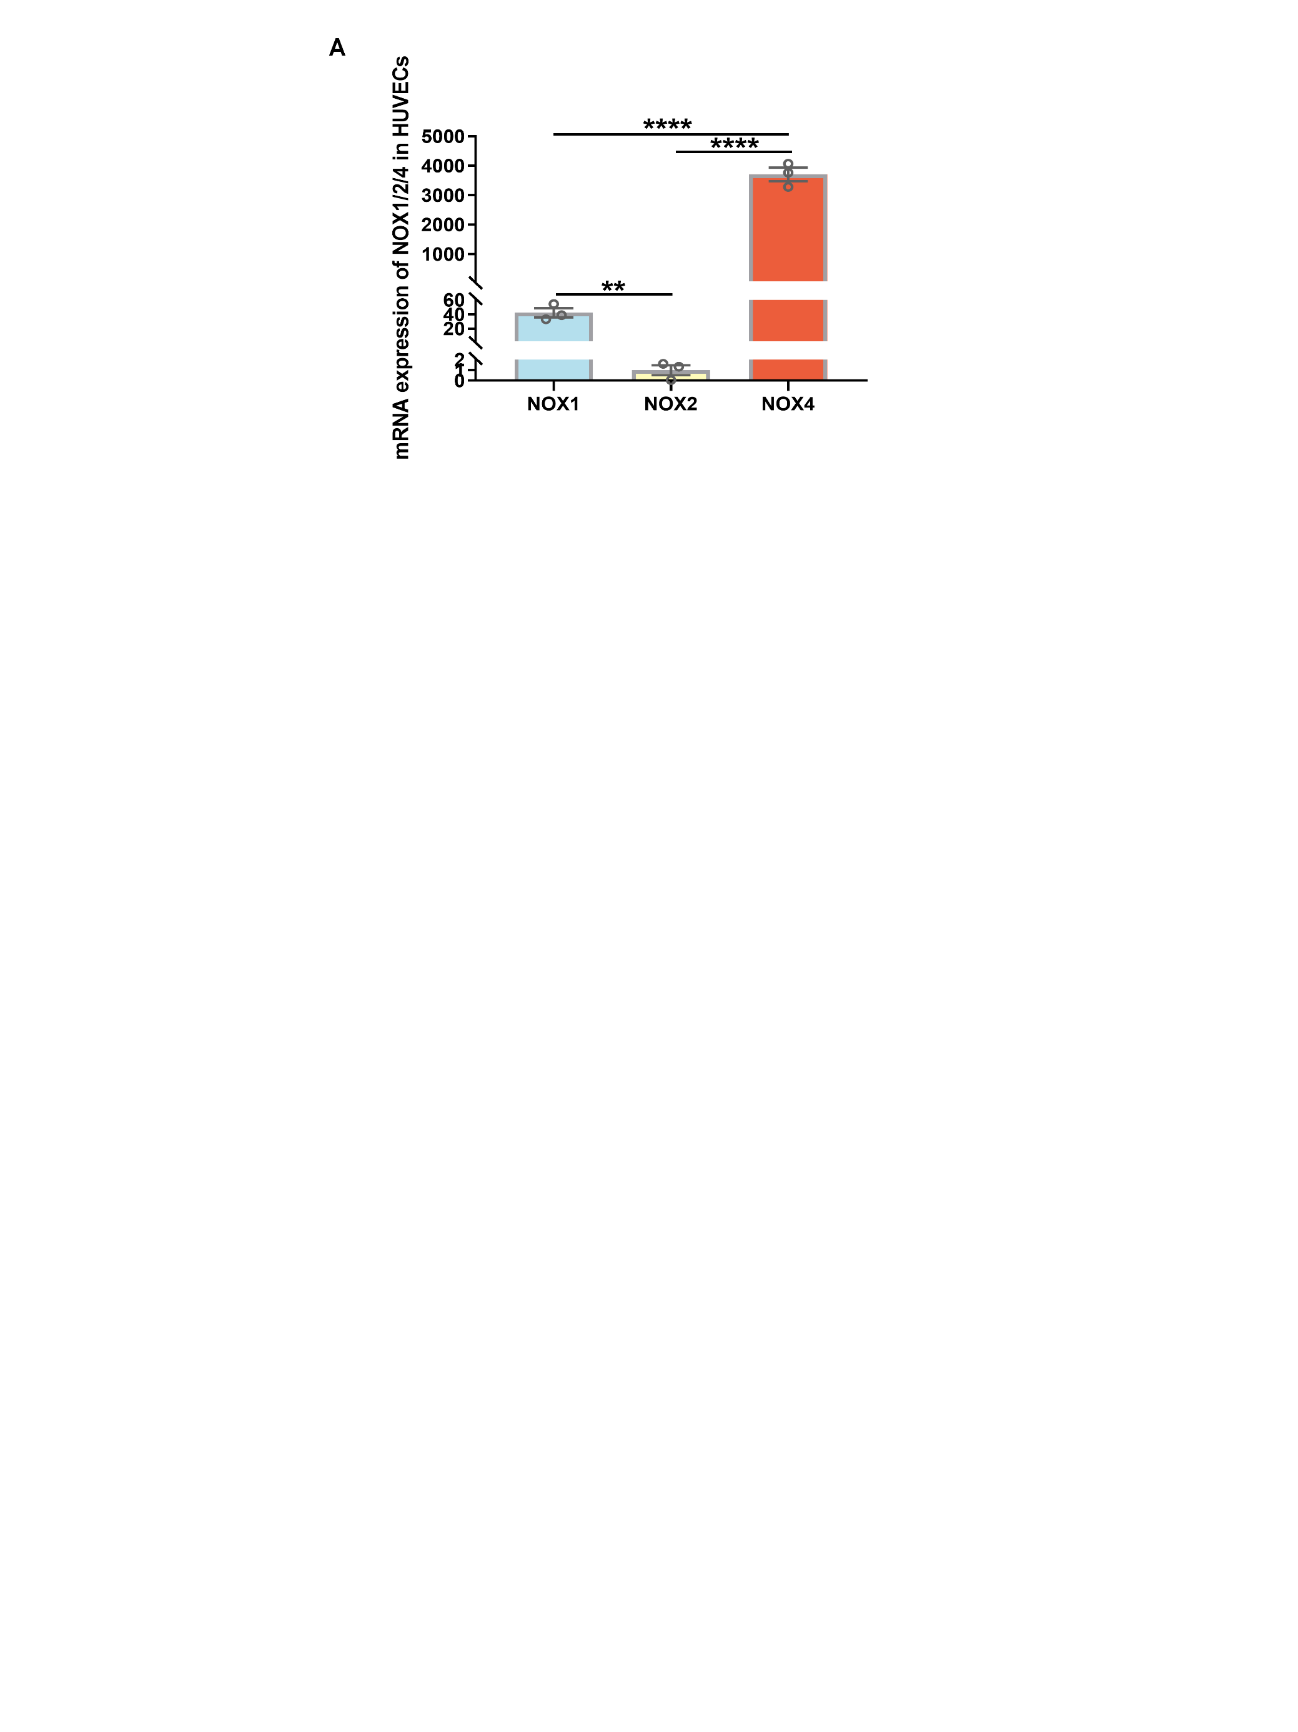

Supplementary Table S1. The primary and secondary antibodies for western blot, immunofluorescence staining and flow cytometry.
Antibodies | Source, company, identifier
GAPDH | Mouse, KANGCHEN, KC-5G4
CD38 (Western blot) | Sheep, R&D, AF4947
CD38 (Immunofluorescence) | Mouse, Santa Cruz, sc-374650
CD31 | Rabbit, Servicebio, GB11063-2
VE-cadherin | Rabbit, Abcam, ab318152
Vimentin | Mouse, Abcam, ab28028
α-SMA | Mouse, Proteintech, 67735-1-lg
Collagen I | Rabbit, Servicebio, GB11022
TGFβ (Western blot) | Rabbit, CST, 3711
TGFβ (Immunofluorescence) | Mouse, Santa, sc-146
P-SMAD3 | Rabbit, CST, 9520
SMAD3 | Rabbit, CST, 9523
ICAM1 | Mouse, Proteintech, 60299-1-lg
VCAM1 | Rabbit, Abcam, ab134047
TLR4 | Mouse, Santa, sc-293072
MyD88 | Rabbit, Wanleibio, WL02494
P-ERK | Rabbit, Affinity, DF7576
ERK | Rabbit, CST, 9102S
P-JNK | Rabbit, CST, 9255S
JNK | Rabbit, CST, 9252S
NOX1 | Rabboit, Proteintech, 17772-1-AP
SOD2 | Rabbit, CST, 13141
Catalase | Rabbit, CST, 14097S
SIRT3 | Rabbit, Servicebio, GB11354
Goat Anti-Rabbit IgG (HRP) | Goat, ThermoFisher, 31460
Goat Anti-Mouse IgG (HRP) | Goat, ThermoFisher, 31430
Donkey Anti-sheep IgG (HRP) | Goat, R&D, HAF016
Goat Anti-Rabbit IgG (Alexa Fluor® 594) | Goat, Abcam, ab150080
Goat Anti-Mouse IgG (Alexa Fluor® 488) | Goat, Abcam, ab150113
Goat Anti-Mouse IgG (Alexa Fluor® 594) | Goat, Abcam, ab150116
FITC Anti-Mouse CD31 | Rat, Biolegend, 160211
APC Anti-Mouse CD38 | Rat, Biolegend, 102711
Alexa Fluor 647 Anti-Mouse Vimentin | Rat, Biolegend, 699307
Goat Anti-Mouse IgG H&L antibody | Goat, Bioss, bs-0296G-APC

Supplementary Table S2. The primer sequences for RT-qPCR.
Genes | Sequences
Mouse-Collagen Ⅰ F | CTGGCGGTTCAGGTCCAAT
Mouse-Collagen Ⅰ R | TTCCAGGCAATCCACGAGC
Mouse-TNFα F | CCTGTAGCCCACGTCGTAG
Mouse-TNFα R | GGGAGTAGACAAGGTACAACCC
Mouse-IL-6 F | CTGCAAGAGACTTCCATCCAG
Mouse-IL-6 R | AGTGGTATAGACAGGTCTGTTGG
Human-CD38 F | AAGTTGCCATTAGCTCCCCC
Human-CD38 R | GCAGCCACTTCAAGGGGTAT
Human-CD31 F | AGCGTCATTGGCGTGTTG
Human-CD31 R | CTCCTTCCCGTTTACCTTTCC
Human-α-SMA F | CTATGAGGGCTATGCCTTGCC
Human-α-SMA R | GCTCAGCAGTAGTAACGAAGGA
Human-NOX1 F | GCACACCTGTTTAACTTTGACTG
Human-NOX1 R | GGACTGGATGGGATTTAGCCA
Human-NOX2 F | TGCCAGTCTGTCGAAATCTGC
Human-NOX2 R | ACTCGGGCATTCACACACC
Human-NOX4 F | TGTGCCGAACACTCTTGGC
Human-NOX4 R | ACATGCACGCCTGAGAAAATA

