Supplementary Materials

SH-SY5Y cell line
The human SH-SY5Y neuronal cell line was cultured in DMEM high glucose containing 10% Fetal Bovine Serum (FBS), 2.5 mM L-Glutamine, 100 U/ml penicillin, and 100 μg/ml streptomycin (all purchased from Euroclone).

In vitro treatment
To silence SMN, SH-SY5Y cells were transfected with SMN1 silencer siRNA (15 nM, Thermofisher, #s531467) using Lipofectamine™ RNAiMAX (Life Technologies, #13778075). 72 h post-treatment, the cells were harvested for Western blot analyses.

Histological analyses
For immunohistochemical analyses, WT, AAV9::Stmn2 or AAV9::null treated SMA mice were sacrificed at P10. Spinal cord samples were fixed in PFA 4% for 24 h. The next day PFA was removed, tissues were washed in PBS 1X and transfer in 30% sucrose solution in PBS 1X for 24 h. Then, the spinal cords were extracted from the column, and the lumbar section was cut and frozen in dry ice embedded in Tissue-Tek O.C.T. Compound (Sakura Finetek) and stored at −80 °C. At least 24 h after freezing, tissues were cryosectioned on polysine adhesion microscope slides (Epredia).

MN detection
To evaluate the number of MNs in the spinal cord (n = 6 animals/group) in immunofluorescence, slices were blocked in PBS 1X with 10% normal donkey serum (NDS) and 0.3% Triton X-100 for 1 h at RT. We stained sections at least 100 μm apart to avoid double counting of the same cell. Primary antibody ChAT was added ON at 4 °C, then the slides were incubated for 1 h 30 min at RT with the specific secondary biotinylated antibody, and then they were incubated for 1 h at RT with Streptavidin Cy3. Counts were made in the anterior ventral horns of the spinal cord of serial sections acquired with an optical microscope Leica DMi8 at 20X magnification.

Gliosis
To assess the presence of gliosis in the spinal cord of mice (n = 3 animals/group), we blocked slices in PBS 1X with 10% NGS and 0.3% Triton X-100 for 1 h at RT. GFAP and ionized IBA antibodies were added ON at 4 °C, then the slides were incubated with Alexa 488 secondary antibody or Alexa 594 secondary antibody for 1 h 30 min at RT. Images were acquired using a Leica TCS SP8 confocal microscope at 40X magnification to count at least n = 400 nuclei/animal, and calculate the percentage of them positive for GFAP or for IBA1.

Supplementary Tables

Table S1. Characteristics of iPSC lines derived from SMA and healthy subjects.
yrs: years; m: months

iPSC line | Diagnosis | Sex | Age | Reprogramming strategy | Reference
SMA 1.1  (CS83iSMA) | SMA type I | M | fetal | Episomal plasmid | Cedars Sinai
SMA 1.2  (CS77iSMA-n10) | SMA type I | M | 2 yrs | Episomal plasmid | Cedars Sinai
SMA 1.3  (CS32iSMA-n3) | SMA type I | M | 7 m | Episomal plasmid | Cedars Sinai
SMA 1.4 | SMA type I | M | neonatal | Episomal plasmid | Generated in our Lab
CTR 2.1 | / | M | 34 yrs | Episomal plasmid | Generated in our Lab
CTR 2.2  (CS5NXHiCTR) | / | M | 28 yrs | Episomal plasmid | Cedars Sinai
CTR 2.3 | / | M | 9 yrs | Episomal plasmid | Generated in our Lab
CTR 2.4 | / | M | 46 yrs | Episomal plasmid | Generated in our Lab

Table S2. Primary antibodies used for immunohistochemistry (IHC), immunocytochemistry (ICC), and Western blotting (WB).
Primary Antibodies
Target | Manufacturer | Host species |  | Dilution
 |  |  |  | IHC | ICC | WB
Actin | Sigma Aldrich (#A2066) |  | Rabbit |  |  | 1:2000
STMN2 | Proteintech (#10586-1-AP) |  | Rabbit |  |  | 1:1600
SMN | BD Transduction (#610647) |  | Mouse |  |  | 1:1000
β-III tubulin | Abcam (AB18207) |  | Rabbit |  | 1:1000
β-III tubulin | Biolegend (#801202) |  | Mouse |  | 1:500
STMN2 | Novus (#NBP1-49461) |  | Rabbit |  | 1:4000
Neurofilament M | Merck Chemicon (#AB1987) |  | Rabbit | 1:250
α-BTX, AF-555 | Invitrogen (#B35451) |  |  | 1:200
ChAT | Merck Millipore (#AB144P) |  | Goat | 1:250 | 1:100
GFAP | Merck Millipore (#MAB360) |  | Mouse | 1:600
IBA1 | WAKO Fujifilm (#019-19741) |  | Rabbit | 1:500
HB9 | Abcam (AB92606) |  | Rabbit |  | 1:200

Table S3. Secondary antibodies used for immunohistochemistry (IHC), immunocytochemistry (ICC), and Western blotting (WB).
Secondary Antibodies
Target | Manufacturer | Dilution
 |  | IHC/ICC | WB
Goat anti-Rabbit IgG (H+L) Highly Cross-Adsorbed Secondary Antibody, Alexa Fluor™ 488 | Invitrogen (#A-11034) | 1:1000
Goat anti-Mouse IgG (H+L) Cross-Adsorbed Secondary Antibody, Alexa Fluor™ 488 | Invitrogen (#A-11001) | 1:1000
Goat anti-Rabbit IgG (H+L) Cross-Adsorbed Secondary Antibody, Alexa Fluor™ 568 | Invitrogen (#A-11011) | 1:1000
Goat anti-Mouse IgG (H+L) Cross-Adsorbed Secondary Antibody, Alexa Fluor™ 568 | Invitrogen (#A-11004) | 1:1000
Rabbit Anti-Goat IgG Antibody (H+L), Biotinylated | Vector Laboratories (#BA-5000) | 1:400
Streptavidin−Cy3™ from Streptomyces avidinii | Sigma-Aldrich (#S6402) | 1:400
IRDye® 680RD Donkey anti-Mouse IgG Secondary Antibody | LI-COR (#926-68072) |  | 1:20000
IRDye® 800CW Donkey anti-Rabbit IgG Secondary Antibody | LI-COR (#926-32213) |  | 1:20000

Supplementary Figures
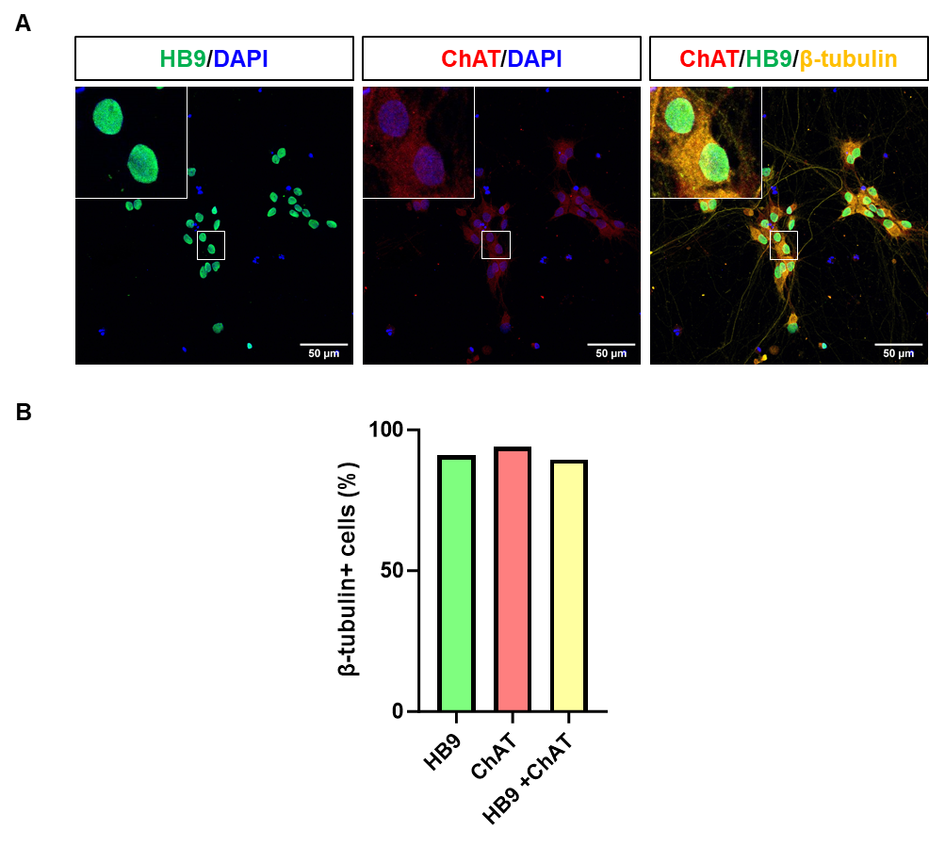
Fig. S1. Differentiation of human iPSCs-derived MNs.
A Representative immunofluorescence images of MNs stained for HB9 (green), ChAT (red), β-tubulin (yellow), and DAPI (blue) and acquired with a confocal microscope at 40X magnification. Scale bar = 50 µm. B Relative quantification of HB9+ and ChAT+ percentage on β-tubulin positive cells (n = 3 cell lines/group). All inserts are 4X magnification.

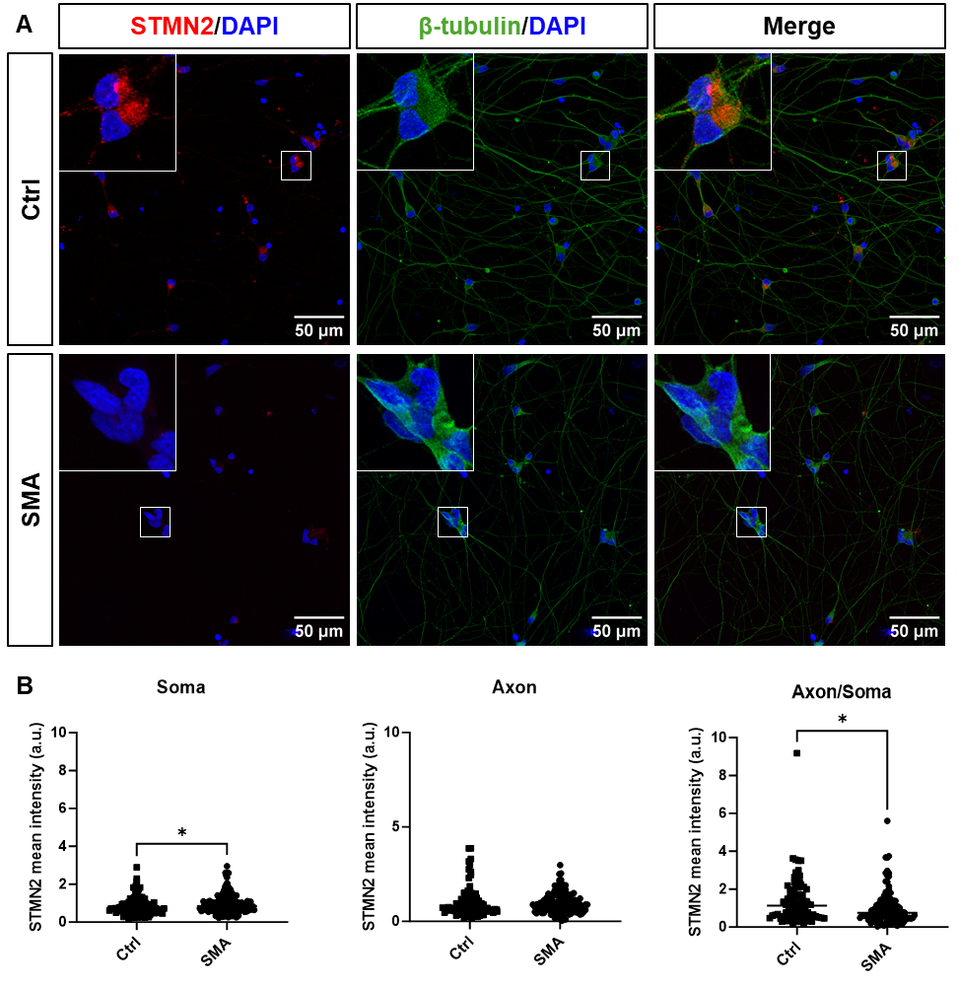

Fig. S2. Human spinal SMA MNs STMN2 level showed STMN2 dysregulation. A Representative immunofluorescence images of Ctrl and SMA d21 MNs stained for STMN2 (red), β-tubulin (green), and DAPI (blue) and acquired with a confocal microscope at 40X magnification. Scale bar = 50 µm. All inserts are 4X magnification. B Quantification of STMN2 level intensity (n = 3 cell lines/group) in A reporting separately soma, axon, and the ratio axon/soma data. STMN2 levels were normalized to SMA average values. Values show means ± SEM from 3 independent experiments. Statistical significance was determined by Student’s t-test. *P< 0.05.

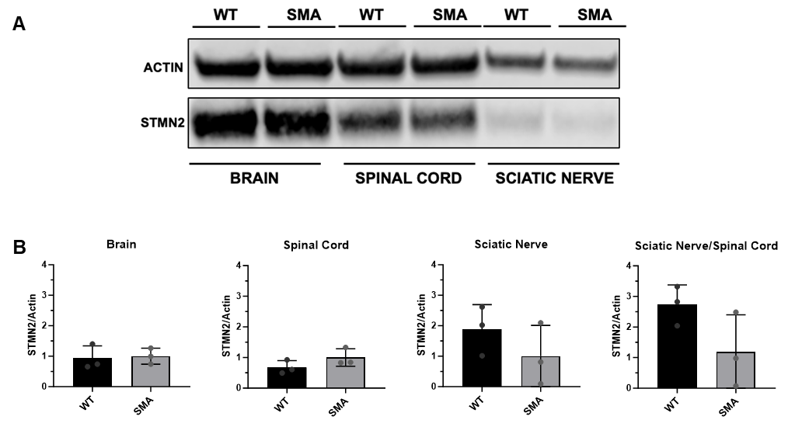

Fig. S3. Brain, spinal cord and sciatic nerves from WT and SMA mice at P10 did not show STMN2 dysregulation. A Representative Western blot of STMN2 in brain, spinal cord, and sciatic nerves of WT and SMA mice at P10. B Densitometric quantification of STMN2/actin levels in A normalized to SMA (n = 3 animals/group). The values are represented as mean value ± SEM.
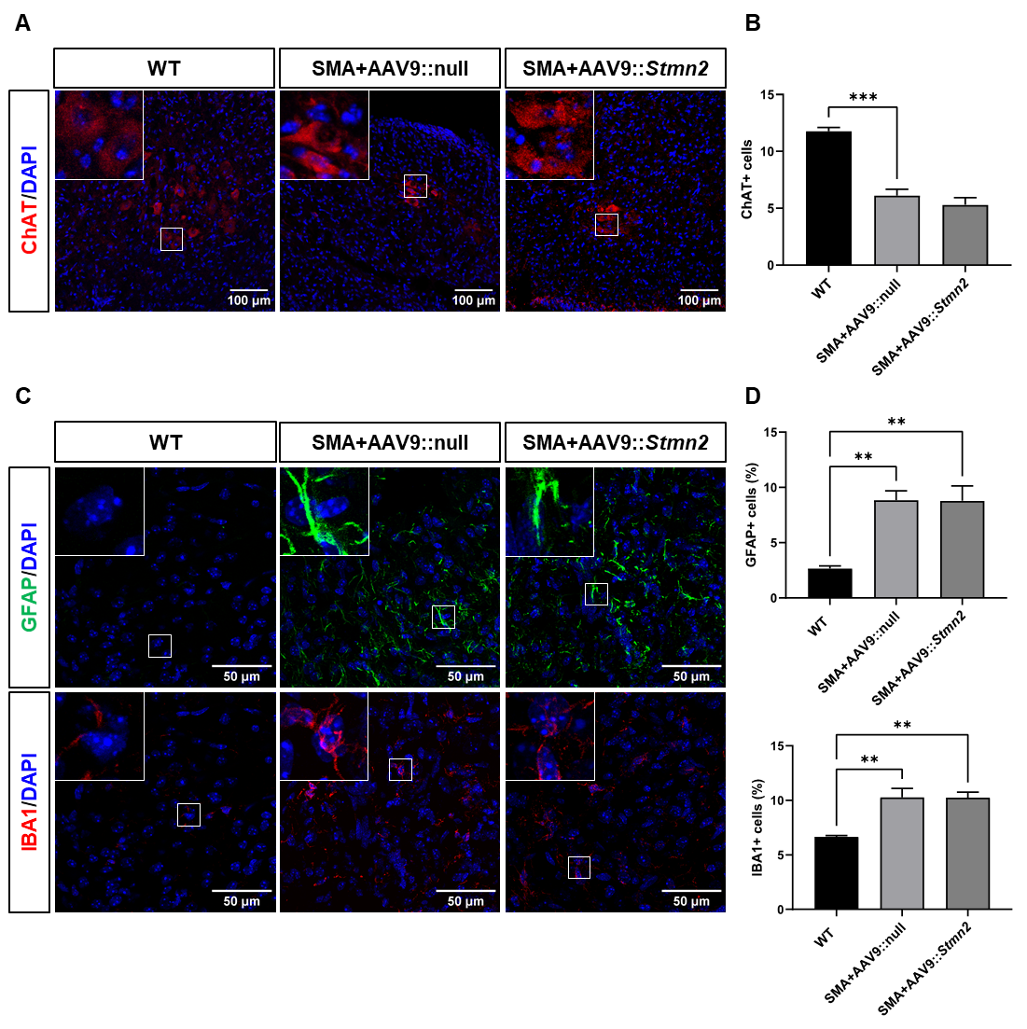
Fig. S4. AAV9::Stmn2 did not ameliorate spinal cord neuropathology in SMA mice. A Representative immunofluorescence images of ventral horn spinal cord of WT, SMA mice treated with AAV9::null and AAV9::Stmn2 at P10 stained for ChAT (red) and DAPI (blue) and acquired with a confocal microscope at 20X magnification. Scale bar = 100 µm. B Count of MN number (n = 6 animals/group) in A expressed as hemi-slice absolute value of ChAT-positive cells mean ± SEM. Statistical significance was determined by one-way ANOVA followed by Tukey’s post-hoc test. C Representative immunofluorescence images of spinal cord of WT, SMA mice treated with AAV9::null and AAV9::Stmn2 at P10 stained for GFAP (up, green) or IBA1 (down, red) and DAPI (blue) and acquired with a confocal microscope at 40X magnification. Scale bar = 50 µm. D Quantification of GFAP- or IBA1-positive cells in C expressed as the percentage of the total number of cells counted (n=3 animals/group). The values are expressed as mean value ± SEM. Statistical significance was determined by one-way ANOVA followed by Tukey’s post-hoc test. **P<0.01, ***P<0.001. All inserts are 4X magnification.
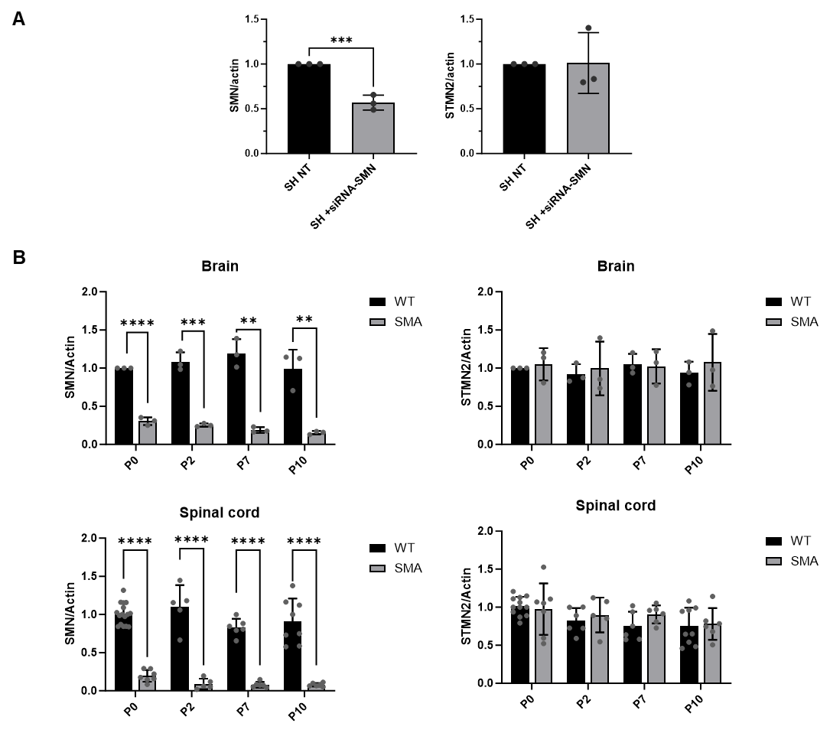

Fig. S5. SMN downregulation does not decrease STMN2 levels in in vitro and in vivo models.
A Quantification of SMN/actin (left) and STMN2/actin (right) on SH-SY5Y cell line untreated (SH NT) and treated with SMN1-siRNA (SH siRNA-SMN) for 72h (15 nM, n = 3 experiment). The values are represented as mean value ± SEM, normalized on the respective untreated sample. Statistical significance was determined by Student’s t-test. B Densitometric quantification of SMN/actin (left) and STMN2/actin (right) of WT and SMA mice (n = 3 animals/group) in brain (up) and spinal cord (down) at different time points (P0, P2, P7, P10). The values are represented as mean value ± SEM. Statistical significance was determined by multiple Student’s t-test. *P<0.05, **P<0.01, ***P<0.001, ****P<0.0001.

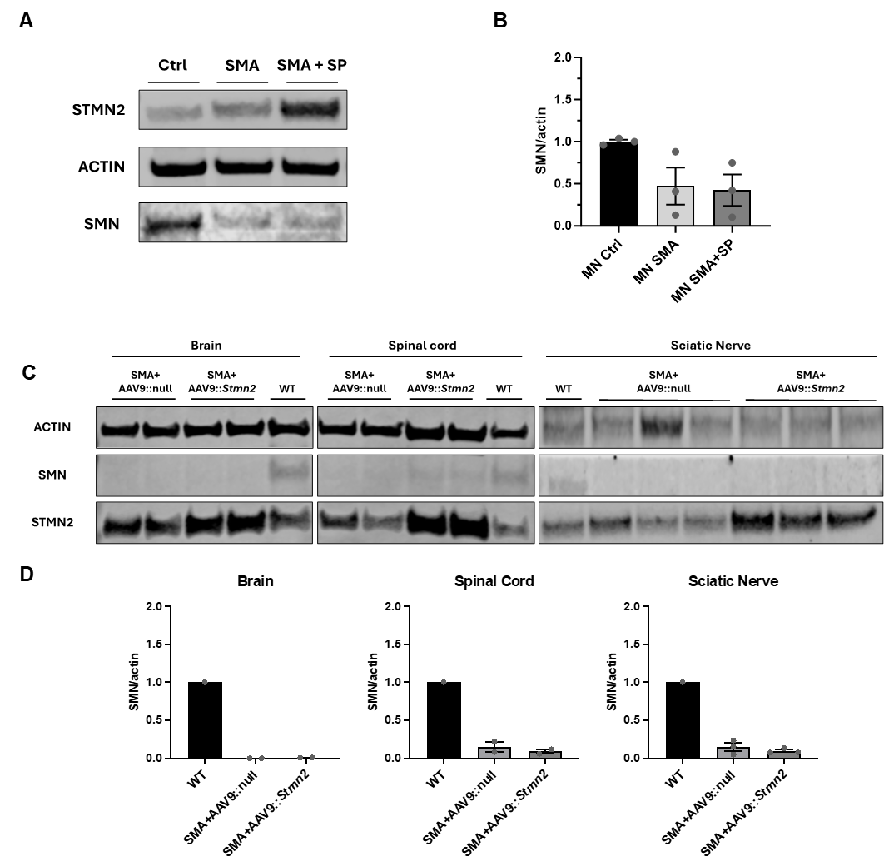
Fig S6. STMN2 overexpression does not modulate SMN levels in in vitro and in vivo models. A Representative Western blot of STMN2 and SMN in Ctrl, SMA and SMA+SP MNs. B Densitometric quantification of SMN/actin levels in A normalized to SMA (n = 3 cell lines/group). C Representative Western blot of STMN2 and SMN in the brain, spinal cord, and sciatic nerves of WT, SMA + AAV9::null and SMA + AAV9::Stmn2 mice at P10. D Densitometric quantification of SMN/actin levels in C normalized to WT mice. The values are represented as mean value ± SEM.

Video S1 AAV9::Stmn2 SMA mice maintain good motor skills. Representative video of SMA mice treated with AAV9::Stmn2 or with AAV9::null at P8.

