Supplementary material
Ketogenic diet induces an inflammatory reactive astrocytes phenotype reducing glioma growth
Journal: Cellular and molecular life science

Maria Rosito^{1,2*}, Javeria Maqbool¹, Alice Reccagni¹, Micol Mangano¹, Tiziano D’Andrea³, Arianna Rinaldi¹, Giovanna Peruzzi², Beatrice Silvestri^{2,4}, Alessandro Rosa^{2,4}, Flavia Trettel¹, Giuseppina D’Alessandro^{1,3}, Myriam Catalano¹, Sergio Fucile^{1,3}, Cristina Limatola^{3,5 *} .

¹Department of Physiology and Pharmacology, Sapienza University, Rome, Italy
² Center for Life Nanoscience & Neuroscience Istituto Italiano di Tecnologia@Sapienza, Rome, Italy;
³IRCCS Neuromed, Pozzilli, IS, Italy;
⁴Department of Biology and Biotechnologies "Charles Darwin", Sapienza University of Rome, Rome, Italy.
⁵Department of Physiology and Pharmacology, Sapienza University, Laboratory affiliated to Institute Pasteur Italia – Rome, Italy.
* Corresponding authors:
Cristina Limatola, Department of Physiology and Pharmacology, Sapienza University, P.le Aldo Moro 5, 00185, Rome, Italy; cristina.limatola@uniroma1.it
Maria Rosito, Department of Physiology and Pharmacology, Sapienza University, P.le Aldo Moro 5, 00185, Rome, Italy; maria.rosito@gmail.com

Fig.S1: Effect of the ad libitum feeding on tumor growth and body weight
A) Bar plot showing tumor size in SD, CD and KD mice, n = 5-6. Data are presented as the mean ± SEM *p <0.05, One-way ANOVA - Dunnett’s multiple comparison test. Lower pictures: Representative images of brain coronal slices, scale bar = 1 mm. B) Body weight measurements of SD, CD and KD GL261 bearing mice. n = 5-6 Data are presented as the mean ± SEM. SD vs KD: § p < 0.05; CD vs KD: ** p < 0.005; *** p < 0.001. One-way ANOVA – Tukey’s multiple comparison test, evaluated on days 6, 14, and 20.

Fig. S2: Transcriptional expression of monocarboxylate transporters and ketolytic enzymes
A) Bar plot showing the MTT assay on CT2a cells stimulated with different β-HB concentrations Data are presented as the mean ± SEM *** p < 0.001. One-way ANOVA - Dunnett’s multiple comparison test versus time 0. B) RT-qPCR from GL261 mRNA. Gene expression of Mct2 and Mct4 is normalized to the housekeeping gene Gapdh, n = 6 to 7 samples pulled from 3 independent experiments. Data are presented as the mean ± SEM. C) RT-qPCR from GL261 mRNA. Gene expression of Bdh1, Bdh2, and Oxct1 is normalized to the housekeeping gene Gapdh, n = 6 to 7 samples pulled from 3 independent experiments. Data are presented as the mean ± SEM. D) RT-qPCR from astrocytes mRNA. Gene expression of Mct2 and Mct4 and E) Bdh1, Bdh2, and Oxct1 are normalized to the housekeeping gene Gapdh, n = 6 to 7 samples pulled from 3 independent experiments. Data are presented as the mean ± SEM. F) RT-qPCR from microglia mRNA. Gene expression of Mct2 and Mct4 and G) Bdh1, Bdh2, and Oxct1 are normalized to the housekeeping gene Gapdh, n = 4 to 7 samples pulled from 3 independent experiments. Data are presented as the mean ± SEM * p < 0.05 ** p < 0.005 *** p < 0.001 Two-way ANOVA. Fisher’s LSD test.

Fig. S3: Astrocytes phenotyping upon β-HB administration
A) RT-qPCR from astrocytes with or without β-HB and GCM administration showing the relative expression of pro-inflammatory and (B) anti-inflammatory genes. Gene expression is normalized to the housekeeping gene Gapdh. Data are presented as the mean ± SEM n = 7 to 16 mice pulled from 4 independent experiments. *** p <0.001** p <0.01; Two-way ANOVA, Fisher’s LSD test.
C) Gate strategy for isolation of glioma cells based on luciferase expression level. Luciferase positive cells were sorted according to the represented gating strategy for a representative sample. Dot plot show an initial glioma cell population (4%) isolated for luciferase expression levels (FITC signal, 68%). Green dot plot on the left show the final purity of the sorted cells.

Fig. S4: Microglia/macrophages phenotyping upon KD and β-HB administration
A) RT-qPCR from Cd11b⁺ cells isolated from CD and KD tumoral hemisphere reveals transcriptional expression levels of pro-inflammatory and B) anti-inflammatory genes. Gene expression is normalized to the housekeeping gene Gapdh. Data are presented as the mean ± SEM n = 4 to 8 mice pulled from two independent experiments. ** p <0.01; *p <0.05, Student’s t-test. C) RT-qPCR from primary microglia with or without β-HB and GCM administration showing the relative expression of pro-inflammatory and D) anti-inflammatory genes. Gene expression is normalized to the housekeeping gene Gapdh. Data are presented as the mean ± SEM n = 4 to 9 samples pulled from 3 independent experiments. *** p <0.001** p <0.01 *p <0.05; Two-way ANOVA, Fisher’s LSD test.

Fig. S5 Effect of MCM and β-HB on GL261 proliferation
A) Scatter dot plot showing the MTT assay on GL261 cells in the presence of MCM and β-HB. Data are presented as the mean ± SEM n = 16 to 18 samples pulled from 3 independent experiments. ** p <0.01 *p <0.05; One-way ANOVA, Tukey’s multiple comparison test.

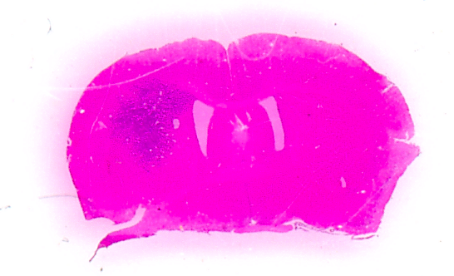
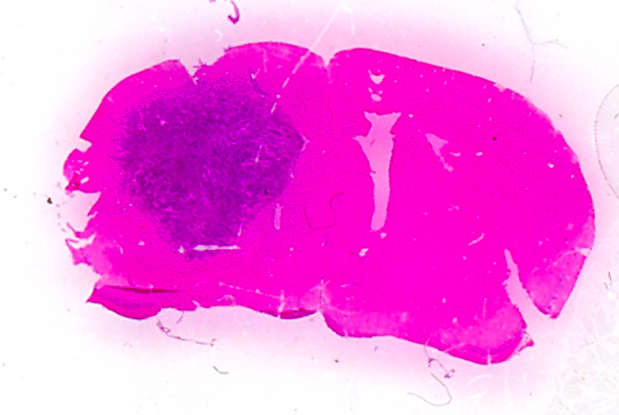
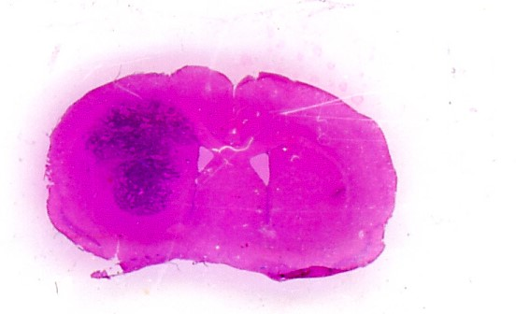
Rosito et al., Fig. S1
Weeks of diet
BW (gr)
A

B
Mct2 Mct4
- + - + - + - + 𝛽-HB
- - + + - - + + GCM
A
B
Bdh1 Bdh2 Oxct1
Ctrl
β-HB
Mct2 Mct4
- + - + - + - + - + - + 𝛽-HB
- - + + - - + + - + - + GCM
Bdh1 Bdh2 Oxct1
C
D
E
G
F
Mct2 Mct4
Bdh1 Bdh2 Oxct1
- + - + - + - + 𝛽-HB
- - + + - - + + GCM
0 48 72 96 h
CT2a
- + - + - + - + - + - + 𝛽-HB
- - + + - - + + - + - + GCM
GL261
Astrocytes
Microglia
GL261
Astrocytes
Microglia
Rosito et al., Fig. S2

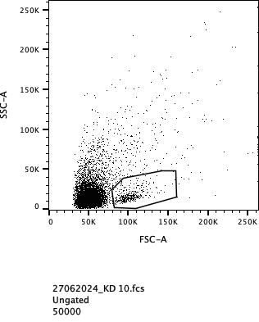
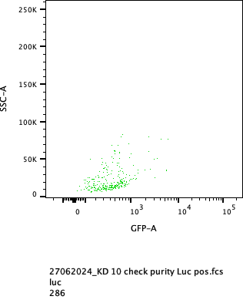
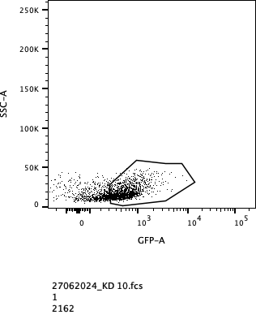
SSC
FITC
SSC
FSC
SSC
FITC
Luc+
4%
luc+ cells
68%
S100a10 Ptx3 Emp1
- + - + - + - + - + - + 𝛽-HB
- - + + - - + + - - + + GCM
B
anti-inflammatory genes
- + - + - + - + - + - + 𝛽-HB
- - + + - - + + - - + + GCM
C3 Amigo2 Srgn
A
pro-inflammatory genes
C
Rosito et al., Fig. S3

A
pro-inflammatory genes
anti-inflammatory genes
Il1𝛽 Tnf⍺ iNos Il6 Il1⍺
Chil3 Arg1 Fizz1 CD206 Tgf𝛽 Il10
Chil3 Arg1
Il1𝛽 Tnf⍺ iNos
- + - + - + - + - + - + 𝛽-HB
- - + + - - + + - - + + GCM
- + - + - + - + 𝛽-HB
- - + + - - + + GCM
B
C
D
CD
KD
Rosito et al., Fig. S4

A
Rosito et al., Fig. S5
Table 1 Diets composition and analytical components
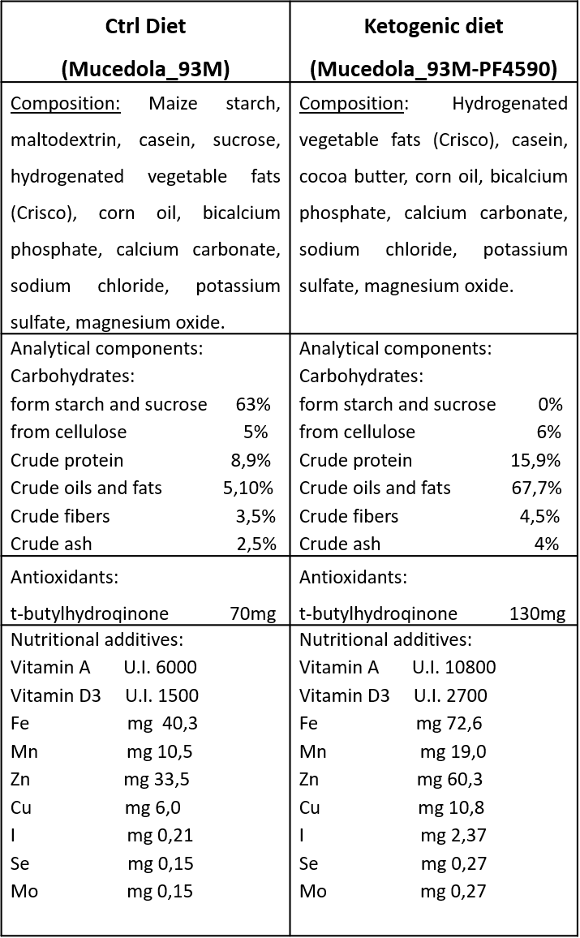
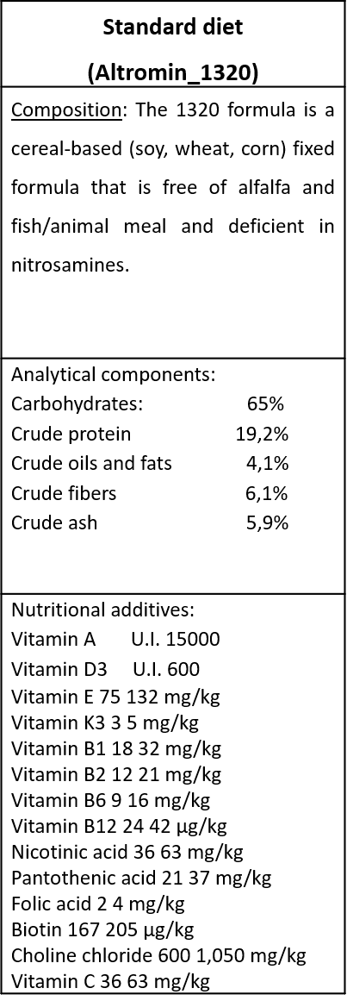
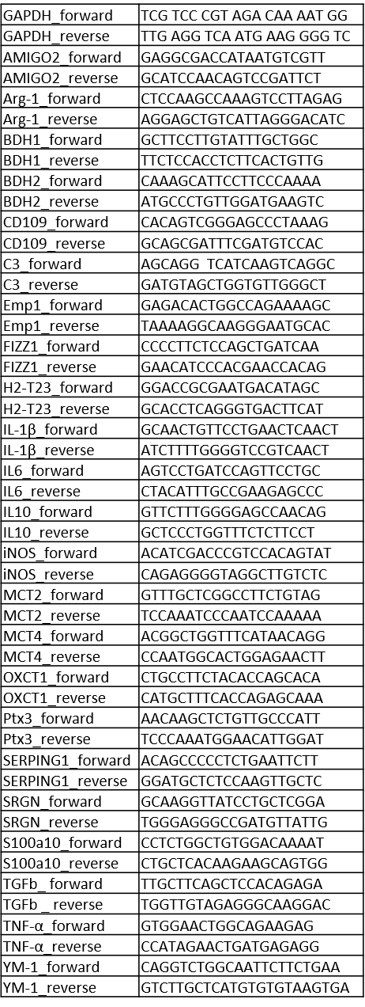
Table 2 List of oligoes

