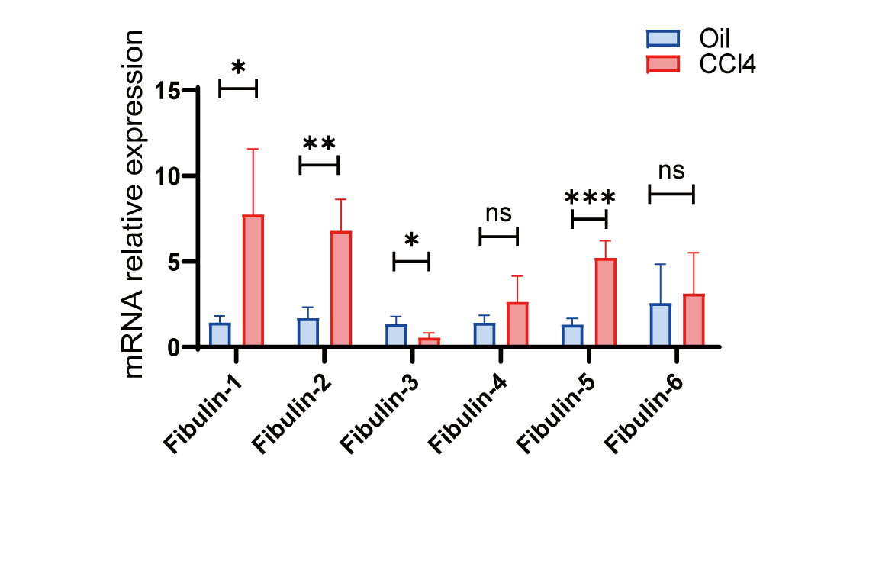
Figure. S1 Gene expression levels of Fibulin family in liver fibrosis mice models treated by CCl₄. Among Fibulin family, the expression of Fibulin-1 showed the most significant increase than Fibulin-2 or Fibulin-5 in fibrosis stage, while the level of Fibulin-3 was down-regulated. Data are presented as the mean ± SEM. Statistical analysis was performed by unpaired two-tailed Student's t-test (*P < 0.05, **P < 0.01).

Figure. S2 Representative images of HE, Masson trichrome, Reticular fiber staining and Fibulin-1 immunohistochemical staining of liver tissue from cirrhosis patients with MASH (n=2) or HBV (n=2).

Figure. S3 qPCR analysis for Fibulin-1, Acta-2, Elastin and Col1α1 in 3T3 cells with transfection of siFibulin-1. Data are presented as the mean ± SEM. Statistical analysis was performed by unpaired two-tailed Student's t-test (*P < 0.05, **P < 0.01).

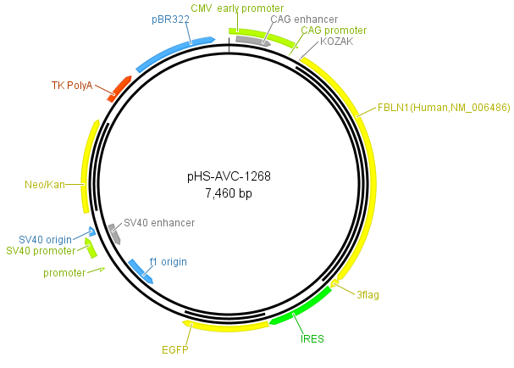
Figure. S4 Map of Fibulin-1 overexpression plasmid.

Figure. S5 Immunofluorescent staining of EGFP (green, represented for AAV8 ) and α-SMA (red, represented for HSCs) in liver slices from fibrosis mice treated with AAV8. Co-localization of EGFP (green) and α-SMA (red) is shown as yellow.

Figure. S6 Determination of the concentration of SB203580. Western blot analysis (A) and quantification (B) of p-p38 and p38 with different concentrations of SB203580.

Figure. S7 CCK-8 analysis for cell viability with different concentrations of SB203580 (A), siRNA (B) and overexpression plasmid transfection (C).

Figure. S8 It showed no effect on HSC activation by culture with elastin and recombinant Fibulin-1C protein. (A) Schematic flow of the elastin/Fibulin-1C-coated plates. (B) qPCR analysis for Fibulin-1, Acta-2, Elastin and Col1α1 in LX-2 cells coated by elastin with or without Fibulin-1C. Data are presented as the mean ± SEM. Statistical analysis was performed by unpaired two-tailed Student's t-test and one-way ANOVA followed by Tukey's post hoc test (*P < 0.05, **P < 0.01).

