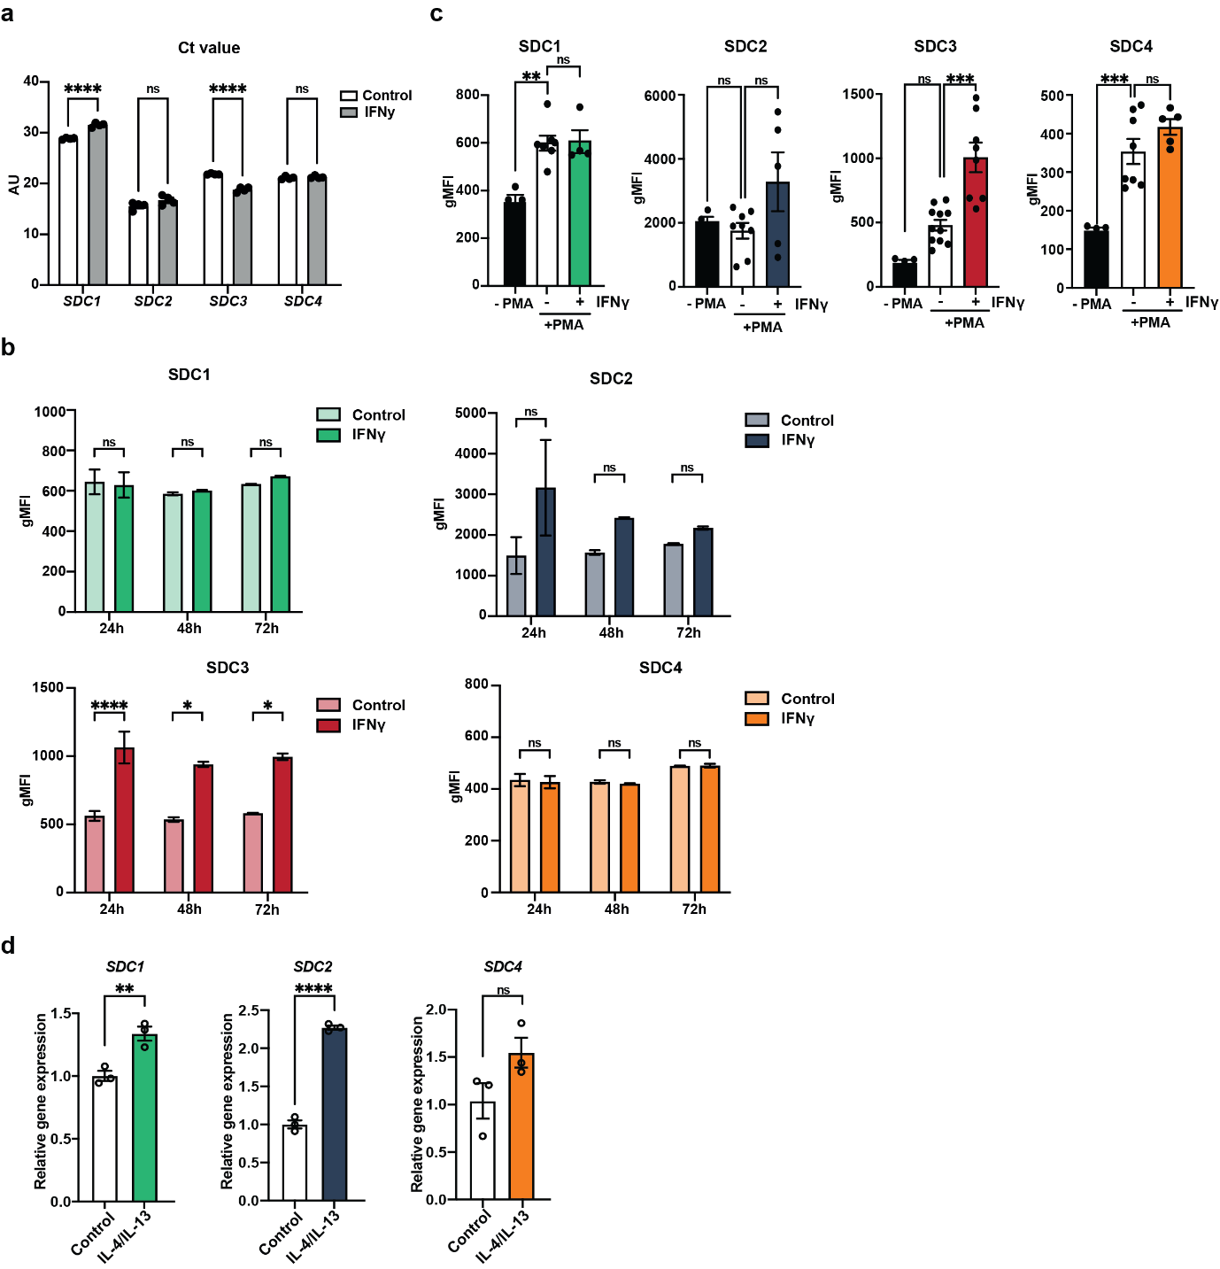
Supplementary Figure 1. SDC3 is upregulated at the gene and protein levels in response to IFNγ. (a) Ct levels of SDC1, SDC2, SDC3 and SDC4 mRNA in control and IFNγ-treated THP-1 macrophages, as assessed by RT-qPCR (n=4-6). (b) Flow cytometry data showing the expression of SDC1, SDC2, SDC3 and SDC4 in control and IFNγ-treated THP-1 macrophages at the indicated time-points (n=3). (c) Flow cytometry data showing the expression of SDC1, SDC2, SDC3 and SDC4 in undifferentiated monocytes and control and IFNγ-treated THP-1 macrophages (n=4-11). (d) SDC1, SDC2, and SDC4 mRNA levels in IL-4/IL-13-treated macrophages, as assessed by RT-qPCR (n=3). Means ± SEM. Statistically significant difference from controls or between indicated groups is shown by ns: not significant, *p<0.05, **p<0.01, ***p<0.001 and ****p<0.0001.

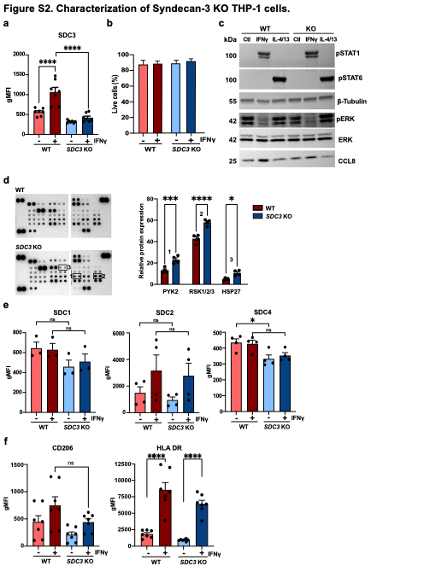

Supplementary Figure 2. Characterization of SDC3 KO THP-1 macrophages. (a) Expression of SDC3 in WT or SDC3 KO THP-1 macrophages stimulated with 100 ng/ml of IFNγ, as quantified by flow cytometry (n=7). (b) Percentage of live WT or SDC3 KO THP-1 macrophages stimulated with 100 ng/ml of IFNγ (n=3). (c) Representative immunoblots (n=3) of WT or SDC3 KO THP-1 macrophages stimulated with either 100 ng/ml of IFNγ or 20 ng/ml of IL-4/IL-13 cocktail. (d) Representative phospho-kinase array of WT or SDC3 KO THP-1 macrophages stimulated with 100 ng/ml of IFNγ (left) and quantification of top 3 differentially expressed hits (right). (e) Expression of SDC1, SDC2 and SDC4 in WT or SDC3 KO THP-1 macrophages stimulated with 100 ng/ml of IFNγ, as quantified by flow cytometry (n=3-4). (f) Flow cytometry data showing the expression of CD206 and HLA-DR in WT or SDC3 KO THP-1 macrophages stimulated with 100 ng/ml of IFNγ (n=7). Means ± SEM. Statistically significant difference from controls or between indicated groups is shown by ns: not significant *p<0.05, ***p<0.001 and ****p<0.0001.

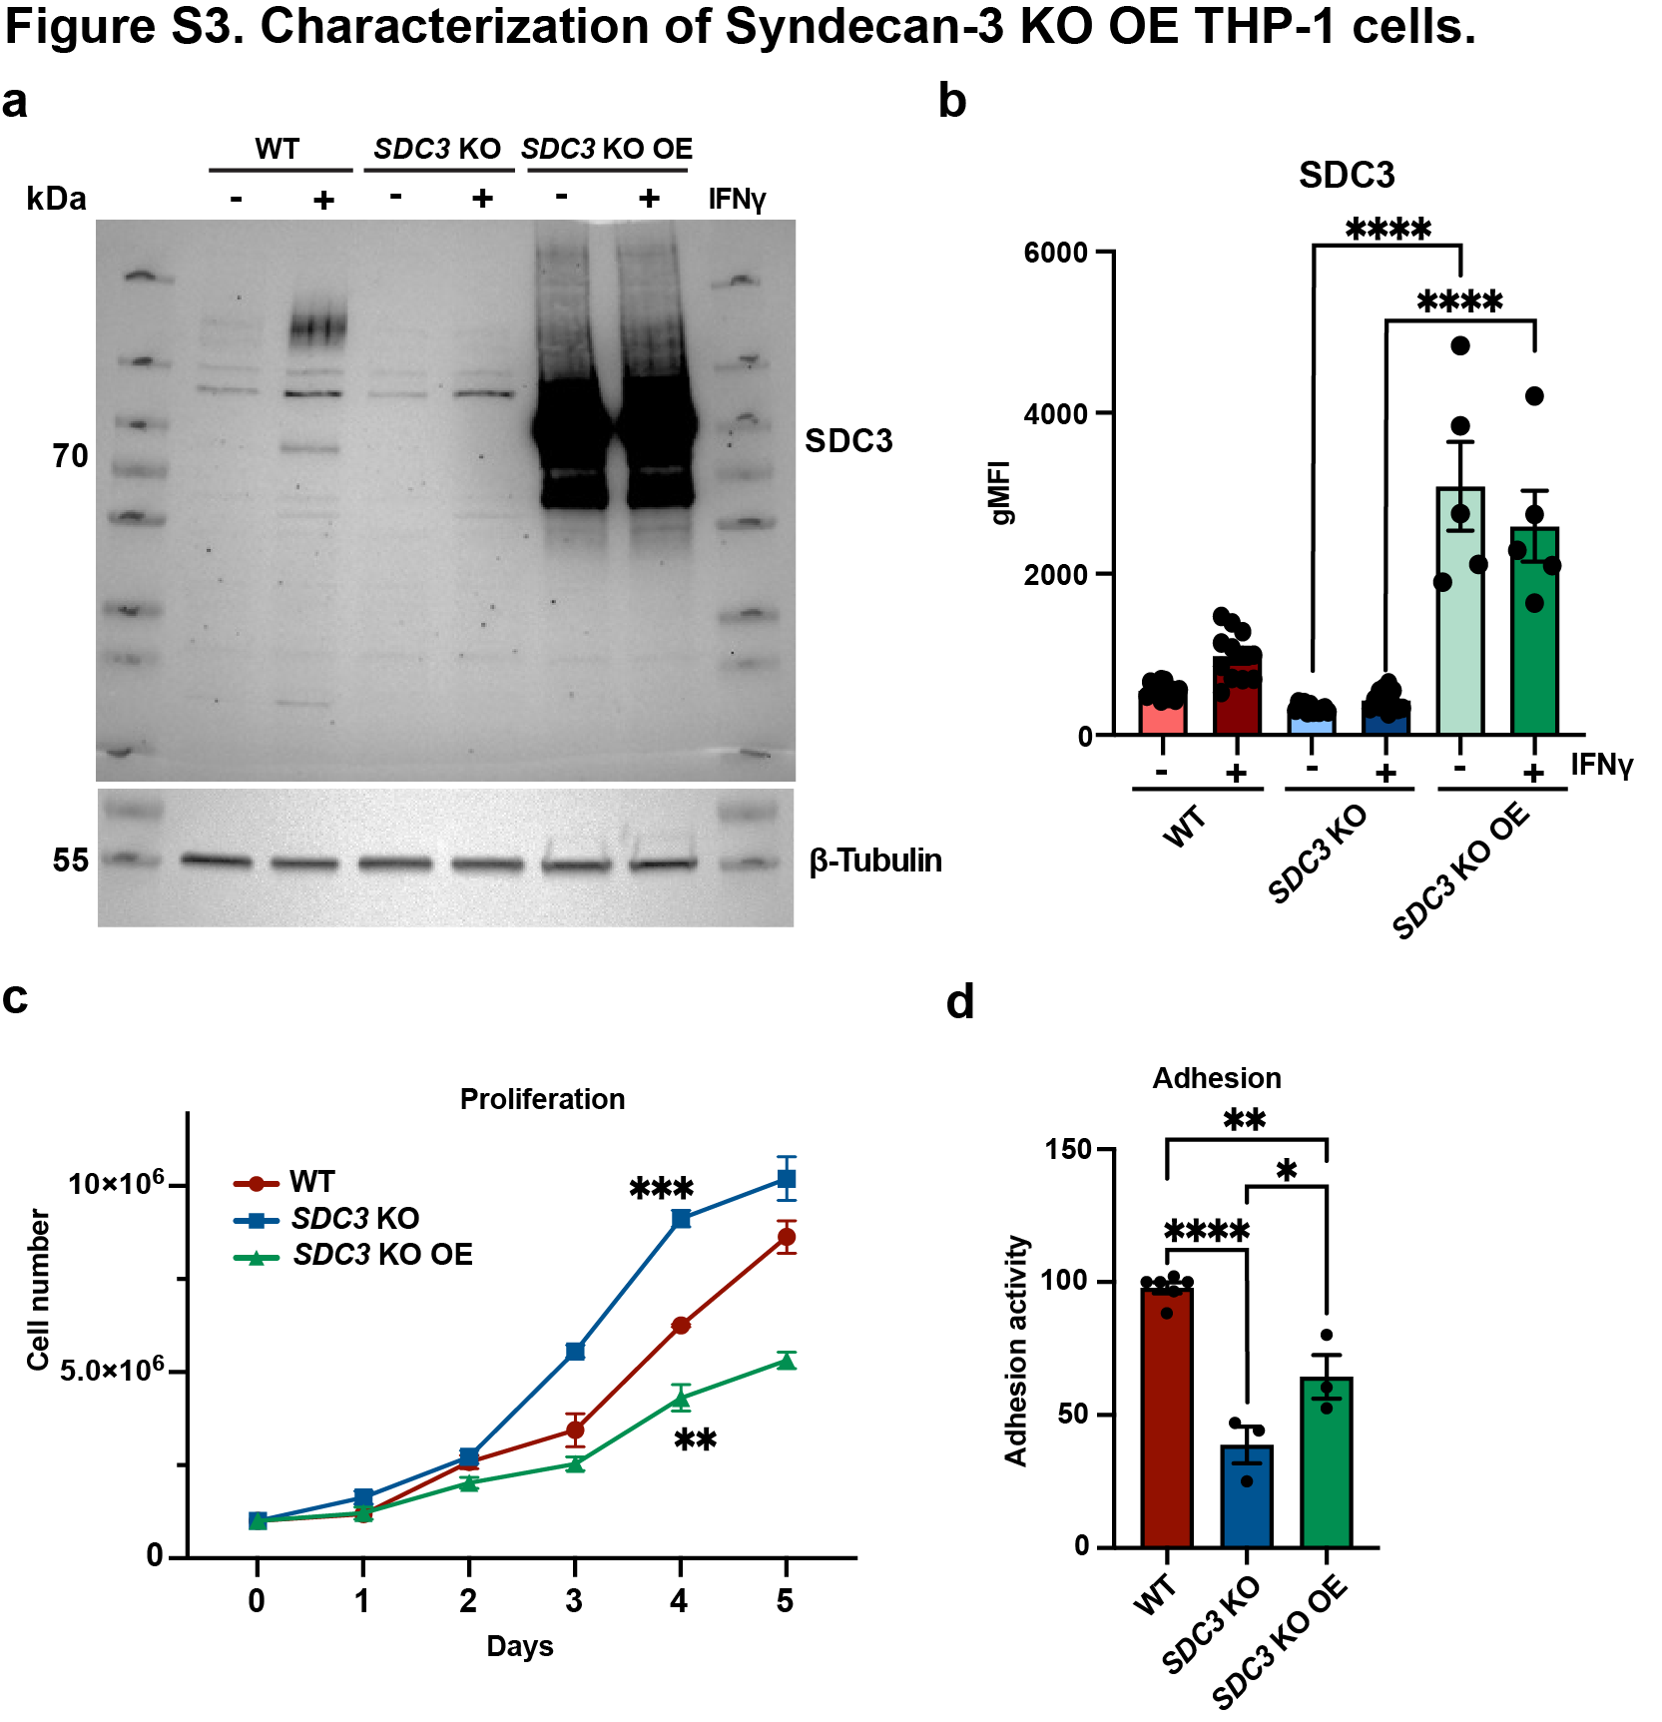

Supplementary Figure 3. Characterization of SDC3 KO OE cells. (a) Representative immunoblots (n=3) of WT, SDC3 KO and SDC3 KO OE THP-1 macrophages under control or 100 ng/ml of IFNγ stimulation. (b) Expression of SDC3 in WT, SDC3 KO and SDC3 KO OE THP-1 macrophages stimulated with 100 ng/ml of IFNγ, as quantified by flow cytometry (n=5-7). (c) Proliferation of WT, SDC3 KO and SDC3 KO OE THP-1 cells up to 5 days (n=3). (d) Adhesion activity of WT, SDC3 KO and SDC3 KO OE THP-1 macrophages, as quantified by Crystal Violet (n=3-6). Means ± SEM. Statistically significant difference from controls or between indicated groups is shown by *p<0.05, **p<0.01, ***p<0.001 and ****p<0.0001.

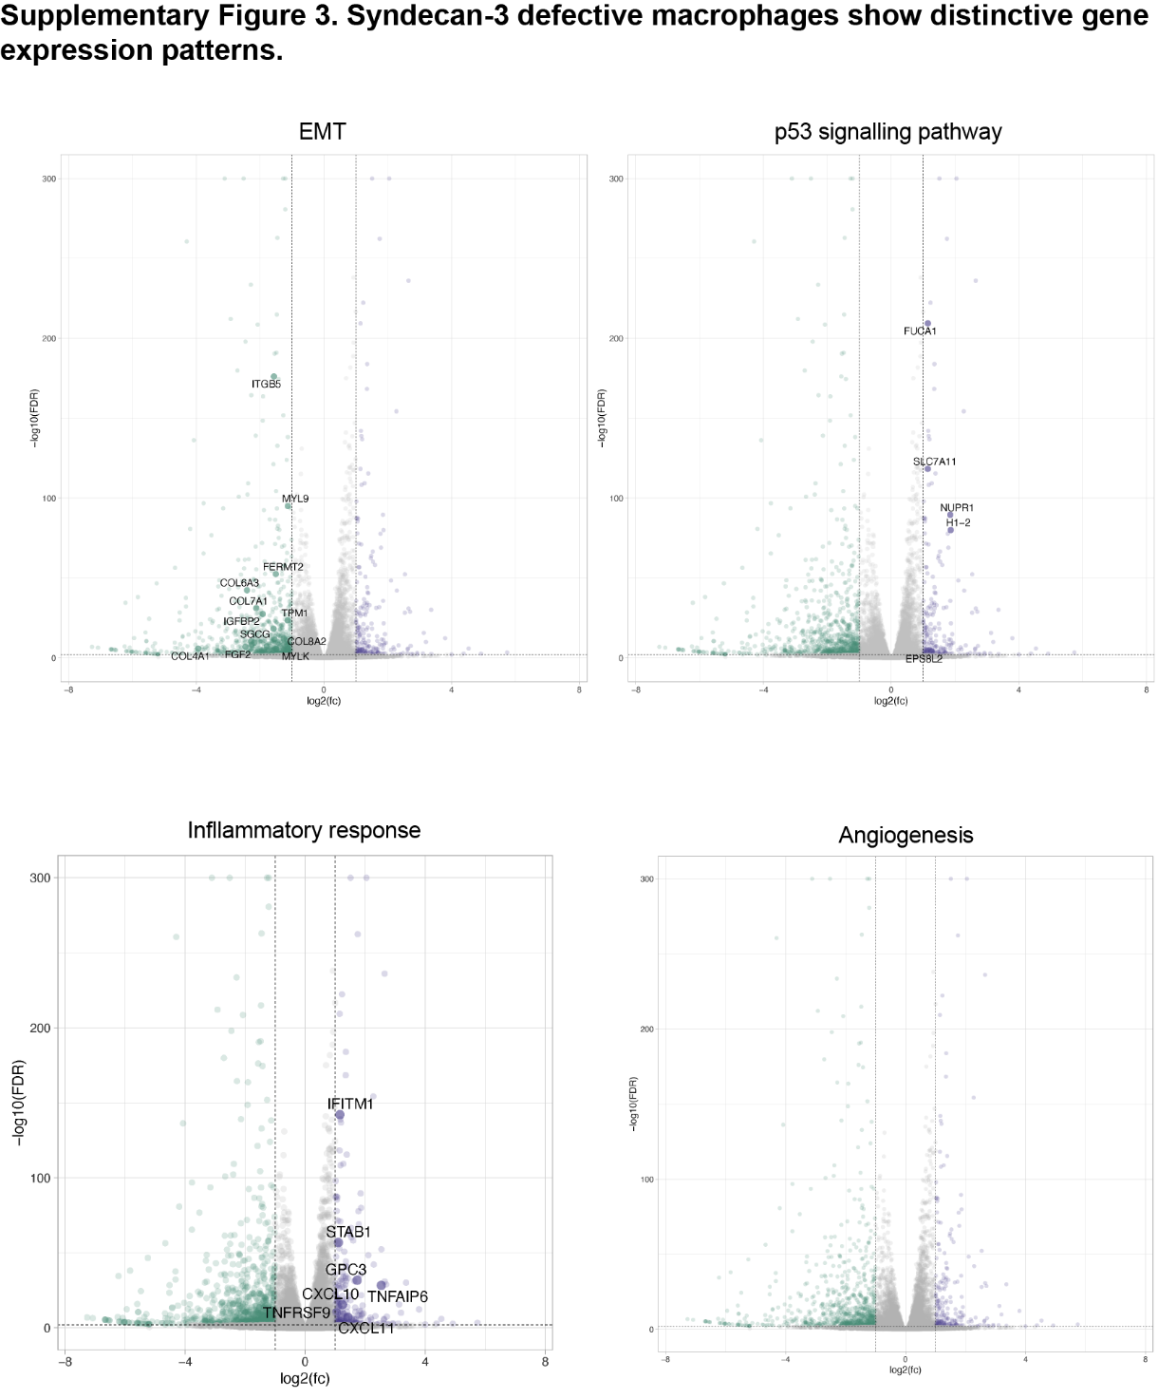

Supplementary Figure 4. SDC3 KO macrophages exhibit changes in pathways related to tumour progression, inflammation and angiogenesis. Volcano plots showing differentially expressed pathways in IFNγ-treated THP-1 WT and SDC3 KO macrophages. Most significantly dysregulated proteins are explicitly indicated (n=3, purple represents upregulation and green represents downregulation).

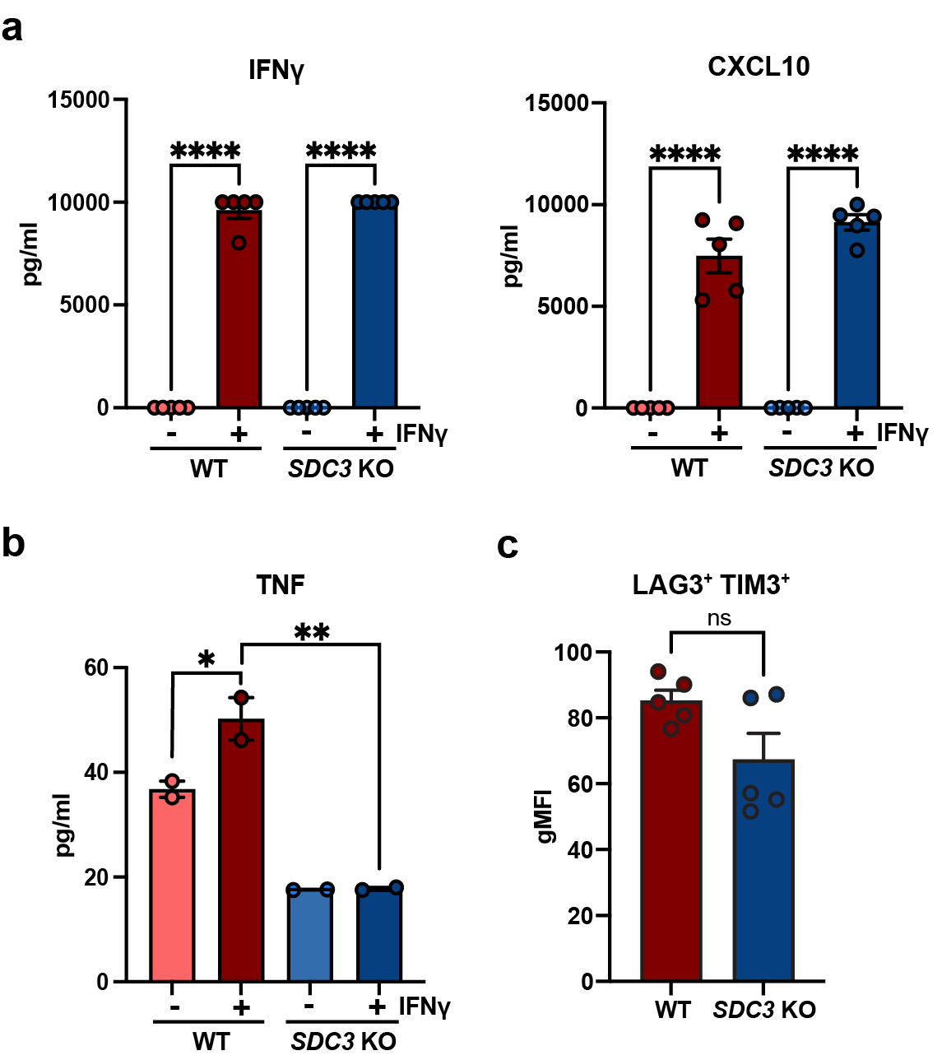
Supplementary Figure 5. SDC3 deficient macrophages show altered protein secretion. (a) Cytokine quantification in cell supernatants from WT or SDC3 KO THP-1 macrophages stimulated with 100 ng/ml of IFNγ, using the LEGENDplex™ HU Essential Immune Response Panel (n=5). (b) TNF quantification by ELISA in the supernatants of WT or SDC3 KO THP-1 macrophages stimulated with 100 ng/ml of IFNγ (n=2). (c) Quantification of co-expression of T cell activation markers LAG3 and TIM3 by flow cytometry in CD8⁺ T cells co-cultured with IFNγ-treated WT or SDC3 KO THP-1 macrophages (n=5). Means ± SEM. Statistically significant difference from controls or between indicated groups is shown by ns: not significant, *p<0.05, **p<0.01 and ****p<0.0001.

Supplementary Table 1. List of flow cytometry antibodies.

Target protein | Fluorochrome | Company | Cat. number
Syndecan-1(CD138) | BV421 | BD | 565943
Syndecan-2 | PE | R&D Systems | 2965P
Syndecan-3 | APC | R&D Systems | 3539A
Syndecan-4 | Alexa488 | R&D Systems | 29181G
CD11b | APC | BD | 550019
CD11b | FITC | INVITROGEN | 101205
CD16 | APC-H7 | BD | 560192
HLA-DR | BV711 | BioLegend | 307643
CD86 | PE | BD | 555665
CD40 | BV605 | BD | 740410
CD206 | BV786 | BD | 740999
PDL1 | PE-Cy7 | BD | 558017
CD163 | BUV737 | BD | 741863
CD95 | BV711 | BD | 305643
CD8 | BUV396 | BD | 563795
CD4 | BUV805 | BD | 612887
CD45RO | APC | BD | 559865
CD45RA | BV786 | BD | 563870
PD1 | BV421 | BD | 562516
CD62L | BV650 | BD | 304831
TIM3 | PE-Cy7 | BioLegend | 345013
LAG3 | PE-Dazzle 594 | BioLegend | 369332

Supplementary Table 2. List of primers for RT-qPCR.

Gene | Forward sequence (5´-3´) | Reverse sequence (5´-3´)
SDC1 | GAAGATCAAGATGGCTCTGGG | GTTCTGGAGACGTGGGAATAG
SDC2 | CCAGCCGAAGAGGATACAAATG | TCTCATGCGATACACCAACAG
SDC3 | AACTGGATGACCTCTACTCGGGGTCGGG | CTCCAGGGTGGGGCGCTCAGAGGGGAGCTCT
SDC4 | CCACCGAACCCAAGAAACTA | TGGGGGCTTTCTTGTAGATG
TNF | CTCTTCTGCCTGCTGCACTTTG | ATGGGCTACAGGCTTGTCACTC
PD-L1 | ACCTGGCTGCACTAATTGTCT | GGGAGAGCTGGTCCTTCAAC
IL10 | TCTCCGAGATGCCTTCAGCAGA | TCAGACAAGGCTTGGCAACCCA
VEGFA | TTGCCTTGCTGCTCTACCTCCA | GATGGCAGTAGCTGCGCTGATA
CD86 | CCATCAGCTTGTCTGTTTCATTCC | GCTGTAATCCAAGGAATGTGGTC
iNOS | TTCAGTATCACAACCTCAGCAAG | TGGACCTGCAAGTTAAAATCCC

