Supplementary Materials
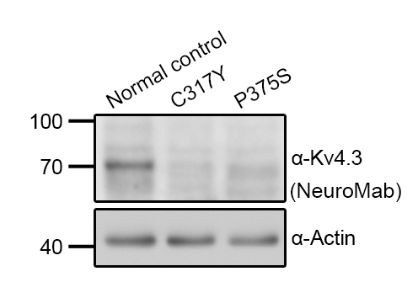
Supplementary Figure S1 Representative immunoblot comparing endogenous Kv4.3 protein level in human fibroblast cells collected from a normal subject and the indicated patients with a monoclonal mouse anti-K_{V}4.3 antibody (NeuroMab).

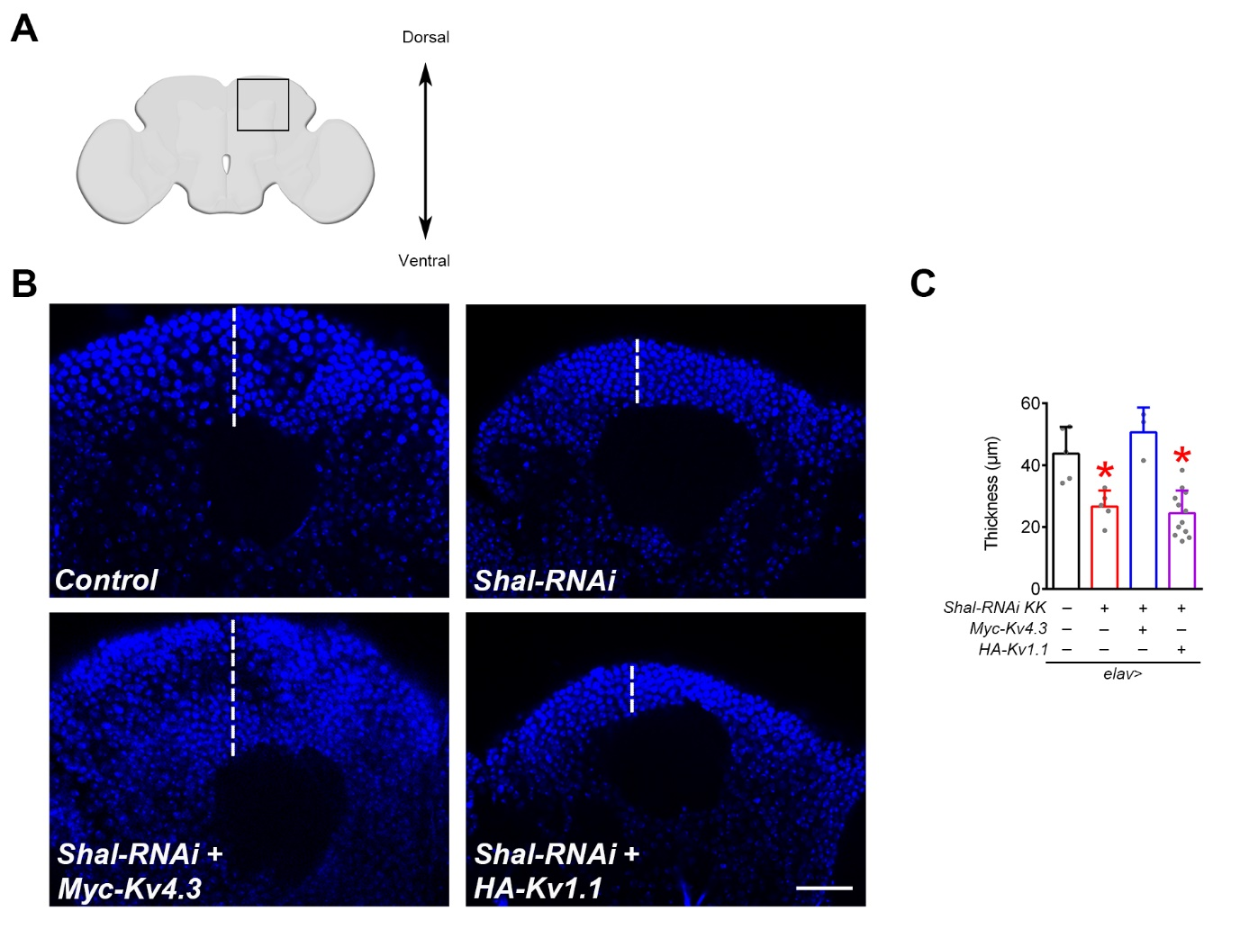
Supplementary Figure S2 Human K_{V}4.3 rescues brain cortex deficit in Shal-deficient flies. A Schematic drawing of the cross section of the fly brain in the head. The black box highlights the region of interest in the dorsal external cortex of the central brain chosen for confocal microscopic imaging. B Representative DAPI fluorescent images of the cortical neurons in control fly, transgenic elav> Shal-RNAi KK fly, and transgenic elav> Shal-RNAi KK fly with pan-neuronal (elav-GAL4-driven) overexpression of human K_{V}4.3 (Myc-K_{V}4.3) or Kv1.1 (HA-K_{V}1.1). White dashed lines refer to the corresponding cortical region for assessing the thickness of the brain cortex. Scale bar, 25 μm. C Quantification of the maximal cortical thickness of 3 days post-eclosion adult flies. Brain cortex thickness (in μm) (n = 3-12): elav> Control, 43.73±3.84; elav> KK, 26.65±2.30; elav> KK & K_{V}4.3, 50.63±4.61; elav> KK & K_{V}1.1, 24.47± 2.12. Asterisks denote significant differences from the cognate elav> Control (*, P < 0.05).

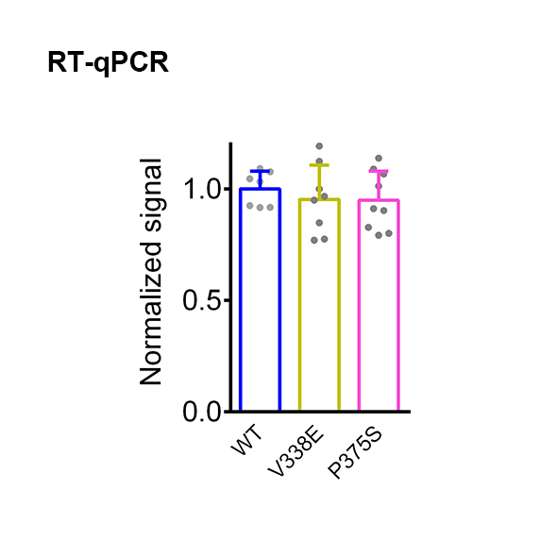
Supplementary Figure S3 Comparable mRNA levels of K_{V}4.3 WT, V338E, and P375S. K_{V}4.3 WT and mutants were expressed in HEK293T cells. RNA extracted from HEK293T cells was reverse transcribed into cDNA, followed by qPCR analyses (n=7-9).

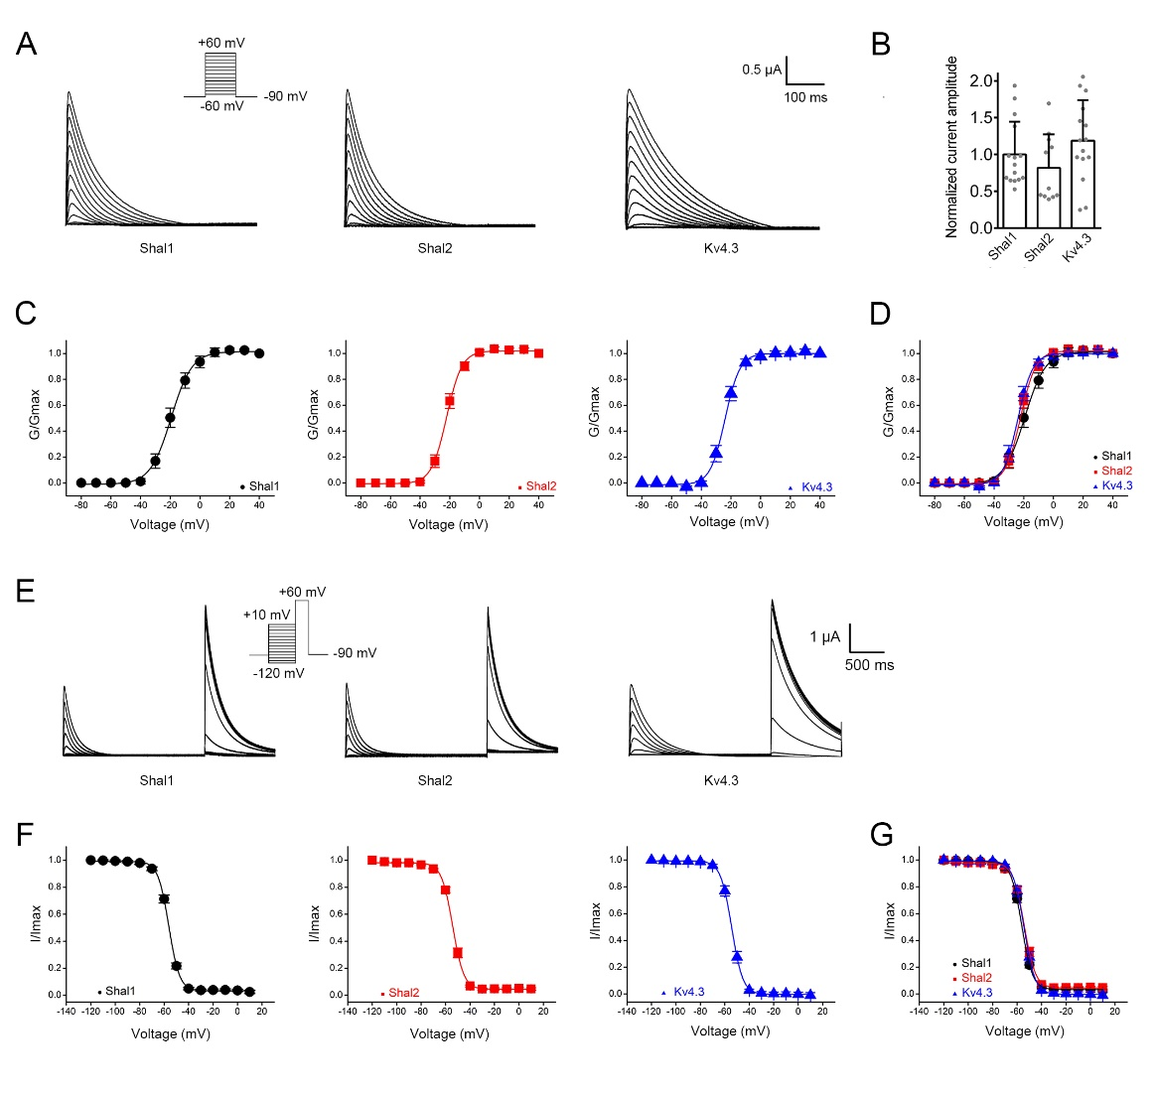
Supplementary Figure S4 Functional similarity of Drosophila Shal and human K_{V}4.3 channels in Xenopus oocytes. A Representative Shal1, Shal2, and K_{V}4.3 K⁺ current traces in response to the indicated pulse protocol for analyzing voltage-dependent activation. B Quantification of relative K⁺ current amplitudes at +60 mV. C-D Steady-state activation curves of Shal1 (black), Shal2 (red), and Kv4.3 (blue) channels. E Representative Shal1, Shal2, and K_{V}4.3 K⁺ current traces in response to the indicated pulse protocol for analyzing voltage-dependent inactivation. F-G Steady-state inactivation curves of Shal1 (black), Shal2 (red), and Kv4.3 (blue) channels. Solid lines in the activation and inactivation curves represent Boltzmann equation fits to the data points. See the Methods section for more details on the analyses of voltage gating properties.

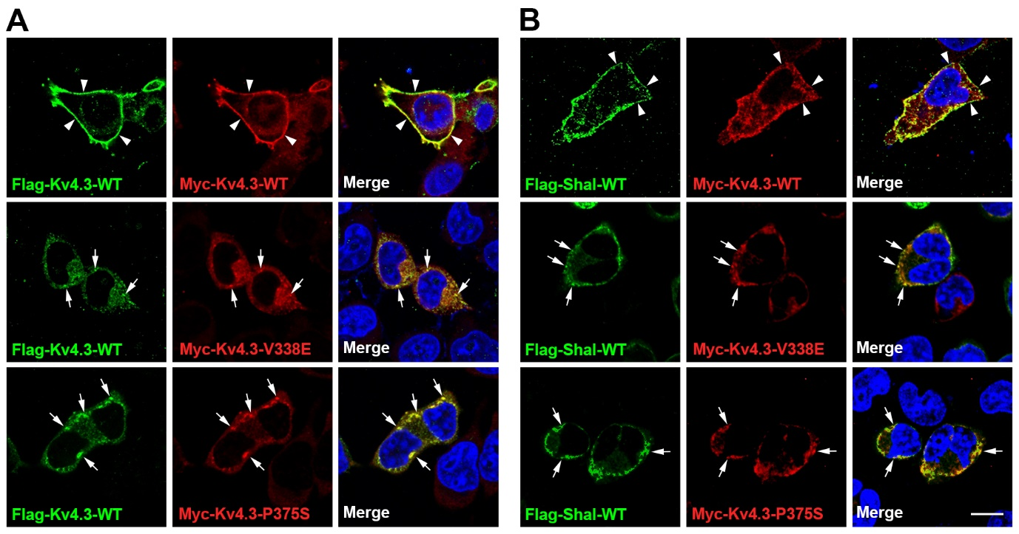
Supplementary Figure S5 Reduced cell-surface localization of wild-type K_{V}4.3 (A) and Shal (B) in the presence of the SCA19/22-causing K_{V}4.3 mutants. Representative immunofluorescent images of HEK293T cells coexpressing Flag‐K_{V}4.3-WT or Flag-Shal1-WT with Myc-K_{V}4.3-WT, Myc-K_{V}4.3-V338E, or Myc-K_{V}4.3-P375S. Fluorescent signals of Flag-K_{V}4.3/Shal1 (green), Myc-K_{V}4.3-WT/V338E/P375S (red), and the nuclear counterstain DAPI (blue) were acquired with confocal microscopy. Arrowheads and arrows represent plasma membrane and cytoplasm/ER‐localization, respectively. Scale bar, 10 μm.

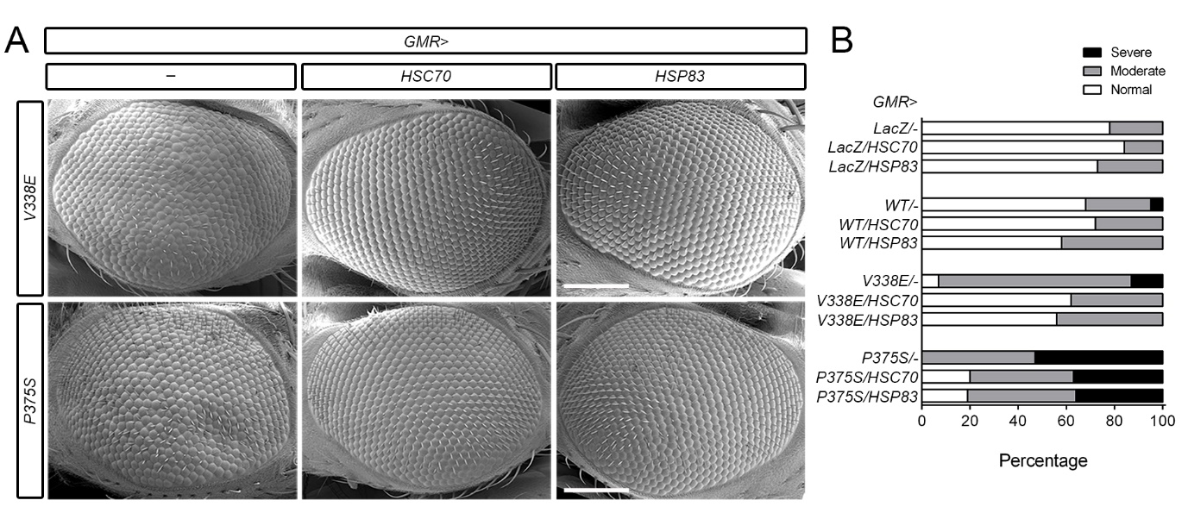
Supplementary Figure S6 Improvement of ommatidia morphology by HSC70 and HSP83 in transgenic SCA19/22 flies. Effect of eye-specific GMR-GAL4-driven (GMR>) overexpression of HSC70/HSP83 on the compound eye morphology of 35-day-old GMR-driven transgenic K_{V}4.3 V338E and P375S adult flies. Also analyzed were age-matched GMR-driven Control (−) and LacZ-expressing flies. A Representative SEM images of fly compound eyes. Scale bars, 100 μm. B Quantification of the extent of deformity in the fly compound eye. Classification of fly eye morphology was based on the criteria depicted in Figure 6A. Note that GMR-driven HSC70/HSP83 overexpression resulted in enhanced presence of normal ommatidia in transgenic V338E and P375S flies.

