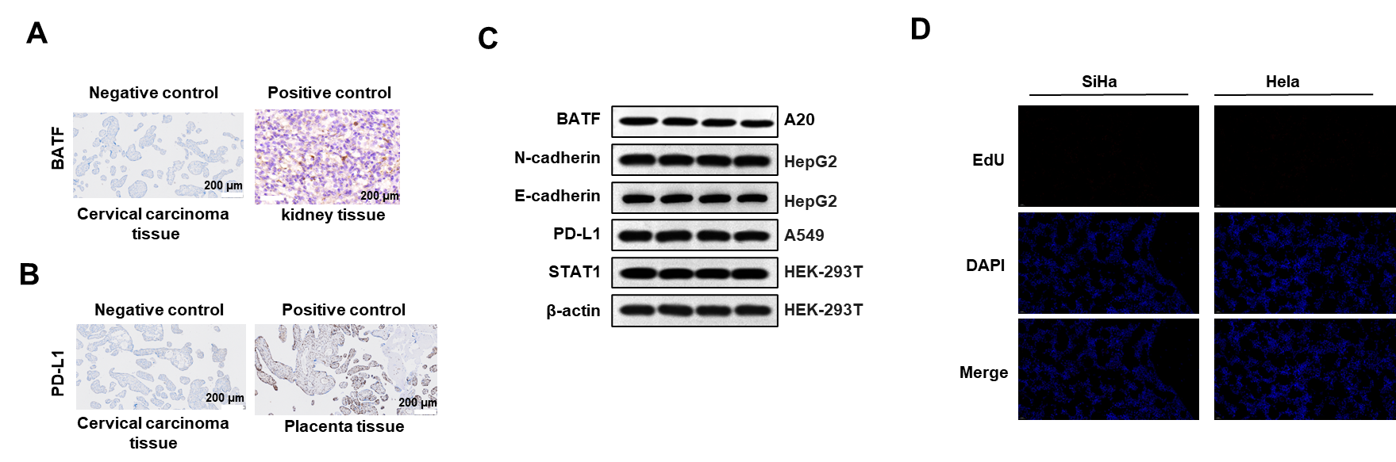
Supplementary Figure S1. Positive and/or negative controls in IHC, EdU, and Western blot. (A-B) Negative controls for immunohistochemistry (IHC) in cervical carcinoma tissues were performed using non-immune mouse serum in place of the primary antibody. Kidney tissue served as a positive control for BATF antibody detection, while placental tissue was used as a positive control for PD-L1 antibody detection. (C) Western blot analysis showing positive controls for the antibodies employed in this study (n = 4 biological replicates). (D) SiHa and HeLa cells not exposed to EdU were used as negative controls in the EdU incorporation assay.

