Supplementary Figure 1
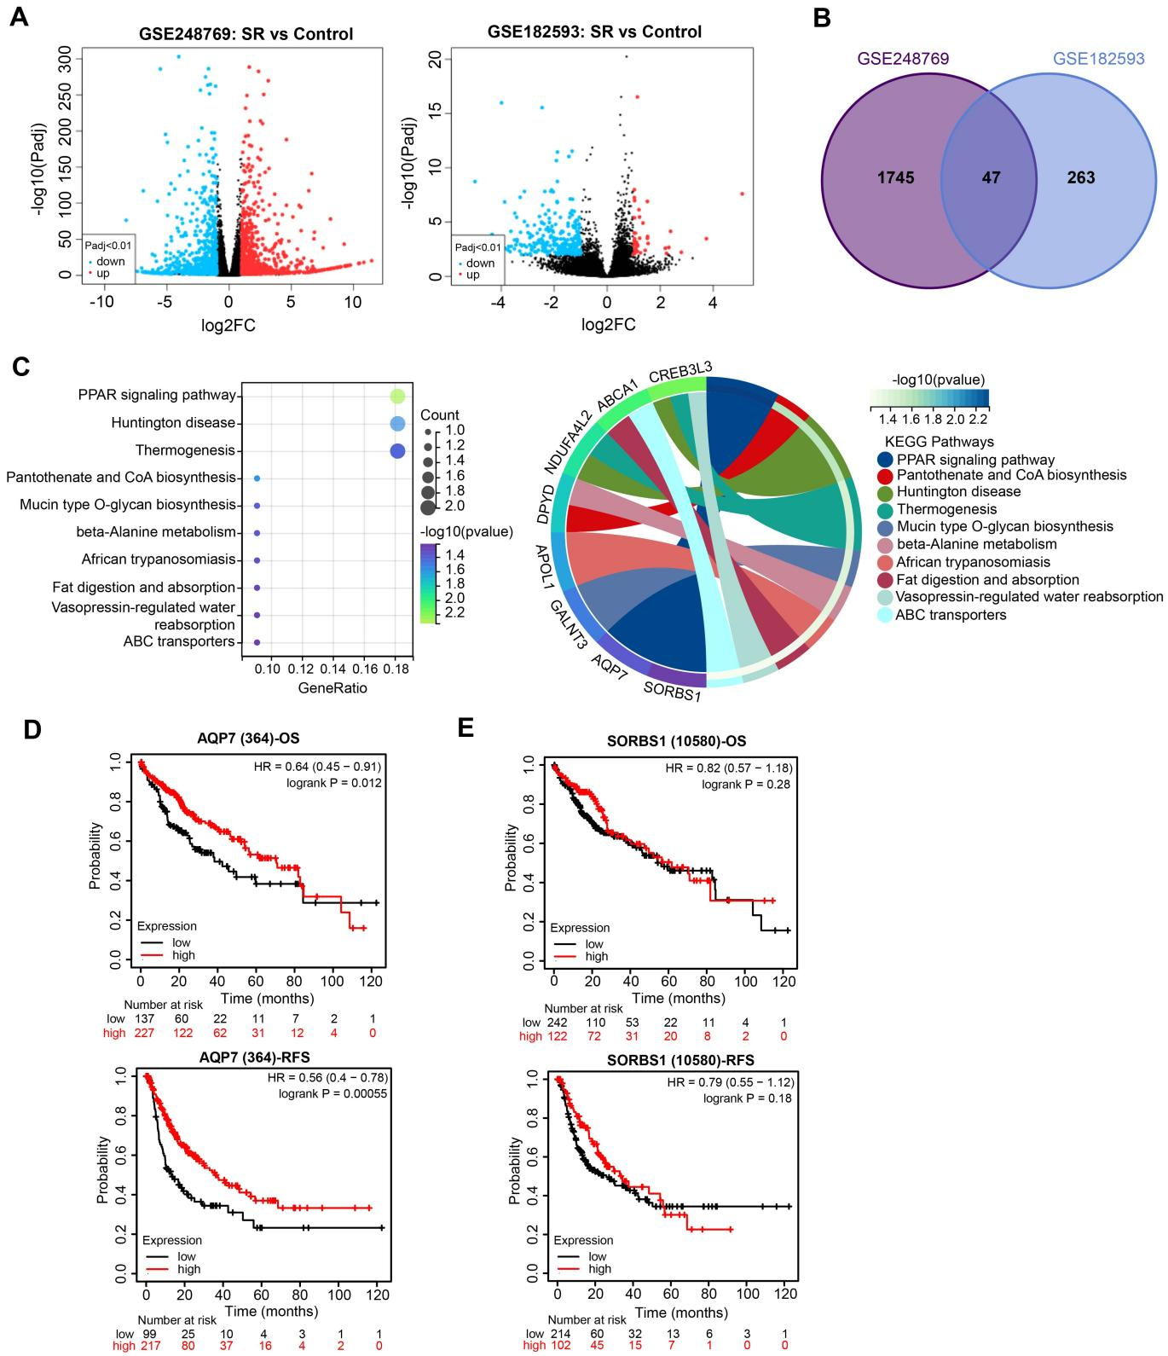
Supplementary Figure 1 Screening of SR-related targets in HCC. (A) The volcano maps of DEGs in the GSE248769 and GSE182593 datasets were filtered with a screening threshold of adjusted p < 0.01 and |Log2FoldChange| > 1. (B) The Venn map of DEGs in the GSE248769 and GSE182593 datasets. (C) KEGG pathway enrichment analysis of 47 intersecting DEGs. The prognostic significance of AQP7 (D) and SORBS1 (E) expression on the OS and RFS of HCC patients was predicted in the Kaplan-Meier Plotter database.
Supplementary Figure 2
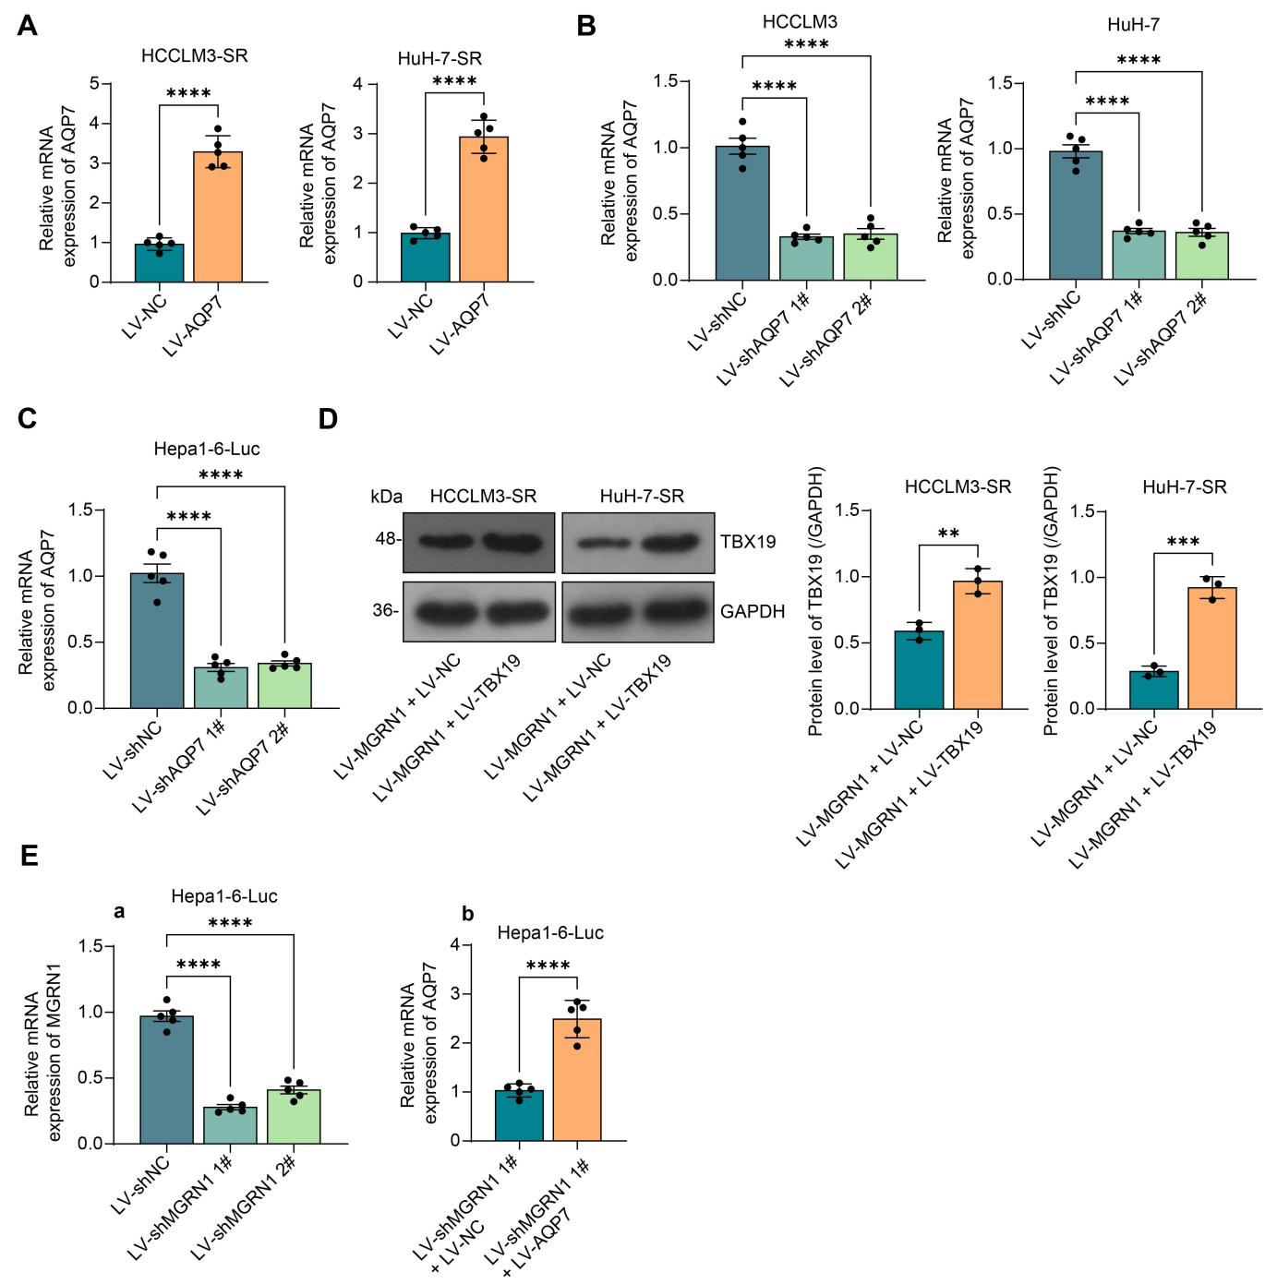
Supplementary Figure 2 The efficiency of genetic interventions in different cell lines. (A) The overexpression efficiency of AQP7 in HCC-SR cells was examined using RT-qPCR assay (n = 5). (B) The efficiency of the knockdown of AQP7 in HCC cells was examined using RT-qPCR assay (n = 5). (C) The efficiency of knockdown of AQP7 in Hepa1-6-Luc cells was examined using RT-qPCR assay (n = 5). (D) The TBX19 protein expression in HCC-SR cells infected with LV-MGRN1 + LV-NC or LV-TBX19 using western blot assay (n = 3). (E) The MGRN1 mRNA expression in Hepa1-6-Luc cells infected with LV-shNC, LV-shMGRN1 1# and 2# and AQP7 mRNA expression in Hepa1-6-Luc cells infected with LV-shMGRN1 1# + LV-NC or LV-AQP7 was examined using RT-qPCR assay (n = 5). An unpaired t-test was used to assess the differences between the two groups (A, D, Eb). One-way (B, C, Ea) analysis of variance (ANOVA) was used to compare more than two groups. **p < 0.01, ***p < 0.001 and ****p < 0.0001.

Supplementary Figure 3
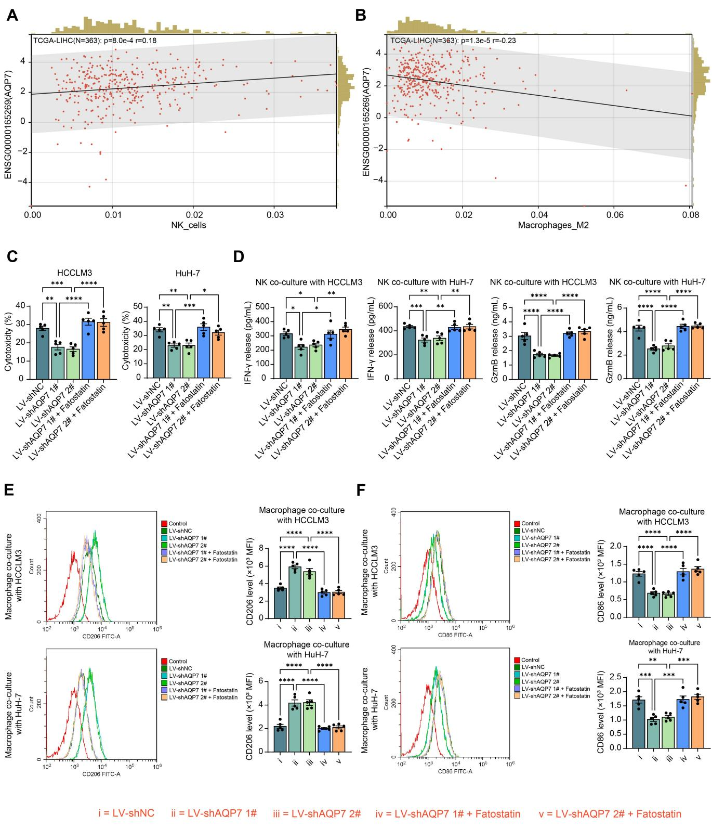
Supplementary Figure 3 AQP7 low expression induces immune evasion in HCC through lipid metabolic pathways. Correlation of AQP7 expression with NK cells (A) and M2 type macrophage (B) infiltration in HCC tumor tissues. (C) The effect of knockdown of AQP7 in HCC parental cells and combined Fatostatin (1 μM) treatment on NK cell-mediated cytotoxic effects was examined using LDH activity assay (n = 5). (D) IFN-γ and GzmB released by NK cells co-cultured with HCC cells were examined using ELISA (n = 5). The effects of knockdown of AQP7 in HCC parental cells and combined Fatostatin (1 μM) treatment on CD206 (E) and CD86 expression (F) on macrophages co-cultured with HCC were analyzed using flow cytometry (n = 5). One-way analysis of variance (ANOVA) was used to compare more than two groups. *p < 0.05, **p < 0.01, ***p < 0.001 and ****p < 0.0001.

Supplementary Figure 4
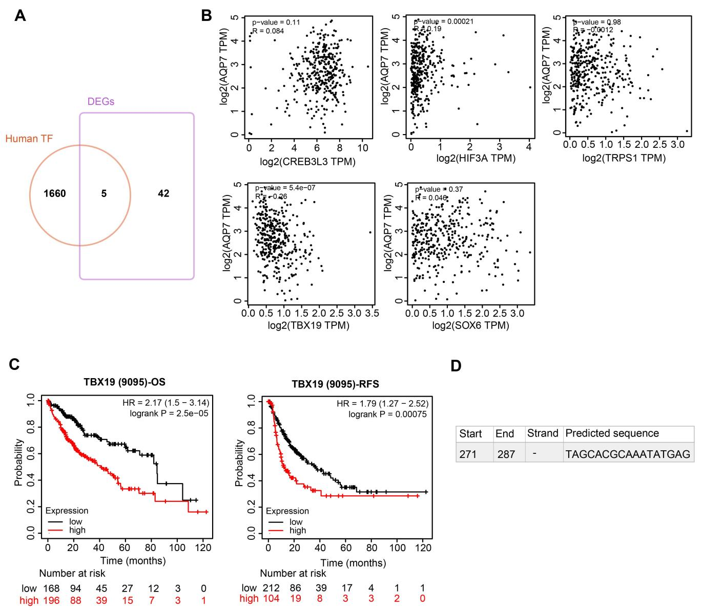
Supplementary Figure 4 Screening of upstream transcription factors of AQP7. (A) Cross-screening for human TFs present in DEGs in the GSE248769 and GSE182593 datasets. (B) The correlations between five transcription factors and AQP7 expression in HCC tumor tissues were predicted in the GEPIA database. (C) The prognostic significance of TBX19 on survival in HCC patients was predicted in the Kaplan-Meier Plotter database. (D) The predicted sequence of TBX19 to the AQP7 promoter on the Jaspar database.

