Supplementary Materials
Quantifying the mRNA epitranscriptome reveals epitranscriptome signatures and roles in cancer
Ying Feng, Xiaoli He, Mingxin Guo, Ying Tang, Guantong Qi, Qian Huang, Wenran Ma, Hong Chen, Yifan Qin, Ruiqi Li, Jin Wang and Yu Liu
Contents:
• Figure S1: Bioanalyzer analysis of total RNA using the RNA 6000 Pico LabChips.
• Figure S2: Bioanalyzer analysis of poly(A) RNA using the RNA 6000 Pico LabChips.
• Figure S3: Calibration curves for the quantification of modified nucleosides.
• Figure S4: Quantification of modified nucleosides in mRNA from WPMY-1 and LNCAP clone FGC.
• Figure S5: Quantification of modified nucleosides in mRNA from QSG-7701 and SNU-182.
• Figure S6: Quantification of modified nucleosides in mRNA from Hs 578Bst and BT-20.
• Figure S7: Quantification of modified nucleosides in mRNA from HeLa, DDP-treated HeLa, and DDP-resistant HeLa.
• Figure S8: Quantification of modified nucleosides in mRNA from HeLa, PTX-treated HeLa, and PTX-resistant HeLa.
• Figure S9: Quantification of modified nucleosides in mRNA from HeLa cells after knocking down the m¹A modification enzymes TRMT6, TRMT61A, TRMT6-61A, TRMT10C, and the demodification enzyme ALKBH3.
• Figure S10: Flow cytometry analysis of the impact on the cell cycle after 72h of knockdown of m¹A regulatory enzymes TRMT10C, ALKBH3, TRMT6, TRMT61A, and TRMT6-61A.
• Figure S11: Transcriptomic and proteomic analysis of ALKBH3 treated HeLa cells.
• Figure S12: Transcriptomic and proteomic analysis of TRMT6-61A treated HeLa cells.
• Figure S13: Transcriptomic and proteomic analysis of TRMT6 treated HeLa cells.
• Figure S14: Transcriptomic and proteomic analysis of TRMT61A treated HeLa cells.
• Figure S15: Transcriptomic and proteomic analysis of TRMT10C treated HeLa cells.
• Figure S16: Quantitative analysis using single-standard spike-in of m³C, m⁴C, m⁵C, and m⁶C.
• Figure S17: Product Spectrum of isobaric nucleosides.
• Table S1: siRNA used for transfection.
• Table S2: Primers used for qPCR analysis.
• Table S3: Cellular composition at different cell cycle phases after knocking down m¹A regulatory enzymes in HeLa cells.
• Table S4: Detection limits of known and potentially existing modified nucleosides.
• Table S5: Dynamic MRM parameters for ribonucleosides based on optimizer results.

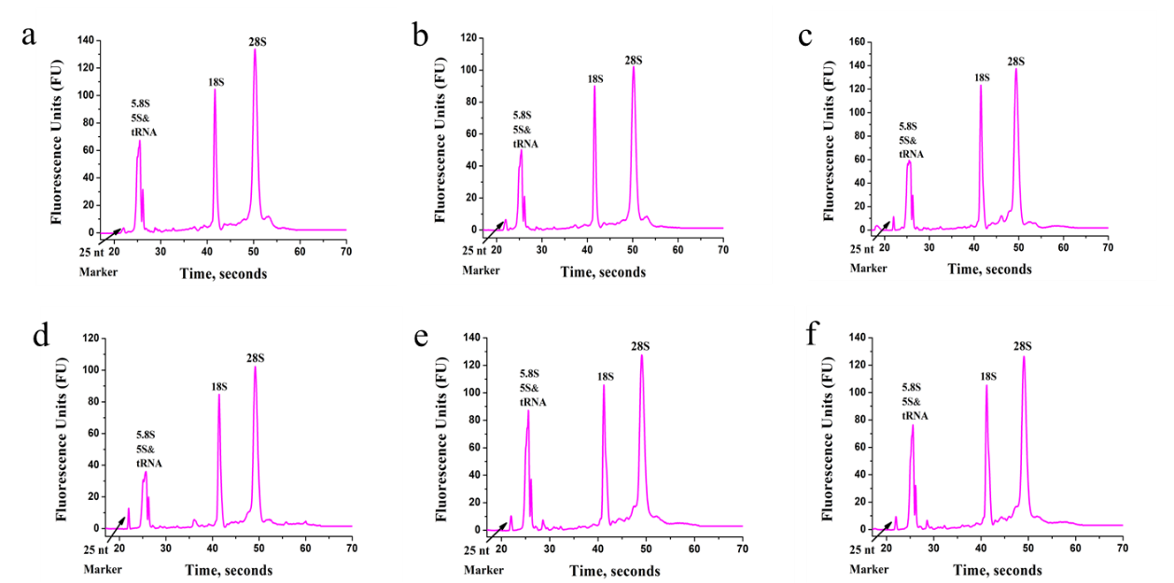
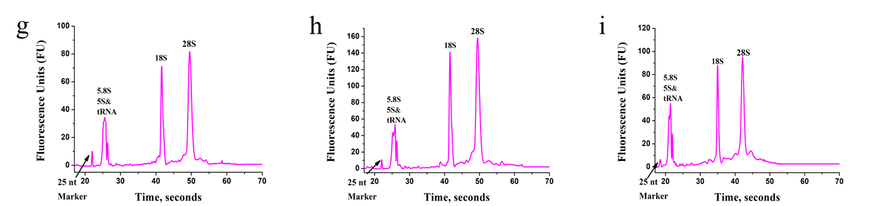
Figure S1. Bioanalyzer analysis of total RNA using the RNA 6000 Pico LabChips. (a) total RNA from human prostate cancer cell LNCAP clone FGC, (b) total RNA from human normal prostate stromal immortalized cell WPMY-1, (c) total RNA from human liver cancer cell SNU-182, (d) total RNA from human normal hepatocyte QSG-7701, (e) total RNA from human breast cancer cell BT-20, (f) total RNA from human normal breast cell Hs 578Bst total RNA, (g) total RNA from HeLa cells, (h) total RNA from HeLa cells treated with the anticancer drug cisplatin (DDP), (i) total RNA from HeLa cells treated with the anticancer drug paclitaxel (PTX), (j) total RNA from HeLa cells resistant to cisplatin (DDP), (k) total RNA from HeLa cells resistant to paclitaxel (PTX), (l) total RNA from HeLa cells after transfection with NC-siRNA, (m) total RNA from HeLa cells after knocking down the m¹A modification enzyme TRMT6, (n) total RNA from HeLa cells after knocking down the m¹A modification enzyme TRMT61A, (o) total RNA from HeLa cells after knocking down the m¹A modification enzyme TRMT6-61A, (p) total RNA from HeLa cells after knocking down the m¹A modification enzyme TRMT10C, (q) total RNA from HeLa cells after knocking down the m¹A modification enzyme ALKBH3, (r) 6000 Pico RNA ladder.
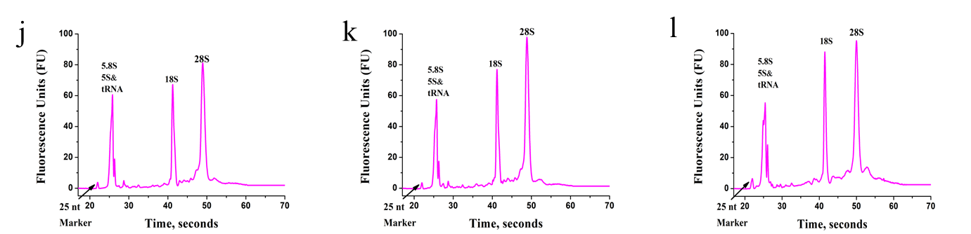
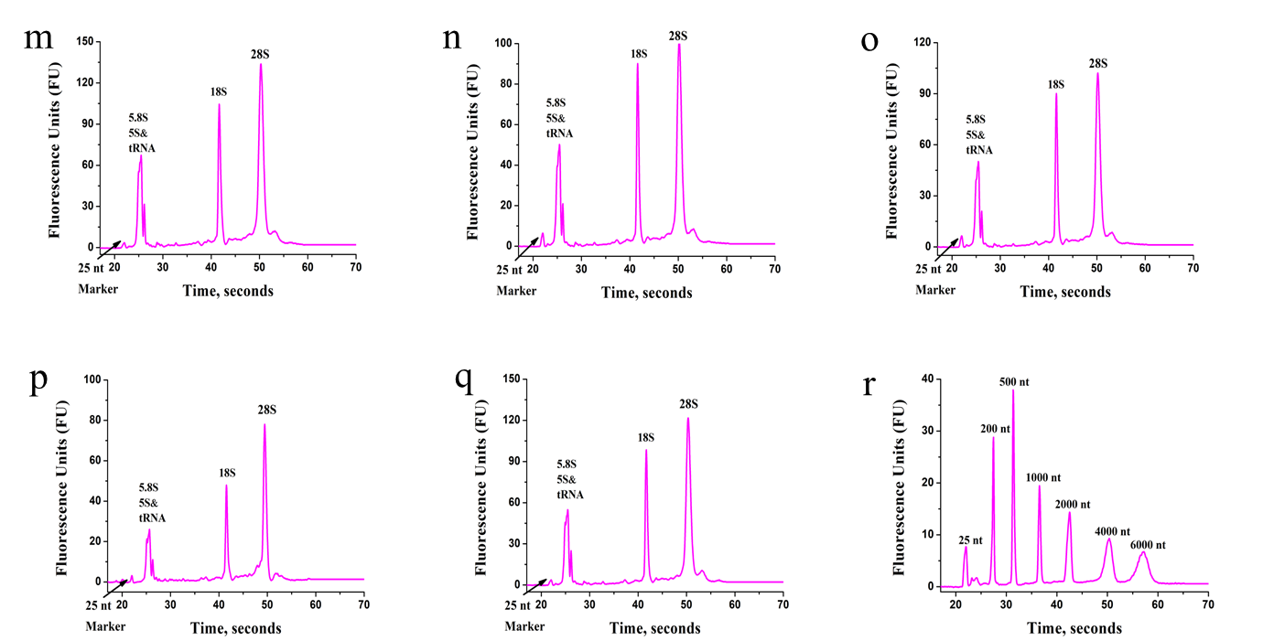
Figure S1, continued

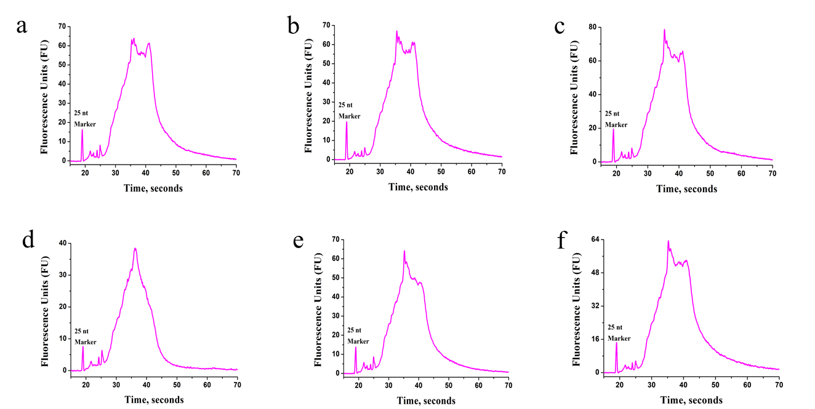
Figure S2. Bioanalyzer analysis of rRNA-depleted poly(A) RNA using the RNA 6000 Pico LabChips. (a) rRNA-depleted poly(A) RNA from human prostate cancer cell LNCAP clone FGC, (b) rRNA-depleted poly(A) RNA from human normal prostate stromal immortalized cell WPMY-1, (c) rRNA-depleted poly(A) RNA from human liver cancer cell SNU-182, (d) rRNA-depleted poly(A) RNA from human normal hepatocyte QSG-7701, (e) rRNA-depleted poly(A) RNA from human breast cancer cell BT-20, (f) rRNA-depleted poly(A) RNA from human normal breast cell Hs 578Bst, (g) rRNA-depleted poly(A) RNA from HeLa cells, (h) rRNA-depleted poly(A) RNA from HeLa cells treated with the anticancer drug cisplatin (DDP), (i) rRNA-depleted poly(A) RNA from HeLa cells treated with the anticancer drug paclitaxel (PTX), (j) rRNA-depleted poly(A) RNA from HeLa cells resistant to cisplatin (DDP), (k) rRNA-depleted poly(A) RNA from HeLa cells resistant to paclitaxel (PTX), (l) rRNA-depleted poly(A) RNA from HeLa cells after transfection with NC-siRNA, (m) rRNA-depleted poly(A) RNA from HeLa cells after knocking down the m¹A modification enzyme TRMT6, (n) rRNA-depleted poly(A) RNA from HeLa cells after knocking down the m¹A modification enzyme TRMT61A, (o) rRNA-depleted poly(A) RNA from HeLa cells after knocking down the m¹A modification enzyme TRMT6-61A, (p) rRNA-depleted poly(A) RNA from HeLa cells after knocking down the m¹A modification enzyme TRMT10C, (q) rRNA-depleted poly(A) RNA from HeLa cells after knocking down the m¹A modification enzyme ALKBH3, (r) 6000 Pico RNA ladder.

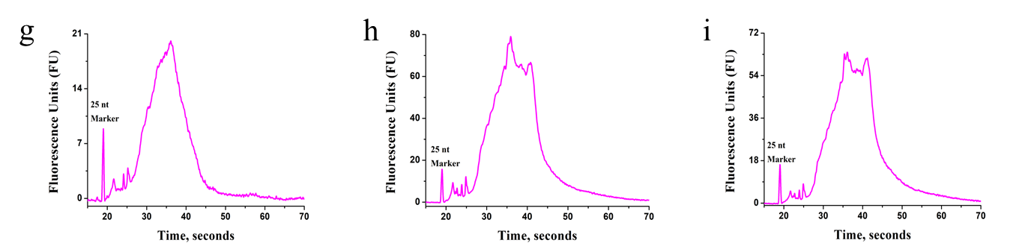
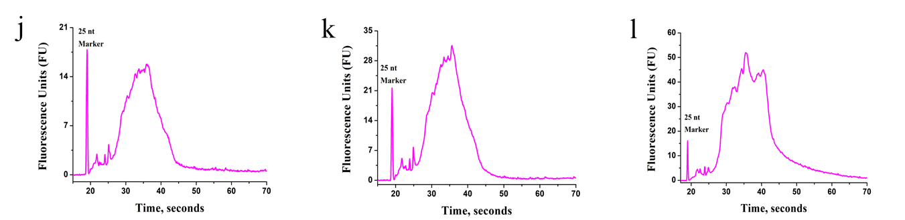
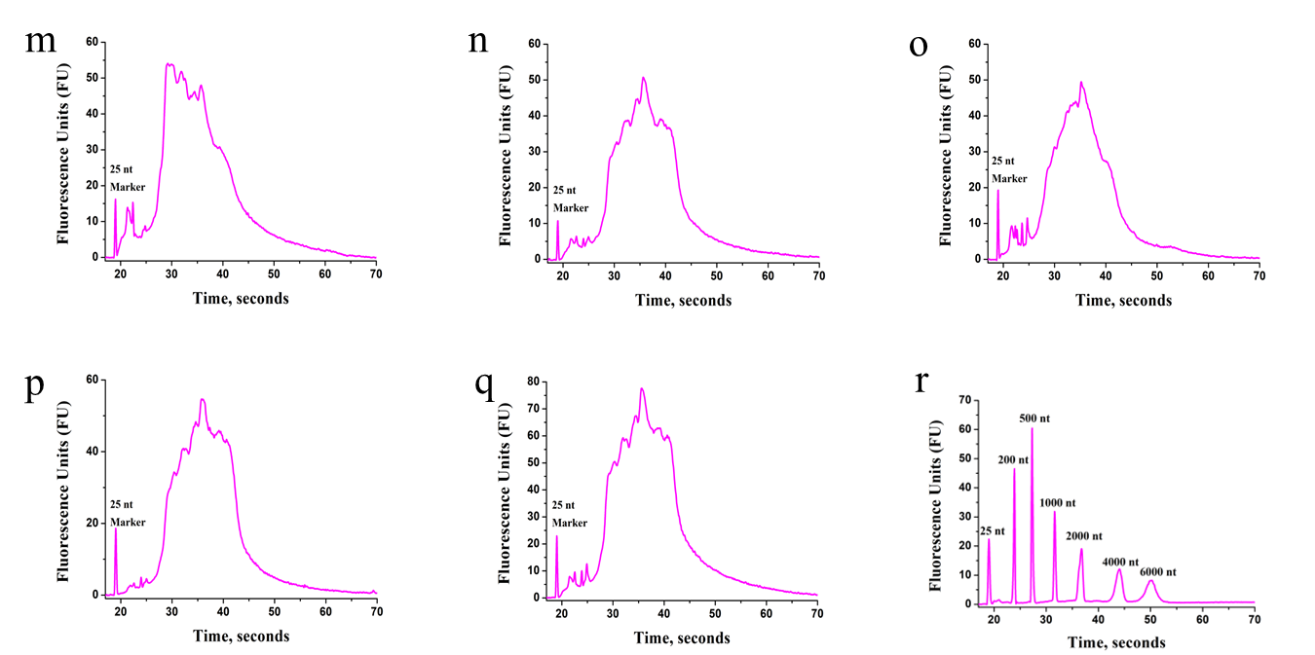
Figure S2, continued

Figure S3. Calibration curves for the quantification of modified nucleosides. (a-ah) Am, m¹A, m²A, m⁶A, m⁶Am, m⁸A, m^{6,6}A, ms²m⁶A, i⁶A, t⁶A, Um, m³Um, m⁵Um, hm⁵U, ncm⁵U, ψ, mchm⁵U, mnm⁵s²U, Cm, m⁵C, hm⁵C, ca⁵C, ac⁴C, Gm, m¹G, m²G, m⁶G, m⁷G, m^{2,2}G, m^{2,7}G, m^{2,2,7}G, D, I, imG-14。
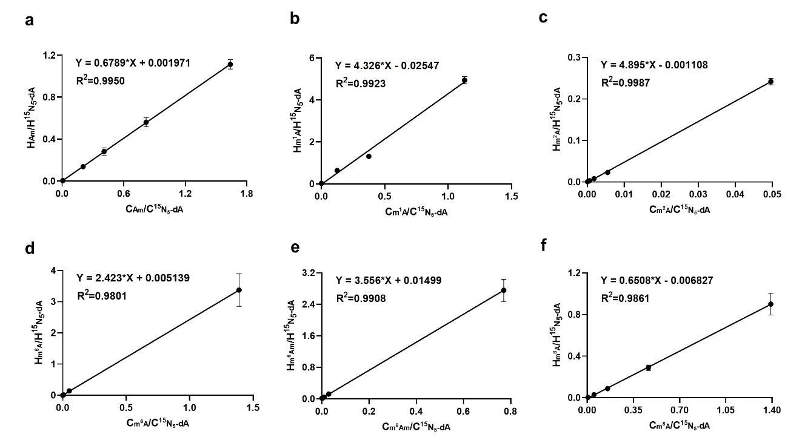
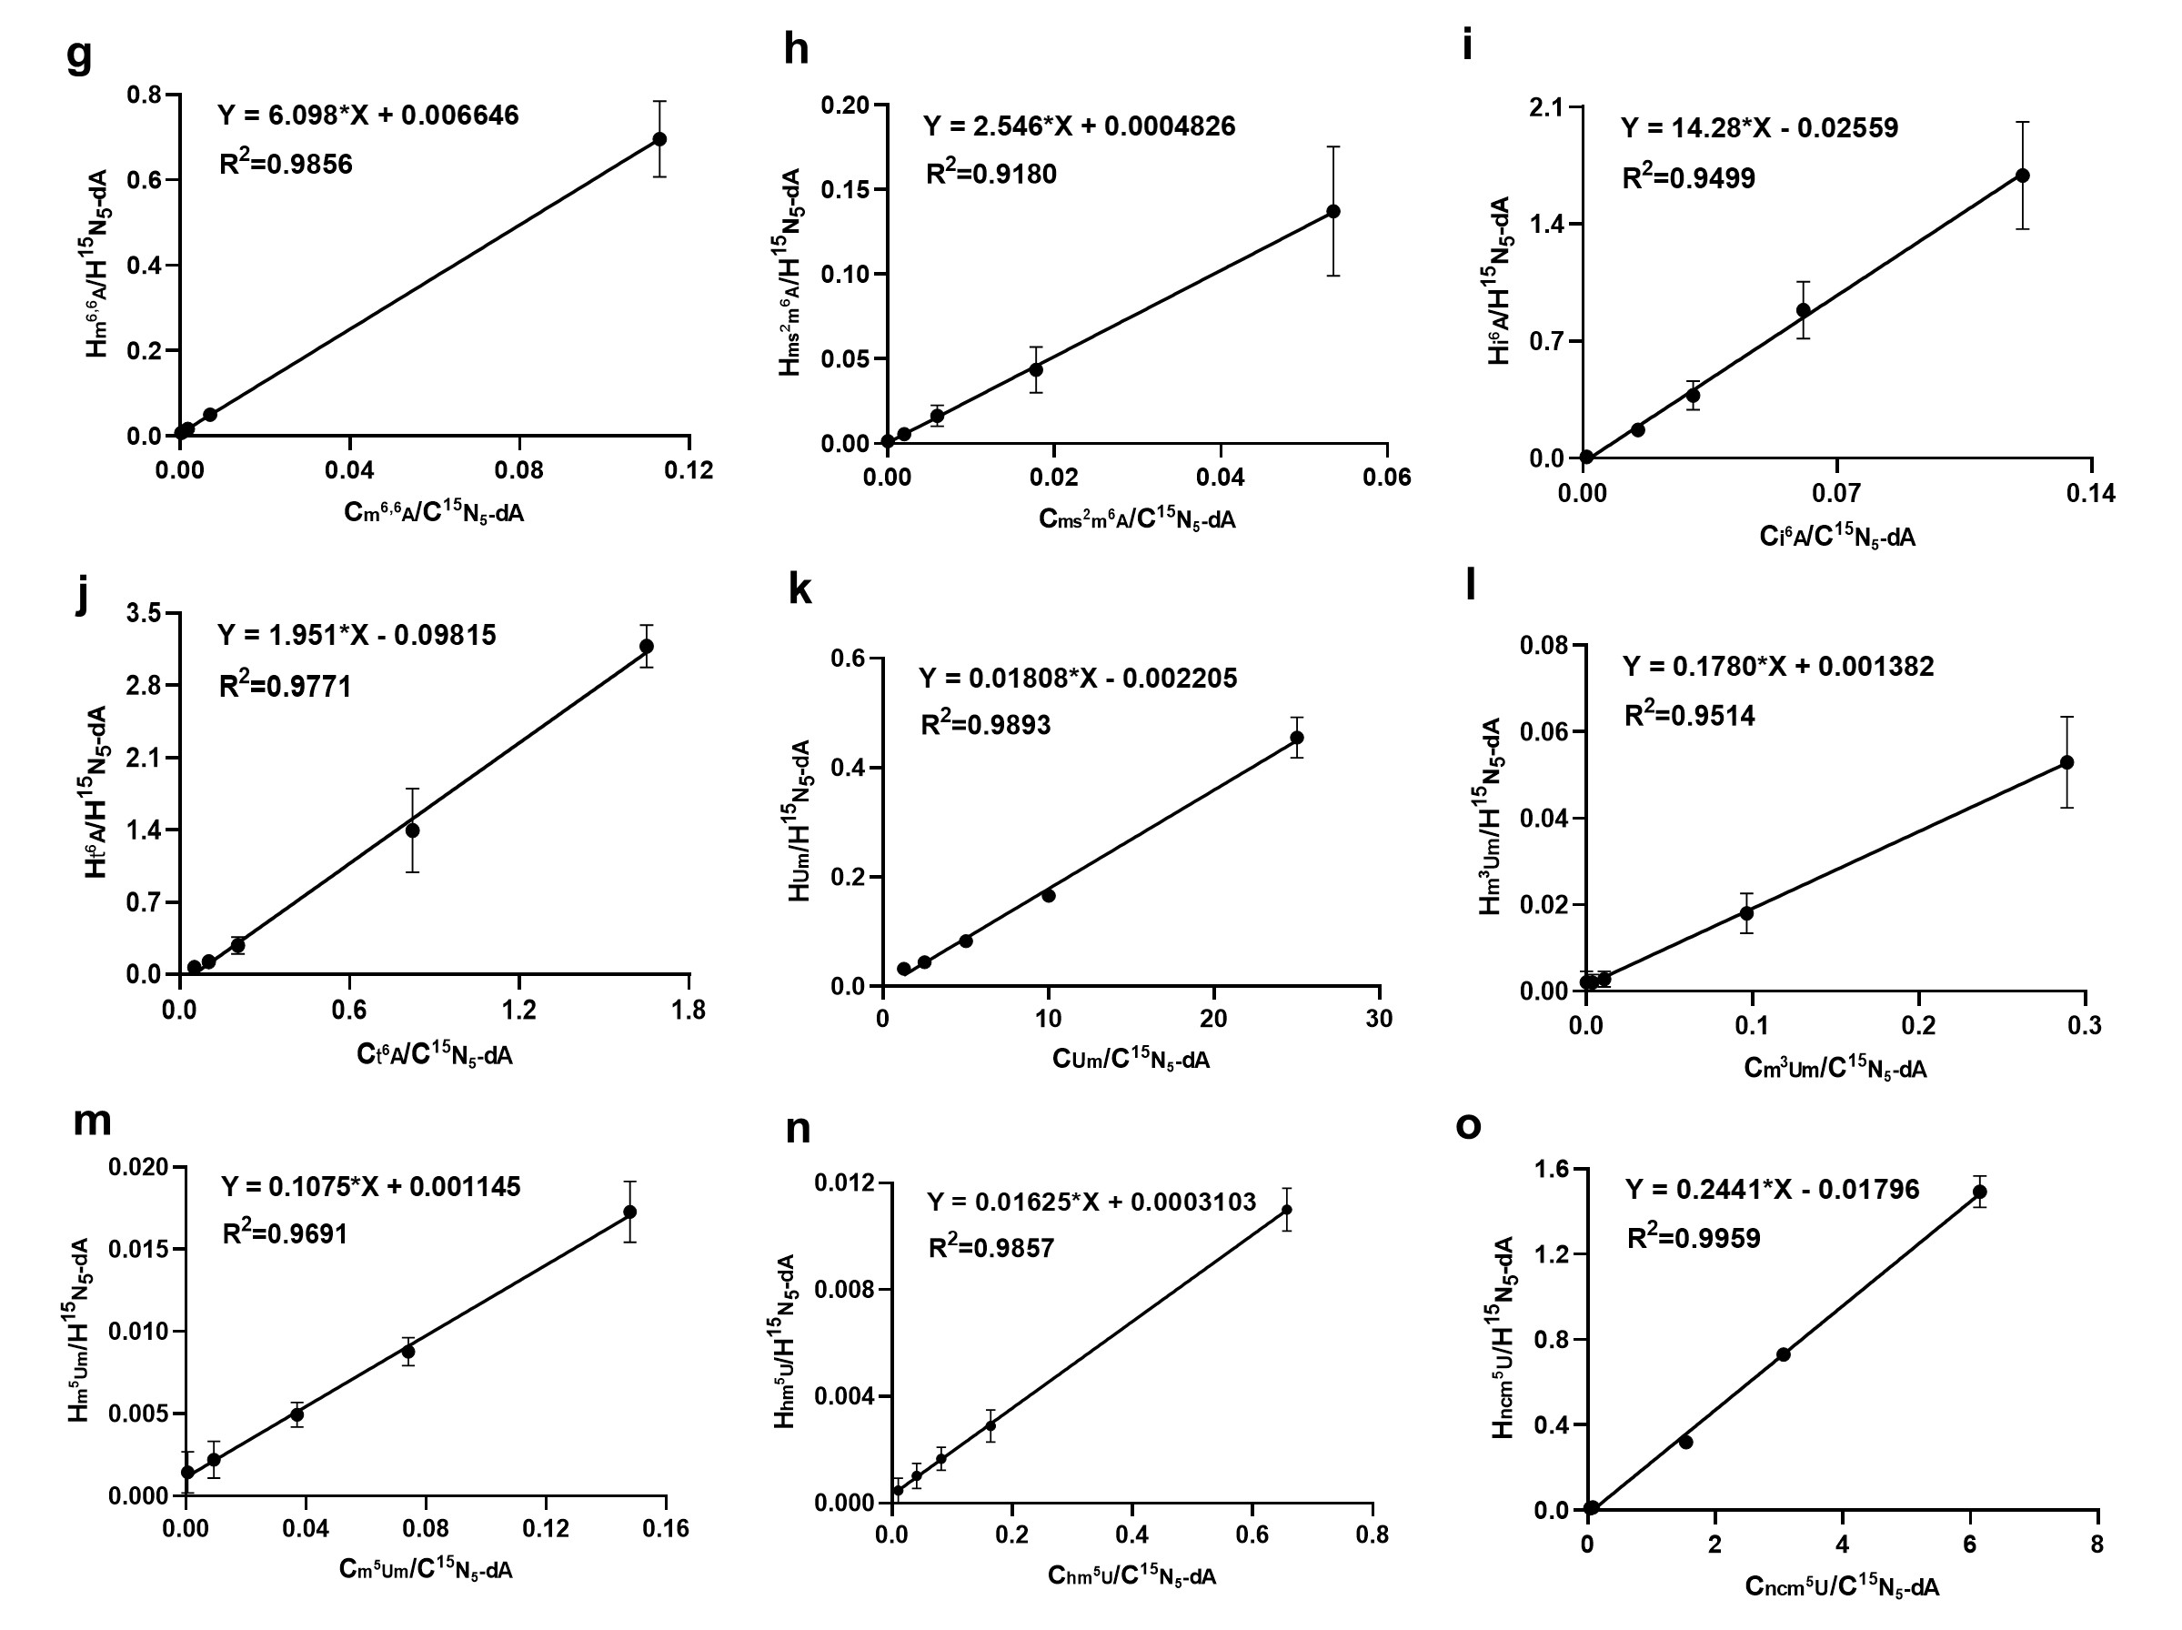
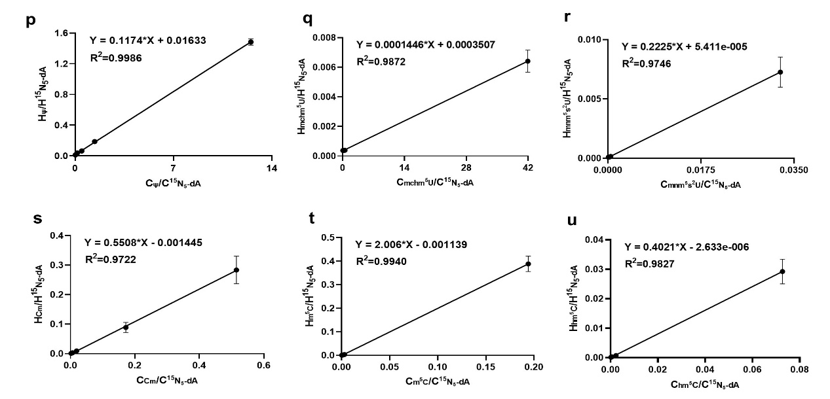
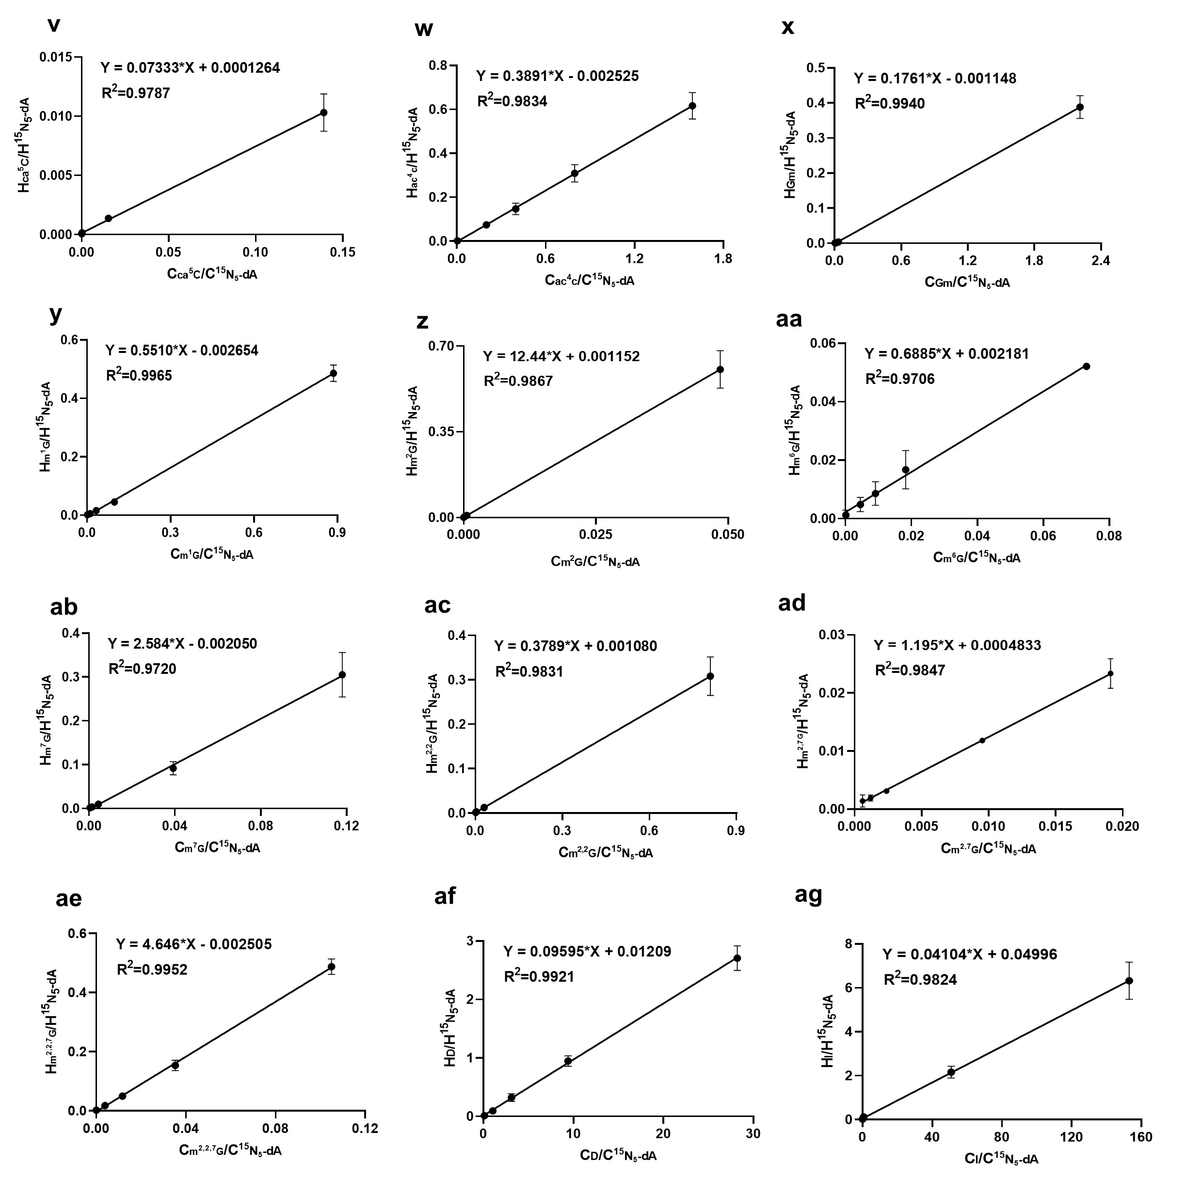
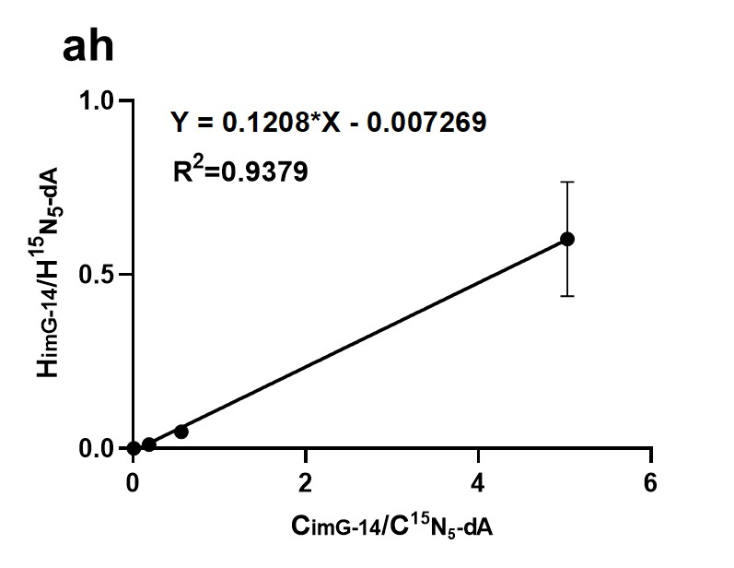
Figure S3, continued
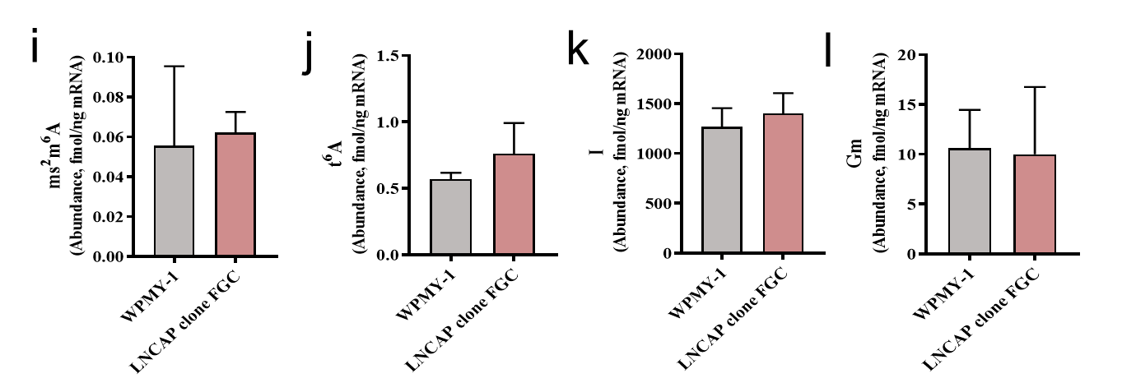
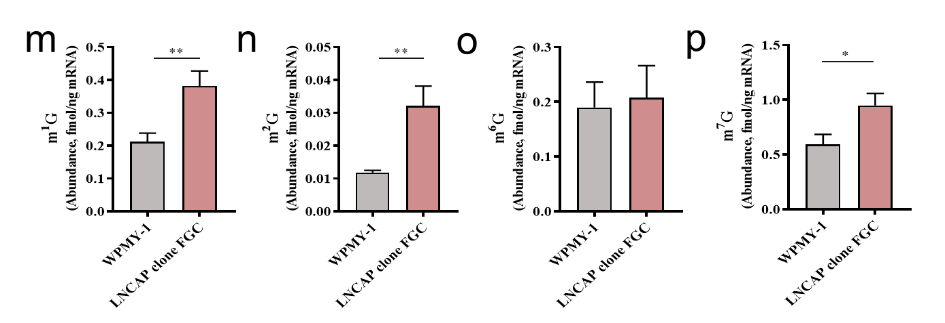
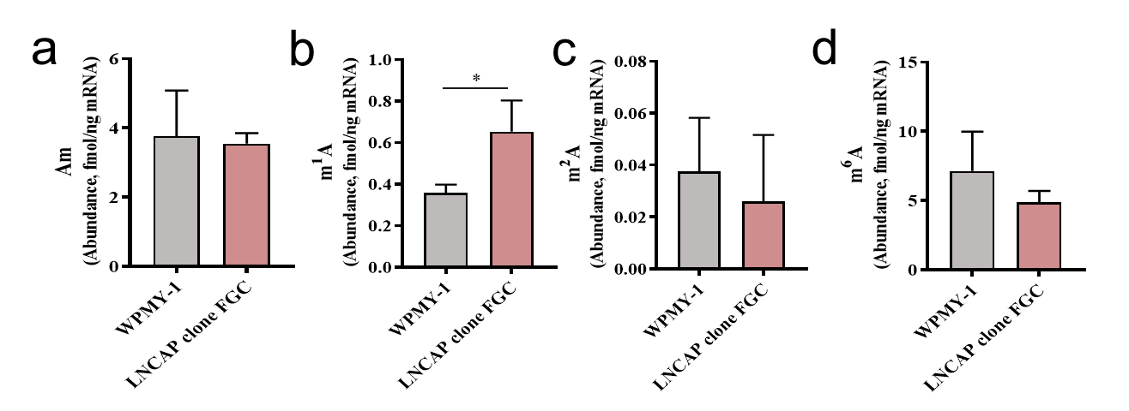
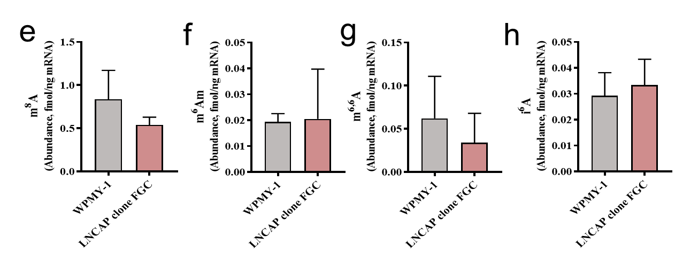
Figure S4. Quantification of the release of modified nucleosides during mRNA digestion of WPMY-1 and LNCAP clone FGC. (a-ah) Am, m¹A, m²A, m⁶A, m⁸A, m⁶Am, m^{6,6}A, i⁶A, ms²m⁶A, t⁶A, I, Gm, m¹G, m²G, m⁶G, m⁷G, m^{2,7}G, m^{2,2}G, m^{2,2,7}G, imG-14, Cm, m⁵C, ac⁴C, ca⁵C, hm⁵C, Um, m³Um, m⁵Um, mchm⁵U, ncm⁵U, mnm⁵s²U, hm⁵U, ψ, D. Values represent the mean ± SD of three biological experiments. "nd" indicates not detected. * p < 0.05, ** p < 0.01, *** p < 0.001.
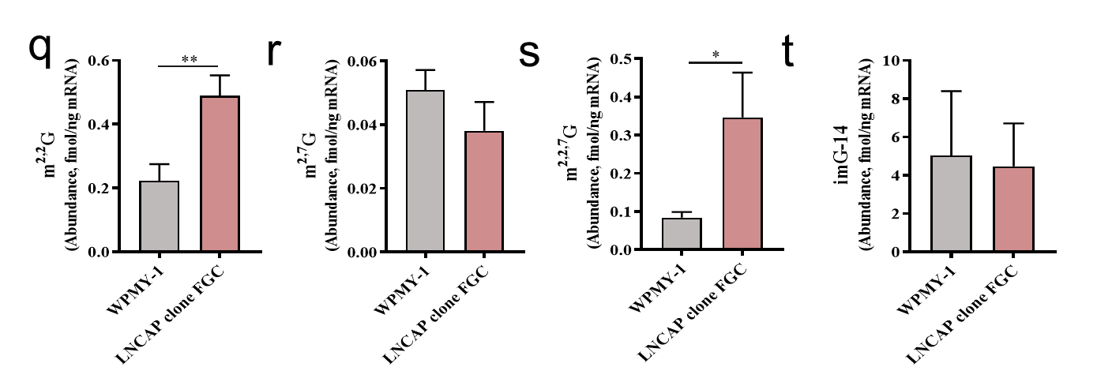
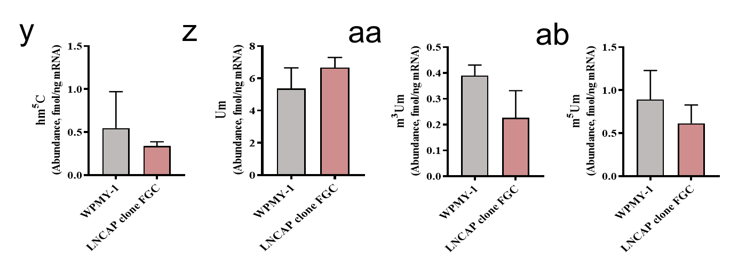
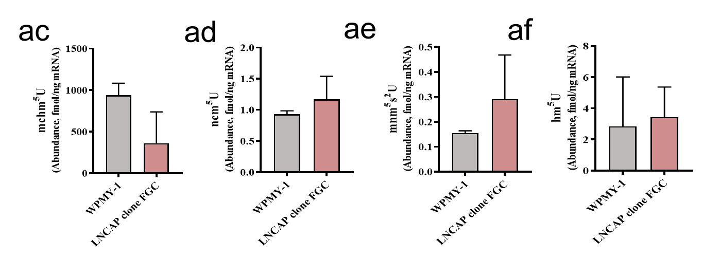
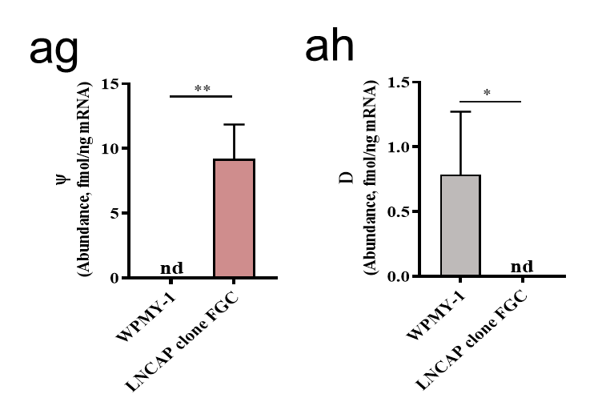
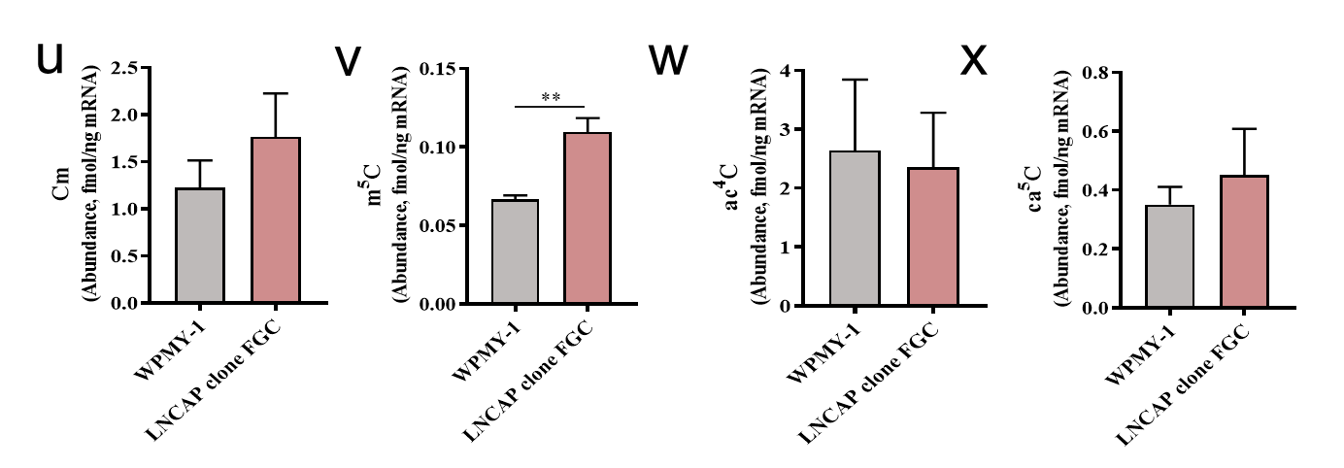
Figure S4, continued
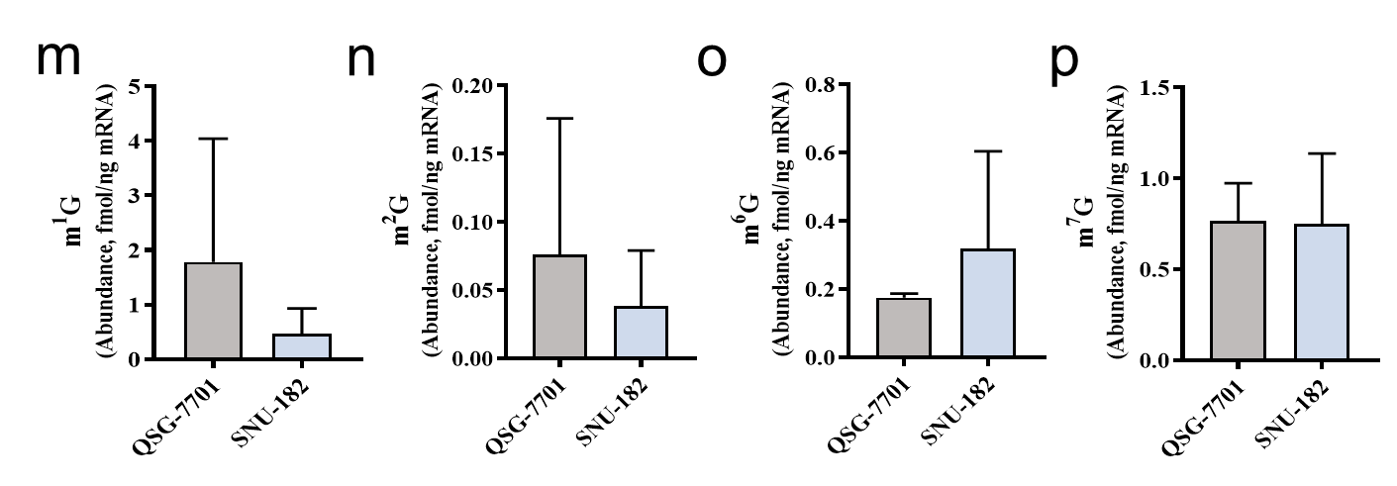
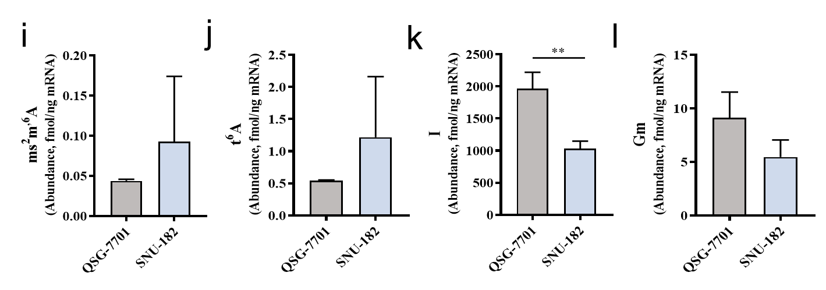
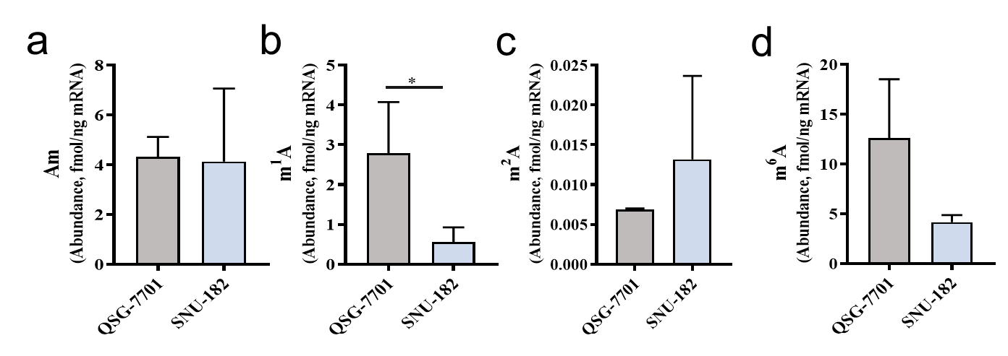
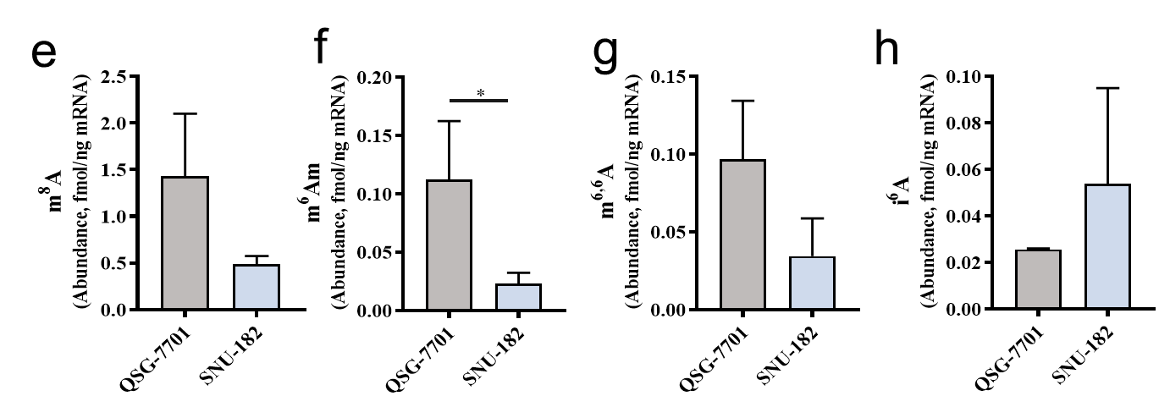
Figure S5. Quantification of the release of modified nucleosides during mRNA digestion of QSG-7701 and SNU-182. (a-ah) Am, m¹A, m²A, m⁶A, m⁸A, m⁶Am, m^{6,6}A, i⁶A, ms²m⁶A, t⁶A, I, Gm, m¹G, m²G, m⁶G, m⁷G, m^{2,7}G, m^{2,2}G, m^{2,2,7}G, imG-14, Cm, m⁵C, ac⁴C, ca⁵C, hm⁵C, Um, m³Um, m⁵Um, mchm⁵U, ncm⁵U, mnm⁵s²U, hm⁵U, ψ, D. Values represent the mean ± SD of three biological experiments. "nd" indicates not detected. * p < 0.05, ** p < 0.01, *** p < 0.001.
Figure S5, continued
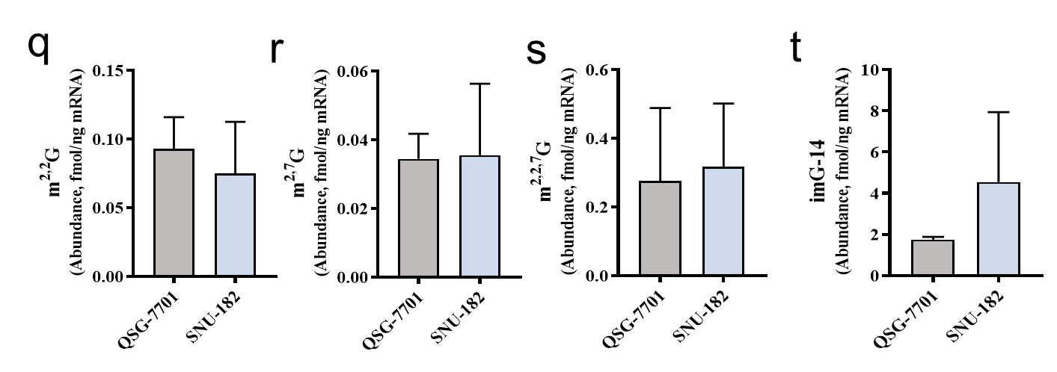
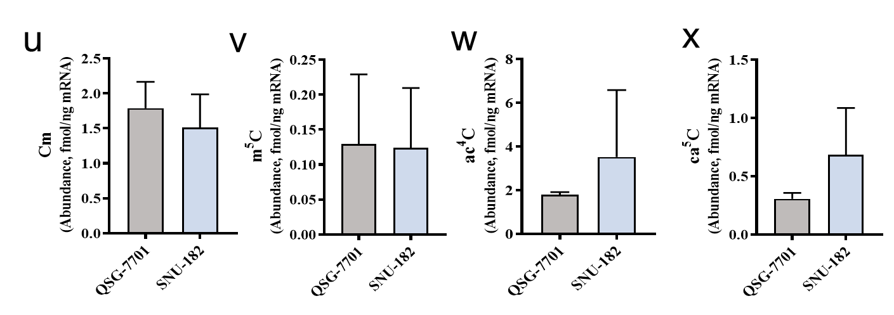
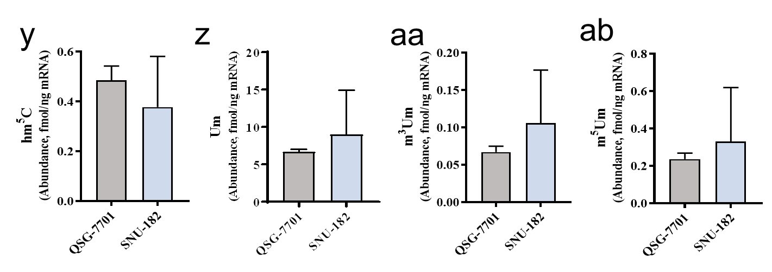
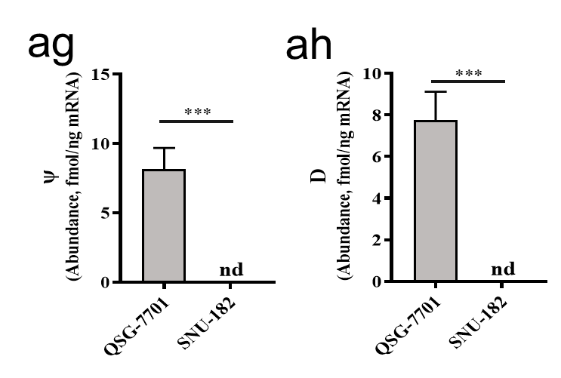
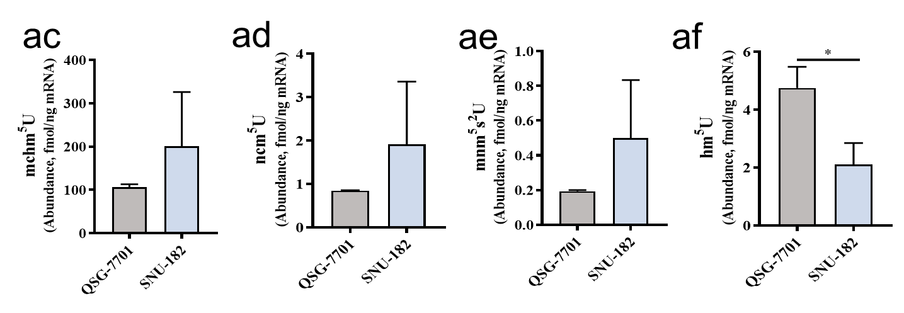
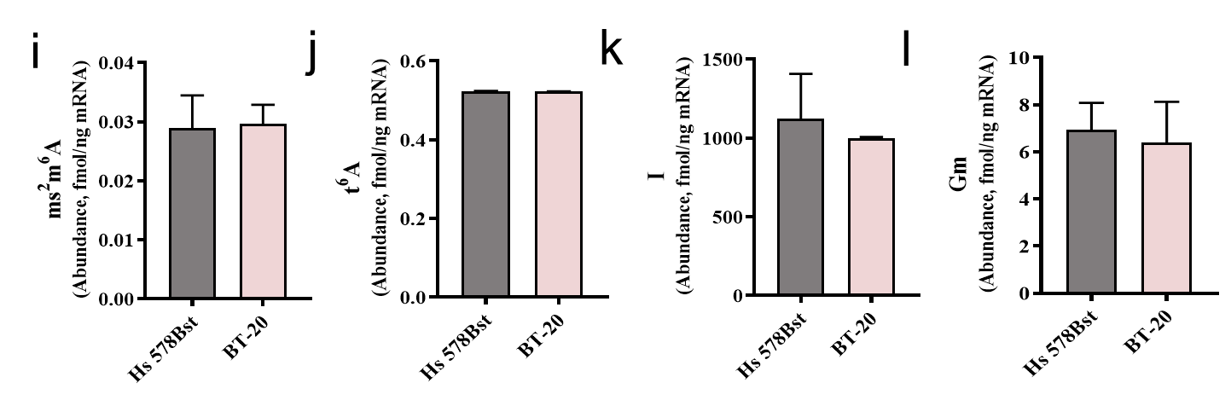
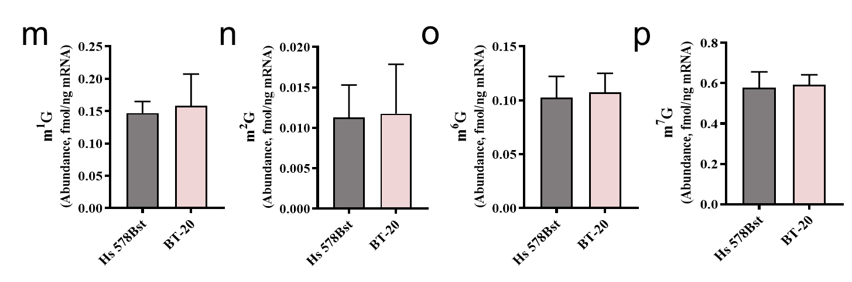
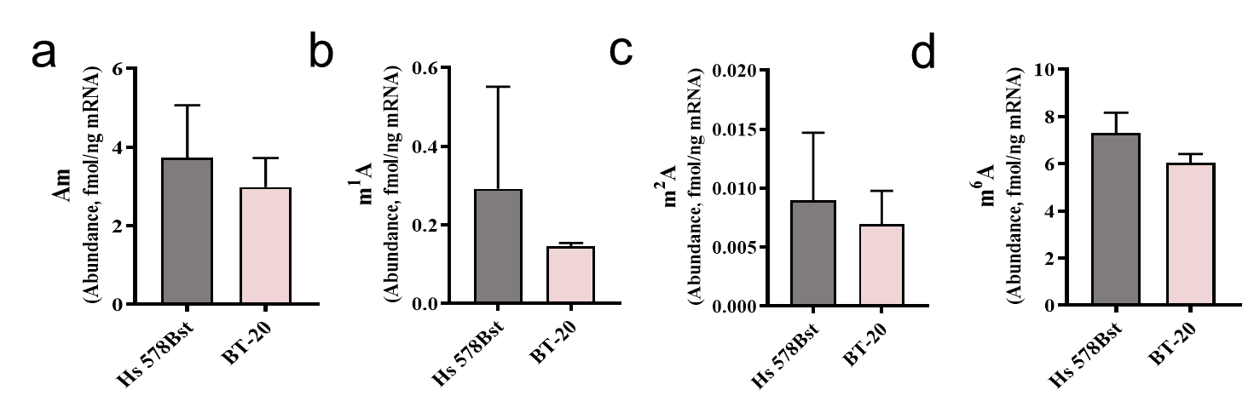
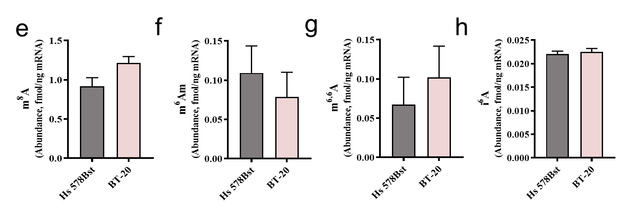
Figure S6. Quantification of the release of modified nucleosides during mRNA digestion of Hs 578Bst and BT-20 (a-ag) Am, m¹A, m²A, m⁶A, m⁸A, m⁶Am, m^{6,6}A, i⁶A, ms²m⁶A, t⁶A, I, Gm, m¹G, m²G, m⁶G, m⁷G, m^{2,7}G, m^{2,2}G, m^{2,2,7}G, imG-14, Cm, m⁵C, ac⁴C, ca⁵C, hm⁵C, Um, m³Um, m⁵Um, mchm⁵U, ncm⁵U, mnm⁵s²U, hm⁵U, ψ. Values represent the mean ± SD of three biological experiments. "nd" indicates not detected. * p < 0.05, ** p < 0.01, *** p < 0.001.

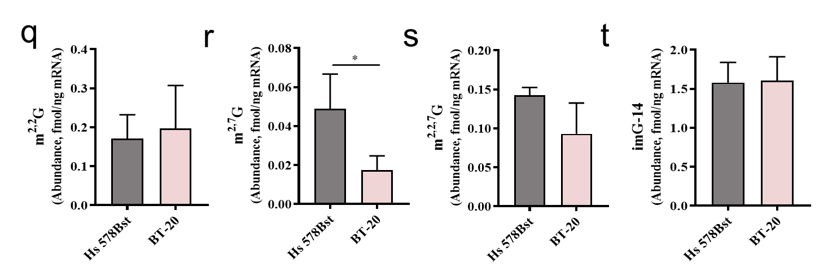
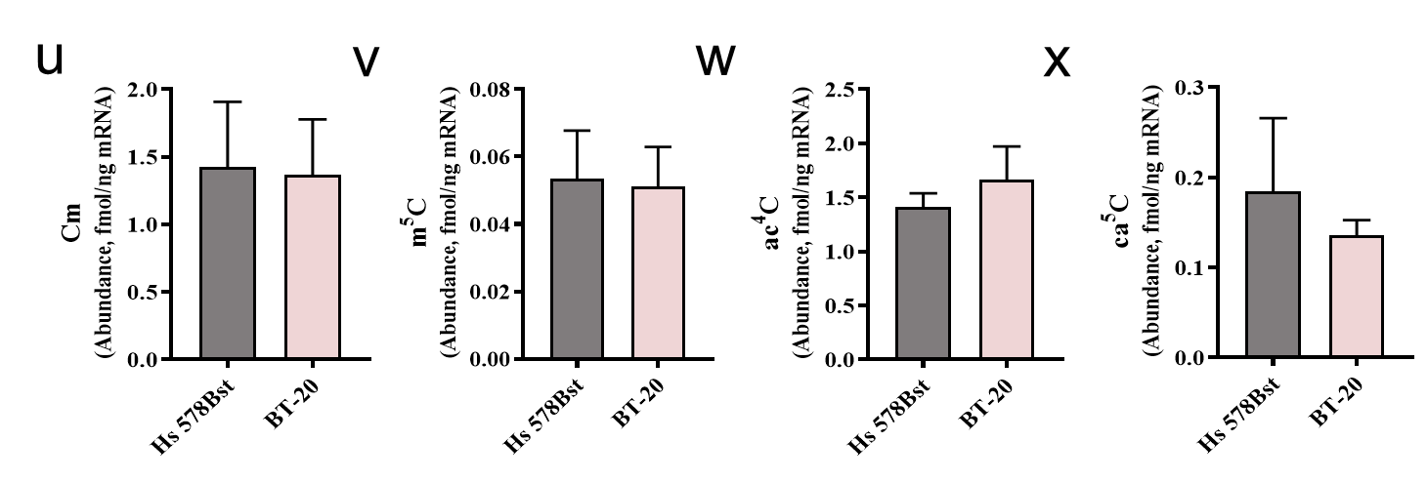
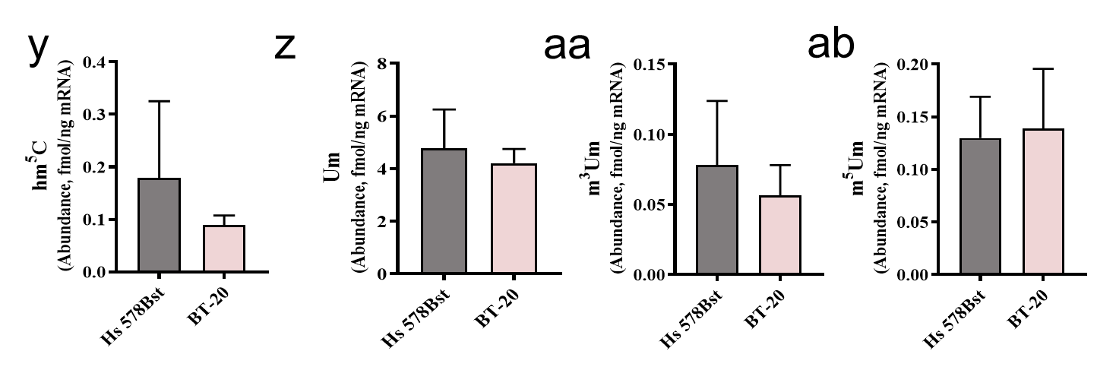
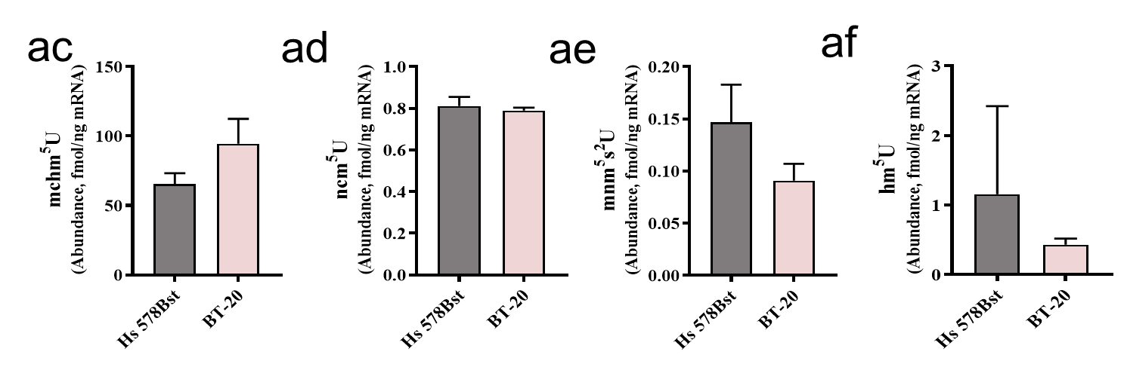
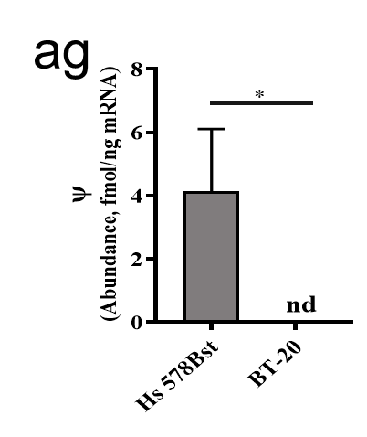
Figure S6, continued
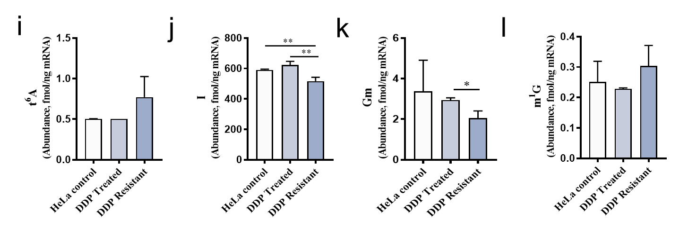
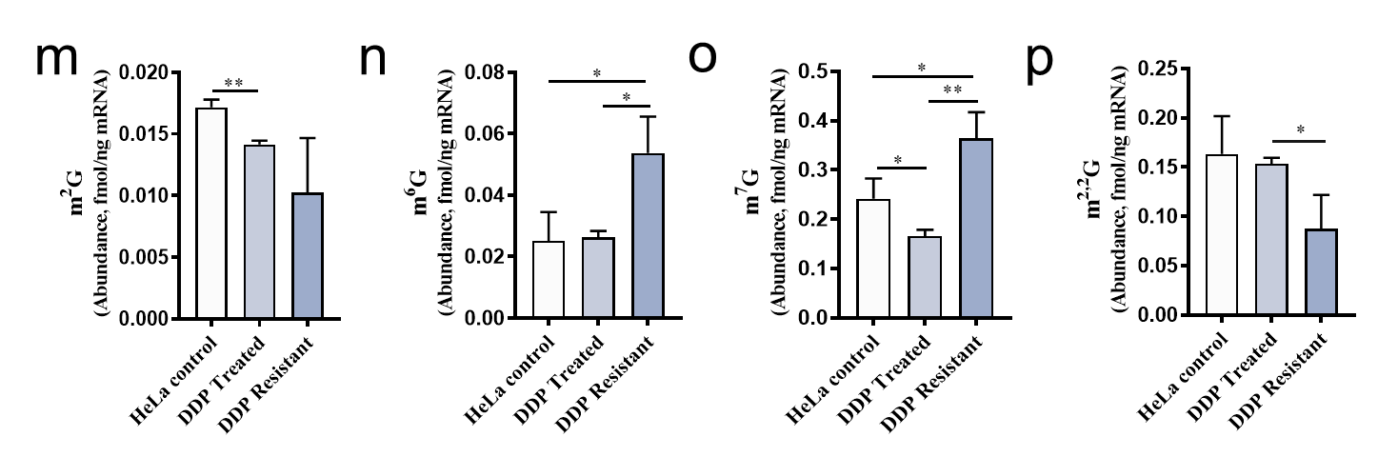
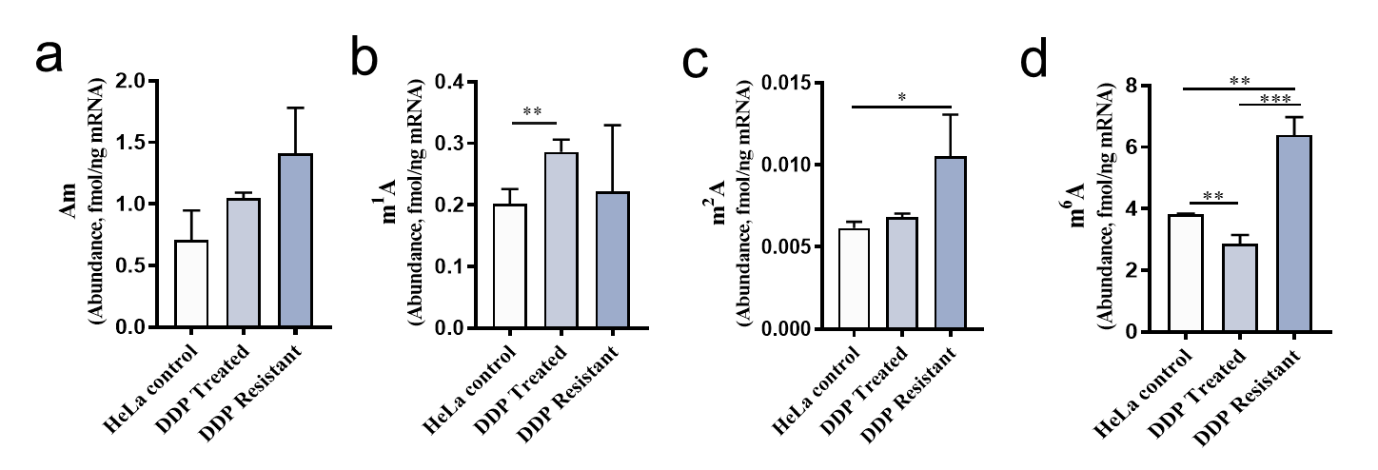
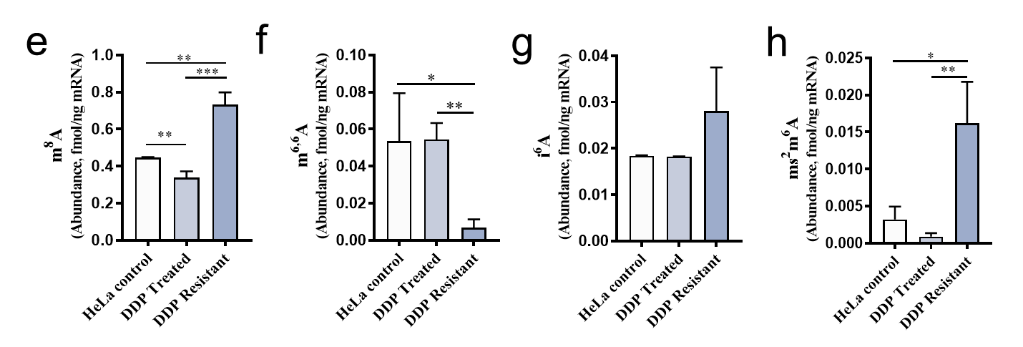
Figure S7. Quantification of the release of modified nucleosides during mRNA digestion of HeLa, DDP-treated HeLa, and DDP-resistant HeLa. (a-ab) Am, m¹A, m²A, m⁶A, m⁸A, m^{6,6}A, i⁶A, ms²m⁶A, t⁶A, I, Gm, m¹G, m²G, m⁶G, m⁷G, m^{2,7}G, m^{2,2}G, m^{2,2,7}G, imG-14, Cm, m⁵C, ac⁴C, ca⁵C, hm⁵C, Um, ncm⁵U, D, ψ. Values represent the mean ± SD of three biological experiments. "nd" indicates not detected. * p < 0.05, ** p < 0.01, *** p < 0.001.
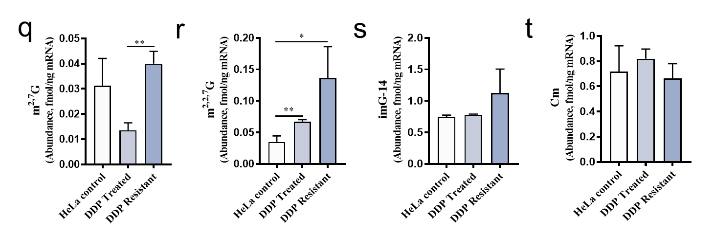
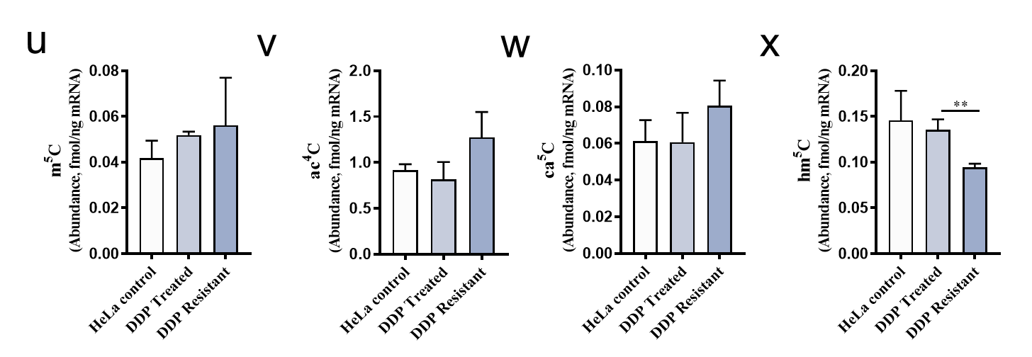
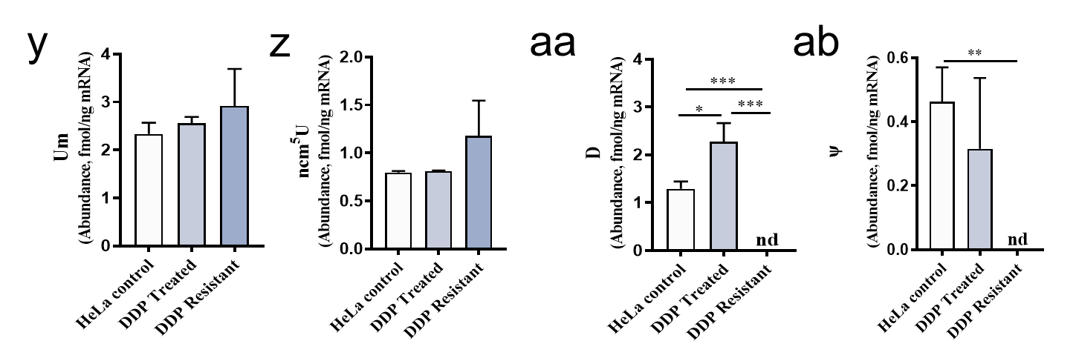
Figure S7, continued

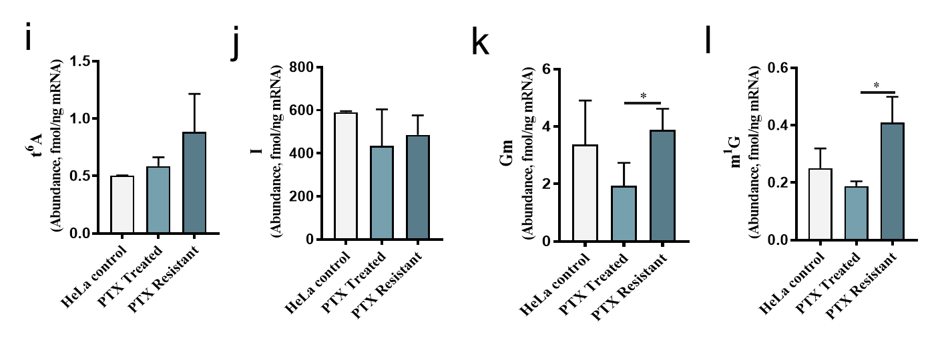
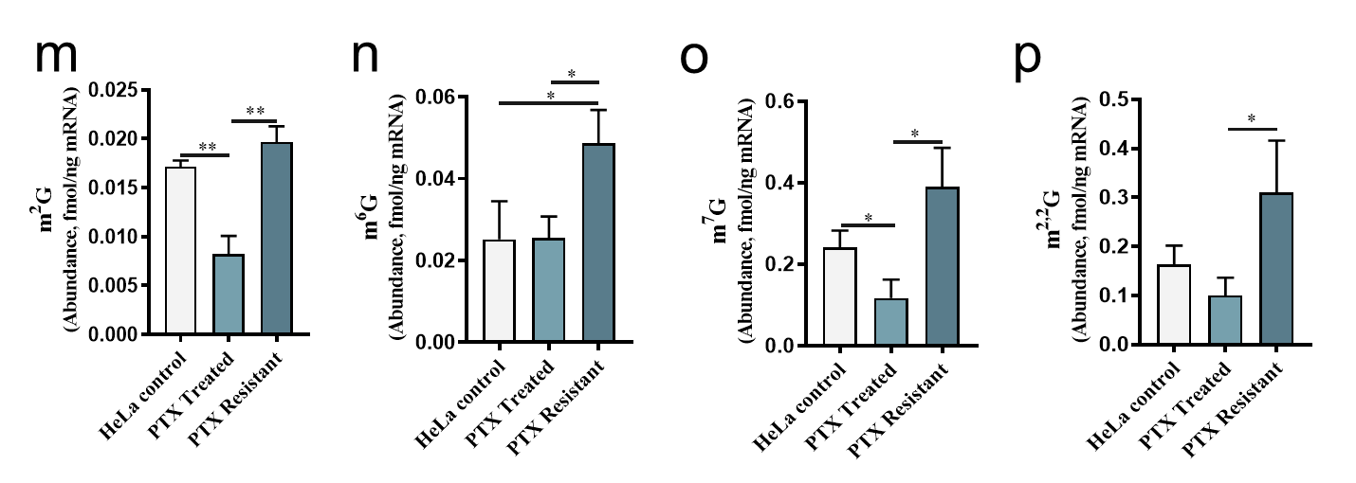
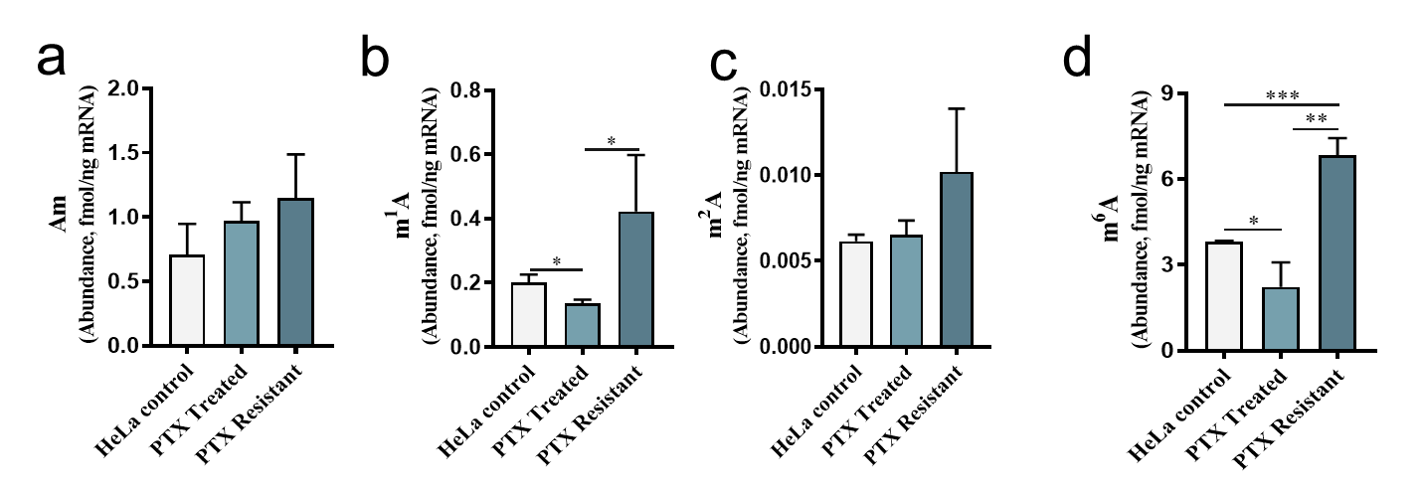
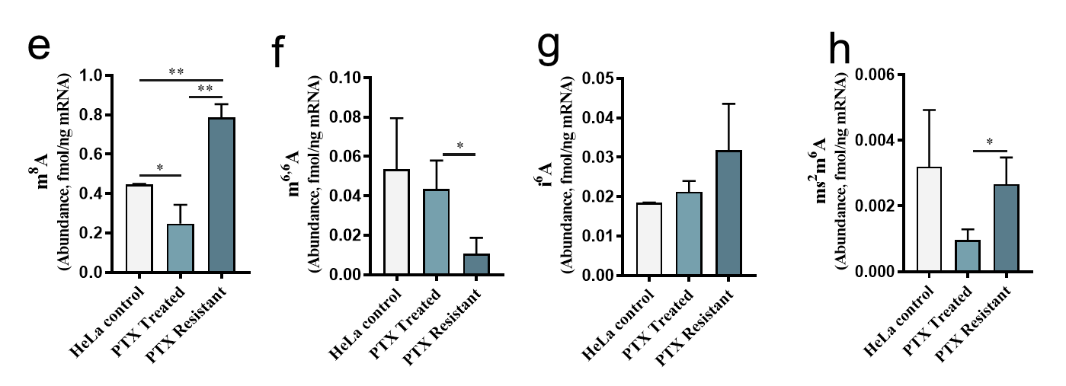
Figure S8. Quantification of the release of modified nucleosides during mRNA digestion of HeLa, PTX-treated HeLa, and PTX-resistant HeLa. (a-ab) Am, m¹A, m²A, m⁶A, m⁸A, m^{6,6}A, i⁶A, ms²m⁶A, t⁶A, I, Gm, m¹G, m²G, m⁶G, m⁷G, m^{2,7}G, m^{2,2}G, m^{2,2,7}G, imG-14, Cm, m⁵C, ac⁴C, ca⁵C, hm⁵C, Um, ncm⁵U, D, ψ. Values represent the mean ± SD of three biological experiments. "nd" indicates not detected. * p < 0.05, ** p < 0.01, *** p < 0.001.
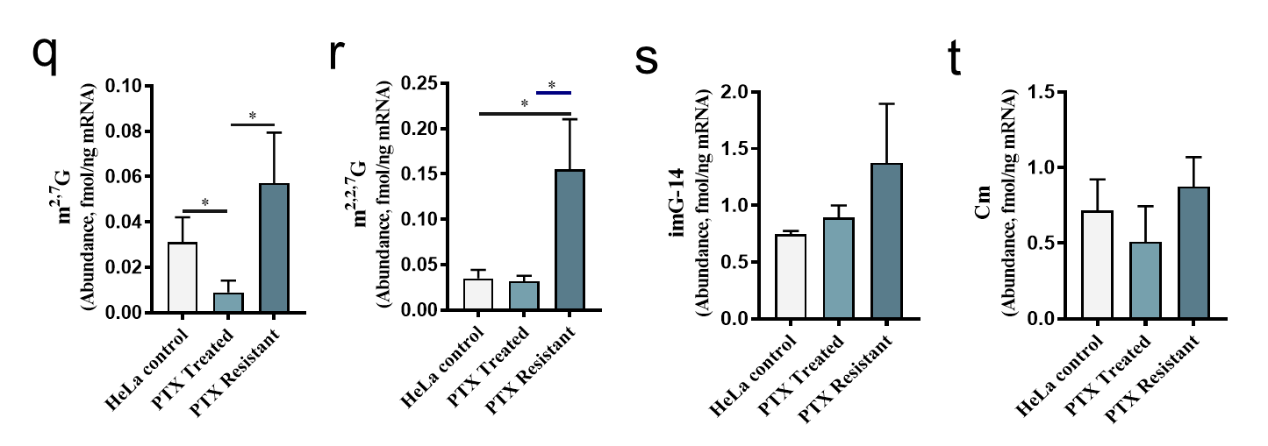
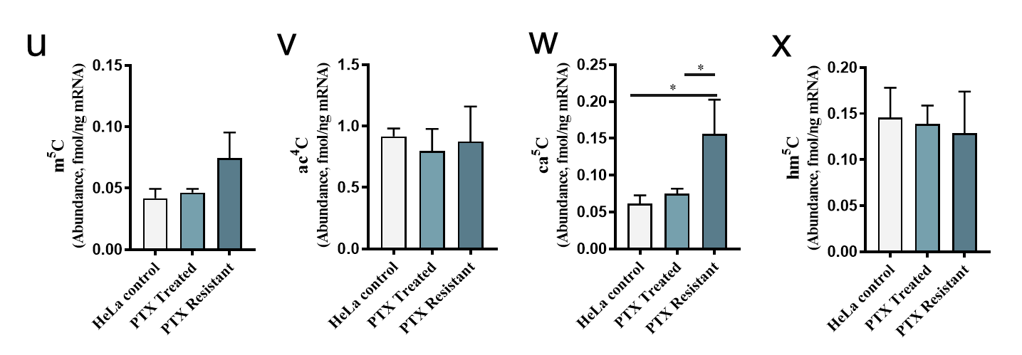
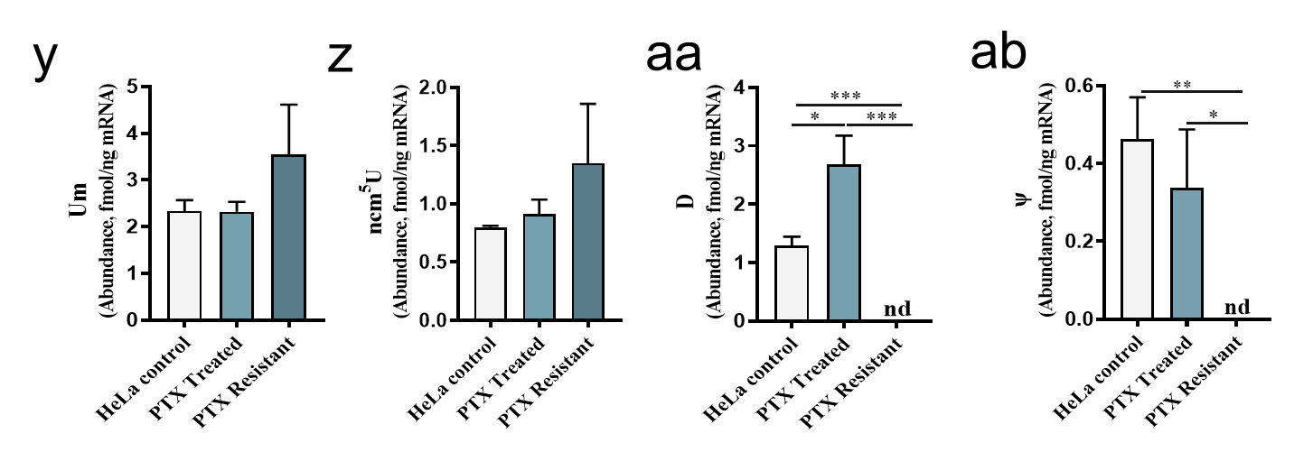
Figure S8, continued

Figure S9. Quantification of the release of modified nucleosides during mRNA digestion of HeLa cells after knocking down the m¹A modification enzymes TRMT6, TRMT61A, TRMT6-61A, TRMT10C, and the demodification enzyme ALKBH3. (a-ab) Am, m¹A, m²A, m⁶A, m⁸A, m^{6,6}A, i⁶A, ms²m⁶A, t⁶A, I, Gm, m¹G, m²G, m⁶G, m⁷G, m^{2,7}G, m^{2,2}G, m^{2,2,7}G, imG-14, Cm, m⁵C, ac⁴C, ca⁵C, hm⁵C, Um, ncm⁵U, D, ψ. Values represent the mean ± SD of three biological experiments. "nd" indicates not detected. * p < 0.05, ** p < 0.01, *** p < 0.001, **** p < 0.0001.
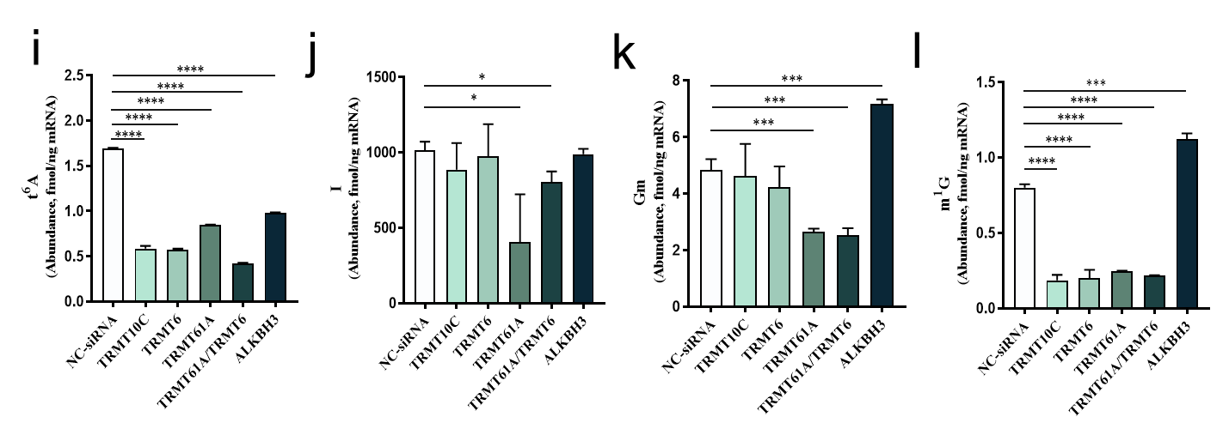
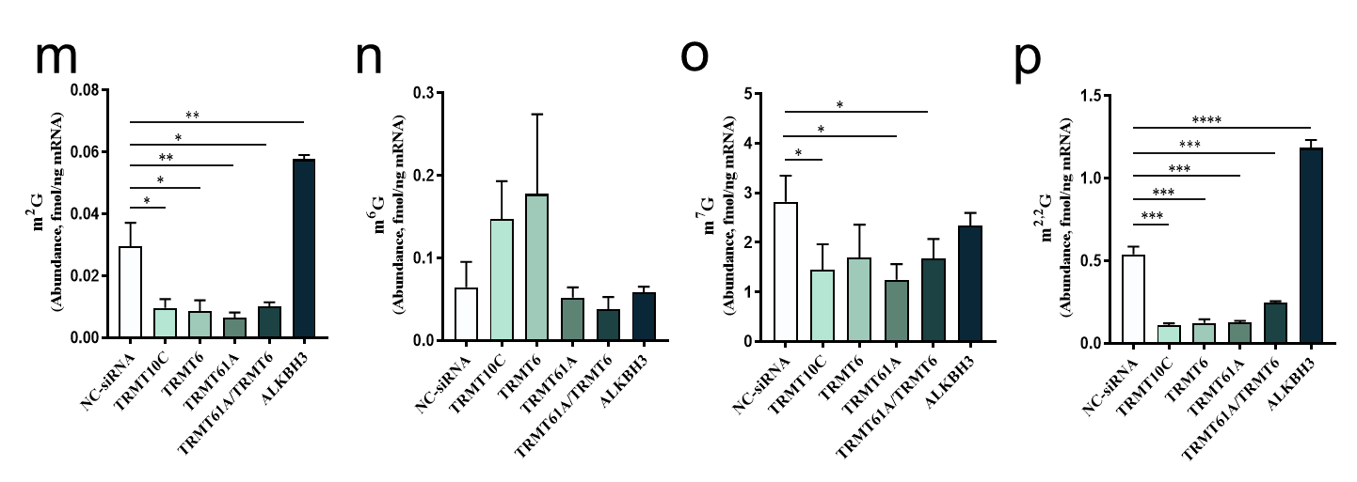
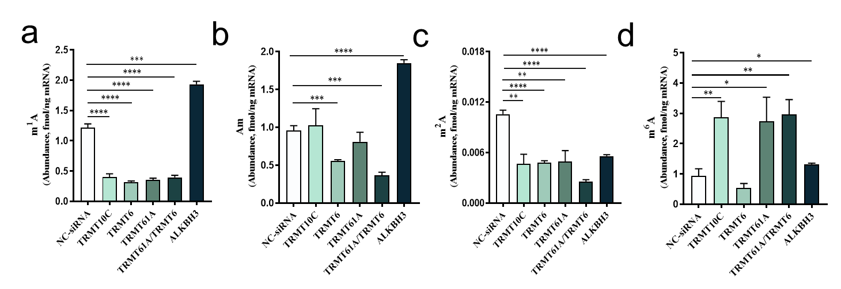
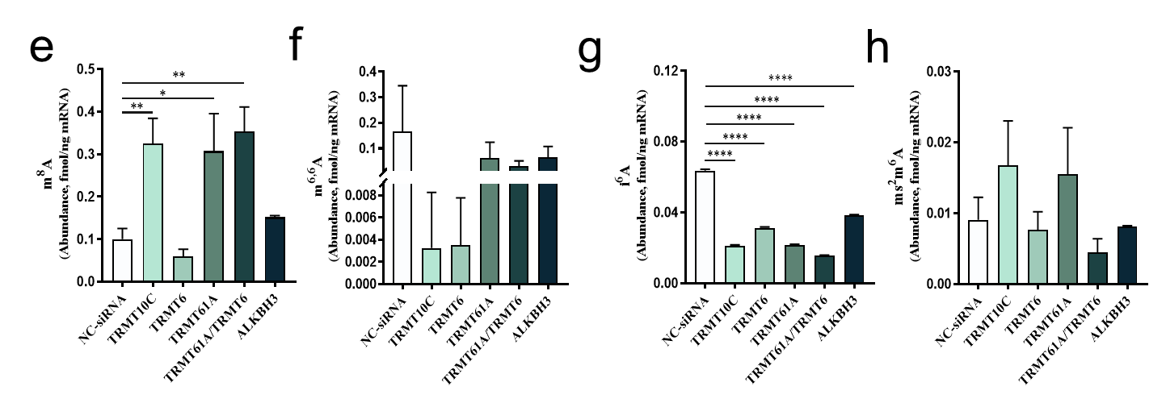
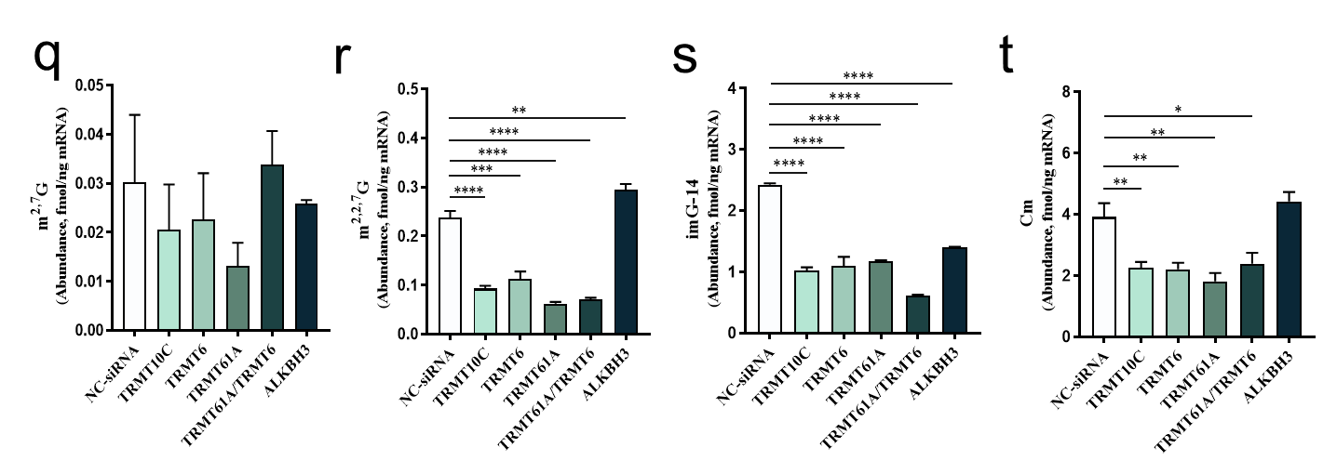
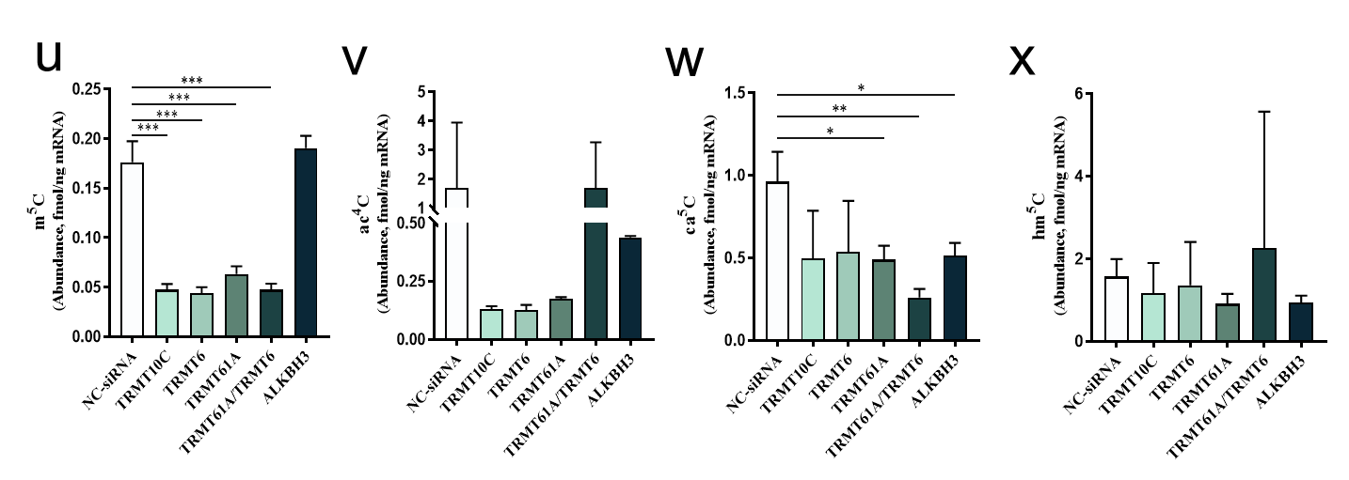
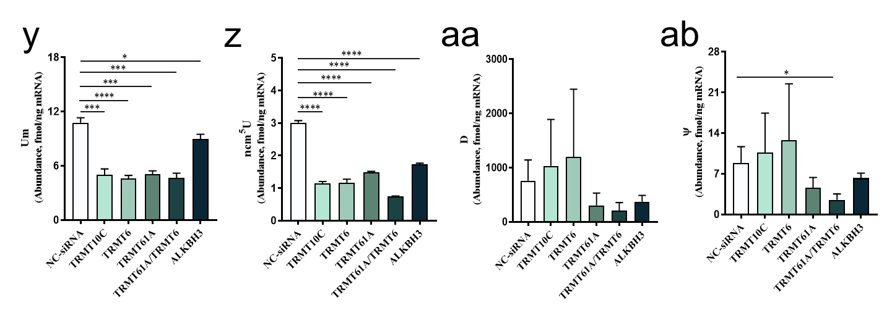
Figure S9, continued

Figure S10. Flow cytometry analysis of the impact on the cell cycle after 72h of knockdown of m¹A regulatory enzymes TRMT10C, ALKBH3, TRMT6, TRMT61A, and TRMT6-61A.
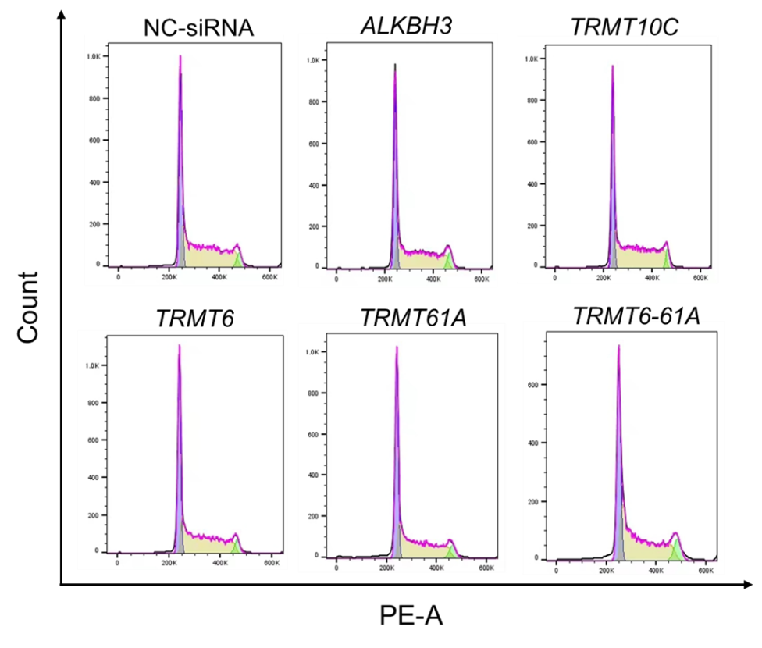

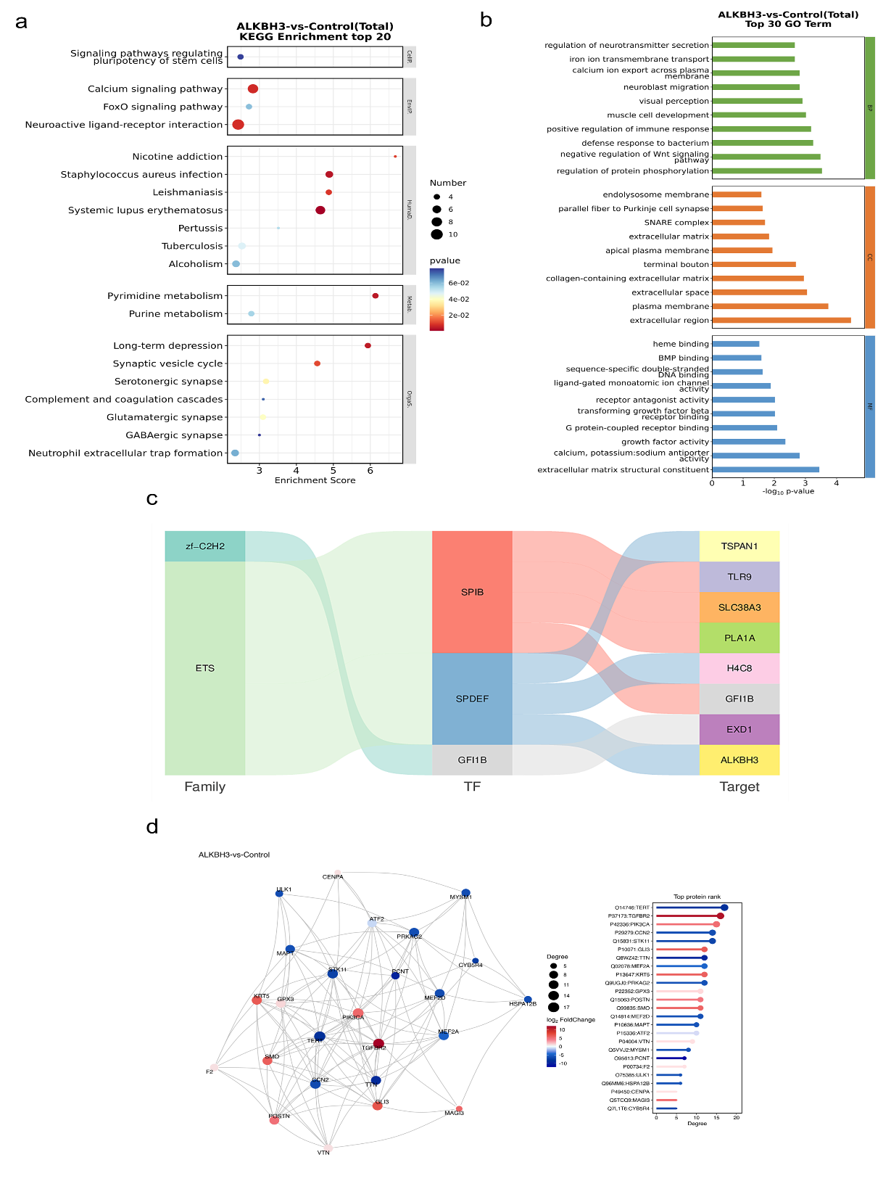
Figure S11. Transcriptomic and proteomic analysis of ALKBH3 treated HeLa cells. Transcriptome: (a) Top 20 KEGG enrichment bubble chart, (b) GO enrichment of the top 30 pathways, (c) Differential transcription factor-target gene Sankey diagram. Proteome: (d) Top 25 connectivity protein interaction network diagram, (e) GO enrichment of the top 15 pathways, (f) Top 20 KEGG enrichment bubble chart. Combined transcriptomic and proteomic analysis: (g) Bar chart of the top 30 KEGG (GSEA) pathways shared across different omics.
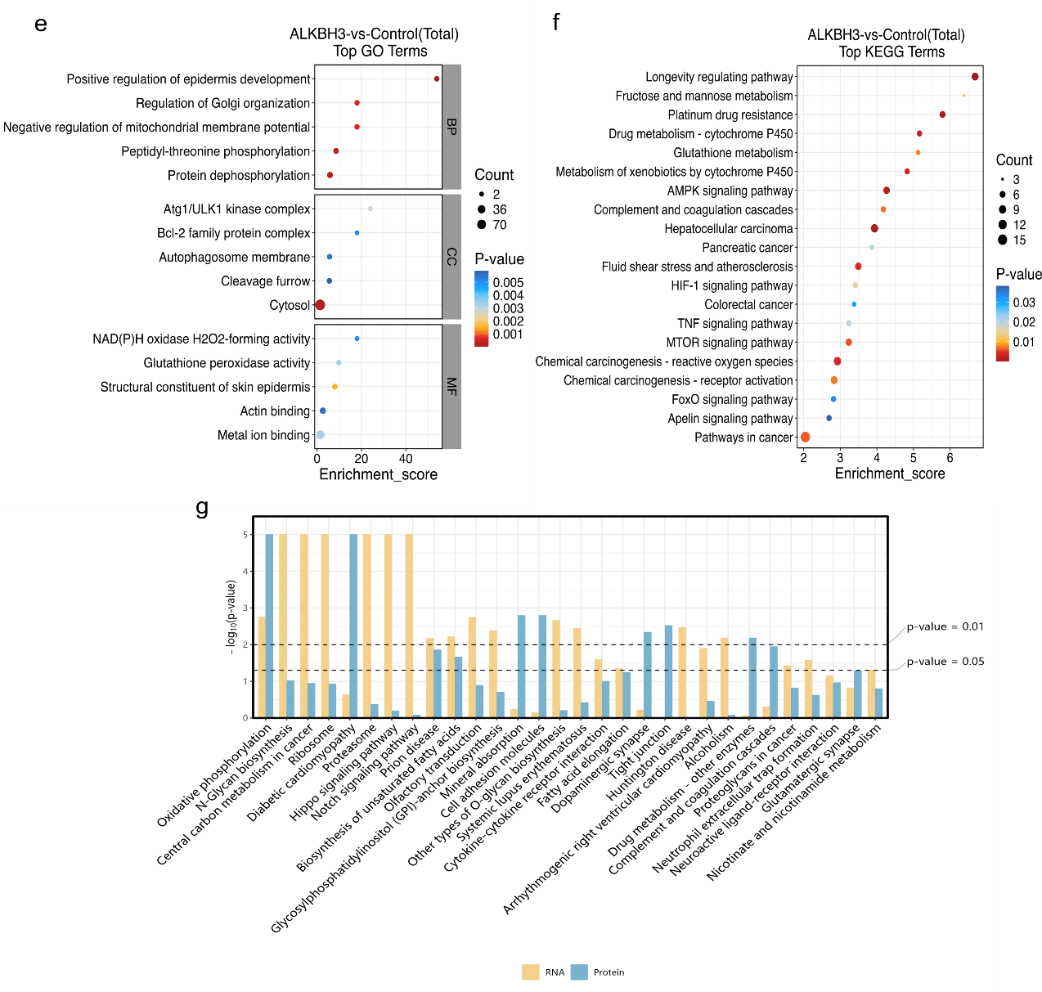
Figure S11, continued

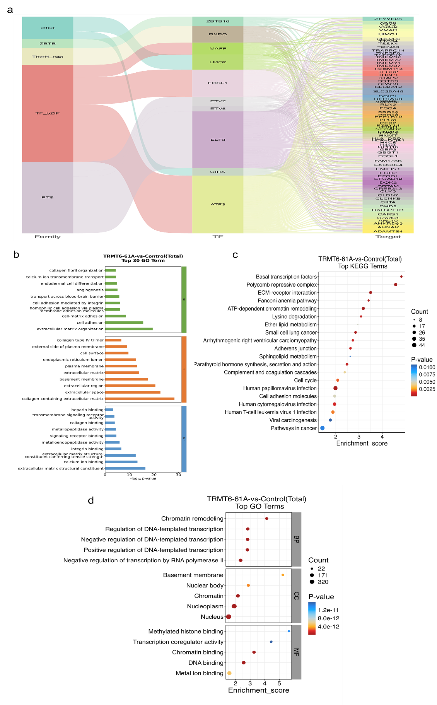
Figure S12. Transcriptomic and proteomic analysis of TRMT6-61A treated HeLa cells. Transcriptome: (a) Differential transcription factor-target gene Sankey diagram, (b) GO enrichment of the top 30 pathways. Proteome: (c) Top 20 KEGG enrichment bubble chart, (d) GO enrichment of the top 15 pathways.
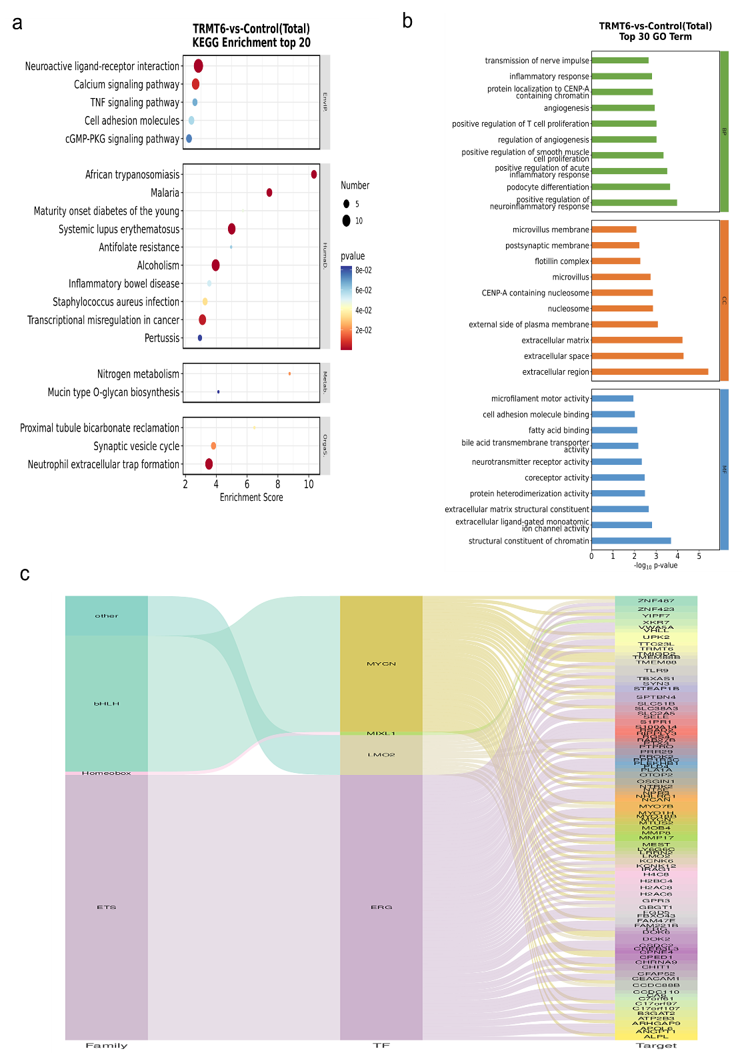
Figure S13. Transcriptomic and proteomic analysis of TRMT6 treated HeLa cells. Transcriptome: (a) Top 20 KEGG enrichment bubble chart, (b) GO enrichment of the top 30 pathways, (c) Differential transcription factor-target gene Sankey diagram. Proteome: (d) Top 25 connectivity protein interaction network diagram, (e) GO enrichment of the top 15 pathways, (f) Top 20 KEGG enrichment bubble chart. Combined transcriptomic and proteomic analysis: (g) Bar chart of the top 30 KEGG (GSEA) pathways shared across different omics.
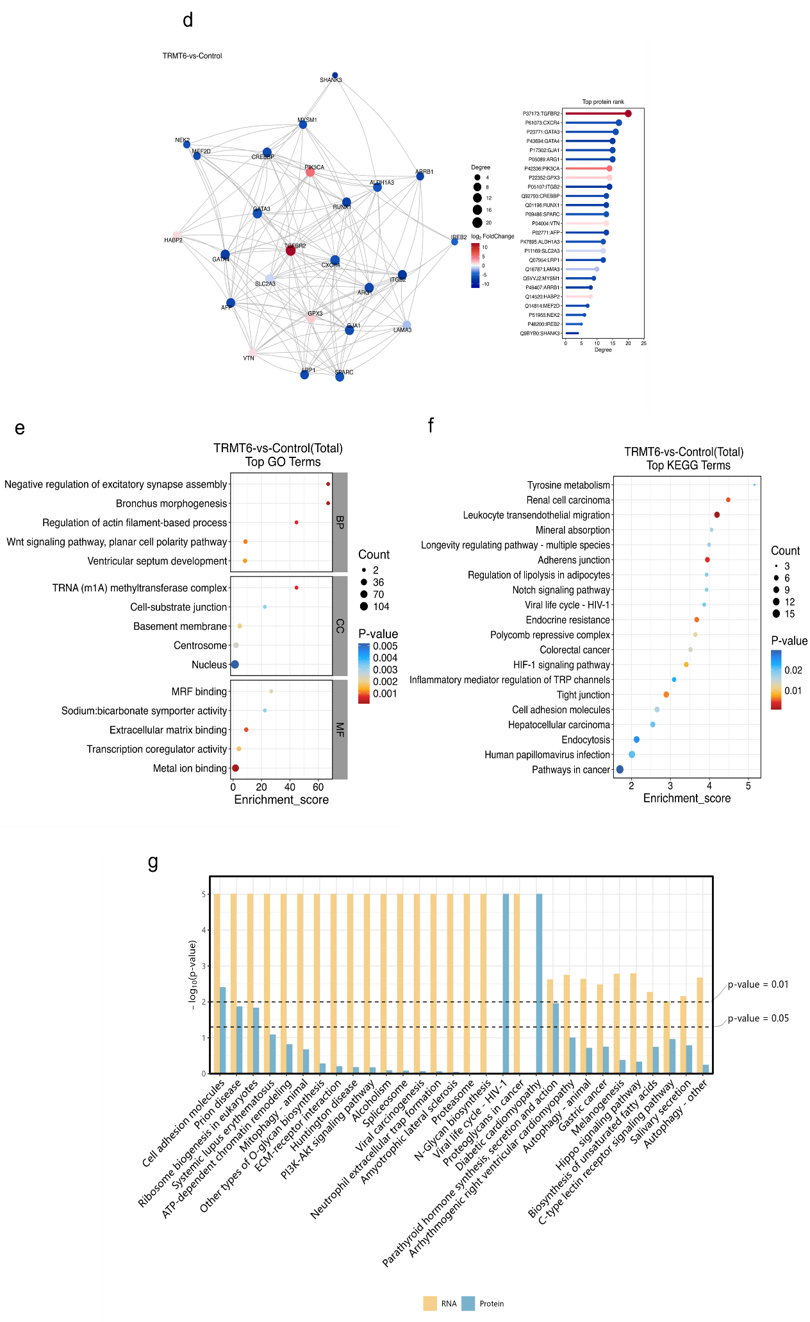
Figure S13, continued
Figure S14. Transcriptomic and proteomic analysis of TRMT61A treated HeLa cells. Transcriptome: (a) Top 20 KEGG enrichment bubble chart, (b) GO enrichment of the top 30 pathways, (c) Differential transcription factor-target gene Sankey diagram. Proteome: (d) Top 25 connectivity protein interaction network diagram, (e) GO enrichment of the top 15 pathways, (f) Top 20 KEGG enrichment bubble chart. Combined transcriptomic and proteomic analysis: (g) Bar chart of the top 30 KEGG (GSEA) pathways shared across different omics.
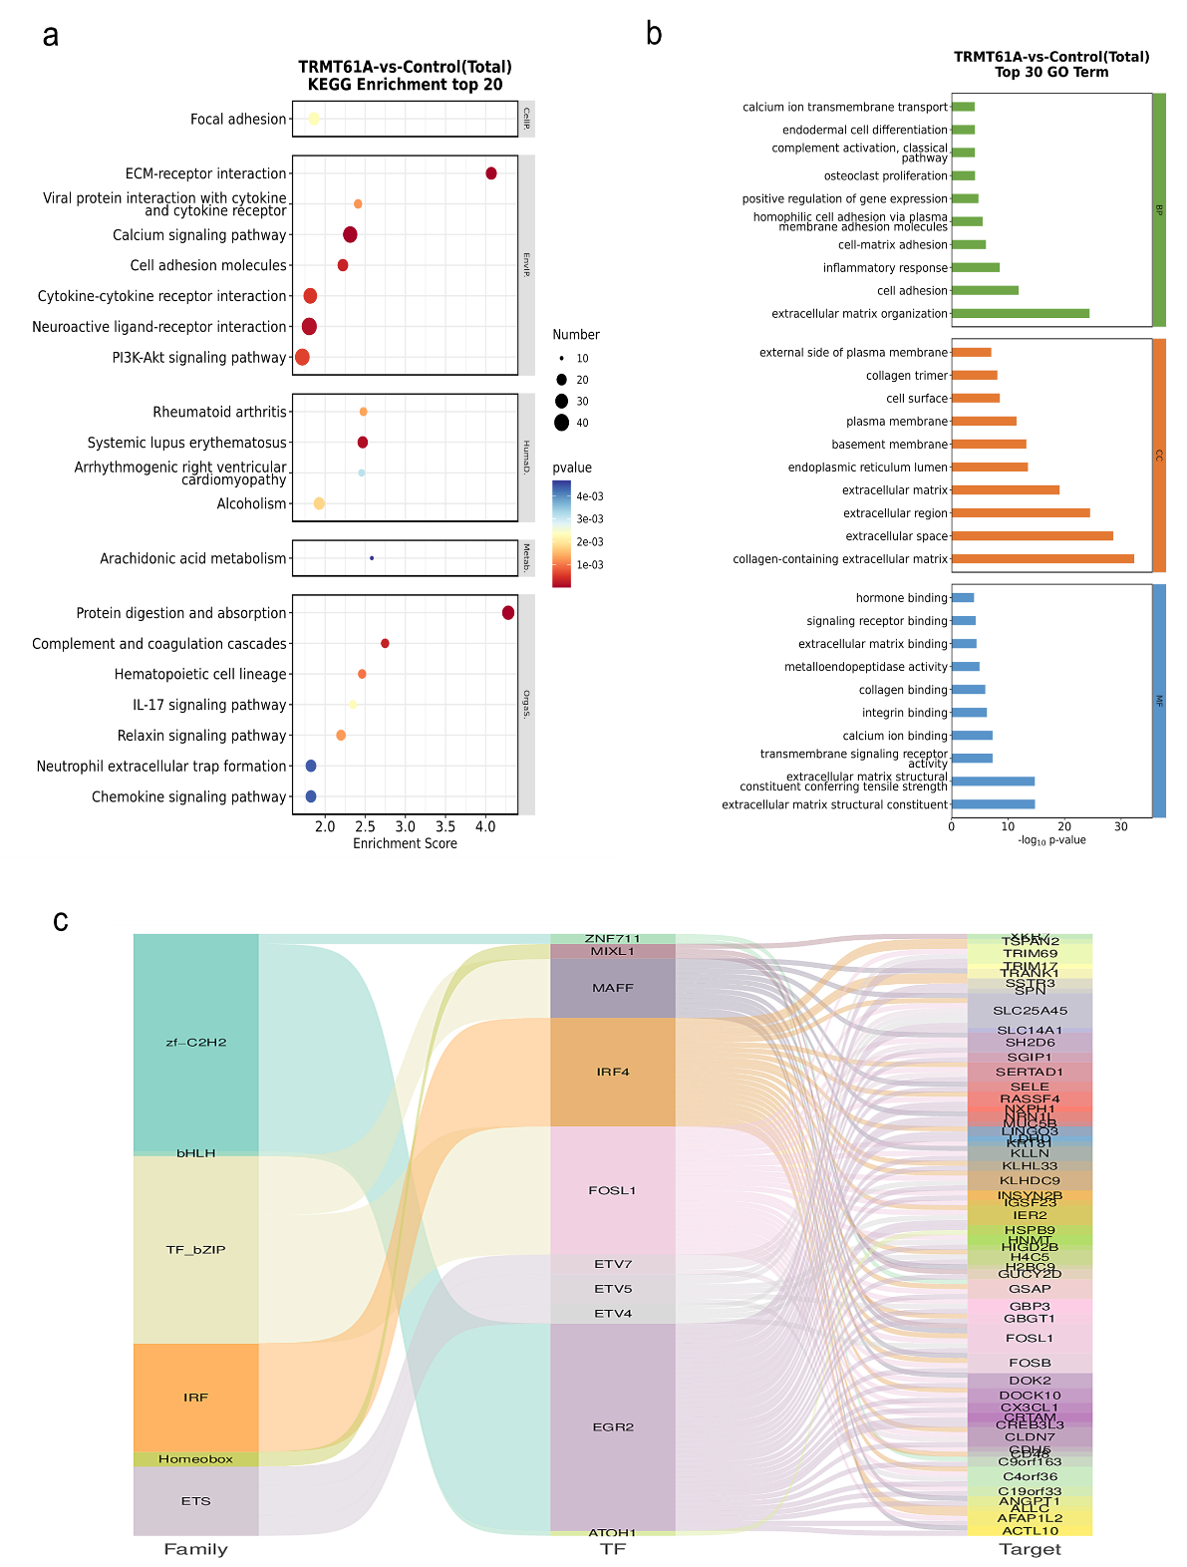
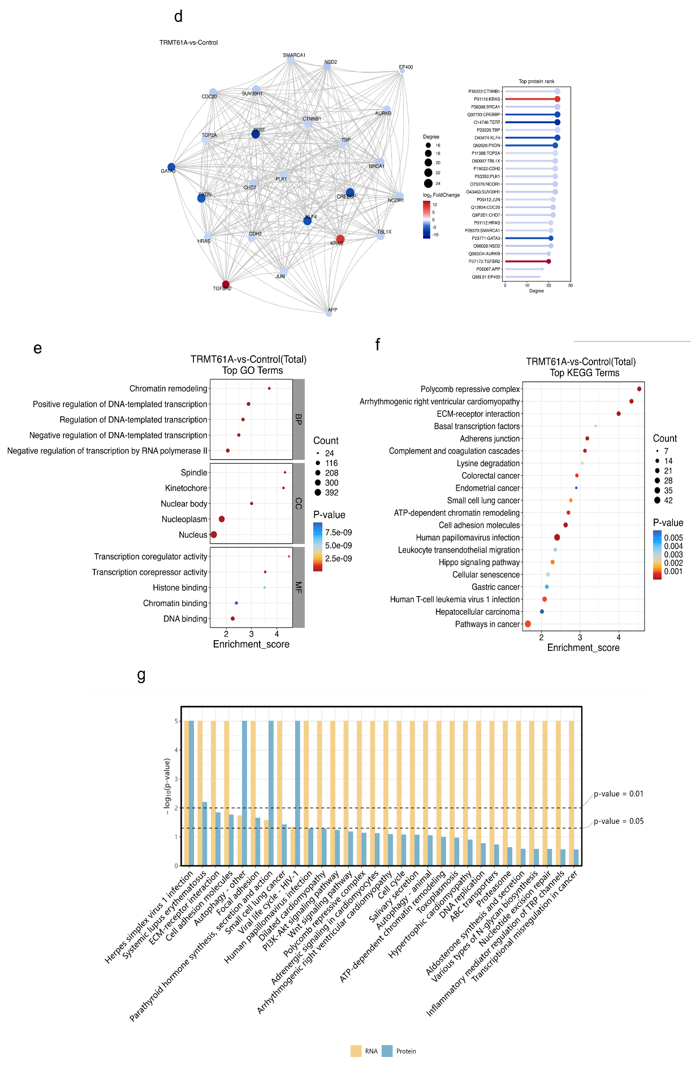
Figure S14, continued
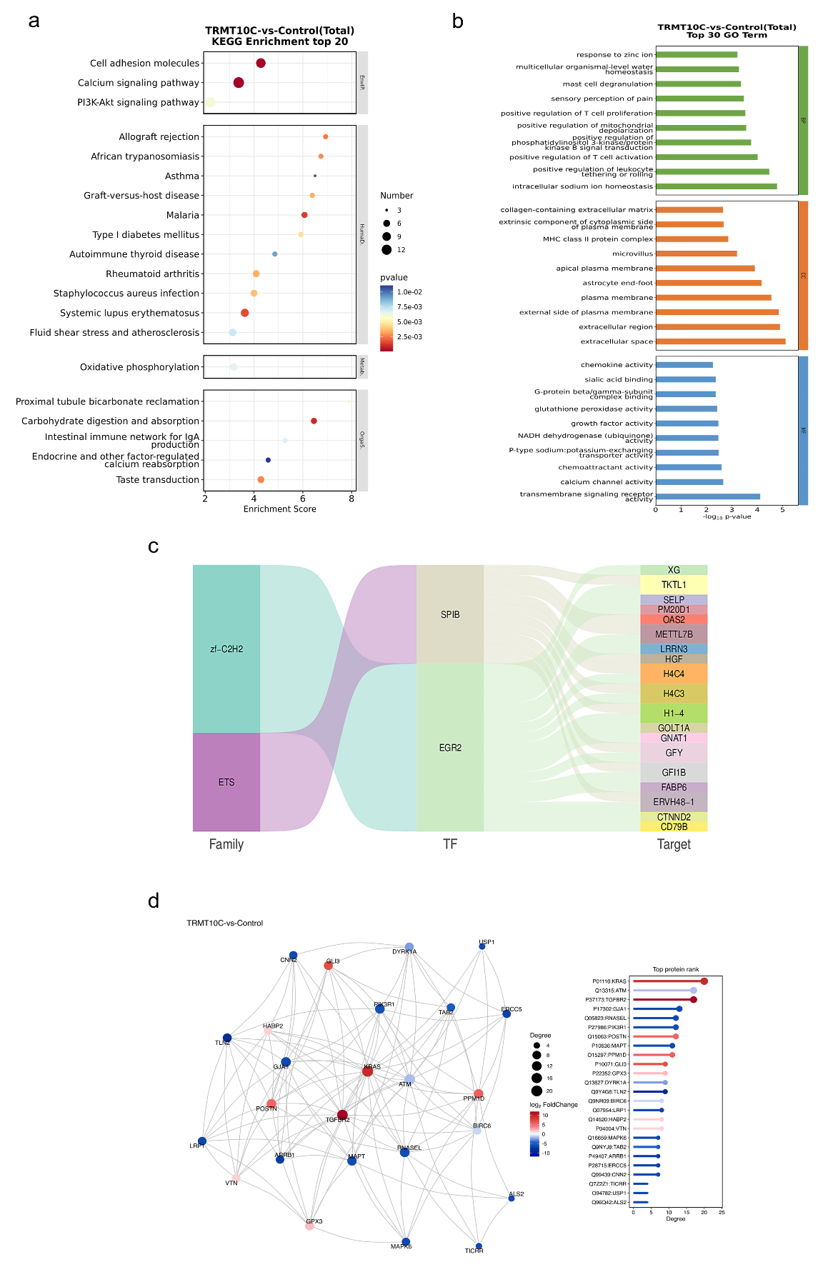
Figure S15. Transcriptomic and proteomic analysis of TRMT10C treated HeLa cells. Transcriptome: (a) Top 20 KEGG enrichment bubble chart, (b) GO enrichment of the top 30 pathways, (c) Differential transcription factor-target gene Sankey diagram. Proteome: (d) Top 25 connectivity protein interaction network diagram, (e) GO enrichment of the top 15 pathways, (f) Top 20 KEGG enrichment bubble chart. Combined transcriptomic and proteomic analysis: (g) Bar chart of the top 30 KEGG (GSEA) pathways shared across different omics.
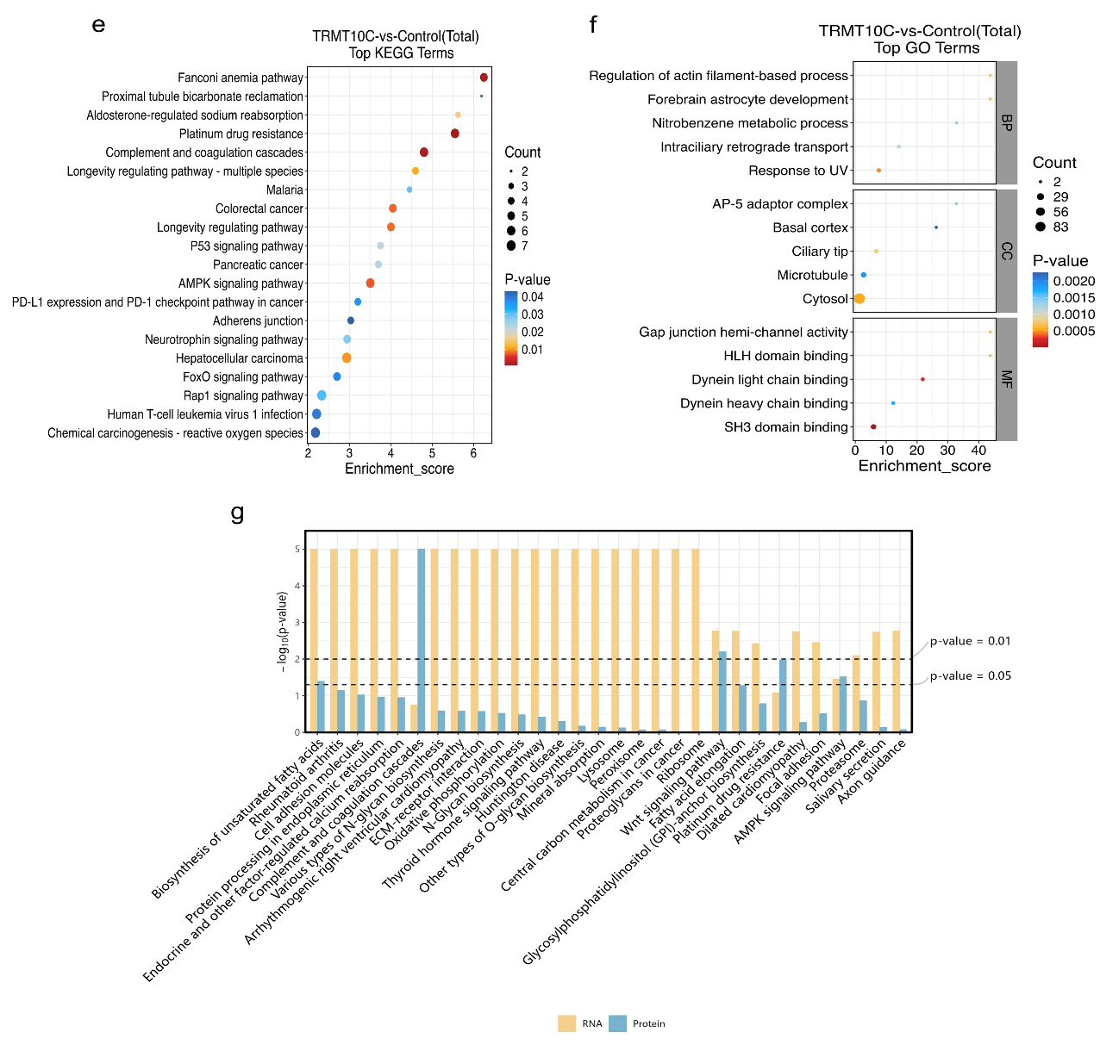
Figure S15, continued
Figure S16. Quantitative analysis using single-standard spike-in of m³C, m⁴C, m⁵C, and m⁶C (exemplified in HeLa cells). (a) m³C, (b) m⁴C, (c) m⁵C, (d) m⁶C.
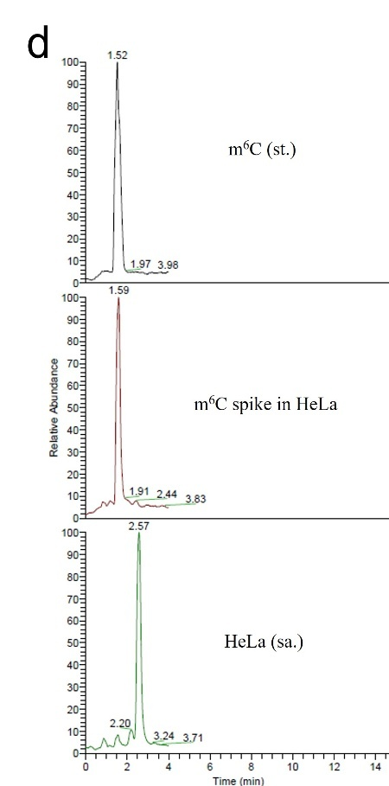
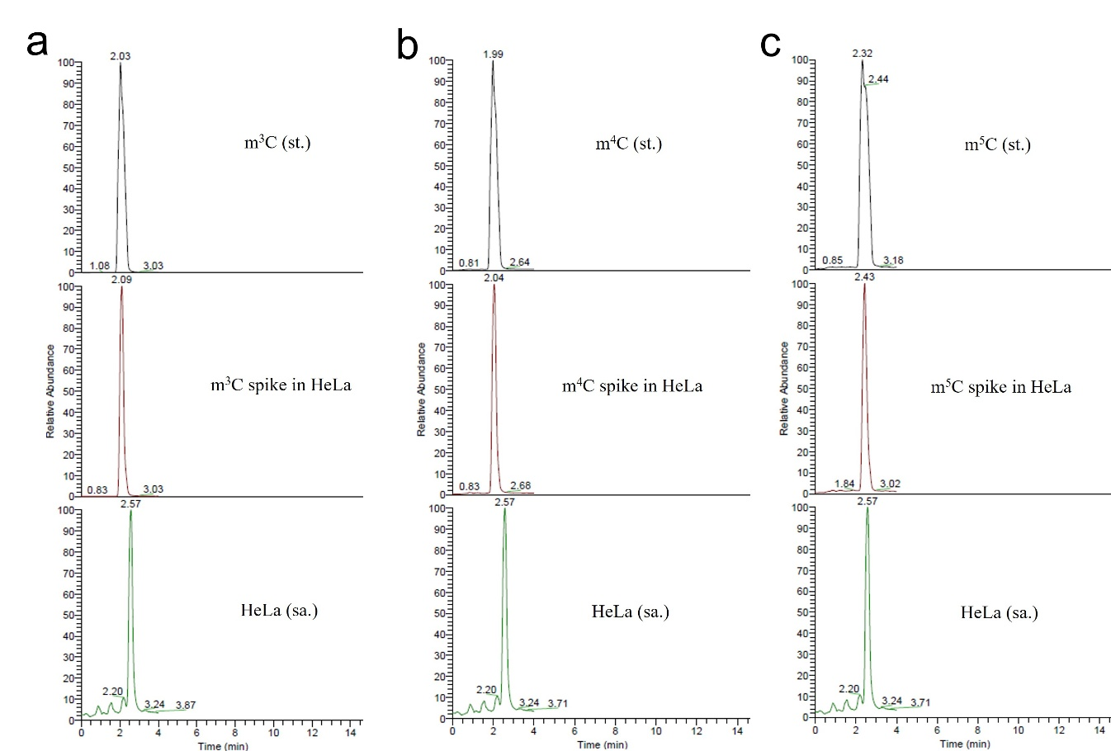
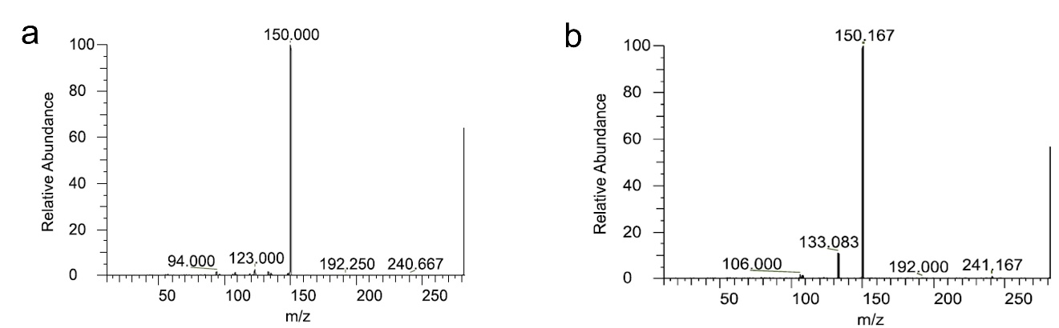
Figure S17. Product Spectrum of isobaric nucleosides: (a) m⁶A, (b) m⁸A

Table S1. siRNA used for transfection. S stands for Sense, and A stands for Antisense.
NC-siRNA
S | UUGUACUACACAAAAGUACUG
A | GUACUUUUGUGUAGUACAAUU
TRMT6-siRNA (NM_015939)
S | GGGAAAUCUCAGAAACUUATT
A | UAAGUUUCUGAGAUUUCCCTT
TRMT61A-siRNA (NM_152307)
S | GACAGUGCCUAUGUGAUCATT
A | UGAUCACAUAGGCACUGUCTT
TRMT10C-siRNA (NM_017819)
S | GAGUGUUAGUGUCAAUUUCTT
A | GAAAUUGACACUAACACUCTT
ALKBH3-siRNA (NM_139178)
S | UGGCUUUGUUGACGUGAAATT
A | UUUCACGUCAACAAAGCCATT

Table S2. Primers used for qPCR analysis.
Gapdh Human qPCR Primer Pair (NM_002046)
F | TGACATCAAGAAGGTGGTGAAGCAGG | product length = 100
R | GCGTCAAAGGTGGAGGAGTGGGT | product length = 100
TRMT6 Human qPCR Primer Pair (NM_015939)
F | CTGTCTTTGCTGGACTTTGTGGC | product length = 104
R | AGACAGCCTGAGGTTGATGACC | product length = 104
TRMT61A Human qPCR Primer Pair (NM_152307)
F | TCCTCTACTCCACAGACATCGC | product length = 98
R | CAATGGTGCGGATGATGGCGTG | product length = 98
TRMT10C Human qPCR Primer Pair (NM_017819)
F | CAAAACGGCTGAACCTGGCAAC | product length = 122
R | GCAGAGCCTCTTGCCAATTACC | product length = 122
ALKBH3 Human qPCR Primer (NM_139178)
F | CCACTGCTAAGAGCCATCTCCA | product length = 114
R | TCAATCACTCGTGGCTCAGGAG | product length = 114

Table S3. Cellular composition at different cell cycle phases after knocking down m¹A regulatory enzymes in HeLa cells.
groups | G1% | S% | G2/M%
NC-siRNA | 32.9±2.0 | 56.4±2.5 | 4.2±0.5
ALKBH3 | 37.0±0.6 | 51.0±0.6 | 6.0±0.8
TRMT10C | 32.9±0.3 | 56.1±0.5 | 4.9±0.8
TRMT6 | 38.9±0.4 | 50.6±0.3 | 4.5±0.5
TRMT61A | 38.6±1.1 | 47.4±1.3 | 5.5±1.3
TRMT6+TRMT61A | 35.9±1.5 | 47.5±2.1 | 8.1±0.8

Table S4. Detection limits of known and potentially existing modified nucleosides studied.
Compound | Limit of quantification (LOQ), amol | Limit of detection (LOD), amol
hm⁵C | 8.07 | 2.42
ψ | 2310 | 694
ca⁵C | 77.2 | 23.2
s²ψ | 22200 | 6670
ncm⁵U | 179 | 53.7
hm⁵U | 1850 | 412
m¹A | 0.391 | 0.117
m²A | 34.3 | 10.3
m⁶A | 5.29 | 1.59
m⁸A | 11.5 | 3.46
D | 2650 | 794
mnm⁵s²U | 229 | 68.6
m³C | 27.4 | 8.23
m⁴C | 9.80 | 2.94
m⁵C | 41.2 | 12.4
m⁶C | 6.24 | 1.87
s²C | 123 | 37.0
cm⁵U | 187 | 56.1
Cm | 95.0 | 28.5
m¹ψ | 18500 | 5560
m³ψ | 2650 | 794
ho⁵U | 726 | 218
m⁵D | 125 | 37.4
s²U | 2180 | 654
s⁴U | 8550 | 2560
Um | 19600 | 5880
c⁷A | 10.6 | 3.17
m¹G | 309 | 92.6
m²G | 12.5 | 3.74
m⁶G | 337 | 101
m⁷G | 31.7 | 9.50
f⁵C | 247 | 74.1
I | 114 | 34.3
m¹Am | 4.57 | 1.37
m⁶Am | 22.9 | 6.86
m³U | 412 | 123
m⁵U | 11.7 | 3.52
mo⁵U | 882 | 265
m⁵s²U | 374 | 112
c⁷G | 7940 | 2380
m¹I | 19600 | 5880
m⁵Cm | 68.6 | 20.6
m^{4,4}Cm | 274 | 82.3
mchm⁵U | 100000 | 30000
m^{2,7}G | 41.2 | 12.4
mcm⁵U | 317 | 95.0
Gm | 27.4 | 8.23
OHyW | 5.08 | 1.52
yW | 1.41 | 0.423
OHyWx | 0.0306 | 0.00918
Im | 2.12 | 0.635
Ar(P) | 0.635 | 0.191
ms²io⁶A | 0.339 | 0.102
tm⁵U | 3.63 | 1.09
cmnm⁵U | 16.9 | 5.08
Q | 10.2 | 3.05
ncm⁵Um | 16.9 | 5.08
ms²i⁶A | 926 | 381
tm⁵s²U | 3090 | 926
ms²t⁶A | 0.267 | 0.0802
manQ | 16.9 | 5.08
galQ | 16.9 | 5.08
i⁶A | 0.318 | 0.0953
ms²m⁶A | 0.254 | 0.0762
cmo⁵U | 1.75 | 0.526
m¹acp³ψ | 374 | 112
mcm⁵s²U | 2310 | 694
chm⁵U | 5.08 | 1.52
O²yW | 11100 | 3700
m^{6,6}Am | 337 | 41.2
t⁶A | 1.69 | 0.191
imG-14 | 1.02 | 0.305
PreQ0 | 28.6 | 8.57
m^{6,6}A | 112 | 33.7
ac⁴Cm | 61.7 | 18.5
mcm⁵Um | 374 | 112
m^{2,2}G | 58.8 | 13.7
m⁵Um | 1230 | 370
m³Um | 514 | 103
m^{2,2,7}G | 4.16 | 1.25
f⁵Cm | 142 | 19.5
mcmo⁵U | 650 | 195
ac⁴C | 112 | 33.7
Am | 168 | 41.2

Table S5. Dynamic MRM parameters for ribonucleosides based on optimizer results.
rN nameª | RT (min) | RT Window (min) | Precursor (m/z) | Product (m/z) | CE (V) | Min Dwell Time (ms) | RF Lens (V)
hm⁵C | 1.6 | 3 | 274 | 142 | 11 | 31.125 | 36
m⁶C | 1.47 | 2 | 258 | 126 | 12 | 29.799 | 76
ho⁵U | 1.50 | 2 | 261 | 129 | 10 | 29.799 | 57
m⁵D | 1.80 | 2 | 261 | 129 | 10 | 29.799 | 57
m⁴C | 1.92 | 2 | 258 | 126 | 12 | 29.799 | 76
m³C | 1.97 | 2 | 258 | 126 | 12 | 29.799 | 76
ψ | 2.00 | 4 | 245 | 209 | 9 | 29.799 | 34
m⁵C | 2.27 | 2 | 258 | 126 | 12 | 29.799 | 76
ca⁵C | 2.29 | 4 | 288 | 156 | 11 | 29.799 | 36
s²ψ | 2.50 | 4 | 261 | 225 | 10 | 29.799 | 38
ncm⁵U | 2.50 | 4 | 302 | 170 | 10 | 29.799 | 40
hm⁵U | 2.51 | 3 | 275 | 125 | 14 | 29.799 | 47
m¹A | 2.51 | 3 | 282 | 150 | 18 | 29.799 | 53
D | 2.60 | 4 | 247 | 115 | 9 | 29.799 | 55
m³ψ | 2.60 | 5 | 259 | 223 | 10 | 29.799 | 39
mnm⁵s²U | 2.81 | 4 | 304 | 141 | 18 | 29.799 | 42
s²C | 3.00 | 3.5 | 260 | 128 | 12 | 29.799 | 37
cm⁵U | 3.00 | 3 | 303 | 171 | 9 | 29.799 | 40
m¹ψ | 3.39 | 5 | 259 | 223 | 10 | 29.799 | 39
m⁵U | 3.58 | 7 | 259 | 127 | 11 | 29.799 | 34
Cm | 3.59 | 3 | 258 | 112 | 11 | 29.799 | 37
Um | 4.00 | 4 | 259 | 113 | 8 | 29.799 | 46
s²U | 4.12 | 7 | 261 | 129 | 10 | 29.799 | 57
c⁷A | 4.14 | 8 | 267 | 135 | 19 | 29.799 | 56
m⁷G | 4.40 | 6 | 298 | 166 | 14 | 29.799 | 39
f⁵C | 4.63 | 4 | 272 | 140 | 11 | 29.799 | 33
I | 4.71 | 4 | 269 | 137 | 11 | 29.799 | 40
c⁷G | 4.74 | 6 | 283 | 151 | 18 | 29.799 | 57
s⁴U | 4.76 | 7 | 261 | 129 | 10 | 29.799 | 57
m¹Am | 4.9 | 4 | 296 | 150 | 17 | 29.799 | 55
m³U | 5.34 | 7 | 259 | 127 | 11 | 29.799 | 34
m²A | 5.62 | 6 | 282 | 150 | 18 | 23.57 | 49
mo⁵U | 5.66 | 4 | 275 | 143 | 11 | 29.799 | 36
m⁵Cm | 6.73 | 9 | 272 | 126 | 13 | 28.576 | 37
¹⁵N⁵-dA | 7.00 | 8 | 257 | 141 | 14 | 28.576 | 38
m^{4,4}Cm | 7.26 | 4 | 286 | 140 | 14 | 44.846 | 40
m¹I | 7.98 | 6 | 283 | 151 | 18 | 29.799 | 57
mchm⁵U | 8.39 | 4 | 333 | 187 | 18 | 39.851 | 72
m^{2,7}G | 8.68 | 4 | 312 | 180 | 14 | 34.117 | 45
mcm⁵U | 8.70 | 3 | 317 | 185 | 9 | 42.208 | 38
m¹G | 9.27 | 7 | 298 | 166 | 17 | 23.485 | 56
m⁸A | 10.30 | 6 | 282 | 106 | 54 | 23.57 | 47
m⁶A | 10.44 | 6 | 282 | 94 | 56 | 23.57 | 41
Gm | 10.15 | 6 | 298 | 152 | 12 | 23.537 | 36
Am | 10.70 | 8 | 282 | 136 | 16 | 23.485 | 49
m²G | 10.81 | 7 | 298 | 166 | 17 | 23.485 | 56
ac⁴C | 11.15 | 6 | 286 | 154 | 9 | 23.485 | 31
m⁵Um | 11.24 | 6 | 273 | 127 | 12 | 23.485 | 35
mcmo⁵U | 11.28 | 6 | 333 | 201 | 9 | 23.485 | 41
f⁵Cm | 11.46 | 5 | 286 | 140 | 11 | 23.485 | 36
m^{2,2,7}G | 11.72 | 5 | 326 | 194 | 15 | 23.485 | 48
m⁵s²U | 12.00 | 9 | 275 | 143 | 10 | 23.485 | 36
m^{2,2}G | 12.02 | 5 | 312 | 180 | 22 | 23.485 | 48
mcm⁵Um | 12.42 | 4 | 331 | 185 | 9 | 23.485 | 36
m⁶Am | 12.46 | 5 | 296 | 150 | 17 | 23.485 | 53
m³Um | 12.52 | 6 | 273 | 127 | 12 | 23.485 | 35
ac⁴Cm | 12.54 | 4 | 300 | 154 | 10 | 23.485 | 36
m^{6,6}A | 12.56 | 4 | 296 | 164 | 21 | 23.485 | 63
PreQ0 | 12.56 | 4 | 308 | 176 | 16 | 23.485 | 59
m⁶G | 12.63 | 7 | 298 | 166 | 17 | 23.485 | 56
imG-14 | 12.78 | 5 | 322 | 190 | 15 | 23.485 | 47
t⁶A | 12.80 | 4 | 413 | 281 | 12 | 23.485 | 56
m^{6,6}Am | 12.94 | 4 | 310 | 164 | 19 | 23.485 | 64
O²yW | 12.94 | 4 | 542 | 496 | 16 | 23.485 | 117
chm⁵U | 13.10 | 6 | 319 | 278 | 8 | 23.485 | 67
mcm⁵s²U | 13.20 | 5 | 333 | 169 | 19 | 23.485 | 46
m¹acp3ψ | 13.22 | 5 | 360 | 319 | 6 | 23.485 | 57
cmo⁵U | 13.32 | 6 | 319 | 187 | 9 | 23.485 | 43
ms²m⁶A | 13.42 | 4 | 328 | 196 | 21 | 23.485 | 63
i⁶A | 13.46 | 4 | 336 | 204 | 16 | 23.485 | 63
manQ | 13.47 | 4 | 572 | 526 | 16 | 23.485 | 97
galQ | 13.58 | 4 | 572 | 526 | 16 | 23.485 | 97
ms²t⁶A | 13.80 | 4 | 459 | 327 | 14 | 23.485 | 73
tm⁵s²U | 13.90 | 4 | 398 | 263 | 13 | 23.485 | 66
ms²i⁶A | 14.32 | 5 | 382 | 250 | 19 | 23.485 | 92
ncm⁵Um | 14.36 | 5 | 361 | 279 | 14 | 23.485 | 81
Q | 14.40 | 4 | 410 | 295 | 19 | 23.485 | 75
cmnm⁵U | 15.94 | 5 | 322 | 125 | 18 | 23.485 | 41
tm⁵U | 17.20 | 5 | 382 | 266 | 16 | 35.771 | 90
ms²io⁶A | 17.80 | 5 | 398 | 377 | 5 | 47.783 | 72
Ar(P) | 18.20 | 5 | 480 | 439 | 7 | 59.373 | 105
Im | 18.72 | 5 | 283 | 247 | 11 | 77.699 | 49
OHyWx | 20.40 | 6 | 453 | 433 | 5 | 112.008 | 80
yW | 21.00 | 6 | 509 | 463 | 22 | 112.008 | 117
OHyW | 21.70 | 6 | 525 | 465 | 22 | 112.02 | 120

