Supplementary Materials
Figure and Figure legends
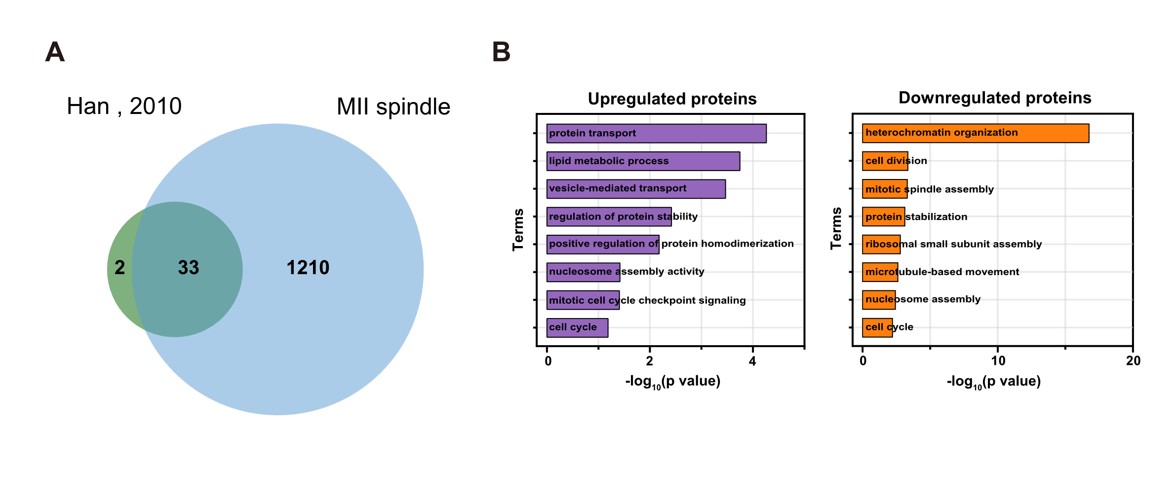
Fig S1. DEPs of the meiotic spindles of mouse oocyte at MI and MII stages. A. Venn diagram showing the numbers of proteins identified in previous study and our data. B. GO enrichment analysis of DEPs between MI spindles and MII spindles.
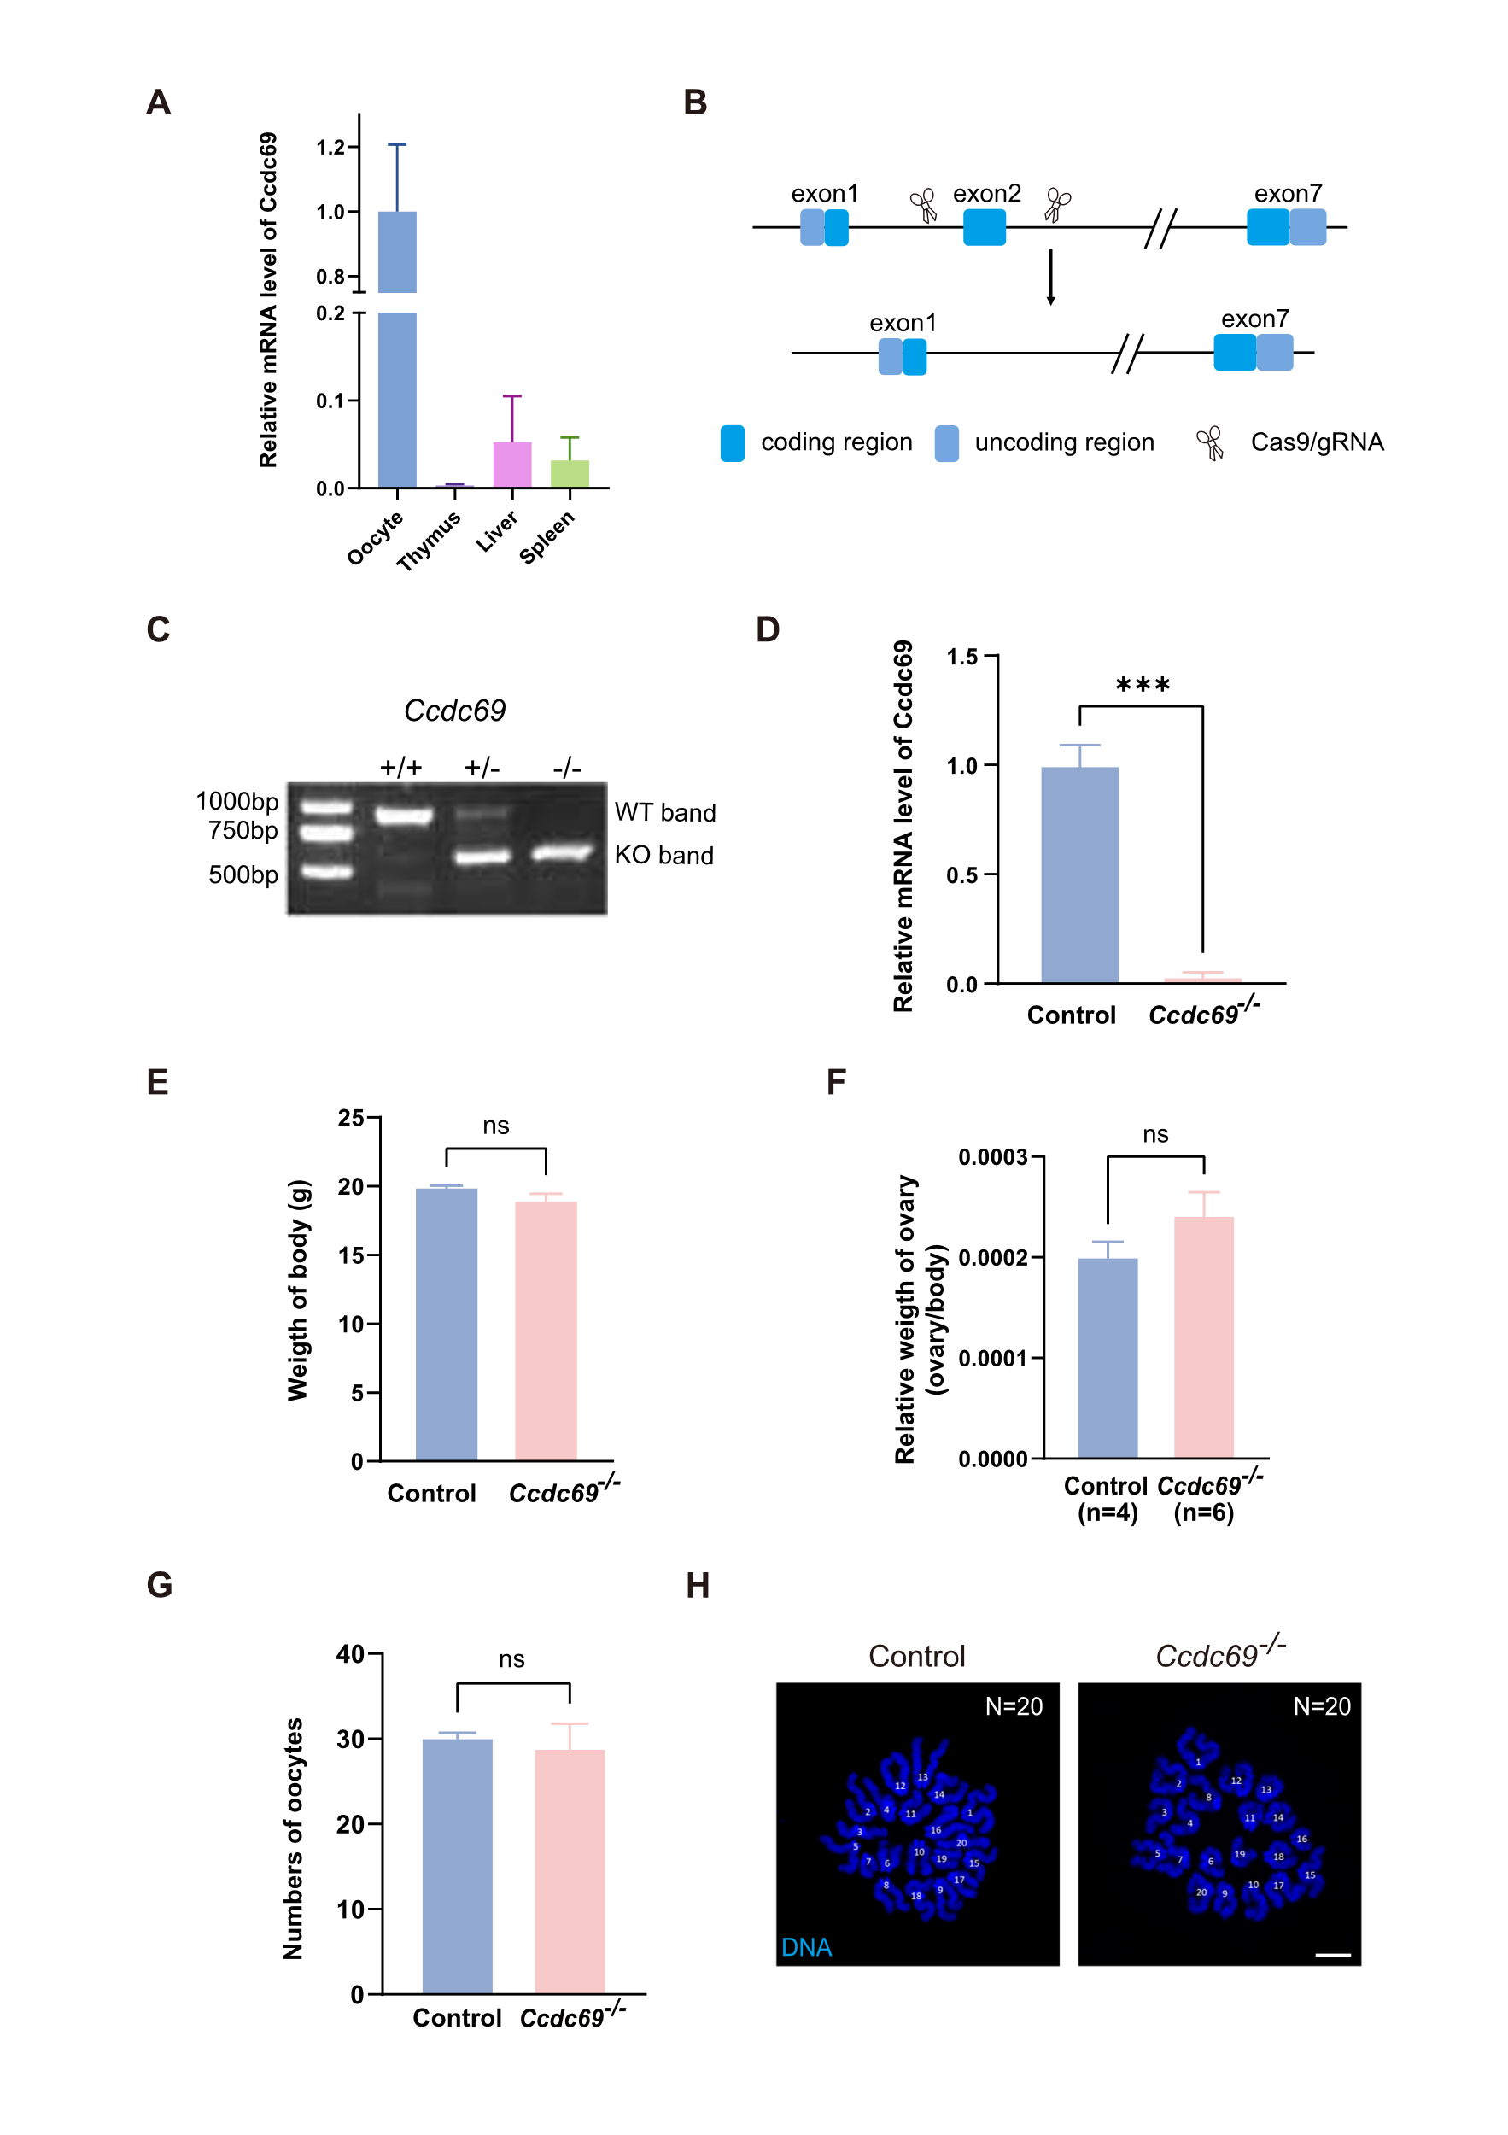
Fig S2. Deletion of Ccdc69 in mouse. A. The level of Ccdc69 mRNAs in different tissue. B. Schematic diagram of the homologous recombination-mediated KO strategy of Ccdc69 gene. C. Genotyping PCR for Ccdc69^{+/+}, Ccdc69^{+/-} and Ccdc69^{-/-} mice. WT, wild type; KO, knockout. D. The level of Ccdc69 mRNAs in control and Ccdc69^{-/-} ovary. ***p < 0.001. E. The weight of ovaries of control and Ccdc69^{-/-} mice. p = 0.1681. F. Relative weight of single ovary compared to body weight of control and Ccdc69^{-/-} female mice. p = 0.1681, n = number of ovaries. G. The number of MII oocytes obtained from each control and Ccdc69^{-/-} female mouse after superovulation. Four mice of each genotype were examined. p = 0.6752. H. Chromosome spreads for ovulated oocytes of control and Ccdc69^{-/-}, DNA were stained with DAPI (blue). White numbers showing the counting of sister centromere pairs. N = number of chromosomes. Scale bar = 10 μm.
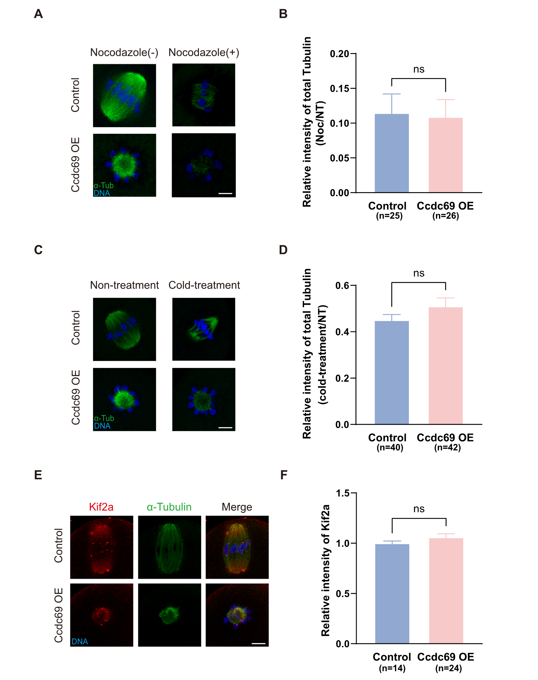
Fig S3. Ccdc69 does not affect microtubule stability. A. Representative images of microtubules before and after 10min of treatment with 1 μM nocodazole for control and Ccdc69-OE oocytes. Green, α-Tubulin; blue, DNA. Scale bar = 10 μm. B. Immunofluorescence analysis of microtubule mass before and after nocodazole treatment in control and Ccdc69-OE oocytes. Noc, nocodazole treated; NT, nontreated. p = 0.8787, n = number of oocytes. C. Representative images of microtubules before and after 15min of cold treatment for control and Ccdc69-OE oocytes. Green, α-Tubulin; blue, DNA. Scale bar = 10 μm. D. Immunofluorescence analysis of microtubule mass before and after cold treatment in control and Ccdc69-OE oocytes. NT, nontreated. p = 0.1771, n = number of oocytes. E. Representative images of Kif2a in control and Ccdc69-OE oocytes at MI stage. Red, Kif2a; green, α-Tubulin; blue, DNA. Scale bar = 10 μm. F. Immunofluorescence analysis of Kif2a in control and Ccdc69-OE oocytes. p = 0.2260, n = number of oocytes.
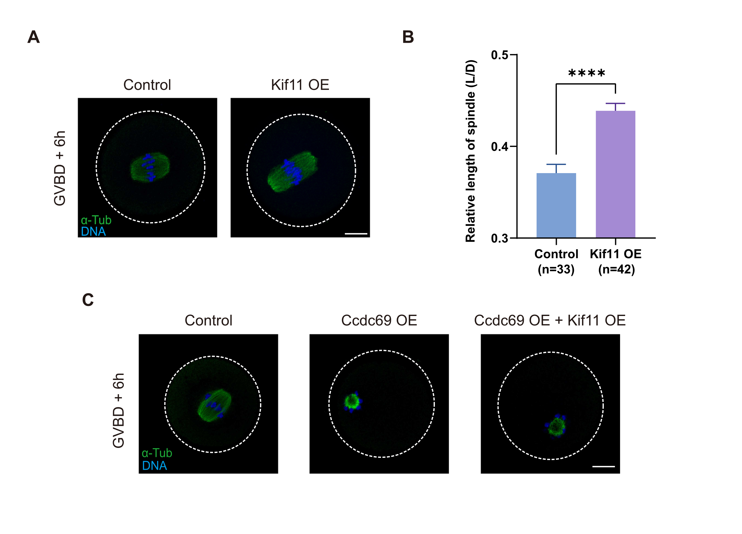
Fig S4. KIF11 hardly recues spindle defect in Ccdc69-OE oocytes. A. Elongated spindles of control and Kif11-OE oocytes at MI stage. Green, α-Tubulin; blue, DNA. Scale bar = 20 μm. B. Relative length of spindles of control and Kif11-OE oocytes at MI stage ****p < 0.0001, n = number of oocytes. C. Representative images of spindle morphology in MI oocytes of control, Ccdc69-OE and Ccdc69-OE & Kif11-OE respectively. Green, α-Tubulin; blue, DNA. Scale bar = 20 μm.

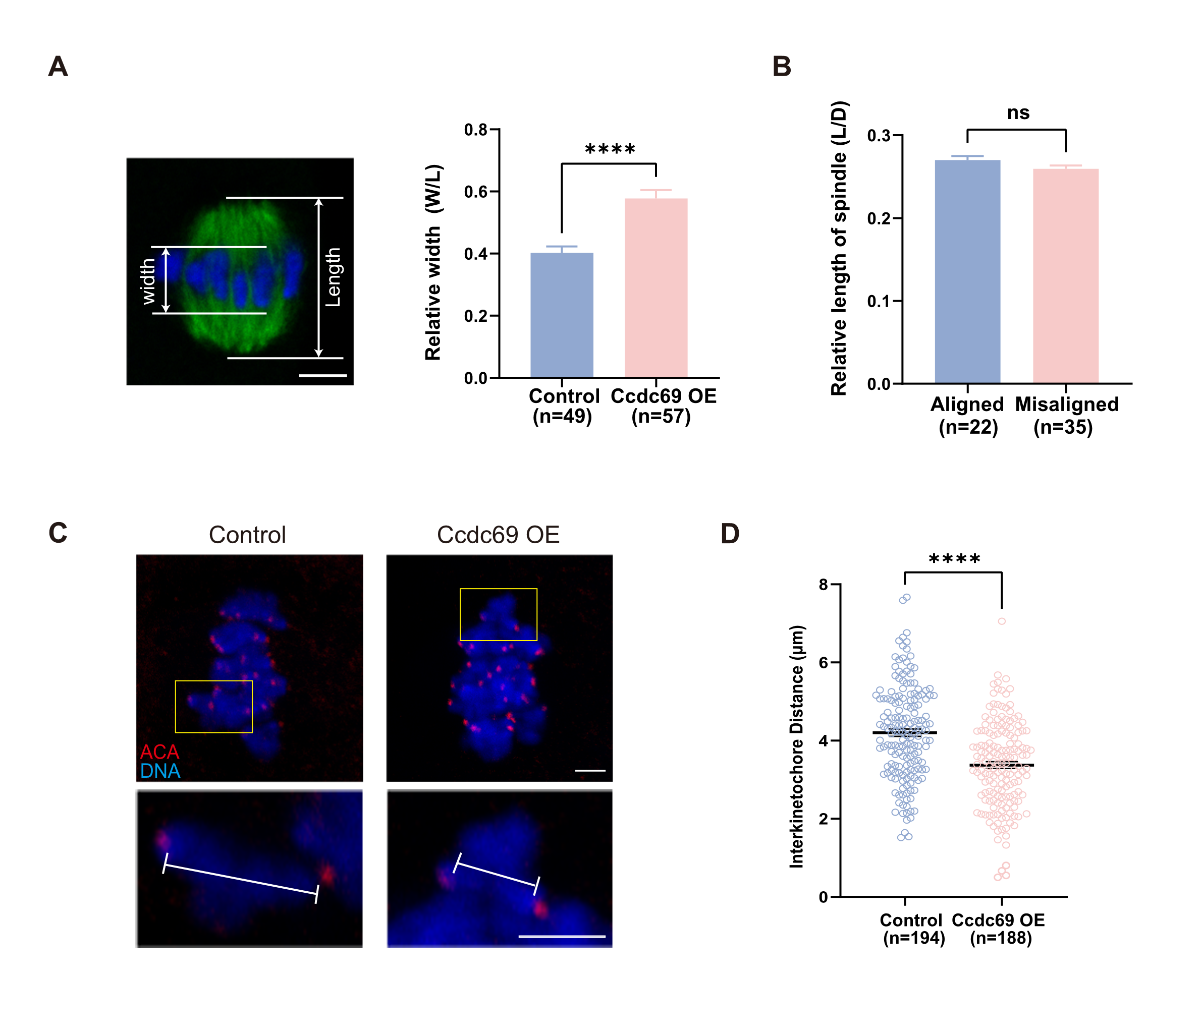
Fig S5. Overexpression of Ccdc69 reduced tension of stretched bivalents in oocytes. A. Quantitative analysis of the ratio of the spindle length to middle plate width in control and Ccdc69-OE oocyte at MI stage. ****p < 0.0001, n = number of oocytes. Scale bar = 5 μm. B. Relative length of spindles with aligned chromosome and misaligned chromosomes in Ccdc69-OE oocytes at MI stage. p = 0.1143, n = number of oocytes. C. Representative images of bivalents and kinetochores in control and Ccdc69-OE oocytes. Magnifications of stretched chromosomes were shown in the yellow insets. Distances between interkinetochore were determined as indicated in the magnifications. Red, ACA; blue, DNA. Scale bar = 2.5 μm. D. Quantitative analysis of interkinetochore distances. ****p < 0.0001, n = number of bivalents.

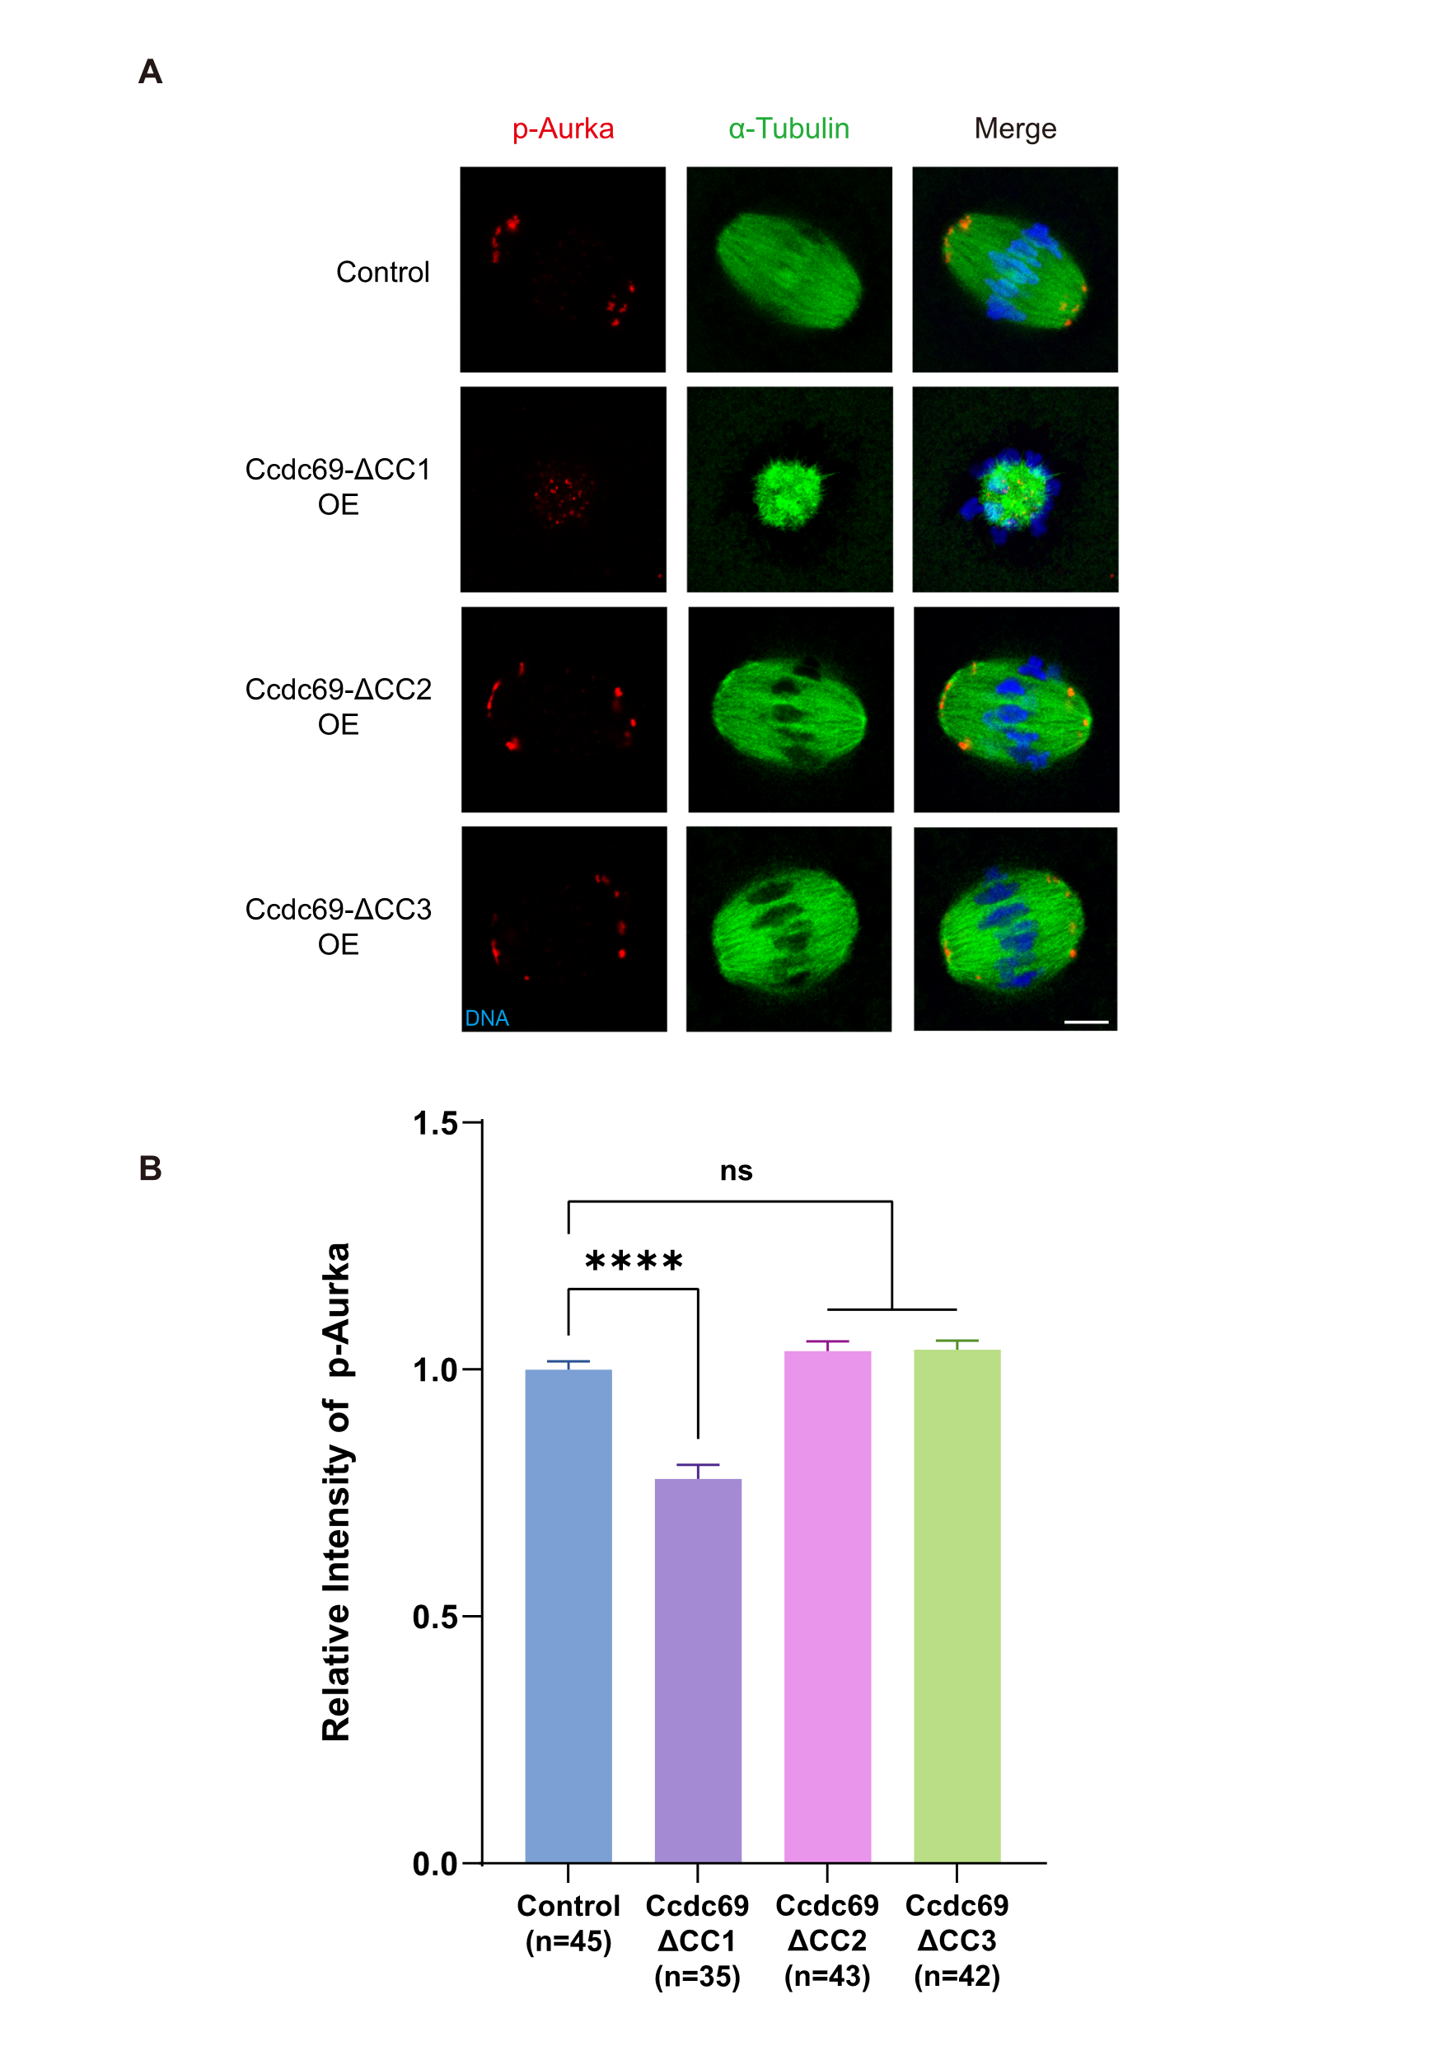
Fig S6. Roles of the Coiled-Coil domains in Ccdc69-mediated regulation of p-Aurka. A. Representative images of p-Aurka in control and truncated Myc-Ccdc69-OE oocytes at MI stage. Red, p-Aurka; green, α-Tubulin; blue, DNA. Scale bar = 10 μm. B. Immunofluorescence analysis of p-Aurka in control and truncated Myc-Ccdc69-OE oocytes. ****p < 0.0001, n = number of oocytes.

Table S1: Proteome of meiotic spindles in mouse oocyte.
Table S2: Differentially expressed proteins in MI and MII spindles.

