SUPPLEMENTARY METHODS
Unless otherwise indicated, for all data processing we use the statistical language R (1), under the RStudio interphase.

Methods for Figure 1 and Supplementary Figure 1
ChIP-seq data processing and SE analysis
After read alignment and peak calling, all ChIP-seq samples were subjected to a quality control step. Fingerprint curves of all samples were generated for each dataset using the plotFingerprint tool from the deeptools suite (2), randomly sampling 100000 500bp-long regions across the genome, with all other parameters as default. Cell lines that showed low quality fingerprints were discarded and, in cases where multiple datasets were available for the same cell line, we used this analysis to keep the best one. The final set of ChIP-Seq samples used is indicated in Supplementary Table 1.
The reads (bam) and peaks (bed) files corresponding to the selected datasets were used as inputs to call super-enhancers (SE) for each individual cell line using the ROSE2 algorithm (3,4) with default options (as described in https://bitbucket.org/young_computation/rose). To compare SE presence between cell lines or subtypes, all overlapping and/or immediately adjacent regions from different cell lines were merged into a single SE set using bedtools merge.
H3K27ac signal files (in bigwig format) were obtained for each cell line using the deeptools (2) BamCompare tool. Since the data was single-end, theoretical fragments were generated by extending the reads from both IP and Input files according to the average fragment size on each ChIP sample, obtained from MACS. The signal was calculated using the library-size normalized number of fragments from the IP sample that fall on 25bp-bins covering the whole genome, subtracting the corresponding normalized fragment counts from the Input sample. All negative values were converted to zeroes, to diminish the effect of dissimilar Input qualities between the different datasets.
The total H3K27ac signal on each region of the unique SE set was quantified from the bigwig files using deeptools (2) multiBigwigSummary BED-file tool. This matrix was log₁₀-transformed, scaled and centered by cell line. Next, a principal component analysis (PCA) was performed (Fig. A) and pairwise similarity between cell lines was assessed using the Spearman correlation coefficient (Fig. B). This exploratory analysis did not identify any cell line as outlier.

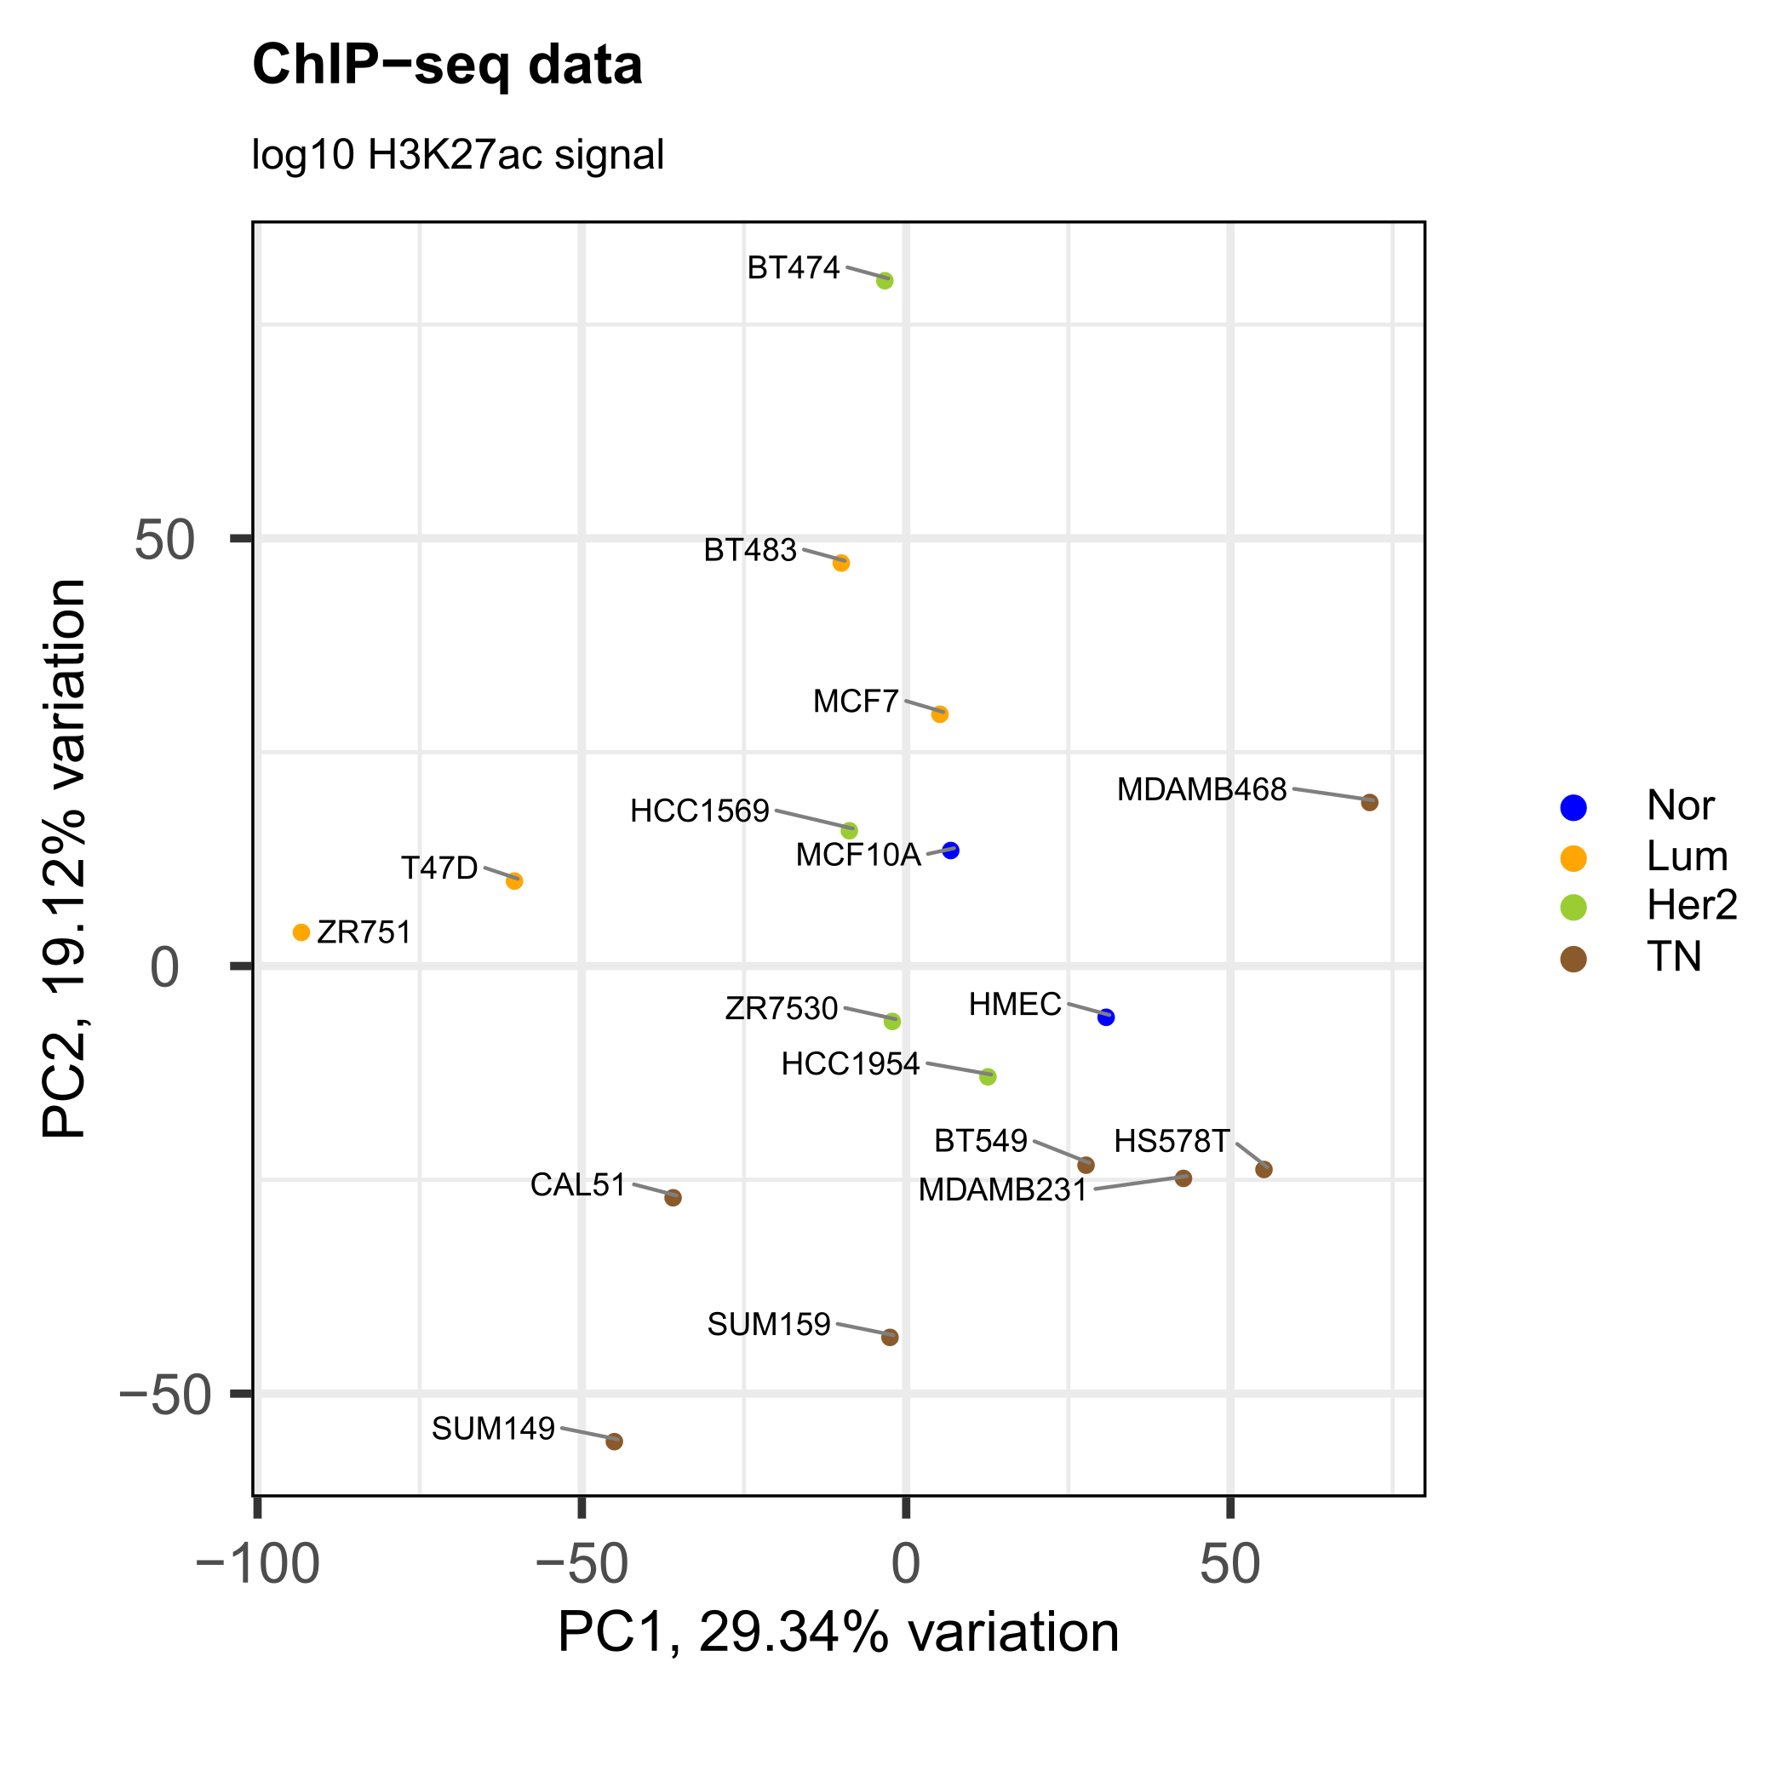
Figure A. Principal component analysis of the selected ChIP-seq signal files based on the SE H3K27ac signal, centered and scaled. Samples are colored by subtype.
The heatmaps on Supplementary Figure 1 were generated with a subset of SE using the scaled and centered H3K27ac signal. First, a filter on the scaled median signal of at least -1 was applied and then the 200 most variable regions were selected. Plots were generated using the heatmap.2 function from the gplots R (5) package, with and without hierarchical clustering of the cell lines.
The SE circo plot was generated using the circlize R package (6).
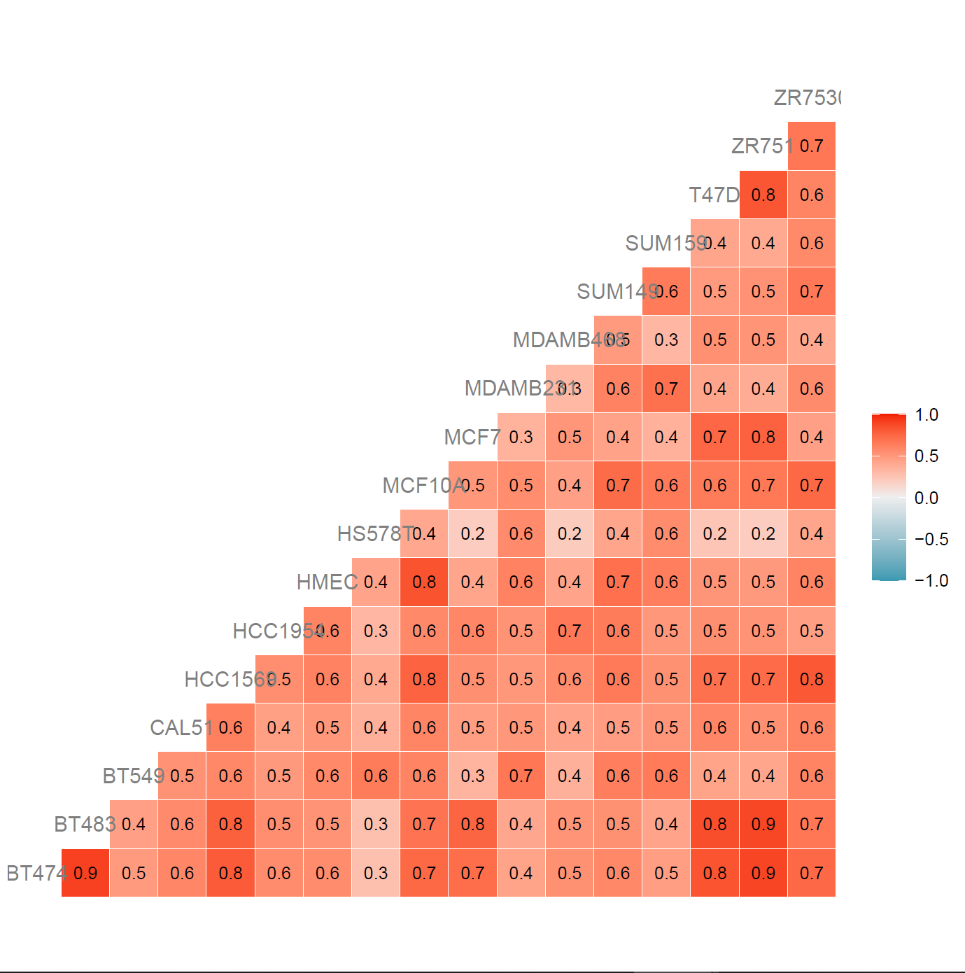
Figure B. Spearman correlation analysis of the selected ChIP-seq signal files based on the SE H3K27ac total signal.

Functional enrichment analysis of SE-associated genes
Genomic Regions Enrichment of Annotations Tool (GREAT) (7) through the rGREAT R (8) package was used to assess the enrichment of SE-associated genes into Gene Ontology (GO) - Biological Processes terms. The gene regulatory domain was defined using the "basal plus extension" rule, setting a distance of 10Kbp upstream and downstream of the TSS to define the basal domain plus a 1Mbp extension. The set of interest and the background set used in each case is described in the main text.
Only those terms with a Benjamini-Hochberg adjusted p-value lower than 0.05 and a fold-enrichment ≥ 2 were kept. For visualization purposes, the resulting terms were reduced by similarity of their associated genes using the rrvgo R package (https://www.bioconductor.org/packages/release/bioc/html/rrvgo.html). The "Rel" similarity measure was selected, with a 0.9 similarity threshold for the analysis on all SE and a 0.7 similarity threshold for the analysis of specific SE sets. The treemap plots were generated using the treemapPlot function from the package on the resulting table of reduced terms.

Differential activity analysis of master regulators
The Virtual Inference of Protein activity by Enriched Regulon analysis (VIPER) method (9) was used to assess differential activity of key transcriptional regulators in specific breast cancer subtypes. VIPER infers the activity of key nodes in a gene regulatory network (termed "master regulators") from the expression levels of their targets. It requires expression data and a regulatory network, including the mode of regulation of their components, as inputs. Expression levels for all genes were taken from RNA-seq data for the different breast cancer cell lines (published data from (10), GEO: GSE73526). A previously built breast cancer regulatory network ("regulonbrca") was used, containing master regulators and their targets (regulons), available through the aracne.network R (11) package. RNA-seq read counts were normalized to tpm and a graphical exploration of the data was made to ensure that the distribution of gene expression signals was similar between cell lines (Fig. C). Also, gene IDs were converted from Ensembl to Entrez format to match those of the “regulonbrca” network. In this process, genes with missing HGNC or Entrez aliases were lost.
A multiple-sample VIPER (msVIPER) analysis was performed for the comparison of each BRCA subtype against all the other samples. Briefly, for each contrast and each regulon, the program calculates and ranks a Gene Expression Signature (GES) to obtain a normalized enrichment score (NES) based on the position shift on the mode of regulation rank. The GES was obtained from the RNA-seq data, after doing a two-group Student's t-test and normalizing the t-statistics to Z-scores. Enrichment significance was assessed by comparison with a null model, consisting in 1000 uniform and random permutations of the sample labels in the original data. A positive/negative NES is indicative of an over/under-activation of a master regulator on its subtype. Because there is a correlation between the significance of the master regulator differential activity (p-value) and the absolute NES values (Fig. D), a threshold of 2 on the absolute NES value was used to select those master regulators with a meaningful change in their activities.
The final set of differentially active master regulators shown in Figure 1 resulted from keeping those master regulators overlapping any SE from the common SE set.

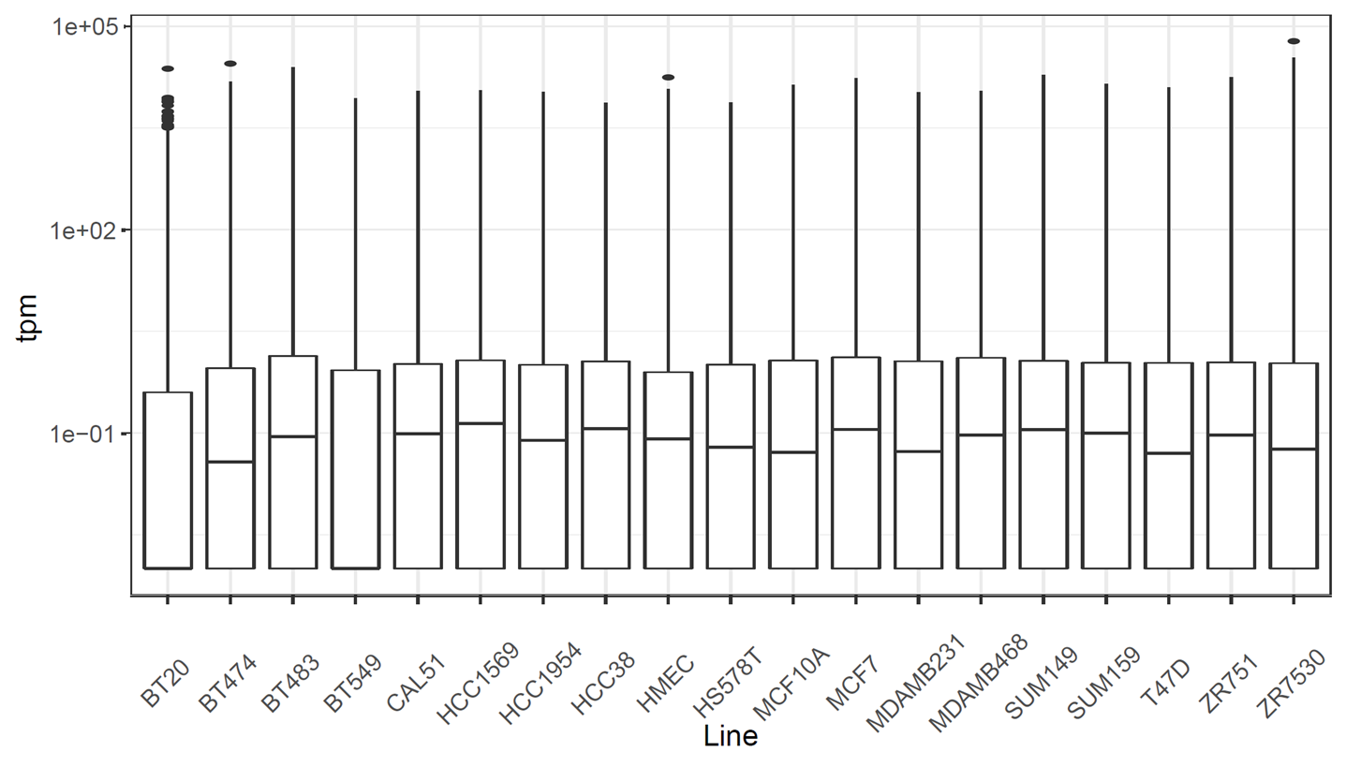
Figure C. Gene expression signal (tpm) distribution of all lines analyzed.

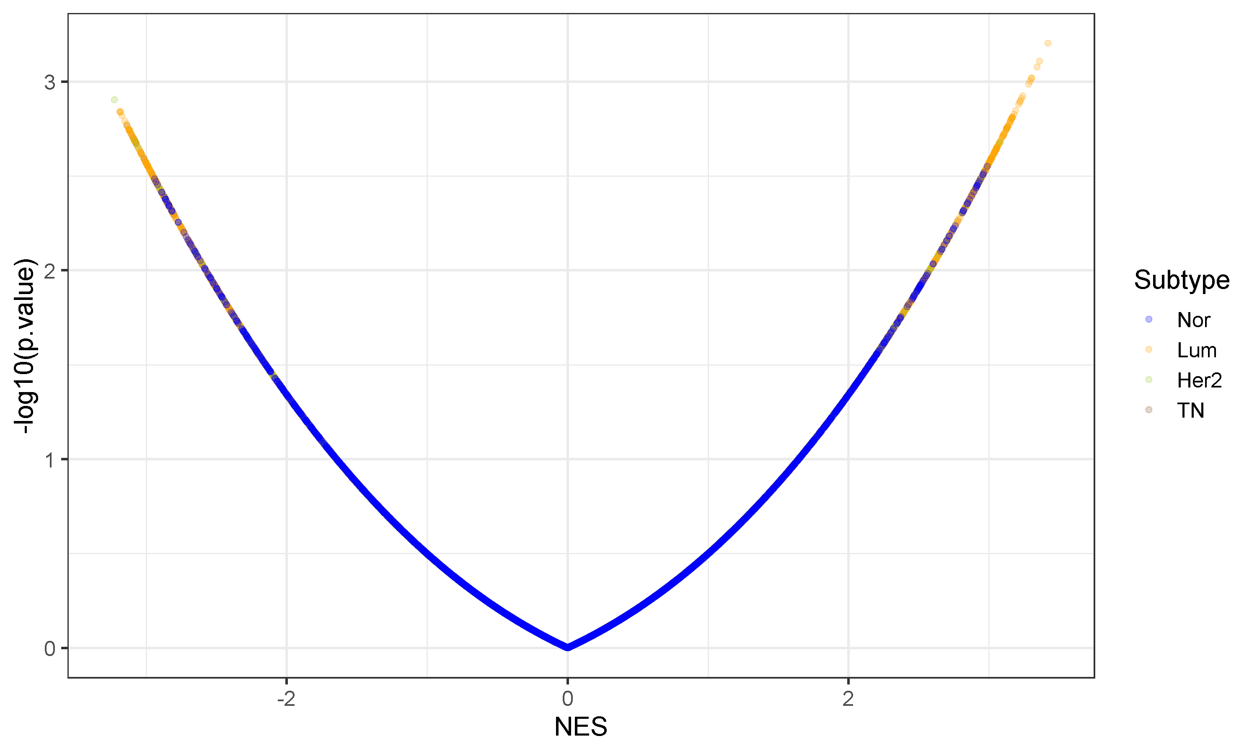
Figure D. Volcano plot of the NES values obtained by the VIPER analysis, colored by subtype.

Methods for Supplementary figure 3
TCGA Gene Expression and DNA Methylation Data
TCGA normalized RNA-sequencing FPKM-UQ expression values and normalized DNA methylation beta values, as well as corresponding sample metadata were downloaded using TCGAbiolinks package in R (12-14) . Additional clinical data for ER, PR and HER2 status by immunohistochemistry (IHC) annotation was downloaded using the cgdsr package in R (https://rdrr.io/cran/cgdsr/) using the Breast Invasive Carcinoma (TCGA, Firehose Legacy) annotation file. IHC receptor status groups were defined as either HR+/- and HER2+/- based on ER, PR and HER2 status by IHC. HR+ includes ER+ PR+, ER+ PR-, ER- PR+, ER+, PR+; HER2+ and HER2- excludes Her2equivocal. PAM50 intrinsic molecular subtypes are annotated as PAM50 Normal, LumA, LumB, HER2 or Basal. Analysis was restricted to samples from women with either PAM50 intrinsic molecular subtype or receptor status by IHC annotation.
Distribution of ThPOK log2(FPKM-UQ+1) expression values in breast cancer tissue were assessed across matched normal (Normal n=112) and PAM50 subtypes (PAM50 Normal n=40, PAM50 LumA n=566, LumB n=207, HER2 n=82, Basal n=194); or IHC receptor status (HR+ HER2+ n=123, HR+ HER2- n=444, HR- HER2+ n=37, HR- HER2- n=115). Non-parametric Kruskal-Wallis test was performed to compare ThPOK expression across groups. Wilcoxon test was then performed for post-hoc pairwise comparisons between groups; p- values were adjusted for multiple-testing across all pairwise comparisons using Benjamini-Hochberg (BH) method.
Distribution of ThPOK methylation beta values in breast cancer tissue were assessed across matched normal (Normal n=97) and PAM50 subtypes (PAM50 Normal n=34, PAM50 LumA n=422, LumB n=142, HER2 n=46, Basal n=137). Non-parametric Kruskal-Wallis test was performed to compare ThPOK methylation across groups; p-values were adjusted (BH) for multiple-testing across CpG probes. Wilcoxon test was then performed for post-hoc pairwise comparisons between groups; p-values were adjusted (BH) for multiple-testing across all pairwise comparison and across CpG probes.

Methods for Supplementary figure 5
ThPOK activity calculation in METABRIC data and correlation with clinical data
METABRIC data (15) was retrieved from cBioportal (https://www.cbioportal.org/). We used the ER status determined by IHC to stratify the samples. ThPOK activity was calculated from METABRIC expression data (expressed as z-scores using all samples as references) with the VIPER algorithm (9) as described above. For the survival analysis, data was divided into two groups using the surv_cutpoint function of the survminer package in R, and plots and their statistical analysis were generated using the survfit function of the survival package in R and the ggsurvplot function of the survminer package in R, respectively. For the Nottingham Prognostic Index (NPI) analysis, NPI values were rounded to have an ordinal variable. For the positive lymph nodes analysis, the number of positive lymph nodes was converted into a categorical variable (0 = NO; else = YES). All boxplots and their statistical analysis were performed using the ggpubr package in R.

Metastatic Breast Cancer (MBC) Project data
We downloaded provisional MBC data (https://mbcproject.org/data-release) through cBioPortal (https://www.cbioportal.org/). We used MedR (Medical Record) Time to Metastatic Diagnosis and ZBTB7B copy number status (CNA from gistic variable) as variables. Grouping by ER status was done using the PATH (Pathology Report Data) Estrogen Receptor Status variable. Boxplots and statistical analysis were performed using the ggpubr package in R.

SUPPLEMENTARY FIGURE LEGENDS

Supplementary Fig. 1: Characterization of the consolidated breast cancer cell lines SE set. a) Heatmaps of the scaled H3K27ac signal (see Supplementary Methods) corresponding to the 200 most variable regions from the set of 5917 SEs across the 17 cell lines. The cell lines were subjected to hierarchical clustering, and the reported subtype is shown in the upper color bar. b) Idem to a, but the lines are grouped according to its reported subtype. Note that the unsupervised clustering of the cell lines based on this 200 most variable SEs resembles the subtype classification. c) Significant GO Biological Process terms found enriched for genes associated to all SEs when performing GREAT analysis. Similar terms (those sharing similar gene sets) are grouped in squares of the same color, and a representative term is shown superposed in white. The full list of terms is shown in Suppl. Table 3.

Supplementary Fig. 2: Super-enhancers disruption by BRD4 inhibition leads to decreased ThPOK expression. a) Individual SE calls from ROSE2 for each of the 17 cell lines around the ZBTB7B locus, grouped and colored by subtype. The box highlights the SE in the region overlapping the ZBTB7B gene. b) Idem to main Figure 1, but only the SE region overlapping ZBTB7B gene is shown. c) ThPOK (left panel) and ACTB (right panel) mRNA levels measured by qRT-PCR in luminal (T47D, MCF7) and HER2+ (BT474) cells after 6h treatment with the BRD4 inhibitors iBET and JQ1 at the indicated concentrations. d) ThPOK (left panel) and ACTB (right panel) mRNA levels measured by qRT-PCR in TNBC cells (MDA-MB-231, HCC1143) overexpressing ThPOK cells after 6h treatment with BRD4 inhibitors iBET and JQ1 at the indicated concentrations. For c-d, all expression values are depicted relative to the mean of the corresponding controls. Error bars represent the SD of ≥3 biological replicates. NS: non-significant; *: p < 0.05; **: p < 0.005; ***: p < 0.0005; two-tailed Student’s t-test.

Supplementary Fig. 3: ThPOK gene expression and promoter methylation by breast cancer subtype. a) Immunohistochemistry demonstrating the specificity of the ThPOK antibody (right panel) compared with an IgG control (left panel). b) Hematoxylin and eosin staining of breast carcinoma samples shown in Fig. 2g. c-d) ThPOK expression in TCGA breast cancer subtypes. Boxplots showing distribution of RNA-seq log2 FPKM across c) matched normal and PAM50 intrinsic molecular subtypes (Kruskal-Wallis p-value < 3.5x10⁻³⁴); and d) matched normal and receptor status by immunohistochemistry (Kruskal-Wallis p-value < 1.32x10⁻²⁵). Post-hoc Wilcoxon p-value significance levels adjusted for multiple testing across all pairwise comparisons are annotated (see below). e) ThPOK genomic coordinates in UCSC Genome Browser with location of CpG islands and Infinium 450K probes annotated. f-g) DNA methylation levels at CpG sites mapping to ThPOK across matched normal and PAM subtypes. f) Median +/- median absolute deviation of methylation beta values at annotated gene regions: TSS1500, TSS200, 5’UTG, gene body and 3’UTR with Kruskal-Wallis p-value significance levels adjusted for multiple testing across CpG probes. g) Boxplots showing distribution of methylation beta values with post-hoc Wilcoxon p-value significance levels adjusted for multiple testing across all pairwise comparisons and across CpG probes. Significance levels are annotated as follows: adjusted p-value < 0.05 (*), < 0.01 (**), < 0.001 (***), < 0.0001 (****).

Supplementary Fig. 4: Pan-cancer mRNA and protein ThPOK expression levels. a) ThPOK protein expression depicted as percentage of patients whose tissues were scored positive for ThPOK staining by IHC using two different antibodies. Patient samples were scored positive when moderate to strong nuclear staining was observed. Two cores were sampled from each individual and protein expression is annotated in tumor cells. For more details refer to: www.proteinatlas.org. b) Box plot showing the distribution of ThPOK mRNA levels expressed in FPKM obtained from TCGA RNA-seq data in 17 cancer types. Box plots shown as median and 25th and 75th percentiles.

Supplementary Fig. 5: ThPOK activity and copy number variation are associated with aggressive features in breast tumors. a) VIPER-inferred ThPOK activity is higher in ER+ breast cancer samples. 1874 METABRIC breast cancer samples were divided into ER+ (n = 1445) and ER- (n = 429) according to their ER IHC status. ThPOK activity on each tumor sample was inferred using VIPER on METABRIC breast cancer samples expression data (expressed as z-scores using all samples as references) as retrieved from cBioPortal (16) and the aracne.networks breast cancer gene regulatory network. P-value corresponds to a Wilcoxon rank sum test. b-c) VIPER-inferred ThPOK activity is lower in breast tumors with worse prognosis. b) METABRIC breast tumors were divided into prognosis groups according to their informed Nottingham prognostic index (NPI) in level 1 (n = 29), 2 (n = 134), 3 (n = 477), 4 (n = 662), 5 (n = 408) or 6 (n = 194), with NPI = 1 having the best prognosis and NPI = having the worst. c) As b) but only ER+ by IHC status were considered (NPI 1 (n = 20), 2 (n = 124), 3 (n = 439), 4 (n = 490), 5 (n = 254) and 6 (n = 118)). P values correspond to Kruskal-Wallis tests. d-e) VIPER-inferred ThPOK activity is lower in breast cancer patients with positive lymph nodes. d) METABRIC breast cancer patients were divided into two groups (Positive (n = 911) and Negative (n = 993)) by the presence of tumor cells in lymph nodes. e) As d) but only ER+ by IHC status were considered (Positive (n = 662) and Negative (n = 783)). P values correspond to Wilcoxon rank sum tests. f-g) Low VIPER-inferred ThPOK activity is related to worse relapse free survival of breast cancer patients. Relapse-free survival (RFS) of 1903 METABRIC breast cancer patients (f) or just 1444 ER+ patients (g) were compared between high or low ThPOK activity groups through Kaplan-Meier analysis. The threshold of ThPOK activity was calculated using the surv_cutpoint function in the survminer package in R. P values correspond to log rank tests. h-i) Deletions of the ZBTB7B gene correlate with shorter time to metastatic diagnosis. The Metastatic Breast Cancer Project data was retrieved from cBioPortal (16). h) Breast cancer samples were divided by their copy number alterations into -2 (complete deletion, n = 3), -1 (heterozygous deletion, n = 18), 0 (diploid, n = 30), +1 (gain, n = 147) and +2 (amplification, n = 181). i) As h) but only ER+ by IHC status were considered (-2 (n = 3), -1 (n = 12), 0 (n = 20), +1 (n = 114) and +2 (n = 111)). P values correspond to Kruskal-Wallis tests.

Supplementary Fig. 6: ThPOK knockdown leads to morphological as well as transcriptional changes associated with an increase in mesenchymal and stemness markers. a) ThPOK protein levels measured by western-blot in luminal (T47D, MCF7 and ZR75.1) and HER2+ (BT474) cells expressing 3 different shRNA against ThPOK (kd#1-3) or a control shRNA control (Scramble, Scr). β-Actin was used as loading control. Relative ThPOK amounts (bottom) were calculated by measuring the background-corrected integrated density of the ThPOK band divided by that of the β-Actin band, using the Scr control of each line as reference. b) Morphological changes elicited by ThPOK deficiency images taken at 10X magnification. Scale: each side of the square is 400µm. c) Flow cytometry analysis showing CD44 expression in luminal T47D, MCF7 and ZR75.1 scr or ThPOK kd cells (kd#1 was used as representative for each cell line). d) CD44 expression in luminal (T47D, MCF7 and ZR75.1) cells with ThPOK knockdown (kd#1-3) measured by flow cytometry and plotted as the mean fluorescence intensity ratio over the Scr-expressing cells. e) Stemness score is higher in low-ThPOK expressing tumors. ZBTB7B mRNA levels and RNA-based stemness score were obtained from TCGA breast tumors’ genomic data. Welch’s t-test p = 4.169x10⁻⁸. f) Increased migration in luminal ThPOK deficient cells (kd#1-3) measured by Boyden chamber assay (bar 190µm).

Supplementary Fig. 7: Evaluation of ThPOK variants expression in breast cancer cell lines. a) Schematic of primer design to discern between the expression of ThPOK variants #3 and #5, and PCR amplification of ThPOK from cDNA of various BCCs to determine whether these cells express variant #3 (PCR product should be 450bp) or #5 (PCR product should be 208bp). b) Dot plots showing the isoform-level expression per line for the five different ZBTB7B mRNAs annotated in Ensembl. Expression values are based in the RNA-seq data and informed in TPM.

Supplementary Fig. 8: ThPOK overexpression reduces migration of TNBC and HER2+ cells. a) ThPOK protein levels measured by western-blot in TNBC (MDA-MB-231, HCC1143, BT549) and HER2+ (HCC1954) transduced with a lentiviral vector coding for ThPOK or an empty vector (EV) control. β-Actin and GAPDH were used as loading controls. b) Decreased migration in TNBC and HER2+ ThPOK overexpressing cells or EV control, measured by Boyden chamber assay (bar 190µm).

Supplementary Fig. 9: ThPOK and TGFβ have opposing roles in regulating the expression of ECM genes. a) FN1 and COL1A1 relative mRNA levels measured by qRT-PCR in ZR75.1 and BT474 cells treated with DMSO (Veh), Veh + conditioned media (CM) from ThPOK kd cultures, and CM + TGBRI inhibitor (LY2157299, LY). b) COL1A1 relative mRNA levels measured by qRT-PCR in MCF7 cells after 3 days treatment with rTGFβ, and T47D cells after 3 and 10 days treatment with rTGFβ. c) COL1A1 relative mRNA levels measured by qRT-PCR in MDA-MB-231 cells with ThPOK^{OE} or EV, untreated (Untr) or treated with rTGFβ for 3 or 7 days. *: p < 0.05; **: p < 0.005; ***: p < 0.0005. All p-values in this figure were calculated based on a two-tailed Student’s t-Test.

REFERENCES FOR SUPPLEMENTARY METHODS

1. Team, R.C. (2013) A Language and Environment for Statistical Computing.
2. Ramírez, F., Ryan, D.P., Grüning, B., Bhardwaj, V., Kilpert, F., Richter, A.S., Heyne, S., Dündar, F. and Manke, T. (2016) deepTools2: a next generation web server for deep-sequencing data analysis. Nucleic Acids Res, 44, W160-165.
3. Loven, J., Hoke, H.A., Lin, C.Y., Lau, A., Orlando, D.A., Vakoc, C.R., Bradner, J.E., Lee, T.I. and Young, R.A. (2013) Selective inhibition of tumor oncogenes by disruption of super-enhancers. Cell, 153, 320-334.
4. Whyte, W.A., Orlando, D.A., Hnisz, D., Abraham, B.J., Lin, C.Y., Kagey, M.H., Rahl, P.B., Lee, T.I. and Young, R.A. (2013) Master transcription factors and mediator establish super-enhancers at key cell identity genes. Cell, 153, 307-319.
5. Warnes, G.B., B.; Bonebakker, L.; Gentleman, R.; Huber, W.; Liaw, A.; Lumley, T.; Maechler, M.; Magnusson, A.; Moeller, S.; Gregory, R.; Schwartz, M.; Venables, B. (2015) Gplots: Various R programming tools for plotting data. Scienceopen.
6. Gu, Z., Gu, L., Eils, R., Schlesner, M. and Brors, B. (2014) circlize Implements and enhances circular visualization in R. Bioinformatics, 30, 2811-2812.
7. McLean, C.Y., Bristor, D., Hiller, M., Clarke, S.L., Schaar, B.T., Lowe, C.B., Wenger, A.M. and Bejerano, G. (2010) GREAT improves functional interpretation of cis-regulatory regions. Nat Biotechnol, 28, 495-501.
8. Gu, Z. and Hubschmann, D. (2023) rGREAT: an R/bioconductor package for functional enrichment on genomic regions. Bioinformatics, 39.
9. Alvarez, M.J., Shen, Y., Giorgi, F.M., Lachmann, A., Ding, B.B., Ye, B.H. and Califano, A. (2016) Functional characterization of somatic mutations in cancer using network-based inference of protein activity. Nat Genet, 48, 838-847.
10. Marcotte, R., Sayad, A., Brown, K.R., Sanchez-Garcia, F., Reimand, J., Haider, M., Virtanen, C., Bradner, J.E., Bader, G.D., Mills, G.B. et al. (2016) Functional Genomic Landscape of Human Breast Cancer Drivers, Vulnerabilities, and Resistance. Cell, 164, 293-309.
11. Giorgi, F.M. (2020). 1.16.0 ed, pp. R package.
12. Colaprico, A., Silva, T.C., Olsen, C., Garofano, L., Cava, C., Garolini, D., Sabedot, T.S., Malta, T.M., Pagnotta, S.M., Castiglioni, I. et al. (2016) TCGAbiolinks: an R/Bioconductor package for integrative analysis of TCGA data. Nucleic Acids Res, 44, e71.
13. Silva, T.C., Colaprico, A., Olsen, C., D'Angelo, F., Bontempi, G., Ceccarelli, M. and Noushmehr, H. (2016) TCGA Workflow: Analyze cancer genomics and epigenomics data using Bioconductor packages. F1000Res, 5, 1542.
14. Mounir, M., Lucchetta, M., Silva, T.C., Olsen, C., Bontempi, G., Chen, X., Noushmehr, H., Colaprico, A. and Papaleo, E. (2019) New functionalities in the TCGAbiolinks package for the study and integration of cancer data from GDC and GTEx. PLoS Comput Biol, 15, e1006701.
15. Curtis, C., Shah, S.P., Chin, S.F., Turashvili, G., Rueda, O.M., Dunning, M.J., Speed, D., Lynch, A.G., Samarajiwa, S., Yuan, Y. et al. (2012) The genomic and transcriptomic architecture of 2,000 breast tumours reveals novel subgroups. Nature, 486, 346-352.
16. Cerami, E., Gao, J., Dogrusoz, U., Gross, B.E., Sumer, S.O., Aksoy, B.A., Jacobsen, A., Byrne, C.J., Heuer, M.L., Larsson, E. et al. (2012) The cBio cancer genomics portal: an open platform for exploring multidimensional cancer genomics data. Cancer Discov, 2, 401-404.

