Lactococcus lactis-HSP65 requires TLR2 to induce tolerogenic dendritic cells and confer protection against type 1 diabetes in a murine model

SUPPLEMENTAL FIGURES

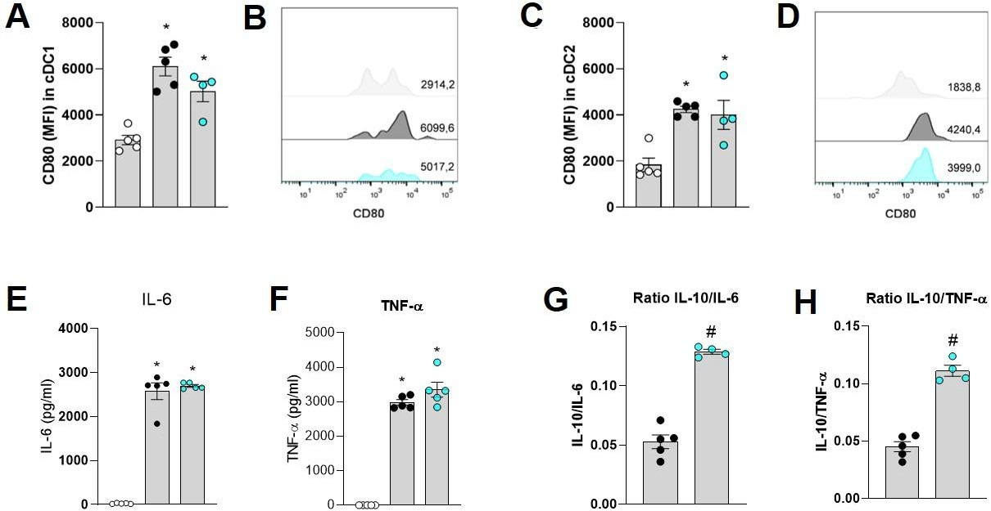

Fig. S1 Activation and production profile of bone marrow-derived dendritic cells (BMDCs) stimulated with rHSP65. Bar graph (A) and histograms (B) represent the MFI of CD80 in cDC1. Bar graphs (C) and histograms (D) represent the MFI of CD80 in cDC2. The concentration of the cytokines IL-6 (E) and TNF-α (F) was detected in the culture supernatant by ELISA. The ratio between the concentrations of IL-10/IL-6 (G) and IL-10/TNF-α (H). Data are expressed as mean ± SEM of a representative experiment of two independent experiments performed (n= 4-5 wells per condition) and analyzed by One-way ANOVA and Tukey's post- test. Data were considered statistically significant when p < 0.05. * medium vs stimuli, # rHSP65 vs LPS.

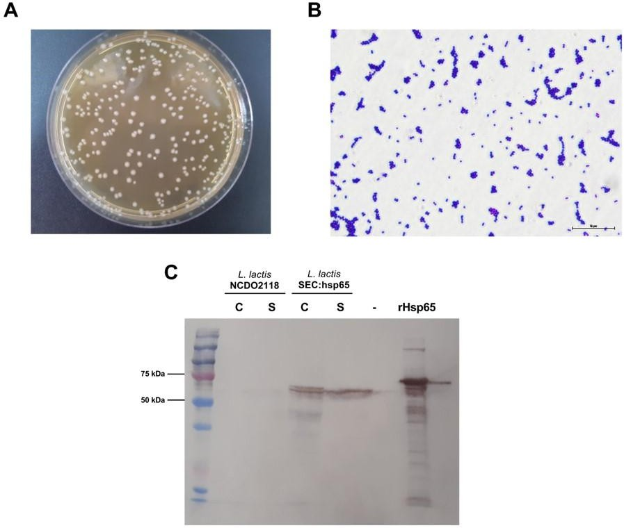

Fig. S2 Validation of culture and heterologous expression of HSP65 in Lactococcus lactis. Morphological appearance of L. lactis colonies after 24 h of growth in M17 agar at room temperature (A). Photomicrograph of L. lactis (magnification 1000x, scale bar: 10 μm) stained using Gram stain (B). Protein extracts of L. lactis NCDO2118 (wild-type strain) and NCDO2118:pXIES:SEC:hsp65 (secretory, recombinant) were prepared from the cell fraction (columns C) and supernatant (columns S) and analyzed by Western blot using anti-Hsp65 antibodies. (- empty channel).

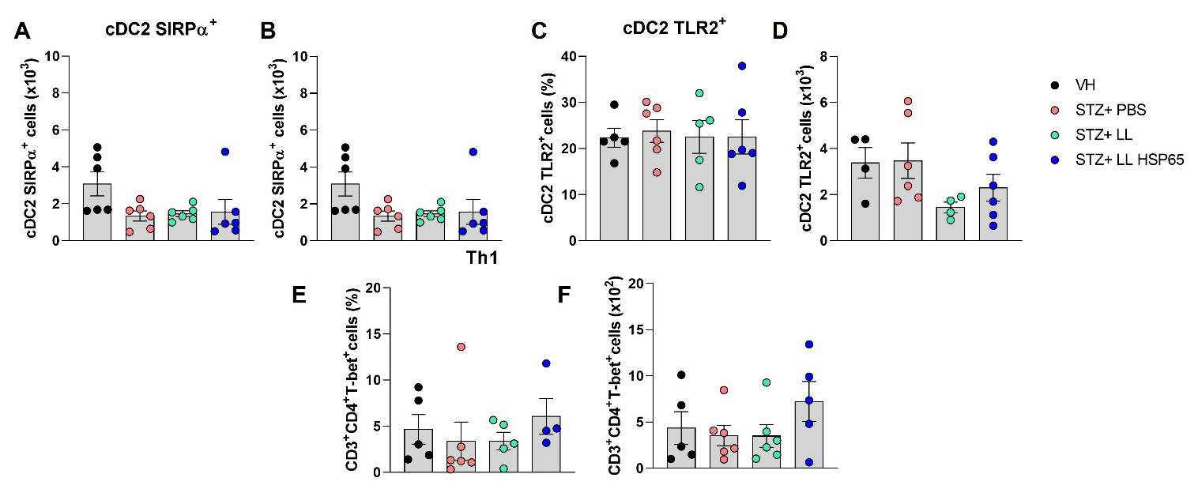

Fig. S3. L. lactis-HSP65 does not affect cDC2 subset frequencies or TLR2 expression in cecum-associated mesenteric lymph nodes (cMLNs) and has no significant impact on Th1 cell frequencies in the pancreas during T1D. Percentage (A) and absolute number (B) of SIRPα⁺ cDC2 in the cMLN evaluated by flow cytometry. Percentage (C) and absolute number (D) of TLR2⁺ cDC2 in the cMLN. Percentage (E) and absolute number (F) of CD4⁺ T-bet⁺ (Th1 cells) in pancreas evaluated by cytometry. Data expressed as mean ± SEM representative of an experiment performed (n= 4-6 animals per group) and analyzed by One-way ANOVA and Tukey's post-test, being considered statistically different when p < 0.05. * vs VH, # vs STZ+PBS, & L. lactis wild-type vs L. lactis HSP65.

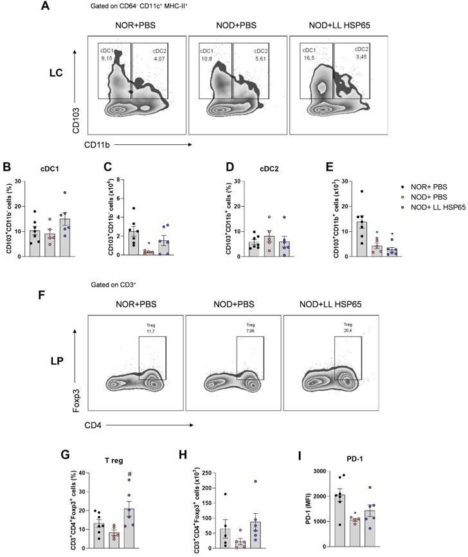

Fig. S4 L. lactis-HSP65 does not alter cDC1 in cecum-associated mesenteric lymph node (cMLN) but increases Tregs in pancreatic lymph nodes (PLN) of NOD mice. Contour plots representing cDC1 and cDC2 populations in cMLN assessed by flow cytometry (A). Percentage of cDC1 in cMLN (B). The absolute number of cDC1 in cMLN (C). Percentage of cDC2 in cMLN (D). The absolute number of cDC2 in cMLN (E). Contour plots representing the percentage of Treg in PaLN assessed by flow cytometry (F). Percentage of Tregs in PaLN (G). The absolute number of Tregs in PaLN (H). Mean fluorescence intensity (MFI) of PD-1 on Tregs in PaLN (I). Data expressed as mean ± SEM representative of an experiment performed (n= 4-6 animals per group) and analyzed by One-way ANOVA and Tukey's post-test, being considered statistically different when p < 0.05. * vs NOR, # vs NOD+ PBS.

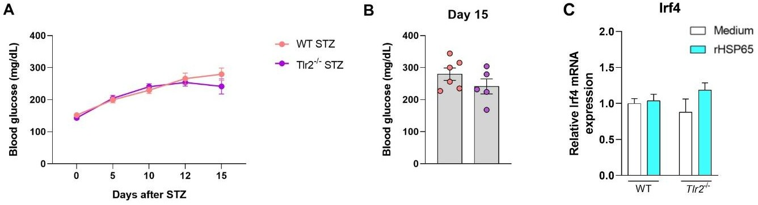

Fig. S5. TLR2 deficiency does not affect the development of STZ-induced T1D or the expression of Irf4 in BMDCs. Time course of fasting blood glucose levels in WT and TLR2- deficient mice during STZ induction of T1D (A). Fasting blood glucose levels on day 15 after STZ administration (B). Relative expression of Irf4 (C) in BMDCs from WT or Tlr2^{-/-} mice stimulated with rHSP65 or medium (12 μg.ml⁻¹) for 24 h, evaluated by qRT-PCR. Data are expressed as mean ± SEM and are representative of one experiment (n= 5–6 animals per group) and analyzed by one-way ANOVA and Tukey's post-test. Data were considered statistically significant when p < 0.05. * vs WT STZ.

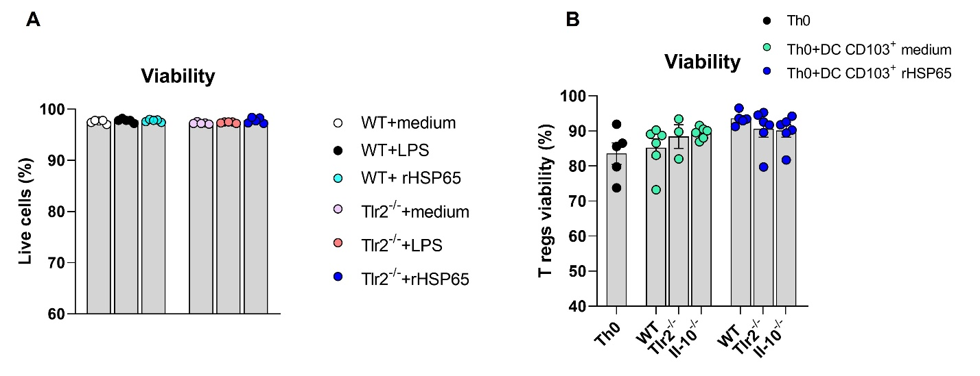
Figure S6. Cell viability assessed by flow cytometry. Viability of BMDCs from WT or Tlr2⁻/⁻ mice following stimulation with different conditions (A). Viability of Tregs generated in co-culture assays with CD103⁺ BMDCs from WT, Tlr2⁻/⁻, or Il10⁻/⁻ mice stimulated with rHSP65.(B) . Data are expressed as mean ± SEM and are representative of two independent experiments (n = 3–6 wells per condition). Statistical analysis was performed using one-way ANOVA followed by Tukey’s post-test. p < 0.05 was considered significant.

