Table S1. The clinical characteristics of AKI patients
Patients | Pathological number | Age | Gender(F/M) | Triggers | Scr  (μmol/L) | BUN  (mmol/L) | eGFR  (ml/min/l) | ACR  (mg/g cr ) | NAG  (U/L)
1 | 7328 | 53 | M | infect | 281 | 10.7 | 31.3 | 3025.71 | 172
2 | 7336 | 69 | M | hypovolemia | 279 | 9.9 | 34.0 | 2804.26 | 177
3 | 7372 | 25 | F | infect | 301 | 11.8 | 37.1 | 3186.36 | 189
4 | 7374 | 59 | F | drug | 264 | 7.8 | 36.2 | 2353.44 | 166
5 | 7375 | 45 | M | drug | 237 | 7.9 | 63.4 | 2478.23 | 166
6 | 7383 | 50 | F | immunity | 110 | 5.3 | 62.7 | 1411.08 | 69
7 | 7395 | 55 | M | drug | 163 | 8 | 45.5 | 1491.57 | 72
8 | 7473 | 23 | F | infect | 137 | 5.6 | 44.1 | 1648.5 | 64
9 | 7507 | 78 | F | infect | 177 | 7.2 | 65.9 | 2235.12 | 88
10 | 7534 | 72 | M | hypovolemia | 93 | 4.5 | 77.4 | 504.76 | 52
11 | 7545 | 70 | M | immunity | 152 | 5.3 | 68.2 | 1710.65 | 70
12 | 7560 | 60 | F | drug | 74 | 4.4 | 74.2 | 471.44 | 47
13 | 7564 | 56 | M | drug | 89 | 4.1 | 69.6 | 443.2 | 72
14 | 7601 | 22 | F | infect | 69 | 3.9 | 91.8 | 503.96 | 44
15 | 7608 | 27 | M | hypovolemia | 105 | 4.2 | 59.9 | 1051.54 | 83
16 | 7609 | 44 | F | immunity | 77 | 4.1 | 90.5 | 425.87 | 45
17 | 7675 | 19 | M | immunity | 78 | 4.4 | 94.7 | 1480.44 | 71
18 | 7811 | 74 | F | hypovolemia | 84 | 4.2 | 91.7 | 2203.48 | 160
19 | 7847 | 54 | F | drug | 82 | 4.5 | 87.4 | 2783.09 | 169
20 | 7871 | 17 | M | infect | 159 | 5.5 | 52.1 | 1543.33 | 164
Scr, Serum Creatinine. BUN, Blood Urea Nitrogen. eGFR, Estimated Glomerular Filtration Rate. ACR, Albumin-to-creatinine Ratio.NAG, N-acetyl-β-D-glucosaminidase.

Table S2. Primary antibodies used for Western blotting, immunoprecipitation, immunohistochemistry and immunofluorescence

Antibody | Target Species | Catalog NO. | Identifier
IER3 | Rabbit | ab65152 | Abcam
GAPDH | Mouse | 60004-1-lg | Proteintech
β-Actin | Mouse | 20536-1-AP | Proteintech
N-gal | Mouse | ab125075 | Abcam
KIM-1 | Rabbit | 83221-2-RR | Proteintech
Lamin B1 | Rabbit | 12987-1-AP | Proteintech
DCR2 | Mouse | ab108421 | Abcam
γ-H2A.X | Rabbit | ab229914 | Abcam
P53 | Rabbit | ab32049 | Abcam
P21 | Rabbit | ab188224 | Abcam
P16 | Mouse | ab189034 | Abcam
PRDX5 | Rabbit | ab180587 | Abcam
CyclinD1 | Mouse | 60186-1-Ig | Proteintech
VDAC1 | Rabbit | 10866-1-AP | Proteintech
Parl | Mouse | ab118554 | Abcam
AQP1 | Mouse | ab300845 | Abcam
SMA | Mouse | BM0002 | BOSTER
Fibronectin | Mouse | ab2413 | Abcam
Collagen 1 | Mouse | ab6308 | Abcam

Table S3. The PCR Primer Sequence
Gene | Target sequence
IER3 | CGAAATTTTCACCTTCGACCCTCTCC
IER3 | TGTTACAGCAGGGAGGCATATCTCGCACC
PARK7 | AGCCAGTGTGATGGTGTTGG
PARK7 | TCCAGAGCTGCTGGTCTTCT
GADD45A | CAGAGACCTGGTGATGGAGG
GADD45A | GTGATGATGCTGCTGCTGTC
P16 | TGGAGCAGGTAGTGGGAATG
P16 | CAGTCTTCTTGGCTGTGCTG
DCR2 | GACAGCCTTCTGCTGCTGAA
DCR2 | TTCTGCTGGGTCAGGTTGTC
PRDX5 | GCAGAGCTGGTGGACAAGAT
PRDX5 | GGCTGGGTCTGGTAGTTGTC
GAPDH | AGGTCGGTGTGAACGGATTTG
GAPDH | TGTAGACCATGTAGTTGAGGTCA

1 Schematic diagram of primer positions for PCR identification
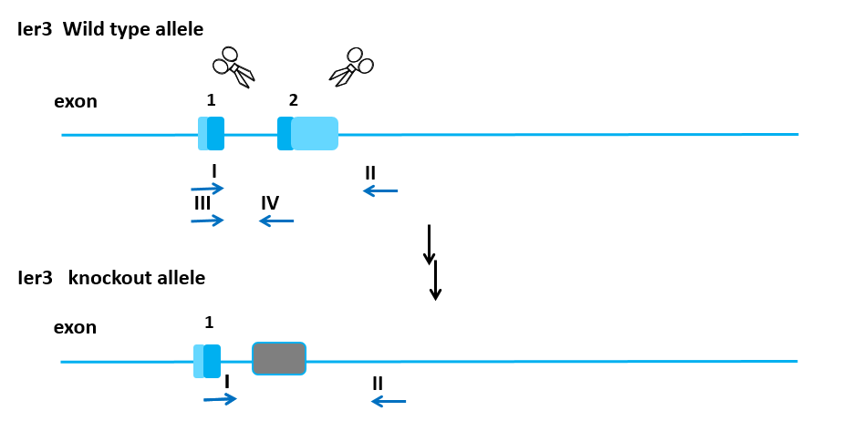

2 PCR results
IER3+/-：45,46,104
IER3-/-：48,55,67,90,91
WT：44,50
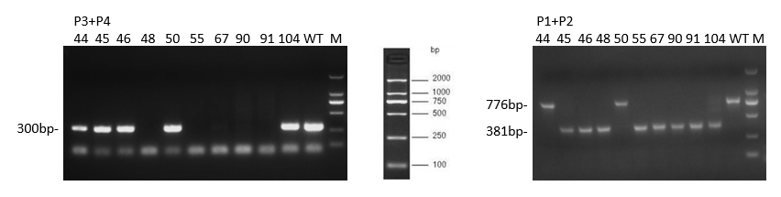
Mouse PCR electrophoresis image M:DL2000

Table S4. The Lentiviral and siRNA Sequence
Gene | Sequence
shPRDX5-1 | ACCGCGCGTTTGAACACTTCT
shPRDX5-2 | GCCTGGCACCCAATATCGCAT
shPRDX5-3 | GAGCAGAAGCTGAAGCATGA
shPRDX5-NC | GGACTATGCGCTGGATCTTAA
siParl | GGAUGAGAGCUCUGAAGAUC
siParl-NC | TTCTCCGAACGTGTCACGT
lv-IER3oe | The overexpression lentiviral sequence was provided by Jikai Gene Company
lv-IER3-NC | CTATTGGCGTTACTATTGACG

Table S5. The clinical characteristics of patients with Sc-RNAseq
Patients | Age | Gender(F/M) | Triggers | Scr  (μmol/L) | BUN  (mmol/L) | eGFR  (ml/min/1.73m²) | 24-hour urine output (ml)
1 | 15 | F | infect | 181 | 8.2 | 59.09 | 607
2 | 22 | F | Immune | 133.3 | 7.1 | 53.12 | 600
3 | 44 | M | drug | 912 | 28.1 | 3.68 | 513
4 | 21 | F | Renal carcinoma | 72 | 5.3 | 92.2 | 1230
5 | 57 | M | Renal carcinoma | 85 | 5.4 | 91.0 | 1100
6 | 54 | M | Renal carcinoma | 69 | 5.6 | 98.2 | 1170

Figure legends:
Figure S1 The expression dynamics of IER3 in renal tissues during CLP-induced AKI.
- Preparation of the SAKI animal model. B-D. Verification of the knockout efficiency of IER3 at both the mRNA and protein levels. E-G. IER3 expression at different times via RT-qPCRand Western blot. H-I. Immunofluorescence detection of the location of IER3 expression in SAKI. Data are the means ±SD (n= 3 independent experiments); *P< 0.05, **P< 0.01, ***P< 0.001, ****P< 0.0001.
Figure S2 Dynamic changes of IER3 expression in RTECs under LPS-induced AKI.
- Preparation of the SAKI cell model. B-D. IER3 expression following stimulation with different concentrations of LPS, as determined via RT-qPCR and Western blot. E-G. IER3 expression after LPS stimulation for different durations, as determined via RT-qPCR and Western blot. Data are the means ±SD (n= 3 independent experiments); *P< 0.05, **P< 0.01, ***P< 0.001, ****P< 0.0001.
Figure S3 Under physiological conditions, IER3-KO mice exhibit normal baseline phenotypes
Volume size of WT mice and IER3ko mice. B. Kidney size of WT mice and IER3ko mice. C-D. PAS stain and injury score. E. Scr and BUN of WT mice and IER3ko mice. Data are the means ±SD (n= 3 independent experiments); *P< 0.05, **P< 0.01, ***P< 0.001, ****P< 0.0001.
Figure S4 Knockdown of IER3 Attenuates the Progression of SAKI
A-B. Scr and GFR of mice in different groups. C.PAS stain in different groups. Data are the means ±SD (n= 3 independent experiments); *P< 0.05, **P< 0.01, ***P< 0.001, ****P< 0.0001.
Figure S5 Overexpression of IER3 exacerbates LPS-induced stress-associated senescence in RTECs.
- Lentiviral transfection was performed to induce IER3 overexpression in RTEC. B-C. The overexpression efficiency of IER3 was confirmed by RT-qPCR and WB. D-F. The expression levels of senescence-associated markers (P21, DCR2) were analyzed via RT-qPCR and WB in different groups. G-H. Cellular senescence was further assessed by β-gal staining across treatment groups. Data are the means ±SD (n= 3 independent experiments); *P< 0.05, **P< 0.01, ***P< 0.001, ****P< 0.0001.
Figure S6 Validation of PRDX5 inhibition efficiency.
C. The lentiviral knockout efficiency of PRDX5 was verified by RT-qPCR and WB. Data are the means ±SD (n= 3 independent experiments); *P< 0.05, **P< 0.01, ***P< 0.001, ****P< 0.0001.
Figure S7 PRDX5 knockdown promotes cellular senescence in RTECs though to a lesser extent than LPS stimulation.
- B. RT-qPCR detection of P21 and DCR2 expression in different groups. C-D. IHC detection of DCR2 and β-gal staining. E. Intracellular ROS levels were quantitatively assessed by flow cytometry in each treatment group. Data are the means ±SD (n= 3 independent experiments); *P< 0.05, **P< 0.01, ***P< 0.001, ****P< 0.0001.
Figure S8 Validation of Parl inhibition efficiency.
A-C. The efficiency of siRNA in inhibiting Parl was verified by RT-qPCR and WB. Data are the means ±SD (n= 3 independent experiments); *P< 0.05, **P< 0.01, ***P< 0.001, ****P< 0.0001.

Fig S1
Fig S2

Fig S3

Fig S4
Fig S5
Fig S6

Fig S7

Fig S8

