Supplementary Materials for
IL-38 Attenuates Vascular Calcification by Upregulating GPX3-Mediated Antioxidant Defense via the PPAR-γ/NRF2 Axis
Lei Zhu^{1, #}, Qiang Wang^{2, #}, Bingliang Shang^{2, #}, Jun Cui², Yujie Song¹, Bing Zhang¹, Wenlong Chen¹, Jialin Xin¹, Yang Cui¹, Rui Liu ², Panpan Li², Lanrui Jing¹, Haitao Zhou², Wangxia Tang¹, Yang Sun^{2,}*, and Wei Yi^{1,}**
*Correspondence: drsunyang@fmmu.edu.cn
**Correspondence: yiwei@fmmu.edu.cn

This file includes:
Fig. S1 to S7
Other Supplementary Materials for this manuscript include the following:
Table S1 to S2
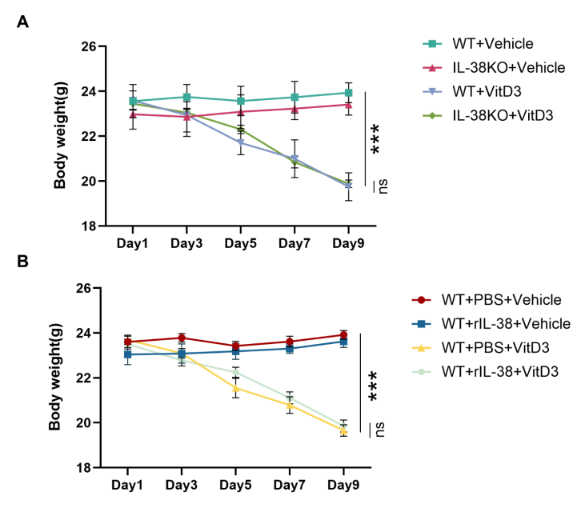
Fig. S1. Changes in Mice Body Weight during the Experimental Period.
(A) Body weight changes in WT and IL-38 KO mice (n=6). (B) Body weight changes in mice with and without rIL-38 treatment (n=6). Statistical analysis was performed using multiple t-tests with appropriate correction for multiple comparisons (B). All data were presented as mean ± SD. ***p < 0.001.
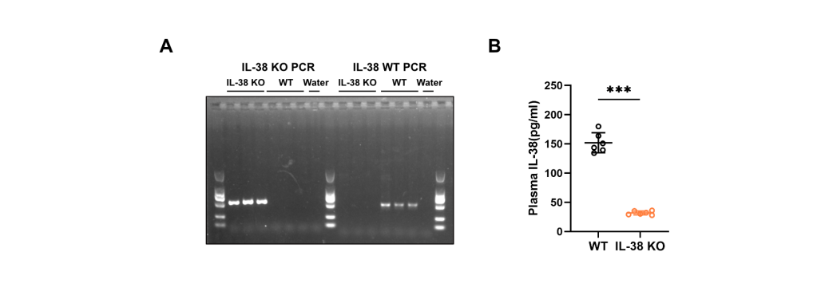
Fig. S2. Genotyping of IL-38 KO Mice.
(A) IL-38 genotyping verification by agarose gel electrophoresis. (B) Plasma IL-38 levels in WT and IL-38 KO mice (n=6). Statistical significance was evaluated via two-tailed, unpaired Student’s t-test (B). All data were presented as mean ± SD. ***p < 0.001.
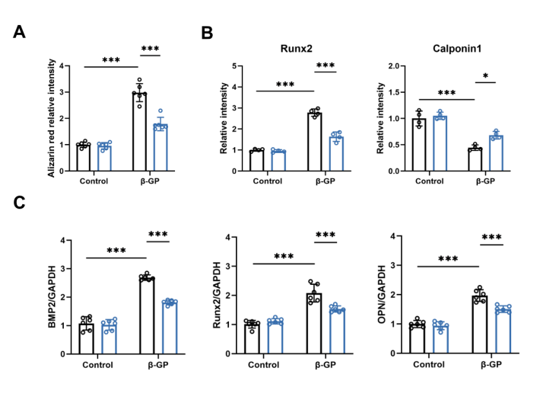
Fig. S3. IL-38 Ameliorates Vascular Calcification both in vivo and in vitro.
(A) Quantification of Alizarin red staining (Fig. 4I) (n=6). (B) Quantification of immunofluorescence staining (Fig. 4J) (n=4). (C) Quantification of immunoblots (Fig. 4M) (n=6). Statistical significance was evaluated via two-way ANOVA followed by the Bonferroni multiple-comparison test (A, B, C). All data were presented as mean ± SD. *p < 0.05, ***p < 0.001.
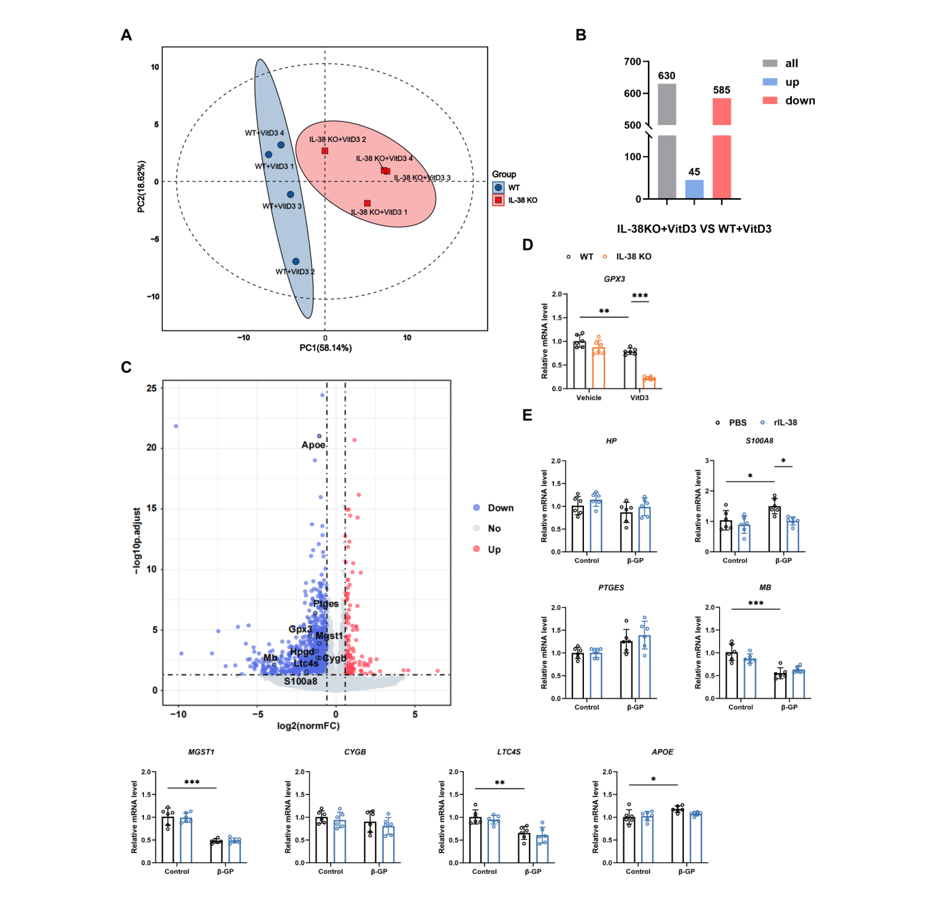
Fig. S4. IL-38 Alleviates Oxidative Stress in Vascular Calcification.
(A) Principal component analysis (PCA) of RNA-seq samples. (B) Differentially expressed genes (DEGs) identified by RNA-seq analysis. (C) Volcano plot of downregulated genes in the antioxidant activity signaling pathway. (D) Relative mRNA expression of GPX3 from aortas(n=6). (E) Relative mRNA expression of down-regulated genes in antioxidant activity signaling pathway from hASMCs (n=6). Statistical significance was evaluated via two-way ANOVA followed by the Bonferroni multiple-comparison test (D, E). All data were presented as mean ± SD. *p < 0.05, **p < 0.01, ***p < 0.001.
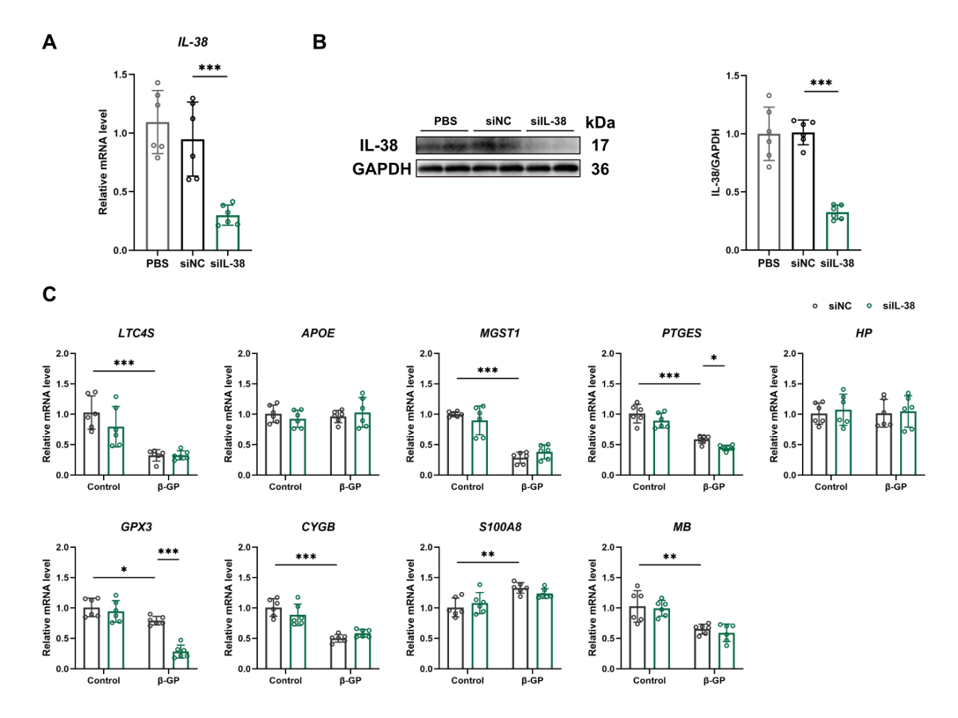
Fig. S5. IL-38 Knockdown Leads to Downregulation of Antioxidant-Related Genes.
(A) Relative mRNA expression of IL-38 (n=6). (B) Representative Western blot results of IL-38 and quantification of immunoblots (n=6). (C) Relative mRNA expression of down-regulated genes in antioxidant activity signaling pathway from hASMCs (n=6). Statistical significance was evaluated via one-way ANOVA followed by the Bonferroni multiple-comparison test (A, B), and two-way ANOVA followed by the Bonferroni multiple-comparison test (C). All data were presented as mean ± SD. *p < 0.05, **p < 0.01, ***p < 0.001.
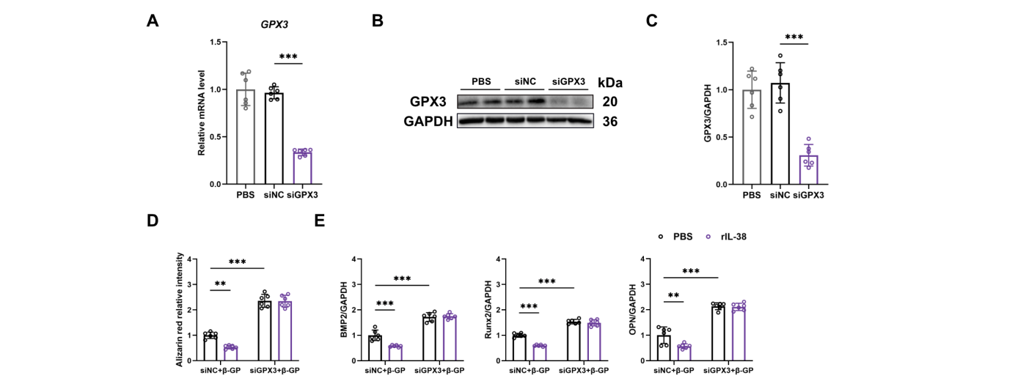
Fig. S6. IL-38 Alleviates Vascular Calcification via GPX3-mediated Antioxidant Defenses.
(A) Relative mRNA expression of GPX3 (n=6). (B) Representative Western blot results of GPX3. (C) Quantification of immunoblots (B) (n=6). (D) Quantification of Alizarin red staining (Fig. 6B) (n=6). (E) Quantification of immunoblots (Fig. 6G) (n=6). Statistical significance was evaluated via one-way ANOVA followed by the Bonferroni multiple-comparison test (A, C), and two-way ANOVA followed by the Bonferroni multiple-comparison test (D, E). All data were presented as mean ± SD. **p < 0.01, ***p < 0.001.
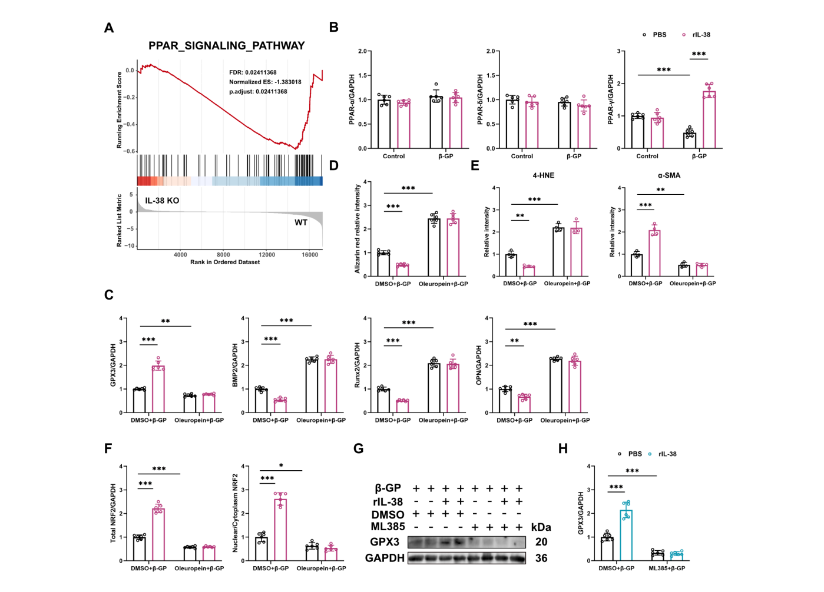
Fig. S7. IL-38 Alleviates Vascular Calcification by Activating the PPAR-γ/NRF2 Axis to Enhance GPX3 Expression.
(A) Gene set enrichment analysis (GSEA) showing enrichment of genes involved in PPAR signaling pathway.
(B) Quantification of immunoblots (Fig. 7B) (n=6). (C) Quantification of immunoblots (Fig. 7D) (n=6). (D) Quantification of Alizarin red staining (Fig. 7E) (n=6). (E) Quantification of immunofluorescence staining (Fig. 7K) (n=4). (F) Quantification of immunoblots (Fig. 7M) (n=6). (G) Representative Western blot results of GPX3. (H) Quantification of immunoblots (G) (n=6). Statistical significance was evaluated via two-way ANOVA followed by the Bonferroni multiple-comparison test (B, C, D, E, H). All data were presented as mean ± SD. *p < 0.05, **p < 0.01, ***p < 0.001.
Characteristic | Non-CAC  (n=40) | CAC  (n=40) | P Value
Demographics
Age, y | 60.53(3.16) | 62.10(6.80) | ＜0.001
Women, n (%) | 20(50.00) | 12(30.00) | 0.068
BMI, kg/m² | 25.60(2.49) | 25.33(1.65) | 0.015
Clinical features
Heart rate, bpm | 79.68(9.60) | 79.86(12.22) | 0.180
SBP, mmHg | 119.58(15.11) | 125.35(18.38) | 0.388
Cigarette smoking(Current/Ever), n (%) | 12(30.00) | 14(35.00) | 0.633
Medical history
Hypertension, n (%) | 11(27.50) | 21(52.50) | 0.022
Dyslipidemia, n (%) | 1(2.50) | 1(2.50) | 1.000
Diabetes mellitus, n (%) | 4(10.00) | 9(22.50) | 0.130
Nonhemorrhagic stroke, n (%) | 3(7.50) | 3(7.50) | 1
Renal insufficiency, n (%) | 0(0.00) | 5(12.5) | 0.021
Biomarkers
Leukocyte count, 10⁹/L | 7.10[5.53,10.82] | 8.56[7.13,11.91] | 0.036
Total cholesterol, mmol/L | 4.73[3.46,5.71] | 4.46[3.31,5.29] | 0.473
Triglyceride, mmol/L | 1.27[1.08,2.07] | 1.35[0.98,2.00] | 0.810
LDL-C, mmol/L | 2.70[2.05,3.46] | 2.66[1.57,3.30] | 0.470
HDL-C, mmol/L | 1.24[1.02,1.40] | 1.26[0.97,1.41] | 0.784
Blood glucose, mmol/L | 5.12[4.70,6.13] | 5.39[4.84,6.66] | 0.258
Platelet counts, 10⁹/L | 171.50[122.00,205.75] | 174.50[112.75,224.00] | 0.946

Table S1. Characteristics and biomarkers of non-CAC and CAC patients at baseline.
Patient inclusion required complete baseline data for all variables. Analysis employed appropriate statistical tests based on variable type: Continuous variables were summarized and analyzed differently; specifically, demographics/ clinical features (age, BMI, heart rate, SBP) were reported as mean± standard deviation and compared using unpaired t-tests, whereas biomarker levels were presented as median (interquartile range) with Wilcoxon rank-sum tests for significance. Categorical variables are provided as frequencies and percentages (n (%)) and were evaluated using χ² tests or Fisher's exact tests. Abbreviations: BMI: body mass index, SBP: systolic blood pressure, LDL-C: low-density lipoprotein cholesterol, HDL-C: high-density lipoprotein cholesterol.
Table S2. Major Resources Table
qPCR primer sequences and siRNA sequences
Gene | Forward primer(5’→3’) | Reverse primer(5’→3’)
Human GPX3 | GAGCTTGCACCATTCGGTCT | GGGTAGGAAGGATCTCTGAGTTC
Human  BMP2 | ACCCGCTGTCTTCTAGCGT | TTTCAGGCCGAACATGCTGAG
Mouse  BMP2 | GGGACCCGCTGTCTTCTAGT | TCAACTCAAATTCGCTGAGGAC
Human  Runx2 | TGGTTACTGTCATGGCGGGTA | TCTCAGATCGTTGAACCTTGCTA
Mouse  Runx2 | GACTGTGGTTACCGTCATGGC | ACTTGGTTTTTCATAACAGCGGA
Human  OPN | CTCCATTGACTCGAACGACTC | CAGGTCTGCGAAACTTCTTAGAT
Mouse  OPN | ATCTCACCATTCGGATGAGTCT | TGTAGGGACGATTGGAGTGAAA
Human  IL-38 | AGAGGGGCCTTCCCTACAG | CAGCAGCCTCAAGCCTGAA
Mouse  IL-38 | TCAAGGATGCACATCAAAAGGC | AGGCAGCAACTTCCTCCCT
Human  APOE | GTTGCTGGTCACATTCCTGG | GCAGGTAATCCCAAAAGCGAC
Human  Mb | TTGGTGCTGAACGTCTGGG | TGGGTGACCCTTAAAGAGCCT
Human  Mgst1 | ATGACAGAGTAGAACGTGTACGC | TACAGGAGGCCAATTCCAAGA
Human  Cygb | CCCGGCTCTATGCCAACTG | CCATGTGCTTGAACTGGCTGA
Human  Hp | CAGCACAGTCCCCGAAAAGAA | CAGTCGCATACCAGGTGTCC
Human  Ptges | TCCTAACCCTTTTGTCGCCTG | CGCTTCCCAGAGGATCTGC
Human  S100a8 | ATGCCGTCTACAGGGATGAC | ACTGAGGACACTCGGTCTCTA
Human  Ltc4s | CGCTTCCGCATCCTAGTCTC | GTTCCTTCGCAGCCACTCT
Human  GAPDH | GGAGCGAGATCCCTCCAAAAT | GGCTGTTGTCATACTTCTCATGG
Mouse  GAPDH | AGGTCGGTGTGAACGGATTTG | TGTAGACCATGTAGTTGAGGTCA
Mouse GPX3 | AGCCAGCTACTGAGGTCTGA | GGGAAGCCCAGAATGACCAA
siGPX3 | GGAUGUCAAUGGAGAGAAATT | UUUCUCUCCAUUGACAUCCTT
siIL-38 | GAAGAUCUGCAUACUUCCUAATT | UUAGGAAGUAUGCAGAUCUUCTT

Software and algorithms
Name | Vendor or Source | Persistent ID / URL
ImageJ | Isolated from adult mice | https://imagej.nih.gov/ij/download.html
GraphPad Prism 10.5 software | GraphPad Software | http://www.graphpad.com/
OlyVIA 4.1 | Olympus | https://lifescience.evidentscientific.com.cn/zh/downloads/detail-iframe/?0[downloads][id]=847254102
Leica Application Suite X 3.7.4 | Leica | https://www.leica-microsystems.com.cn/cn/products/microscope-software/p/leica-application-suite/downloads/

Antibodies
Antibodies | Source | Catalogue No. | Application and dilution
BMP2 | Abcam, Rabbit | ab214821 | WB, 1:3000 in TBST
BMP2 | Santa, Mouse | sc-137087 | WB, 1:500 in TBST
Runx2 | CST, Rabbit | 8486 | WB, 1:1000 in TBST
Runx2 | Santa, Mouse | sc-390351 | WB, 1:500 in TBST
Runx2 | CST, Rabbit | 12556 | IF, 1:400 in PBS
OPN | Santa, Mouse | sc-21742 | WB, 1:500 in TBST
OPN | Proteintech, Rabbit | 83341-1-RR | WB, 1:1000 in TBST
α-SMA | ABclonal, Rabbit | A11032 | WB, 1:3000 in TBST
α-SMA | Abcam, Mouse | ab9465 | IF, 1:200 in PBS
GAPDH | ABclonal，Rabbit | A19056 | WB, 1:50000 in TBST
GPX3 | Abcam, Rabbit | ab275965 | WB, 1:500 in TBST
IL-38 | Abcam, Rabbit | ab180898 | WB, 1:1000 in TBST
IL-38 | Proteintech, Rabbit | 60319-1-Ig | WB, 1:1000 in TBST
IL-38 | R&D Systems, Rat | MAB7774 | IF, 1:200 in PBS
PPAR-α | Proteintech, Mouse | 66826-1-Ig | WB, 1:1000 in TBST
PPAR-δ | Proteintech, Rabbit | 10156-2-AP | WB, 1:1000 in TBST
PPAR-γ | Proteintech, Rabbit | 16643-1-AP | WB, 1:1000 in TBST
NRF2 | Immunoway，Rabbit | YM8624 | WB, 1:2000 in TBST
NRF2 | Abcam, Rabbit | ab62352 | IF，1:200 in PBS
Histone H3(D1H2) | CST,Rabbit | 4499 | WB, 1:2000 in TBST
CACNA1C | Proteintech, Rabbit | 21774-1-AP | WB, 1:1000 in TBST
PMCA | Santa, Mouse | sc-271917 | WB, 1:500 in TBST
TRPM7 | Proteintech, Rabbit | 55251-1-AP | WB, 1:1000 in TBST
Vinculin | Santa, Mouse | sc-73614 | WB, 1:500 in TBST
Calponin1 | Abcam, Rabbit | ab46794 | WB, 1:3000 in TBST
Calponin1 | Santa, Mouse | sc-58707 | IF, 1:200 in PBS

