SUPPLEMENTARY MATERIAL

Mitochondrial and Lipid Metabolism Rewiring during HEV Infection

Quentin Glaziou¹, Qian Chen², Jordi Gouilly^{1‡}, Ming Wu^{1‡}, Marie Duhamel³, Michel Salzet³, Jacques Izopet^{1,4}, Reem Al Daccak^{5*}, Hicham El Costa^{1*}, Nabila Jabrane-Ferrat^{1*#}

¹University Toulouse, INSERM, CNRS, Infinity – Toulouse Institute for Infectious and Inflammatory Diseases, Toulouse, France University of Toulouse, CNRS, INSERM, Infinity, Toulouse, France.
²Division of Immunology and Department of Pediatrics, Boston Children's Hospital, Boston, MA, USA.
³University Lille, INSERM, Laboratory of Proteomics, Inflammatory Response and Mass Spectrometry (PRISM), CHU Lille, France.
⁴Department of Virology, Institut Fédératif de Biologie, CHU Toulouse, France.
⁵University Paris, INSERM UMRS 1342, Saint-Louis Hospital, Paris, France.

‡ Contributed equally.
* Share senior authorship.
# Corresponding author: nabila.jabrane-ferrat@inserm.fr

Supplementary Material Section
Supplementary methods and materials
Supplementary Figures and Legends

SUPPLEMENTARY METHODS
HEV infection and progeny purification
HEV-1 and HEV-3 clinical strains were recovered from infected patient samples and amplified in HepG2/C3A cells as previously described. Briefly, to produce high titer low passage quasi-enveloped virions, monolayers of sub-confluent cell layers were challenged for 24h with 10⁷ copies of HEV-1 or HEV-3 RNA in DMEM supplemented with 2% FCS. After 24 h, the cell layer was rinsed with PBS and subsequently cultured in 10% FCS-medium at 37 °C. Culture supernatants containing enveloped virions were collected when the percentage of infection reached more than 30%. To remove residual cellular debris and large vesicles, culture supernatants were submitted to 15.000 x g ultracentrifugation using clear ultracentrifuge Beckman tubes (Beckman) for 30 min at 4°C. Cleared supernatants were overlayed on a 15% sucrose cushion and subjected to ultracentrifugation at 110.000 x g during 2h30 at 4°C. Pellets containing small vesicles and enveloped HEV were resuspended in 200 µL of cell culture medium (DMEM supplemented with 10% FCS and 1% Penicillin/Streptomycin) overnight at 4°C before storage at -80°C as single-use aliquots.
HepG2-MAVS were infected with 10¹¹ RNA copies of either HEV-1, HEV-3, or left uninfected in DMEM containing 10% FCS at 37 °C. After 24 h, cell layers were rinsed with PBS and subsequently cultured in culture medium at 37°C for 48h or three weeks for long-term infection.
Unless specified under figure legends, long-term infected HepG2-MAVS cells were used for all experiments.
Samples Preparation for Mass Spectrometry
Cell pellets (1x10⁶ cells), derived from long-term HEV-1- or mock-infected samples, were dissolved by mixing in 150 µL of lysis buffer (4% SDS, 100 mM Tris/HCl pH 7.6, 50 mM DTT), heated for 15 min at 95°C then subjected to sonication to shear released DNA. Samples were then prepared for MS analysis using a modified version of the FASP (Filter Aided Sample Preparation method for protein clean-up). Briefly, 100 µg of DTT-reduced proteins were applied to a 10 kDa molecular weight cutoff membrane, washed with denaturing buffer (8M Urea, 0.1M Tris-HCl). Ioadoacetamide (0.05 M) was added to each sample for 15 min at room temperature in the dark to allow protein alkylation. After washing with NH4HCO3 (50 mM), samples were digested with 1 μg of trypsin (Promega) at 37 °C overnight. Digested samples were centrifuged, peptides were transferred to a fresh collection tube and dried under vacuum on SpeedVac Concentrator. Samples were desalted using C18 Ziptip (Millipore), eluted with 80% acetonitrile and vacuum-dried. Dried samples were resuspended in 0.1 formic acid/acetonitrile (98:2, v/v).
NanoLC–MS/MS Characterization of Peptides Extracted from HEV-1 Infected Cells
Peptides separation was performed by reverse phase chromatography on an EASY-nLC 1000 coupled online to a Q-Exactive Orbitrap mass spectrometer (Thermo Scientific) via a nanoelectrospray source. A Proxeon trap column (100 μm ID × 2 cm, Thermo Scientific) and a C18 packed-tip column (100 μm ID × 15 cm, Nikkyo Technos Co. Ltd.) were used. Peptides were separated using an increasing amount of acetonitrile (2–30% over 120 min) at a flow rate of 300 nl/min. The chromatography system was coupled to Thermo Scientific Q-Exactive mass spectrometer programmed to acquire in a data-dependent mode, defined to analyze the 10 most intense ions of MS analysis (Top10). MS analysis was performed with an m/z mass range between m/z 300 and 1600, a resolution of 70,000 FWHM, an AGC of 3e6 ions and a maximum injection time of 120 ms. MS/MS analysis was performed with an m/z mass range between 200 and 2000, an AGC of 5e4 ions, a maximum injection time of 60 ms and the resolution was set at 17,500 FWHM.
All MS data were searched with MaxQuant software using Andromeda search engine against the complete proteome for Homo sapiens (UniProt, release 2/15/2018, 93,738 entries including protein isoforms). Trypsin was selected as enzyme and two missed cleavages were allowed, with N-terminal acetylation and methionine oxidation as variable modifications. The mass accuracies were set to 6 ppm and 20 ppm, respectively for MS and MS/MS spectra. False discovery rate (FDR) at the peptide spectrum matches (PSM) and protein identifications were estimated using a decoy version of the previously defined databases (reverse construction) and set at 1%. A minimum of two peptides with at least one unique is necessary to complete the identification of a protein. The MaxLFQ algorithm was used to perform label-free quantification of the proteins. Analysis of the identified proteins was performed with Perseus software (http://www.perseus-framework.org) (version 1.5.6.0). Hits from the reverse database and proteins with only modified peptides were removed. Hits from potential contaminants were marked, and proteins originating from culture medium or sample preparation (bovine serum albumin, trypsin) were removed. LFQ intensities were transformed by base 2 logarithm before statistical analysis. Statistical analyses were performed using ANOVA with truncation value based on “Benjamini Hochberg FDR” of 5%.

Lipid Extraction and Quantitative Lipid Analysis by LC-MS/MS
Pellets from long-term HEV-infected or mock cells were washed in PBS, snap-frozen in liquid nitrogen and stored at -80°C until extraction. Each sample was extracted as previously described and the amount of proteins was quantified by Bio-Rad BCA. Different classes of lipids were extracted and separated according to the manufacturer’s instructions. Shotgun LC/MS/MS analysis was performed as previously described⁽¹⁴⁾ on an Agilent LC1290 Infinity ultra-high-performance liquid chromatography system coupled to an Agilent 6460 triple quadrupole mass spectrometer (Agilent Technologies, Les Ulis, France) equipped with electrospray ionization operating in the negative mode. Signal intensity for specific lipid species was extracted according to the retention time. Samples with spiked internal standards were quantified according.

Cloning and Validation of ORF3
Four primer pairs were designed to amplify ORF3 sequences from clinical isolates of HEV-1 (GenBank accession no. X98292) and HEV-3 (GenBank accession no. EU495148). The 372 bp PCR products encoding full-length ORF3 cDNAs were cloned into intermediate vectors for sequence validation, and confirmed inserts were subsequently subcloned into the bicistronic lentiviral vector pWPXLd-IRES-GFP.
VSV-G–pseudotyped lentiviruses were produced HEK293T cells by co-transfecting the transfer vector, the packaging plasmid psPAX, and the VSV-G envelope plasmid pMD2G. Viral particles were collected from culture supernatants, titrated on HEK293 cells, and GFP expression quantified by FACS. High-titre stocks were then used to transduce HepG2-C3a cells. GFP⁺ cells were isolated by FACS sorting, and ORF3 expression was confirmed by immunostaining with specific antibodies. Stable clones expressing HEV-1 or HEV-3 ORF3 proteins were generated and employed in subsequent qRT-PCR experiments.
HEK293 cells, and GFP expression was quantified by FACS. High-titre stocks were then used to transduce HepG2-C3a cells. GFP⁺ cells were FACS-sorted, and ORF3 expression was validated by immunostaining using specific antibodies. Stable HepG2-C3A and HeLa clones expressing HEV-1 or HEV-3 ORF3-proteins were established and used in subsequent qRT-PCR experiments.

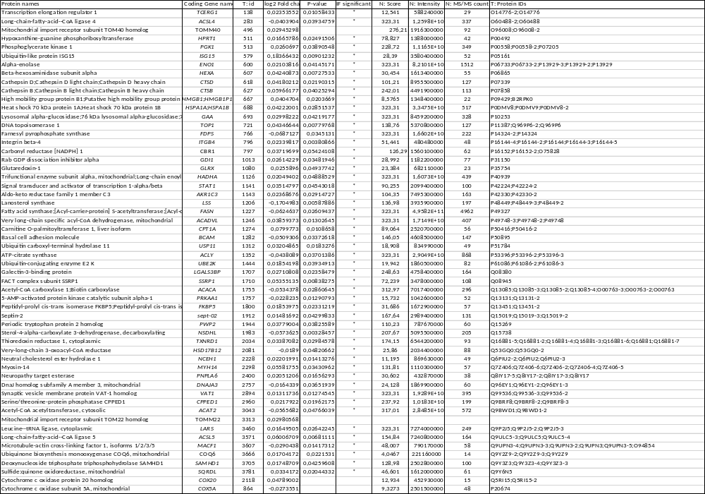
Table 1: Source Data for IPA analysis - Differentially expressed proteins in HEV-1 infected versus Mock-infected Hep-G2-MAVS cells as identified by NanoLC-MS analysis.

Table 2: Resources (Antibodies, Primers, Probes and Kits, drugs, and Chemicals) with their respective purchase origin and final concentrations.
Antibodies for microscopy and Flow cytometry
Anti-HEV ORF2 (clones 4B2), 10 µg/mL |  | Clinisciences | MAB8006
Anti-HEV ORF3 (Rabbit Antibody) |  | ThermoFisher | BS-0212R
Anti-TOMM22 antibody |  | MERCK | T6319
Alexa Fluor-conjugated, class-specific secondary Ab, 5 µg/mL |  | Invitrogen | A-21121
APC Mouse Anti-Human CD36, 1 µg/mL |  | BD-Pharmingen | 550956
Primers
HEV1-ORF3 | Forward: ATGAATAACATGTCTTTTGCTG | Reverse: TTAGCGGCGCGGCCCCAGCTGT
HEV3-ORF3 | Forward: ATGAATAACATGTCTTGTGCATCGC | Reverse: TTAGCGGCGCAGCCCCAGTTG
CD36 | Forward: GCAGCAACATTCAAGTTAAGCAA | Reverse: GGGTTACATTTTCCTTGGCTAGAA
FASN | Forward: CTTCCGAGATTCCATCCTACGC | Reverse: TGGCAGTCAGGCTCACAAACG
DGAT | Forward: TCGCCTGCAGGATTCTTTAT | Reverse: GCATCACCACACACCAGTTC
GPAT1 | Forward: AACCCCAGTATCCCGTCTTT | Reverse: CAGTCACATTGGTGGCAAAC
HPRT | Forward: TGACACTGGCAAAACAATGCA | Reverse: GGTCCTTTTCACCAGCAAGCT
Probes and Kits
BODIPY_{493/503}, 5 µM |  | ThermoFisher | D3922
C11-BODIPY_{581/591}, 5 µM |  | ThermoFisher | D3861
CellROX, 5 µM |  | ThermoFisher | C10491
4,6-Diamidino-2-Phenylindole (DAPI), 0.2 µg/mL |  | Thermofisher | 62248
MitoTracker Green, 0.1µM |  | ThermoFisher | M46750
Nile red, 0.1 µM |  | ThermoFisher | N1142
TMRM, 0.1 µM |  | Invitrogen | T668
L-Lactate assay kit |  | Abcam | ab65331
Live/Dead Fixable Yellow Dead Cell Stain kit |  | ThermoFisher | L34959
Chemicals and Pharmacological Drugs
Antimycin A, 1 µM |  | MERCK | A8674
CD36-Inhibitor, 50 µM |  | MedChem Express | HY-112847A
2-deoxyglucose (2-DG), 50 mM |  | MERCK | D3179
Etomoxir |  | MERCK | E1905
Carbonyl cyanide 4-(trifluoromethoxy) phenylhydrazone (FCCP), 1.5 µM |  | MERCK | SML2959
Oligomycin, 1 µM |  | MERCK | 75351
Rotenone, 1 µM |  | MERCK | R8875
Software
Perseus |  | Maxquant
MaxQuant |  | Maxquant
Ingenuity Pathway Analysis |  | QIAGEN Digital Insights
MS Excel 2019 |  | Microsoft
FIJI |  | NIH GitHub
StarDist |  | NIH GitHub
Prism 9 |  | GraphPad
FlowJo V10 |  | FlowJo LLC

Supplementary Figures 1-2

Figure S1: HEV Infection Impairs Free Fatty Acids and Oxilipin Metabolism.
a, Heatmap comparing clustering of relative different FA-derived oxylipins abundance. Each column represents a single replicate and each row corresponds to a single metabolite.
b, Fatty acid peroxidation probed by C11Bodipy labeling and analyzed by FACS. Mock- (black), HEV-1- (red) and HEV-3-infected cells (blue). Data sets are presented as mean values ± SEM from six independent experiments. p-values are computed using ANOVA. p <0.01 (**), p < 0.001 (***).

Figure S2: HEV ORF3-Dependent Induction of Lipid Metabolism
a, Representative gating strategy for selection and sorting of eGFP expressing cells (left). Immunostaining of stable clones expressing HEV-1 or HEV-3 ORF3 protein. eGPP (green), ORF3 (red), dapi (cyan). Scale bar, 50µm.
b-c, CD36, FASN, DGAT and GPAT1 mRNA expression relative to HPRT house-keeping gene. (b) Mock (black), HEV-1- (red) and HEV-3- (blue) HepG2/C3a-MAVS-KD infected cells, (c) HepG2/C3a cells stably expressing ORF3 protein from HEV-1 or HEV-3. Empty Vector (EV, black), HEV-1-ORF-3 (red) and HEV-3-ORF-3 (blue).
d, Cell viability in the presence of inhibitory drugs. Control (CTRL), CD36 inhibitor (CD36-Inh), Etomoxir, Oligomycin (Oligo), 2DG glucose inhibitor (2DG), glucose restriction (ΔGlu).
Data points represented relative mRNA expression from at least three independent experiments.
p-values are computed using ANOVA. p < 0.05 (*), p < 0.01 (**), p < 0.001 (***), and p < 0.0001 (****).

