Supplementary Material
A B
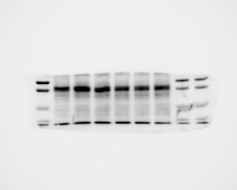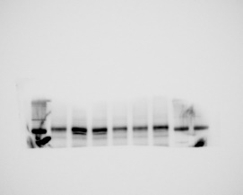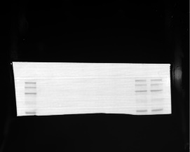
C D
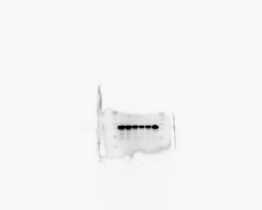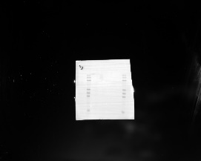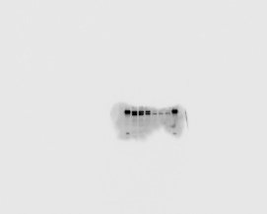

FigS1. Western blot analysis of METTL3 and GAPDH protein expression levels in mouse spleen B cells. (A) Protein gel of GAPDH in CFA and EAE group B cells. (B) Protein gel of METTL3 in CFA and EAE group B cells. (C) Protein gel of GAPDH in Mettl3^{flox/flox} and Mettl3^{flox/flox}Cd19^{Cre} group B cells. (B) Protein gel of METTL3 in Mettl3^{flox/flox} and Mettl3^{flox/flox}Cd19^{Cre} group B cells. n=3 in each group.

FigS2. Detection of relevant inflammatory factor levels
（A-G）Cytometric bead array (CBA) method to detect the secretion of inflammatory factors in peripheral blood of Mettl3flox/flox mice and Mettl3flox/floxCd19Cre mice by flow cytometry. (n=5 to 5, P>0.05). （H）the detection of IL-10 at the transcriptome level. (n=3 to 3, P=0.020081). ﻿(data = mean ±SEM, Statistics employed Student’s t-test)

Gene | Forward sequence (5′-3′) | Reverse sequence (5′-3′ )
﻿ Gapdh | ggttgtctcctgcgacttca | tggtccagggtttcttactcc
Mettl3 | cgtagtgatagtcccgtgcc | gcaaggtcaaggccagatct
Ythdf1 | ttggcctgaagattggggat | acatttgtcccaccattgcc
GAPDH  METTL3  YTHDF1 | ctctcctctgacttcaacagcg  tcctgagttagagaagaagt  ggggacaagtgggtctcaag | accaccctgttgctgtagccaa  gagatggcaagacagatg  agggtgtcgctgtgaaagc
Nrp2  Celsr2  Srgap3  Tox2  Cacna1d  Znp532 | ccacacaatctggactgtacc  tgtcgctgtaaatatggtagagt  ggtcccctcgtgaactatcc  cggggatgttgtcgggat  ccaaccatttgccgtgaaga  gctgcactgaagtctcacat | ccacttgtagagggtcatgc  gcgatgacatggctcctg  atgagtccatctacaccgttg  acttgcagagaggcccag  tgtagttttgcctgctccag  tgtaggcgtgggaatgtgt
Tnfsf13b | taccgaggttcagcaacacc | ccggtgtcaggagtttgact
Table S1: sequences of Primers used in the experiment.

