Supplementary information

Supplementary Tables:
Table S1 | Sequences of primers used for PCR analysis and inventory numbers of TaqMan Gene Expresssion Assays used for qPCR.
Table S2 | The list of significantly altered proteins and annotation of their functional role.
Table S3 | Protein-set enrichment analysis overview (≥2-fold change or ≤−2-fold change).
Table S4 | Protein-set enrichment analysis overview (≥1.5-fold change or ≤−1.5-fold change).
Table S5 | The list of selected synaptic proteins and their abundance ratio assessed in Grin2b^{+/Δ} relative to Grin2b^{+/+} hippocampal tissue.
Table S6 | Data reported in Fig. 8–10, grouped by sex.
Table S7 | Numerical data underlying Fig. 11–12 and Fig. S5–S8.

Supplementary Figures:
Figure S1 | A representative agarose gel showing amplification of a 1200 nt fragment of Grin2b mRNA.
Figure S2 | Correlation between protein expression changes in hippocampal tissue from 4-month-old Grin2b^{+/Δ} and Grin2b^{+/L825V} mice.
Figure S3 | Western blot analysis of HEK293T cells transfected with GFP or GluN2B-GFP subunit.
Figure S4 | The GluN2B^{Δ} subunit disrupts NMDAR surface expression in COS-7 cells.
Figure S5 | Grin2b^{+/Δ} mice display hypoactivity and increased anxiety. Supplementary data from the open field test.
Figure S6 | Elevated plus maze analysis of anxiety-like behavior in Grin2b^{+/Δ} mice.
Figure S7 | Social behavior in Grin2b^{+/Δ} mice.
Figure S8 | Repetitive behavior in Grin2b^{+/Δ} mice.

Supplementary Tables

Gene | Primer Forward | Primer Reverse | Notes
Genotyping PCR
Grin2b | GAGGCAAATGGGGAAAAGCC | GGAAGCTCTCTGGCTCACTG
End-point PCR
Grin2b | CCTATGACCTTTACCTGGTGACC | GCTGATGGAGAAGACCATGC
Grin2b | TGCAGCCGTGCTCAACTACA |  | Sequencing primer (forward)
RT-qPCR (TaqMan Gene Expression Assay)
Grin1 | Mn004338000_m1 |  | Thermo Fisher
Grin2a | Mn004338002_m1 |  | Thermo Fisher
Grin2b | Mn004338020_m1 |  | Thermo Fisher
Gapdh | Mn999999915_m1 |  | Thermo Fisher
β2M | Mm00437762_m1 |  | Thermo Fisher

Table S1 | Sequences of primers used for PCR analyses and inventory numbers of TaqMan Gene Expresssion Assays used for qPCR.

Protein | Protein symbol | Annotation of the Functional Role | Ratio  log₂ (2b^{+/Δ}/2b^{+/+})
MDR3 P-glycoprotein | ABCB4 | ABCB4 transports phospholipids across liver cell membranes for release into bile. | 1.0319
Actin-like protein 6B | ACTL6B | Mutations in this protein result in neurodevelopmental deficits, epilepsy, and dendritic loss in human neurons. | 1.1841
Armadillo-like helical domain-containing protein 3 | ARMH3 | Regulates Golgi organization; localized to the Golgi membrane and cytosol. | 1.7692
Beta-site amyloid precursor protein cleaving enzyme 1 | BACE1 | Plays a key role in the production of amyloid-beta peptides implicated in Alzheimer’s disease. | 1.1617
BCL2-associated X protein | BAX | Bax, a pro-apoptotic Bcl-2 family member, triggers apoptosis and is essential for developmental neuronal cell death. | 1.0368
Cell division cycle 37-like 1 protein | CDC37L1 | This protein has been associated with gastric cancer. | 1.2357
Cysteine-serine-rich nuclear protein 1 | CSRNP1 | CSRNP1 is a tumor suppressor, and its expression is increased by estradiol. | 1.1717
Cytochrome P450 family 4 subfamily V member 2 | CYP4V2 | This protein is a cytochrome P450 enzyme involved in oxidizing substrates in metabolism, particularly in converting fatty acid precursors to n-3 polyunsaturated fatty acids. | 1.0131
DEAD-box helicase 3, Y-linked | DDX3Y | It is a crucial RNA helicase involved in RNA processing, translation regulation, and spermatogenesis. | 1.0381
Fibrous sheath-interacting protein 2 | FSIP2 | FSIP2 is involved in acrosome development during spermiogenesis and may serve as a predictive biomarker for Clear Cell Renal Cell Carcinoma prognosis. | 1.085
Growth arrest-specific protein 8 | GAS8 | A component of the cytoskeleton involved in ciliary function and microtubule organization. | -1.212
Histone H2B ubiquitinated 2 | H2BU2 | This histone is involved in chromatin organization and gene regulation. | -1.332
Histone acetyltransferase 1 | HAT1 | Histone acetyltransferase 1 acts as a succinyltransferase for both histones and non-histones, promoting tumorigenesis. | 1.0848
Inositol 1,4,5-trisphosphate receptor type 3 | ITPR3 | It is a calcium channel that mediates intracellular calcium release from the endoplasmic reticulum. | 1.0904
Minichromosome maintenance complex component 4 | MCM4 | The expression of certain MCM complex components, including MCM4, a helicase essential for DNA replication and genome stability, is linked to the survival of hepatocellular carcinoma (HCC) patients. | 1.1244
Metallothionein 1 | MT1 | This protein is involved in heavy metal detoxification, oxidative stress response, and metal ion homeostasis. | -1.3131
Myosin light chain kinase | MYLK | Encodes the Ca2+/calmodulin-dependent myosin light chain kinase (MLCK), responsible for phosphorylating the regulatory light chain and initiating smooth muscle cell contraction. | 1.0677
Myoferlin | MYOF | Myoferlin is involved in membrane repair and fusion processes in muscle cells and is overexpressed in various cancers, particularly pancreatic and triple-negative breast cancer. | 1.1297
N-deacetylase/N-sulfotransferase 4 | NDST4 | This protein is a candidate tumor suppressor involved in heparan sulfate modification, which regulates cellular signaling and development. | 1.0822
Optic atrophy 3 protein | OPA3 | This protein plays a role in mitochondrial function and is associated with optic atrophy. | 1.0101
Ribosomal RNA Processing Protein 1 | RRP1 | This is a nucleolar protein that helps in processing and assembling ribosomal RNA into functional ribosomes. | -1.0416
Translocation protein SEC62 | SEC62 | This protein is involved in the translocation of nascent proteins across the endoplasmic reticulum membrane. | 1.5698
Vacuole membrane protein 1 | VMP1 | It is involved in autophagy and vacuole membrane formation and is overexpressed in pancreatitis-affected acinar cells, where it mediates zymophagy. | 1.5755

Table S2 | The list of significantly altered proteins and the annotation of their functional role.

Term | Library | p-value | q-value (FDR) | Protein
Positive regulation of neuron apoptotic process (GO:0043525) | a | 0.0003438 | 0.06230 | BACE1; BAX
Positive regulation of neuron death (GO:1901216) | a | 0.001325 | 0.06230 | BACE1; BAX
Histone H4 acetylation (GO:0043967) | a | 0.001382 | 0.06230 | ACTL6B; HAT1
Histone acetylation (GO:0016573) | a | 0.002996 | 0.06230 | ACTL6B; HAT1
Regulation of neuron apoptotic process (GO:0043523) | a | 0.005623 | 0.06230 | BACE1; BAX
Increased hepatocellular carcinoma incidence MP:0003331 | b | 0.001943 | 0.07983 | ABCB4; MCM4
Postnatal lethality, incomplete penetrance MP:0011086 | b | 0.004172 | 0.07983 | BACE1; ACTLB; MCM4; GAS8
Abnormal locomotor activation MP:0003313 | b | 0.004262 | 0.07983 | BACE1; ITPR3
Abnormal myelination MP:0000920 | b | 0.00436 | 0.07983 | BACE1; ACTL6B
Decreased fibroblast proliferation MP:0011704 | b | 0.00446 | 0.07983 | HAT1; MCM4
Release of apoptotic factors from mitochondria R-HSA-111457 | c | 0.008023 | 0.1722 | BAX
CLEC7A (Dectin-1) induces NFAT activation R-HSA-5607763 | c | 0.01258 | 0.1722 | ITPR3
Unwinding of DNA R-HSA-176974 | c | 0.01258 | 0.1722 | MCM4
Elevation of cytosolic Ca2+ Levels R-HSA-139853 | c | 0.01712 | 0.1722 | ITPR3
Signaling by NTRK3 (TRKC) R-HSA-9034015 | c | 0.01825 | 0.1722 | BAX
Gastric acid secretion | d | 0.003424 | 0.1780 | ITPR3; MYLK
Platelet activation | d | 0.00886 | 0.1780 | ITPR3; MYLK
Vascular smooth muscle contraction | d | 0.01013 | 0.1780 | ITPR3; MYLK
Apelin signaling pathway | d | 0.01073 | 0.1780 | ITPR3; MYLK
Apoptosis | d | 0.01149 | 0.1780 | BAX; ITPR3

Table S3 | Protein-set enrichment analysis overview (≥2-fold change or ≤−2-fold change). The table presents the results of enrichment analysis for proteins showing a ≥2-fold increase or ≤−2-fold decrease across two ontologies, a – GO_Biological_Process_2021 and b – MGI_Mammalian_Phenotype_Level_4_2021, and two pathway databases, c – Reactome_2022 and d – KEGG_2021_Human. The analyses were performed using Enrichr (https://maayanlab.cloud/enrichr-kg). Enriched terms were ranked according to their FDR to assess the significance of biological processes and pathways associated with the analyzed protein set. Columns list, in order: term name (protein set) with reference identifier, the corresponding ontology or pathway database, p-value (Fisher’s exact test), and q-value/FDR (Benjamini–Hochberg correction).
Term | Library | p-value | q-value (FDR) | Protein
Negative regulation of microtubule polymerization (GO:0031115) | a | 0.0000936 | 0.06084 | CADH5; STMN1; DYRK1A
Negative regulation of microtubule polymerization or depolymerization (GO:0031111) | a | 0.0001028 | 0.06084 | CADH5; STMN1; DYRK1A; HDGFL3
Cellular component assembly (GO:0022607) | a | 0.0001954 | 0.07712 | VMP1; TTC26; ARL6IP1; FLNA; RHOH; TUBGCP4; PARVB; GAS8; LIMS1
Abnormal blood homeostasis MP:0009642 | b | 0.0001993 | 0.2151 | CFH; ARG1; ABCB4; OPA3; RDX; ALPL
Cell-extracellular matrix interactions R-HSA-446353 | c | 0.0002329 | 0.1043 | FLNA; PARVB; LIMS1
Increased circulating aspartate transaminase level MP:0005343 | b | 0.0005943 | 0.2498 | PON3; ATXN3; ABCB4; RDX; FACE1
Regulation of protein modification process (GO:0031399) | a | 0.0006376 | 0.1509 | CDK9; CADH5; FINC; PUM3
Focal adhesion | d | 0.0009542 | 0.1584 | LAMA1; COL6A1; FINC; FLNA; FLNB; PARVB; MYLK
Incomplete embryo turning MP:0001701 | b | 0.001038 | 0.2498 | CADH5; GLMN; FINC; MGAT1
Negative regulation of protein polymerization (GO:0032272) | a | 0.001143 | 0.1509 | CADH5; STMN1; DYR1A
Abnormal thrombosis MP:0005048 | b | 0.001143 | 0.2498 | CFAH; FLNA; PDLI7
Abnormal artery development MP:0003410 | b | 0.0016 | 0.2498 | PKHG5; FLNB
Regulation of cytoskeletal remodeling and cell spreading by IPP complex components R-HSA-446388 | c | 0.0016 | 0.3584 | PARVB; LIMS1
Cell junction organization R-HSA-446728 | c | 0.004402 | 0.5327 | CADH5; FLNA; PARVB; LIMS1
Signaling by receptor tyrosine kinases R-HSA-9006934 | c | 0.005151 | 0.5327 | CADH5; LAMA1; COL6A1; STMN1; BAX; ITPR3; RICTR; T2FB; GLUN2B; JAK3
Proteoglycans in cancer | d | 0.005165 | 0.4287 | RADI; FINC; FLNA; MOES; FLNB; ITPR3
Sensory processing of sound by outer hair cells of cochlea R-HSA-9662361 | c | 0.007915 | 0.5327 | CLIC5; RADI; MOES
Spinocerebellar ataxia | d | 0.02478 | 0.6944 | ATX3; ITPR3; ATG13; GLUN2B
ECM-receptor interaction | d | 0.03054 | 0.6944 | LAMA1; COL6A1; FINC
Small-cell lung cancer | d | 0.03419 | 0.6944 | LAMA1; FINC; BAX

Table S4 | Protein-set enrichment analysis overview (≥1.5-fold change or ≤−1.5-fold change). The table presents the results of enrichment analysis for proteins showing a ≥1.5-fold increase or ≤−1.5-fold decrease across two ontologies, a – GO_Biological_Process_2021 and b – MGI_Mammalian_Phenotype_Level_4_2021, and two pathway databases, c – Reactome_2022 and d – KEGG_2021_Human. The analyses were performed using Enrichr (https://maayanlab.cloud/enrichr-kg). Enriched terms were ranked according to their FDR to assess the significance of biological processes and pathways associated with the analyzed protein set. Columns list, in order: term name (protein set) with reference identifier, the corresponding ontology or pathway database, p-value (Fisher’s exact test), and q-value/FDR (Benjamini–Hochberg correction).
Protein name | Protein symbol | Ratio  (Grin2b^{+/Δ} /Grin2b^{+/+})
Disks large homolog 2 | DLG2 | 1.03
Disks large homolog 3 | DLG3 | 1.01
Disks large homolog 4 | DLG4 | 1.12
Disks large-associated protein 1 | DLGAP1 | 1.10
Disks large-associated protein 2 | DLGAP2 | 1.03
Disks large-associated protein 3 | DLGAP3 | 0.98
Disks large-associated protein 4 | DLGAP4 | 1.00
Homer protein homolog 1 | HOMER1 | 1.08
Homer protein homolog 2 | HOMER2 | 1.09
Homer protein homolog 3 | HOMER3 | 1.26
Neurexin-1 | NRXN1 | 1.04
Neurexin-2 | NRXN2 | 1.08
Neurexin-3 | NRXN3 | 1.11
Neuroligin-2 | NLGN2 | 1.03
Neuroligin-3 | NLGN3 | 1.14
Protein bassoon | BSN | 0.90
Protein piccolo | PCLO | 0.95
Regulating synaptic membrane exocytosis protein 1 | RIMS1 | 1.09
Regulating synaptic membrane exocytosis protein 2 | RIMS2 | 1.00
SH3 and multiple ankyrin repeat domains protein 1 | SHANK1 | 1.17
SH3 and multiple ankyrin repeat domains protein 2 | SHANK2 | 1.10
SH3 and multiple ankyrin repeat domains protein 3 | SHANK3 | 1.16
Synapsin-1 | SYN1 | 1.08
Synapsin-2 | SYN2 | 1.23
Synapsin-3 | SYN3 | 0.83
Synaptic vesicle glycoprotein 2A | SV2A | 0.90
Synaptic vesicle glycoprotein 2B | SV2B | 1.12
Synaptic vesicle membrane protein VAT-1 | VAT-1 | 1.31
Synaptic vesicle membrane protein VAT-1homolog-like | VAT-1I | 0.90
Synaptobrevin homolog YKT6 | YKT6 | 0.97
Synaptophysin | SYP | 1.09
Synaptophysin-like protein 1 | SYPL1 | 1.27
Synaptosomal-associated protein 25 | SNAP25 | 0.95
Synaptosomal-associated protein 47 | SNAP47 | 1.10
Synaptotagmin-1 | SYT1 | 1.14
Synaptotagmin-11 | SYT11 | 1.21
Synaptotagmin-12 | SYT12 | 1.13
Synaptotagmin-17 | SYT17 | 1.04
Synaptotagmin-2 | SYT2 | 0.92
Synaptotagmin-3 | SYT3 | 1.04
Synaptotagmin-7 | SYT7 | 1.14
Syntaxin-12 | STX12 | 1.07
Syntaxin-16 | STX16 | 1.38
Syntaxin-17 | STX17 | 1.05
Syntaxin-1A | STX1A | 1.06
Syntaxin-1B | STX1B | 1.04
Syntaxin-4 | STX4 | 1.16
Syntaxin-5 | STX5 | 1.15
Syntaxin-8 | STX8 | 1.22
Syntaxin-binding protein 1 | STXBP1 | 0.89
Syntaxin-binding protein 3 | STXBP3 | 1.12
Syntaxin-binding protein 5 | STXBP5 | 1.05
Syntaxin-binding protein 5-like | STXBP5L | 1.11
Vesicle-associated membrane protein 1 | VAMP1 | 1.10
Vesicle-associated membrane protein 2 | VAMP2 | 1.18
Vesicle-associated membrane protein 4 | VAMP4 | 1.53
Vesicle-associated membrane protein 7 | VAMP7 | 1.19
Vesicle-associated membrane protein-associated protein A | VAPA | 1.10
Vesicle-associated membrane protein-associated protein B | VABP | 0.99
Vesicular glutamate transporter 1 | VGLUT1 | 1.07
Vesicular glutamate transporter 2 | VGLUT2 | 0.72

Table S5 | The list of selected synaptic proteins and their abundance ratio in Grin2b^{+/Δ} relative to Grin2b^{+/+} hippocampal tissue.
 | Grin2b^{+/+} |  |  | Grin2b^{+/Δ}
 | Male | Female |  | Male | Female
 | Mean ± SEM (n) | Mean ± SEM (n) | p-value | Mean ± SEM (n) | Mean ± SEM (n) | p-value
Agonist induced whole-cell currents
NMDA current density (pA/pF) | 52.0 ± 3.4 (32) | 48.3 ± 5.3 (22) | 0.17 | 29.1 ± 3.7 (17) | 26.6 ± 2.2 (42) | 0.49
AMPA current density (pA/pF) | 43.3 ± 4.5 (27) | 54.4 ± 13.2 (13) | 0.93 | 35.0 ± 4.6 (14) | 33.4 ± 2.4 (43) | 0.64
Ifenprodil inhibition (%) | 24.8 ± 2.5 (32) | 25.3 ± 3.8 (19) | 0.91 | 18.5 ± 2.8 (17) | 17.7 ± 1.9 (41) | 0.72
EPSCs
NMDA eEPSC current density (pA/pF) | 17.2 ± 3.1 (35) | 21.5 ± 6.9 (21) | 0.85 | 20.5 ± 4.5 (32) | 12.6 ± 3.0 (19) | 0.75
AMPA eEPSC current density (pA/pF) | 36.9 ± 5.0 (36) | 37.3 ± 8.5 (22) | 0.8 | 39.8 ± 6.3(33) | 34.7 ± 7.5 (21) | 0.90
Ifenprodil inhibition (%) | 31.1 ± 2.5 (25) | 33.0 ± 2.9 (19) | 0.71 | 31.3 ± 3.0 (25) | 29.5 ± 5.7 (15) | 0.77
Tau weighted (ms) | 208 ± 11 (36) | 238 ± 16 (21) | 0.12 | 147 ± 8 (32) | 142 ± 9 (18) | 0.69
Paired-pulse ratio | 0.91 ± 0.05 (28) | 1.00 ± 0.06 (20) | 0.24 | 1.03 ± 0.06 (26) | 0.92 ± 0.04 (17) | 0.28
Spontaneous activity
Frequency (Hz) | 3.7 ± 1.0 (21) | 3.1 ± 0.9 (17) | 0.7 | 4.2 ± 1.1 (28) | 2.8 ± 1.2 (19) | 0.04
Amplitude (pA) | 18.6 ± 2.1 (21) | 20.3 ± 1.7 (17) | 0.27 | 28.8 ± 2.0 (28) | 24.6 ± 2.4 (19) | 0.07

Table S6 | Data reported in Fig. 8-10, grouped by sex. Data from 13–43 neurons per group (Grin2b^{+/+} and Grin2b^{+/Δ}) are presented as mean ± SEM. Reported p-values refer to the comparisons between sexes within genotypes (Student’s t-test).

Test |  | Male |  |  | Female
 |  | Grin2b^{+/+} | Grin2b^{+/Δ} |  | Grin2b^{+/+} | Grin2b^{+/Δ}
 |  | Mean ± SEM (n) | Mean ± SEM (n) | p-value | Mean ± SEM (n) | Mean ± SEM (n) | p-value
Open field test | Whole arena average speed (m/s) | 3.8 ± 0.2 (10) | 2.9 ± 0.2 (11) | 0.044 | 3.9 ± 0.2 (12) | 4.0 ± 0.2 (10) | 0.89
Open field test | Periphery distance travelled (m) | 165.8 ± 1.0 (10) | 13.3 ± 0.9 (11) | 0.19 | 16.8 ± 0.9 (12) | 17.9 ± 1.0 (10) | 0.54
Open field test | Periphery resting time (s) | 419 ± 12 (10) | 467 ± 13 (11) | 0.02 | 430 ± 11 (12) | 451 ± 12 (10) | 0.44
Open field test | Periphery permanence time (s) | 502 ± 12 (10) | 548 ± 12 (11) | 0.039 | 519 ± 11 (12) | 541 ± 12 (10) | 0.24
Open field test | Periphery average speed (m/s) | 3.2 ± 0.2 (10) | 2.7 ± 0.2 (11) | 0.15 | 3.3 ± 0.2 (12) | 3.4 ± 0.2 (10) | 0.79
Open field test | Center resting time (s) | 58 ± 8 (10) | 35 ± 5 (11) | 0.08 | 46 ± 6 (12) | 35 ± 5 (10) | 0.29
Open field test | Center permanence time (s) | 95 ± 11 (10) | 56 ± 6 (11) | 0.03 | 82 ± 8 (12) | 64 ± 7 (10) | 0.22
Open field test | Whole arena resting time (s) | 482 ± 6 (10) | 507 ± 5 (11) | 0.03 | 477 ± 5 (12) | 483 ± 6 (10) | 0.56
Open field test | Center distance travelled (m) | 7.0 ± 0.5 (10) | 4.5 ± 0.5 (11) | 0.001 | 7.0 ± 0.5 (12) | 6.2 ± 0.5 (10) | 0.43
Open field test | Number of center entries | 46.6 ± 3.1 (10) | 34.0 ± 2.9 (11) | 0.016 | 45.7 ± 2.8 (12) | 44.8 ± 3.1 (10) | 0.89
Open field test | Total distance travelled (m) | 22.8 ± 1.2 (10) | 17.8 ± 1.2 (11) | 0.04 | 23.8 ± 1.1 (12) | 24.2 ± 1.2 (10) | 0.86
Open field test | Center average speed (m/s) | 7.5 ± 0.5 (10) | 6.3 ± 0.5 (11) | 0.23 | 8.4 ± 0.5 (12) | 9.5 ± 0.5 (10) | 0.22
Open field test | Latency to center entry (s) | 16.8 ± 3.9 (10) | 22.9 ± 5.1 (11) | 0.43 | 12.5 ± 2.7 (10) | 33.8 ± 7.9 (10) | 0.04
IntelliCage system | Activity | - | - | - | 51.6 ± 1.5 (9) | 51.8 ± 1.5 (8) | 0.93
IntelliCage system | Place preference learning (%) | - | - | - | 41.3 ± 1.1 (9) | 40.3 ± 1.1 (8) | 0.44
IntelliCage system | Place preference reversal (%) | - | - | - | 73.9 ± 0.9 (9) | 69.3 ± 0.9 (8) | 0.26
IntelliCage system | Place preference extinction (%) | - | - | - | 27.2 ± 1.3 (9) | 24.6 ± 1.2 (8) | 0.11
IntelliCage system | Patrolling (%) | - | - | - | 26.9 ± 0.6 (9) | 27.8 ± 0.6 (8) | 0.31
Freezing time | Baseline (%) | 1.1 ± 0.4 (10) | 1.9 ± 0.8 (11) | 0.64 | 1.2 ± 0.5 (12) | 0.4 ± 0.3 (10) | 0.18
Freezing time | Context (%) | 0.8 ± 0.2 (10) | 0.9 ± 0.2 (11) | 0.89 | 1.5 ± 0.3 (12) | 1.8 ± 0.4 (10) | 0.59
Freezing time | Cue (%) | 7.5 ± 2.4 (10) | 10.8 ± 2.5 (11) | 0.34 | 15.7 ± 6.0 (12) | 12.7 ± 2.9 (10) | 0.49
PPI | 70 dB (%) | 46.6 ± 1.9 (11) | 29.6 ± 2.4 (11) | <0.001 | 46.2 ± 1.9 (12) | 35.9 ± 2.2 (8) | < 0.001
PPI | 78 dB (%) | 56.6 ± 1.8 (11) | 51.4 ± 1.8 (11) | >0.05 | 55.8 ± 1.5 (12) | 48.1 ± 1.6 (11) | < 0.001
PPI | 82 dB (%) | 66 ± 2 (11) | 53 ± 2 (11) | <0.001 | 56 ± 2 (12) | 56 ± 2 (11) | >0.05
PPI | 85 dB | 63 ± 2 (11) | 58 ± 2 (11) | >0.05 | 58 ± 2 (12) | 65 ± 1 (11) | < 0.001
Elevated plus maze (time spent in each zone) | Open arms (s) | 18 ± 1 (15) | 26 ± 2 (11) | 0.09 | 31 ± 4 (16) | 35 ± 5 (12) | 0.51
Elevated plus maze (time spent in each zone) | Closed arms (s) | 238 ± 11 (15) | 235 ± 12 (11) | 0.09 | 222 ± 21 (16) | 200 ± 22 (12) | 0.51
Elevated plus maze (time spent in each zone) | Center zone (s) | 34.6 ± 1.9 (15) | 39.9 ± 2.7 (11) | 0.09 | 27.9 ± 3.3 (16) | 37.1 ± 4.9 (12) | 0.51
Elevated plus maze (visits) | Open arms | 6.2 ± 0.6 (15) | 5.3 ± 0.7 (11) | 0.17 | 5.0 ± 0.5 (16) | 8.2 ± 0.8 (12) | 0.019
Elevated plus maze (visits) | Closed arms | 12.9 ± 0.6 (15) | 11.4 ± 0.7 (11) | 0.17 | 11.6 ± 0.8 (16) | 13.1 ± 0.9 (12) | >0.05
Elevated plus maze (distance) | Open arms (m) | 1.6 ± 0.3 (15) | 1.6 ± 0.4 (11) | 0.45 | 1.9 ± 0.3 (16) | 1.7 ± 0.3 (12) | 0.98
Elevated plus maze (distance) | Closed arms (m) | 12.2 ± 0.3 (15) | 11.5 ± 0.4 (11) | 0.45 | 11.4 ± 0.7 (16) | 12.1 ± 0.8 (12) | 0.98
Object recognition | Duration familiar (s) | 6.7 ± 1.7 (15) | 3.6 ± 1.3 (11) | 0.28 | 18.3 ± 3.4 (16) | 10.2 ± 2.5 (12) | 0.15
Object recognition | Duration novel (s) | 4.7 ± 0.9 (15) | 5.5 ± 1.2 (11) | 0.74 | 5.7 ± 0.9 (16) | 4.9 ± 1.1 (12) | 0.71
Object recognition | Discrimination index | 0.60 ± 0.04 (15) | 0.6 ±0.1 (11) | 0.32 | 0.80 ± 0.03 (16) | 0.60 ± 0.04 (12) | 0.02
Social discrimination | Duration juvenile (s) | 73.4 ± 7.8 (16) | 64.3 ± 9.4 (11) | 0.59 | 63.6 ± 7.8 (16) | 64.3 ± 9.4 (11) | 0.59
Social discrimination | Duration object (s) | 28.8 ± 4.2 (16) | 18.8 ± 4.2 (11) | 0.15 | 37.8 ± 4.7 (16) | 21.5 ± 4.5 (11) | 0.14
Social discrimination | Discrimination index | 0.70 ± 0.03 (16) | 0.80 ± 0.03 (11) | 0.22 | 0.60 ± 0.03 (16) | 0.80 ± 0.03 (11) | 0.01
Nestlet shredding | % of shredded nestlet | 18.4 ± 2.2 (15) | 14.7 ± 2.2 (11) | 0.42 | 10.9 ± 1.5 (16) | 7.6 ± 1.4 (12) | 0.21

Table S7 | Numerical data underlying Fig. 11–12 and Fig. S5–S8. Data from 8–16 animals per group (Grin2b^{+/+} and Grin2b^{+/Δ} mice) are presented as mean ± SEM. Genotype comparisons within each sex (male and female) were made using ANOVA. Reported p-values indicate statistical differences between genotypes within each sex.
Supplementary Figures

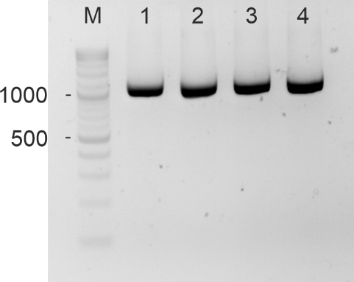

Figure S1 | A representative agarose gel showing amplification of a 1200 nt fragment of Grin2b mRNA. The mRNA was obtained from hippocampal tissue of Grin2b^{+/Δ} female mice at 4 months of age. The forward primer was located in exon 7 and the reverse primer in exon 13 (see Table S1 for sequences). For direct Sanger sequencing of the PCR amplicons, an additional forward primer located in exon 12 was used (see Table S1). M denotes the molecular weight marker; lanes 1–4 represent samples from four individual mice.

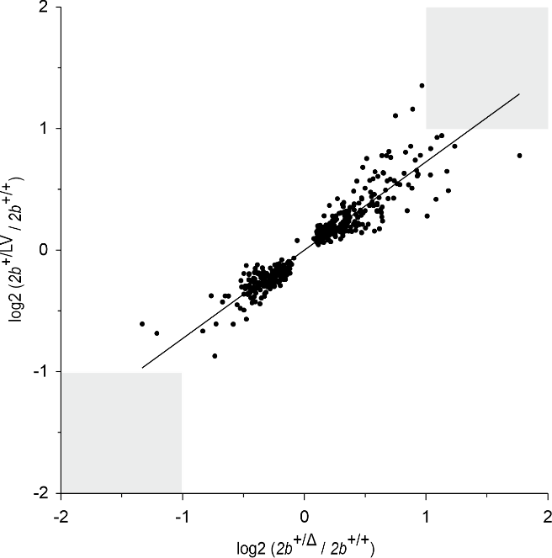
Figure S2 | Correlation between protein expression changes in hippocampal tissue from 4-month-old Grin2b^{+/Δ} and Grin2b^{+/L825V} mice. The scatter plot shows log₂-fold changes for Grin2b⁺^{/Δ} / Grin2b⁺/⁺ and Grin2b⁺^{/L825V} / Grin2b⁺/⁺ mice (Pearson r = 0.939, p < 0.001; n = 461). No proteins exhibited a ≥2-fold increase or decrease in both genotypes, as indicated by the grey rectangles.

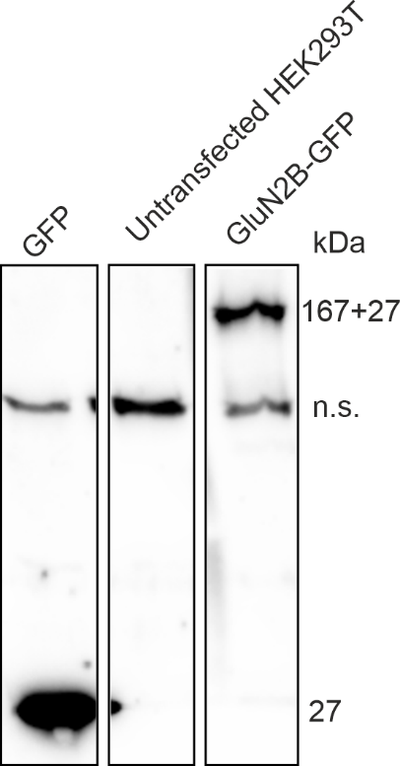

Figure S3 | Western blot analysis of HEK293T cells transfected with GFP or GluN2B-GFP subunit. Note the non-specific band at ~120 kDa (n.s.).

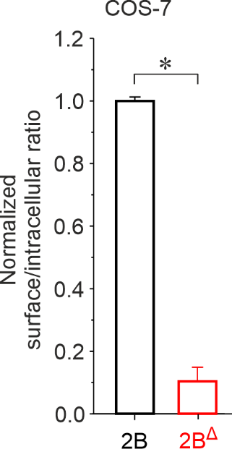

Figure S4 | GluN2B^{Δ} subunit disrupts NMDAR surface expression in COS-7 cells. COS˗7 cells were co-transfected with GluN1 and wild-type GluN2B-GFP (2B) or mutant GluN2B^{Δ}-GFP (2B^{Δ}) subunits. The graph shows the relative surface expression of GluN1/GFP-GluN2B and GluN1/GluN2B^{Δ}-GFP receptors, quantified using a colorimetric assay. Data are presented as mean ± SEM. Asterisk (*) indicates a statistically significant difference (Student's t-test; n = 4 independent experiments, with the relative surface expression measured in quadruplicate per experiment).
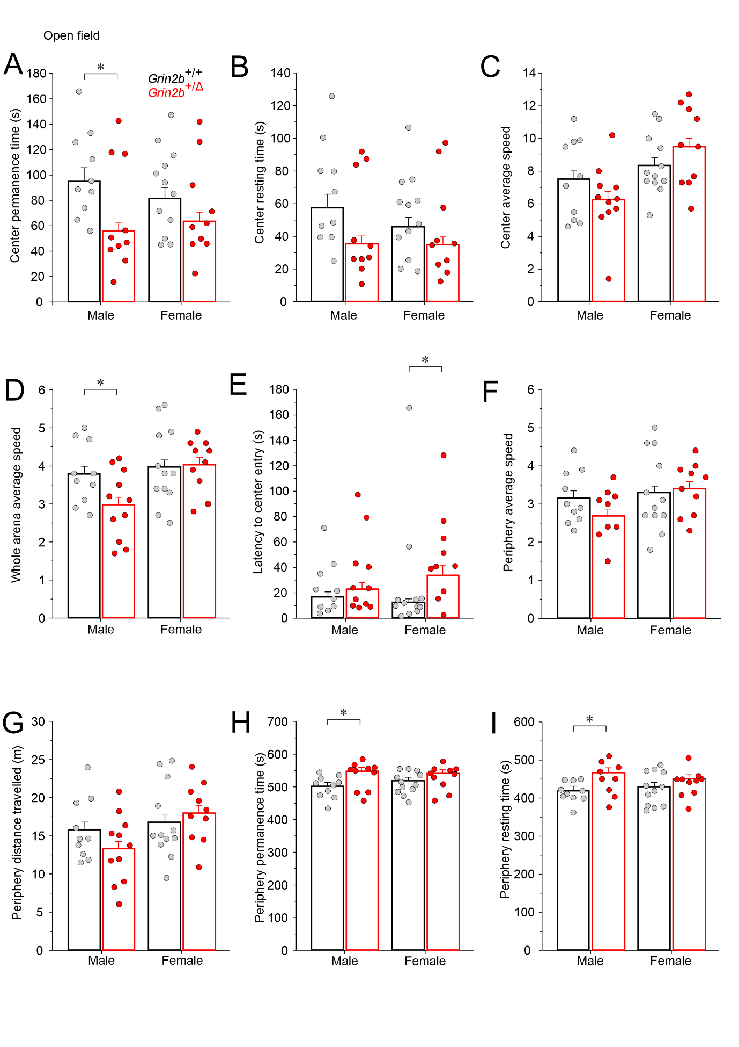
Figure S5 | Grin2b^{+/Δ} mice display hypoactivity and increased anxiety. Supplementary data from the open field test. (A–I) Center permanence time, center resting time, center average speed, whole arena average speed, latency to first center entry, periphery average speed, periphery distance traveled, periphery permanence time, and periphery resting time were measured in male and female Grin2b^{+/Δ} and Grin2b^{+/+} mice. Data are presented as mean ± SEM. Number of animals Grin2b^{+/+}/Grin2b^{+/Δ}: n = 10/11 males and n = 12/10 females. Asterisks (*) indicate significant genotype differences (Student’s t-test). The numerical data underlying this figure are shown in Table S7.

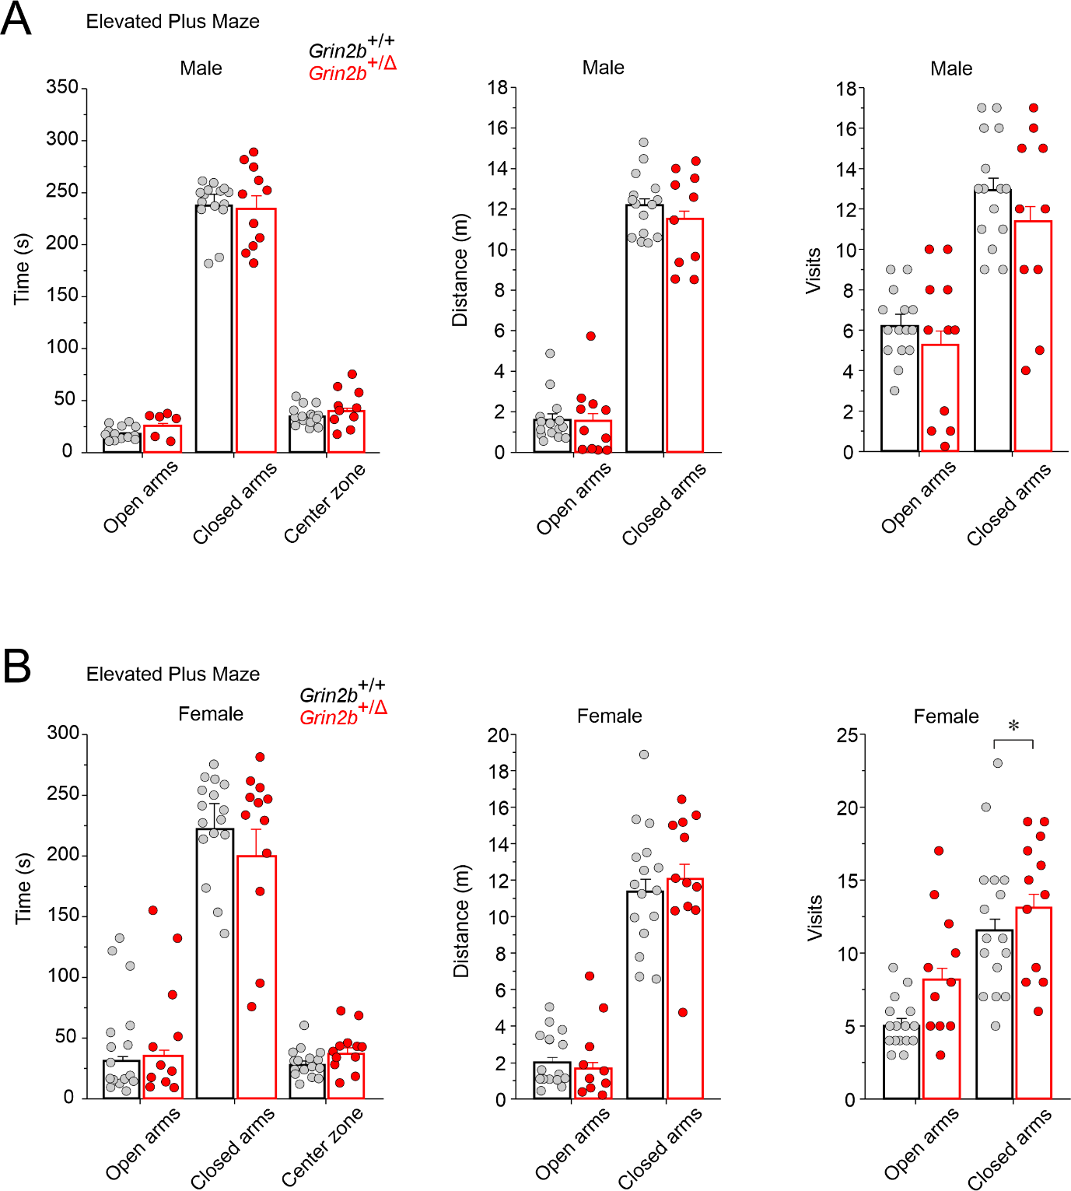

Figure S6 | Elevated plus maze analysis of anxiety-like behavior in Grin2b^{+/Δ} mice. Bar graphs show measures of anxiety for male (A) and female (B) Grin2b^{+/Δ} mice, including time spent, distance traveled, and number of entries into the closed and open arms. Data are presented as mean ± SEM and were analyzed by ANOVA followed by post hoc LSD test. Number of animals Grin2b^{+/+}/Grin2b^{+/Δ}: n = 15/11 males and n = 16/12 females. Asterisk (*) indicates a significant genotype difference. The numerical data underlying this figure are shown in Table S7.

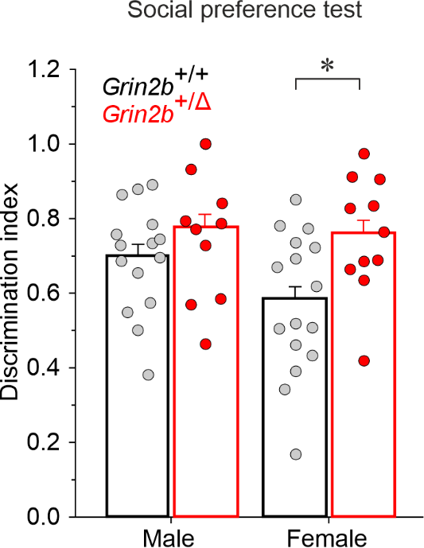

Figure S7 | Social behavior in Grin2b^{+/Δ} mice. Social preference was assessed, with the discrimination index representing the time spent exploring a juvenile target relative to an object. Data are presented as mean ± SEM and were analyzed by Student’s t-test. Number of animals Grin2b^{+/+}/Grin2b^{+/Δ}: 16/11 males, 16/11 females. Asterisk (*) indicates a significant genotype difference. The numerical data underlying this figure are shown in Table S7.

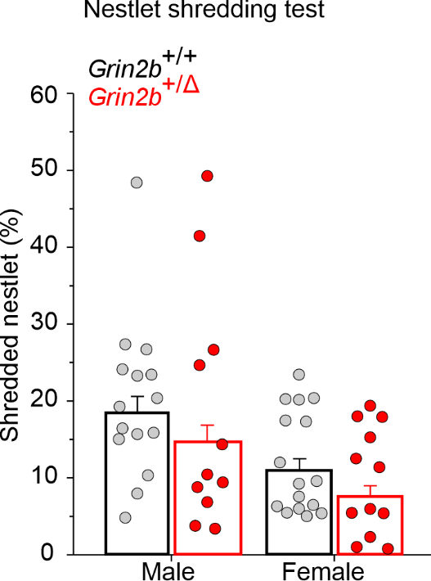

Figure S8 | Repetitive behavior in Grin2b^{+/Δ} mice. Performance in the nestlet shredding test, measured as the % weight of unused nesting material (initial weight = 10 g). Data are presented as mean ± SEM and were analyzed by Student's t-test. Number of animals Grin2b^{+/+}/Grin2b^{+/Δ}: n = 15/11 males, n = 16/12 females. The numerical data underlying this figure are provided in Table S7.

