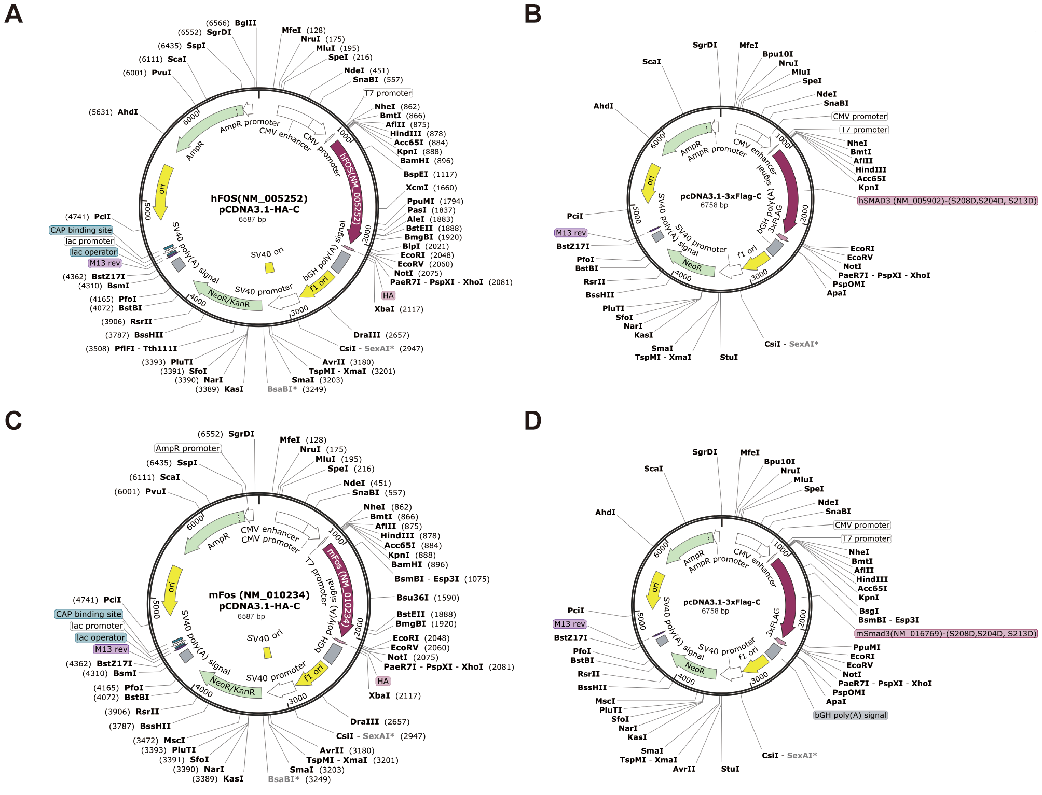
Fig.S1 Schematic diagrams of plasmid constructs.
(A) Human FOS overexpression plasmid. (B) Human p-Smad3 overexpression plasmid. (C) Mouse Fos overexpression plasmid. (D) Mouse p-Smad3 overexpression plasmid.

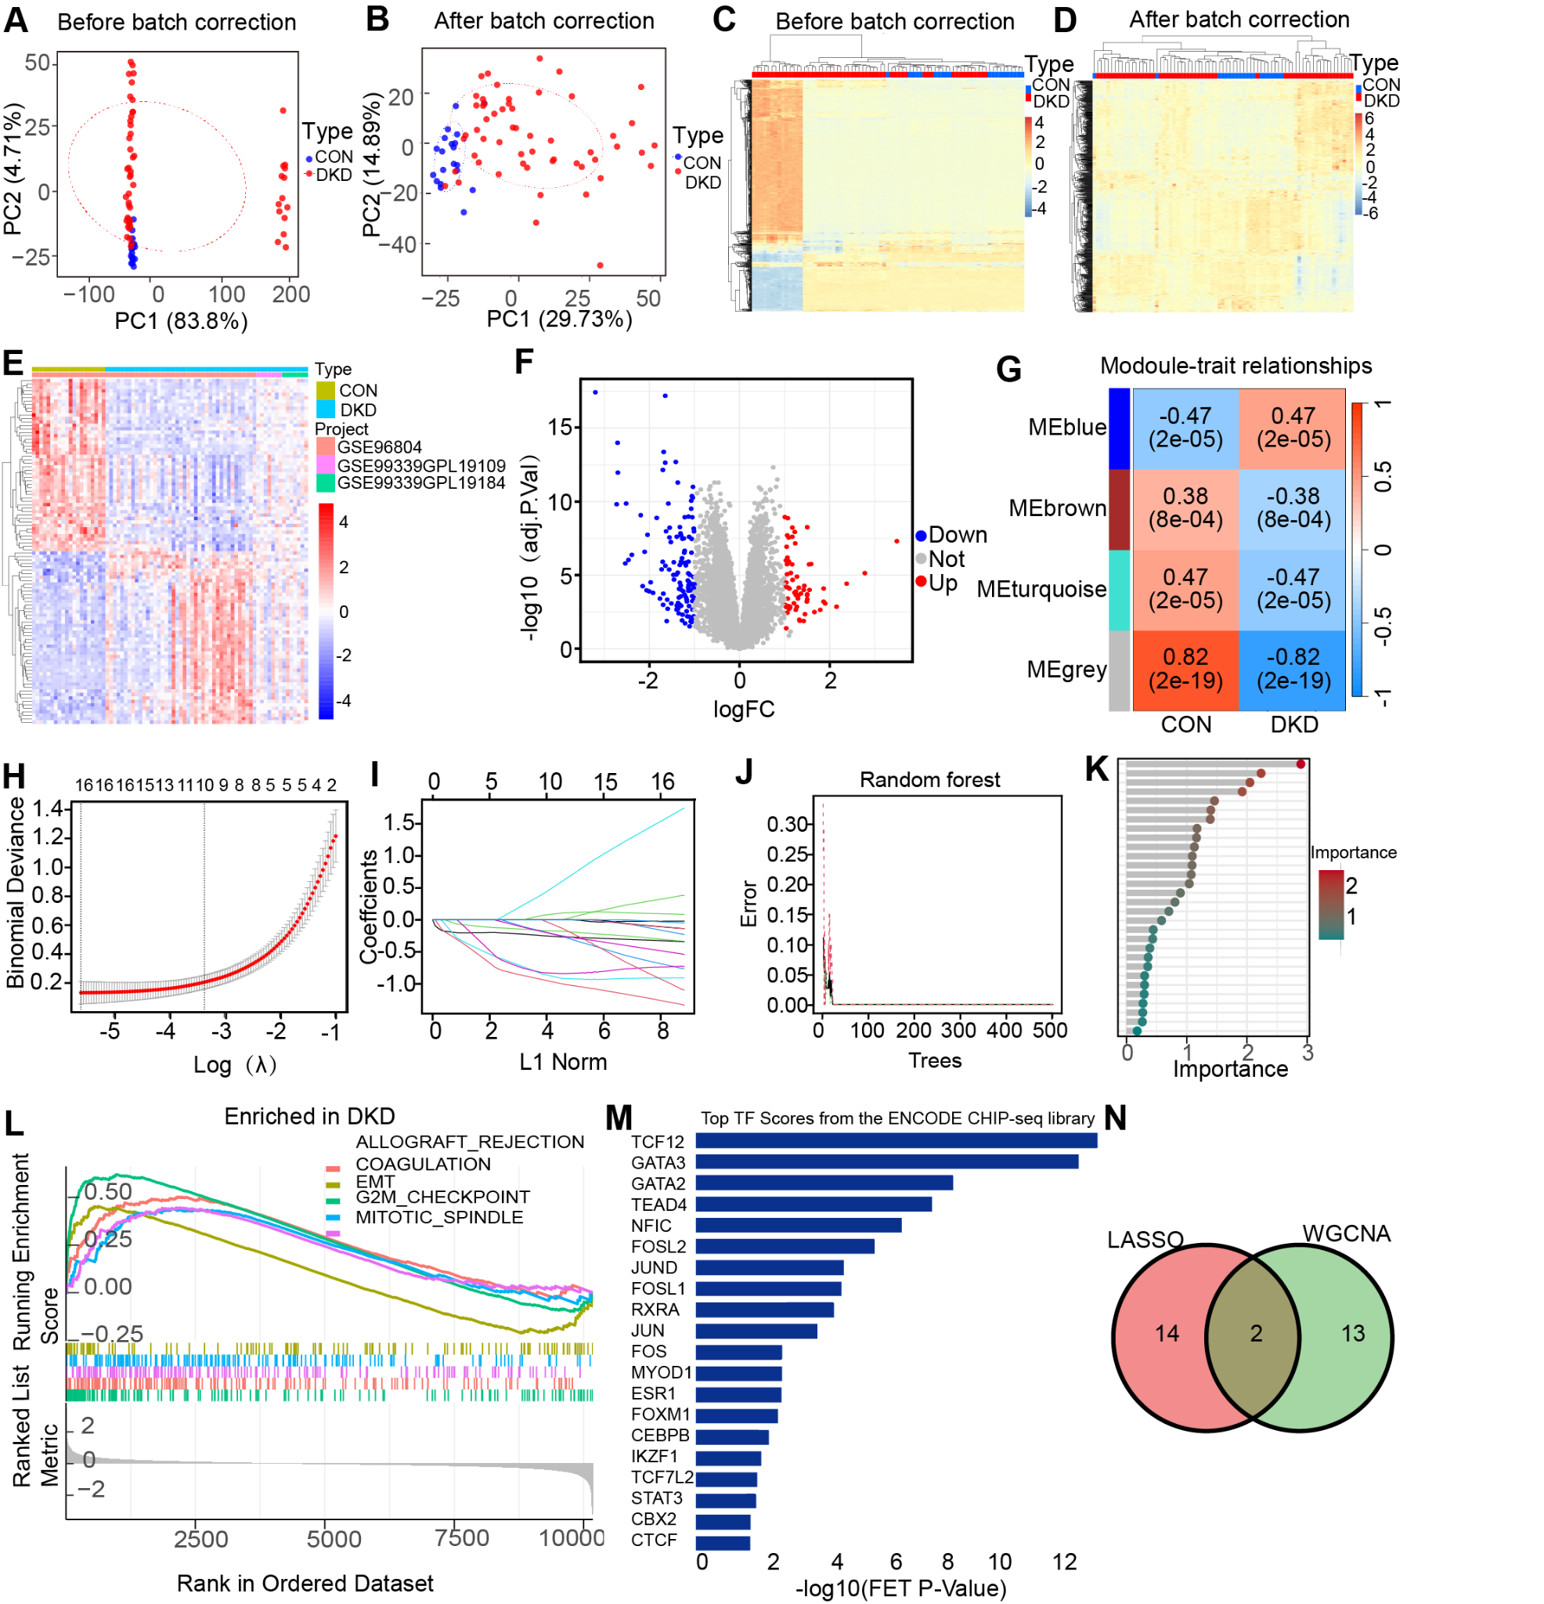
Fig.S2 The identification of related genes in DKD.
(A-B) PCA plot before (A) and after (B) batch correction showing sample distribution colored by experimental group (CON, blue; DKD, red). (C-D) Hierarchical clustering heatmap of samples before
(C) and after (D) batch correction using the top 1000 most variable genes. (E, F) Heatmap and volcano plot of the DEGs. (G)Heatmap displaying correlations between different modules. (H-K) Feature selection through (H, I) LASSO regression analysis. (J, K) RF algorithm. (L) Gene Set Enrichment Analysis. (M) Transcription factor enrichment analysis. (N) Venn plot exhibiting DEGs among WGCNA and LASSO.

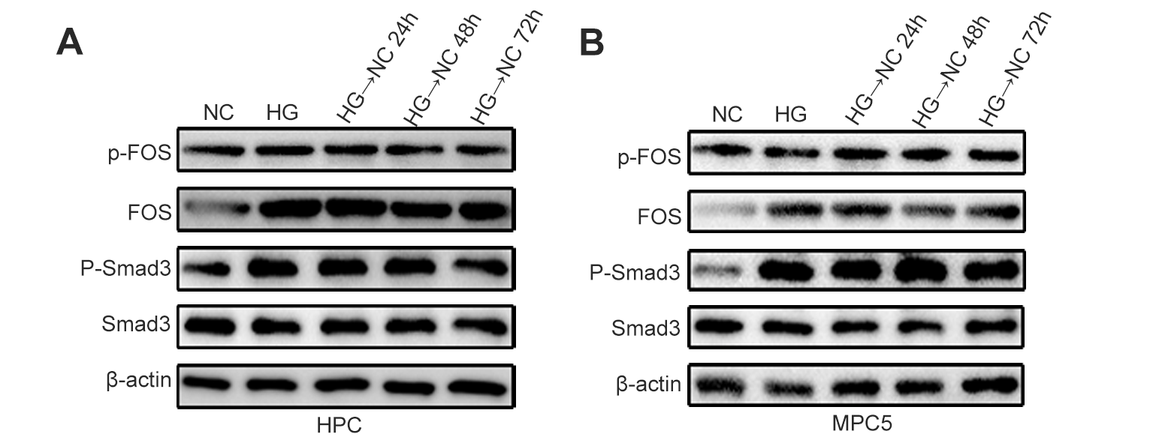

Fig.S3 Protein expression of FOS and Smad3 in HPC and MPC5 podocytes under different treatments.
Podocyte cell lines (HPC and MPC5) were treated under the following conditions: Normal Glucose (NC), High Glucose (HG), and HG followed by recovery in NC for 24, 48, or 72 hours (HG→NC 24h, HG→NC 48h, HG→NC 72h). Western blot analysis was performed to assess the protein levels of p-FOS, FOS, p-Smad3, and Smad3.

