Supplemental information

MicroRNA-29 acutely regulates Memory Stability, Expression Synaptic Genes, and DNA Methylation in the Mouse Adult Hippocampus

Aurelia Viglione^{1,2}, Chiara Giannuzzi¹, Elena Putignano³, Raffaele Mazziotti^{3,4,5}, Sara Bagnoli¹, Paola Tognini⁷, Alessandro Cellerino^{1,6} and Tommaso Pizzorusso^{1,3*}

1 BIO@SNS lab, Scuola Normale Superiore, Pisa, Italy;
2 Center for Behavioral Sciences and Mental Health, Istituto Superiore di Sanità, Rome, Italy;
3 Institute of Neuroscience, National Research Council, Pisa, Italy;
4 Department of Developmental Neuroscience, IRCCS Stella Maris Foundation, Pisa, Italy;
5 Department of Neuroscience, Psychology, Pharmacology, and Child Health, University of Florence, Florence, Italy;
6 Leibniz Institute on Aging – Fritz Lipmann Institute (FLI) Jena Germany
7Health Science Interdisciplinary Center, Scuola Superiore Sant'Anna, Pisa, Italy

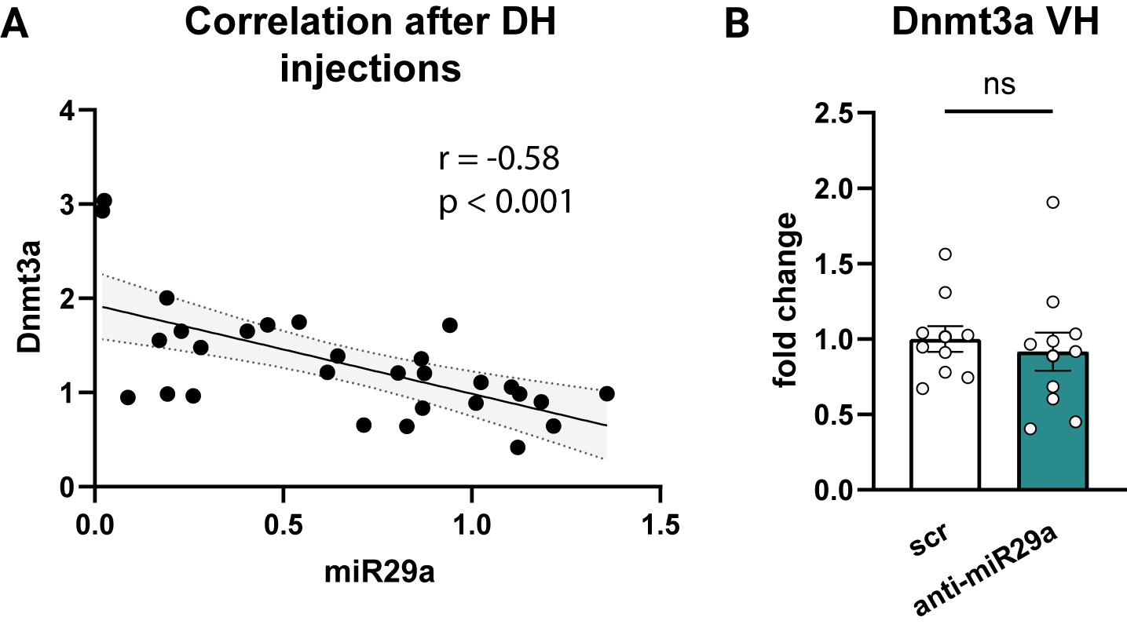

Supplementary Figure 1. Specificity of anti-miR-29a injection. (A) Spearman’s correlation between Dnmt3a and miR-29a levels after the LNA injection. scr: N = 16, anti-miR29a N = 13. (B) LNA injection in the dorsal hippocampus did not affect the expression of Dnmt3a in the ventral hippocampus confirming the specificity of the injection site within the dorsal hippocampus (Mann-Whitney U test: U = 43, p = 0.4359). scr: N = 10, anti-miR29a N = 11. DH = Dorsal Hippocampus; VH = Ventral Hippocampus.

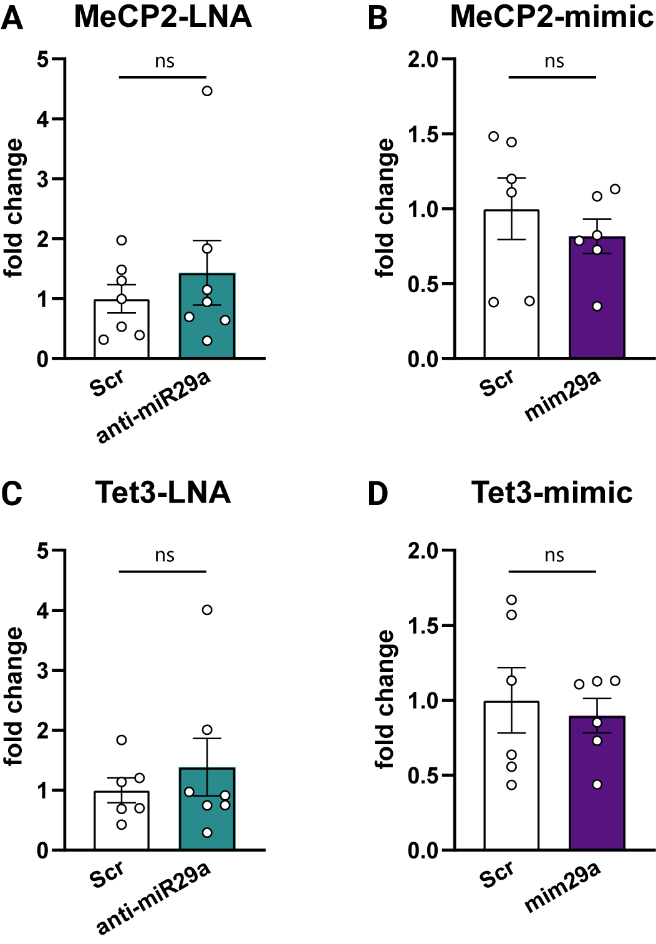

Supplementary Figure 2. Effects of miR-29a modulation on MeCP2 and Tet3 expressions in the dorsal hippocampus. (A) MeCP2 expression levels following anti-miR-29a LNA injection compared to scr control (Mann–Whitney U test: U = 23, p = 0.9015; scr N = 7, anti-miR-29a N = 7). One sample from the anti-miR-29a group was excluded as a significant outlier. (B) MeCP2 expression following miR-29a mimic administration compared to scr control (Mann–Whitney U test: U = 11, p = 0.3095; scr n = 6, miR-29a mimic n = 6). (C) Tet3 expression after anti-miR-29a LNA treatment compared to scr control (Mann–Whitney U test: U = 18, p = 0.7308; scr n = 7, anti-miR-29a n = 7). One sample from the anti-miR-29a group was excluded as a significant outlier. (D) Tet3 expression following miR-29a mimic administration compared to scr control (Mann–Whitney U test: U = 16, p = 0.8182; scr n = 6, miR-29a mimic n = 6). All analyses were conducted on samples remaining after the primary experimental analyses.

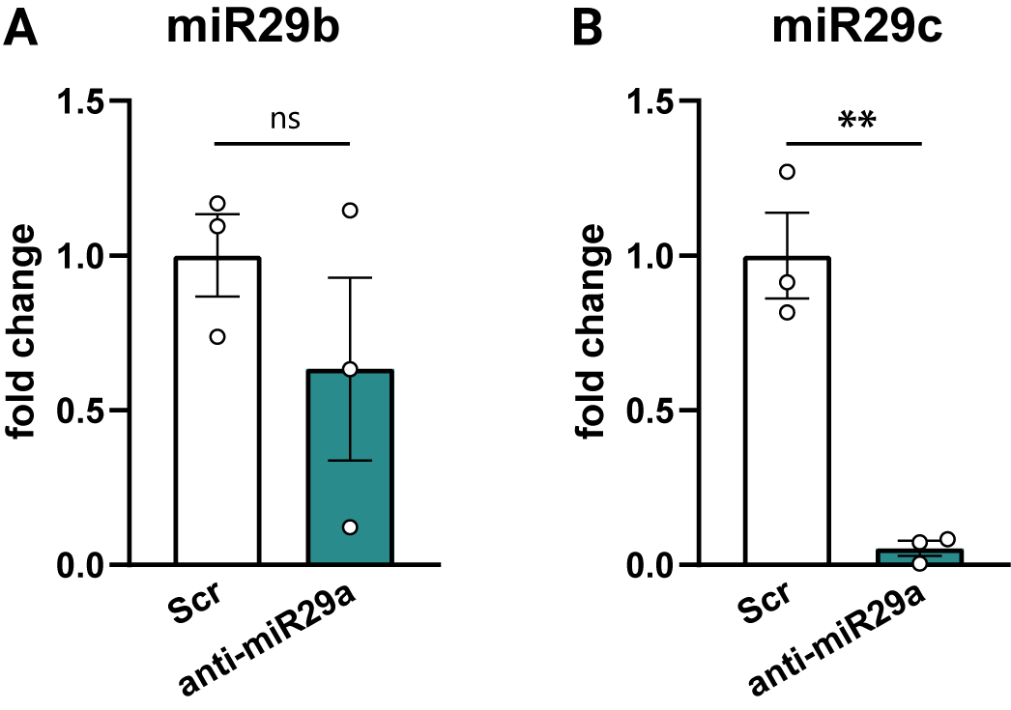

Supplementary Figure 3. Effects of anti-miR-29a treatment on miR-29b and miR-29c expression. (A) miR-29b expression was not significantly affected by anti-miR-29a treatment (scr: N = 3; anti-miR-29a: N = 3; unpaired t-test: p = 0.321; Mann–Whitney U test: U = 2, p = 0.40). (B) miR-29c expression was significantly reduced following anti-miR-29a treatment (scr: N = 3; anti-miR-29a: N = 3; unpaired t-test: p < 0.01; Mann–Whitney U test: U = 0, p = 0.10).

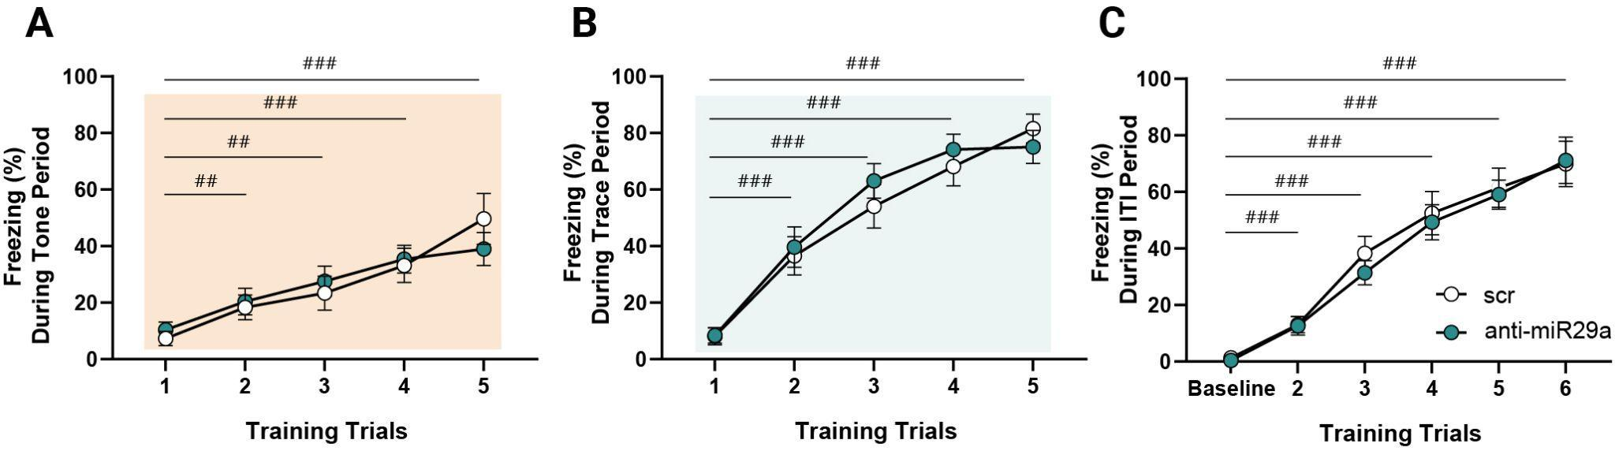

Supplementary Figure 4. Learning curves during TFC training. Both anti-miR29a and scr treated mice showed the same learning profile during conditioning for the different TCF training phases. (A) Freezing during Tone presentation (Two-way RM ANOVA, main effect of treatment F(1,19) = 8.73x10-4, p = 0.98; main effect of trials F(2.61,49.71) = 23.77, p < 0.0001; trials × treatment interaction F(4,76) = 1.21,p = 0.31). (B) Freezing during Trace period (Two-way RM ANOVA , main effect of treatment F(1,19)=0.22, p = 0.63; main effect of trials F(3.43, 65.28) = 58.40, p < 0.0001; trials × treatment interaction F(4,76) = 0.64,p = 0.63). (C) Freezing during intertrial interval (ITI, Two-way RM ANOVA, main effect of treatment F(1,19) = 0.14, p = 0.70; main effect of trials F(2.36,44.86) = 78.13, p < 0.0001; trials × treatment interaction F(5, 95) = 0.21, p = 0.95). scr: N=10, anti-miR29a N=11; Tukey’s multiple comparison vs trial 1 or baseline, ##P-value < 0.01, ###P-value < 0.001.

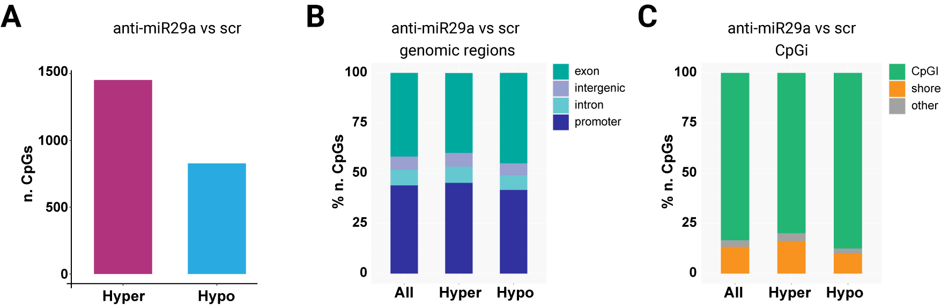

Supplementary Figure 5. DNA methylation changes in the dorsal hippocampus after miR-29a downregulation in a different cohort of mice. (A) The number of hyper- and hypo- methylated CpGs. We found 2,279 differentially methylated CpGs (DMCs), with a prevalence of hypermethylation over hypomethylation (1,452 CpGs vs 827 CpGs, p < 10-16, Fisher’s exact test) between anti29a and scr hippocampal treated samples. (B-C) DMCs distribution across chromosomes. DMCs exhibited an even distribution across chromosomes and were enriched in CpG island (CpGi).

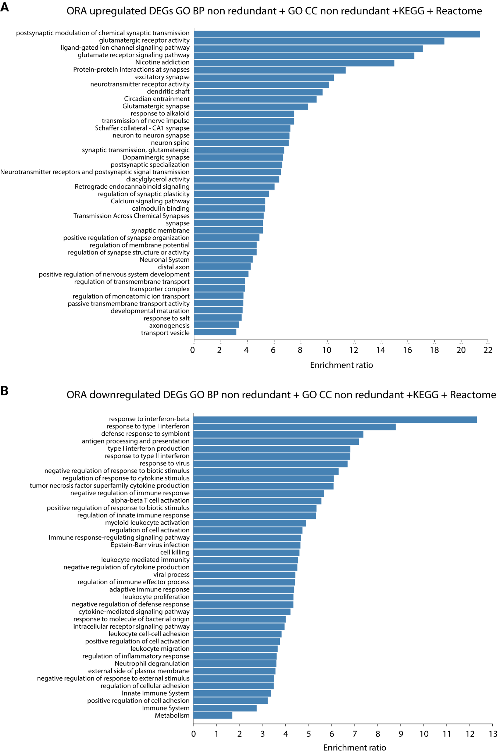

Supplementary Figure 6. Functional enrichment analysis of differentially expressed genes (DEGs). Over-representation analysis (ORA) was performed on upregulated and downregulated DEGs using non-redundant terms from Gene Ontology Biological Process (GO BP), Gene Ontology Cellular Component (GO CC), KEGG, and Reactome databases. Bar plots show the top enriched categories ranked by enrichment ratio. (A) Enriched pathways among upregulated DEGs, predominantly associated with neuronal and synaptic functions, including chemical synaptic transmission, glutamatergic signaling, synapse organization, and neuronal system processes. (B) Enriched pathways among downregulated DEGs, mainly related to immune and inflammatory responses, including response to interferon-β, defense response to virus, antigen processing and presentation, cytokine signaling, and leukocyte-mediated immunity.

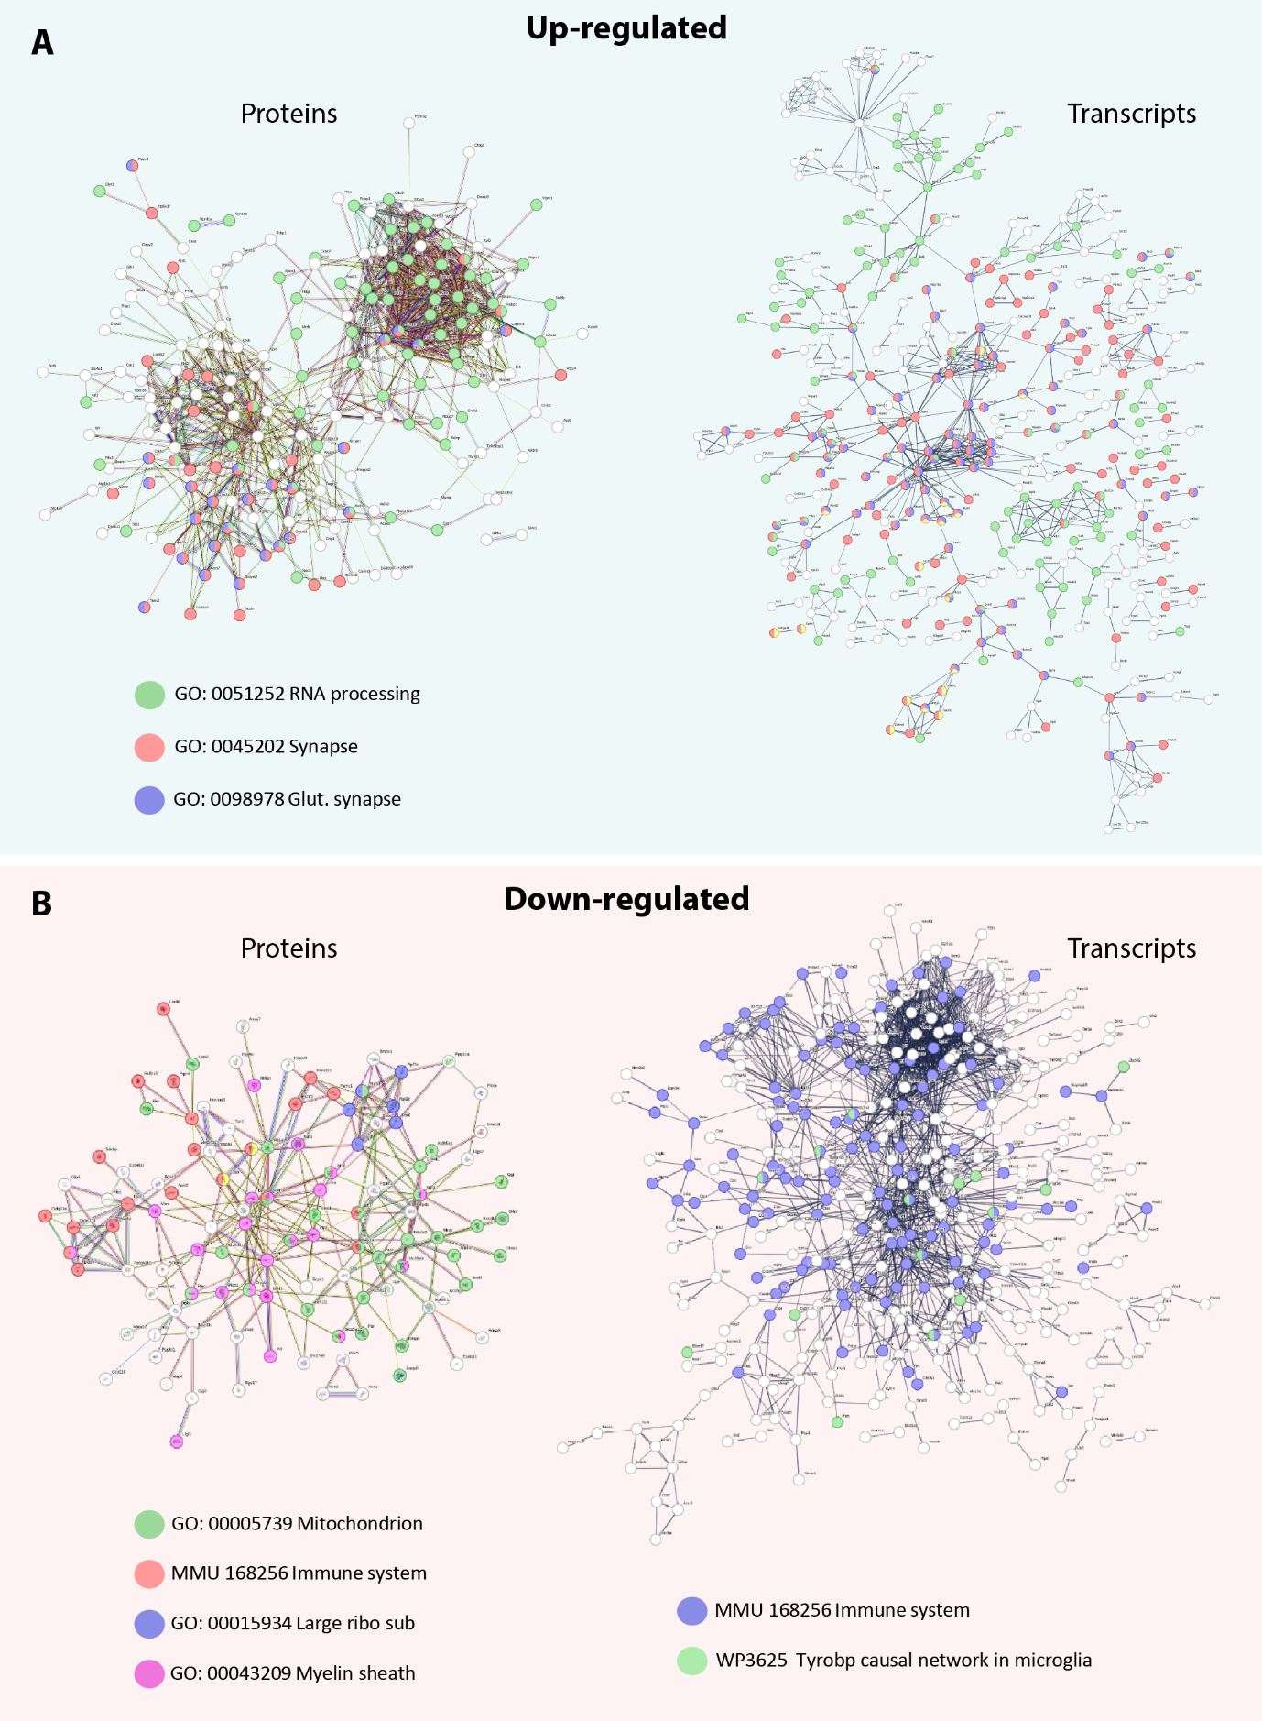

Supplementary Figure 7. Functional interaction networks of differentially expressed transcripts and proteins following miR-29 downregulation. (A) Networks of significantly upregulated proteins (left) and transcripts (right). (B) Networks of significantly downregulated proteins (left) and transcripts (right). Nodes represent genes or proteins, and edges indicate functional or physical interactions. Colored nodes correspond to genes/proteins annotated in Gene Ontology (GO) or Reactome with the selected terms, codes linking terms to color are indicated in the legends. White nodes represent genes/proteins which are part of the interaction network but are not annotated with any of the highlighted enriched terms.. Network analysis was performed using STRING.

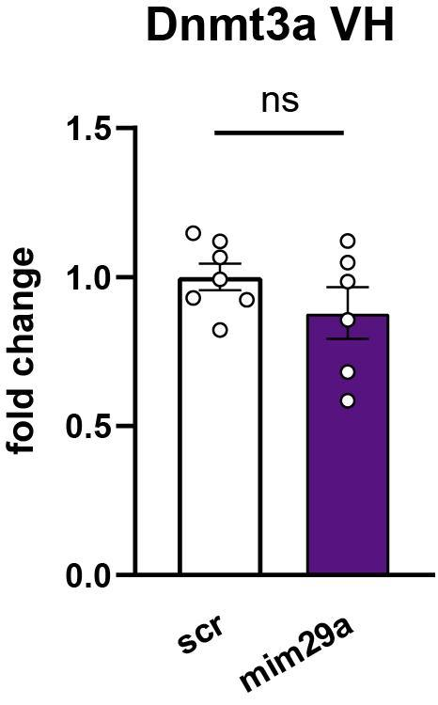

Supplementary Figure 8. Quantification of Dnmt3a levels in the ventral hippocampus of mim29a and scr treated mice. (A) mimic 29a injection in the dorsal hippocampus did not affect the expression of Dnmt3a in the ventral hippocampus confirming the specificity of the injection site within the dorsal hippocampus (Mann-Whitney U test: U =,14 p = 0.37). scr: N = 7, mim29a N = 6. DH = Dorsal Hippocampus; VH = Ventral Hippocampus.

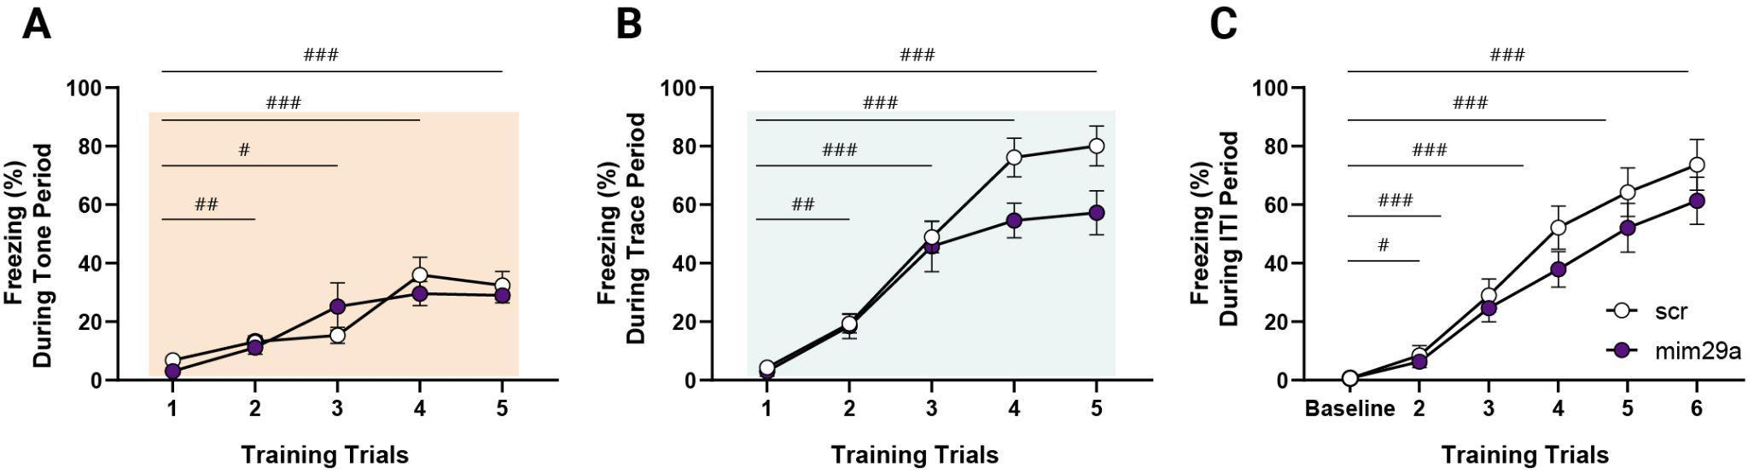

Supplementary Figure 9. Learning curves during TFC training. Both mim29a and scr treated mice showed the same learning profile during conditioning for all the different TCF training intervals. (A) Freezing during Tone presentation (Two-way RM ANOVA, main effect of treatment F(1,14) = 0.11, p = 0.75; main effect of trials F(2.52,35.24) = 21.48, p < 0.0001; trials × treatment interaction F(4,56) = 1.53, p = 0.20). (B) Freezing during Trace period (Two-way RM ANOVA, main effect of treatment F(1,14) = 4.18, p = 0.06; main effect of trials F(3.79,39.14) = 64.76, p < 0.0001; trials × treatment interaction F(4,56) = 2.5, p = 0.053). (C) Freezing during intertrial interval (ITI, Two-way RM ANOVA, main effect of treatment F(1,14) = 0.58, p = 0.23; main effect of trials F(2.64,36.99) = 66.44, p < 0.0001; trials × treatment interaction F(5,70) = 0.83, p = 0.53). scr: N = 10, anti-miR29a N = 11; Tukey’s multiple comparison vs. trial 1 or baseline, # P-value < 0.05, ## P-value < 0.01, ### P-value < 0.001.

Supplementary Table 1: Statistical analysis of sex differences across behavioral and molecular outcomes in anti-miR29a and miR29a mimic experiments.

LNA-anti-miR29a miR29a mimic
