SUPPLEMENTARY MATERIAL

Additional information on Supplementary Movies is detailed below:

Movie S1. (Related to Fig. 3E). Dynamics of FM1-43 dye uptake in 67NR cells following localised plasma membrane injury. 67NR cell was exposed to localised plasma membrane injury via laser ablation under physiological conditions in the presence of FM1-43 dye.

Movie S2. (Related to Fig. 3E). Dynamics of FM1-43 dye uptake in 4T1 cells following localised plasma membrane injury. 4T1 cell was exposed to localised plasma membrane injury via laser ablation under physiological conditions in the presence of FM1-43 dye.

Movie S3. (Related to Fig. 5A). Dynamics of ANXA1 and ANXA2 recruitment to injury site following plasma membrane injury in 67NR cells. 67NR cells were transfected with ANXA1-GFP and ANXA2-RFP and exposed to localised plasma membrane injury via laser ablation.

Movie S4. (Related to Fig. 5B). Dynamics of ANXA1 and ANXA2 recruitment to injury site following plasma membrane injury in 4T1 cells. 4T1 cells were transfected with ANXA1-GFP and ANXA2-RFP and exposed to localised plasma membrane injury via laser ablation.

Movie S5. (Related to Fig. 7H). Dynamics of FM1-43 dye uptake in MDA-MB-231 cells following localised plasma membrane injury. MDA-MB-231 cell was exposed to localised plasma membrane injury via laser ablation under physiological conditions in the presence of FM1-43 dye.

Movie S6. (Related to Fig. 7H). Dynamics of FM1-43 dye uptake in MDA-MB-231Br7 cells following localised plasma membrane injury. MDA-MB-231Br7 cell was exposed to localised plasma membrane injury via laser ablation under physiological conditions in the presence of FM1-43 dye.
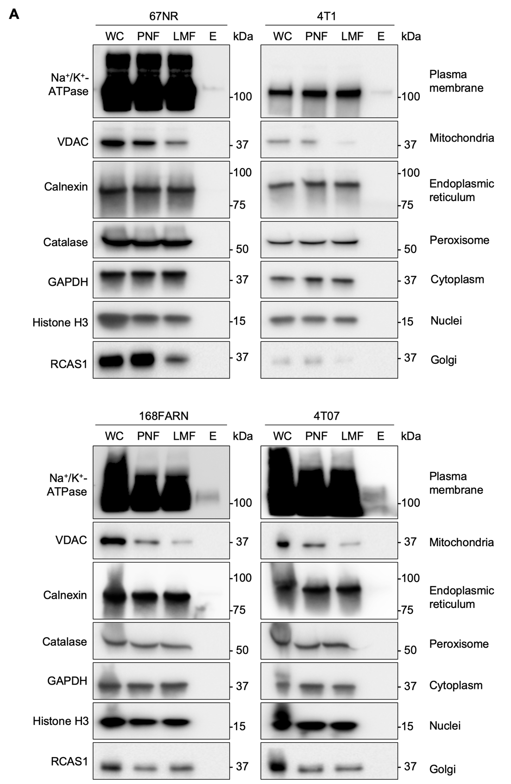
Figure S1. (Related to Fig. 2). Western blot analysis of samples used for quantitative mass spectrometry-based shotgun lipidomic analysis. Cellular fractions from the plasma membrane purification process were collected and analysed. Bands shown were detected using antibodies against the different cellular organelles: plasma membrane (Na⁺/K⁺-ATPase), mitochondria (VDAC), endoplasmic reticulum (Calnexin), peroxisome (Catalase), cytoplasm (GAPDH), nuclei (Histone H3), Golgi apparatus (RCAS1). (A) 67NR and 4T1 cells. (B) 168FARN and 4T07 cells. Abbreviations: whole cell fraction (WC), post-nuclear fraction (PNF), light membrane fraction (LMF), elute (E).
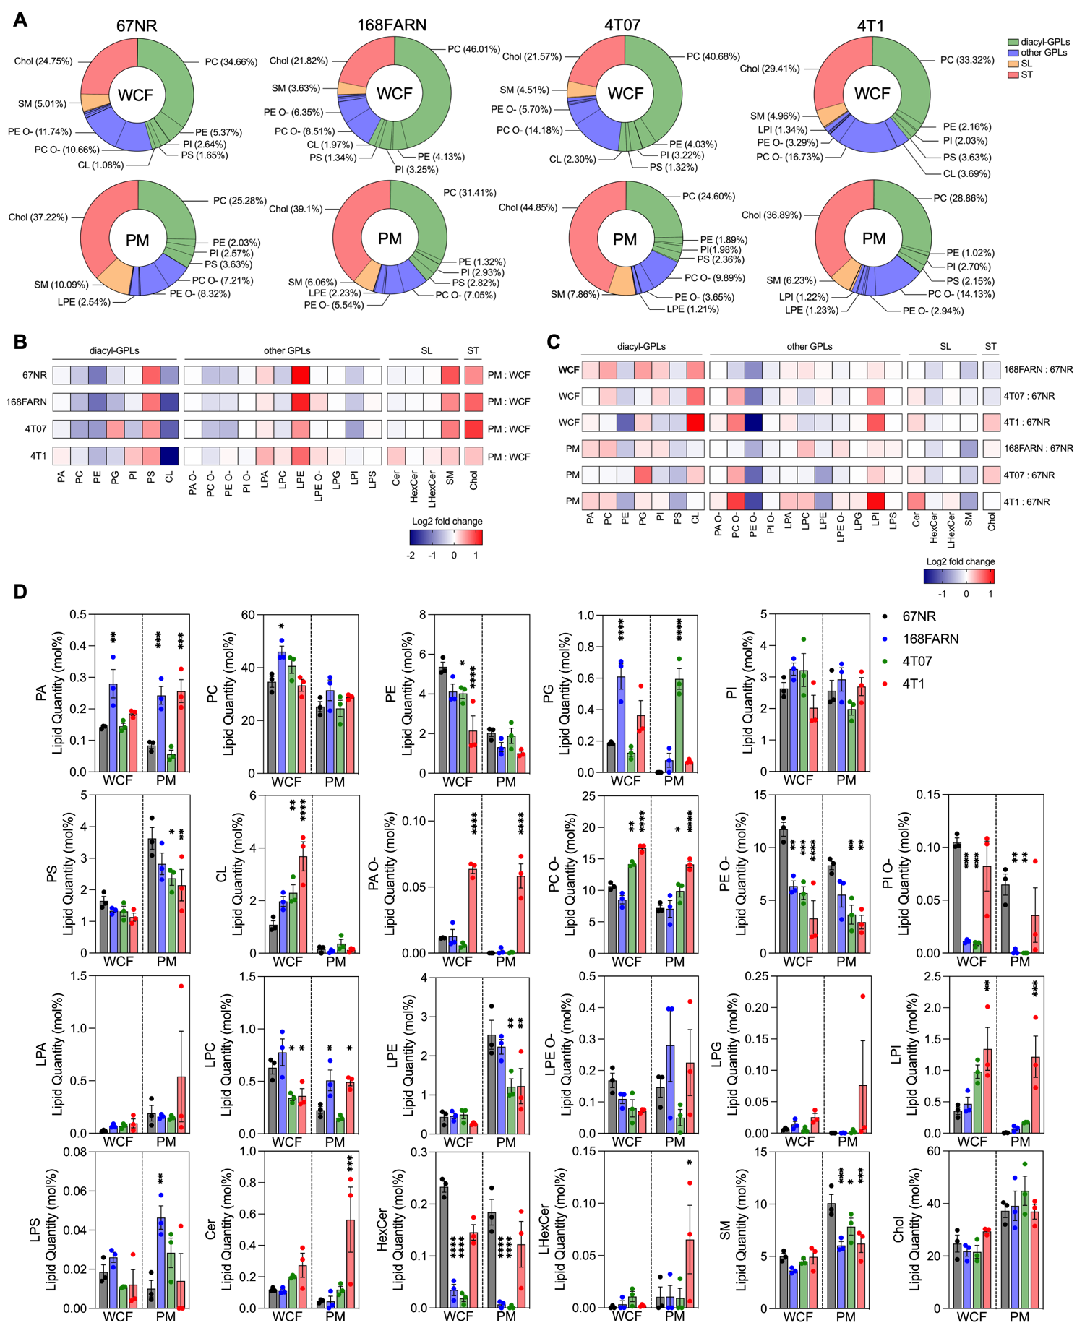
Figure S2. (Related to Fig. 2 and Fig. S1). Major lipid classes of the different cell fractions from 67NR, 168FARN, 4T07 and 4T1 cells expressed endogenously. (A) Heatmap showing mol% of all detected major lipid classes in the different cellular fractions obtained from 67NR, 168FARN, 4T07 and 4T1 cells. (B) Endogenous lipid quantity (mol%) of all detected major lipid classes in the different cellular fractions of 67NR, 168FARN, 4T07 and 4T1 cells. Data represented as the mean ± S.E.M. for three independent experiments. Abbreviations: whole cell fraction (WCF), plasma membrane (PM), diacylglycerol (DAG), phosphatidic acid (PA), phosphatidylcholine (PC), phosphatidylethanolamine (PE), phosphatidylglycerol (PG), phosphatidylinositol (PI), phosphatidylserine (PS), cardiolipin (CL), alkyl-PA (PA O-), alkyl-PC (PC O-), alkyl-PE (PE O-), alkyl-PI (PI O-), lysoPA (LPA), lysoPC (LPC), lysoPE (LPE), alkyl-LPE (LPE O-), lysoPG (LPG), lysoPI (LPI), lysoPS (LPS), ceramide (Cer), hexosylceramide (HexCer), lysoHexCer (LHexCer), sphingomyelin (SM), cholesterol (Chol).
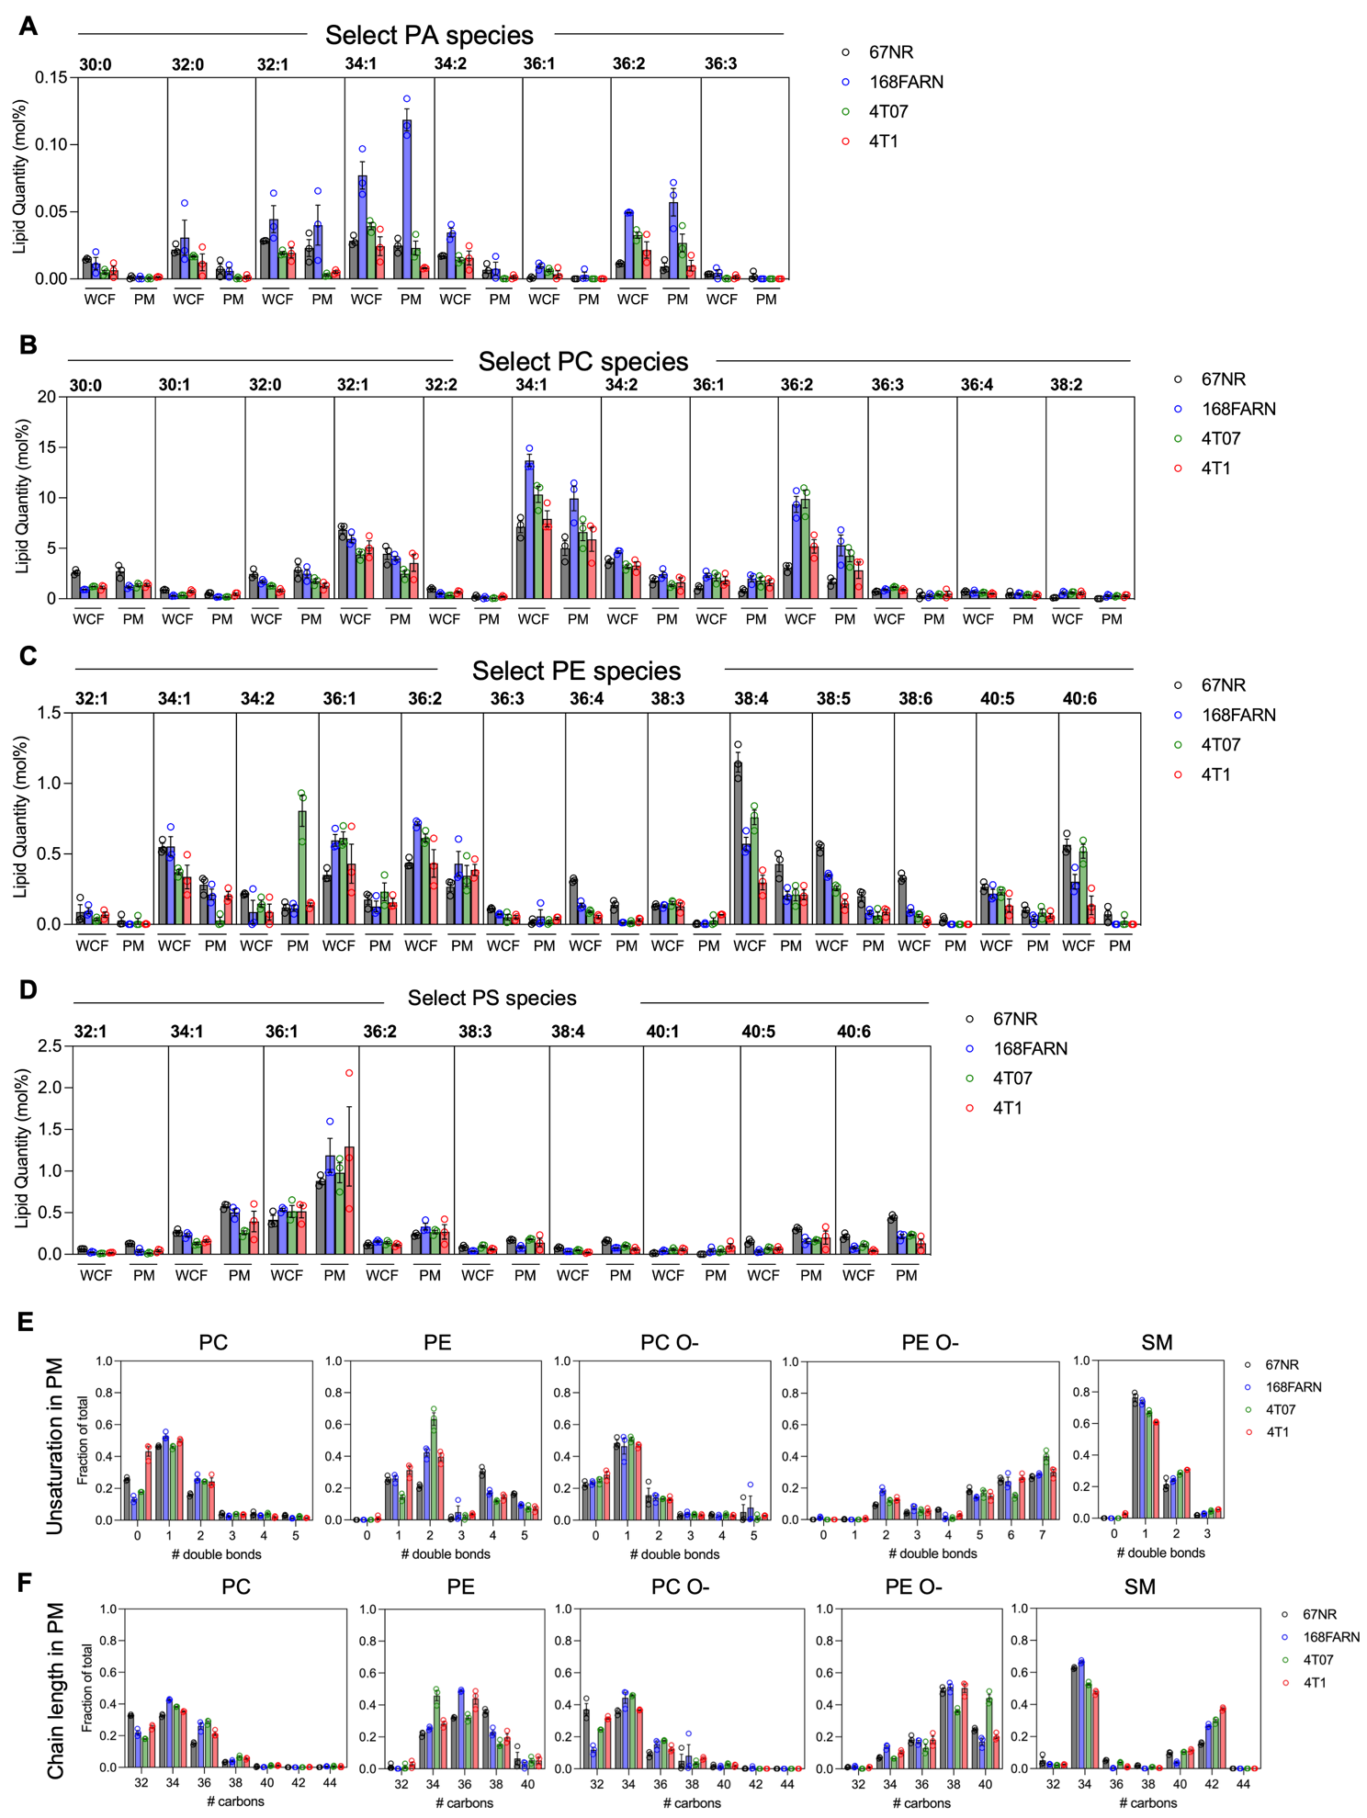
Figure S3. (Related to Fig. 2). Selected lipid species from major lipid classes expressed endogenously in 67NR, 168FARN, 4T07 and 4T1 cells. Lipid species with the highest abundance (mol%) are shown for (A) diacylglycerol (DAG), (B) phosphatidic acid (PA), (C) phosphatidylcholine (PC), (D) phosphatidylethanolamine and (E) phosphatidylserine (PS). Data represented as the mean ± S.E.M. for three independent experiments.
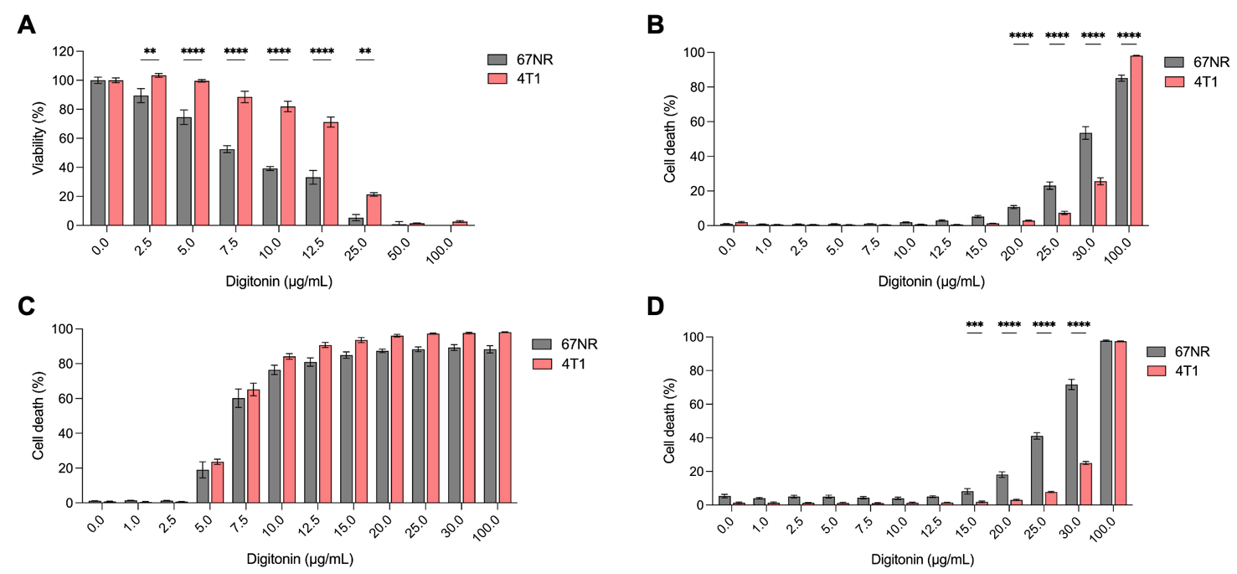
Figure S4. (Related to Fig. 3 and Fig. 4). Full range of digitonin concentrations treated in 67NR and 4T1 cells. (A) Viability of 67NR and 4T1 cells measured using MTS assay, when treated with the indicated digitonin concentrations at 37°C for 30 min under physiological conditions. (B) Percentage cell death of 67NR and 4T1 cells measured using PI/Hoechst cell death assay, when treated with the indicated digitonin concentrations at 37°C for 30 min under physiological conditions. (C) Percentage cell death of 67NR and 4T1 cells measured using PI/Hoechst cell death assay, when treated with the indicated digitonin concentrations at 37°C for 30 min under calcium-chelating conditions with 10 mM EGTA. (D) Percentage cell death of 67NR and 4T1 cells measured using PI/Hoechst cell death assay, when treated with the indicated digitonin concentrations at 37°C for 30 min under calcium-chelating conditions with 10 mM EGTA and 50 mM CaCl₂. Data represented as the mean ± S.E.M. for three independent experiments. P-values based on two-way ANOVA followed by Šídák’s post-hoc test: **P ≤ 0.01, ***P ≤ 0.005, ****P ≤ 0.0001.
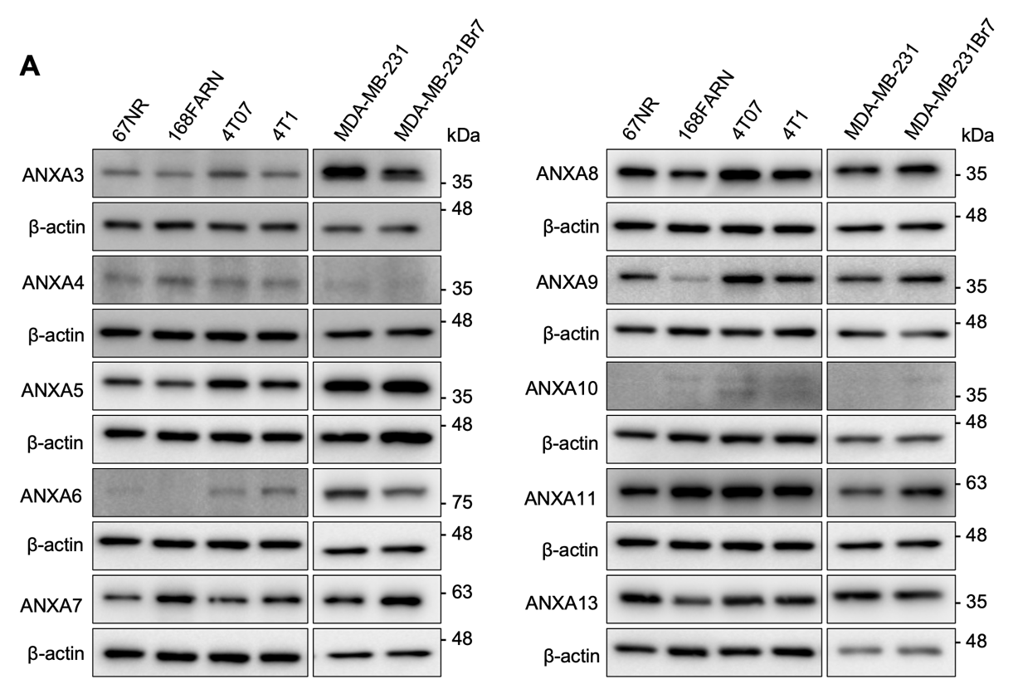
Figure S5. (Related to Fig. 4 and Fig. 7). Western blot analysis of endogenous annexin protein levels in 67NR, 168FARN, 4T07, 4T1, MDA-MB-231, MDA-MB-231Br7 cells. The blots show bands detected with monoclonal antibodies against ANXA3, ANXA4, ANXA5, ANXA6, ANXA7, ANXA8, ANXA9, ANXA10, ANXA11, ANXA13 and β-actin in whole cell lysates of the indicated cell lines. Representative blots of three biological replicates shown.
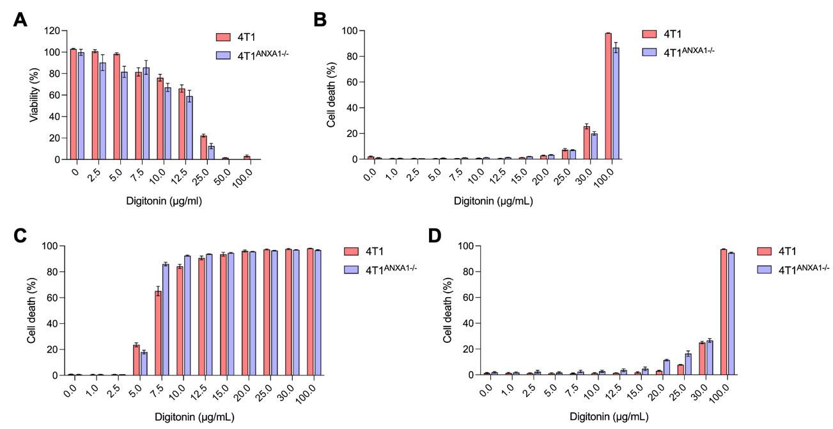
Figure S6. (Related to Fig. 6). Full range of digitonin concentrations treated in 4T1 and ANXA1-depleted 4T1 cells. (A) Viability of 4T1 and 4T1^{ANXA1-/-} cells measured using MTS assay, when treated with the indicated digitonin concentrations at 37°C for 30 min under physiological conditions. (B) Percentage cell death of 4T1 and 4T1^{ANXA1-/-} cells measured using PI/Hoechst cell death assay, when treated with the indicated digitonin concentrations at 37°C for 30 min under physiological conditions. (C) Percentage cell death of 4T1 and 4T1^{ANXA1-/-} cells measured using PI/Hoechst cell death assay, when treated with the indicated digitonin concentrations at 37°C for 30 min under calcium-chelating conditions with 10 mM EGTA. (D) Percentage cell death of 4T1 and 4T1^{ANXA1-/-} cells measured using PI/Hoechst cell death assay, when treated with the indicated digitonin concentrations at 37°C for 30 min under calcium-chelating conditions with 10 mM EGTA and 50 mM CaCl₂. Data represented as the mean ± S.E.M. for three independent experiments. Statistical significance calculated based on two-way ANOVA followed by Šídák’s post-hoc test, but no significant differences were found.
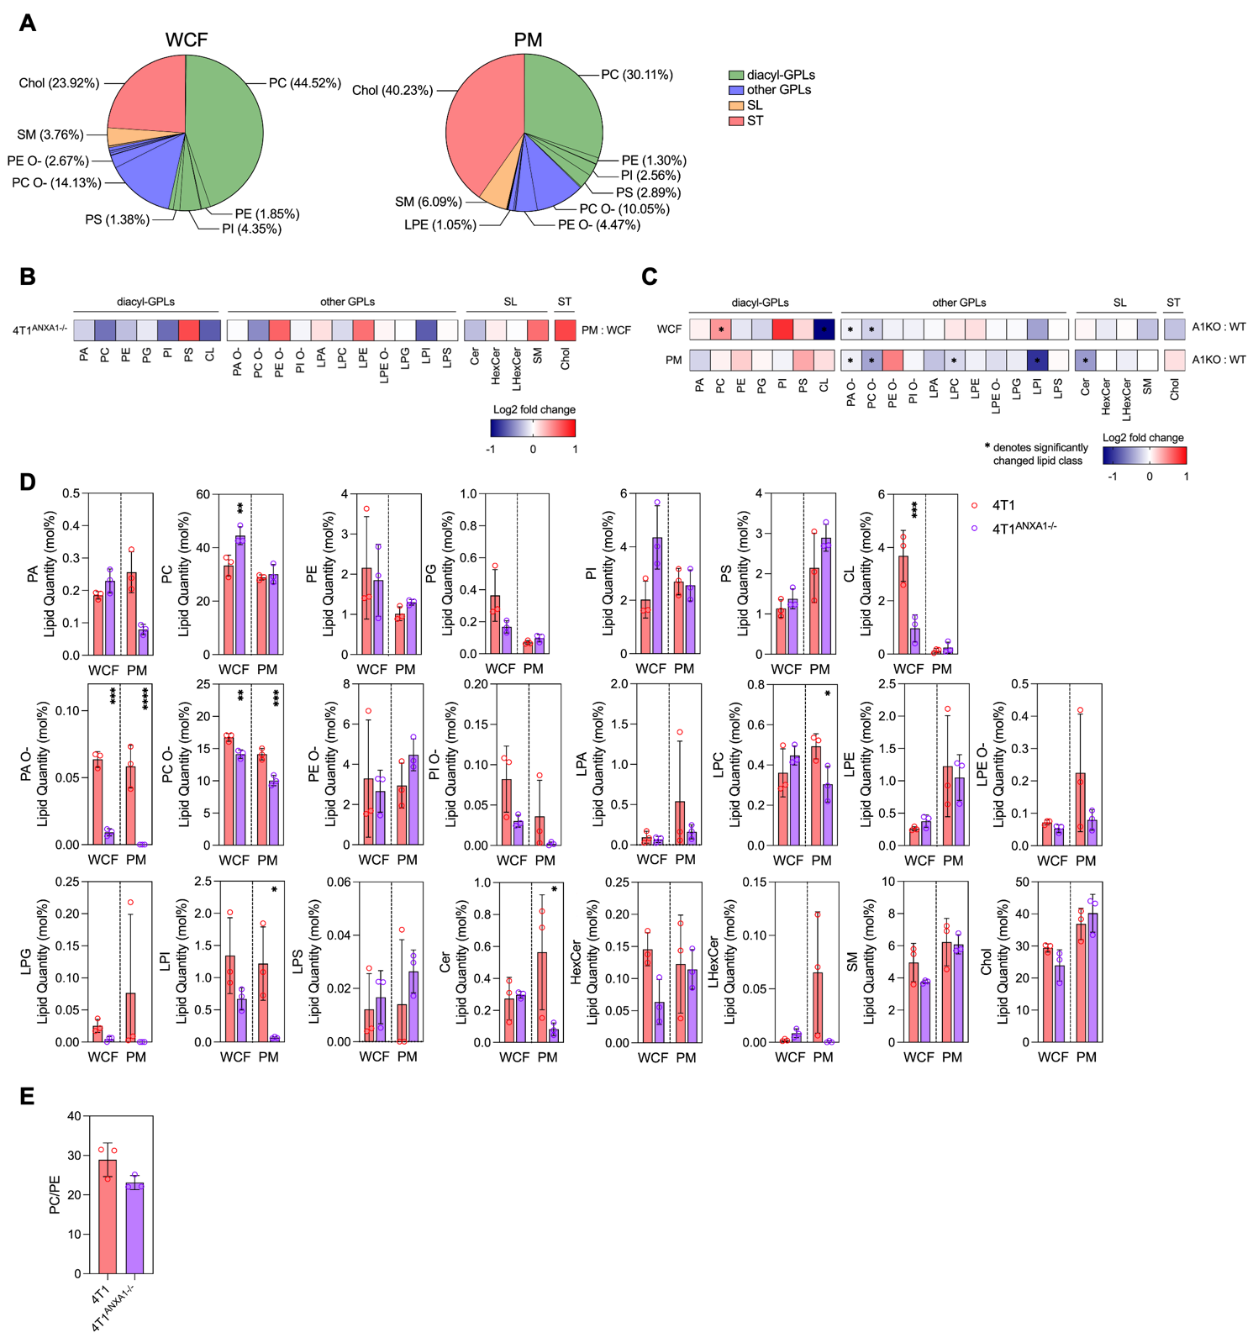
Figure S7. (Related to Fig. 6). Major lipid classes of the different cell fractions from 4T1 and ANXA1-depleted 4T1 cells expressed endogenously. (A) Pie chart showing mean mol% of the different detected major lipid classes in the WCF and PM of ANXA1-depleted 4T1 cells. (B) Heatmap showing log2 FC of the individual lipid classes in the PM from the WCF in ANXA1-depleted 4T1 cells. (C) Heatmaps showing log2 FC of the individual lipid classes in ANXA1-depleted 4T1 cells from 4T1 cells in the WCF and PM fraction. (D) Endogenous lipid quantity (mol%) of all detected major lipid classes in the different cellular fractions of 4T1 and ANXA1-depleted 4T1 cells. (E) membrane PC to PE ratio of 4T1 and ANXA1-depleted 4T1 cells. Data represented as the mean ± S.E.M. for three independent experiments. P-values based on unpaired two-tailed Student’s t-test (E), one-way ANOVA (H) and two-way ANOVA followed by Šídák’s post-hoc test (C): * p ≤ 0.05, ** p ≤ 0.01, **** p ≤ 0.001.

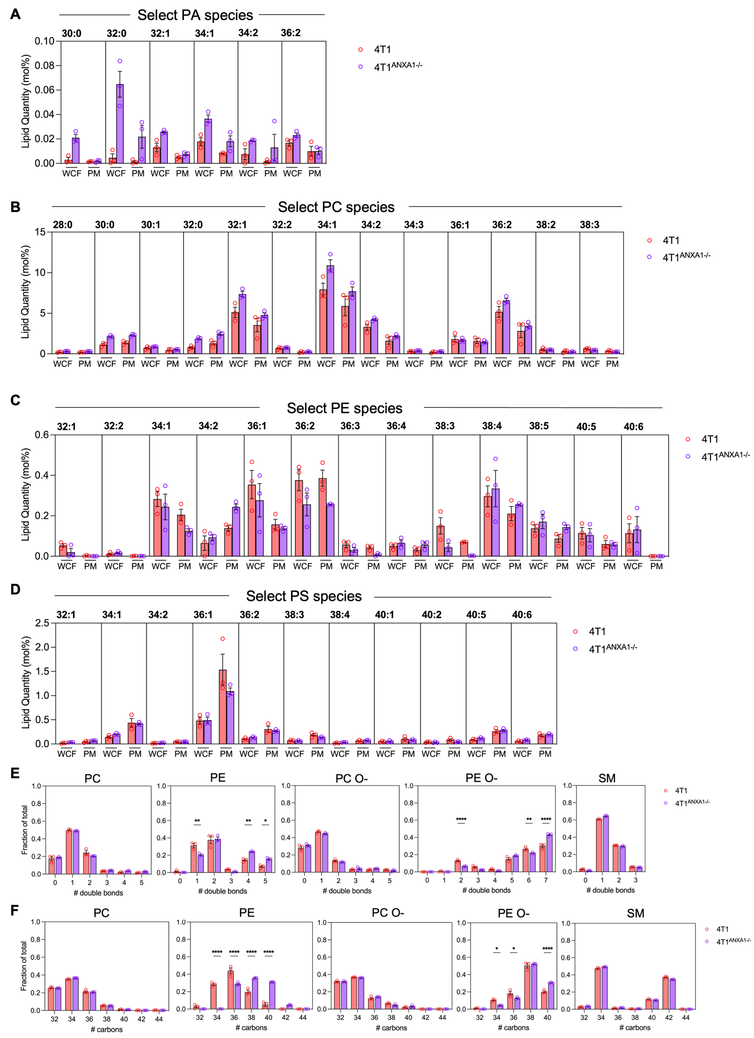
Figure S8. (Related to Fig. 6). Selected lipid species from major lipid classes expressed endogenously in 4T1 and ANXA1-depleted 4T1 cells. Lipid species with the highest abundance (mol%) are shown for (A) diacylglycerol (DAG), (B) phosphatidic acid (PA), (C) phosphatidylcholine (PC), (D) phosphatidylethanolamine and (E) phosphatidylserine (PS). Data represented as the mean ± S.E.M. for three independent experiments. P-values based on two-way ANOVA followed by Šídák’s post-hoc test: * p ≤ 0.05, ** p ≤ 0.01, *** p ≤ 0.005. **** p ≤ 0.001.
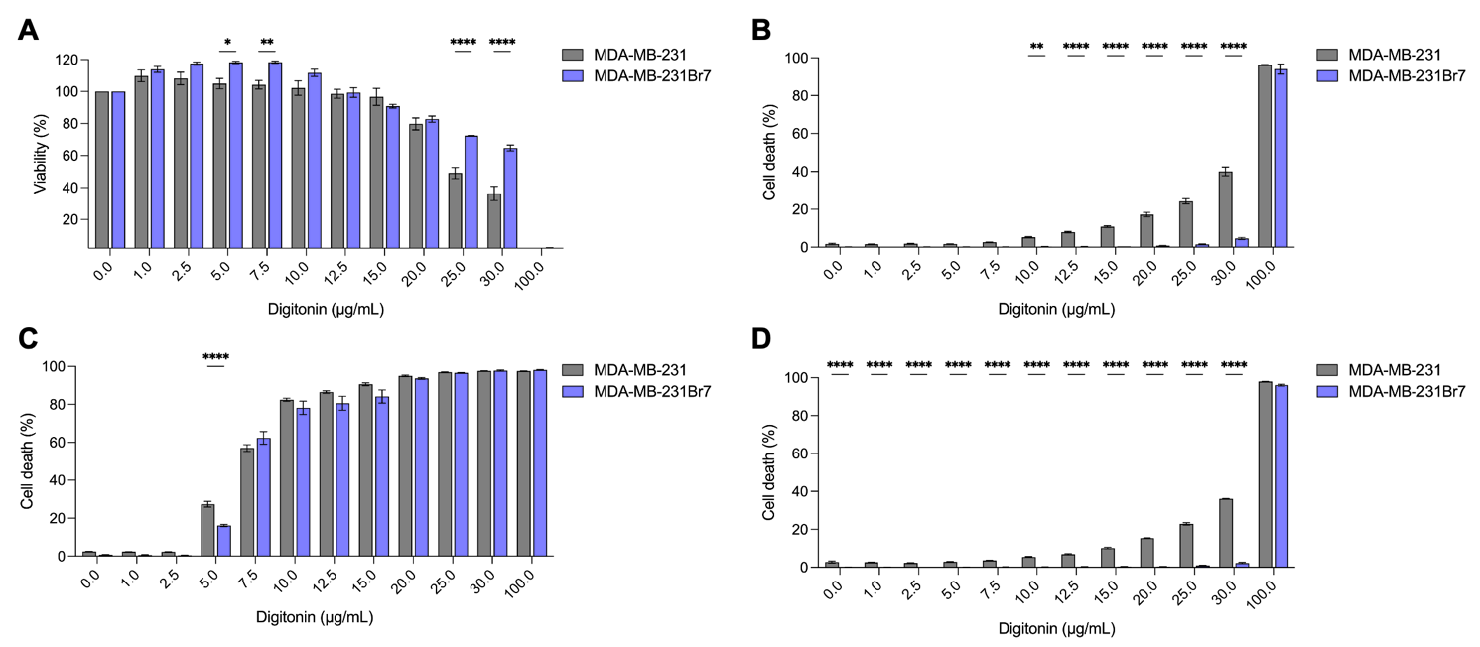
Figure S9. (Related to Fig. 7). Full range of digitonin concentrations treated in MDA-MB-231 and MDA-MB-231Br7 cells. (A) Viability of MDA-MB-231 and MDA-MB-231Br7 cells measured using MTS assay, when treated with the indicated digitonin concentrations at 37°C for 30 min under physiological conditions. (B) Percentage cell death of MDA-MB-231 and MDA-MB-231Br7 cells measured using PI/Hoechst cell death assay, when treated with the indicated digitonin concentrations at 37°C for 30 min under physiological conditions. (C) Percentage cell death of MDA-MB-231B and MDA-MB-231Br7 cells measured using PI/Hoechst cell death assay, when treated with the indicated digitonin concentrations at 37°C for 30 min under calcium-chelating conditions with 10 mM EGTA. (D) Percentage cell death of MDA-MB-231and MDA-MB-231Br7 cells measured using PI/Hoechst cell death assay, when treated with the indicated digitonin concentrations at 37°C for 30 min under calcium-chelating conditions with 10 mM EGTA and 50 mM CaCl₂. Data represented as the mean ± S.E.M. for three independent experiments. P-values based on two-way ANOVA followed by Šídák’s test: **P ≤ 0.01, ***P ≤ 0.005, ****P ≤ 0.0001.
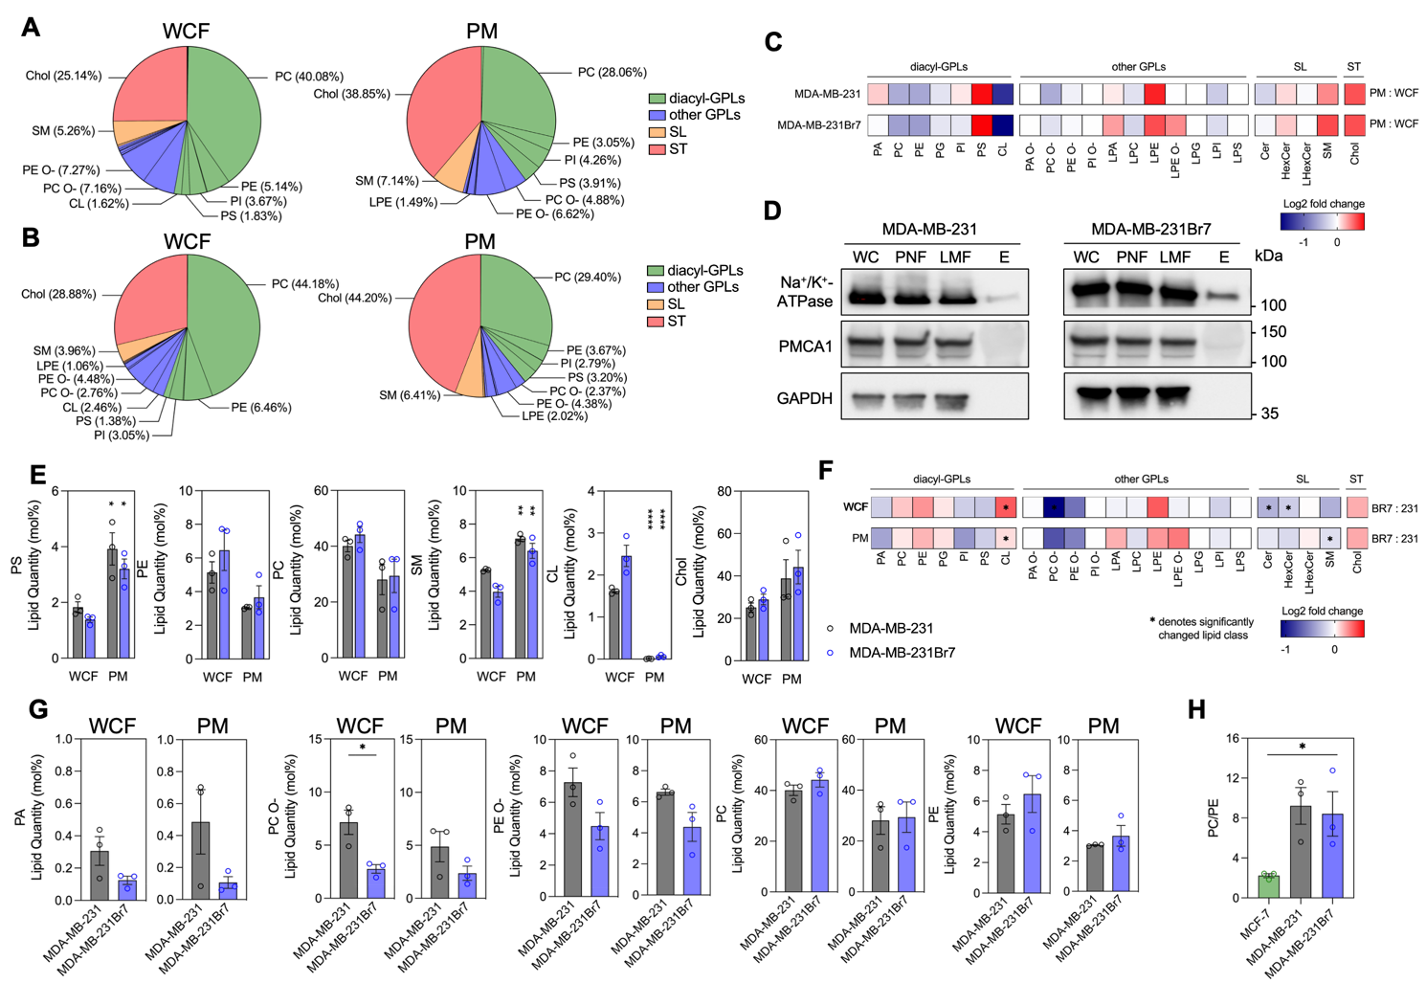
Figure S10. (Related to Fig. 7, S11 – S13). Major lipid classes of the different cell fractions from MDA-MB-231 and brain-metastasised MDA-MB-231Br7 expressed endogenously. Pie chart showing mean mol% of the different detected major lipid classes in the WCF and PM of (A) MDA-MB-231 and (B) MDA-MB-231Br7. (C) Heatmaps showing log2 fold change (FC) of the individual lipid classes in the PM from the WCF in MDA-MB-231 and MDA-MB-231Br7 (D) Western blot analysis of WCF, PNF, LMF and E fractions from MDA-MB-231 and MDA-MB-231Br7 showing bands detected with antibodies against the indicated key intracellular compartments. Other intracellular compartments presented in Figure S11. (E) Validation of the PM from WCF lipid profile indicated by the lipid quantity (mol%) of PS, PE, PC, SM, CL and Chol. (F) Heatmaps showing log2 fold change (FC) of the individual lipid classes in MDA-MB-231Br7 from MDA-MB-231 in the WCF and PM fraction. (G) Levels of prominently different endogenous major lipid classes in mol% in the WCF and PM of MDA-MB-231 and MDA-MB-231Br7, including PA, PC O-, PE O-, PC and PE. All other detected lipid classes are shown in Figure S12. (H) Membrane PC to PE ratio of MDA-MB-231 and MDA-MB-231Br7 compared to non-metastatic MCF-7 cells. Data represented as the mean ± S.E.M. for three independent experiments. P-values based on unpaired two-tailed Student’s t-test (G), one-way ANOVA (H) and two-way ANOVA followed by Šídák’s post-hoc test (E): * p ≤ 0.05, ** p ≤ 0.01, **** p ≤ 0.001.
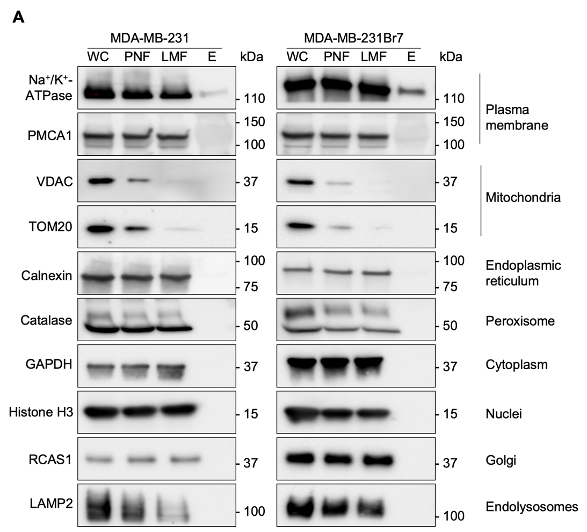
Figure S11. (Related to Fig. 7, S10 – S13). Western blot analysis of samples used for quantitative mass spectrometry-based shotgun lipidomic analysis. Cellular fractions from the membrane purification process were collected and analysed. Bands shown were detected using antibodies against the different cellular organelles: plasma membrane (Na⁺/K⁺-ATPase), plasma membrane (PMCA1), mitochondria (VDAC), mitochondria (TOM20), endoplasmic reticulum (Calnexin), peroxisome (Catalase), cytoplasm (GAPDH), nuclei (Histone H3), Golgi apparatus (RCAS1), endolysosome (LAMP2). (A) MDA-MB-231 and MDA-MB-231Br7 cells. Abbreviations: whole cell fraction (WC), post-nuclear fraction (PNF), light membrane fraction (LMF), elute (E).

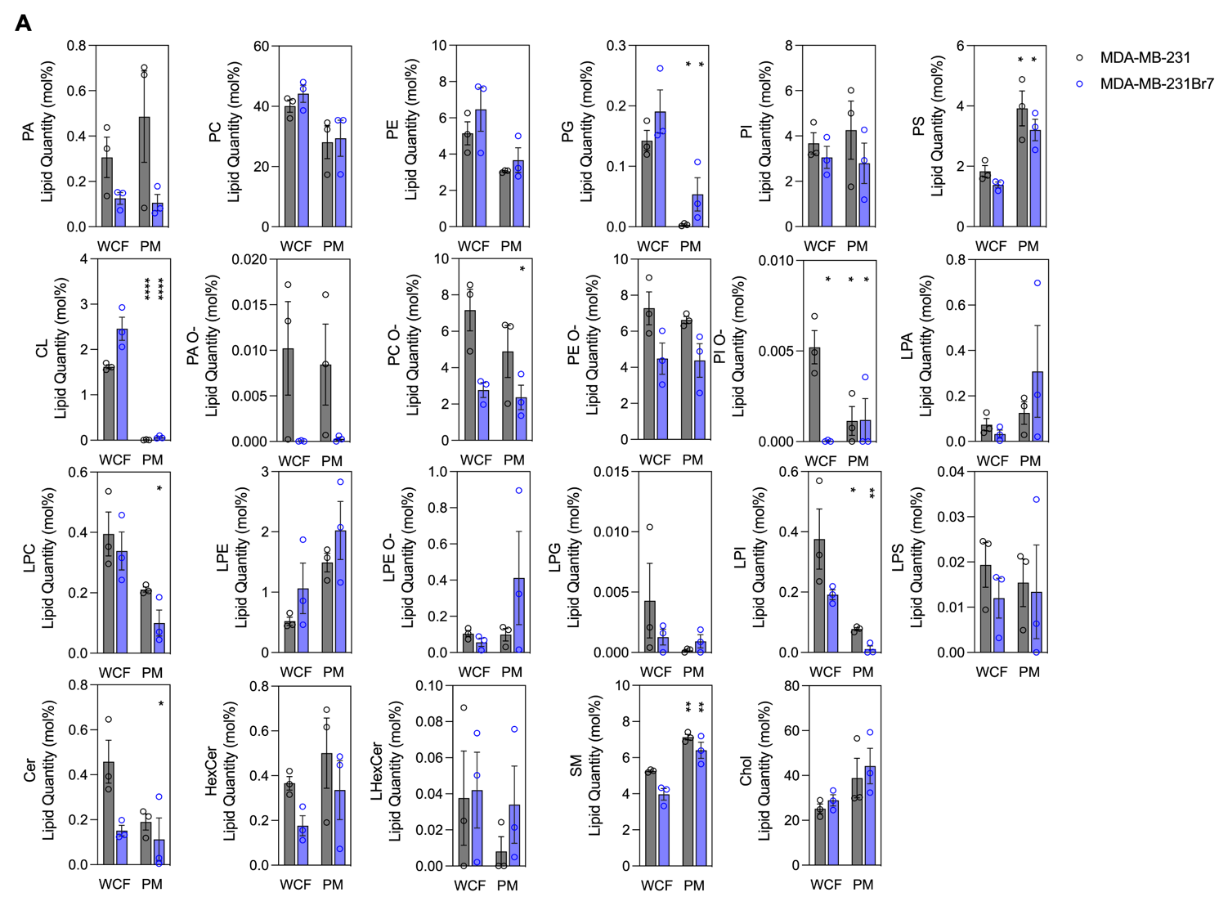
Figure S12. (Related to Fig. 7, S10 – S13). Major lipid classes of the different cell fractions from MDA-MB-231 and MDA-MB-231Br7 cells expressed endogenously. (A) Endogenous lipid quantity (mol%) of all detected major lipid classes in the different cellular fractions of MDA-MB-231 and MDA-MB-231Br7 cells. Data represented as the mean ± S.E.M. for three independent experiments. P-values based on two-way ANOVA followed by Šídák’s post-hoc test (E, F, J, K): * p ≤ 0.05, ** p ≤ 0.01, **** p ≤ 0.001. Abbreviations: whole cell fraction (WCF), plasma membrane (PM), diacylglycerol (DAG), phosphatidic acid (PA), phosphatidylcholine (PC), phosphatidylethanolamine (PE), phosphatidylglycerol (PG), phosphatidylinositol (PI), phosphatidylserine (PS), cardiolipin (CL), alkyl-PA (PA O-), alkyl-PC (PC O-), alkyl-PE (PE O-), alkyl-PI (PI O-), lysoPA (LPA), lysoPC (LPC), lysoPE (LPE), alkyl-LPE (LPE O-), lysoPG (LPG), lysoPI (LPI), lysoPS (LPS), ceramide (Cer), hexosylceramide (HexCer), lysoHexCer (LHexCer), sphingomyelin (SM), cholesterol (Chol).
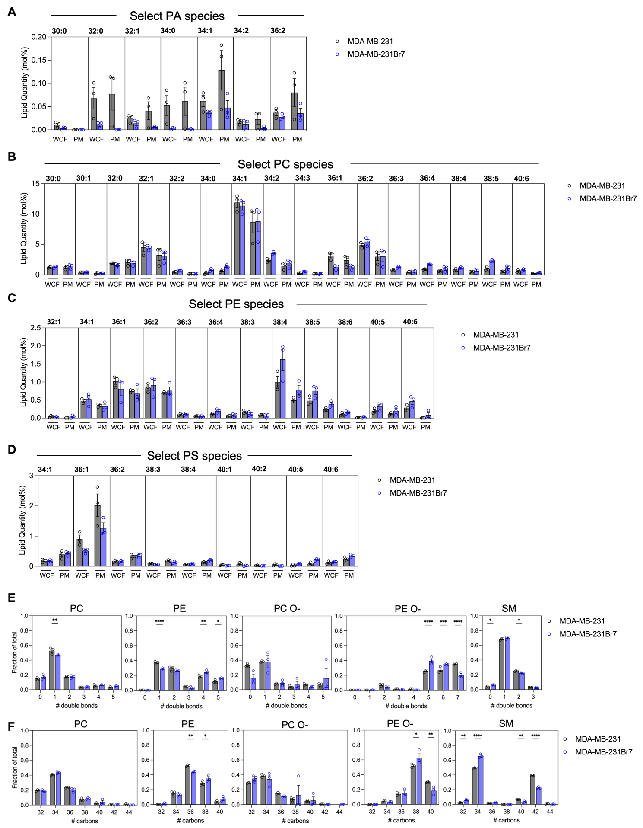
Figure S13. (Related to Fig. 7, S10 – S13). Selected lipid species from major lipid classes expressed endogenously in MDA-MB-231 and MDA-MB-231Br7. Lipid species with the highest abundance (mol%) are shown for (A) PA, (B) PC, (C) PE and (D) PS. (E) Carbon chain lengths and (F) number of carbon double bonds in major PM phospholipids in MDA-MB-231 and MDA-MB-231Br7. Data represented as the mean ± S.E.M. for three independent experiments. P-values based on two-way ANOVA followed by Šídák’s post-hoc test: * p ≤ 0.05, ** p ≤ 0.01, *** p ≤ 0.005, **** p ≤ 0.001.
Table S1. Antibody information for western blotting.
Antibody | Supplier | Identifier | Dilution
ANXA1 | Cell Signaling Technology #3229 | RRID:AB_2274094 | 1:1000
ANXA2 | Santa Cruz Biotechnology #sc-28385 | RRID:AB_626677 | 1:1000
ANXA3 | Santa Cruz Biotechnology #sc-390502 | RRID:AB_3698731 | 1:1000
ANXA4 | Santa Cruz Biotechnology #sc-46693 | RRID:AB_626679 | 1:1000
ANXA5 | Santa Cruz Biotechnology #sc-74438 | RRID:AB_1118989 | 1:1000
ANXA6 | Santa Cruz Biotechnology #sc-271859 | RRID:AB_10708132 | 1:1000
ANXA7 | Santa Cruz Biotechnology #sc-17815 | RRID:AB_626681 | 1:1000
ANXA8 | Santa Cruz Biotechnology #sc-514498 | RRID:AB_3698732 | 1:1000
ANXA9 | Santa Cruz Biotechnology #sc-374288 | RRID:AB_10986126 | 1:1000
ANXA10 | Santa Cruz Biotechnology #sc-398736 | RRID:AB_3076229 | 1:1000
ANXA11 | Santa Cruz Biotechnology #sc-46686 | RRID:AB_626682 | 1:1000
ANXA13 | Santa Cruz Biotechnology #sc-377327 | RRID:AB_3698734 | 1:1000
Beta-Actin | Cell Signaling Technology #4970 | RRID:AB_2223172 | 1:2000
Histone H3 | Abcam #ab18521 | RRID:AB_732917 | 1:1000
Catalase | Abcam #ab209211 | RRID:AB_3086611 | 1:1000
Calnexin | Abcam #ab22595 | RRID:AB_2069006 | 1:1000
LAMP2 | DSHB #H4B4 | RRID:AB_528129 | 1:1000
PMCA1 | Abcam #ab190355 | RRID:AB_2893200 | 1:1000
GAPDH | Cell Signaling Technology #2118 | RRID:AB_561053 | 1:2000
Na+/K+-ATPase | Abcam #ab76020 | RRID:AB_1310695 | 1:1000
RCAS1 | Cell Signaling Technology #12290 | RRID:AB_2736985 | 1:1000
TOM20 | Santa Cruz Biotechnology #sc-11415 | RRID:AB_2207533 | 1:1000
VDAC | Cell Signaling Technology #12454 | RRID:AB_2797922 | 1:1000
Polyclonal Rabbit Anti-Mouse Immunoglobulin HRP | Agilent #P0260 | RRID:AB_2632969 | 1:5000
Goat Anti-Rabbit IgG (H+L) Peroxidase | Vector Laboratories #PI-1000 | RRID:AB_2336198 | 1:5000
Polyclonal Rabbit Anti-Goat Immunoglobulin HRP | Agilent #P0449 | RRID:AB_2617143 | 1:5000
Polyclonal Rabbit Anti-Rat Immunoglobulin HRP | Agilent #P0450 | RRID:AB_2630354 | 1:5000

Table S2. Internal lipid standard mixture.
Lipid class | Standard | Supplier | Identifier | Molar quantities (pmol)
FA | FA 16:0-D4 | TRC-Canada | P145502 | 37.5
DAG | DAG 12:0/12:0 | Avanti Polar Lipids | 800812 | 45.6
TAG | TAG 17:0/17:0/17:0 | Larodan | 33-1700 | 907.5
PA and PA O- | PA 12:0/12:0 | Avanti Polar Lipids | 840635 | 28.3
PC and PC O- | PC 12:0/12:0 | Avanti Polar Lipids | 850335 | 35.9
PE and PE O- | PE 12:0/12:0 | Avanti Polar Lipids | 850702 | 39.5
PG and PG O- | PG 12:0/12:0 | Avanti Polar Lipids | 840435 | 29.3
PI and PI O- | PI 8:0/8:0 | Avanti Polar Lipids | 850181 | 28.4
PS and PS O- | PS 12:0/12:0 | Avanti Polar Lipids | 840038 | 25.4
CL | CL 14:0/14:0/14:0/14:0 | Avanti Polar Lipids | 710332 | 72.2
LPA and LPA O- | LPA 17:0 | Avanti Polar Lipids | 11067 | 31.1
LPC and LPC O- | LPC 12:0 | Avanti Polar Lipids | 855475 | 25.0
LPE and LPE O- | LPE 13:0 | Avanti Polar Lipids | 110696 | 30.8
LPG and LPG O- | LPG 17:1 | Avanti Polar Lipids | 858127 | 30.2
LPI and LPI O- | LPI 13:0 | Avanti Polar Lipids | 110716 | 22.9
LPS and LPS O- | LPS 17:1 | Avanti Polar Lipids | 858141 | 14.3
Ceramide-1-phosphate (CerP) | CerP 18:1;2/12:0;0 | Avanti Polar Lipids | 860531 | 25.0
Cer | Cer 18:1;2/12:0;0 | Avanti Polar Lipids | 860512 | 31.3
SHexCer | SHexCer 18:1;2/12:0;0 | Avanti Polar Lipids | 860573 | 35.8
HexCer | GlcCer 18:1;2/12:0;0 | Avanti Polar Lipids | 860543 | 28.9
diHexCer | diHexCer 18:1;2/17:0;0 | Avanti Polar Lipids | 860595 | 23.2
triHexCer | triHexCer 18:1;2/17:0;0 | Larodan | 56-1061 | 51.2
HexSph | GluSph-¹³C₆ 18:1;2 | Larodan | 781107 | 25.0
SM | SM 18:1;2/12:0;0 | Avanti Polar Lipids | 860583 | 21.3
Chol | Chol-D4 | QMX | D-6359 | 356.9
CE | CE-D7 15:0 | Avanti Polar Lipids | 700144 | 29.3
GM1-3 | GM3 18:1;2/18:0;0-D3 | Larodan | 71-1107 | 37.5

