Supplementary materials
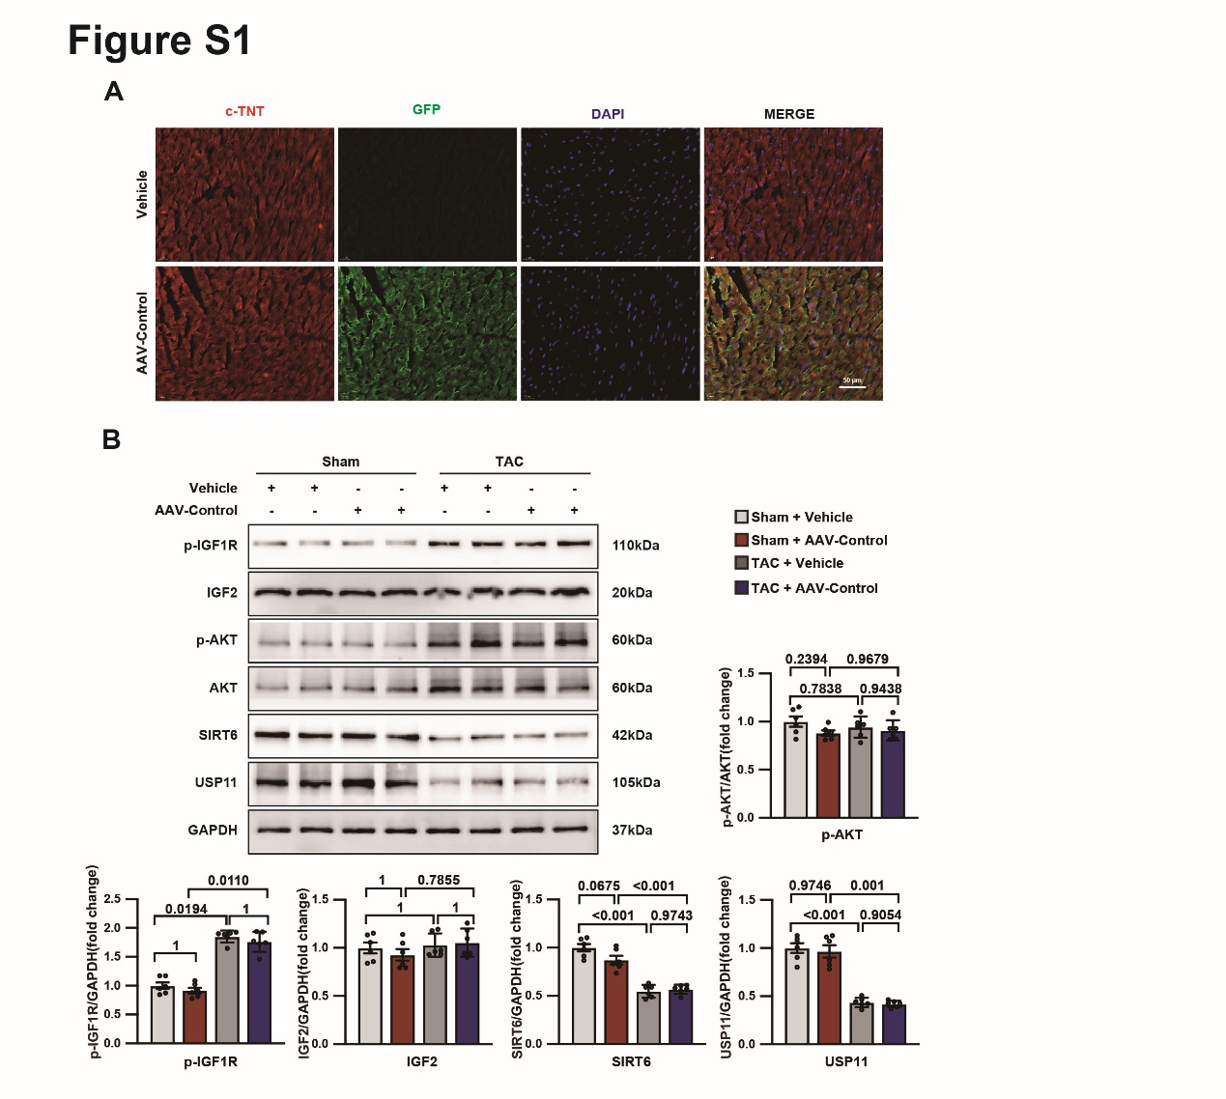
Fig.S1 AAV-Control specifically targets cardiomyocytes in vivo without altering IGF2–IGF1R–AKT signaling.
A, Representative immunofluorescence images of cTnT (red), GFP (green), and DAPI (blue) in hearts from Vehicle or AAV-Control treated mice, showing cardiomyocyte-restricted AAV transduction. B, Immunoblots and quantification of p-IGF1R, IGF2, p-AKT, AKT, SIRT6, and USP11 in LV tissues from Sham-operated or TAC-operated mice treated with Vehicle or AAV-Control, showing no significant effect of AAV-Control alone on IGF2–IGF1R–AKT signaling or SIRT6/USP11 expression. Data are presented as mean ± SD with individual data points. Statistics: one-way ANOVA with Tukey’s multiple-comparisons test.

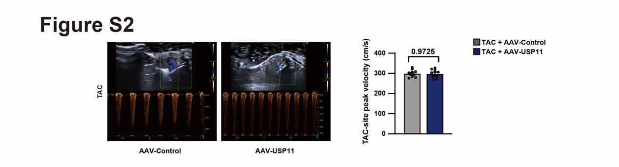
Fig. S2 Comparable of TAC constriction severity between AAV-Control and AAV-USP11 groups.
Representative Doppler images of blood flow velocity at the TAC ligation site in TAC mice expressing AAV-Control or AAV-USP11. Right, quantification of TAC-site peak velocity shows no significant difference between groups, indicating comparable constriction severity (n = 10). Data are presented as mean ± SD with individual data points. Statistics: two-tailed unpaired Student’s t test.

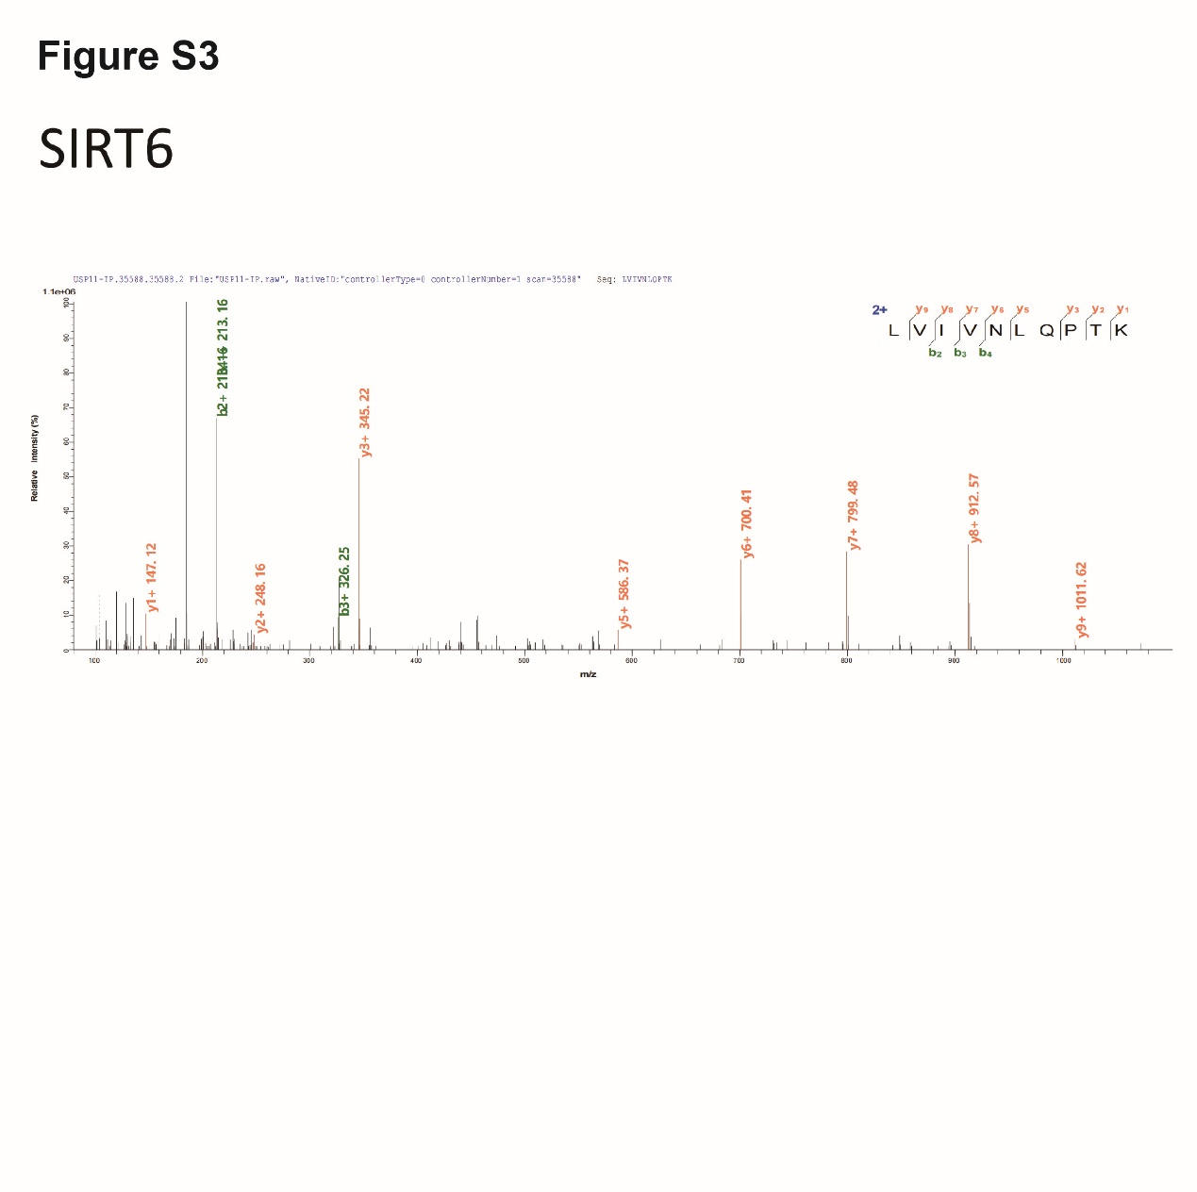
Fig. S3 Annotated MS/MS spectrum supporting SIRT6 identification in USP11 immunoprecipitates.
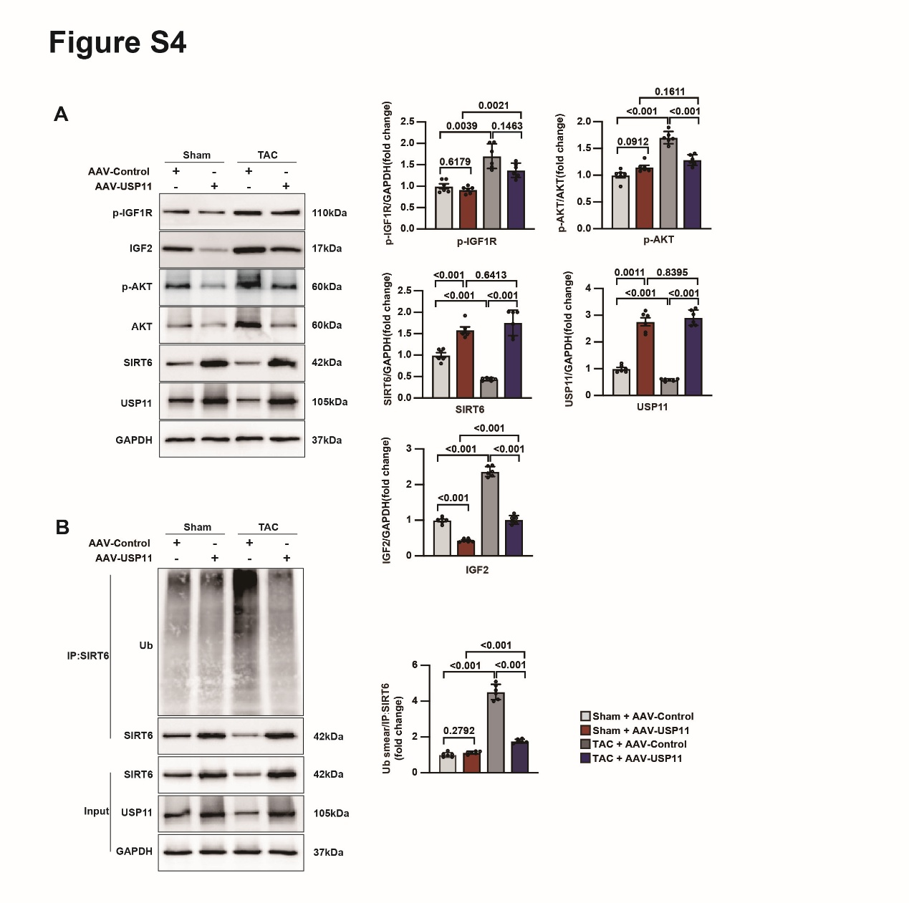
Fig. S4 USP11 overexpression reduces SIRT6 ubiquitination and attenuates IGF2-AKT signaling in vivo.
A, Western blot of p-IGF1R, IGF2, p-AKT, AKT, USP11 and SIRT6 in mice after tail vein injection of AAV-USP11 (n = 6). B, The ubiquitination level of SIRT6 in mice after tail vein injection of AAV-USP11 (n = 6).
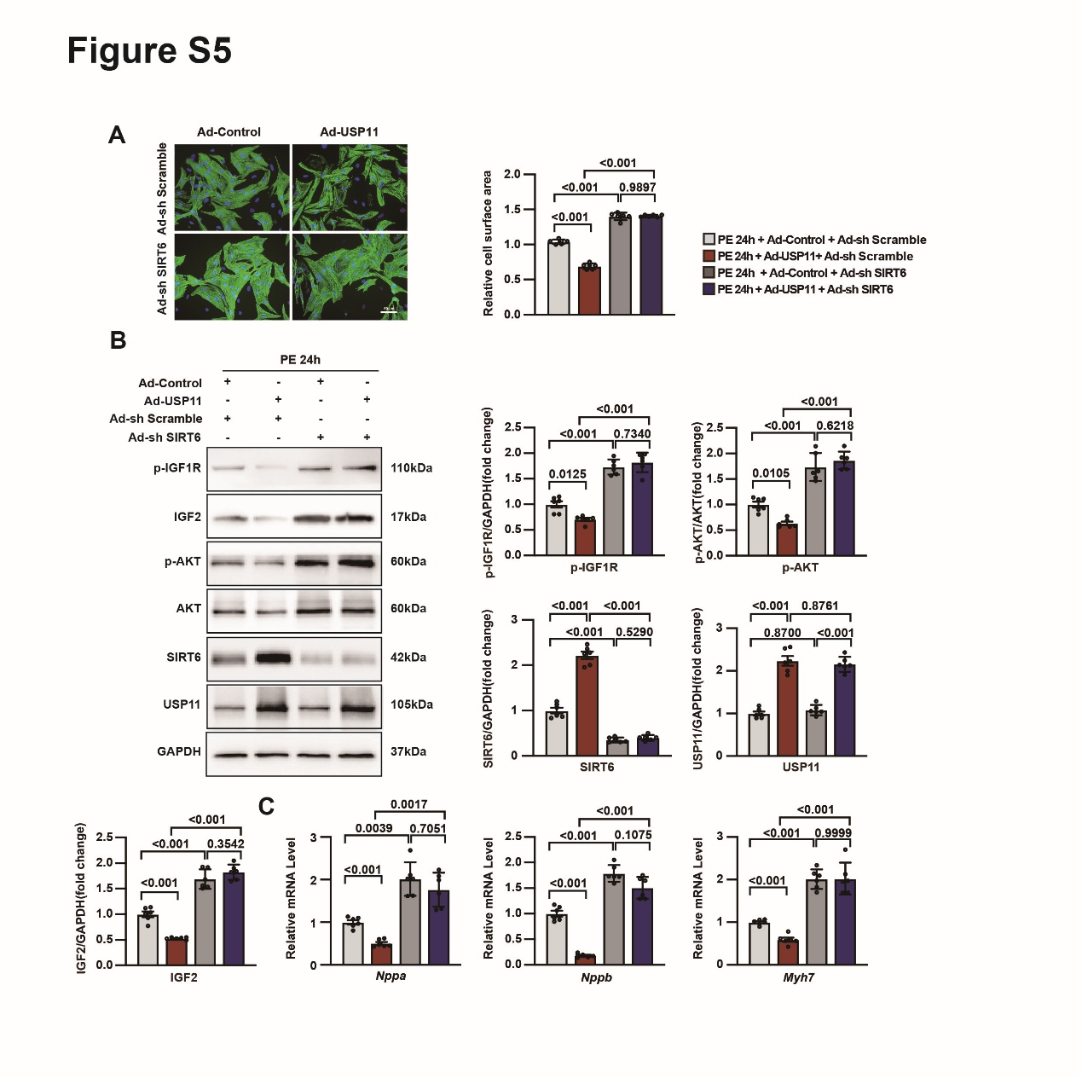
Fig. S5 SIRT6 knockdown abolishes the anti-hypertrophic effect of USP11 overexpression in cardiomyocytes.
A, Representative immunofluorescence staining images of cTnT in NRVMs infected with Ad-USP11 and Ad-sh SIRT6 (n = 6). B, Western blot of p-IGF1R, IGF2, p-AKT, AKT, SIRT6 and USP11 in NRVMs infected with Ad-USP11 and Ad-sh SIRT6 (n = 6). C, qPCR analysis of Nppa, Nppb, Myh7 in NRVMs infected with Ad-USP11 and Ad-sh SIRT6 (n = 6).

Supplementary Table 1
Antibodies | SOURCE | IDENTIFIER | Dilution of Western blot
anti-USP11 | Proteintech | Cat# 10244-1-AP | 1:500
anti-ANP | Proteintech | Cat# 27426-1-AP | 1:2000
anti-BNP | ABclonal | Cat# A23996 | 1:1000
anti-P-IGF1R | Proteintech | Cat# 82830-15-RR | 1:1000
anti-P-AKT | Proteintech | Cat# 28731-1-AP | 1:1000
anti-AKT | Proteintech | Cat# 10176-2-AP | 1:2000
anti-SIRT6 | Proteintech | Cat# 13572-1-AP | 1:500
anti-UB | Proteintech | Cat# 10201-2-AP | 1:1000
anti-GAPDH | Proteintech | Cat# 60004-1-Ig | 1:50000

Supplementary Table 2
GENE | FORWARD | REVERSE
MOUSE Usp11 | AACAACATACCGGACGAGGAT | CCTTCATGCCTAGAGGGTTCC
MOUSE Nppa | GCTTCCAGGCCATATTGGAG | GGGGGCATGACCTCATCTT
MOUSE Nppb | GAGGTCACTCCTATCCTCTGG | GCCATTTCCTCCGACTTTTCTC
MOUSE Myh7 | ACTGTCAACACTAAGAGGGTCA | TTGGATGATTTGATCTTCCAGGG
MOUSE Col1a1 | GCTCCTCTTAGGGGCCACT | CCACGTCTCACCATTGGGG
MOUSE Col3a1 | CTGTAACATGGAAACTGGGGAAA | CCATAGCTGAACTGAAAACCACC
MOUSE Ctgf | GTGCACTGCCAAAGATGGTG | CTTTGGAAGGACTCACCGCT
RAT Nppa | GCAAACATCAGATCGTGCCC | CAATATGGCCTGGGAGCCAA
RAT Nppb | TGACGGGCTGAGGTTGTTTT | ACACTGTGGCAAGTTTGTGC
RAT Myh7 | CCGAGTCCCAGGTCAACAAG | CAGGCATCCTTAGGGTTGGG

