Supplementary Materials

Sirt5 preserves mitochondrial homeostasis to improve cardiac function in ischemia-reperfusion injury by inhibiting ANT2 lysine lactylation modification
Simeng Li^{1,2,†}, Siman Shen^{1,†}, Yongfang Hong^{3,†}, Kun Ding¹, Suyun Chen¹, Jianning Chen¹, Changsen Wang⁴, Yaofeng Wen¹, Guixi Mo⁴, Lili Yu^{2,5,‡}, De-Li Shi^{6,‡}, Liangqing Zhang^{1,2,‡}

This includes:

Fig. S1 to S13
Table S1

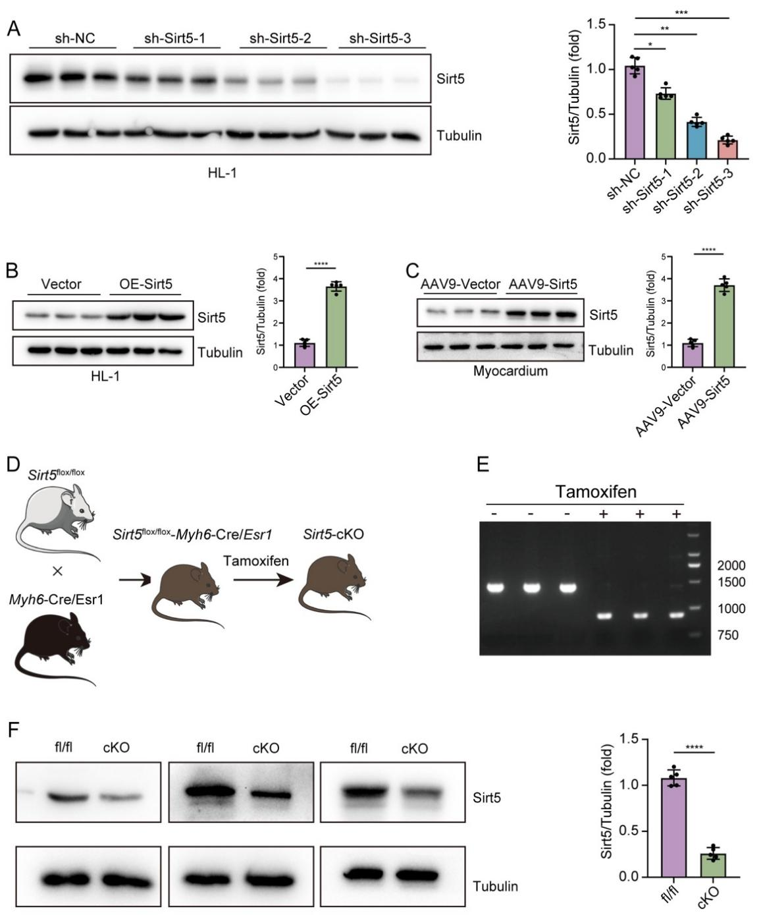
Fig. S1. Validation of Sirt5 overexpression and knockdown or knockout. (A) Western blot analysis and quantification shows the efficiency of three shRNAs targeting Sirt5 in HL-1 cells 48 hours after transfection. The sh-Sirt5-3 was used throughout the study. One-way ANOVA (*, P < 0.05; **, P < 0.01; ***, P < 0.001). (B) Western blot analysis and quantification shows increased Sirt5 protein levels after plasmid transfection in HL-1 cells. Two-tailed t-test (****, P < 0.0001). (C) AAV9-mediated overexpression of Sirt5 in the mouse myocardium 14 days after injection of the viruses into the tail vein. Two-tailed t-test (****, P < 0.0001). (D) Procedure for the generation of cardiac-specific Sirt5 conditional knockout mice. (E) PCR-mediated genotyping to verify the deletion of the floxed exon 3 in the Sirt5 locus, which produces a 1508 bp or 847 fragment before and after administration of tamoxifen, respectively. (F) Reduction of Sirt5 protein levels 5 days after tamoxifen treatment in three independent mice. Two-tailed t-test (****, P < 0.0001).

Fig. S2. Sirt5 attenuated mPTP opening under HR condition. OE-Sirt5 attenuated mPTP opening in HR-injured HL-1 cells , whereas sh-Sirt5 exacerbated mPTP opening in HR-injured HL-1 cells. One-way ANOVA (*, P < 0.05; **, P < 0.01; ***, P < 0.001).

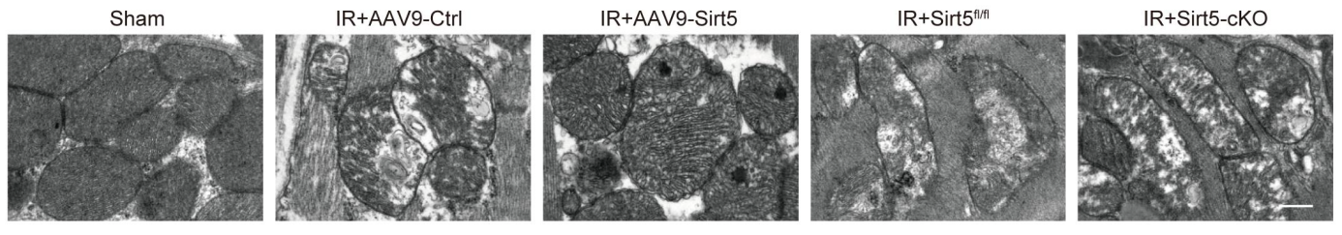
Fig. S3. Sirt5 protects mitochondrial integrity under IR condition. IR injury of the myocardium was induced 14 days after injection of AAV9-Sirt5 and 5 days after administration of tamoxifen. Overexpression of Sirt5 rescues IR-induced mitochondrial disorganization, whereas knockout of Sirt5 enhances IR-induced mitochondrial defects. Scale bar, 500 nm.

Fig. S4. IR-induced PTMs in the myocardium. (A to E) Western blot analyses of protein lactylation (Kla), crotonyllysine (Kcr), succinyllysine (Ksuc), ß-hydroxybutyryllysine (Kbhb) and acetylation (Kac) modifications in IR-injured mouse myocardial tissues. Two-tailed t-test (*, P < 0.05; **, P < 0.01; ***, P < 0.001).

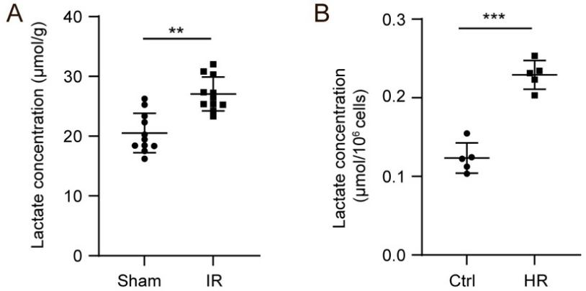
Fig. S5. Increase of lactate levels after IR and HR. (A) Quantification of lactate levels in IR-injured mouse myocardial tissues. Two-tailed t-test (**, P < 0.01). (B) Quantification of lactate levels in HR-treated HL-1 cells. Two-tailed t-test (***, P < 0.001).

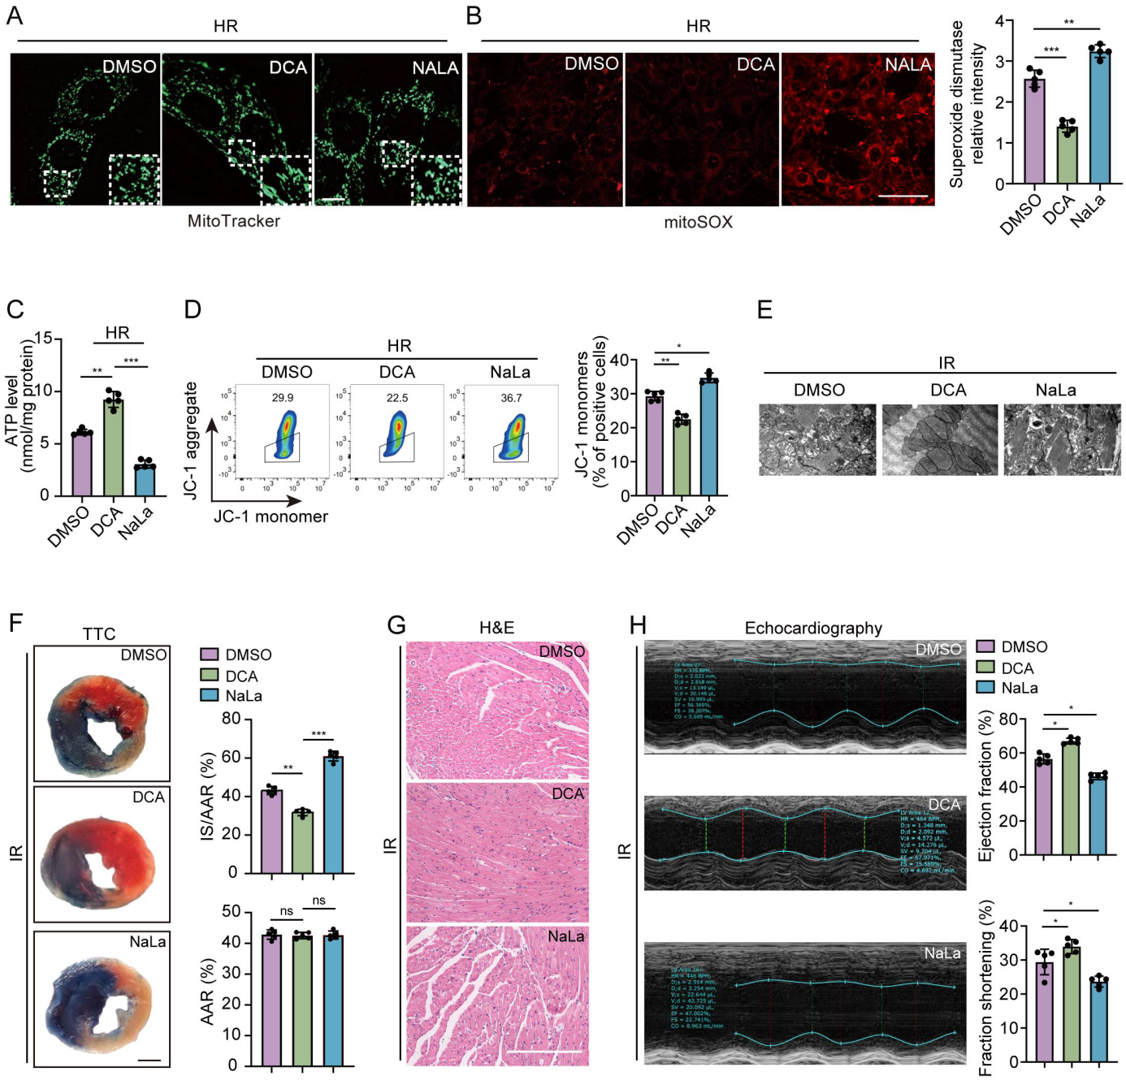
Fig. S6. Improvement of mitochondrial and cardiac functions by inhibiting lactate production and lactylation modification. (A) DCA reduces, whereas NaLa enhances, the severity of mitochondrial fragmentation in HR-injured HL-1 cells. Scale bar, 10 µm. (B) DCA reduces, whereas NaLa enhances, mitochondrial ROS in HR-injured HL-1 cells. One-way ANOVA (**, P < 0.01; ***, P < 0.001). Scale bar, 40 µm. (C) ATP production in HR-injured HL-1 cells treated with DCA or NaLa. One-way ANOVA (**, P < 0.01; ***, P < 0.001). (D) DCA improves mitochondrial membrane potential in HR-injured HL-1 cells by reducing the formation of JC-1 monomers. One-way ANOVA (*, P < 0.05; **, P < 0.01). (E) TEM analyses show that DCA improves, whereas NaLa aggravates, mitochondrial integrity in IR-injured mouse myocardial tissues. Scale bar, 500 nm. (F) TTC staining shows that DCA reduces, whereas NaLa further increase, the infarct size (IS) relative to the myocardial area at risk (AAR) from IR-injured mice, but without effect on the AAR. One-way ANOVA (**, P < 0.01; ***, P < 0.001; ns, not significant). (G) DCA reduces, whereas NaLa aggravates, inflammatory cell infiltration in IR-injured mouse myocardial tissues. TTC staining was performed 24 hours after IR injury. Scale bar, 200 µm. (H) DCA improves heart function by increasing the percentage of ejection fraction and fraction shortening in IR-injured mice, whereas NaLa shows the opposite effect. Echocardiography was performed 48 hours after IR injury. One-way ANOVA (*, P < 0.05).

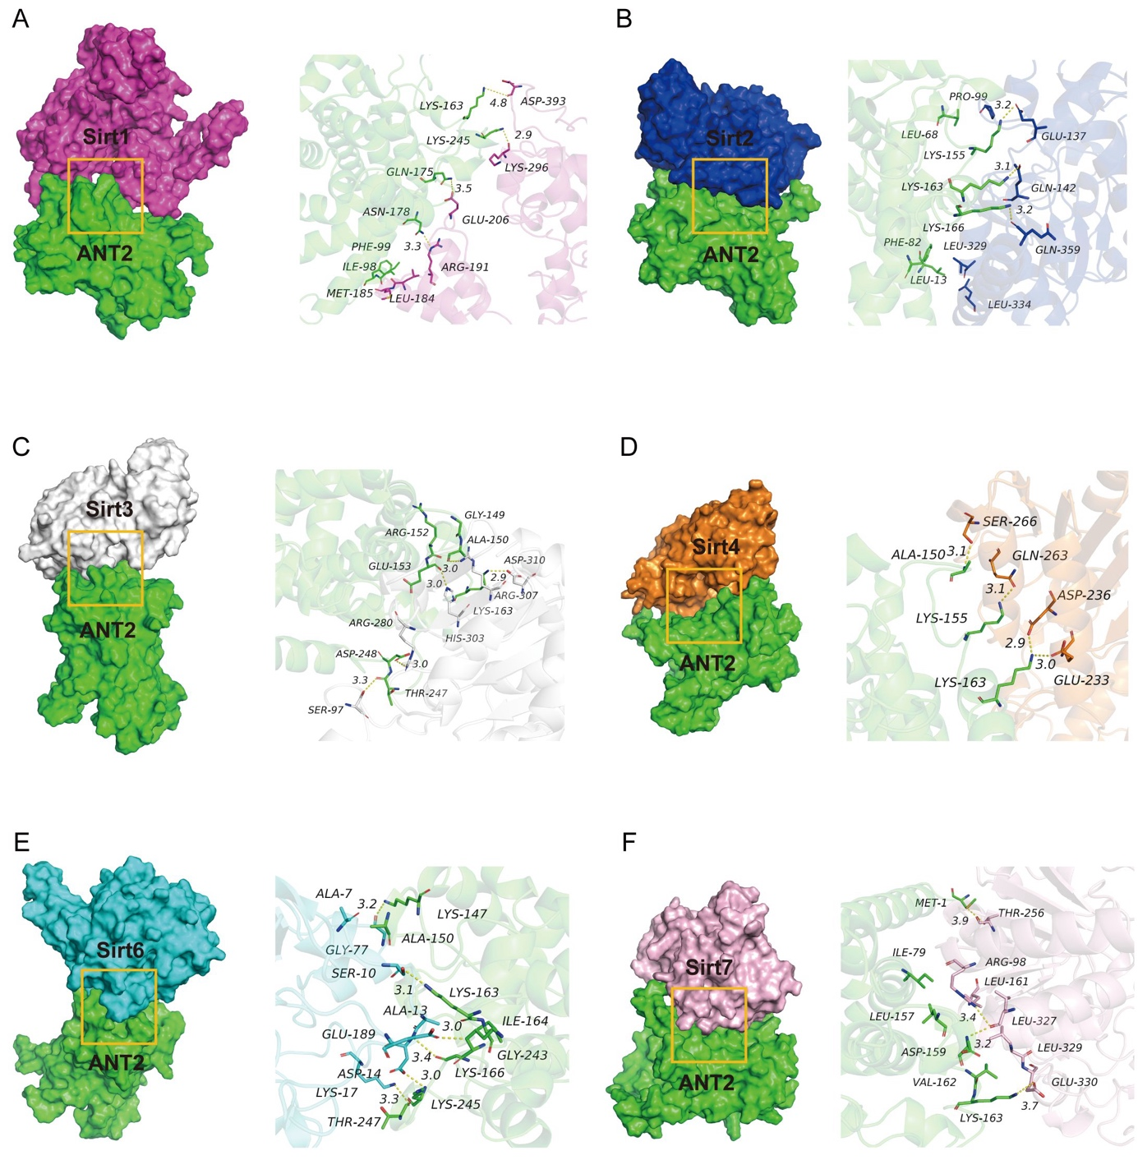
Fig. S7. Molecular docking of ANT2 interaction with Sirt proteins. (A) Sirt1 interaction with ANT2. (B) Sirt2 interaction with ANT2. (C) Sirt3 interaction with ANT2. (D) Sirt4 interaction with ANT2. (E) Sirt6 interaction with ANT2. (F) Sirt7 interaction with ANT2. The 3D interactions of ANT2-K163 with Sirt proteins are shown on the right.

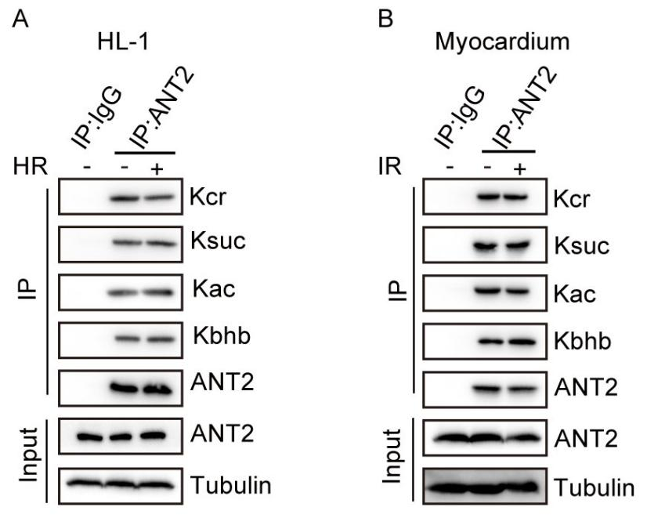
Fig. S8. Analysis of ANT2 post-translational modifications. (A and B) Western blot analyses of ANT2-Kcr, ANT2-Ksuc, ANT2-Kbhb and ANT2-Kac following immunoprecipitation of ANT2 in HL-1 cells and mouse myocardial tissues under HR or IR condition.

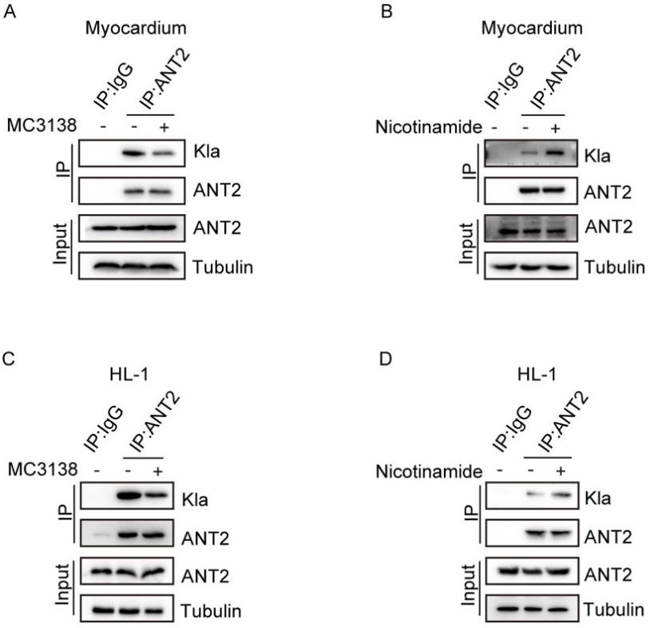

Fig. S9. Regulation of ANT2 lysine lactylation by Sirt5 activator and inhibitor. (A and B) Decreased and increased ANT2 lysine lactylation 14 days following treatment of mouse myocardial tissues with Sirt5 activator MC3138 and inhibitor nicotinamide, respectively. (C and D) Decreased and increased ANT2 lysine lactylation 24 hours following treatment of HL-1 cells with Sirt5 activator MC3138 and inhibitor nicotinamide, respectively.

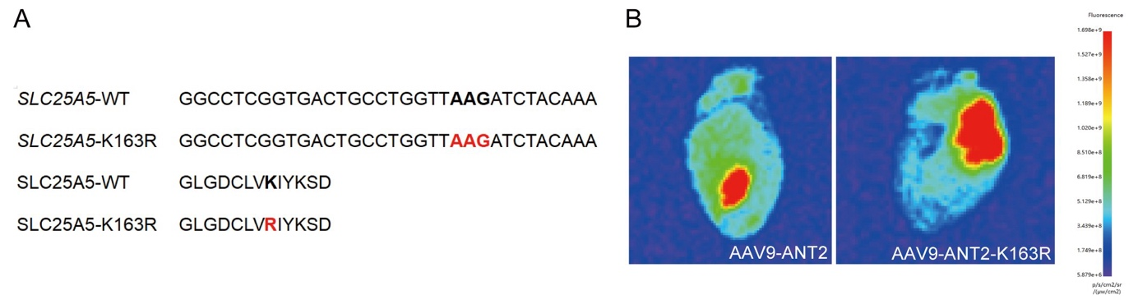
Fig. S10. AAV9-mediated cardiac expression of ANT2 and ANT2-K163R. (A) Nucleotide and amino acid sequences showing the substitution of the lysine residue in human SLC25A5 (ANT2) by an arginine residue. (B) Fluorescence images show the efficiency of AAV9-mediated expression of ANT2 and ANT2-K163R in the heart 14 days after tail vein injection.

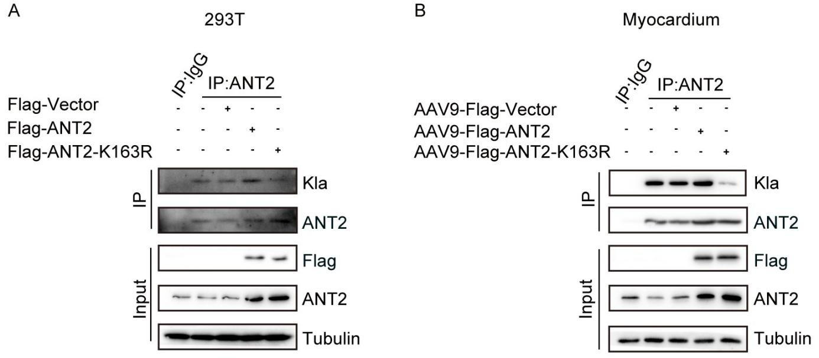
Fig. S11. ANT2-K163R is less sensitive to lactylation modification. (A) Western blot analysis of lactylated ANT2 following immunoprecipitation of ANT2 in HEK293T cells treated with Flag-Vector; Flag-ANT2; Flag-ANT2-K163R. (B) Western blot analysis of lactylated ANT2 following immunoprecipitation of ANT2 in mouse myocardial tissues treated with AAV9-Flag-Vector; AAV9-Flag-ANT2; AAV9-Flag-ANT2-K163R. Note that ANT2-K163R shows reduced lactylation compared to ANT2.
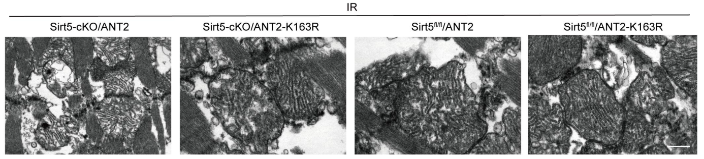
Fig. S12. ANT2-K163R protects mitochondrial integrity in the myocardium. Overexpression of ANT2-K163R reduces the extent of mitochondrial defects induced by IR injury with or without Sirt5 conditional knockout.

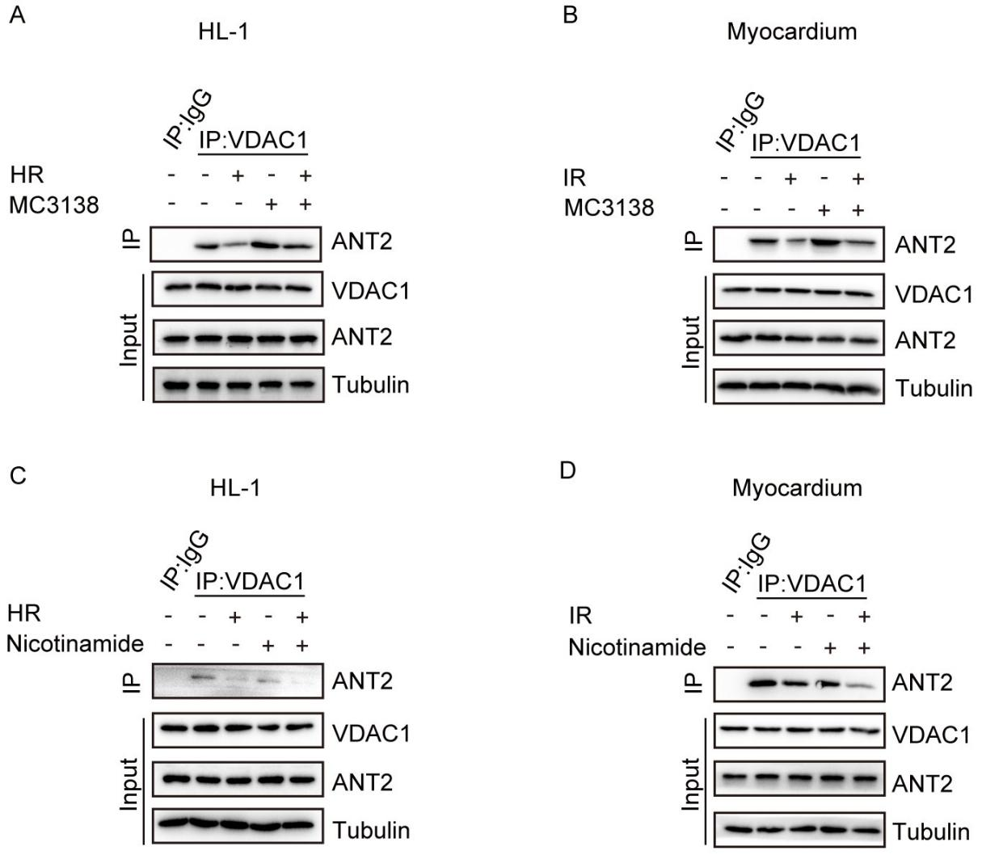
Fig. S13. Regulation of ANT2 interaction with VDAC1 by Sirt5 activator and inhibitor. (A and B) Co-IP shows that the Sirt5 activator MC3138 promotes the interaction of ANT2 with VDAC1 in HL-1 cells and mouse myocardial tissues, which is prevented by HR or IR. (C and D) Co-IP shows that the Sirt5 inhibitor nicotinamide prevents the interaction of ANT2 with VDAC1 in HL-1 cells and mouse myocardial tissues, which is further reduced by HR or IR.
Table S1. shRNA target sequences used in this study.
Sirt5-Mus-82 (1) | CCAGTTGTGTTGTAGACGA
Sirt5-Mus-142 (2) | GGCTCGTCCAAGTTCAAAT
Sirt5-Mus-313 (3) | CTTTGCTCGAAACCCATCA
SIRT5-Homo-826 | GTGGCTGAGAATTACAAGAGT
SIRT5-Homo-905 | GCATCCCAGTTGAGAAACTTC
SIRT5-Homo-1153 | GCTACGAACAGATTCAGGTT
sh-Ctrl | TTCTCCGAACGTGTCACGT

