Single-cell analysis reveals impaired Müller glia-mediated intercellular communication and photoreceptor pathology in USH1C retinal organoids

Nicole Wenck^{1,2}, Mark Zorin^{1,2}, Qiang Wang³, Selina Kröll^{1,2}, Anna Justen^{1,2}, Katharina Hay^{1,2}, Christof Rickert⁴, Maria Méndez-Lago⁵, Sivarajan Karunanithi⁵, Dimitra Athanasiou⁶, Kalliopi Ziaka⁶, Pietro De Angeli⁷, Katarina Stingl⁸, Susanne Kohl⁷, Michael E. Cheetham⁶, Thomas Mittmann³ and Kerstin Nagel-Wolfrum^{1,2,9*}

¹Institute of Developmental Biology and Neurobiology, Johannes Gutenberg-University Mainz, Mainz, Germany; ²Institute of Molecular Physiology, Johannes Gutenberg-University Mainz, Mainz, Germany; ³Institute of Physiology, University Medical Centre of Johannes Gutenberg-University Mainz, Mainz, Germany; ⁴Light Microscopy Core Facility (LMCF) of Faculty of Biology, Johannes Gutenberg-University Mainz, Mainz, Germany; ⁵Institute of Molecular Biology GmbH (IMB), Mainz, Germany; ⁶UCL Institute of Ophthalmology, University College London, London, UK; ⁷Institute for Ophthalmic Research, Centre for Ophthalmology, University of Tuebingen, Tuebingen, Germany; ⁸University Eye Hospital, Centre for Ophthalmology, University of Tuebingen, Tuebingen, Germany; ⁹Institute of Quantitative and Computational Biosciences (IQCB), Johannes Gutenberg-University Mainz, Mainz, Germany

*Corresponding Author: Dr. Kerstin Nagel-Wolfrum, Institute of Developmental Biology and Neurobiology, Institute of Molecular Physiology, and Institute of Quantitative and Computational Biosciences (IQCB), Johannes Gutenberg-University Mainz, Mainz, Germany; Hanns-Dieter-Hüsch-Weg 17, 55128 Mainz, Germany. Phone: +49 6131 39 20131; e-mail: nagelwol@uni-mainz.de

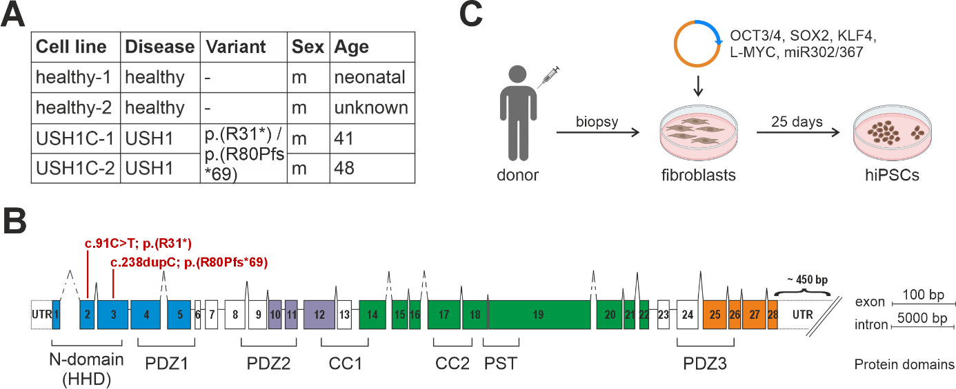
Fig. S1 Characteristics of human dermal fibroblasts. A) Fibroblast lines with corresponding disease state of the donor, pathogenic variants, sex and age at biopsy. B) Schematic of the USH1C gene. The USH1C gene consists of 28 exons that can form up to seven different protein domains. Patient-specific pathogenic variants c.91C>T; p.(R31*) and c.238dupC; p.(R80Pfs*69) are indicated in exon 2 and 3. HHD (harmonin homology domain), PDZ (PSD-95, DLG, ZO-1) domain, PST (proline–serine–threonine rich) domain, CC (coiled-coil) domain. C) hiPSCs were generated from donor fibroblasts by episomal reprogramming using the Yamanaka factors OCT3/4, SOX2, KLF4, L-MYC and miR302/367.

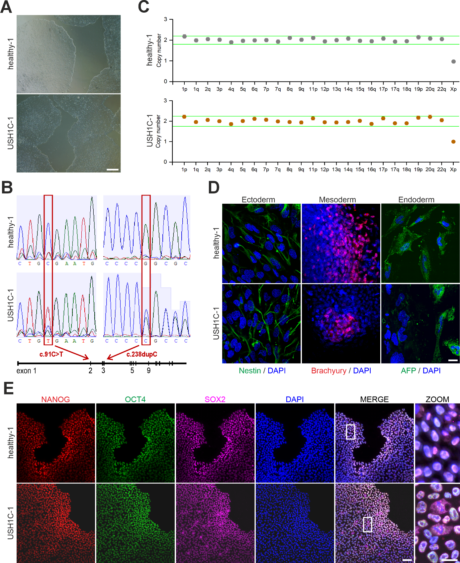
Fig. S2 Characterization of healthy-1 and USH1C-1 human induced pluripotent stem cells. A) Morphology of healthy-1 and USH1C-1 human induced pluripotent stem cell (hiPSC) colonies. Scale bar: 500 µm. B) Sanger sequencing determined the absence or presence of the c.91C>T; p.(R31*) and the c.238dupC; p.(R80Pfs*69) USH1C pathogenic variants in exon 2 and 3, respectively. C) Genomic stability of healthy-1 and USH1C-1 hiPSCs was assessed by testing for copy number variations (CNVs). D) Differentiation ability of healthy-1 and USH1C-1 hiPSCs into the three germ layers was assessed by an embryoid body (EB)-assay. Nestin was used as an ectodermal, Brachyury as a mesodermal and AFP as an endodermal marker. Scale bar: 25 µm. E) Expression of transcription factors NANOG, OCT4 and SOX2 confirmed the undifferentiated state of healthy-1 and USH1C-1 hiPSCs. Scale bars: 75 µm and 25 µm.
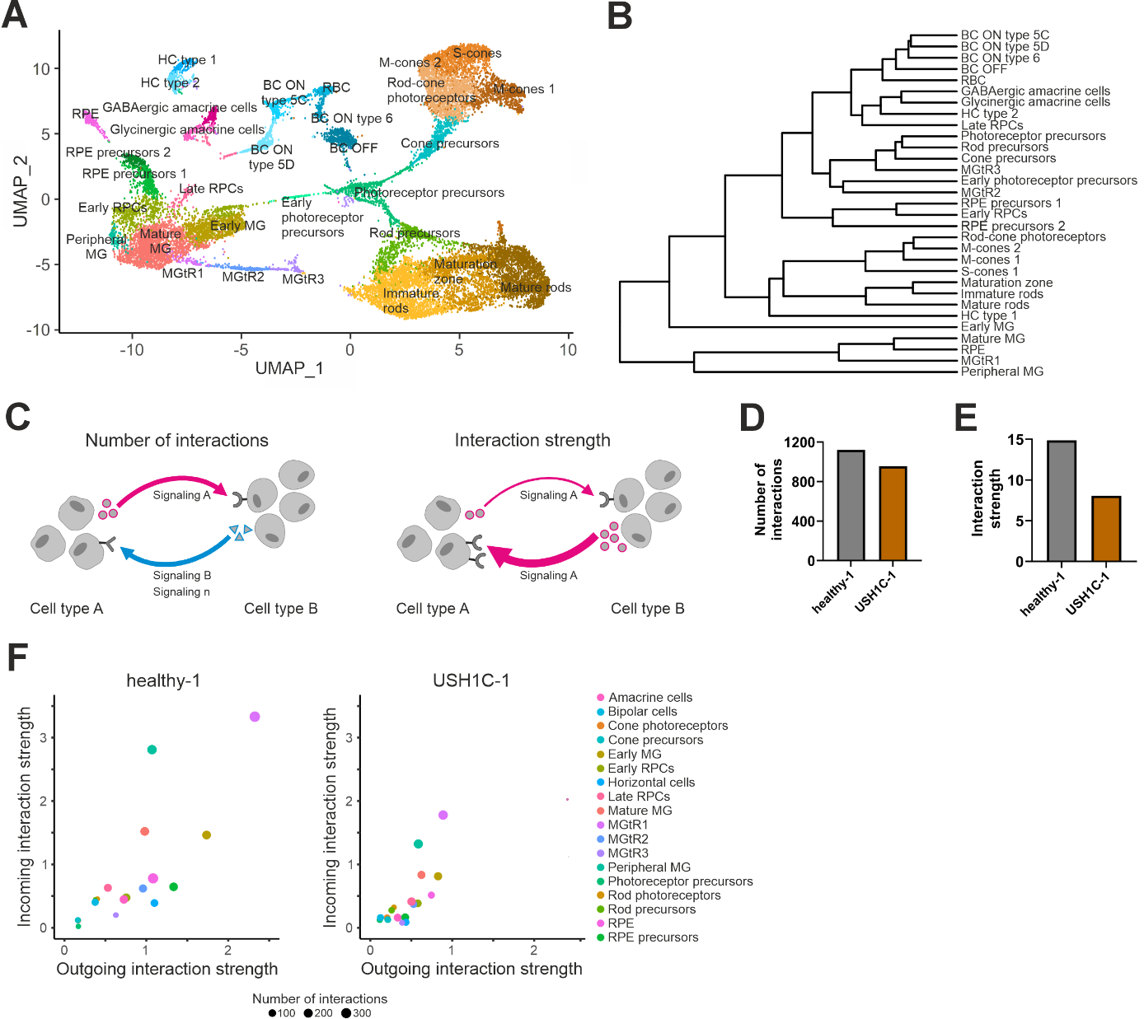
Fig. S3 Single-cell RNA sequencing of mature healthy-1 and USH1C-1 retinal organoids. A) Two-dimensional UMAP representation of the 31 different cell types identified based on the transcriptomes of 19,173 single cells. n = 4 healthy-1 and n = 3 USH1C-1 ROs. B) Dendrogram grouping cell types according to gene expression pattern similarity. C) Schematic illustrating the concept of intercellular communication. Number of interactions indicates the variety of signaling pathways (e.g., signaling A [pink], signaling B [blue], signaling n) used between cell types A and B. Interaction strength implements the relative activity with which a specific signaling pathways (e.g., signaling A [pink]) is utilized between these cell types. Arrow thickness correlates with interaction strength. D) Number of interactions and interaction strength for healthy-1 (dark grey) and USH1C-1 (dark orange) ROs. E) Number and strength of interactions for all 18 cell types in healthy-1 and USH1C-1 ROs. Outgoing interaction strength is shown on x-axis. Incoming interaction strength is shown on y-axis. The number of distinct interactions is indicated by dot size.

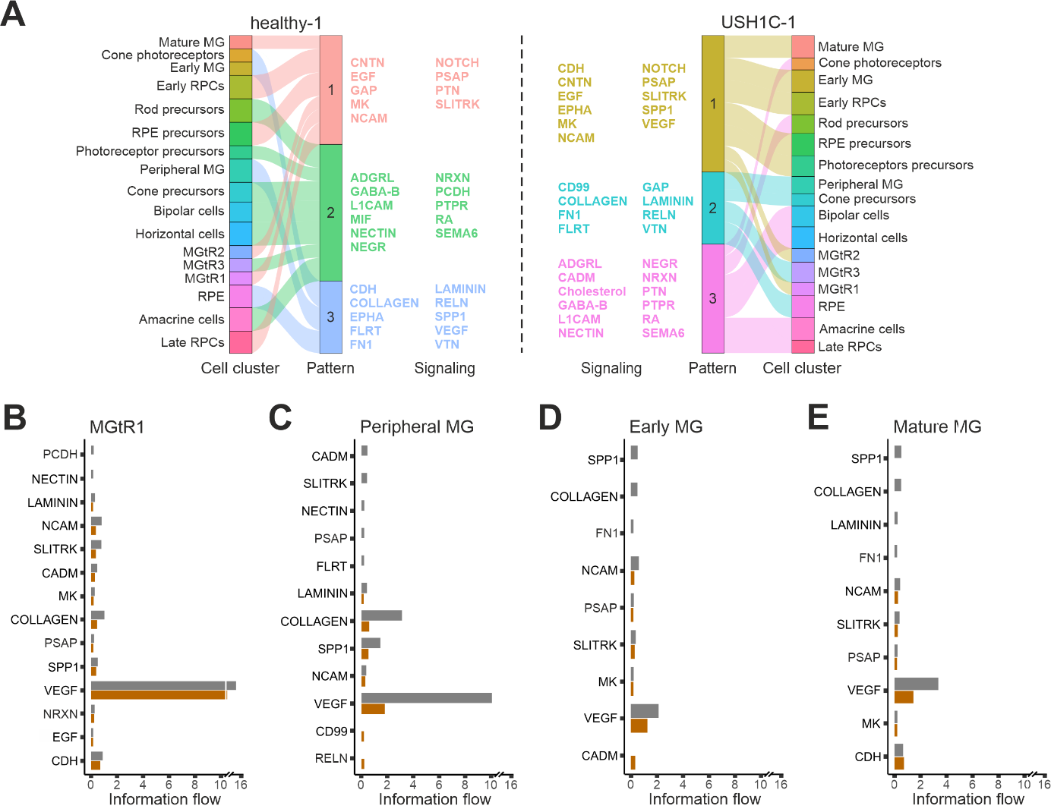
Fig. S4 Incoming intercellular signaling in mature healthy-1 and USH1C-1 retinal organoids. A) River plot grouping cell types of healthy-1 and USH1C-1 ROs according to similarities in their incoming communication. Each signaling pattern is defined by different signaling pathways. B-E) Comparison of significant differential incoming signaling pathways from MGtR1, peripheral MG, early MG and mature MG cells of healthy-1 (dark grey) and USH1C-1 (dark orange) ROs. Statistical analysis was done using Wilcoxon test.
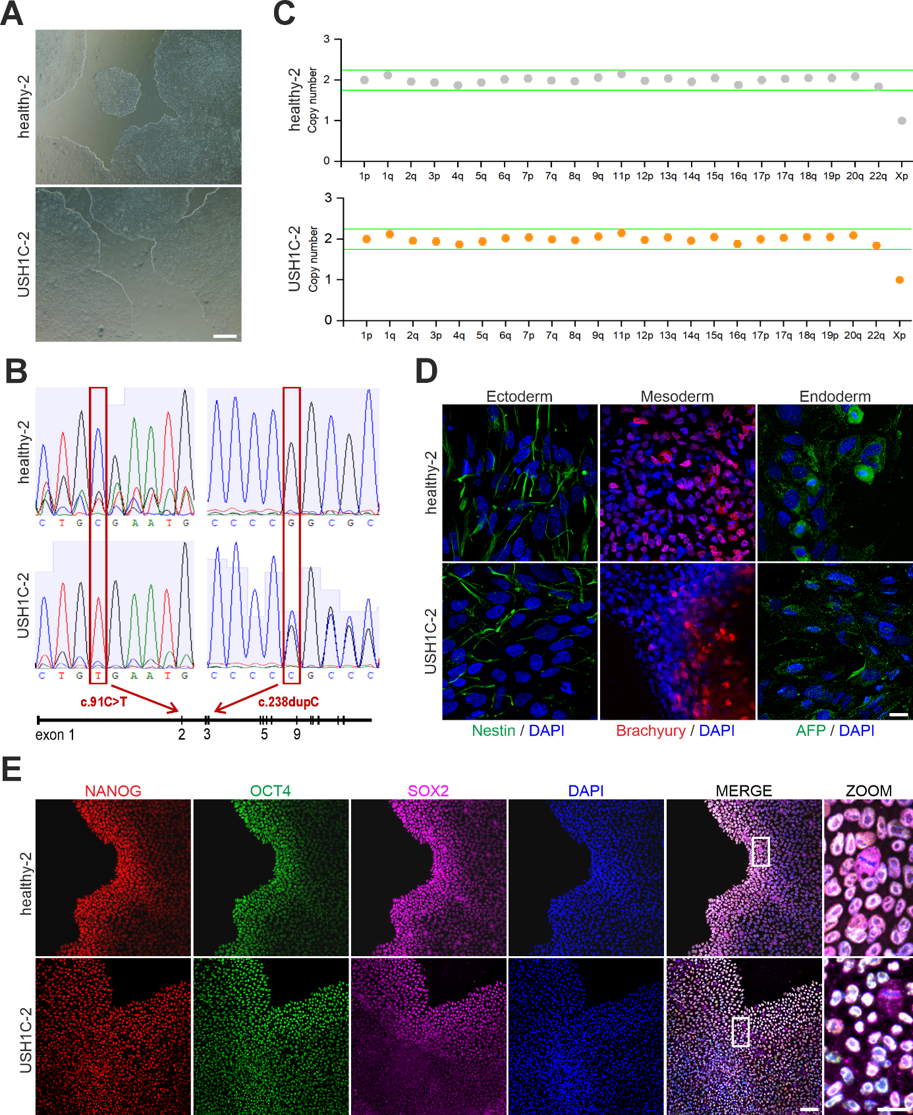
Fig. S5 Characterization of healthy-2 and USH1C-2 human induced pluripotent stem cells. A) Morphology of healthy-2 and USH1C-2 human induced pluripotent stem cell (hiPSC) colonies. Scale bar: 500 µm. B) Sanger sequencing determined the absence or presence of the c.91C>T; p.(R31*) and the c.238dupC; p.(R80Pfs*69) USH1C pathogenic variants in exon 2 and 3, respectively. C) Genomic stability of healthy-2 and USH1C-2 hiPSCs was assessed by testing for copy number variations (CNVs). D) Differentiation ability of healthy-2 and USH1C-2 hiPSCs into the three germ layers was assessed by an embryoid body (EB)-assay. Nestin was used as an ectodermal, Brachyury as a mesodermal and AFP as an endodermal marker. Scale bar: 25 µm. E) Expression of transcription factors NANOG, OCT4 and SOX2 confirmed the undifferentiated state of healthy-2 and USH1C-2 hiPSCs. Scale bars: 75 µm and 25 µm.
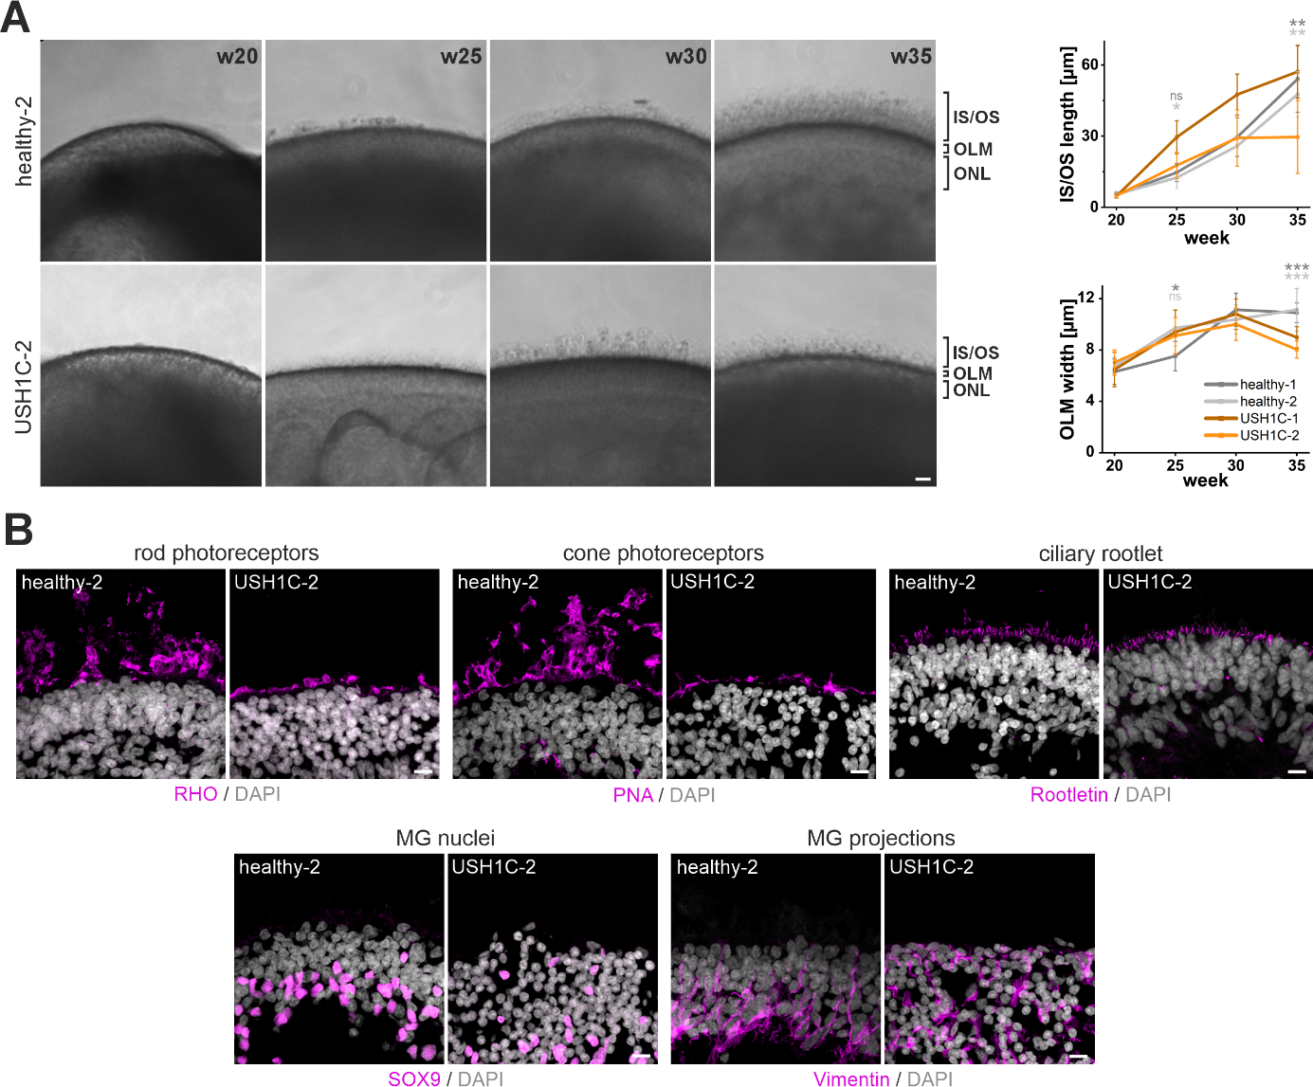
Fig. S6 Morphological characterization of healthy-2 and USH1C-2 retinal organoids. A) Representative images showing the final 15 weeks of healthy-2 and USH1C-2 RO maturation. Scale bar: 25 µm. Quantification of the IS/OS length and OLM thickness at w20, 25, 30 and 35. Independent samples t-test for n = 6-10 ROs per cell line/time point, 12 measurements per RO. Significant differences of USH1C-2 to healthy-1 and USH1C-2 to healthy-2 is indicated in dark grey and light grey asterix, respectively. B) IF-analysis of mature ROs for rod photoreceptors (RHO), cone photoreceptors (PNA), photoreceptor ciliary rootlet (Rootletin), MG cells (SOX9) and MG projections (Vimentin). Scale bar: 10 µm. n = 3 ROs.

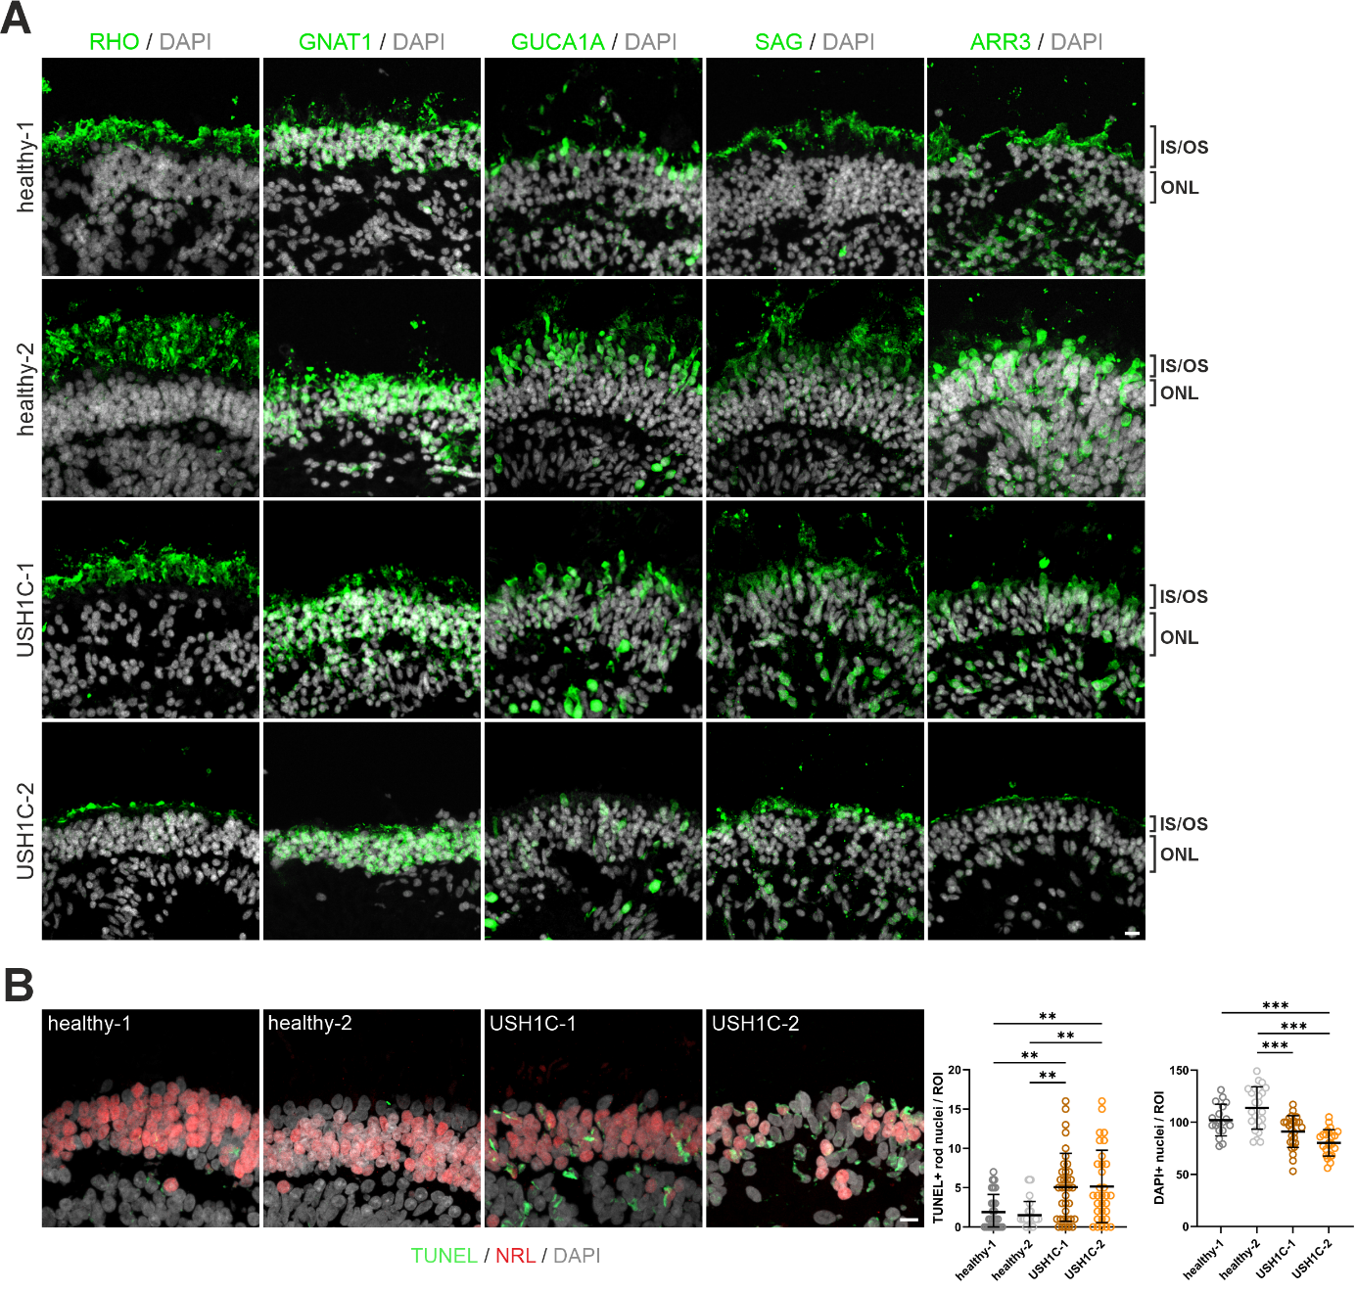
Fig. S7 Immunofluorescence analysis of phototransduction proteins in mature ROs. A) Representative unprocessed images used for IF-quantification of phototransduction proteins in mature healthy-1, healthy-2, USH1C-1 and USH1C-2 ROs. Phototransduction proteins Rhodopsin (RHO; rods), Opsin (cones), G protein subunit alpha transducin 1 (GNAT1; rods), Guanylate cyclase activator 1A (GUCA1A; rods and cones), S-antigen visual arrestin (SAG; rods) and Arrestin-3 (ARR3; cones) were stained in green. Nuclei were stained with DAPI. Scale bar: 10 µm. B) IF-analysis for apoptotic nuclei (TUNEL), rod photoreceptor nuclei (NRL) and nuclei (DAPI). Scale bar: 10 µm. Quantification of TUNEL-positive rod nuclei in the ONL. Kruskal-Wallis test for n = 3 ROs per cell line, 2-4 sections per organoid, 4 random images per section, 1 ONL-located ROI per image. Quantification of DAPI-positive nuclei in the ONL. One-way ANOVA for n = 3 ROs per cell line, 2-4 sections per organoid, 3 random images per section, 1 ONL-located ROI per image.

Table S1. Primers used for PCR.
Primer name | Sequence 5'-3' | Amplicon [bp] | Experiment
gDNA_harm_R31*_fwd | GGGTGGTCTGCATAGGTCTG | 858 | Sequencing of hiPSCs
gDNA_harm_R31*_rev | CCCTCGCAGTTGGAAAGGAA | 858 | Sequencing of hiPSCs
gDNA_harm_c238.dup_fwd | GGAAAGATCCCAACAGCCGA | 661 | Sequencing of hiPSCs
gDNA_harm_c238.dup_rev | CTGACCGCCTTTGATGAGGT | 661 | Sequencing of hiPSCs

Table S2. Primary antibodies used for immunofluorescence analysis.
Primary Antibody | Protein | Host | Dilution | Supplier | Order Number
Anti-AFP | Alpha fetoprotein | mouse | 1:200 | Sigma | WH0000174M1
Anti-ARR3 | Arrestin 3 | goat | 1:200 | Novus Biologicals | NBP1-3700
Anti-TBXT | Brachyury | goat | 1:200 | R&D Systems | AF2085
Anti-CROCC | Rootletin | rabbit | 1:100 | selfmade | [1]
Anti-CTNNB1 | Catenin beta 1 | mouse | 1:100 | Santa Cruz | sc7963
Anti-GNAT1 | G protein subunit alpha transducin 1 | rabbit | 1:250 | Proteintech | 55167-1-AP
Anti-GUCA1A | Guanylate cyclase activator 1A | rabbit | 1:200 | Proteintech | 12944-1-AP
Anti-NANOG | Nanog homeobox | goat | 1:200 | R&D Systems | AF1997
Anti-NES | Nestin | mouse | 1:200 | Novus Biologicals | NBP1-92717SS
Anti-NRL | Neural retina leucine zipper | goat | 1:200 | R&D Systems | AF-2945-SP
Anti-OCT4A | POU class 5 homeobox 1 | rabbit | 1:400 | Cell Signaling | 2840
Anti-RCVRN | Recoverin | rabbit | 1:300 | Millipore | AB5585
Anti-RHO | Rhodopsin | mouse | 1:300 | Invitrogen | MA1-722
Anti-SAG | S-antigen visual arrestin | mouse | 1:100 | selfmade | [2]
Anti-SOX2 | SRY-box transcription factor 2 | mouse | 1:500 | Santa Cruz | sc17320
Anti-SOX9 | SRY-box transcription factor 9 | rabbit | 1:100 | Abcam | ab185966
Anti-VIM | Vimentin | mouse | 1:200 | Abcam | sc32322
Table S3. Secondary antibodies and dyes used for immunofluorescence analysis.
Secondary Antibody and Dyes | Dilution | Supplier | Order Number
ALEXA 488 donkey-anti-goat | 1:400 | Abcam | 150133
CF 555 donkey-anti-goat | 1:400 | Sigma | SAB4600059
ALEXA 488 donkey-anti-mouse | 1:400 | Invitrogen | A-21202
ALEXA 647 donkey-anti-mouse | 1:400 | Invitrogen | A-31571
ALEXA 488 goat-anti-rabbit | 1:400 | Invitrogen | A-11034
CF 543 donkey-anti-rabbit | 1:400 | Biotrend | 20308-1
CF 640R donkey-anti-rabbit | 1:400 | Biotrend | 20178
4’,6-diamidino-2-phenylindole (DAPI) | 1:12000 | Roth | 6335.1
Peanut Agglutinin (PNA) | 1:400 | Invitrogen | L21409
Rhodamin-Phalloidin | 1:400 | Sigma | P1951
In Situ Cell Death Detection Kit (TUNEL) |  | Merck | 11684795910

Table S4. Overview of the experimental usage of retinal organoid lines.
Organoid line | Week | Experiments performed
healthy-1 | 35 | Initial morphological characterization, Single cell RNA-sequencing analyses, Photoreceptor IS/OS characterization, Electrophysiological analyses, TUNEL assay, SOX9+ cell characterization, OLM characterization
healthy-2 | 35 | Initial morphological characterization, Photoreceptor IS/OS characterization, TUNEL assay, SOX9+ cell characterization, OLM characterization
USH1C-1 | 35 | Initial morphological characterization, Single cell RNA-sequencing analyses, Photoreceptor IS/OS characterization, Electrophysiological analyses, TUNEL assay, SOX9+ cell characterization, OLM characterization
USH1C-2 | 35 | Initial morphological characterization, Photoreceptor IS/OS characterization, Electrophysiological analyses, TUNEL assay, SOX9+ cell characterization, OLM characterization

Table S5. Marker genes for UMAP representing 31 different cell types.
See Excel file.

Table S6. Marker genes for UMAP representing 18 different cell types.
See Excel file.

Table S7. Differential outgoing and incoming interaction strength per cell type. A decreased cellular interaction in USH1C-1 ROs compared to healthy-1 ROs is highlighted in blue. An increased cellular interaction in USH1C-1 ROs compared to healthy-1 ROs is highlighted in red.
Cell type | Differential outgoing interaction strength |  | Differential incoming interaction strength | Cell type
MGtR1 | -1.43 |  | -1.55 | MGtR1
Early MG | -0.91 |  | -1.49 | Peripheral MG
RPE precursors | -0.91 |  | -0.69 | Mature MG
Horizontal cells | -0.66 |  | -0.65 | Early MG
Peripheral MG | -0.48 |  | -0.48 | RPE precursors
MGtR2 | -0.43 |  | -0.30 | Horizontal cells
Amacrine cells | -0.39 |  | -0.29 | Amacrine cells
Mature MG | -0.36 |  | -0.26 | RPE
RPE | -0.34 |  | -0.25 | MGtR2
Bipolar cells | -0.25 |  | -0.24 | Bipolar cells
MGtR3 | -0.24 |  | -0.22 | Late RPCs
Early RPCs | -0.17 |  | -0.17 | Rod precursors
Rod precursors | -0.11 |  | -0.13 | Rod photoreceptors
Rod photoreceptors | -0.11 |  | -0.12 | MGtR3
Photoreceptor precursors | -0.05 |  | -0.09 | Early RPCs
Late RPCs | -0.03 |  | 0.01 | Cone precursors
Cone photoreceptors | 0.04 |  | 0.04 | Cone photoreceptors
Cone precursors | 0.05 |  | 0.10 | Photoreceptor precursors

Table S8. Differential number of interactions per cell type. A decreased cellular interaction in USH1C-1 ROs compared to healthy-1 ROs is highlighted in blue. An increased cellular interaction in USH1C-1 ROs compared to healthy-1 ROs is highlighted in red.
Cell type | Differential number of interactions
MGtR1 | -107
MGtR2 | -52
Mature MG | -51
RPE precursors | -46
Amacrine cells | -44
Early MG | -39
Early RPCs | -36
Horizontal cells | -35
Peripheral MG | -29
Bipolar cells | -13
RPE | -12
MGtR3 | 3
Rod photoreceptors | 6
Photoreceptor precursors | 20
Cone precursors | 23
Late RPCs | 27
Cone photoreceptors | 34
Rod precursors | 34

Table S9. Signaling pathways of MG subtypes related to retinal adhesion. Signaling is associated with different protein families that fullfil functions related to ECM-receptor interaction, focal adhesion, cell adhesion and adherens junctions.
Signaling | Function | Literature
CADM | Cell adhesion molecules. | KEGG pathway database
CDH | Cell adhesion molecules, adherens junction. Tissue morphogenesis, neural circuit formation, neuronal survival, photoreceptor development and maintenance. CDH mutations are associated with cone-rod dystrophy, rod-cone dystrophy. CDH23 mutations are associated with Usher syndrome type 1D. | KEGG pathway database; [3]
CD99 | Cell adhesion molecules. | KEGG pathway database
CNTN | Cell adhesion molecules. Neural cell migration, axon guidance. | KEGG pathway database; [4]
Collagen | ECM-receptor interaction. ECM component. Maintenance of structural strength of connective tissues. | KEGG pathway database; [5]
FLRT | Cell adhesion molecules. | [6]
FN1 | ECM-receptor interaction, regulation of actin cytoskeleton, Focal adhesion. Serves as a template for assembly of other ECM proteins. | KEGG pathway database; [7, 8]
Laminin | ECM-receptor interaction. ECM Component. Maintenance of structural integrity. | KEGG pathway database; [8, 9]
NCAM | Cell adhesion molecules. Cell interaction, cell migration, axon growth, synaptic plasticity, regeneration. | KEGG pathway database; [10, 11]
NECTIN | Cell adhesion molecules, adherens junction. | KEGG pathway database
NRXN | Cell adhesion molecules. Synapse formation, synapse regulation. | KEGG pathway database; [12]
PCDH | Cell adhesion molecules. PCDH15 mutations are associated with Usher syndrome type 1D. | [13]
PTPR | Cell adhesion molecules, adherens junction. | KEGG pathway database
RELN | ECM-receptor interaction, focal adhesion. | KEGG pathway database; [14]
SLITRK | Cell adhesion molecules. Synapse formation. | KEGG pathway database; [15]
SPP1 | ECM-receptor interaction, focal adhesion. | KEGG pathway database

Table S10. DEG analysis for UMAP representing 18 different cell types.
See Excel file.

Table S11. Number of identified DEGs per cell type.
Cell type | Number of DEGs
Rod photoreceptors | 253
Cone photoreceptors | 233
Mature MG | 192
RPE precursors | 110
Bipolar cells | 98
Early RPCs | 96
Early MG | 81
Rod precursors | 24
Cone precursors | 23
Horizontal cells | 19
RPE | 12
MGtR2 | 9
Amacrine cells | 7
Photoreceptor precursors | 7
MGtR3 | 4
Peripheral MG | 2
Late RPCs | 1
MGtR1 | 1

Table S12. GO-term and KEGG analysis based on DEGs.
See Excel file.

Table S13. DEGs related to phototransduction in rod and cone photoreceptors. DEGs associated with phototransduction in rod and cone photoreceptors were identified either automatically using ClueGO or manually via literature research. A drecreased gene expression in USH1C-1 ROs compared to healthy-1 ROs is highlighted in blue. An increased gene expression in USH1C-1 ROs compared to healthy-1 ROs is highlighted in red.
 | Rod photoreceptors | Cone photoreceptors
Automatically identified DEGs related to phototransduction | GNAT1 | GNAT2
Automatically identified DEGs related to phototransduction | GRK1 | GUCA1B
Automatically identified DEGs related to phototransduction | PDE6A | PDE6B
Automatically identified DEGs related to phototransduction | PDE6G
Automatically identified DEGs related to phototransduction | RHO
Automatically identified DEGs related to phototransduction | SAG
Automatically identified DEGs related to phototransduction | GNGT1
Automatically identified DEGs related to phototransduction | RCVRN
Manually identified DEGs related to phototransduction | GUCA1A | ARR3
Manually identified DEGs related to phototransduction | GNB3 | GNB3
Manually identified DEGs related to phototransduction | PDE6H | GNGT2
Manually identified DEGs related to phototransduction |  | OPN1MW3
Manually identified DEGs related to phototransduction |  | PDE6H
Manually identified DEGs related to phototransduction |  | OPN1MW

References
1. Yang J, Liu X, Yue G, et al (2002) Rootletin, a novel coiled-coil protein, is a structural component of the ciliary rootlet. J Cell Biol 159:431–440. https://doi.org/10.1083/jcb.200207153
2. Lieb WE, Smith-Lang L, Dua HS, et al (1991) Identification of an S-antigen-like molecule in Drosophila melanogaster: An immunohistochemical study. Exp Eye Res 53:171–178. https://doi.org/10.1016/0014-4835(91)90071-L
3. Yusuf IH, Garrett AM, MacLaren RE, Charbel Issa P (2022) Retinal cadherins and the retinal cadherinopathies: Current concepts and future directions. Prog Retin Eye Res 90:101038. https://doi.org/10.1016/j.preteyeres.2021.101038
4. Mohebiany AN, Harroch S, Bouyain S (2014) New Insights into the Roles of the Contactin Cell Adhesion Molecules in Neural Development. In: Berezin V, Walmod P (eds) Cell Adhesion Molecules. Advances in Neurobiology. Springer, New York, NY, pp 165–194
5. Ihanamäki T, Pelliniemi LJ, Vuorio E (2004) Collagens and collagen-related matrix components in the human and mouse eye. Prog Retin Eye Res 23:403–434. https://doi.org/10.1016/j.preteyeres.2004.04.002
6. Seiradake E, del Toro D, Nagel D, et al (2014) FLRT Structure: Balancing Repulsion and Cell Adhesion in Cortical and Vascular Development. Neuron 84:370–385. https://doi.org/10.1016/j.neuron.2014.10.008
7. Miller CG, Budoff G, Prenner JL, Schwarzbauer JE (2017) Minireview: Fibronectin in retinal disease. Exp Biol Med 242:1–7. https://doi.org/10.1177/1535370216675245
8. Prieto-López L, Pereiro X, Vecino E (2024) The mechanics of the retina: Müller glia role on retinal extracellular matrix and modelling. Front Med (Lausanne) 11:1393057. https://doi.org/10.3389/fmed.2024.1393057
9. Dorgau B, Felemban M, Sharpe A, et al (2018) Laminin γ3 plays an important role in retinal lamination, photoreceptor organisation and ganglion cell differentiation. Cell Death Dis 9:615. https://doi.org/10.1038/s41419-018-0648-0
10. Parcerisas A, Ortega-Gascó A, Pujadas L, Soriano E (2021) The Hidden Side of NCAM Family: NCAM2, a Key Cytoskeleton Organization Molecule Regulating Multiple Neural Functions. Int J Mol Sci 22:10021. https://doi.org/10.3390/ijms221810021
11. Lobanovskaya N, Zharkovsky T, Jaako K, et al (2015) PSA modification of NCAM supports the survival of injured retinal ganglion cells in adulthood. Brain Res 1625:9–17. https://doi.org/10.1016/j.brainres.2015.08.008
12. Tian Y, Li T, Sun M, et al (2013) Neurexin Regulates Visual Function via Mediating Retinoid Transport to Promote Rhodopsin Maturation. Neuron 77:311–322. https://doi.org/10.1016/j.neuron.2012.11.012
13. Pancho A, Aerts T, Mitsogiannis MD, Seuntjens E (2020) Protocadherins at the Crossroad of Signaling Pathways. Front Mol Neurosci 13:00117. https://doi.org/10.3389/fnmol.2020.00117
14. Rice DS, Nusinowitz S, Azimi AM, et al (2001) The Reelin Pathway Modulates the Structure and Function of Retinal Synaptic Circuitry. Neuron 31:929–941. https://doi.org/10.1016/S0896-6273(01)00436-6
15. Schroeder A, de Wit J (2018) Leucine-rich repeat-containing synaptic adhesion molecules as organizers of synaptic specificity and diversity. Exp Mol Med 50:1–9. https://doi.org/10.1038/s12276-017-0023-8

