Supplementary Materials for

Matrix stiffness induced CREB3L1 activation contributed to skin fibrosis through calcium influx triggered endoplasmic reticulum stress
Dongsheng Wen et al.
Corresponding authors: Yangdan Liu, liuyangdan5375@163.com; Qingfeng Li, dr.liqingfeng@shsmu.edu.cn; Yifan Zhang, zhangyifan82@126.com.

The file includes:
Figs. S1 to S4
Legends for Supplementary Movie 1 to 3
Other Supplementary Material for this manuscript includes the following:
Supplementary Movie 1 to 3

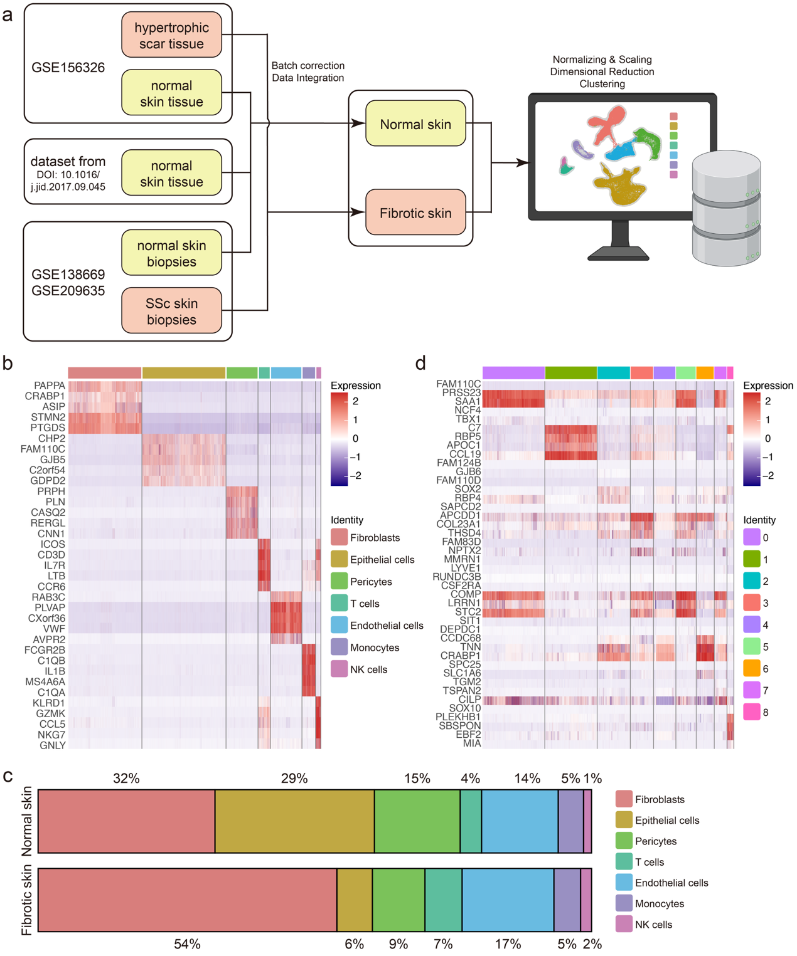
Figure S1. Bioinformatic analysis workflow and single-cell transcriptomic atlas characterization. (a) Schematic workflow of integrated single-cell sequencing analysis of normal skin, hypertrophic scar, and systemic sclerosis skin samples. (b) Heatmap displaying the top differentially expressed genes for each cell type. (c) Proportional composition of each cell type in normal versus fibrotic skin samples. (d) Heatmap displaying the top differentially expressed genes across each Seurat clusters of fibroblasts.
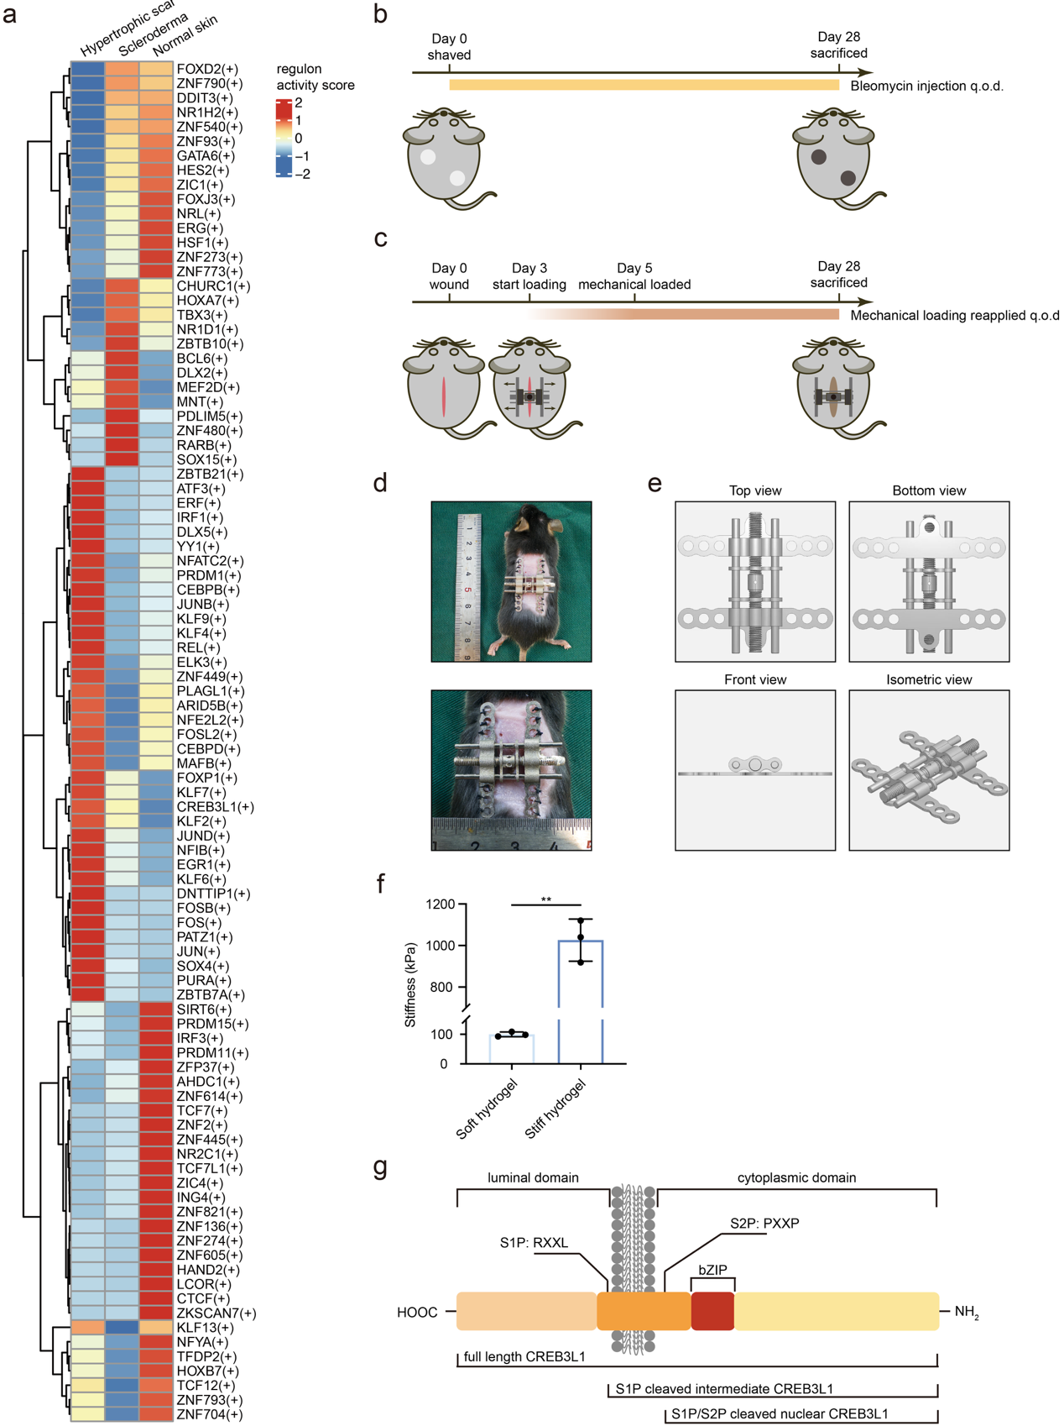
Figure S2. SCENIC analysis identified CREB3L1 as a profibrotic TF. (a) Heatmap displaying the complete TF-target gene interactions identified by SCENIC analysis. (b) Schematic timeline of the bleomycin induced skin fibrosis model and (c) mechanical loading induced skin fibrosis model. (d) Illustration and (e) three-view orthographic diagram of the mechanical loading device. (f) Quantification of Young’s modulus of soft and stiff hydrogels. (g) Domain architecture of human CREB3L1 protein, including the bZIP DNA-binding domain and S1P/S2P cleavage site. ** P < 0.01
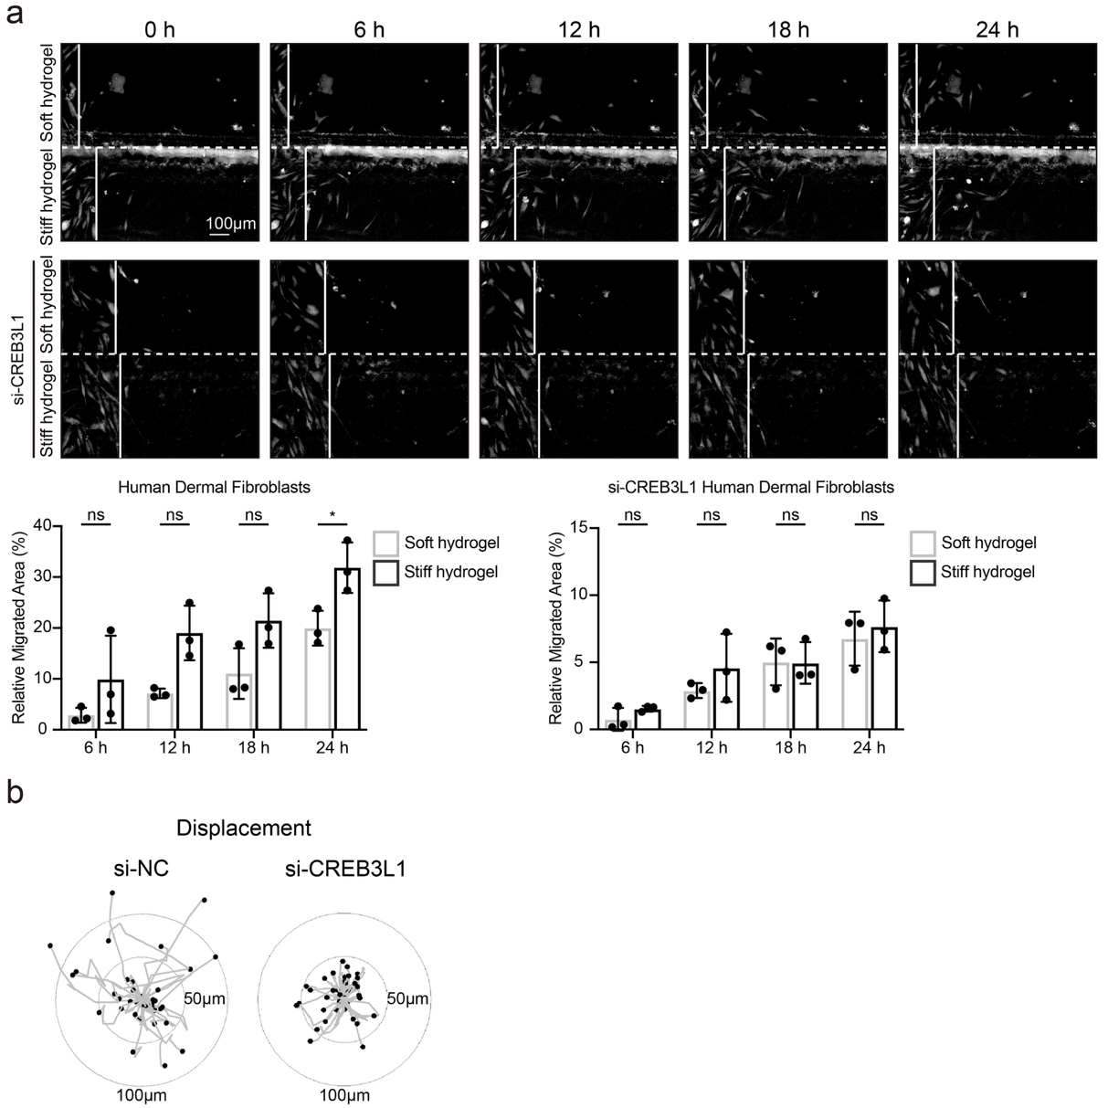
Figure S3. CREB3L1 depletion diminished the migratory capacity of fibroblasts. (a) Representative images and quantification of wound healing assays of human dermal fibroblasts and CREB3L1 knockdown fibroblasts cultured on hydrogels with different (soft and stiff) stiffness for the indicated times. White solid lines indicated the initial edge of fibroblasts. White dashed line indicated the interface between soft and stiff hydrogel. The relative migrated area (%) was calculated as: migrated area / the area from the initial edge of fibroblasts to the right margin of the field of view. (b) Single-cell trajectory plots showing migration paths of fibroblasts with CREB3L1 depletion and negative control. Trajectories were aligned to a common origin. * P < 0.05, ns = not significant.
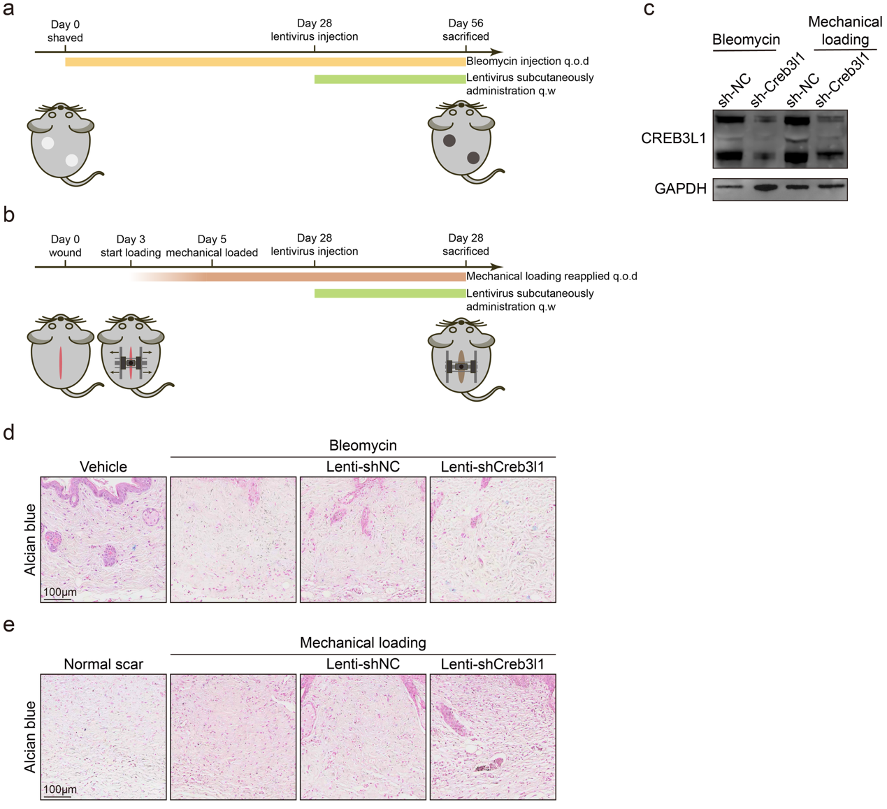
Figure S4. Schematic of skin fibrosis model and in vivo Creb3l1 knockdown. (a) Schematic timeline of the bleomycin induced skin fibrosis model and (b) mechanical loading induced skin fibrosis model established on negative control and Creb3l1 knockdown mice. (c) Western blot analysis of CREB3L1 expression in bleomycin induced and mechanical loading induced fibrotic skin transfected with sh-Creb3l1 or sh-NC lentivirus. (d) Representative images of Alcian blue staining of mouse skin from vehicle (PBS) or bleomycin injection and with sh-NC or sh-Creb3l1 lentivirus administration. (e) Representative images of Alcian blue staining of mouse skin following incision with or without mechanical loading and with sh-NC or sh-Creb3l1 lentivirus administration.
Supplementary Movie 1. Video recording of human dermal fibroblasts migration on soft and stiff hydrogel. Representative phase contrast images of fibroblasts at 0h, 6h, 12h, 18h, 24h and annotation were shown in Figure. S3a. The soft hydrogel was located above the horizontal boundary line, whereas stiff hydrogel was located below the horizontal boundary line. The time interval between each phase contrast images was 1 hour.

Supplementary Movie 2. Video recording of CREB3L1 knockdown human dermal fibroblasts migration on soft and stiff hydrogel. Representative phase contrast images of fibroblasts at 0h, 6h, 12h, 18h, 24h and annotation were shown in Figure. S3a. The soft hydrogel was located above the horizontal boundary line, whereas stiff hydrogel was located below the horizontal boundary line. The time interval between each phase contrast images was 1 hour.

Supplementary Movie 3. Video recording of CREB3L1 knockdown and negative control human dermal fibroblasts migration on stiff hydrogel. Representative phase contrast images of fibroblasts at 0h, 6h, 12h, 18h, 24h and annotation were shown in Figure. 3e. The negative control fibroblasts were seeded on the left margin of the field of view, whereas CREB3L1 knockdown fibroblasts were seeded on the right margin. The time interval between each phase contrast images was 1 hour.

