Supplement files
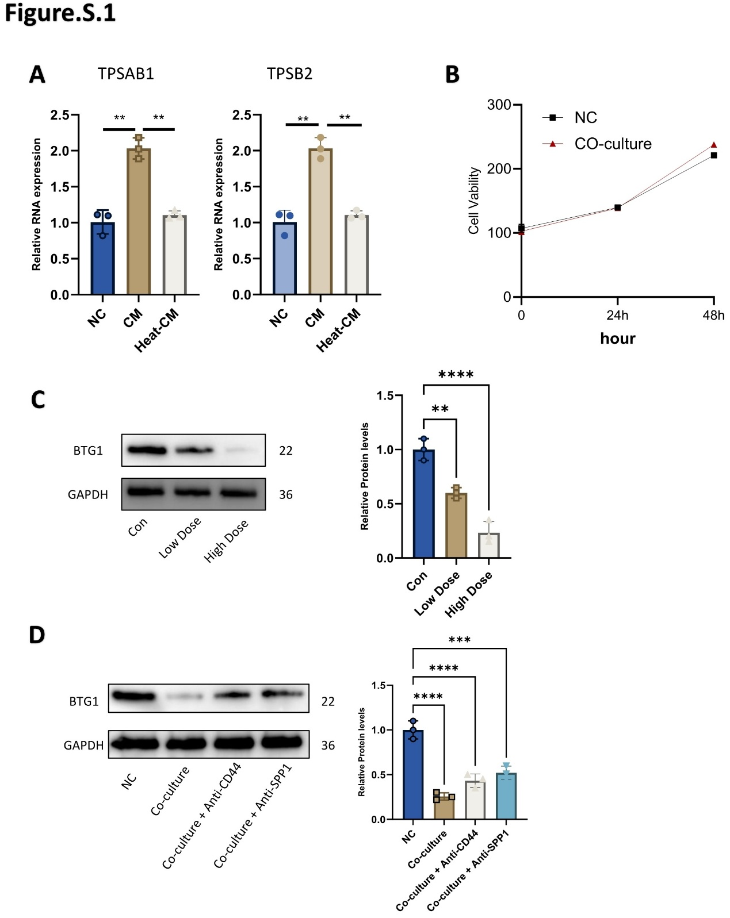
Figure Supplementary 1. TPSAB1/TPSB2 expression, cell viability, and BTG1 protein levels under co-culture or dose treatments. (A) Relative mRNA expression of TPSAB1 and TPSB2 in NC and co-culture groups. (B) Cell viability measured in NC and co-culture groups. (C) Western blot analysis of BTG1 protein levels under low-dose and high-dose SPP1 treatment, GAPDH as control. (D) Western blot analysis of BTG1 protein levels under co-culture, anti-SPP1 and anti-CD44 treatment, GAPDH as control. Student’s t-test was used to compare two groups. Data are presented as means ± SD of three independent experiments. *p < 0.05, **p < 0.01, ***p < 0.001, ****p < 0.0001.
Table 1 Clinical feature of the included CRC patients
No. | Sex | Age | T | N | M | Tumor stage | Site | Source
1 | F | 52 | T2 | N1 | M1 | IV | colon | primary
2 | M | 57 | T4 | N1 | M1 | IV | colon | primary
3 | M | 54 | T4 | N0 | M1 | IV | colon | primary
4 | F | 46 | T2 | N0 | M1 | Ⅳ | colon | primary
5 | M | 63 | T4 | N2 | M1 | IV | colon | primary
6 | F | 67 | T4 | N2 | M1 | IV | colon | primary
7 | F | 51 | T4 | N1 | M1 | IV | colon | primary
8 | M | 62 | T4 | N1 | M1 | IV | colon | primary
9 | F | 80 | T4 | N1 | M1 | IV | colon | primary
10 | M | 80 | T4 | N1 | M1 | IV | colon | primary
11 | M | 60 | T4 | Nx | M1 | IV | colon | primary
12 | F | 69 | T4 | N0 | M1 | IV | colon | primary
13 | M | 60 | T3 | N1 | M1 | IV | colon | primary
14 | M | 77 | T4 | N2 | M1 | IV | colon | primary
15 | F | 85 | T4 | N1 | M1 | IV | colon | primary
16 | M | 72 | T4 | N1 | M1 | Ⅳ | colon | primary
17 | F | 72 | T4 | N0 | M1 | IV | colon | primary
18 | M | 60 | T4 | N2 | M1 | IV | colon | primary
19 | M | 64 | T4 | N1 | M1 | IV | rectal | primary
20 | M | 85 | T4 | N0 | M1 | IV | colon | metastasis
21 | F | 69 | T4 | N3 | M1 | IV | colon | metastasis
22 | M | 70 | T4 | N2 | M1 | IV | rectal | metastasis
23 | F | 62 | T4 | N1 | M1 | IV | colon | metastasis
24 | M | 51 | T4 | N0 | M1 | IV | rectal | metastasis
25 | M | 61 | T4 | N0 | M1 | IV | rectal | metastasis
26 | M | 70 | T4 | N0 | M1 | IV | colon | metastasis

Table S2 Silence sequence of BTG1
Silence | Sequence
BTG1
NC | TTCTCCGAACGTGTCACGTAA
siRNA1 | CGGGTTACCGTTGTATTCGCATCAA
siRNA2 | GCTGTTCAGGCTTCTCCCAAGTGAA
siRNA3 | CAAATGGTAGACAGCCGAATCAGCT

Table S3 RT-qPCR sequence of each gene
 | Direction | Sequence | Product size (bp)
TPSB2 | FORWARD | 5’- GACCGGACGTCAAGGATCTG-3’ | 113
TPSB2 | REVERSE | 5’- GTAGAACTGTGGGTGCACGA-3’ | 113
TPSAB1 | FORWARD | 5’- GGCCCATACTGGATGCACTT-3’ | 152
TPSAB1 | REVERSE | 5’- AGCAGCTGGTCCTGGTAGTA-3’ | 152
CD44 | FORWARD | 5’- GTTAAGTGCCTGGGGAGTCC -3’ | 150
CD44 | REVERSE | 5’- GCCACAAAGGACTTGCCAAG -3’ | 150
SPP1 | FORWARD | 5’- AGCAGAATCTCCTAGCCCCA -3’ | 107
SPP1 | REVERSE | 5’- CTGGCTGTCCACATGGTCAT -3’ | 107
JUN | FORWARD | 5’- ACTCTTTCTGGCCTGCCTTC -3’ | 149
JUN | REVERSE | 5’- ACAAACAACACTGGGCAGGA -3’ | 149
BTG1 | FORWARD | 5’- CCATCGCTCGTCTCTTCCTC -3’ | 119
BTG1 | REVERSE | 5’- AGGCTGAGAGGAAGAGAGGG -3’ | 119
MKI67 | FORWARD | 5’- TGGCCTTCCCCTACGGATTA-3’ | 135
MKI67 | REVERSE | 5’- CCTTCCAAACAAGCAGGTGC-3’ | 135
GAPDH | FORWARD | 5’-GTGGACCTGACCTGCCGTCTAG-3’ | 149
GAPDH | REVERSE | 5’-GAGTGGGTGTCGCTGTTGAAGTC-3’ | 149

