Supplementary figures-

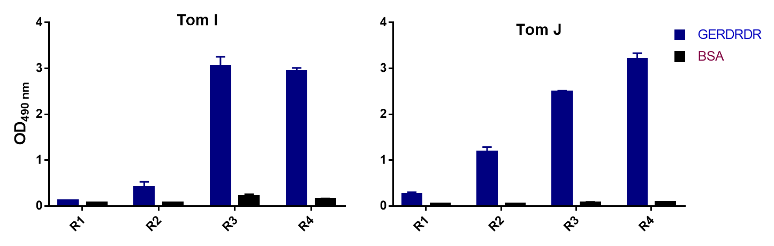
Figure S1. Binding of polyclonal phages against GERDRDR by ELISA. Amplified phages from each round of biopanning were used to assess their binding to GERDRDR via a human-based scFv library.
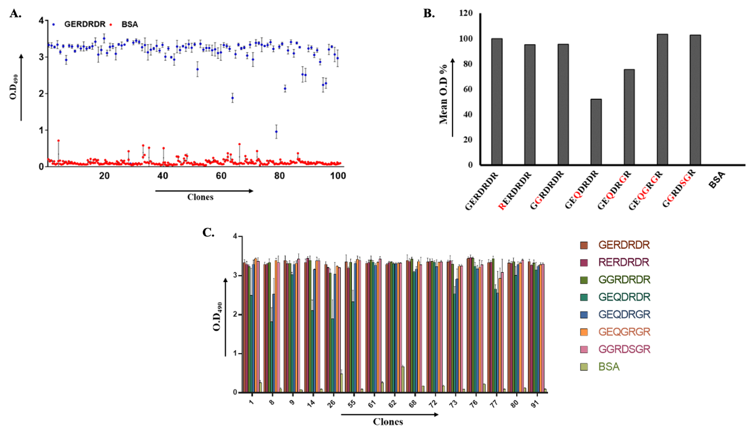
Figure S2. Selection and binding analysis of cross-reactive phage clones targeting GERDRDR A. Selection of high-affinity monoclonal phages from the 384 isolated phages against GERDRDR. The error bar represents the standard deviation from the 3 replicates B. Analysis of the mean O.D. percentage of scFv phages against the native epitope and all the variants showing cross-reactivity. The mean O.D. value percentage is 100% for the native epitope and 0% for BSA. C. Binding of 15 selected phage clones against all the GERDRDR variants by ELISA. Data from the previous 98 phage clones showing cross-reactivity are plotted in Figure 2B
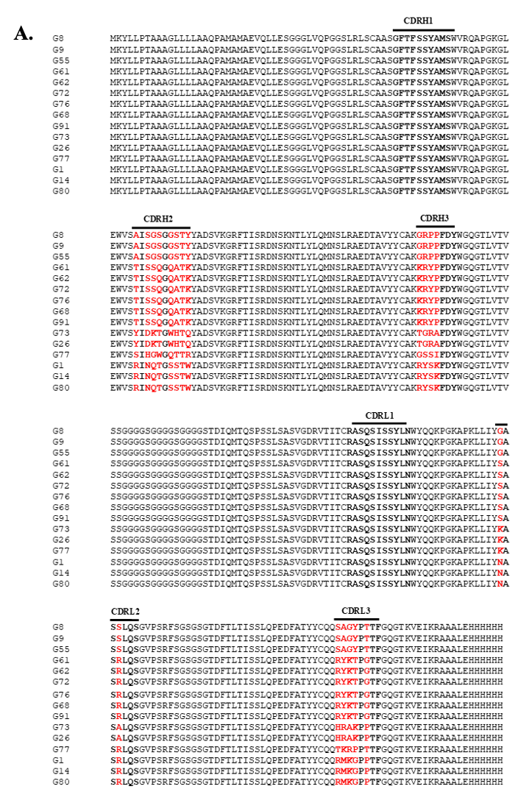
Figure S3. Sequence analysis of selected anti-GERDRDR clones. Multiple sequence alignment of 15 selected high-affinity binders showing diversity in the CDR regions.
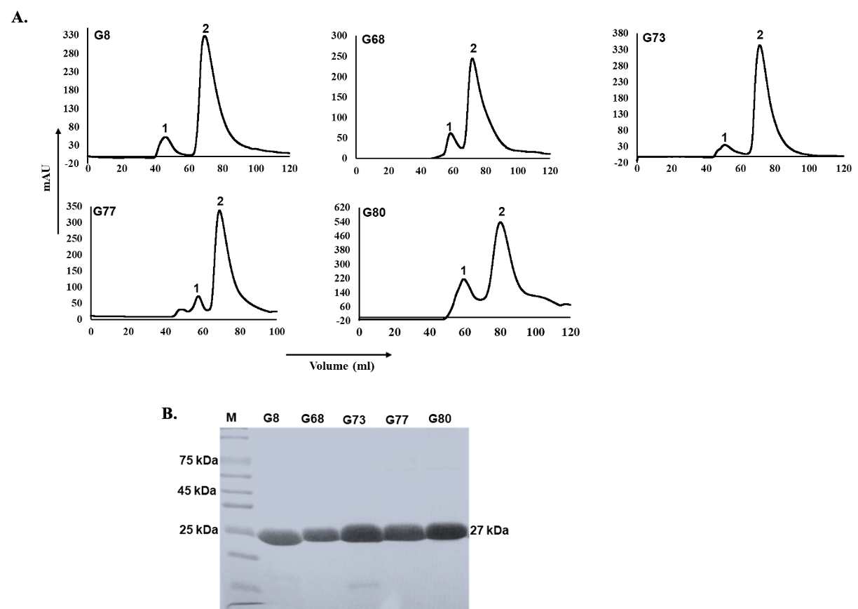
Figure S4. Purification profile of scFvs. A. Chromatogram representing the purification of each scFvs by gel filtration chromatography using HiLoad 16/60 Superdex 75 prep grade column. Peak 1 corresponds to the void volume, and peak 2 represents the scFv eluted at 70 ml retention volume. B. Coomassie-stained SDS-PAGE gel displaying peak 2 for each case, representing the scFv at 27 kDa.

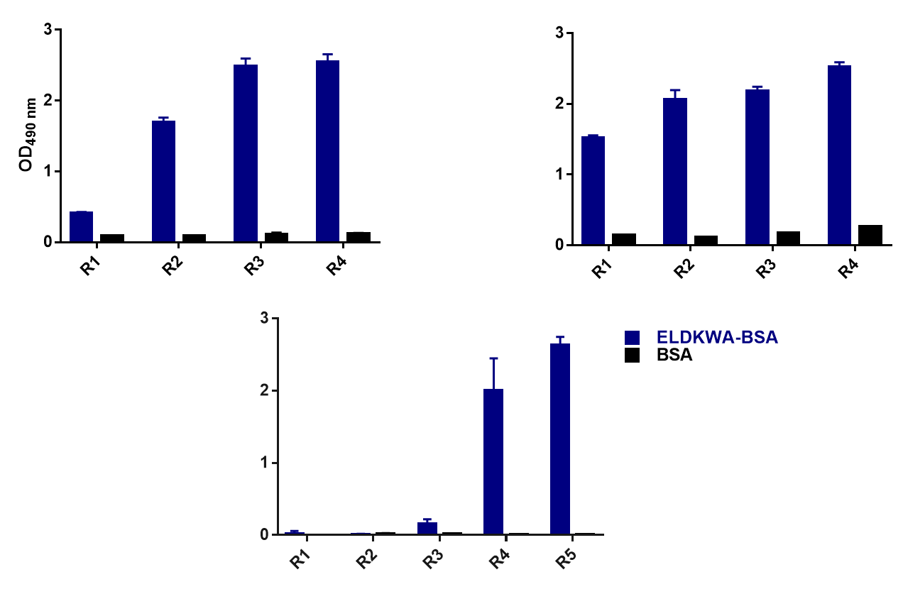
Figure S5. Binding of polyclonal phages against ELDKWA by ELISA. Amplified phages from each round of biopanning were used to check binding against ELDKWA via a human-based scFv library.
HuScL4
Tom J
Tom I

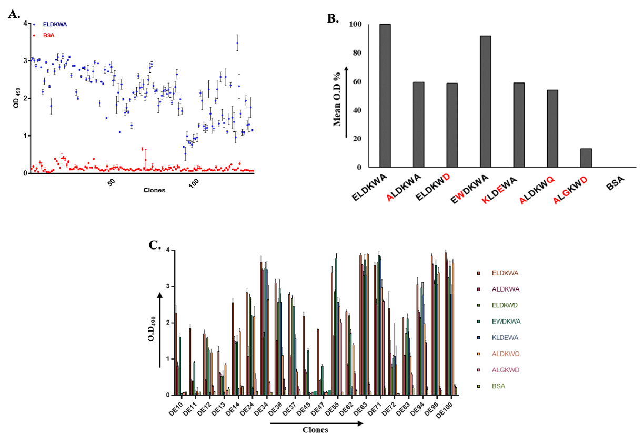
Figure S6. Selection and binding analysis of cross-reactive phage clones targeting ELDKWA A. Selection of high-affinity monoclonal phages from the isolated 1150 phages against ELDKWA. The error bar represents the standard deviation from the 3 replicates. B. Analysis of the mean O.D. percentage of scFv phages against the native epitope and all the variants showing cross-reactivity. C. Binding of 20 selected phage clones against all the variants of ELDKWA by ELISA. Data from the previous 80 phage clones showing cross-reactivity are plotted in Figure 4B.

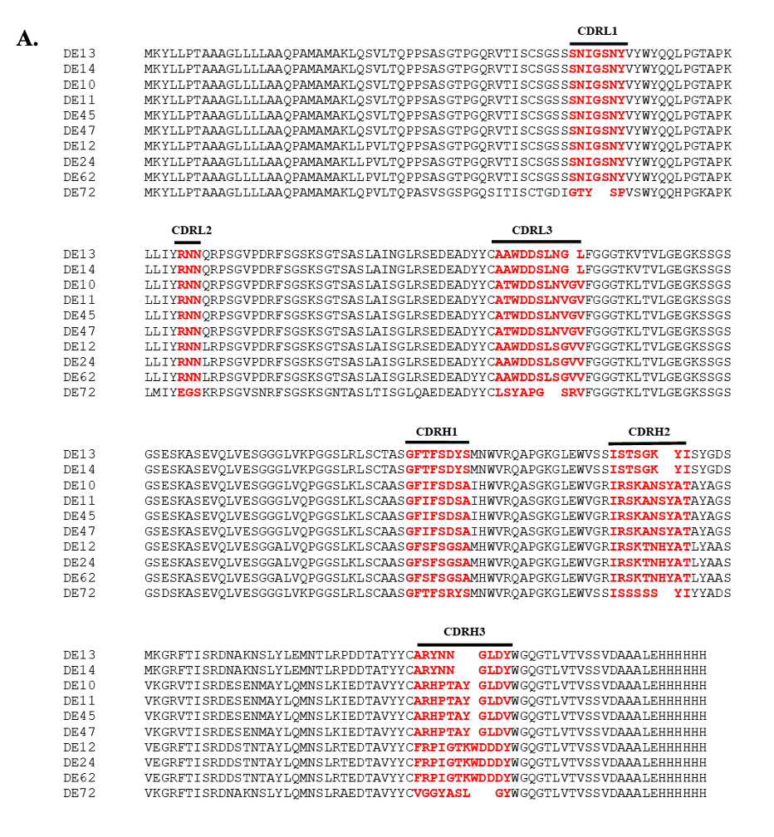
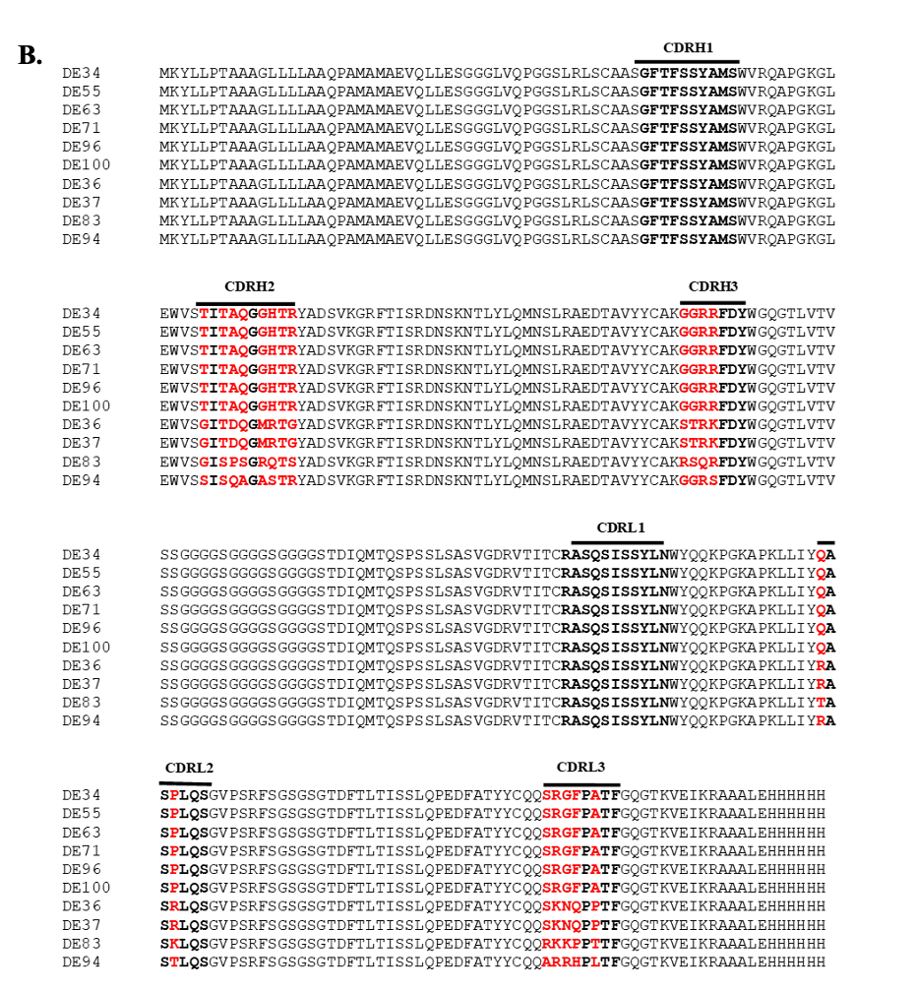Figure S7. Multiple sequence alignment of anti-ELDKWA scFvs. The sequences of all the scFvs were aligned via Clustal omega. Amino acid differences in the CDRs of the scFvs are highlighted in red, and consensus sequences are shown in black. A. Ten scFvs are in the VL-VH format, while B. the other ten scFvs are in the VH-VL format.
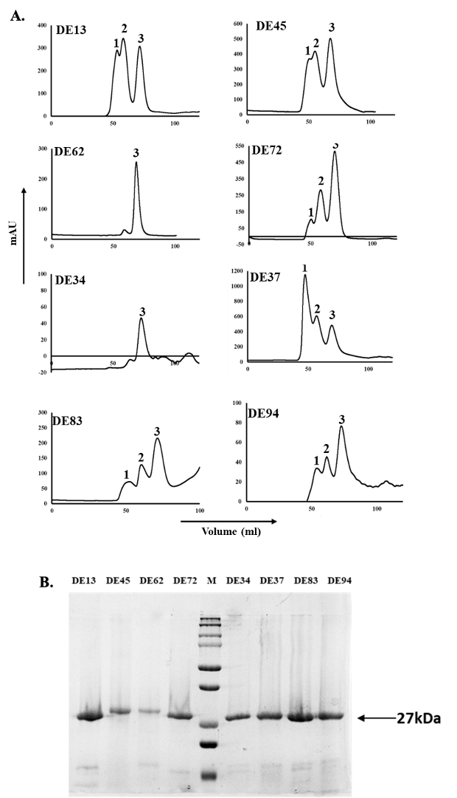
Figure S8. Purification profile of scFvs. A. Gel filtration chromatography profile of the scFvs using HiLoad 16/60 Superdex 75 prep grade column. Peak 1 represents the column void volume, peak 2 corresponds to the oligomeric form of scFv, and peak 3 represents the scFv monomeric form at a retention volume of 70-75 ml. B. Coomassie-stained SDS‒PAGE gel displaying peak 3 for each case, representing the scFv at ̴27 kDa.
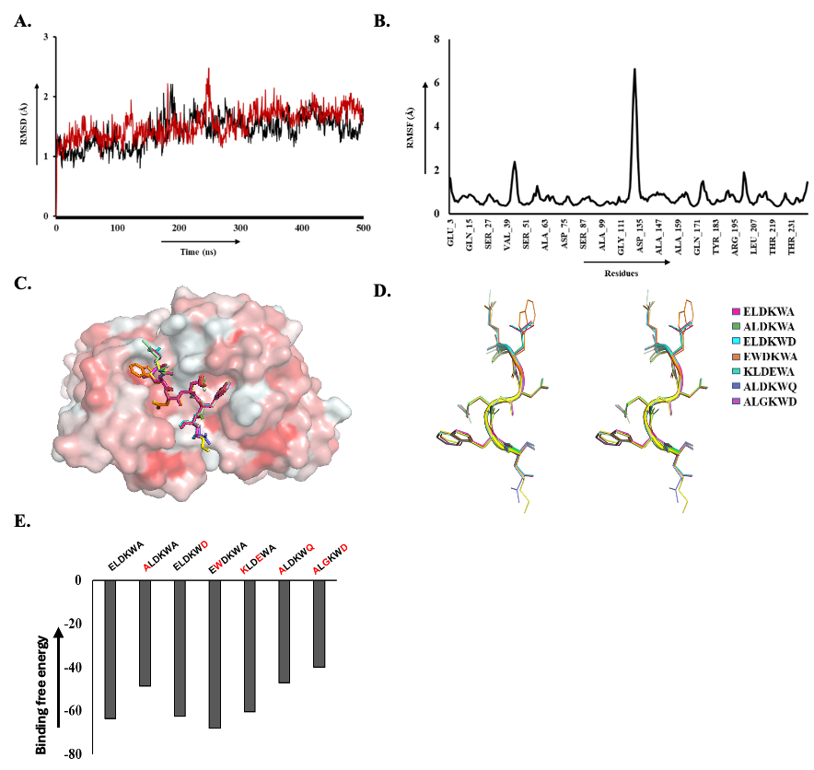
Figure S9. MD simulation and superimposition of the scFv with the native epitope and all the mutants. A. RMSD vs. time plot of the scFv-epitope complex shown in black and the scFv alone in red. B. RMSF of the scFv backbone in complex. C. All the complexes were superimposed, showing surface representations of the scFv, and the epitopes are shown in stick form. D. Stereoscopic representation of the superimposed native epitope and all the variants in the antibody-bound confirmation. E. Relative binding affinity of native and seven mutant complexes calculated via the Prime MMGBSA approach of the Schrödinger suite. Native epitope mutants were generated via PyMOL, and each complex was energy minimized.
Figure S10. Multiple sequence alignment of scFv DE94 and the broadly neutralizing antibody 2F5.
Table S1. Enrichment of epitope-specific output phages in the successive rounds of screening
 | Phages input (ml⁻¹) | Phages output (ml⁻¹) | Recovery phages
TOM I library screening
Round 1 | 4.22 × 10¹² | 3.60 × 10⁴ | 0.85 × 10⁻⁸
Round 2 | 7.23 × 10¹² | 7.40 × 10⁴ | 0.10 × 10⁻⁷
Round 3 | 8.98 × 10¹² | 6.40 × 10⁶ | 0.71 × 10⁻⁶
Round 4 | 8.40 × 10¹² | 9.90 × 10⁶ | 1.18 × 10⁻⁶
TOM J library screening
Round 1 | 4.46 × 10¹² | 5.70 × 10⁵ | 1.27 × 10⁻⁷
Round 2 | 7.52 × 10¹² | 1.24 × 10⁵ | 0.16× 10⁻⁷
Round 3 | 9.41 × 10¹² | 6.20 × 10⁶ | 0.65 × 10⁻⁶
Round 4 | 8.30 × 10¹² | 1.00 × 10⁷ | 1.20 × 10⁻⁶

*The recovered phages were calculated by dividing the output phages by the input phages.
Table S2. Table showing enrichment of epitope-specific output phages in successive rounds of screening
 | Input Phages (ml⁻¹) | Output Phages (ml⁻¹) | Recovery phages
TOM I library screening
Round 1 | 2.61 × 10¹² | 8.00 × 10⁵ | 3.06 × 10⁻⁷
Round 2 | 3.60 × 10¹² | 1.60 × 10⁶ | 4.50 × 10⁻⁷
Round 3 | 2.02 × 10¹² | 3.62 × 10⁸ | 1.79 × 10⁻⁴
Round 4 | 2.82 × 10¹² | 8.41 × 10⁸ | 2.98 × 10⁻⁴
TOM J library screening
Round 1 | 2.44 × 10¹² | 4.96 × 10⁶ | 2.03 × 10⁻⁶
Round 2 | 4.77 × 10¹² | 1.48 × 10⁷ | 3.10 × 10⁻⁶
Round 3 | 3.01 × 10¹² | 1.92 × 10⁹ | 6.40 × 10⁻⁴
Round 4 | 2.78 × 10¹² | 1.34 × 10⁹ | 4.80 × 10⁻⁴
HuScL4 library screening
Round 1 | 2.44 × 10¹² | 1.60 × 10⁵ | 6.55 × 10⁻⁸
Round 2 | 8.80 × 10¹² | 1.28 × 10⁶ | 1.45 × 10⁻⁷
Round 3 | 3.60 × 10¹² | 3.20 × 10⁷ | 8.8 × 10⁻⁶
Round 4 | 1.20 × 10¹² | 2.5 × 10⁸ | 2.08 × 10⁻⁴
Round 5 | 5.70 × 10¹² | 2.50 × 10⁹ | 4.38 × 10⁻⁴

* The recovered phages were calculated by dividing the output phages by the input phages.
Table S3. Data collection and data refinement statistics- Values in parentheses are for the highest resolution shell.
PDB | 9V5N
Diffraction statistics
X-ray source | ESRF ID30B
Space Group | P2₁
Unit cell dimensions a,b,c (Å) α,β,γ (⁰) | 43.80 183.92 65.73  90 93.59 90
Resolution (Å) | 2.53
R_{merge} | 0.15 (0.46)
CC_{1/2} (%) | 97.4 (76.7)
I/𝝈I | 11.72 (2.12)
Completeness (%) | 99.3 (97.6)
Redundancy | 5.2 (4.4)
Refinement statistics
Resolution (Å) | 37.65 - 2.54 (2.61 - 2.54)
No. of reflections | 33670 (2666)
R_{work}/R_{free} | 0.1941/0.2449
No of atoms
Protein | 6436
Ligand/Ion | 55
Water | 151
Average B-factor (Å²)
Protein | 37.23
Ligand/Ion | 47.08
Water | 38.30
RMS deviations
Bond length(Å) | 0.004
Bond angles (⁰) | 0.73
Ramachandran statistics
Favored (%) | 97.71
Allowed (%) | 1.95
Outliers (%) | 0.34

