Supplementary INFORMATION

Drosophila and human transglutaminases are partially interchangeable, revealing evolutionary conserved roles in brain development

Isidora Almonacid-Torres¹, Joaquín Almonacid-Torres¹, Paulina Gómez¹, María Constanza González-Ramírez^{2,3}, Amalia Chamorro-González¹, Rafaella V Zárate⁴, Ian Maze^{5,6,7,8}, Carlos Oliva², María Estela Andrés⁹, Jorge M Campusano¹*.

¹ Laboratorio Neurogenética de la Conducta,
² Laboratorio de Neurodesarrollo and
³ University of South Bohemia, České Budějovice, Czech Republic.
⁴ Departamento Biomédico, Facultad de Ciencias de la Salud, Instituto Antofagasta, Universidad de Antofagasta, Antofagasta, Chile
⁵ Friedman Brain Institute, Icahn School of Medicine at Mount Sinai, New York, NY, USA, and
⁶ Nash Family Department of Neuroscience, Icahn School of Medicine at Mount Sinai, New York, NY, USA, and
⁷ Department of Pharmacological Sciences, Icahn School of Medicine at Mount Sinai, New York, NY, USA, and
⁸Howard Hughes Medical Institute, Icahn School of Medicine at Mount Sinai, New York, NY, USA
⁹ Laboratorio de Regulación Neuroepigenética, Facultad de Ciencias Biológicas, Pontificia Universidad Católica de Chile, Santiago, Chile.

* Corresponding author: jmcampus@uc.cl

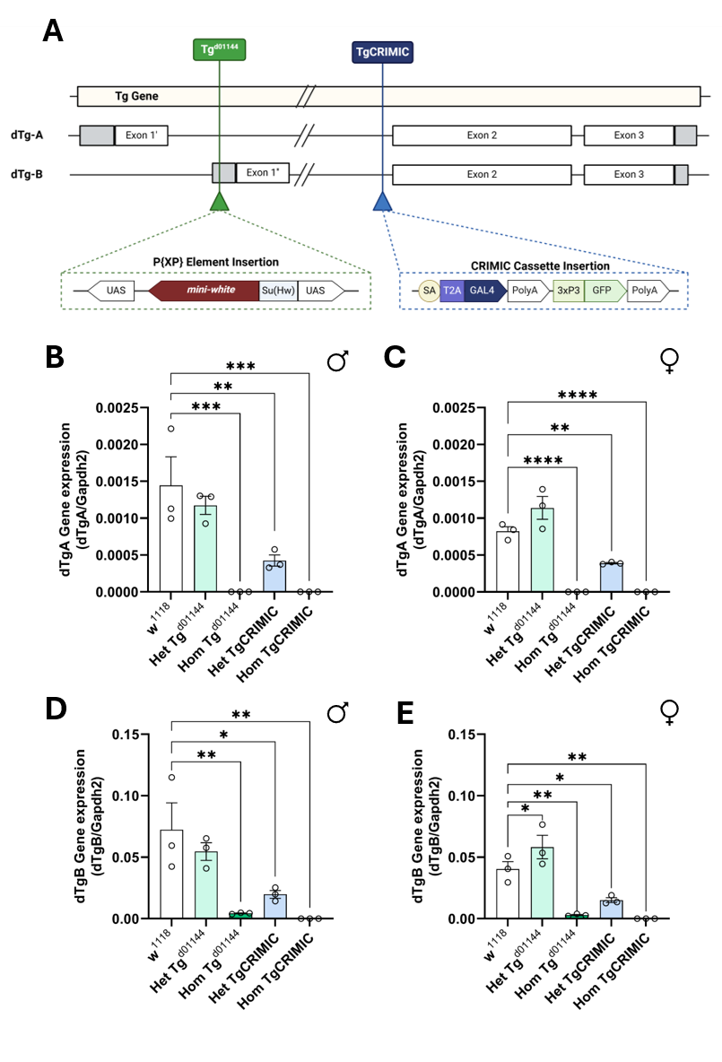
Supplementary Figure 1. Two different insertions in the Drosophila Tg gene lead to the reduction of both of its transcripts, dTg-A and dTg-B. (A) Scheme of the Drosophila melanogaster Tg gene, its mRNA products, and the insertions of the commercial strains Tg^{d01144} and TgCRIMIC. The P{XP} insertion is localized in the first intron of the dTg-A transcript and the dTg-B promoter, while the CRIMIC cassette is inserted at the end of the first intron of both mRNAs. The P{XP} element disrupts transcription via the expression of a mini-white transgene in the opposite direction, while CRIMIC adds poly-adenylation sites (PolyA) that would create truncated transcripts. Relative mRNA expression of (B-C) dTg-A and (D-E) dTg-B transcripts in heads from 3-5 dpe male and female adults. cDNA obtained from total mRNA was amplified via qPCR using specific primers against each isoform. Gapdh2 amplicons were used as loading control to normalize the Tg signal. Data is expressed as mean ± SEM. *, **, *** and **** indicate p<0.05, p<0.01, p<0.001 and p<0.0001, respectively. One-way ANOVA test, followed by Tukey post-hoc test for multiple comparisons between genotypes. Het = Heterozygous; Hom = Homozygous. In B-E, each point represents one independent experiment (N=3 in total), equivalent to 40-50 fly heads.

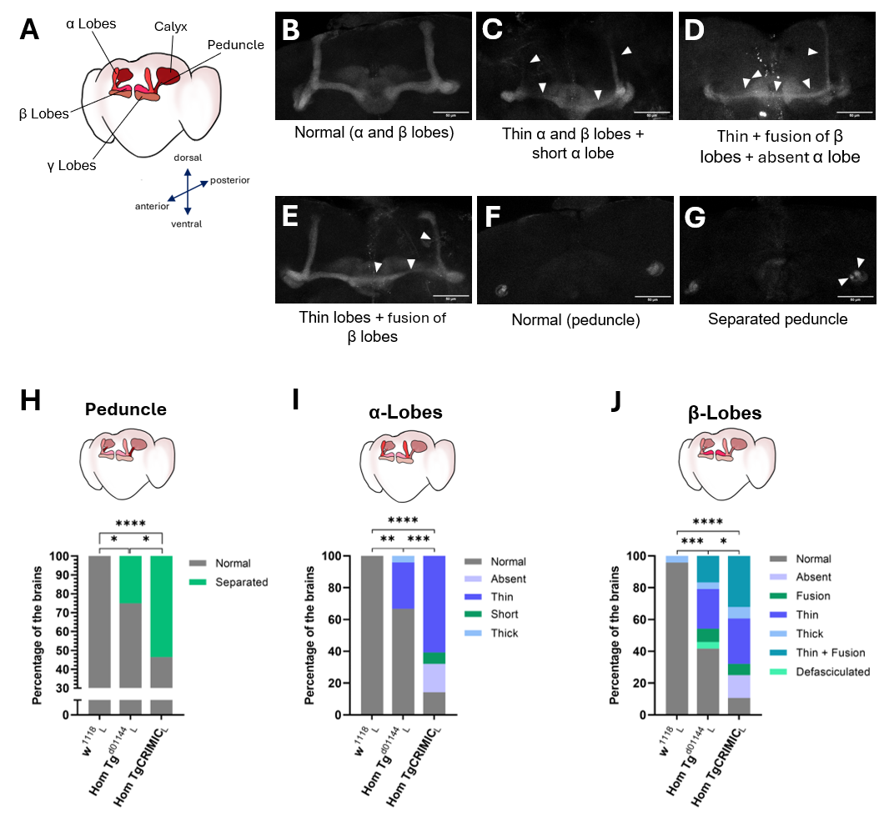
Supplementary Figure 2. Reduced expression of Tg results in impaired mushroom body architecture in female flies, different from males. A Scheme of the normal organization of the MB in the adult male fly brain, with its respective subregions (adapted from Rojo-Cortés et al., 2026). B-G Representatives images of phenotypes found in the adult MB; stained with anti-FasII antibody. Scale bar: 50µm. Full arrowheads indicate alterations in the MB organization. B and F are examples of a normal control brain from the w¹¹¹⁸ strain. E and G are images from the Tg^{d01144} genotype, while C and D are brains from the TgCRIMIC strain. H-J Percentage of fly brains from each genotype presenting identified phenotypes in the (H) peduncle, (I) α lobes and (J) β lobes, from the left (subscript “L”) side of the brain. Data in H-J from female w¹¹¹⁸ control flies (n=24, 2 independent experiments); Tg^{d01144} (n=24, 2 independent experiments); TgCRIMIC (n=28, 3 independent experiments). Differences between strains were calculated for each brain side and MB subregion using the X² test, followed by the Fisher Exact test for multiple comparisons. *, **, *** and **** indicate p<0.05, p<0.01, p<0.001 and p<0.0001, respectively (p adjusted value from the Fisher Exact Test).

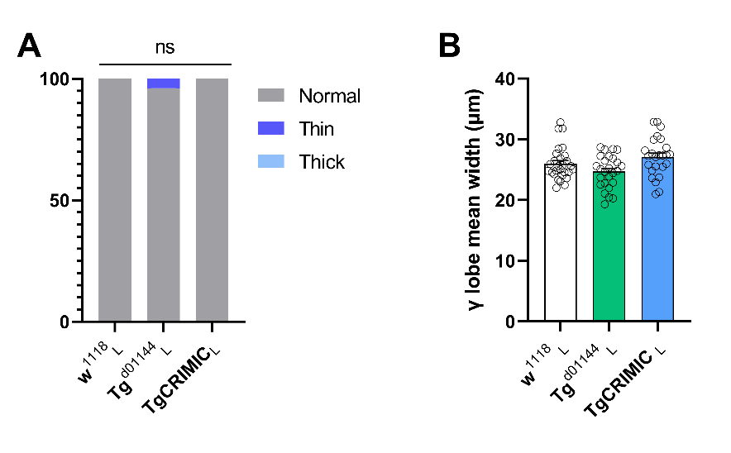
Supplementary Figure 3. MB γ lobes are not affected by Tg deficiency. A Proportion of brains exhibiting thin or thick γ lobes in the three strains of interest, control w¹¹¹⁸ and dTg mutants Tg^{d01144} and TgCRIMIC. One way ANOVA showed no significant differences (ns) between strains. B MB γ lobes mean width in the three strains. Data from female w¹¹¹⁸ control flies (n=24, 2 independent experiments); Tg^{d01144} (n=24, 2 independent experiments); TgCRIMIC (n=28, 3 independent experiments) flies.

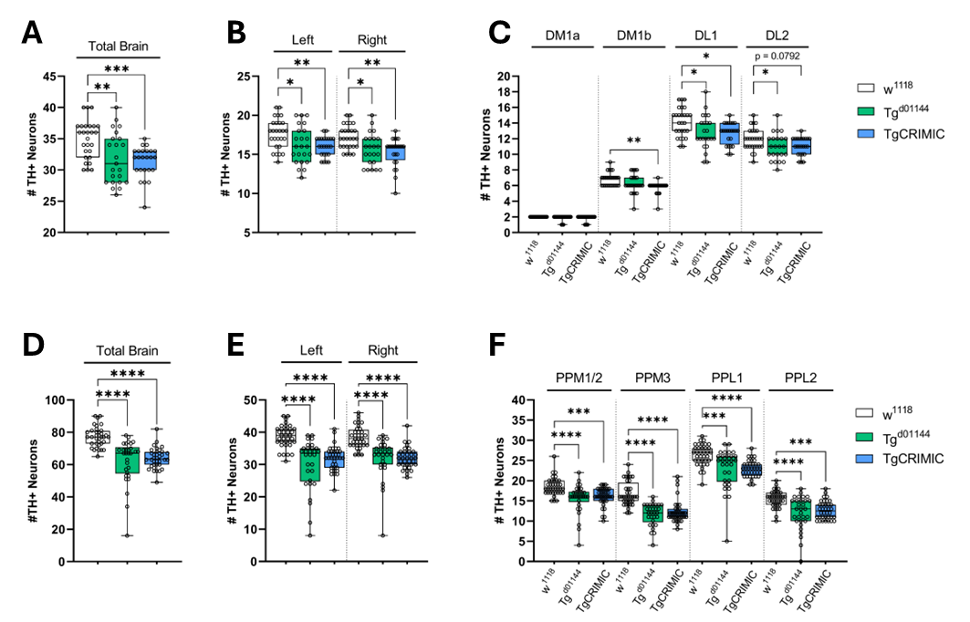
Supplementary Figure 4. Fly Tg deficiency leads to a reduced number of dopaminergic neurons in both larval and adult female brains. Quantification of the number of TH+ neurons in (A) whole brain, (B) per hemisphere, and (C) per identified larval cluster (DM1a, DM1B, DL1, and DL2). Data in A-C from female larval L3 w¹¹¹⁸ (n=27, 3 independent experiments), Tg^{d01144} (n=23, 3 independent experiment) and TgCRIMIC brains (n=24, 3 independent experiments). Quantification of number of TH+ neurons in (D) whole brain, (E) per hemisphere, and (F) per identified adult cluster (PPM1/2, PPM3, PPL1 and PPL2). Data in D-F from female adult w¹¹¹⁸ (n=36, 3 independent experiments), Tg^{d01144} (n=30, 3 independent experiments), and TgCRIMIC (n=36, 3 independent experiments) brains. The data is presented as the interquartile range with maximum and minimum ranges of quantifications. *, **, *** and **** indicate p<0.05, p<0.01, p<0.001 and p<0.0001, respectively. One-way ANOVA test, followed by Tukey post-hoc test for multiple comparisons between genotypes.

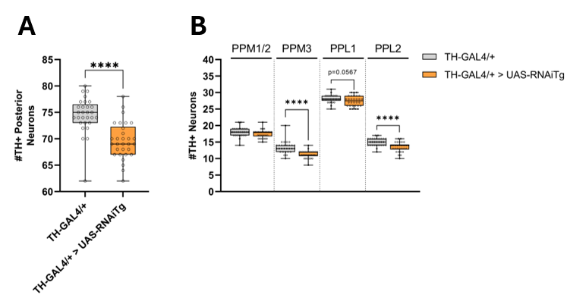

Supplementary Figure 5. Knock-down of dTg in dopaminergic cells results in cluster-specific loss of posterior dopaminergic neurons. Quantification of number of posterior TH+ neurons in (A) whole brain, and (B) per identified adult cluster (PPM1/2, PPM3, PPL1 and PPL2). Data in A-B from 3-5dpe male adult brains of the following genotypes: TH-GAL4/+ (n=29, 3 independent experiments) and TH-GAL4/+>UAS-RNAiTg/+ (n=30, 3 independent experiments), raised at 29°C for optimum interference of transcripts. The data is presented as the interquartile range with maximum and minimum ranges of quantifications. **** indicate p<0.0001. One-way ANOVA test, followed by Tukey post-hoc test for multiple comparisons between genotypes.

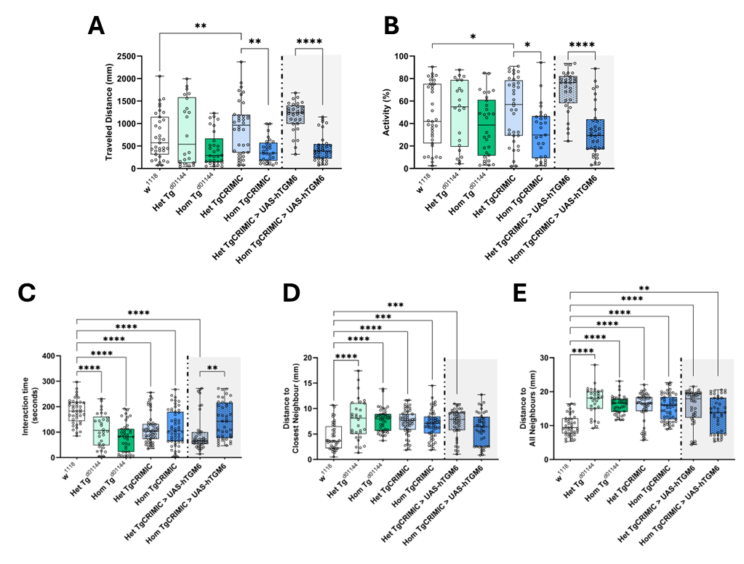
Supplementary Figure 6. Knock-down of Tg results in altered locomotor and social behavior in female flies; the locomotor and asocial behaviors are partially rescued by hTG6 expression. In the context of single basal locomotor behavior, (A) travelled distance and (B) activity of control (w¹¹¹⁸), Tg-deficient mutant animals and genetic rescue using the UAS-GAL4 system to express hTG6 under the Drosophila endogenous Tg promoter. (C-E) Social parameters of grouped flies analyzed during basal locomotion assay. The data corresponds to 3-4 independent experiments per condition. The data is presented as the interquartile range with maximum and minimum ranges of quantifications. *, **, *** and **** indicate p<0.05, p<0.01, p<0.001 and p<0.0001, respectively. One-way ANOVA test, followed by Sidak’s post-hoc test for multiple comparisons between genotypes. For A and B, statistical analysis was performed in transformed data with Log and squared function, respectively (transformation was carried out to achieve normality and homoscedasticity). Het = Heterozygous; Hom = Homozygous.

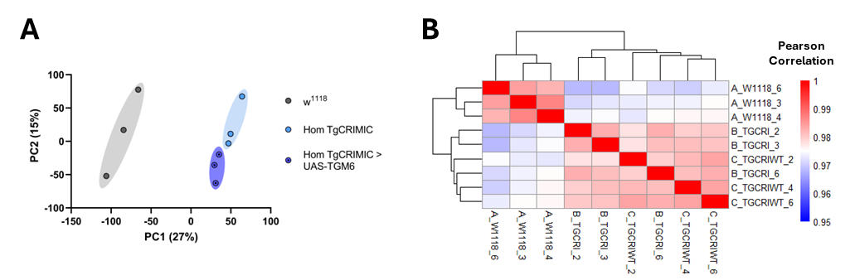

Supplementary Figure 7. w¹¹¹⁸, TgCRIMIC and TgCRIMIC > UAS-TG6 male adult brains exhibit distinct mRNA expression patterns. (A) Principal Component Analysis (PCA) plot from mRNA-seq data of w¹¹¹⁸, TgCRIMIC and TgCRIMIC > UAS-hTG6 male adult brain. Data was previously regularized log-normalized (rlog) using the DESeq2 package. PCA was performed in Rstudio using prcomp function. PCA displays 3 samples per group along PC1 and PC2, which describe 27% and 15% of the variability, respectively. (B) Heatmap plot displaying Pearson’s correlation values between all mRNA-seq samples. Data was also normalized as described for PCA. The correlation matrix was generated using the cor function in Rstudio. The plot was generated using the pheatmap package in Rstudio. The scale bar represents the range of the correlation coefficients shown.

