Calculation of Hydroacoustic Propagation and Conversion to Seismic Phases at T-Stations
Jeffry L. Stevens and Jeffrey Hanson
Leidos, 10260 Campus Point Drive, San Diego, CA 92121
Peter Nielsen, Mario Zampolli, Ronan LeBras and Georgios Haralabus
Comprehensive Nuclear Test-Ban Treaty Organization
Vienna International Center, P.O. Box 1200, 1400, Vienna, Austria
Corresponding Author Jeffry L. Stevens, email Jeffry.L.Stevens@leidos.com

Supplementary Data

Table of Contents
Calculation of Hydroacoustic Propagation and Conversion to Seismic Phases at T-Stations 1
Supplementary Data 1
List of Figures 2
1.0 Sound Speed and Densities for Source Calculations 3
2.0 Movies of T-Phase Propagation and Conversion 8

List of Figures
Figure 1. Sound speed and density profiles for the path to ASCN, azimuth 304 degrees. This is the direction to the Florida explosions. Because the depth at the explosion locations is too shallow for a modal solution, the KRAKEN solution was calculated off the shelf. The RAM calculation used the actual location. In all of these figures the source is at the right end; a point 59 km from the left side of the plot is the input point to the SPECFEM2D calculation. Dashed black line is the bathymetry, black blocks are bathymetry averaged over 25 km segments. Dashed red line is the velocity minimum in the sound channel. 3
Figure 2. Sound speed and density profiles for the path to H02N, azimuth 225 degrees. 3
Figure 3. Sound speed and density profiles for the path to H02S, azimuth 240 degrees. 4
Figure 4. Sound speed and density profiles for the path to H05N, azimuth 102 degrees. 4
Figure 5. Sound speed and density profiles for the path to H05S, azimuth 93 degrees. 4
Figure 6. Sound speed and density profiles for the path to H06E, azimuth 90 degrees. 5
Figure 7. Sound speed and density profiles for the path to H06N, azimuth 345 degrees. 5
Figure 8. Sound speed and density profiles for the path to H06S, azimuth 160 degrees. 5
Figure 9. Sound speed and density profiles for the path to H07N, azimuth 285 degrees. 6
Figure 10. Sound speed and density profiles for the path to H07S, azimuth 140 degrees. 6
Figure 11. Sound speed and density profiles for the path to H09N, azimuth 330 degrees. 6
Figure 12. Sound speed and density profiles for the path to H09W, azimuth 270 degrees. 7
Figure 13. Sound speed and density profiles for the path to Wake, azimuth 310 degrees. 7
Figure 14. ASCN_az304_poly.ram.Q.spca.mp4 8
Figure 15. H02N_az225_poly.ram.Q.spca.mp4 8
Figure 16. H02S_az240_poly.ram.Q.spca.mp4 8
Figure 17. H05N_az102_poly.ram.Q.spca.mp4 8
Figure 18. H05S_az093_poly.ram.Q.spca.mp4 9
Figure 19. H06E_az090_poly.ram.Q.spca.mp4 9
Figure 20. H06N_az345_poly.ram.Q.spca.mp4 9
Figure 21. H06S_az160_poly.ram.Q.spca.mp4 9
Figure 22. H07N_az285_poly.ram.Q.spca.mp4 9
Figure 23. H07S_az140_poly.ram.Q.spca.mp4 10
Figure 24. H09N_az330_poly.ram.Q.spca.mp4 10
Figure 25. H09W_az270_poly.ram.Q.spca.mp4 10
Figure 26. WAKE_az310_poly.ram.Q.spca.mp4 10

1.0 Sound Speed and Densities for Source Calculations
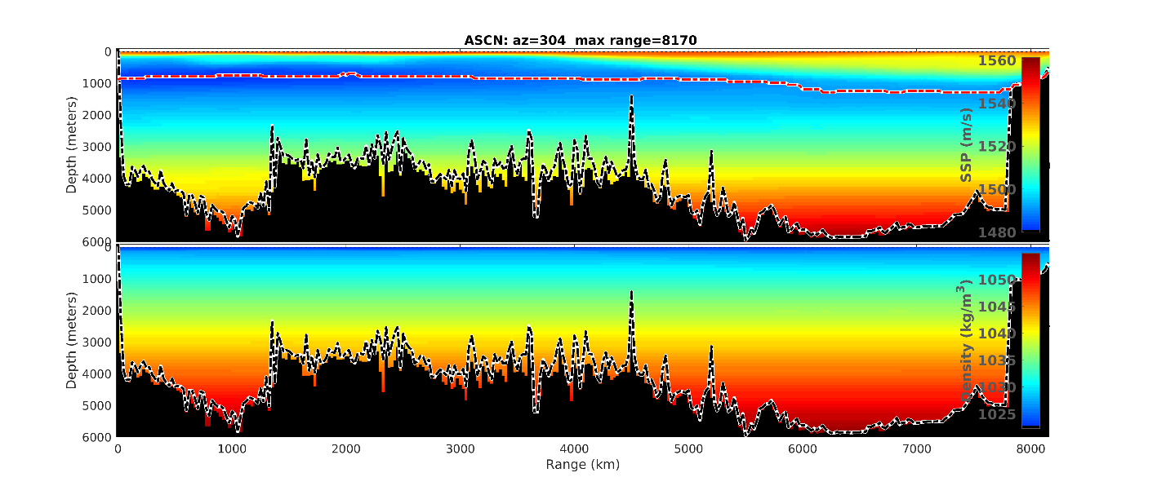
Figure 1. Sound speed and density profiles for the path to ASCN, azimuth 304 degrees. This is the direction to the Florida explosions. Because the depth at the explosion locations is too shallow for a modal solution, the KRAKEN solution was calculated off the shelf. The RAM calculation used the actual location. In all of these figures the source is at the right end; a point 59 km from the left side of the plot is the input point to the SPECFEM2D calculation. Dashed black line is the bathymetry, black blocks are bathymetry averaged over 25 km segments. Dashed red line is the velocity minimum in the sound channel.
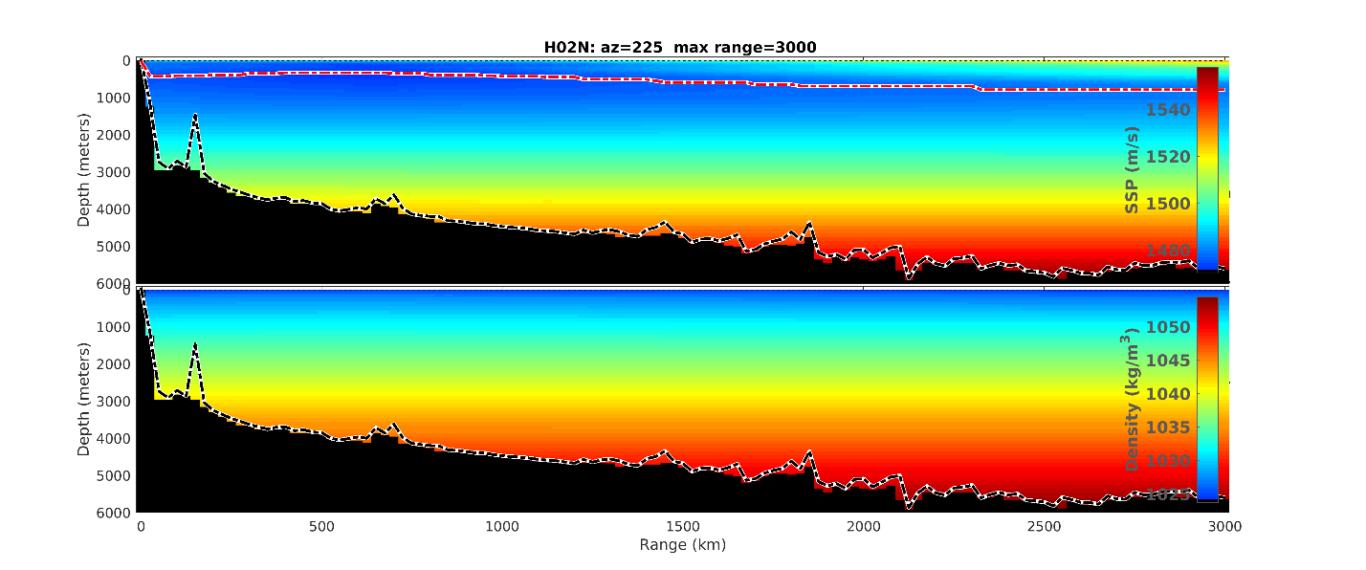
Figure 2. Sound speed and density profiles for the path to H02N, azimuth 225 degrees.
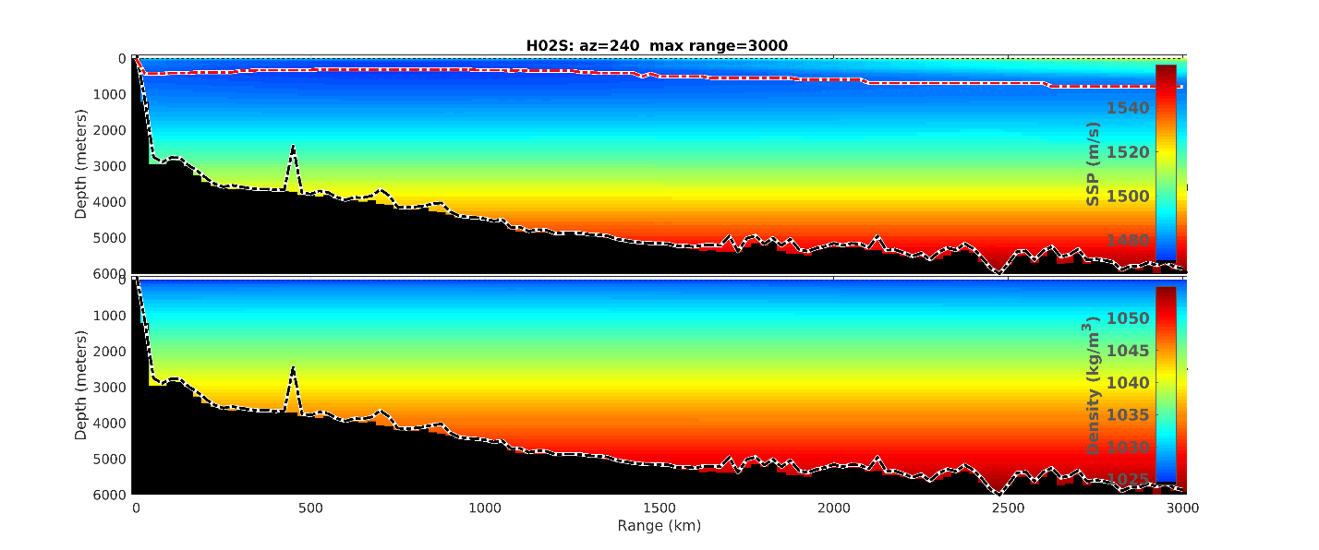
Figure 3. Sound speed and density profiles for the path to H02S, azimuth 240 degrees.
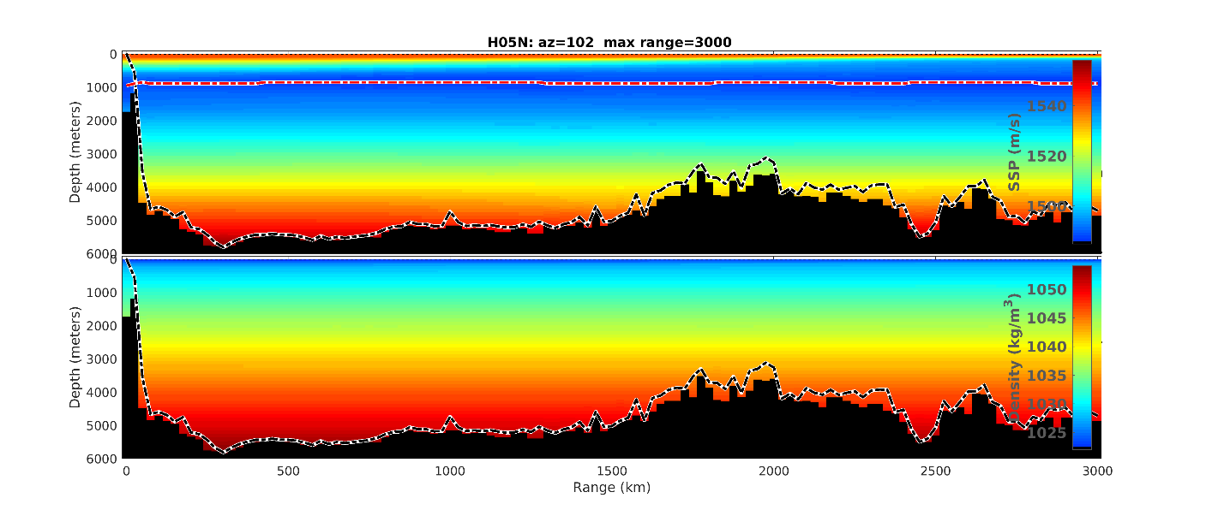
Figure 4. Sound speed and density profiles for the path to H05N, azimuth 102 degrees.
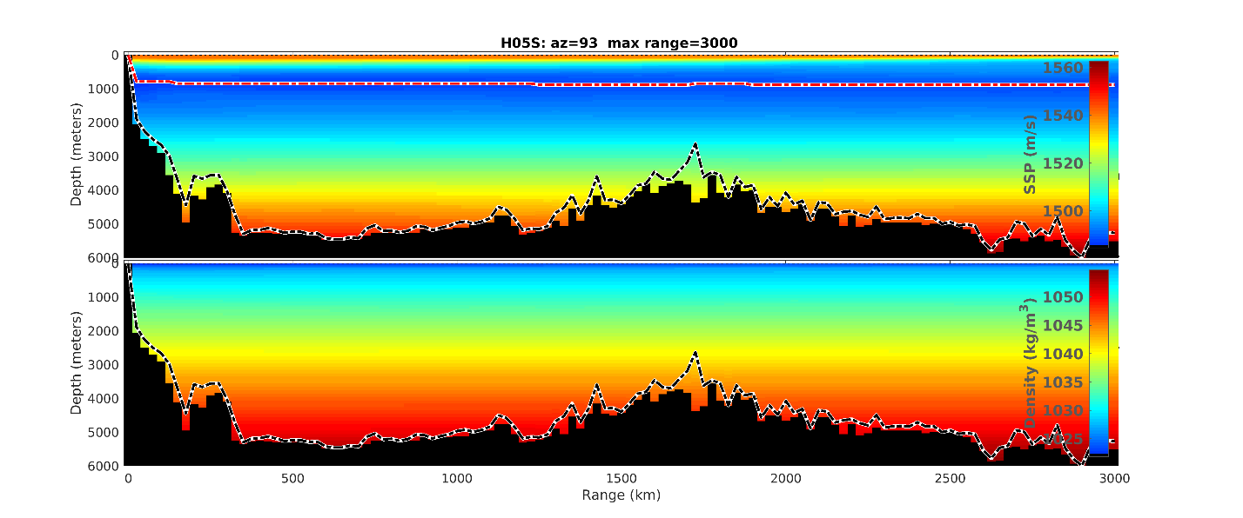
Figure 5. Sound speed and density profiles for the path to H05S, azimuth 93 degrees.
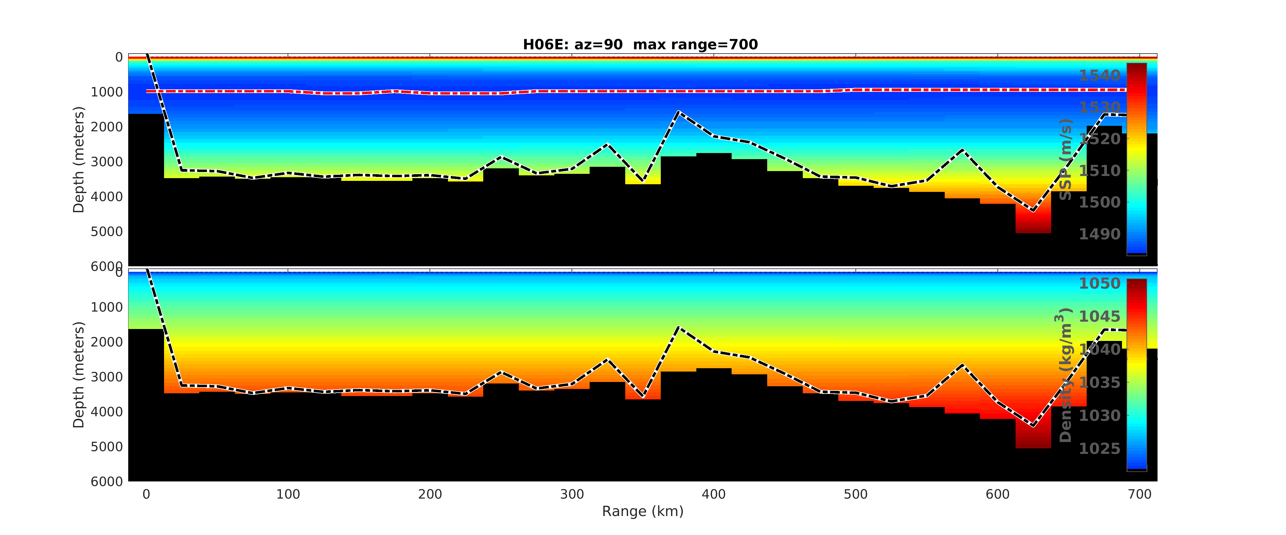
Figure 6. Sound speed and density profiles for the path to H06E, azimuth 90 degrees.
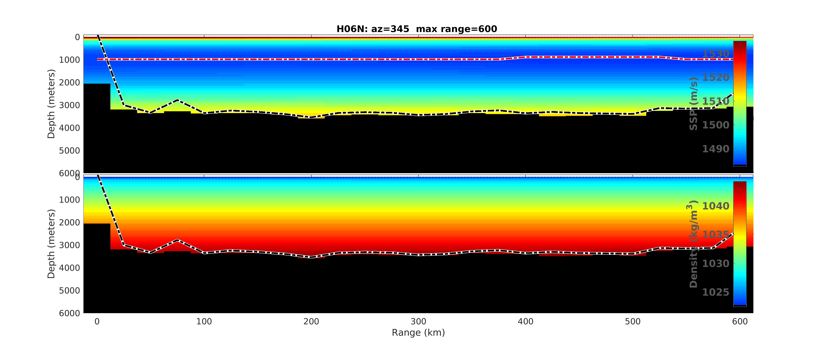
Figure 7. Sound speed and density profiles for the path to H06N, azimuth 345 degrees.
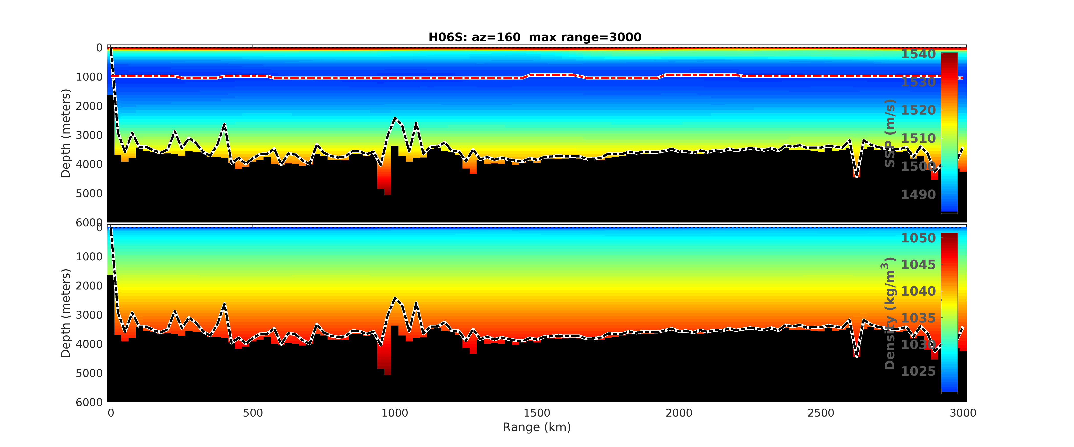
Figure 8. Sound speed and density profiles for the path to H06S, azimuth 160 degrees.
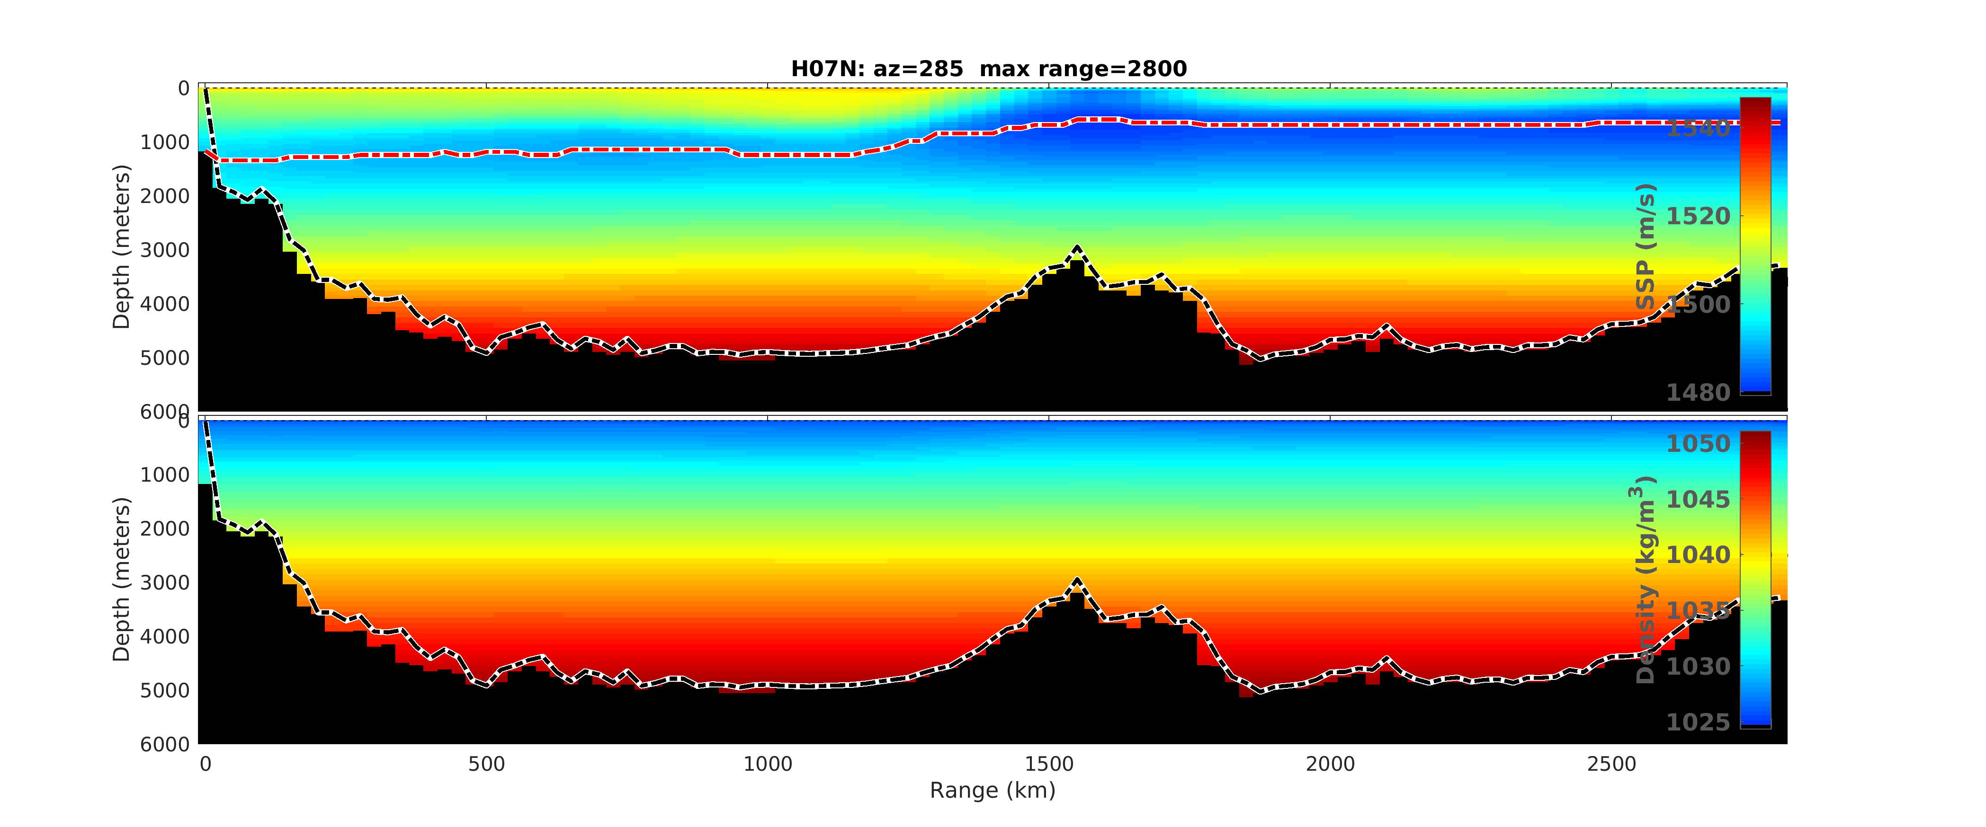
Figure 9. Sound speed and density profiles for the path to H07N, azimuth 285 degrees.
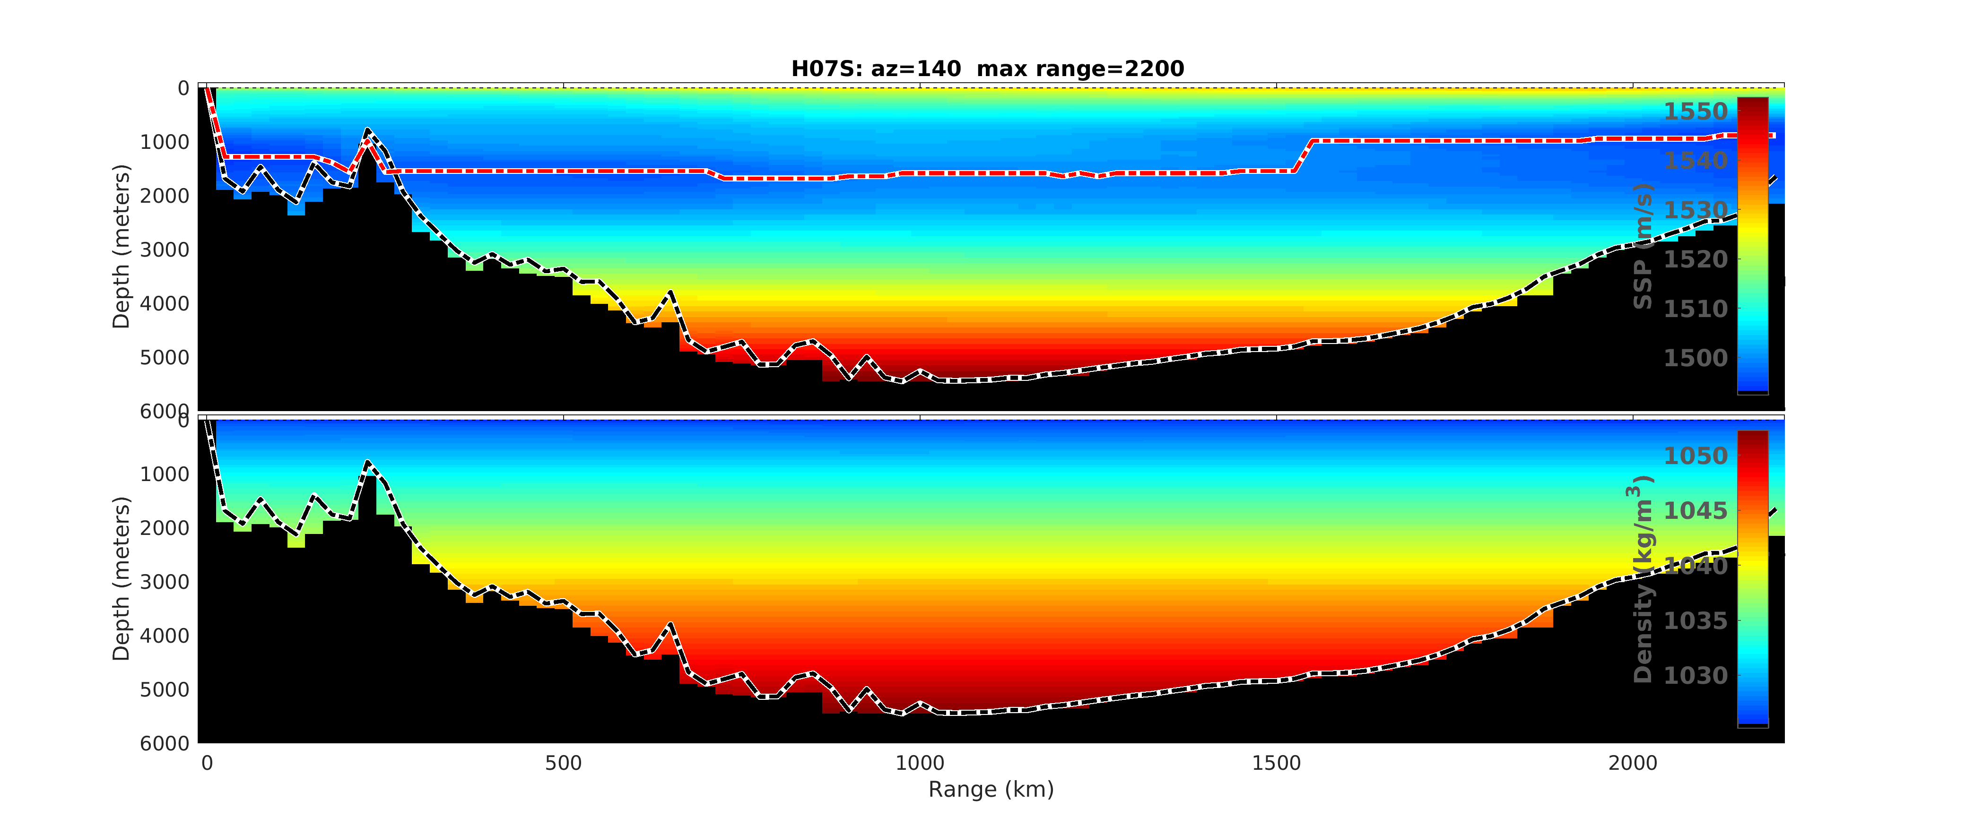
Figure 10. Sound speed and density profiles for the path to H07S, azimuth 140 degrees.
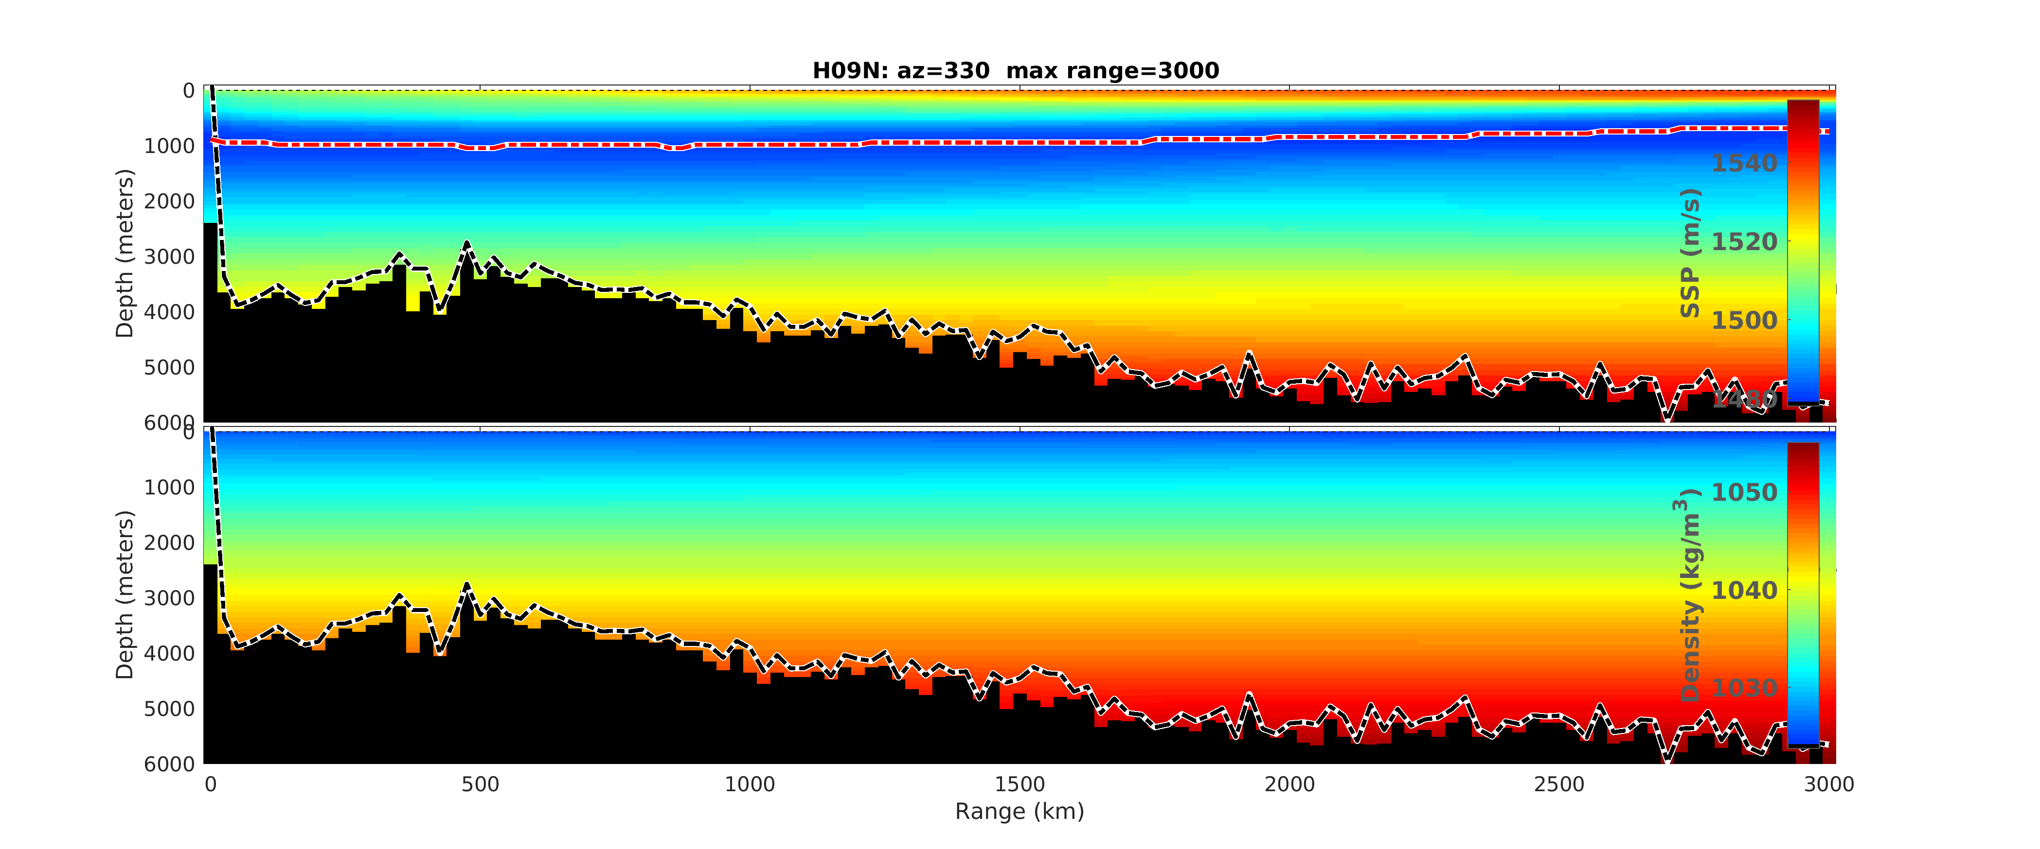
Figure 11. Sound speed and density profiles for the path to H09N, azimuth 330 degrees.
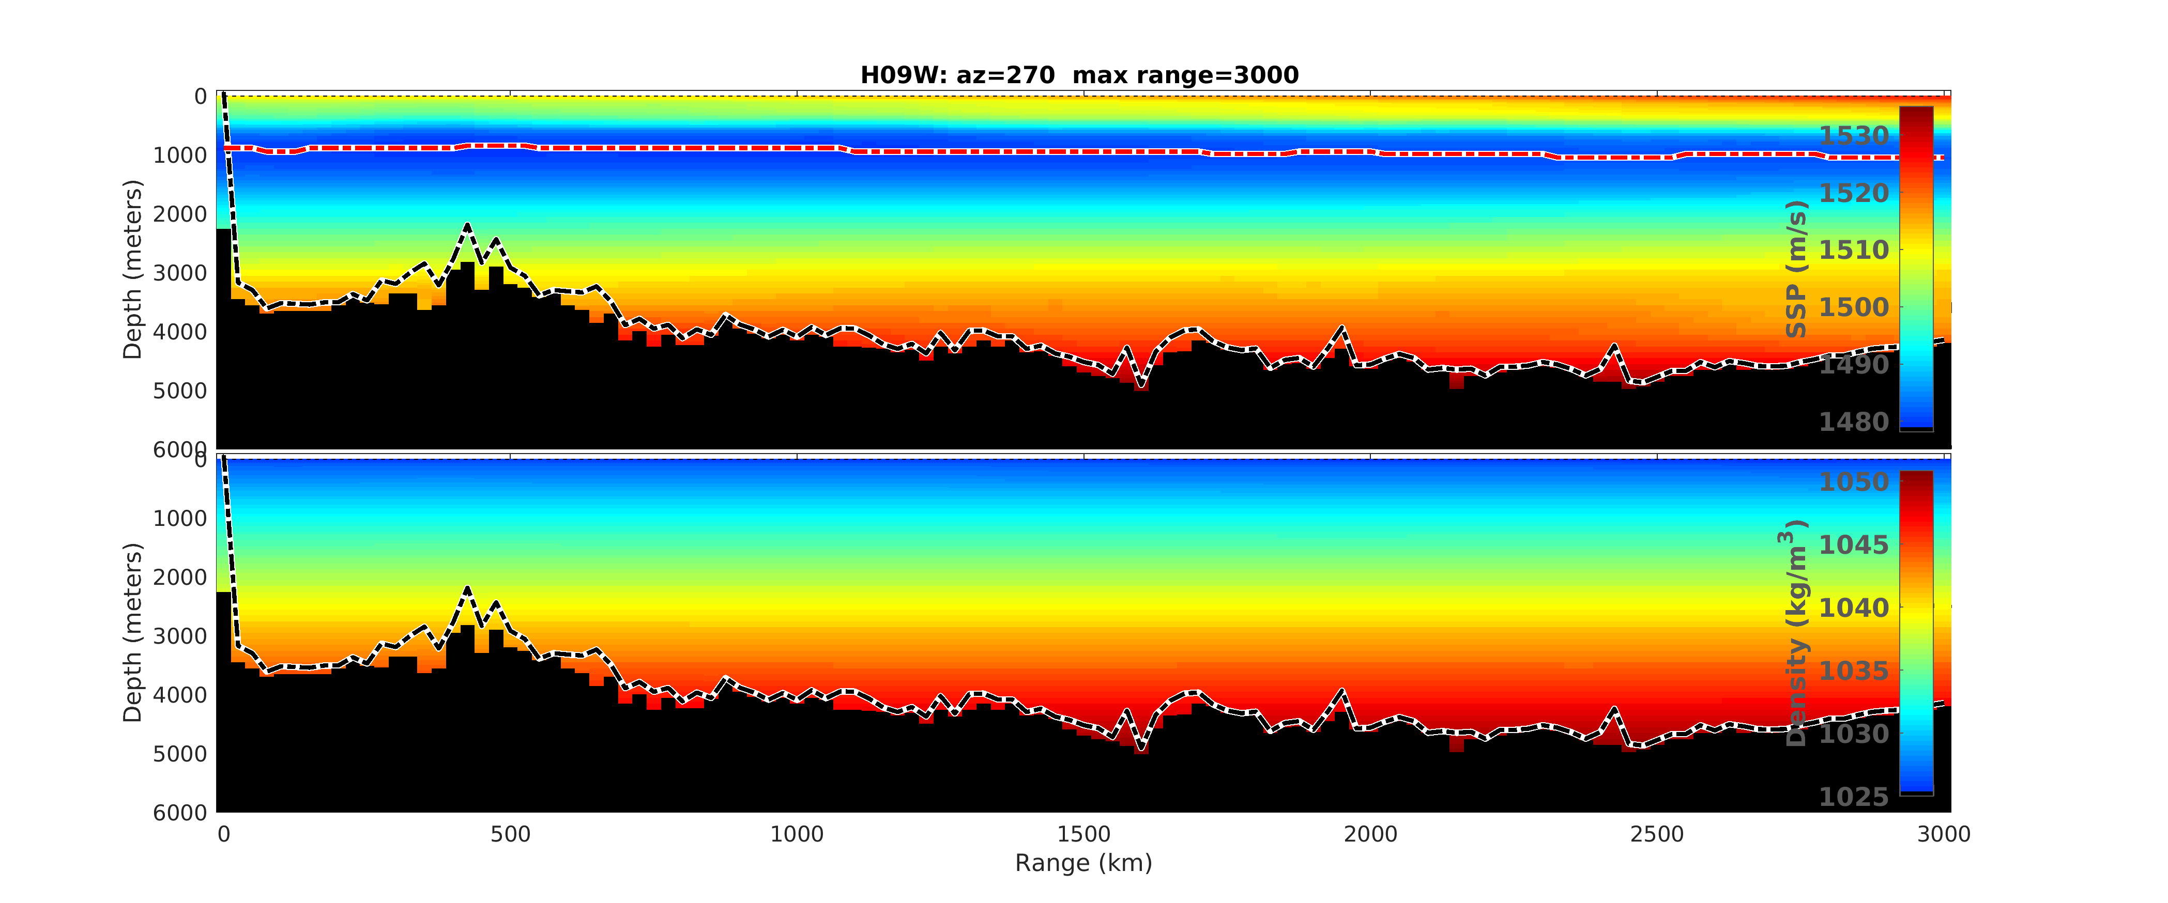
Figure 12. Sound speed and density profiles for the path to H09W, azimuth 270 degrees.
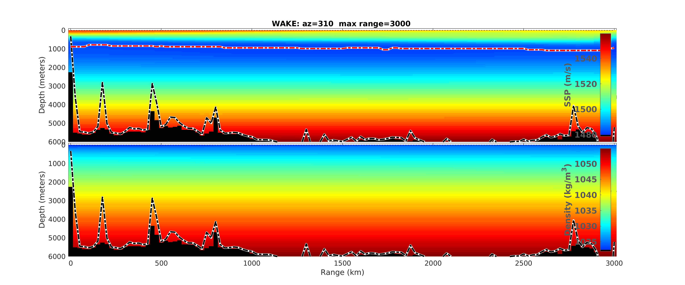
Figure 13. Sound speed and density profiles for the path to Wake, azimuth 310 degrees.

2.0 Movies of T-Phase Propagation and Conversion

Movie files of RAM 60m depth calculations with attenuation, provided as separate files. The following figures show one snapshot from each calculation and the filename for each movie file.

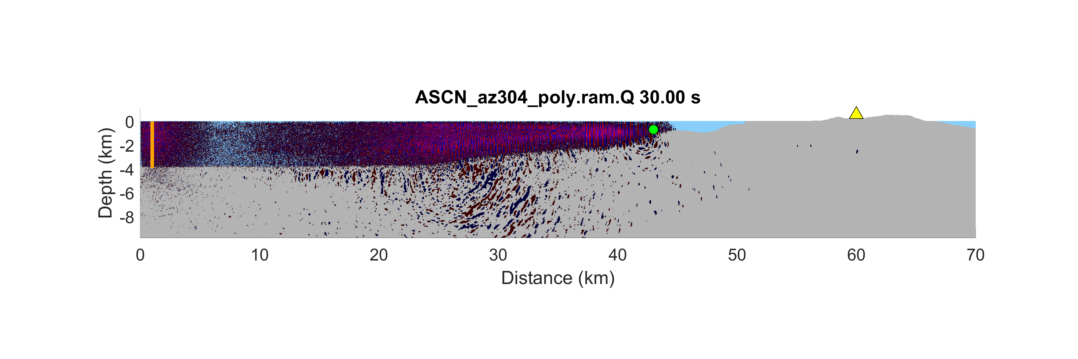
Figure 14. ASCN_az304_poly.ram.Q.spca.mp4
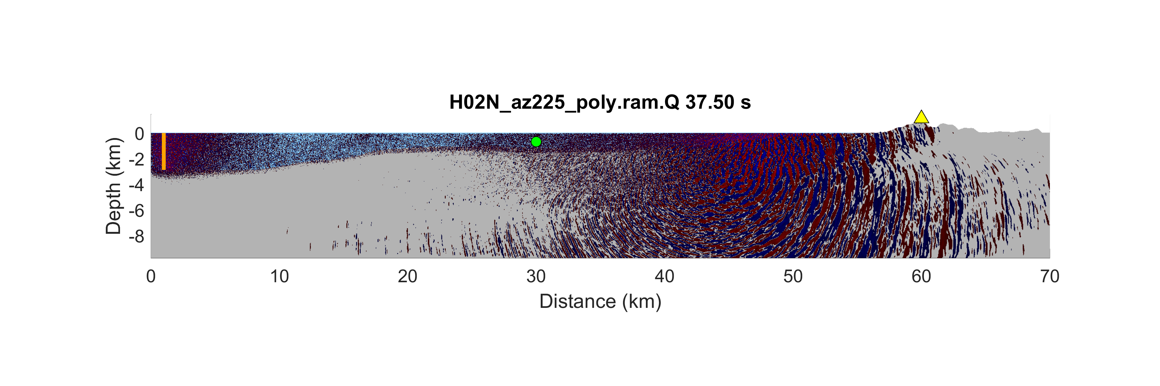
Figure 15. H02N_az225_poly.ram.Q.spca.mp4
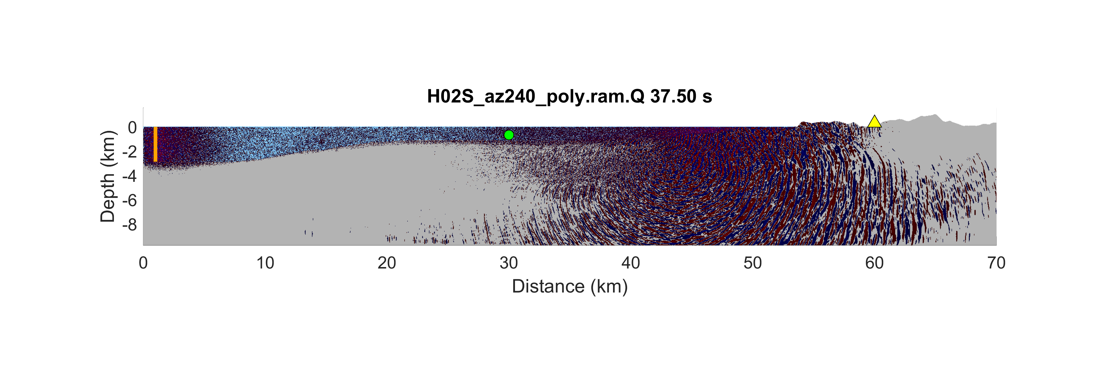
Figure 16. H02S_az240_poly.ram.Q.spca.mp4
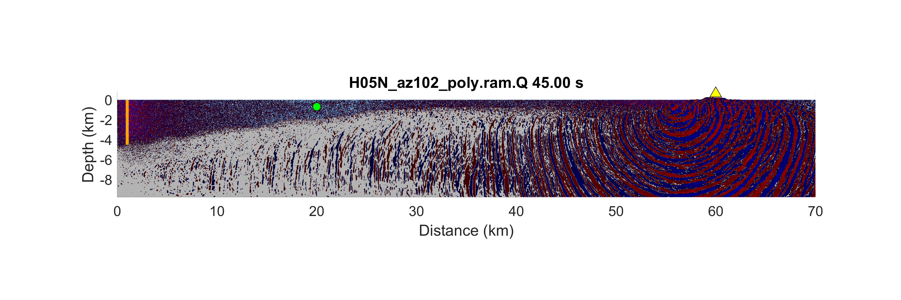
Figure 17. H05N_az102_poly.ram.Q.spca.mp4
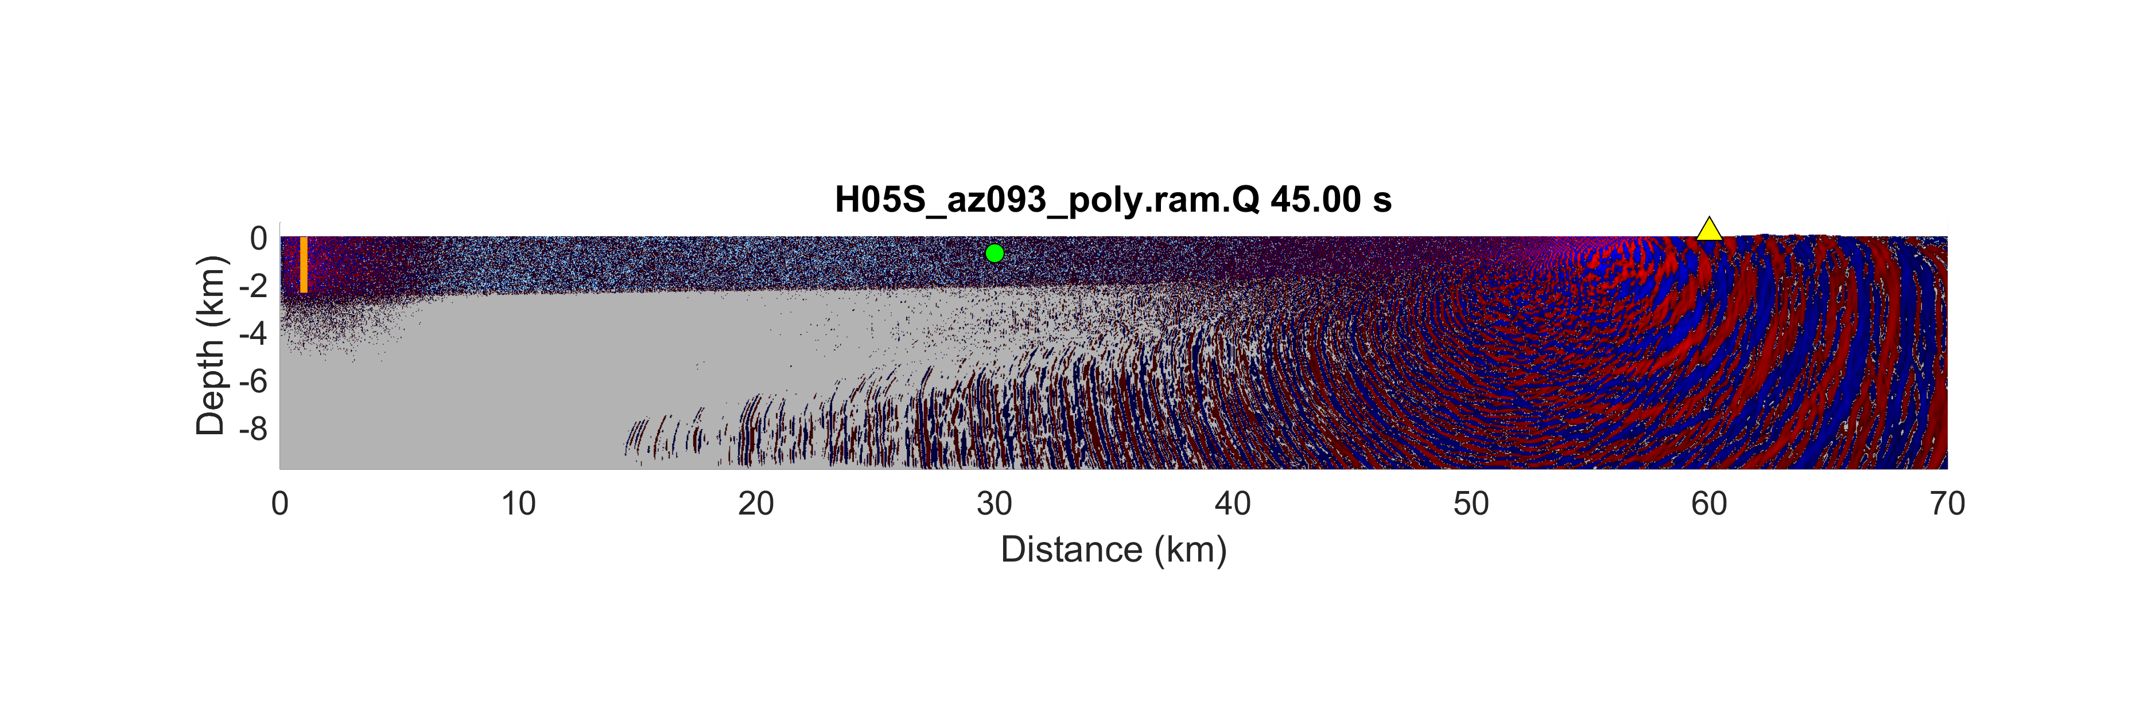
Figure 18. H05S_az093_poly.ram.Q.spca.mp4
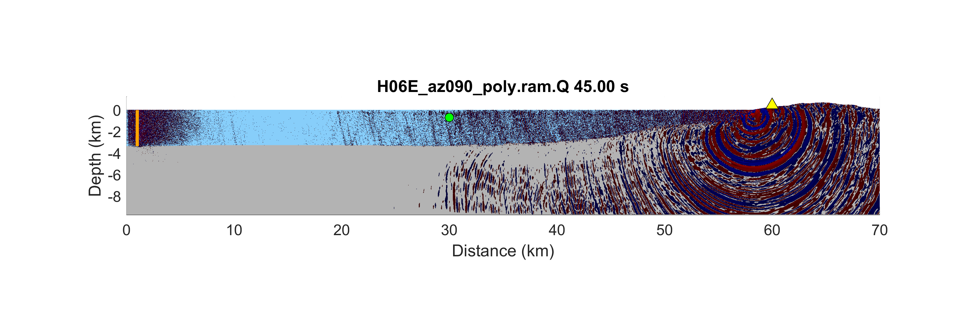
Figure 19. H06E_az090_poly.ram.Q.spca.mp4
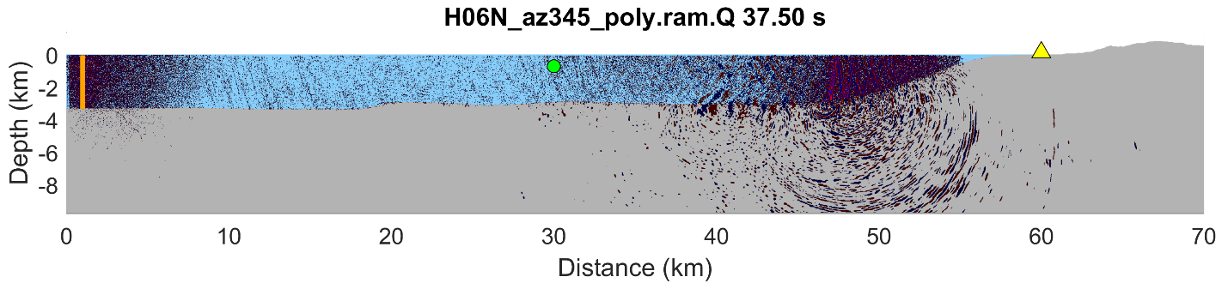
Figure 20. H06N_az345_poly.ram.Q.spca.mp4
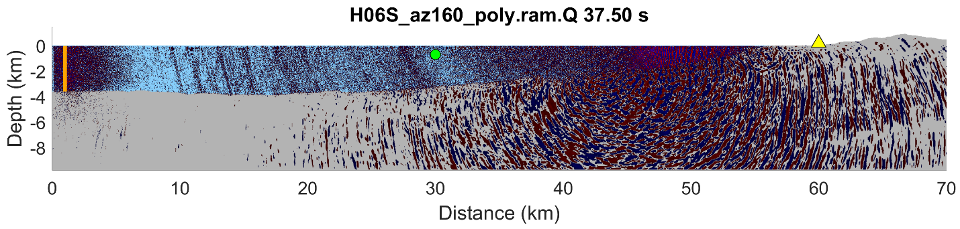
Figure 21. H06S_az160_poly.ram.Q.spca.mp4
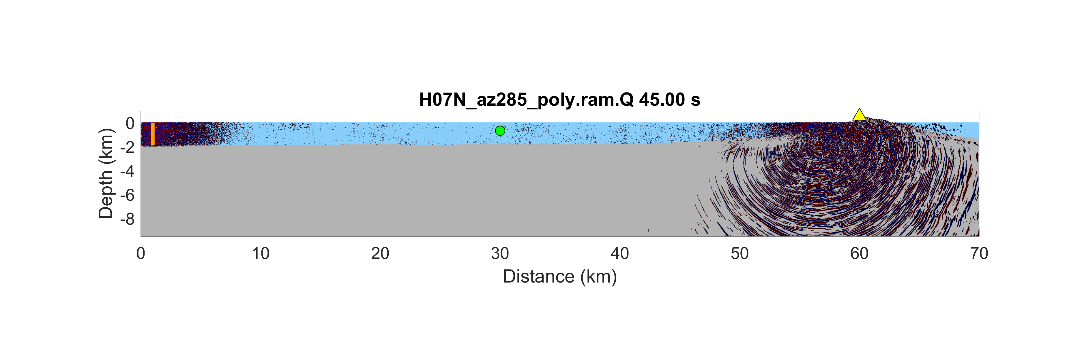
Figure 22. H07N_az285_poly.ram.Q.spca.mp4
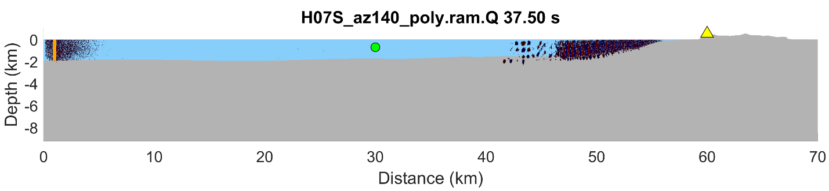
Figure 23. H07S_az140_poly.ram.Q.spca.mp4
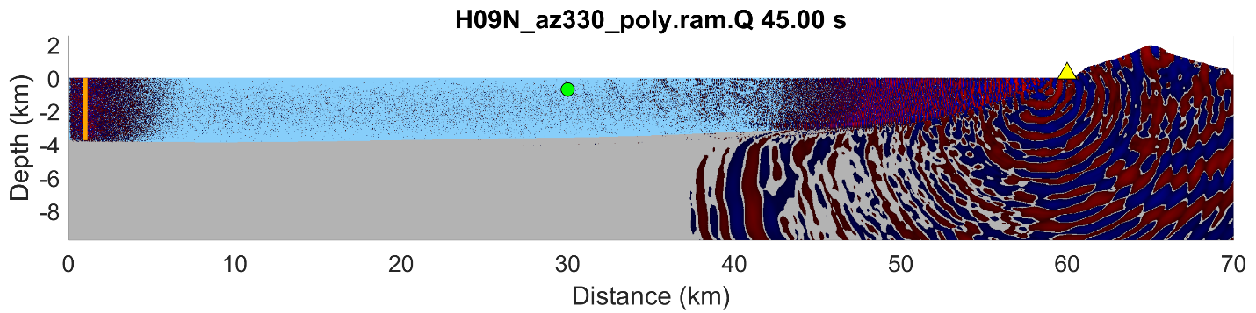
Figure 24. H09N_az330_poly.ram.Q.spca.mp4
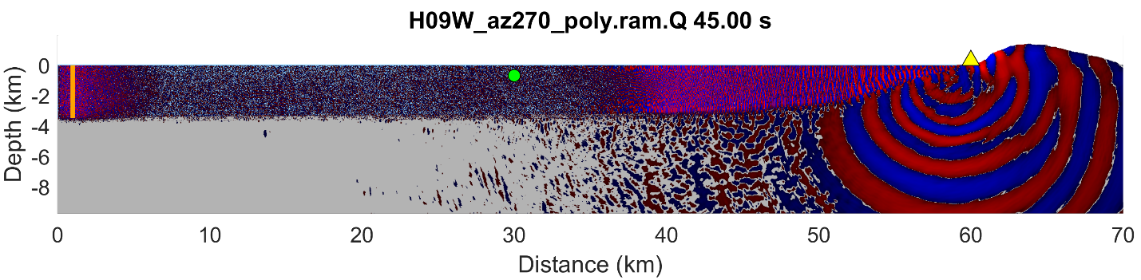
Figure 25. H09W_az270_poly.ram.Q.spca.mp4
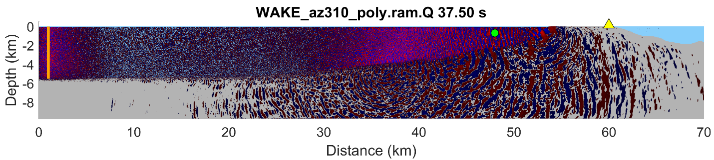
Figure 26. WAKE_az310_poly.ram.Q.spca.mp4

