Supplementary Material for

Re-examination of Slip Distribution of the 2004 Sumatra-Andaman Earthquake (Mw9.2) by the Inversion of Tsunami data using the Green's Functions corrected for Compressible Seawater over the Elastic Earth

Yushiro Fujii^{1, *}, Kenji Satake², Shingo Watada² and Tung-Cheng Ho³

¹International Institute of Seismology and Earthquake Engineering (IISEE), Building Research Institute (BRI)
*Corresponding author

²Earthquake Research Institute (ERI), The University of Tokyo

³Disaster Prevention Research Institute (DPRI), Kyoto University

Contents of this file

Fig. S1 (URL link to the animation)
Figs. S2 to S12
Table S1
Figs. S13 to S17

Introduction

Fig. S1 shows a snapshot of an animation for the tsunami propagation with the satellite altimetry (SA) measurements. Fig. S2 shows a tsunami ray path from a source point to a station point as described in Section 3.2. Figs. S3 to S6 show the inversion results of checkerboard tests as described in Section 3.3. Figs. S7 and S8 show the comparison of tsunami waveforms at tide gauges (TGs) and ocean bottom pressure gauges (OBPGs) from the SA data inversion result. Fig. S9 shows the comparison of observed sea surface heights (SSHs) and synthesized ones from an inverted slip distribution using Green’s functions without the phase correction. Figs. S10 and S11 show the comparison of the far-field tsunami waveforms and SSHs from the TG data inversion, respectively. Fig. S12 shows the comparison of the far-field tsunami waveforms from the SA+TG data inversion. Table S1 shows the other inversion results using each data set with different rupture velocities. Figs. S13 to S16 show the comparison of slip distributions obtained in this study and those from the previous study (Fujii and Satake, 2007) as described in Section 4.5. Fig. S17 shows the comparison of tsunami waveforms at selected tide gauge (TG) stations as described in Section 4.5.

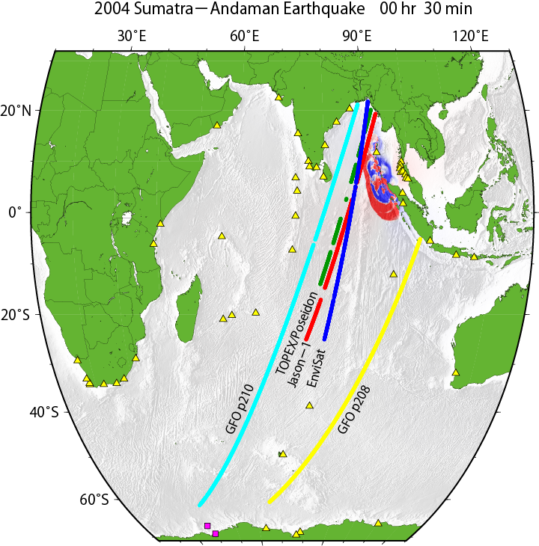
Figure S1. Snapshot of an animation for the tsunami propagation and satellite altimetry measurements. The URL link to this animation is as follow.
https://iisee.kenken.go.jp/staff/fujii/Sumatra2004/tsunami_prop.html

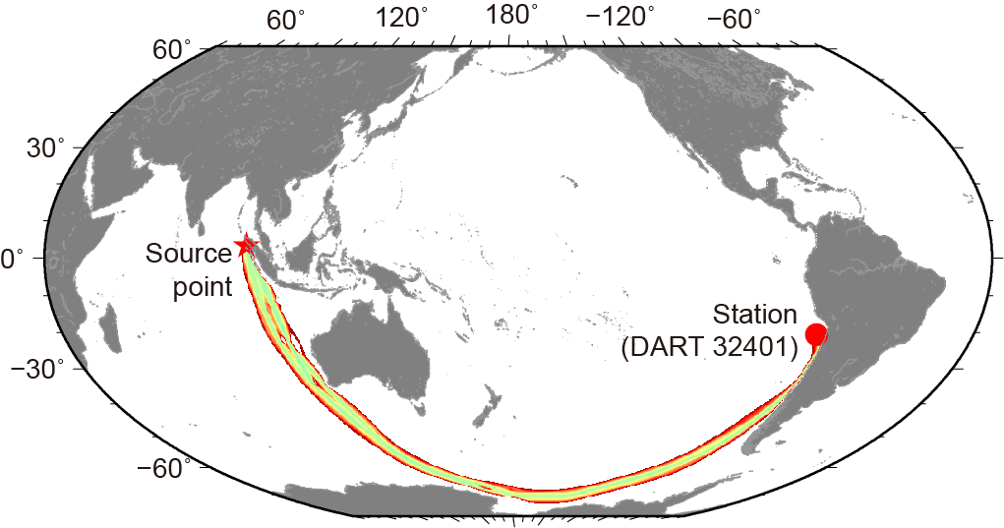
Figure S2. Tsunami ray path image from a source point (the epicenter of the 2004 Sumatra-Andaman earthquake) to a station (DART 32401), which was drawn by the estimation method (Ho et al., 2020). The sum of tsunami travel times from the source to the station and those from the station to the source are shown as red-to-green color corresponding to large-to-minimum values.

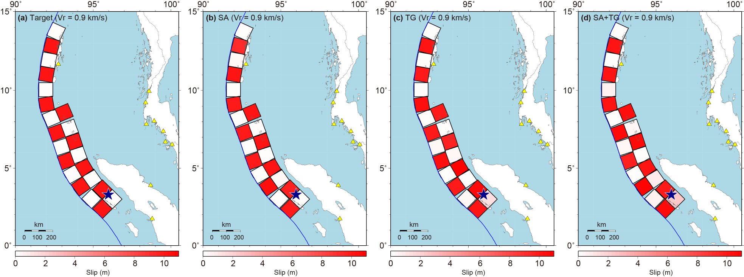
Figure S3. Inversion results for different data sets with a target checkerboard slip distribution. For each data set, we added 20% of random-noise amplitudes which were generated following a normal distribution with the same standard deviation as the synthetic data to be inverted. (a) Target slip distribution to be inverted. The assumed rupture velocity is 0.9 km/s. The slip amounts are 10 m (red) and 0 m (white). (b) Slips inverted from synthetic sea surface heights (SSHs) from satellite altimetry (SA) measurements. (c) Slips inverted from synthetic tsunami waveform data at tide gauges (TGs) and ocean bottom pressure gauges (OBPGs) at the Syowa Base in Antarctica. (d) Slips inverted from synthetic joint data of SSHs and tsunami waveforms at TGs and OBPGs at the Syowa Base.
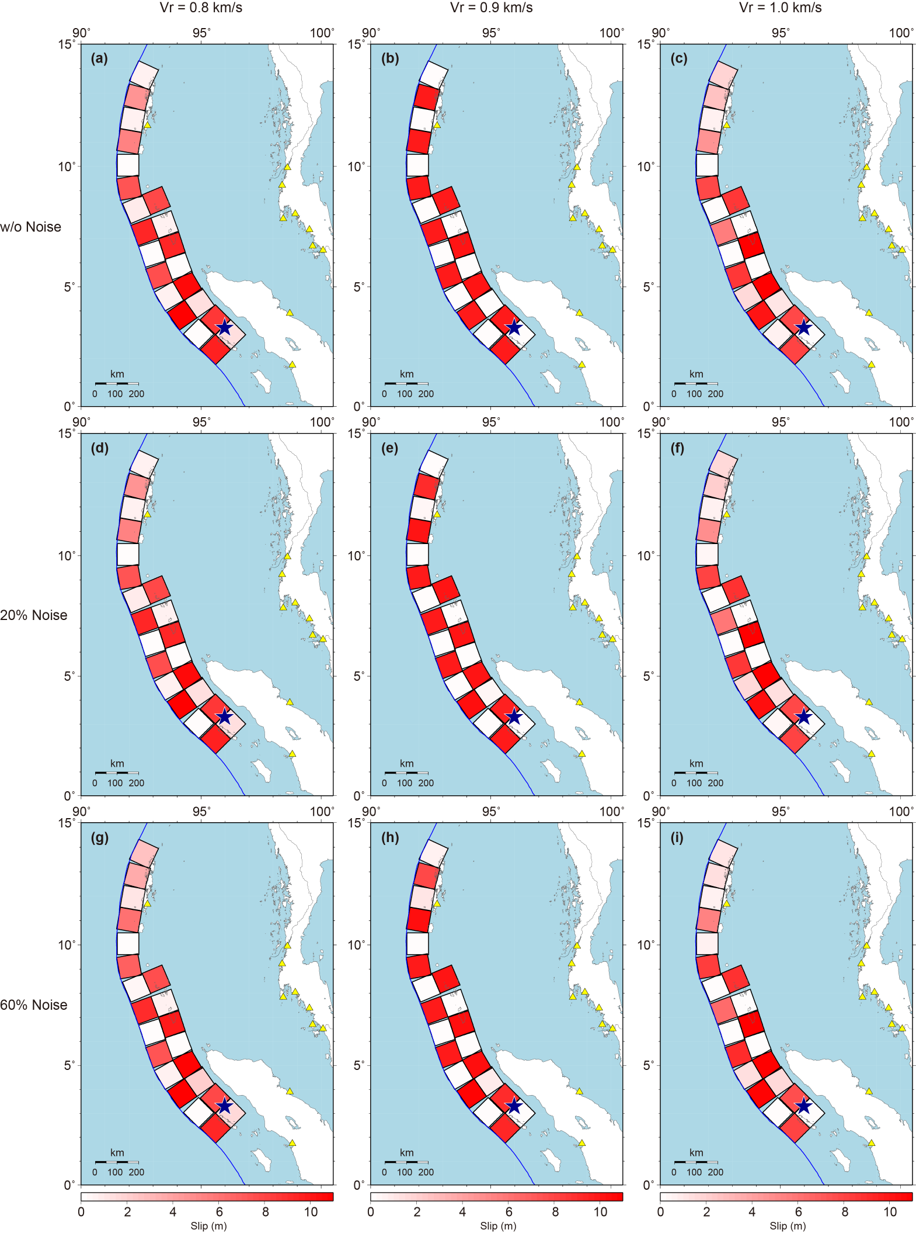
Figure S4. Slip distributions inverted from the SA data synthetized from the target checkerboard slip distribution (Fig. S3a). Top (a, b, c), middle (d, e, f) and bottom (g, h, i) rows correspond to the cases in which no noise, 20% and 60% of the random-noise amplitudes were added to the synthetic data to be inverted, respectively. (a, d, g) Slips inverted from the synthetic data assuming a slower rupture velocity of 0.8 km/s. (b, e, h) Slips inverted from the synthetic data assuming the same rupture velocity of 0.9 km/s with the synthetic data (Figure (e) is the same as Fig. S3b). (c, f, i) Slips inverted from the synthetic data assuming a faster rupture velocity of 1.0 km/s.
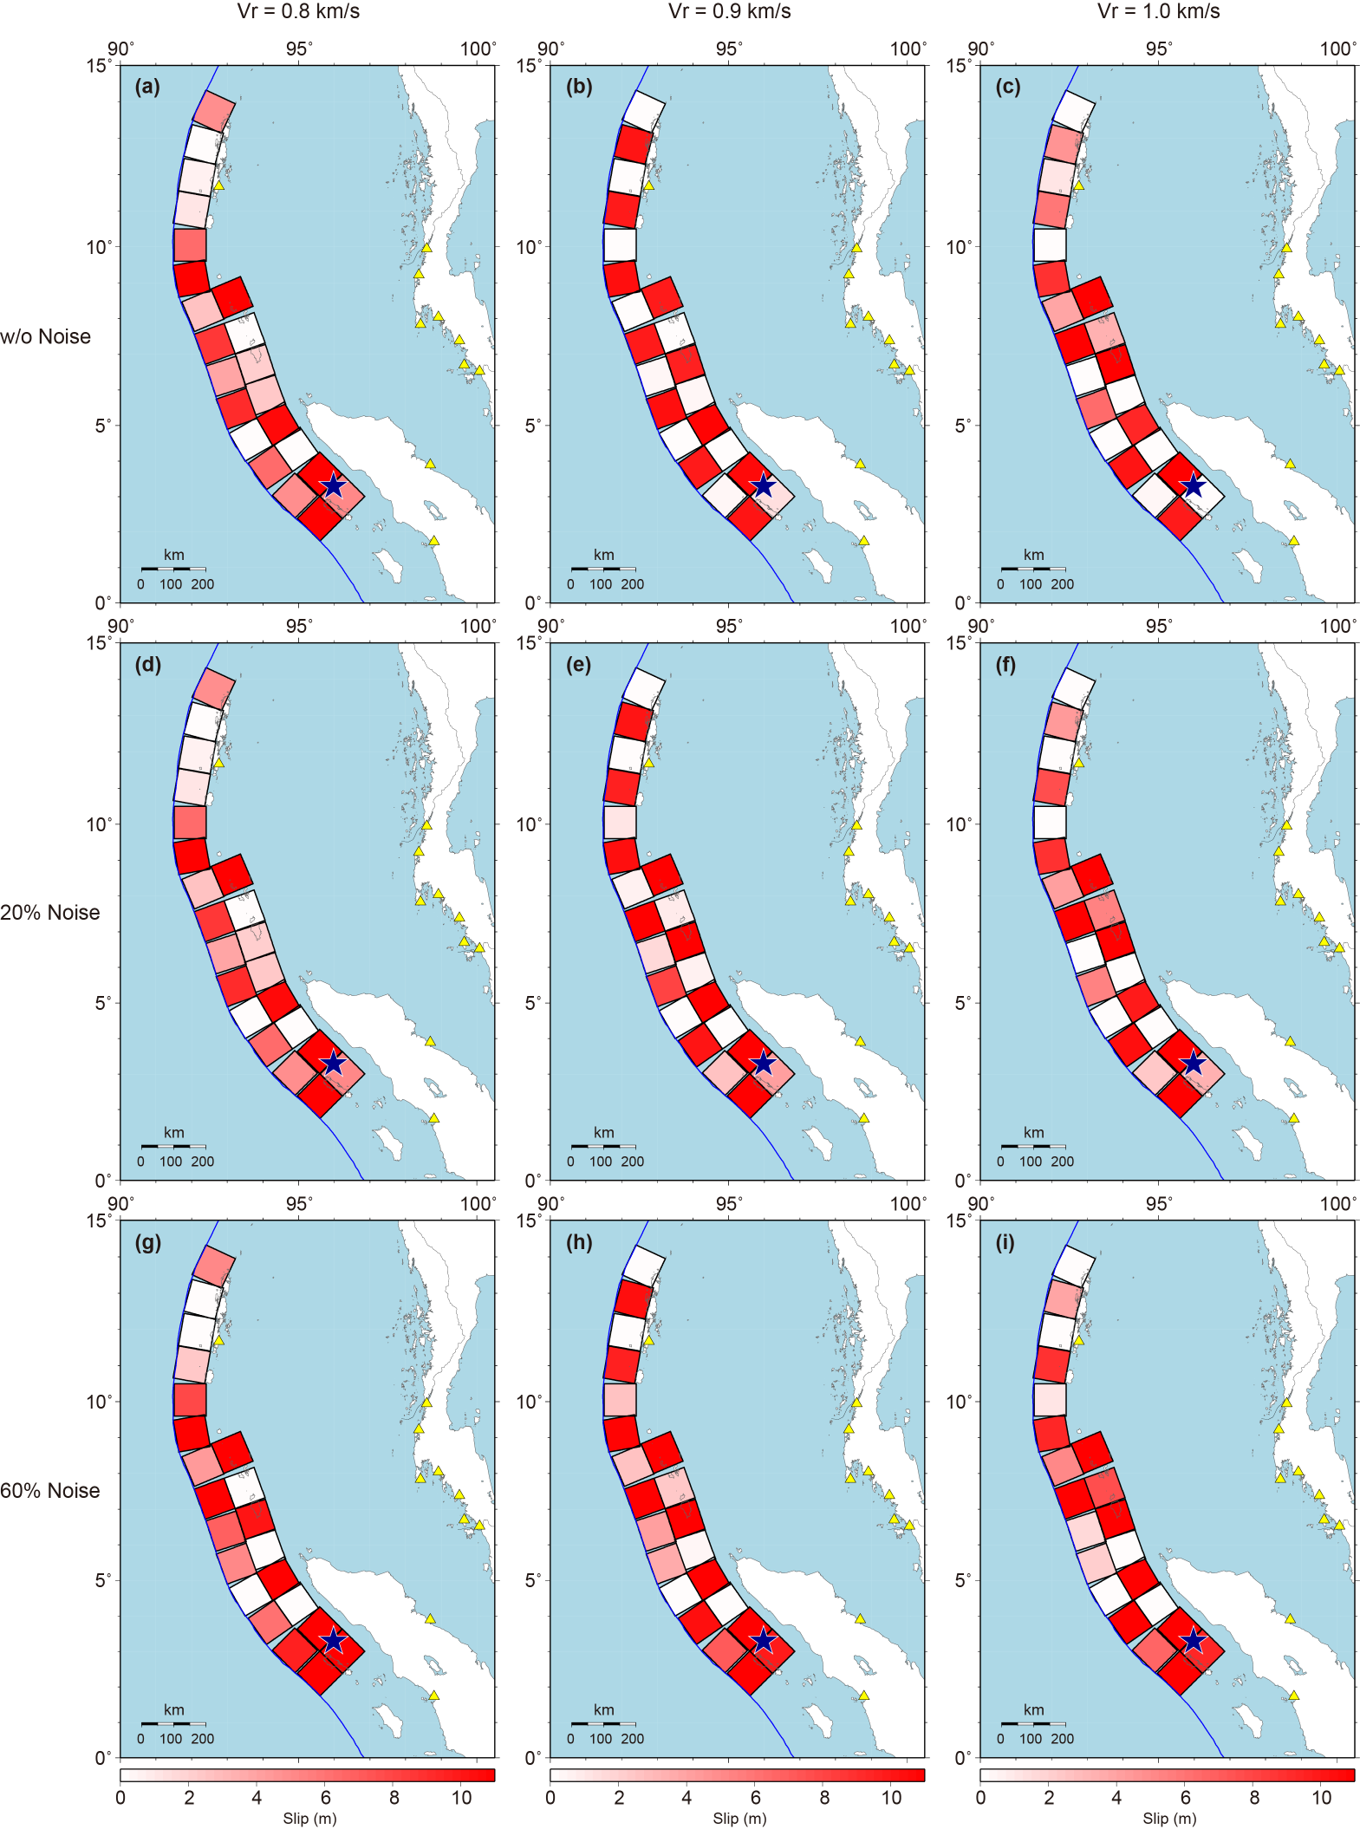
Figure S5. Slip distributions inverted from the TG data synthetized from the target checkerboard slip distribution (Fig. S3a). Top (a, b, c), middle (d, e, f) and bottom (g, h, i) rows correspond to the cases in which no noise, 20% and 60% of the random-noise amplitudes were added to the synthetic waveforms to be inverted, respectively. (a, d, g) Slips inverted from the synthetic data assuming a slower rupture velocity of 0.8 km/s. (b, e, h) Slips inverted from the synthetic data assuming the same rupture velocity of 0.9 km/s with synthetic data (Figure (e) is the same as Fig. S3c). (c, f, i) Slips inverted from the synthetic data assuming a faster rupture velocity of 1.0 km/s.
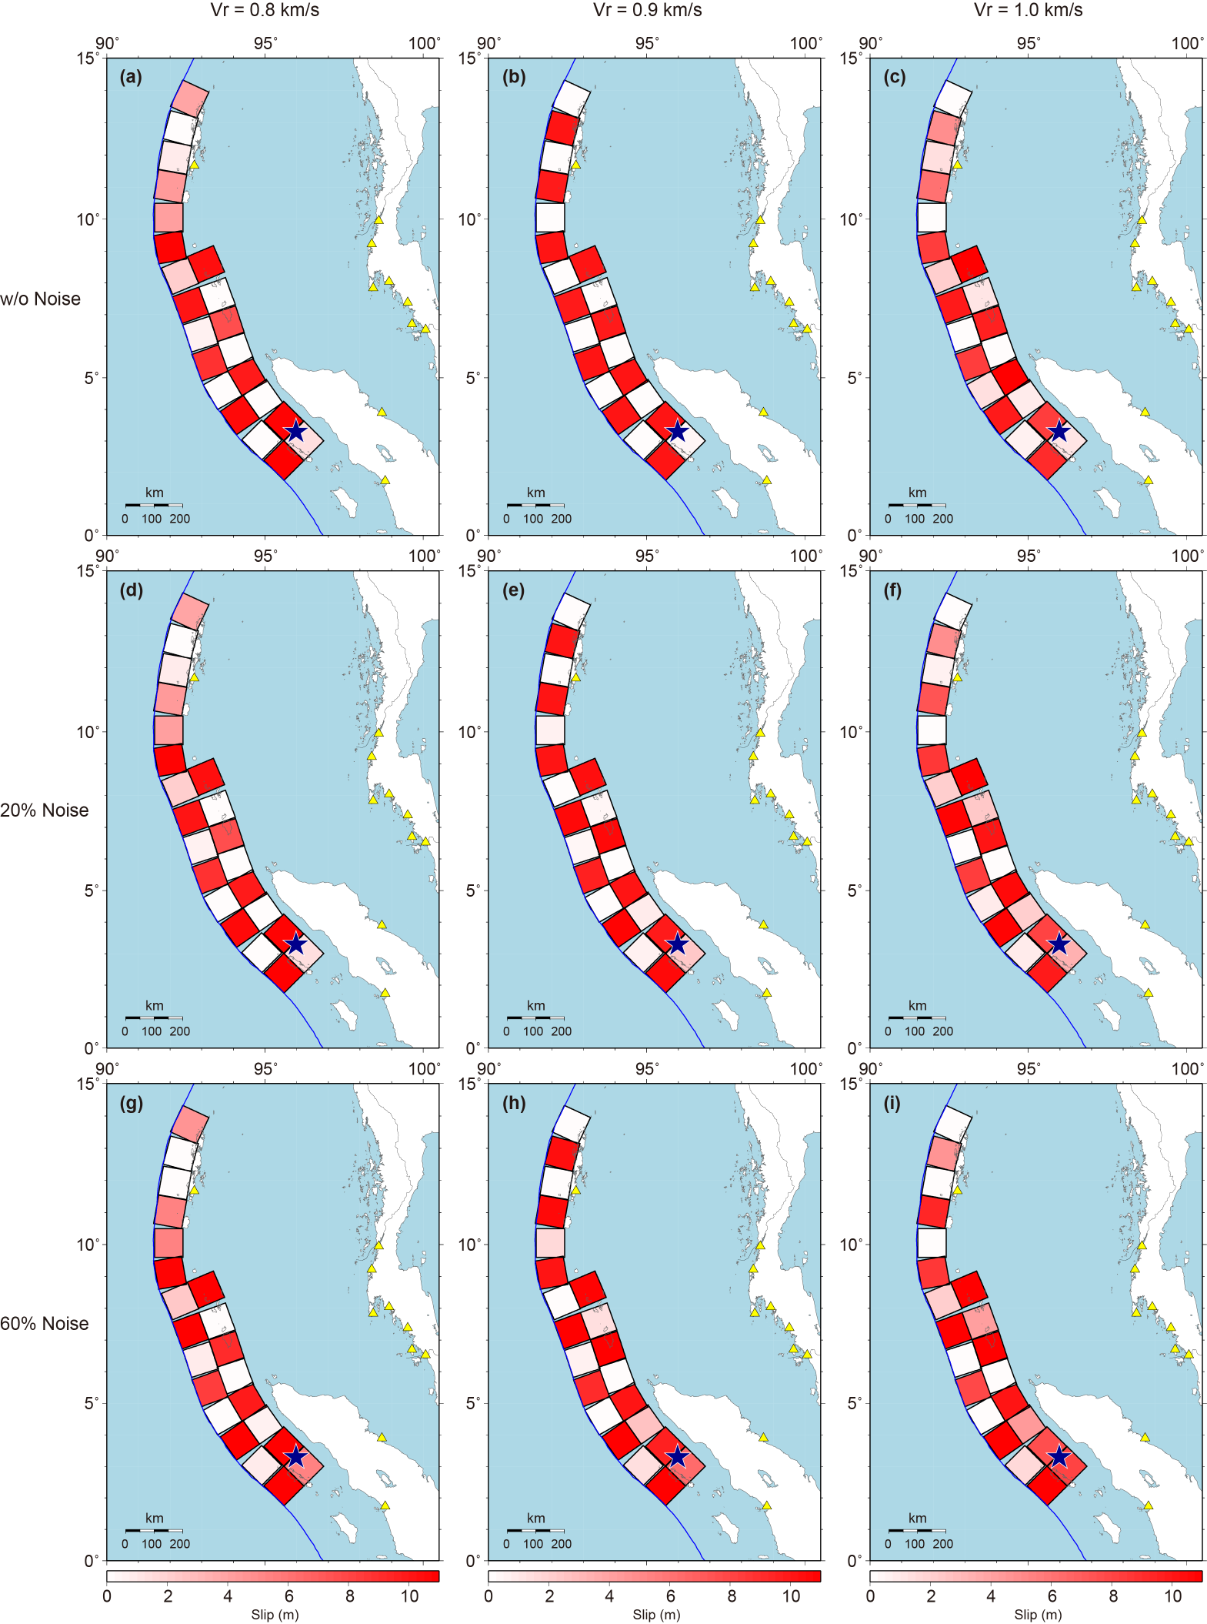
Figure S6. Slip distributions inverted from the SA+TG data synthetized from the target checkerboard slip distribution (Fig. S3a). Top (a, b, c), middle (d, e, f) and bottom (g, h, i) rows correspond to the cases in which no noise, 20% and 60% of the random-noise amplitudes were added to the synthetic waveforms to be inverted, respectively. (a, d, g) Slips inverted from the synthetic data assuming a slower rupture velocity of 0.8 km/s. (b, e, h) Slips inverted from the synthetic data assuming the same rupture velocity of 0.9 km/s with synthetic data (Figure (e) is the same as Fig. S3d). (c, f, i) Slips inverted from the synthetic data assuming a faster rupture velocity of 1.0 km/s.
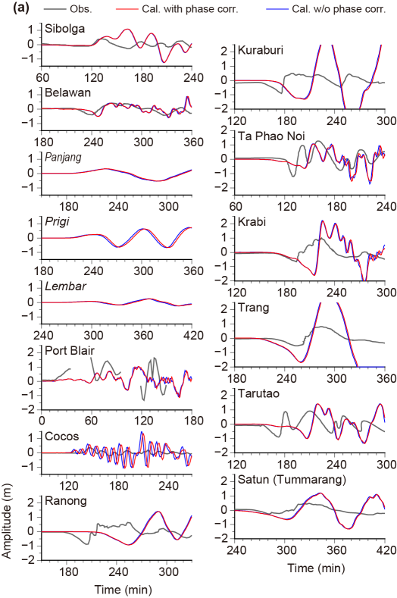
Figure S7 Comparison of tsunami waveforms at tide gauges (TG) from the inversion result using SA data with the assumed rupture velocity of 1.3 km/s. Black lines are observed waveforms. Red and blue lines are calculated waveforms with and without the phase correction, respectively. In the stations shown by narrow italic, only the synthetic tsunami waveforms are shown for comparison.

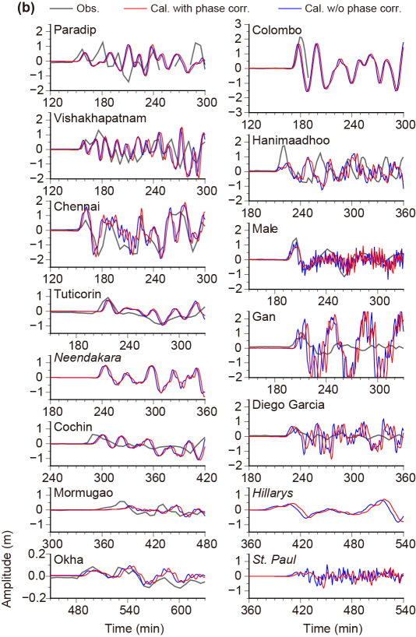
Figure S7 Continued.

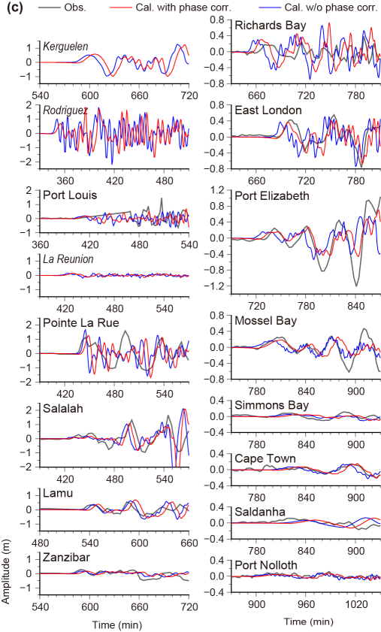
Figure S7 Continued.
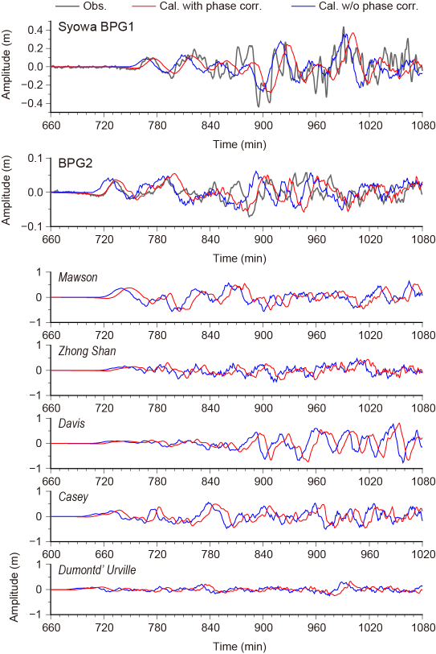
Figure S8 Same as Fig. S7, but for the tsunami waveforms at OBPGs near the Syowa Base and Australian TGs in Antarctica.
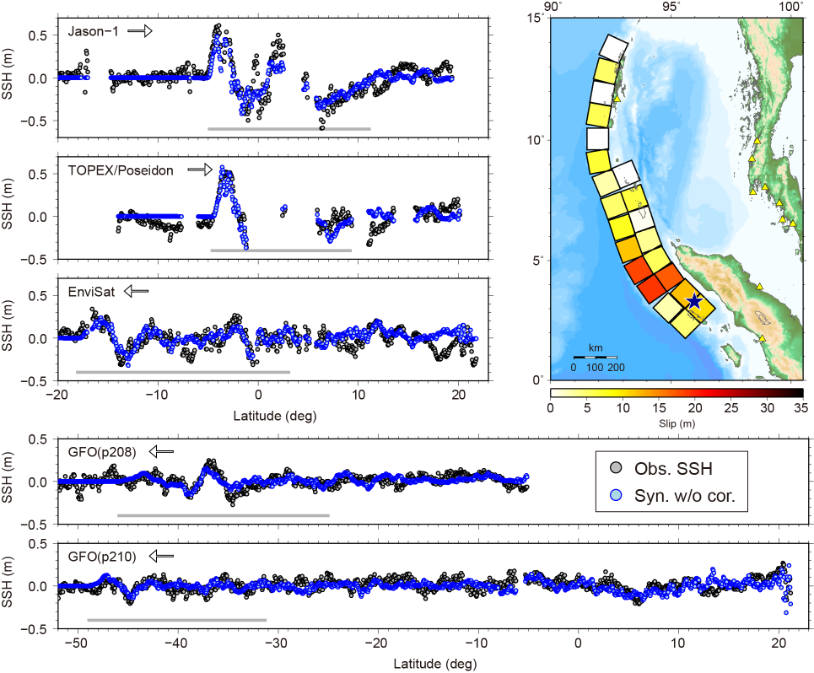
Figure S9. Comparison of SSHs (gray circles) for the inversion using SA data with the assumed rupture velocity of 1.3 km/s. Blue circles are calculated SSHs without the phase correction. The Green’s functions without the phase correction were used for the inversion. Gray bars correspond to the data windows used for the inversion. Right top figure shows the estimated slip distribution.

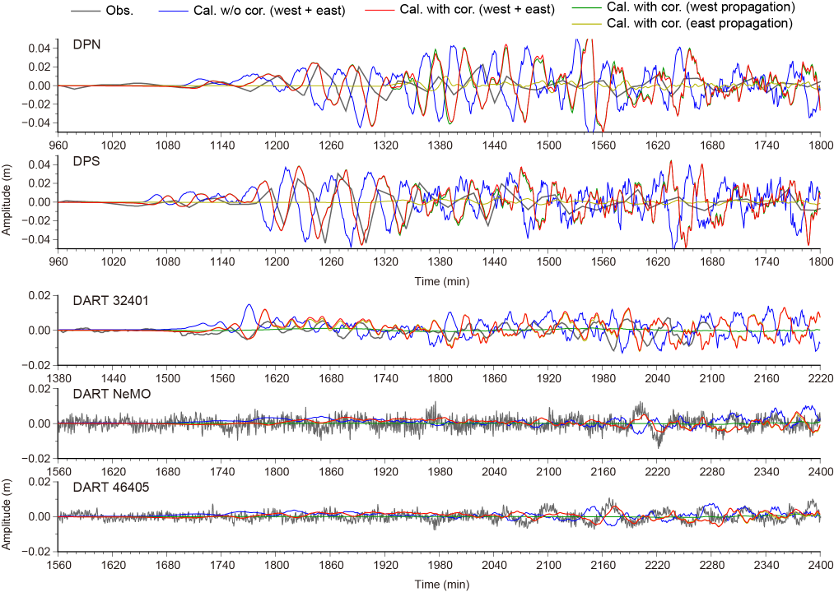
Figure S10 Comparison of far-field tsunami waveforms at OBPGs in the Drake Passage and DARTs off northern Chile and off the Pacific coast of USA, which were calculated from the inversion result using the TG data with the assumed rupture velocity of 1.3 km/s. Black lines are observed waveforms. Red and blue lines are calculated waveforms with and without the phase correction, respectively. Green and dark yellow lines indicate the calculated tsunami waveforms with the phase correction toward west and east from the epicenter, respectively.

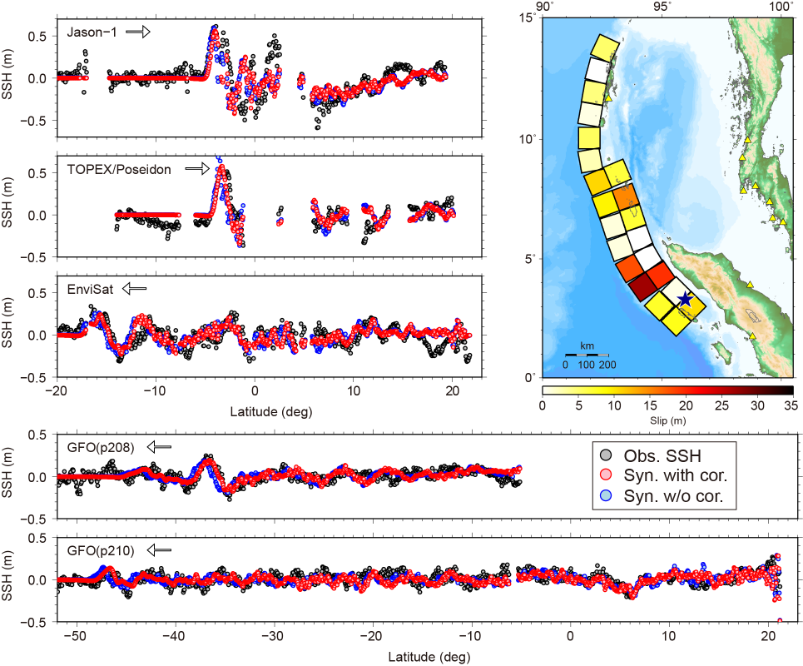
Figure S11 Comparison of SSHs for the inversion using the TG data with the assumed rupture velocity of 1.3 km/s. Black circles are observed SSHs. Red and blue circles are calculated SSHs with and without the phase correction, respectively. Right top figure shows the estimated slip distribution.

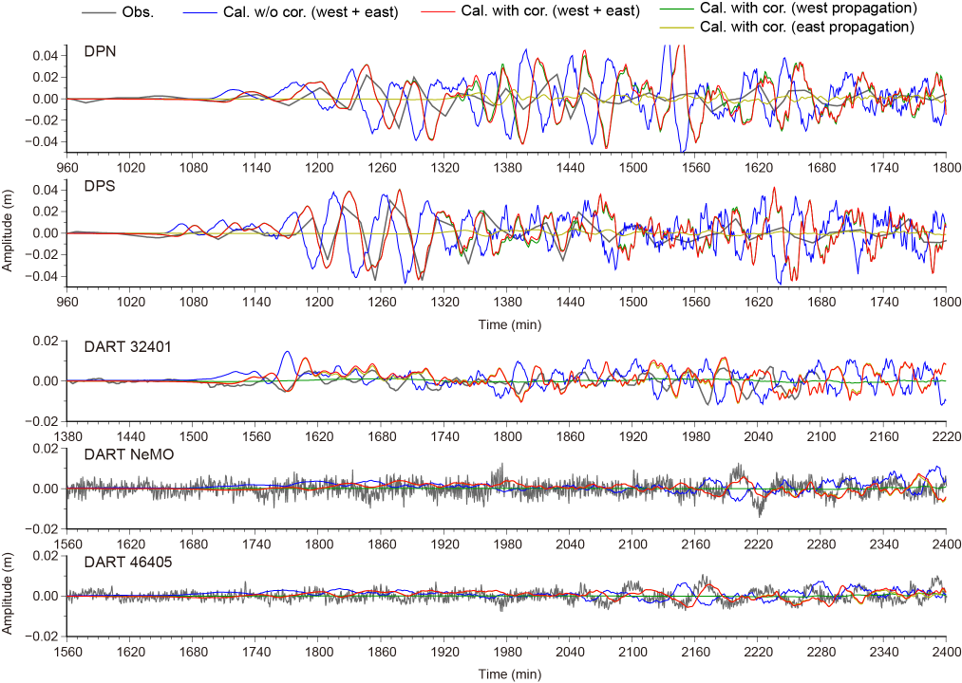
Figure S12 Same as Fig. S10, but from the inversion result using the SA+TG data with the assumed rupture velocity of 1.3 km/s.

Table S1. Slips and errors on subfaults for the 2004 earthquake from the inversions using each SA data, TG data and SA+TG data with different rupture velocities (Vr). Seismic moment (Mo) and moment magnitude (Mw) are also listed.
Subfault number | Slip and error (m)
Subfault number | SA data with assumed Vr of |  |  | TG data with assumed Vr of
Subfault number | 0.9 km/s | 2.0 km/s | 2.5 km/s | 0.9 km/s | 2.0 km/s | 2.5 km/s
1 | 7.10 ± 1.29 | 4.76 ± 1.27 | 4.91 ± 1.33 | 8.19 ± 1.71 | 8.73 ± 1.86 | 8.75 ± 1.78
2 | 9.47 ± 2.59 | 11.64 ± 2.60 | 8.97 ± 2.61 | 17.32 ± 6.07 | 5.73 ± 5.47 | 3.84 ± 5.04
3 | 10.24 ± 1.37 | 9.38 ± 1.56 | 8.78 ± 1.63 | 10.49 ± 3.04 | 6.75 ± 2.63 | 6.32 ± 2.52
4 | 18.81 ± 1.98 | 14.24 ± 1.94 | 15.55 ± 2.01 | 5.99 ± 5.32 | 0.00 ± 2.66 | 0.00 ± 2.61
5 | 21.91 ± 1.73 | 19.66 ± 1.72 | 19.49 ± 1.77 | 21.16 ± 4.98 | 24.99 ± 4.38 | 24.82 ± 4.02
6 | 15.43 ± 1.72 | 20.80 ± 1.55 | 20.68 ± 1.69 | 8.04 ± 5.01 | 20.75 ± 6.16 | 17.79 ± 6.23
7 | 17.46 ± 1.66 | 15.62 ± 1.42 | 16.47 ± 1.78 | 16.39 ± 3.90 | 23.60 ± 4.18 | 26.34 ± 4.27
8 | 0.00 ± 0.69 | 0.00 ± 1.14 | 1.26 ± 1.72 | 0.00 ± 0.48 | 2.00 ± 4.20 | 6.23 ± 5.15
9 | 9.16 ± 1.06 | 7.84 ± 1.44 | 7.78 ± 1.34 | 6.63 ± 2.79 | 0.19 ± 1.39 | 0.00 ± 0.79
10 | 1.33 ± 1.12 | 0.00 ± 1.01 | 0.25 ± 1.09 | 0.00 ± 0.86 | 0.00 ± 0.00 | 0.00 ± 0.14
11 | 4.30 ± 1.46 | 7.46 ± 1.09 | 7.93 ± 1.26 | 4.05 ± 2.38 | 0.00 ± 0.00 | 0.00 ± 0.05
12 | 0.00 ± 0.00 | 0.00 ± 0.97 | 1.48 ± 1.62 | 4.76 ± 2.86 | 7.19 ± 3.30 | 5.00 ± 2.92
13 | 2.76 ± 1.68 | 8.50 ± 1.59 | 9.81 ± 1.37 | 12.14 ± 2.22 | 5.72 ± 2.12 | 1.63 ± 1.67
14 | 5.83 ± 1.81 | 0.84 ± 1.22 | 0.00 ± 0.54 | 13.39 ± 1.97 | 13.55 ± 2.72 | 13.65 ± 2.61
15 | 7.25 ± 1.27 | 6.00 ± 1.64 | 5.18 ± 1.65 | 10.23 ± 1.76 | 3.74 ± 1.54 | 1.04 ± 1.23
16 | 4.65 ± 1.78 | 3.30 ± 2.04 | 5.26 ± 2.23 | 4.49 ± 1.92 | 5.89 ± 1.57 | 4.25 ± 1.74
17 | 0.00 ± 0.14 | 8.20 ± 1.40 | 9.44 ± 1.35 | 0.00 ± 0.87 | 3.11 ± 1.47 | 2.53 ± 1.40
18 | 0.00 ± 0.00 | 0.02 ± 1.28 | 3.67 ± 1.97 | 0.97 ± 1.07 | 3.99 ± 1.35 | 0.00 ± 0.63
19 | 3.73 ± 2.21 | 0.00 ± 0.26 | 0.00 ± 0.29 | 7.31 ± 1.93 | 0.02 ± 0.87 | 0.00 ± 0.45
20 | 3.87 ± 2.11 | 2.34 ± 2.33 | 4.06 ± 3.39 | 3.71 ± 0.71 | 4.50 ± 0.57 | 4.64 ± 0.62
21 | 11.57 ± 2.49 | 1.58 ± 1.77 | 0.86 ± 1.67 | 0.00 ± 0.00 | 1.16 ± 1.06 | 0.61 ± 1.14
22 | 0.00 ± 0.50 | 0.00 ± 1.22 | 2.06 ± 1.86 | 0.00 ± 0.37 | 3.52 ± 1.49 | 3.79 ± 1.40
Mo (Nm) | 7.74 × 10²² | 7.11 × 10²² | 7.69 × 10²² | 7.76 × 10²² | 7.25 × 10²² | 6.56 × 10²²
Mw | 9.2 | 9.2 | 9.2 | 9.2 | 9.2 | 9.1
Bold numbers are deep subfaults.

Table S1. Continued.
Subfault number | Slip and error (m)
Subfault number | SA+TG data with assumed Vr of
Subfault number | 0.9 km/s | 2.0 km/s | 2.5 km/s
1 | 7.50 ± 1.12 | 6.07 ± 1.24 | 5.86 ± 1.23
2 | 13.32 ± 2.58 | 15.38 ± 2.88 | 15.35 ± 2.92
3 | 11.23 ± 1.22 | 8.10 ± 1.52 | 7.30 ± 1.50
4 | 12.87 ± 1.90 | 4.96 ± 2.26 | 3.80 ± 2.33
5 | 23.21 ± 1.75 | 21.45 ± 1.89 | 20.84 ± 1.91
6 | 16.66 ± 1.89 | 22.35 ± 2.10 | 22.05 ± 2.07
7 | 17.14 ± 1.49 | 19.26 ± 2.56 | 20.76 ± 2.63
8 | 0.00 ± 0.52 | 4.03 ± 2.49 | 6.29 ± 2.70
9 | 8.78 ± 0.98 | 4.61 ± 1.35 | 2.70 ± 1.32
10 | 1.44 ± 1.13 | 1.18 ± 1.37 | 0.70 ± 1.25
11 | 4.86 ± 1.20 | 0.48 ± 1.19 | 1.03 ± 1.32
12 | 0.00 ± 0.35 | 2.78 ± 1.90 | 3.67 ± 1.94
13 | 8.74 ± 1.24 | 3.75 ± 1.70 | 1.78 ± 1.70
14 | 10.83 ± 1.27 | 8.68 ± 1.80 | 8.68 ± 1.72
15 | 8.99 ± 0.91 | 1.21 ± 1.28 | 0.00 ± 0.56
16 | 3.01 ± 0.97 | 1.90 ± 1.15 | 2.10 ± 1.29
17 | 0.00 ± 0.31 | 2.83 ± 1.21 | 2.52 ± 1.24
18 | 0.00 ± 0.56 | 2.66 ± 1.18 | 0.00 ± 0.71
19 | 5.29 ± 1.23 | 0.52 ± 0.89 | 0.00 ± 0.65
20 | 4.65 ± 0.51 | 5.11 ± 0.52 | 5.17 ± 0.56
21 | 0.00 ± 0.69 | 1.26 ± 1.11 | 1.30 ± 1.07
22 | 0.00 ± 0.00 | 2.89 ± 1.19 | 2.64 ± 0.95
Mo (Nm) | 7.93 × 10²² | 7.07 × 10²² | 6.73 × 10²²
Mw | 9.2 | 9.2 | 9.2
Bold numbers are deep subfaults.
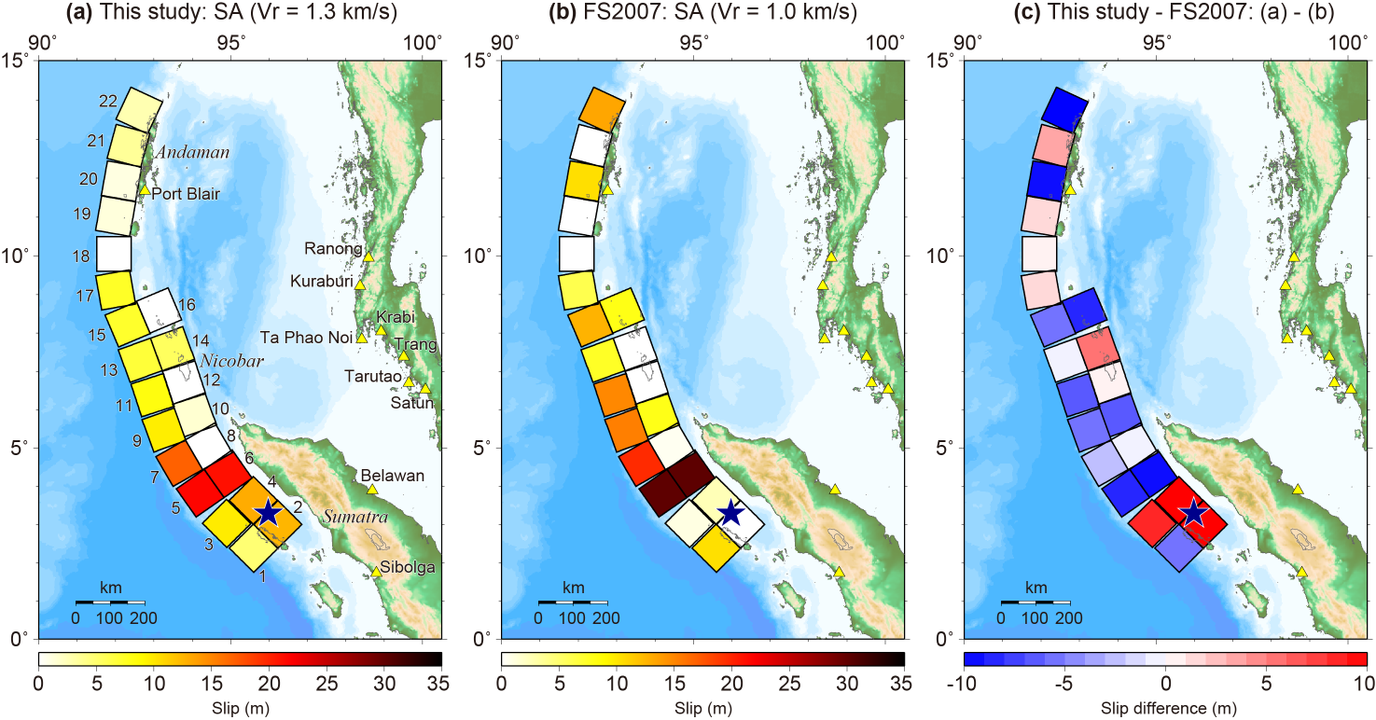
Figure S13. Comparison of slip distributions from the inversions using SA data (a) in this study: with the assumed rupture velocity of 1.3 km/s and (b) in the previous study (Fujii and Satake, 2007) with the assumed rupture velocity of 1.0 km/s. (c) Slip difference between this study (a) and the previous study (b).

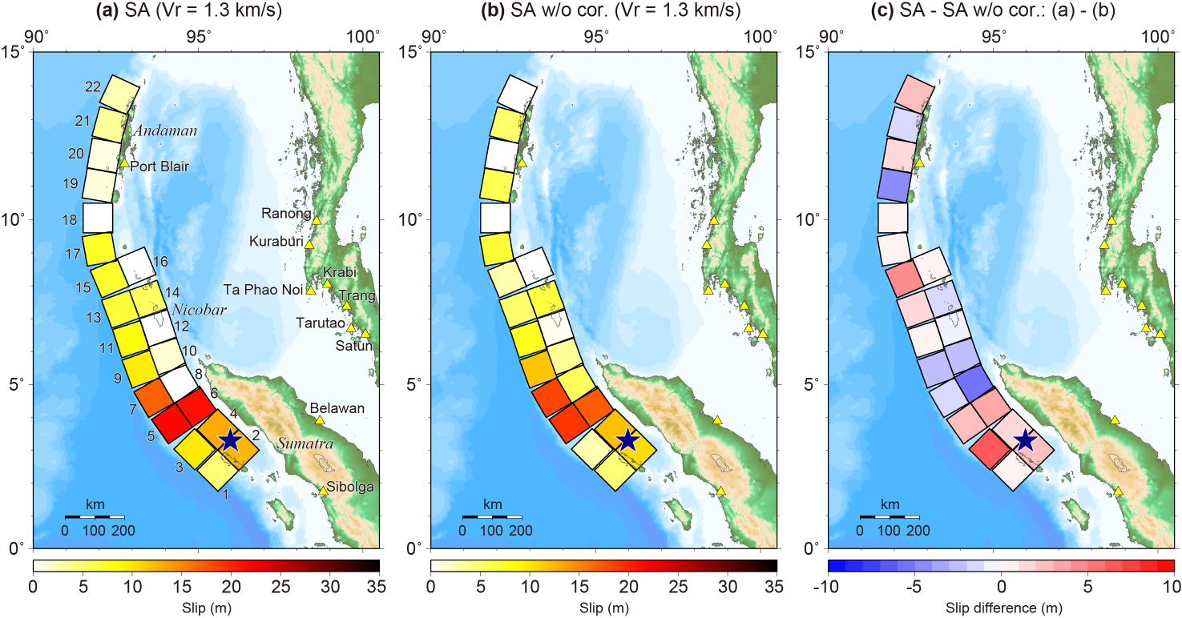
Figure S14. Comparison of slip distributions from the inversions using SA data in the case of the rupture velocity of 1.3 km/s (a) using the phase-corrected Green’s functions and (b) using the Green’s functions without the phase corrections. (c) Slip difference between the slips of (a) and (b).
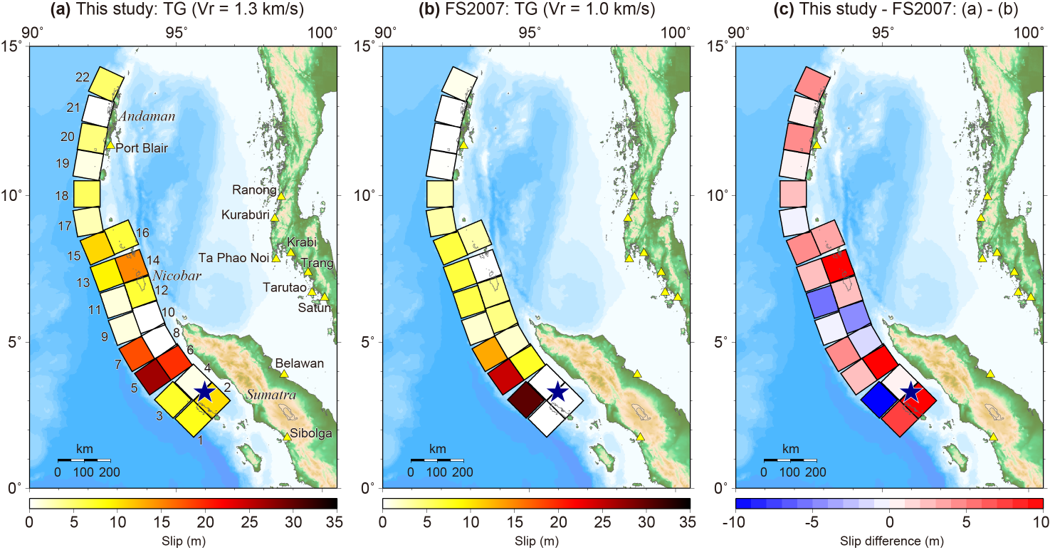
Figure S15. Same as Fig. S13, but for the inversions using TG data.

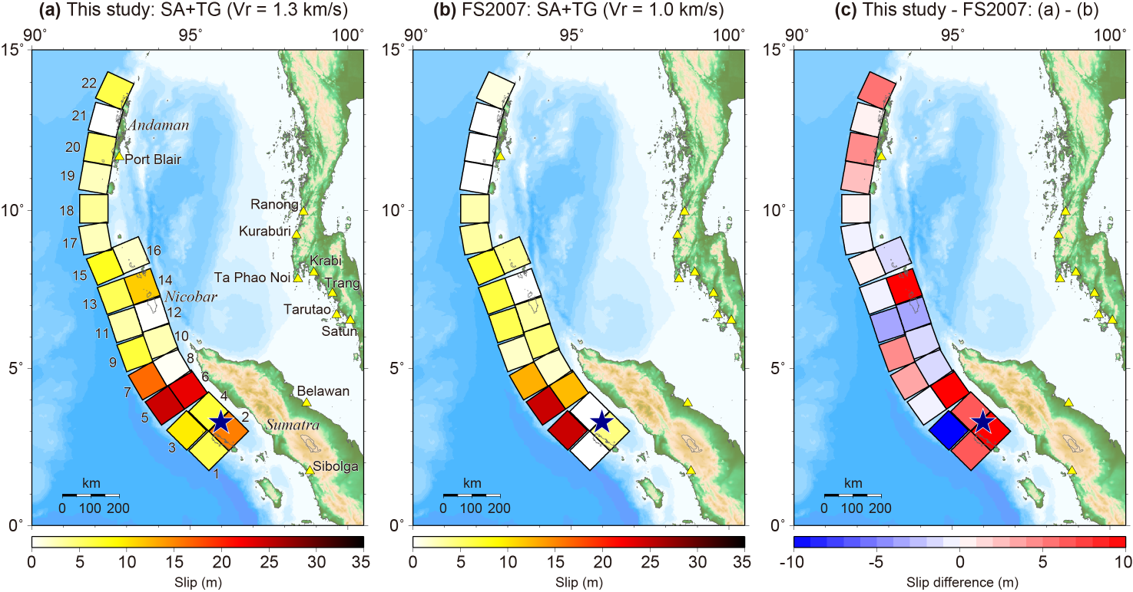
Figure S16. Same as Fig. S13, but for the inversions using SA+TG data.

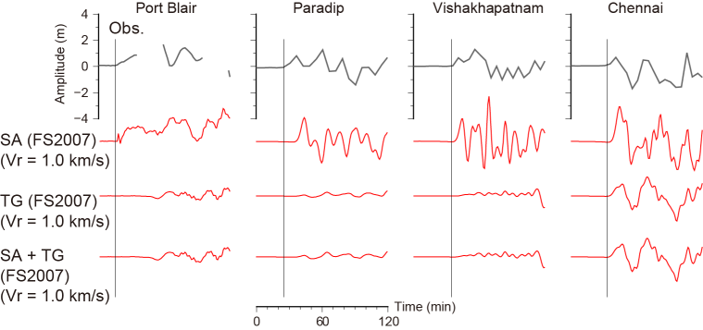
Figure S17. Same as Fig. 6 in main text, but the synthetic tsunami waveforms (red lines) are from the tsunami source models of the previous study (Fujii and Satake, 2007) with the assumed rupture velocity of 1.0 km/s.

